Week 1: January 5-7 2011
- Management: planning for what is going to happen

- Digitization: the replacement of physical tasks by digital means

Five factors to consider when assessing impact of IT:
- Internet growth and technology convergence
- Internet is bringing about rapid changes in markets and market structure
- Internet is bringing about a digital convergence of telecommunications and computing
- Transformation of the business enterprise
- Flattened organizational structure
- Decentralized
- Flexible arrangement of generalists
- Mass-customization and customer service
- Location independence
- Low transaction and coordination costs
- Empowerment
- Collaborative work and teamwork
- Growth of a globally connected economy
- Competition in world markets
- Global workgroups
- Global delivery systems
- Growth of knowledge and information-based economies
- Knowledge and information-based economies
- New products and services
- Knowledge as a central productive and strategic asset
- Emergence of the digital firm
- Digitally enabled relationships with customers, suppliers, and employees
- Core business processes accomplished using digital networks
- Digital management of key corporate assets
- Agile sensing and responding to environmental changes
- Seamless flow of information within the firm, and with strategic partners

Capital Management and Business
- Information and Communications Technology (ICT) is the largest single component of capital investment
- The success of your business in the future may well depend on how you make ICT investment decisions
- Wikis, Social Networking Applications, Twitter have changed how we access and use information
- As business managers we need to know how to leverage their potential to achieve strategic advantage

Why is the world Flattening?
- Globalization created a new world characterized by:
- Worldwide communication
- Collaboration without barriers
- The global economic playing field has been leveled
- Competition is worldwide – Management requires constant planning and re-planning
- Few jobs or markets are constrained by geographic boundaries
- Flattening requires new strategies and business solutions to succeed in this world

- Flattening Challenges
- Political System Challenges
- Cultural challenges
- Regulatory Challenges
- Data-Sharing Challenges
- People and process challenges
- Internet Access and Individual Freedom

Week 2 - January 10-14, 2011
Iivari, Hirschheim and Klein (2004) classify IS body of knowledge as needing:
- technology knowledge
- application domain knowledge
- systems development knowledge
- organizational knowledge
- IS application knowledge

Three Key Concepts
- Business Processes and how IT supports these processes
- Changing paradigm of information and communication technologies
- How to leverage #2 to better do #1
Business Processes and Information Systems
- Manner in which work is organized, coordinated, and focused to produce a valuable product or service
- Concrete work flows of material, information, and knowledge – sets of activities
- Unique ways to coordinate work, information, and knowledge
- Ways in which management coordinates work
- Information systems help organizations achieve great efficiencies by automating parts of processes
- IS also contributes to completely rethinking processes
- Business processes typically span several different functional areas

Examples of Business Processes
- Manufacturing and production:
  - Assembling product, checking quality, producing bills of materials
- Sales and marketing:
  - Identifying customers, creating customer awareness, selling
- Finance & accounting:
  - Paying creditors, creating financial statements, managing cash accounts
- Human resources:
  - Hiring employees, evaluating performance, enrolling employees in benefits plans

Business Processes and Information Systems (Cont)
- Cross-Functional Business Processes:
- Transcend boundary between sales, marketing, manufacturing, and research and development
  - Group employees from different functional specialties to a complete piece of work
  - Example: Order Fulfillment Process

Identifying Competitive Advantages
- To survive and thrive an organization must create a competitive advantage
  - Competitive advantage – a product or service that an organization’s customers place a greater value on than similar offerings from a competitor
  - First-mover advantage – occurs when an organization can significantly impact its market share by being first to market with a competitive advantage

THE FIVE FORCES MODEL – Evaluating Business Processes and Strategy
- Porter’s Five Forces Model determines the relative attractiveness of an industry
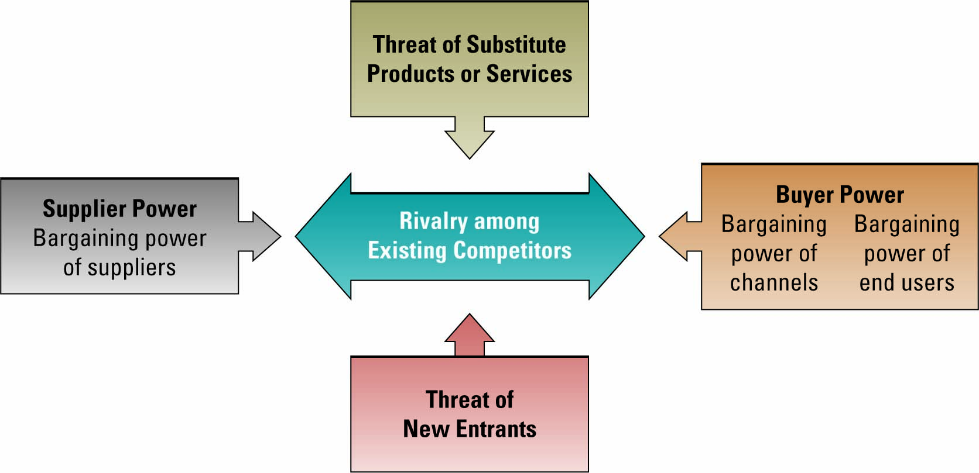
- Buyer power - high when buyers have many choices of whom to buy from and low when their choices are few
- Use IT to reduce buyer power (thus creating a competitive advantage) through loyalty programs

Enterprises IT Systems
Organizations use specific IT to support strategic initiatives including:
  - Supply chain management (SCM) systems
  - Customer relationship management (CRM) systems
  - Enterprise resource planning (ERP) systems
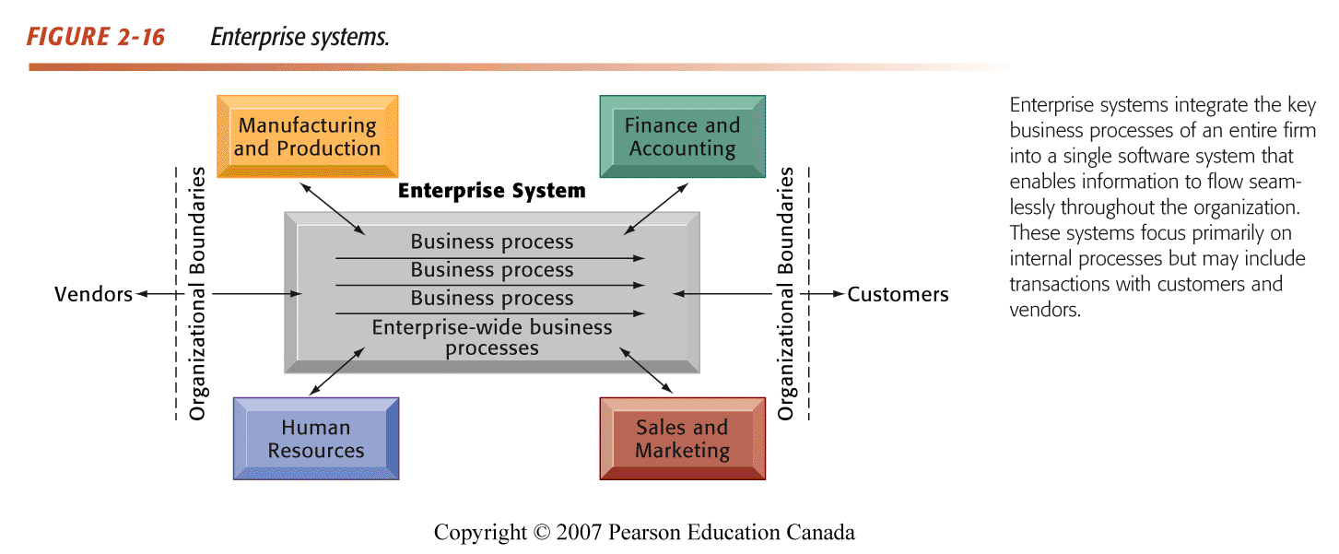
Overview of Supply Chain Management (SCM) Systems
- Integrates supplier, manufacturer, distributor, and customer logistics time
- Reduces time, redundant effort, and inventory costs
- Network of organizations and business processes
- Helps in procurement of materials, transformation of raw materials into intermediate and finished products
- Includes reverse logistics - returned items flow in the reverse direction from the buyer back to the seller

Overview of Customer Relationship Management (CRM) Systems
- Manages all methods a firm uses to deal with existing and potential customers
- Uses information system to coordinate entire business processes of a firm to better understand and deliver customer’s needs
- Provides end-to-end customer care
- Consolidates customer data from multiple sources and provides analytical tools for answering questions

Organizational/Behavioral Impacts
- IT broadens the distribution of timely information
- Increases the speed of decision-making
- Empowers lower-level employees
- Increases management span of control

10 Flatters
- Flattening organizations are more virtual firms, increasing flexibility
- IT facilitates flattening of hierarchies by:
  - Distributing information to empower lower-level employees and increase management efficiency less number of middle managers

- Flattener #1: The Fall of the Berlin Wall: People from the former communist countries gained more freedom
- Flattener #2: Netscape Browser: Gave individuals access to the Internet
- Flattener #3: Work Flow Software: Applications that allow people worldwide to communicate
- Flattener #4: Open Sourcing: Software and source code freely available to everyone

- Flattener #5: Outsourcing: Outsourcing companies profited from the drop in telecommunications costs. The Internet and access to it through Flattener #5 has revolutionized business

- Flattener #6: Off shoring: Mass production and Low Costs

- Flattener #7: Supply Chaining: Integration of retailers, suppliers, and customers

- Flattener #8: In-Sourcing: Delegation of company’s key operations to a subcontractor

- Flattener #9: In-Forming: Individuals have access to massive amounts of information
- The Search Engine has been a monster flattener since it has brought anyone with access to the Internet in touch with any topic they could possibly desire.
- What are the drivers of Globalization 3.0? - Fast changes & Emergence of new industries

- Flattener #10: The Steroids: Digital, Mobile, Personal and Virtual
- all analog content and processes (from entertainment to photography to word processing) can be digitized and therefore shaped, manipulated and transmitted;
- virtual - these processes can be done at high speed with total ease;
- mobile - can be done anywhere, anytime by anyone;
- personal - can be done by you

Impact of the Internet: Positive impact
- Opportunities to alter how business processes are conducted (e.g. efficiency)
- New opportunities for building brands and developing customer relationships (CRM)
- Companies that are better at using IS in general and the Internet in particular do a better job of dealing with Porter’s 5 threats
Impact of the Internet negative impact
- Substitute products or services
  - New substitutes emerge (e.g., online music lowers the value of record stores)
- Customers’ bargaining power
  - Customers have access to info on products & pricing, thus can bargain
- Suppliers’ bargaining power
  - Suppliers have more options to sell their products
- Threat of new entrants
  - The Internet reduces barriers to entry, such as physical location and changes the business environment
- Rivalry among existing competitors
  - The Internet widens geographic market, increasing the number of competitors, pressure to lower prices

Apple – iPod, iPhone, iTunes, iPads -- Merging Technology, Business and Entertainment

- Apple got much of its success from producing digital goods

Digital goods
- Goods that can be delivered over a digital network
- E.g., Music tracks, video, software, newspapers, books
- Cost of producing first unit almost entire cost of product: marginal cost of producing 2nd unit is about zero
- Costs of delivery over the Internet very low
- Marketing costs remain the same
- Industries with digital goods are undergoing revolutionary changes (publishers, record labels, etc.)

Supply-Chaining (Flattener #7) Wal-Mart and others

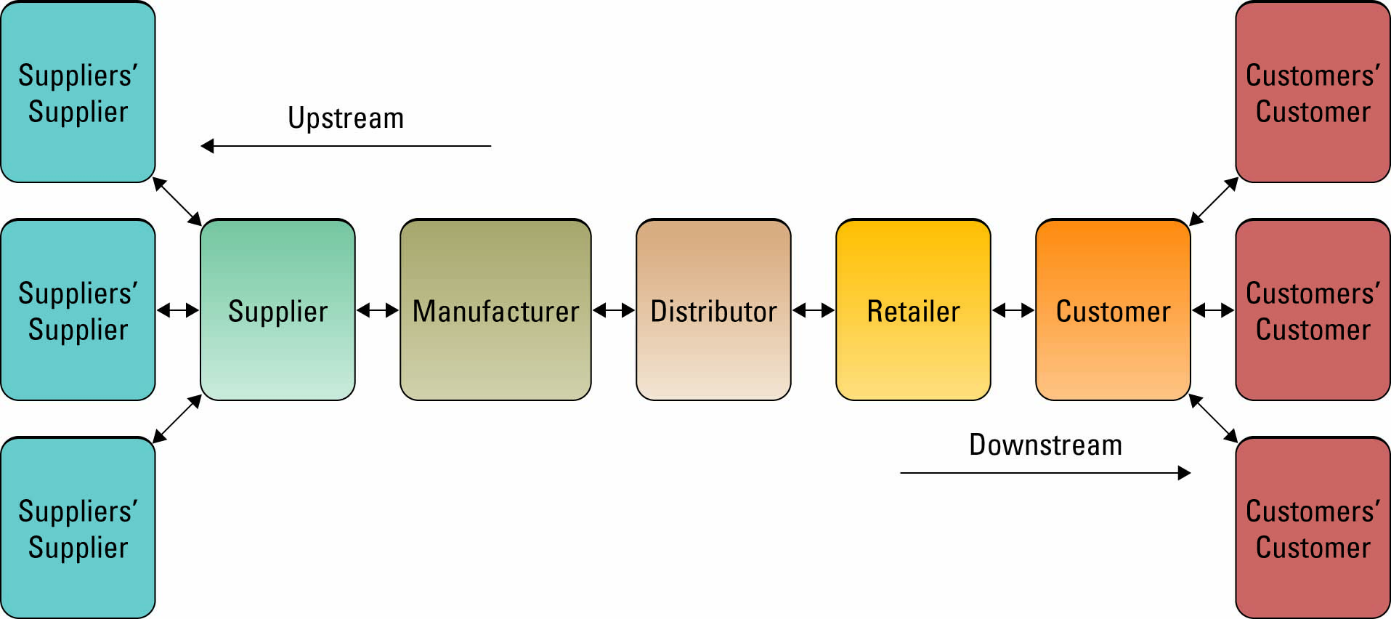

- Wal-Mart (2 basic challenges) - Global Optimization and Supply and Demand
- Wal-Mart’s Solution - Procurement
- Wal-Mart emphasized the need to reduce purchasing costs and offer the best price to the customer.
- The company directly procured from manufacturers, by passing all intermediaries.
- Wal-Mart finalizes a purchase deal only when it is fully confident that the products being bought is not available else where at a lower price.
- Wal-mart’s underlying structure: Uses IT to foster efficiency and streamlining of its operations
- One of the first companies to electronically track inventory and the first to develop a comprehensive computer network to share this information
- Gain of supply-chain efficiencies by working directly with factories
- Mastered the process of production, movement of goods, warehousing of goods, ensuring goods arrives on time at the right place, and for a cheap price

- Wal-Mart Leveraged Technologies for New efficiencies and relationships - Electronic data interchange (EDI)
- Computer-to-computer exchange of standard transactions such as invoices, purchase orders
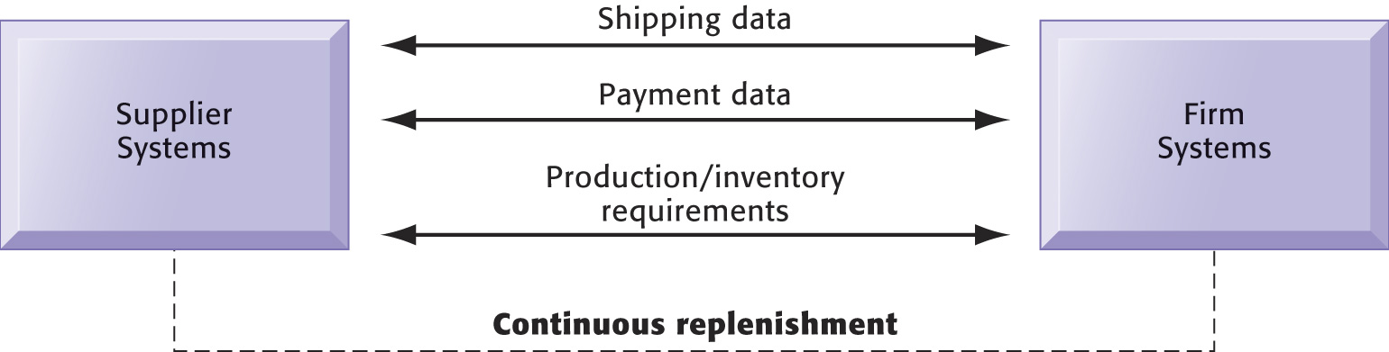
- Using Electronic Data Exchange (EDI) for Procurement
- EDI enabled the suppliers to download purchase orders along with store-to-store sales information relating to their products sold.
- On receiving information about the sales of various products, the suppliers shipped the required goods to Wal-Mart’s distribution centers

- Further Innovation : How does Wal-Mart know what consumers want?
- Information about how often the barcodes are purchased are relayed to the manufactures from Wal-Mart
- RFID Technology(Radio Frequency Identification)
- The company believed that this replacement would reduce its supply chain management costs and enhance efficiency.
- Wal-Mart expected that RFID would reduce the instances of stock-outs at the stores.

- Wal-Mart and Porter
Wal-Mart’s success is based on working together with its key suppliers on a real-time basis by using the Internet to jointly determine product-wise demand forecast.
Required business partners to share forecasts and results data through the Internet, in order to reduce inventory costs while at the same time, enhancing product availability across the supply chain.
Though Wal-Mart had a promising supply chain initiative aimed at a mutually beneficial collaboration between Wal-Mart and its suppliers, its actual implementation required huge investments in time and money.
A few suppliers with whom Wal-Mart tried to implement their supply chain complained that a significant amount of time had to be spent on developing forecasts and analyzing sales data.

Other Supply-Chaining (Flattener #7) Dell and Zara

Flattener #8: UPS: In-Sourcing
- Point 1 - UPS is not only shipping parcels, but also providing smart business solutions
- Example #1:
UPS fixes laptops for companies to speed up service. 3 day turn-around, instead of week (s) for product repairs
- UPS AND IT:
- UPS makes delivery super efficient & super fast, and does this in high volumes.
- Figured out a way to track packages more efficiently. Allow customers to track their own packages online.
- Coding system to track packages - saves money and speeds up delivery .
- UPS is now basically an extension of departments within other companies
- UPS tracks weather and geopolitical disturbances to make sure they’re prepared for that days business.
- What problems do UPS’s IS solve?
- The need to meet high customer expectations
- The need to keep customers from going to the competition
- The need to lower costs by optimizing operations (truck loading, delivery, etc.)

Week 3 - January 17-21, 2011 Web 2.0 and Collaborative Tools
Web 2.0
    - The best future companies are likely those that will create innovative new ways to facilitate collaboration by the hundreds of millions of us who can be reached and embraced by effective architectures of participation

The popular term for advanced Internet technology and applications, including blogs, wikis, RSS, and social bookmarking.
One of the most significant differences between Web 2.0 and the traditional World Wide Web is greater collaboration among Internet users and other users, content providers, and enterprises
CHARACTERISTICS OF WEB 2.0
  - The ability to tap into the collective intelligence of users
  - Data is made available in new or never-intended ways
  - Relies on user-generated and user-controlled content and data
  - Lightweight programming techniques and tools let nearly anyone act as a Web site developer
  - The virtual elimination of software-upgrade cycles makes everything a perpetual beta or work-in-progress. Application can be designed quickly to meet changing needs
  - Users can access applications entirely through a browser
  - An architecture of participation and digital democracy encourages users to add value to the application as they use it
  - A major emphasis on social networks and computing
  - Strong support of information sharing and collaboration
  - Rapid and continuous creation of new business models

- WEB 2.0 COMPANIES AND NEW
- is the Internet. The Internet has had an impact on almost every industry.
- Organizations must be able to transform as markets, economic environments, and technologies changeBUSINESS MODELS
  - Categories of Web 2.0 companies:
    - Social media
    - Video
    - Mobile tools
    - Advertising
    - Enterprise
Challenges with the Free Web:
- When it first launched publicly, the Internet was basically read only

- Web 2.0 creates read and write capabilities – integrated collaboration is much easier to do

- Static Webiste: Once published, it will not change until someone edits its content
- Dynamic Website: database-driven and the content shown depends on the data available in the database
- A wiki is a website or similar online resource which allows users to add and edit content collectively ..
- The predominate benefit of Web 2.0 is Collaboration
- Does every company need a Web 2.0 strategy?...Depends on what the company wants to acheive
- Wikis are collaboration tools
- Blogs and chats are more turned towards conversation
- Wikis are intended to maintain a series of unique documents as their content evolves
- Wikis have built-in version control
- No changes can be made without creating a record of who made those changes
- Reversion to an earlier version is always possible
- RSS (Really Simple Syndication): used to publish frequently updated content such as blog entries and news headlines ..An RSS feed (i.e., document) contains either a summary of content from a website or the full text
- E-busines
- digitally enabled commercial transactions involving organizations & individuals
- E-Business is accelerated and enhanced by IT, in particular the Internet – e.g. collaborative tools

Internet Business Models:
- Based on who is involved
- B2C (business to consumer)
- B2B (business to business)
- C2C (consumer to consumer)
- C2B (consumer to business): consumer indicates a need; businesses compete to fulfill it Electronic exchange: online B2B market with many buyers and sellers
- B2E (business to employee): an organization delivers services and information to its employees
- G2C (government to citizen): government provides services or information to businesses or citizens (also called e-government)

- Based on the medium
- M-commerce (mobile commerce): e-commerce transactions conducted using handheld wireless devices (cell phones, etc.)
- L-commerce (location commerce): m-commerce transactions targeted to individuals in specific locations

- Virtual Storefront: Sells products directly to consumers (B2C) or businesses (B2B)
- Information Broker
  - Provides product, pricing, and availability information to individuals and businesses
  - Revenue from advertising or from directing buyers to sellers
- Transaction Broker
  - Saves users time and money by processing online sales transactions
  - Fee paid per transaction
- Online Marketplace
  - Buyers and sellers meet, search for products, display products and establish prices
  - Revenue from transaction fees
- Content Provider
  - Provides digital content
  - Customer pays for access
  - Advertising can also provide revenue
- Online Service Provider
  - Provides a service
  - Revenue from transaction fees, advertising, or by collecting marketing info from users
- Virtual Community
  - Provides chat room, online meeting place, etc. for people of similar interests
- Portal
  - Provides initial point of entry to the web, specialized content, services

Week 4: January 24-28
- How to develop a social media strategy
- The social technologies enable the strategy, they don’t define it !
- The “change in mindset” required should not be under-estimated
- Start small – Quick Win – BIG Impact
- Social Media is about PEOPLE…

- The Internet – Business Disruption
  - One of the biggest forces changing business
  - Focusing on the unexpected allows an organization to capitalize on the opportunity for new business growth from a disruptive technology

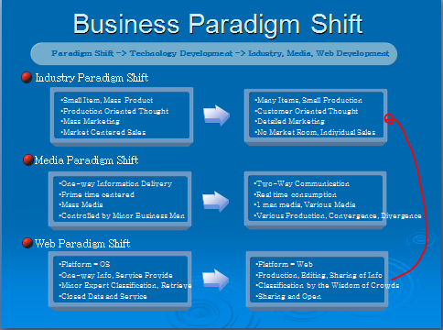

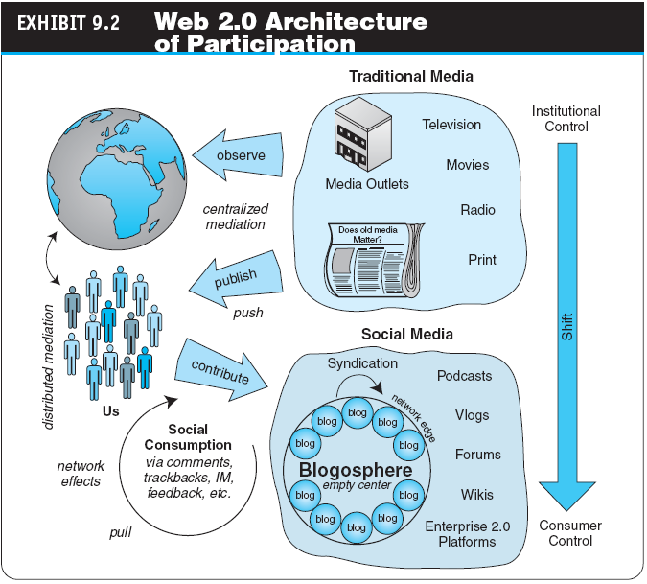

- The Web 2.0 Revolution, Social Media, and Industry Disruptors
- social media
- The online platforms and tools that people use to share opinions, experiences, insights, perceptions, and various media, including photos, videos, and music, with each other
- disruptors
- Companies that introduce a significant change in their industries, thus causing a disruption in normal business operations
- Checklist of questions to help identify disruptors
- Is the service or product simpler, cheaper, or more accessible?
- Does the disruptor change the basis of competition with the current suppliers?
- Does the disruptor have a different business model?
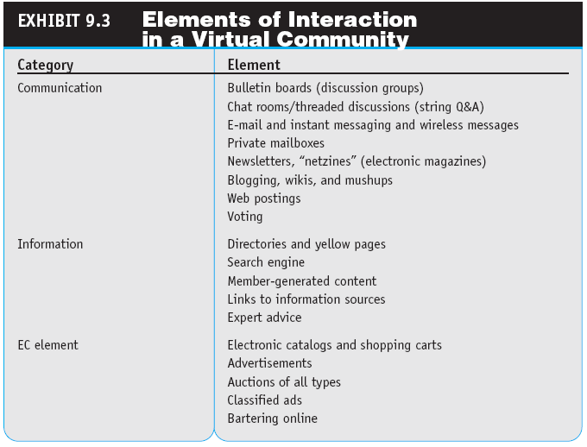
- Does the product or service fit with what customers value and pay for?
- virtual (Internet) community
- A group of people with similar interests who interact with one another using the Internet

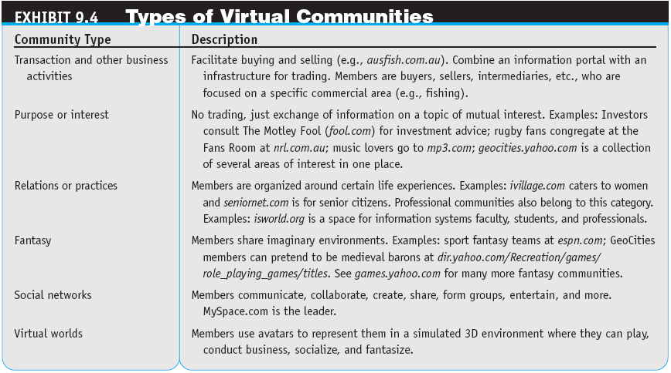

What Is Social Networking?
- A social network is a place where people create their own space, or homepage, on which they write blogs (Web logs); post pictures, videos, or music; share ideas; and link to other Web locations they find interesting
- It Involves relationships defined as: An extended group of people with similar interests or concerns who interact and remain in informal contact for mutual assistance or support. A logical or natural association between two or more things: connection, correlation, interconnection, interdependence, interrelationship, link, linkage, relation, tie-in.
- It Involves building “Social Capital” >> Social capital is a core concept in business, economics, organizational behavior, political science, and sociology, defined as the advantage created by a person's location in a structure of relationships. It explains how some people gain more success in a particular setting through their superior connections to other people.
- social network analysis (SNA software): The mapping and measuring of relationships and information flows among people, groups, organizations, computers, and other information- or knowledge-processing entities
Examples of Network Classification
- Aggregators: Linkedin, Facebook, Xing, Ecademy etc. etc..
- Geographic: “Link to” sites: Chicago, Charlotte, Nashville, New York etc. etc..
- Industry : Wireless Factors, Wine & Spirits, Motor Sports, Entrepreneurs etc. etc..
- Topical: Politics, Music, Sports Investments, etc etc..

- mobile social networking: Members converse and connect with one another using cell phones or other mobile devices

January 25-27
The business Model of Web 2.0
- A business model that uses the net to put people and data together in meaningful exchanges

Commercial Aspects : Virtual Communities
- Understand a particular niche industry
- Build a site that provides the information necessary to that niche
- Set up the site to mirror the steps a user goes through in the information-gathering and decision-making process
- Build a community that relies on the site for decision support
- Start selling products and services that fit into the decision-support process

Commercial Aspects of Web 2.0 and Social Networking Applications
- Consumers can provide feedback on the design of proposed or existing products etc.
- Word-of-mouth (viral marketing) is free advertising
- Increased Web site traffic brings more ad dollars
- Increased sales can come from harnessing techniques based on personal preferences such as collaborative filtering

Business network
- A group of people who have some kind of commercial relationship; for example, sellers and buyers, buyers among themselves, buyers and suppliers, and colleagues and other colleagues

business social network
- A social network whose primary objective is to facilitate business connections and activities

BUSINESS SOCIAL NETWORKING: CONCEPTS AND BENEFITS
- To build better customer relationships
- To improve knowledge management
- To facilitate recruiting and retention
- To increase business opportunities
- To build a community
- To gain expert advice
- To improve tradeshow experiences
- To improve communication and collaboration

ENTERPRISE SOCIAL NETWORKS
- Allow employees to collaborate and communicate in an employee-driven system

OTHER SOCIAL NETWORKING STRUCTURES
- Enterprise 2.0
- Technologies and business practices that free the workforce from the constraints of legacy communication and productivity tools such as e-mail. Provides business managers with access to the right information at the right time through a Web of interconnected applications, services, and devices
- Entrepreneurial Networks

- social marketplace (social + market)
- The term is derived from the combination of social networking and marketplace. An online community that harnesses the power of one’s social networks for the introduction, buying, and selling of products, services, and resources, including one’s own creations. Also may refer to a structure that resembles a social network but is focused on individual members

Commercial Aspects of Web 2.0 and Social Networking Applications
- ADVERTISING USING SOCIAL NETWORKS, BLOGS, AND WIKIS
- Viral (Word-of-Mouth) Marketing
- viral blogging
- Viral marketing done by bloggers
- Classified Ads, Job Listings, and Recruitment
- Special Advertising Campaigns – Companies cater to the needs of specific groups
- Mobile Advertising

- SHOPPING IN SOCIAL NETWORKS
- In/out sourcing
- MySpace offers downloads to people
- Partnerships between companies – YouTube has partnered with Apple and Amazon

- FEEDBACK FROM CUSTOMERS: CONVERSATIONAL MARKETING
- Real time access to customer reviews and input
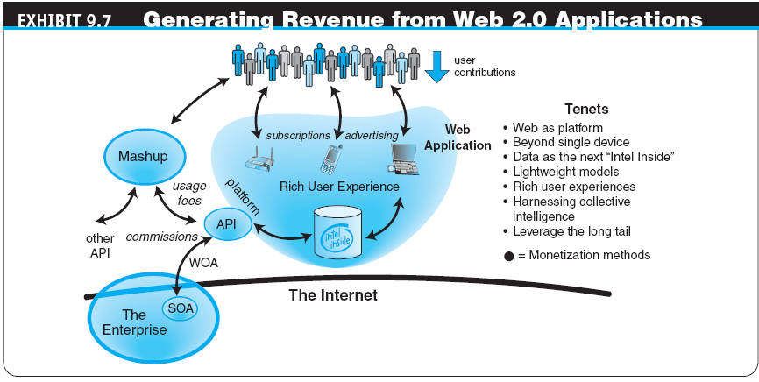
Web 2.0, Social Networks, and E-Commerce
- Other Revenue Generation Strategies in Social Networks
- Offer premium service for monthly or per service fee
- Organizations partner with the social networks, paying them a monthly service fee
- Some social networks have a network of thousands of local physical venues where members can meet; these venues may pay a fee to be associated with the network

- three strategies for generating revenue from Web 2.0 applications:
- Advertising
- Subscriptions
- Commissions



