Why religion?" is a good question. Not considering the question of the divine or supernatural origin of the religions (which most anthropologists will claim are human creations), scholars have identified social and psychological reasons for religions:
- they explain
- they validate
- they comfort
- they define the way the world is
Taking the above into account, a definition of religion proposed in 1966 by Clifford Geertz, an American anthropologist, seems fitting:
Definition of religion: A religion is 1) a system of symbols which acts to establish powerful, pervasive and long-lasting moods and motivations in men by 2) formulating conceptions of a general order of existence and 3) clothing these conceptions with such an aura of factuality that 4) the moods and motivations seem uniquely realistic.(Source: Geertz 1966: Religion as a Cultural System).
Religion therefore defines and explains the world and establishes appropriate reactions towards it, (feeling, thinking, acting in it). Religions are belief systems that serve as models for living, and models of living. Other definitions of religion stress the belief in spiritual beings; yet others stress the quality of sacredness that demarcates the religious from the secular, that is, everyday life.

Religions also vary with regards to the deities and agencies they posit, and with how people relate to them.
Some religious systems, such as animism, believe in the presence of indwelling spirits (ghosts, tree spirits, and other spirit beings) while others, such as animatism, posit the presence of diffuse spiritual power such as Mana in Melanesia, or Orenda in North America.

Religions are expressed through myths, doctrines and rituals.

Rituals
The early anthropological studies of rituals, such as those by French sociologist Durkheim and British anthropologist Radcliffe-Brown saw them as reinforcing collective sentiment and social integration. The nitty-gritty of the ritual itself, that is, the very steps and elements of the rituals, were not considered important. Contemporary anthropology, since the works of Victor Turner in particular, has recognized the structural importance of rituals and the symbolism they carry.
- Myths are sacred texts (oral or written) that seek to explain the order of things and the state of the world. They usually explain how things came to be the way they are: myth of origin, myth of creation.
- Doctrines establish the rules (for human behaviour, and for behaviour vis-à-vis the supernatural beings and the spirits. They are formal statements.
- Rituals are often described as beliefs in action. Well-performed rituals are the ways to honour deities or spirits, to propitiate them, to appease them, and to communicate with them.

Rituals as Channels
Rituals are the channels through which one communicates with the supernatural beings, with spirits or with ancestors. If the rituals are not performed perfectly, then the desired effect might not take place. Rituals include the performance of religious ceremonies, the sacrifice of animals during these ceremonies, the offering of food to spirits or deities, and various types of prayers, incantations and music that favour communication with deities or spirits. Hence the importance given in all religions to the performance of rituals.
Some rituals are secret from the rest of society (such as the one Lianiamae is performing, left), others are communal events (such as religious services), and yet others are individual (individual prayers).

Life-Cycle Rituals
These rituals are often also called rites of passage and they are often associated with or given salience through religion. Think of marriage blessed by priests, briss performed by the Rabbi or funeral rituals. We shall explore rites of passage in greater detail in the lesson on the Life Cycle.

Anthropologist Victor Turner has shown that rituals help people achieve a sense of unity with each other. This is what he has called communitas. During rituals, people’s individuality can be subsumed to an overwhelming feeling of belonging. Note that communitas takes place as well in non-religious rituals or events.
Turner noted that during the state of communitas, the 'normal' social order (including social hierarchy) is often forgotten and people feel as if they belong to a community of equals. During pilgrimages, people traveling together to a sacred site often share a feeling of belonging that erases social differences between pilgrims.
Pilgrimages called Grand Pardons (Great forgiveness) take place once every hundred years since the 13th century on Saint John de Baptiste day (June 24), which coincides with the feast of Corpus Christi. This a Catholic pilgrimage that honours the Virgin Mary.

Liminality and Normal Life
Oppositions between liminality and normal social life.
Liminality | Normal Social Structure
Transition | State
Homogeneity | Heterogeneity
Communitas | Structure
Equality | Inequality
Anonymity | Names
Absence of property | Property
Absence of status | Status
Nakedness or uniform dress | Dress distinctions
Sexual continence or excess | Sexuality
Minimization of sex distinctions | Maximization of sex distinctions
Absence of rank | Rank
Humility | Pride
Disregard of personal appearance | Care for personal appearance
Unselfishness | Selfishness
Total obedience | Obedience only to superior rank
Sacredness | Secularity
Sacred instruction | Technical knowledge
Silence | Speech
Simplicity | Complexity
Acceptance of pain and suffering | Avoidance of pain and suffering

Food for Thought: Emile Durkheim has said that religion serves to reinforce social control by enforcing moral codes and setting rules for appropriate social behaviour.
Can you think of some examples in your own life or that of someone else?
There are religions in which daily life and religious life are intertwined in such a way that social behaviour is often presented as having a divine origin. Think about what is happening currently in Afghanistan, where the Shiite leaders, to the uproar of the West, recently passed a law controlling the movement of married women outside of the home in the name of Islam.
Think about the Catholic Church condemning the use of contraception methods or of the condom for its followers. In all cases known, religion is used by the powers that be to justify or reinforce social practices that seek to control the behaviour of all or some members of the society.
Religions provide guidelines for social behaviour: rules necessary for the maintenance of social order are more powerful if they are attached to threats or rewards from a supernatural power

Part 4: Religion and Change
Even though religions tend to support the social order, they are also agents of change and sometimes revolution (think about the Islamic Revolution in Iran, for instance). During the phase of European colonization, the Catholic Church was instrumental in bringing about major social changes: converting people, condemning songs and dances, teaching literacy and Western religious music, emphasizing the nuclear family as the preferred model of residence, destroying shrines and old belief systems.
While fundamentalist Christians or Muslims today still adhere to strict standards of beliefs, rules, customs and on the literal reading of texts sacred to their faith (the Bible, the Qur'an), they often seek to convert others.
For example, Tele evangelists in the U.S. and fundamentalist Christian preachers are currently converting millions of people to fundamentalist Christianity in South America, Africa and the Pacific.

Case: Liberation theology (within the Catholic Church), as found in Latin America for instance, is a school of theology that claims that the poor have been oppressed by the rich: it claims that it is a moral duty to seek redress on behalf of the poor, and to bring about justice through political action. Liberation theologians act within the confines of democracy to bring about the end of poverty.
Dr. Lindstrom, from the University of Tucson in Arizona, has studied one such movement (the John Frum movement) in Vanuatu, an island country in the South West Pacific, and is a world expert on the topic of cargo cults.

Syncretism
Major crises, such as colonialism, for instance, lead to the adoption of sets of new symbols and rituals, while the meaning of life remains the same.
For example, this is the case among the Maya of Mexico whose Catholicism is imbued with many of the meanings of their pre-Colombian religion. These religions have been called syncretic, meaning the synthesis of old and borrowed elements.
- Examples are voodoo in Haiti, Santeria in Cuba, Candomblé in Brazil. All involve some blend between Catholic, African, and native American beliefs and saints.

New Religions
French philosopher André Malraux claimed that the 21st century would be ‘religious’ or it would not exist (‘Le 21ème siècle sera religieux ou ne sera pas’).
Malraux seems to have been right. Not only has there been a reinforcement and radicalization of some established religions towards a more orthodox bend (Islam, Catholicism, some Christian denominations), but new religions have also developed. These attract people from other religions, but also people who were raised outside of religion.

- Religion is found in all cultures of the world, but in great diversity.
- Religion seems to contribute to social order, to answer general questions about one’s place in the world and the order of existence, to appease anxiety and provide solace.
- All religions of the world involve belief in supernatural beings and powers, rituals and expression of feelings.
- Variation in belief systems in societies is often related to social and environmental contexts.
- New religions often emerge in periods of social upheaval.

Slide 2:

Part 1: Food-Gathering Systems

Sorting out the various types of food-gathering systems
Anthropology has traditionally made a difference between the societies whose main ways of getting food is by collecting it or raising it, and those whose main way of getting food is by producing it.
Using this criterion, we divide the various types of subsistence patterns in this way: | Subsistence Patterns |  | 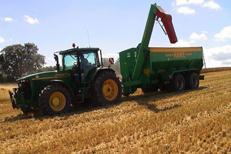
 | Food Collecting | - Foraging
 | Food Producing | - Pastoralism  - Horticulture  - Agriculture (small-scale and industrial farming)
This dichotomy reminds us that the relationship to nature changes when one simply partakes of the food that is available, and one tries to transform nature so as to obtain a bigger yield. But it is probably just as useful to divide these groups according to whether they are nomadic or sedentary.
Here are the five main ways of making a living according to whether a population is nomadic or sedentary: | Nomadism: | 1 - Foraging  2 - Pastoralism | 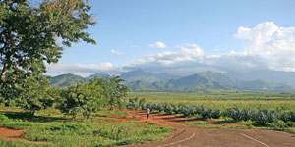
 | Sedentarism: | 3 - Horticulture  4 - Agriculture  5 - Industry
In either case, these typologies are always reductionist, and we need to keep this in mind throughout this lesson.
Above right: Tractor and chaser bin (Source: Hinrich, Wikimedia Commons)
Below right: Plantations in the outskirts of Morogoro, Tanzania with the Uluguru Mountains in the background. Road leading across the farm allows machinery access to the farm for production practices (Source: Muhammad Mahdi Karim, Wikimedia Commons)

Slide 3:

Part 1: Food-Gathering Systems (cont'd)

Modes of Production
Listen to your professor discuss modes of production.
(Video Length 02:33)
Click on Play to view the video.
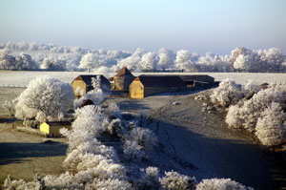
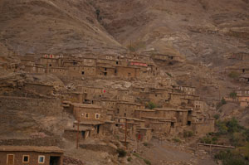
Above: Mr. Cazard’s farm in Labastide-Murat, France, 2007 (Photo: C. Jourdan)
Below: Immini Village, Morocco, 2006 (Photo: C. Jourdan)

Slide 4:

Part 2: Foragers
The first mode of subsistence we will look at is what anthropologists have called hunters and gatherers, sometimes referred to as foragers.
Archaeologists estimate that humans have spent 90% of their existence on earth as foragers.
Bushmen in Africa | Punan in Malaysia
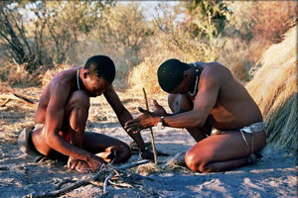 | 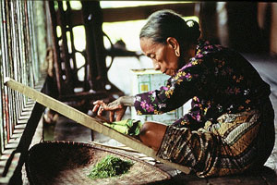
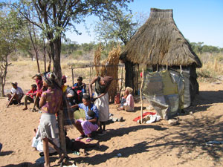 | 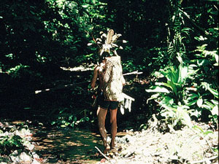
Above: Bushmen in Deception Valley, Botswana, demonstrating how to start a fire by rubbing sticks together (Source: Ian Sewell, Wikipedia)  Below: Bushmen Village, Namibia, 2005 (Source: Wikipedia) | Above: Punan woman, Malaysia (Source: Flickr photo by christiancaron2000)  Below: Punan hunter, Malaysia (Source: Flickr photo by christiancaron2000)

Slide 5:

Part 2: Foragers (cont'd)

Different Types of Foragers
There are a variety of hunting and gathering societies, not only in terms of the presence or absence of horticulture, but also in terms of the reliance on (collecting) vegetable food or on hunting (animal food).
In fact, it would be appropriate to think of a continuum on which contemporary foraging groups could be located.
Netsilik Inuit + hunting < < < < | > > > > Australian Aborigines + collecting
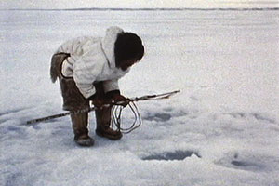 | 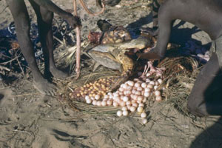
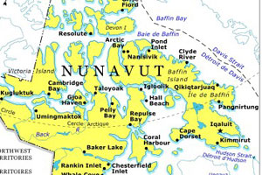  (Click on map to enlarge) | 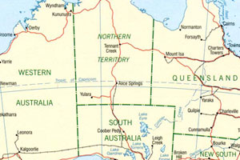  (Click on map to enlarge)
Above: Netsilik hunter (Source: Creative commons)  Below: Map of Nunavut (Source: Natural Resources Canada) | Above: Aborigines preparing and cooking turtle, Yirrkala, Northern Territory (Source: National Library of Australia)  Below: Map of Australia (Source: Perry-Castañeda Library Map Collection)

Slide 6:

Part 2: Foragers (cont'd)

How do Foragers Live?
Listen to your professor explain how foragers live.
(Video Length 03:16)
Click on Play to view the video.
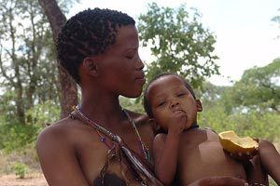
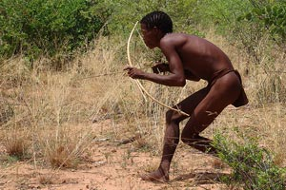
Above: San bushmen mother and child, southern Africa (Source: Flickr photo by CharlesFred)
Below: San bushmen hunter wıth bow and arrow (Source: Flickr photo by CharlesFred)

Slide 7:

Part 2: Foragers (cont'd)

Urban Foraging and Dumpster Diving
Most of you know that in many cities of the world, poor people make a living from foraging in the urban jungle, so to speak. I am referring to a mode of survival that requires people to depend on the refuse of others in order to eat or make a living.
To learn more:  - 'Hundreds' dead in Manila dump collapse  (Source: BBC News Online)  While some poor people, forced by economic necessities, clearly depend on what they find to supplement their diet and meet some of their needs, other forage in dumpster out of political convictions (anti waste movements, ecological considerations, etc.).
   | Watch the video on  Dumpster Diving  from CBC Newsworld(Source: YouTube)

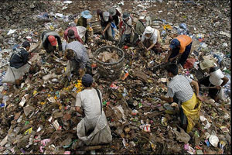 | 
Refugees sorting through a garbage dump  (Source: Flickr photo by Rusty Stewart) | Homeless man looking for food  (Source: Flickr photo by chrisbastian44)

Slide 8:

Part 3: Pastoralism
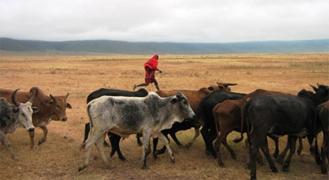
Masai herdsman running along his cattle, Ngorongoro Crater, Tanzania (Source: Stanford School of Medicine)
People who raise animals and take care of herds are called pastoralists or herders. It is very rare to find groups of people who live exclusively off of herding.
- Historically, pastoralism represents an off- shoot of the early mixed agriculture and herding complexes, in association with dry grasslands.
- Pastoral economies, developing in marginal zones around those where settled agriculture predominated, have for several millenia been closely tied to those of sedentary peasants and of states on whose periphery they lay.
- Depending on the regions of the world, different types of animals are being herded and looked after.
Studying pastoralism requires that we look both at the internal organization of such groups, and the outside forces by which they are set. As we start our study of pastoralism, let’s keep in mind the following questions:
- What are the characteristics of pastoralist societies?
- How can we explain the differences?
- Why would pastoralists not want to kill the animals they herd?

Slide 9:

Part 3: Pastoralism (cont'd)

Different Types of Pastoralism
Listen to your professor explain the different types of pastoralism.
(Video Length 01:04)
Click on Play to view the video.
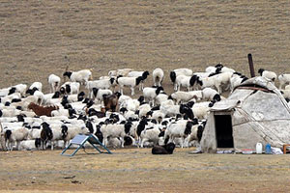
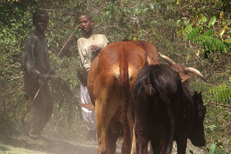
Above: Nomadic herder, Bayanbulak Grasslands (Source: Flickr photo by Yodod)
Below: Young cattle herder, Africa (Source: Flickr photo by Stefan Gara)

Slide 10:

Part 3: Pastoralism (cont'd)

Pastoral Nomadism: The Basseri of Iran
In many areas of the world where grass becomes scarce during certain seasons of the year, or when the weather becomes bad, the animals have to be moved between various areas. This is the case of pastoralism practiced in high mountains such as the Alps or the Himalayas because the physical environment shapes people’s livelihoods. For instance, the Basseri, a pastoralist group living in Iran studied by anthropologist Fredrik Barth, live in the high Himalayas and almost in a symbiotic relationship with agriculturalists who are settled in the same areas and at live at about 5000 feet of elevation.
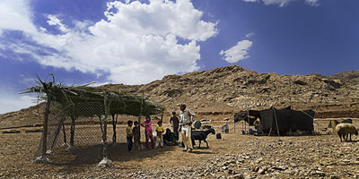  Iranian nomad pastoral scene  (Source: Flickr photo by youngrobv (Rob & Ale)) | 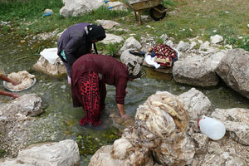  Washing wool from sheared sheep  (Source: Flickr photo by dynamosquito)
Because they live on the products of their herds, the Basseri move their herds of sheep and goats towards the high mountain in the summer to let them take advantage of the fresh new grass, and move them back in the valley during the winter. The whole group is moving. They are nomadic and move their herds along traditional migration routes. They consume the products of their herds, such as meat and milk and use the wool and hides. These can be traded with neighboring villagers to meet other needs. During migration, all the properties of each family in the group must be moved: tents, bedding, cooking equipment, along with the herds. Transportation is provided by horses and donkeys across paths that are very steep. The crossing of rivers is always a dangerous affair. Social groups comprise about 5 to 6 families (conceived as 'tents'), led by a headman, with their own grazing areas and migratory routes. Such groups split away from the larger tribe of about 10-40 families at the time of migration. Membership in this larger tribe or 'oulad' is based on patrilineal descent.
All those groups are ‘welded into a unit by their centralized political system, culminating in the single office of the chief… The chief... is the central, autocratic leader of the tribe’ (Barth 1961: 71). The Basseri, as with other nomadic societies today, have seen their traditional ways curtailed by the nation-states of which they are a part.

Slide 11:

Part 3: Pastoralism (cont'd)

Transhumance in the Alps
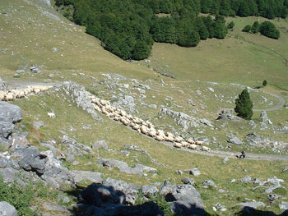

For more information:
- Read: Ariège Pyrenées: The Transhumance
(Source: www.ariege.com)
- Check out examples of transhumance of sheep and cows on the web by entering the word 'transhumance' in the window of your search engine.
The seasonal movement of herds is called transhumance. It is typically found in the mountainous areas of the world where other forms of land exploitation would be difficult.
In the Alps and other such mountainous areas, only the shepherds move with their flock (usually sheep and cows) and spend the summer season in the high pastures looking after their sheep. While watching over their herds, shepherds are busy making cheese with the milk of their animals. The rest of their families stay home in the valley and are busy with farming.
Pastoralism with transhumance is associated with agriculture. The farmers supplement their income and food supply with vegetable gardens, orchards and small farm animals such as chicken, ducks and rabbits. They also grow hay and corn to be used as fodder by the animals during the winter season. At the end of the summer season, the shepherd takes the animals down in the valley and is ready to sell his cheese at local markets and shops: the European Community has imposed rules and quotas of production that are seriously affecting the livelihoods of shepherds.
Transhumance was and still is practiced in many parts of the world as diverse as Scandinavia, Georgia, the Himalayas, Morocco, Italy and Lesotho.
Right: Transhumance in the Pyrenées (France-Spain) (Source: Wikimedia)

Slide 12:

Part 3: Pastoralism (cont'd)

Semi-Nomadic Pastoralism: The Samburu of Kenya
The Samburu are an ethnic group living in Kenya, East Africa. They are closely related to the Maasai. Their livelihood depends on the tending of herds of zebus (local variety of cows), which are their most valuable possessions, but they also take care of goats and camels.
More recently, and given the close contact they have with other non-pastoralist groups, some Samburu have started to be sedentary and to practice agriculture, thus supplementing their diet with grain products.
Samburu District, Kenya, 2005 (Photos courtesy of George-Paul Meiu)
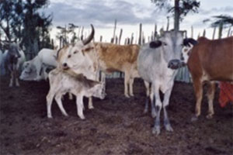 | 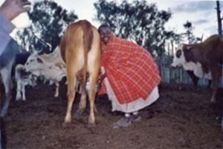
Left: Among the Samburu, cows are one’s most valuable possession.
Right: A Samburu woman is milking the cows in the evening. While milking, every woman lays her head on the cow’s back and sings. In this way, they say, a cow will stay calm and wait patiently to be milked.

Slide 13:

Part 3: Pastoralism (cont'd)

Pastoralism Today
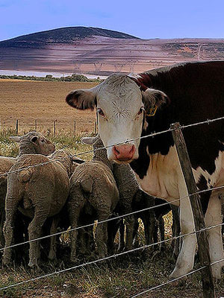
Pastoralism comes in many guises, but it is always a type of ecological adaptation. Pastoralists live in symbiosis with their animals.
This obligatory relationship benefits both humans and animals: humans take care of the herds and ensure that they have access to grazing lands and that they reproduce; in return, they obtain food such as milk, blood, meat, wool and leather depending on the animal being herded.
Although pastoralists rely on their herds for survival, it is not possible to survive exclusively on herding alone. Many pastoralists supplement their diet with hunting, gathering, and fishing. They also cultivate land and trade the by-products of their herds (cheese, for instance, or wool, or hide) with the neighbouring groups.
One of the main difficulties faced by today's pastoralist societies is the encroachment of outside forces on the land that their herds need to have access to. States and governments everywhere have tried to sedentarize them for the purposes of tax collection, social control and control of population movements. This is done with the excuse of providing children with education and access to health services.

Slide 14:

Part 4: Horticulture

Listen to your professor explain horticulture.
(Video Length 03:52)
Click on Play to view the video.

Question: In what way does horticulture differ from agriculture?
Horticulture | Agriculture
- No mechanization | - Mechanization
- No use of fertilizer | - Use of fertilizer
- No irrigation | - Irrigation
- No draught animals | - Use of draught animals
- Small yields per acre | - Larger yields per acre

Slide 15:

Part 4: Horticulture (cont'd)

Horticulture Cycles
As a crop is harvested in one garden, a new garden is cleared and planted. The old garden is allowed to lie fallow, and secondary growth takes place. At some later optimum time (between 10 to 20 years), a new garden will be cleared from the secondary forest, and the logs will be burnt.
The advantage is that the ashes will serve as nutrients and fertilizers for the soil. The garden is then planted and harvested a few months later. In some very arid areas, the optimal length of the fallow cycle is about 10 to 20 years, depending on the areas.
Typically, a few gardens are exploited at the same time so as to ensure a regular supply of food. After a few cycles, the land is so depleted of nutrients that the secondary forest may not grow back.

Slide 16:

Part 4: Horticulture (cont'd)

Successful Horticulture
Food for Thought: Think of ways property relations changed when humans shifted from foraging to horticulture.

Much of the success of extensive agriculture depends on the gardener’s abilities to take care of the land. This includes:  - letting the land lay fallow long enough so that the nutrients in the soils are replenished.  - practicing intercropping (i.e. an ingenious alternation of crops, or mixing of crops on the same plots of land).  - avoiding erosion.  Below both the gardens look a bit unkempt and disorganized compared to the kind of ‘gardens’ some people keep. But there is a logic to this way of gardening, and it has allowed people to live well off their land for many generations without facing famine. | 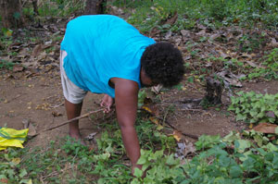  Lily using her digging stick to tend her sweet potato crop (foreground), Honiara, 2008 (Photo: C. Jourdan)

A Kwaio garden, Solomon Islands, 1983 | Lily’s urban garden, Honiara, Solomon Islands , 2007
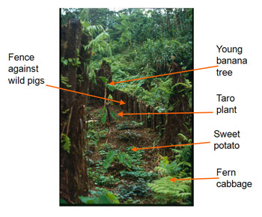 | 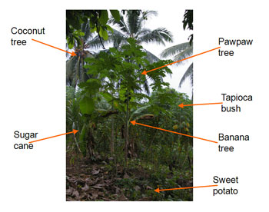
Click on images to enlarge (Photos: C. Jourdan)

Slide 17:

Part 5: Agriculture

Listen to your professor discuss agriculture.
(Video Length 03:00)
Click on Play to view the video.
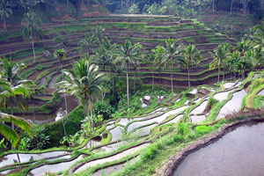
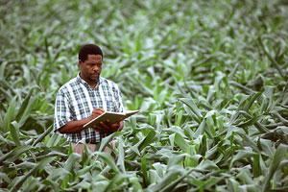
Above: Rice terraces (Source: Flickr photo by Clav)
Below: An agronomist measures and records corn growth and other processes (Source: Agricultural Research Service, Wikimedia)

Slide 18:

Part 5: Agriculture (cont'd)

Intensive Agriculture: Non-Industrial Agriculture
We find two sorts of intensive agriculture: non-industrial and industrial agriculture.
Peasants, who practice subsistence farming (non-industrial agriculture), do not rely to the same extent as industrial farmers on mechanization and fertilization. They make use of simpler tools such as hoes, shovels and animal-drawn plows and the land they tend is smaller. They grow crops and raise animals for their own consumption, and if surplus is produced it can be sold to the market. Farmers and peasants are part of the larger economy of the state in which they live but the production unit is the family unit.
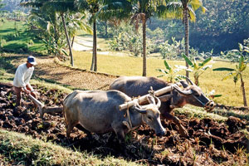 | 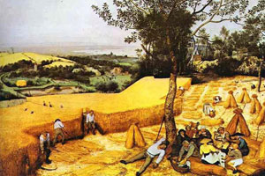
Small-scale farm (Source: Wikipedia) | The Harvesters by Pieter Bruegel (Source: Wikipedia)
On the farm, the division of labour is usually by gender and age. Men perform the bulk of the manual labour while women take care of the house and small farm animals, process the food and take care of small children. In these societies, women’s status is lower than that of men.

Slide 19:

Part 5: Agriculture (cont'd)

Intensive Agriculture: Industrial Agriculture
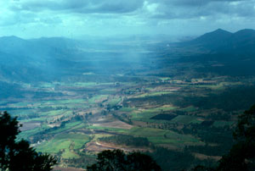
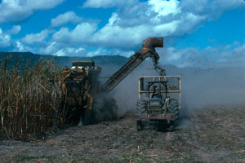
Industrial agriculture is a form of agriculture that relies most heavily on what mechanization and technology can offer and that is found in association with industrialism. It is characterized by large plots of land, use of heavy motorized equipment (tillers, harvesters), chemical fertilizers, herbicides, irrigation and efforts to modify the effects of weather conditions (shading textiles when the sun is too hot; green houses to grow food in off seasons or to speed the development of new crops). Industrial agriculture often rests on the production of one or two types of crops and is pegged to market prices and demands.
It gives high yields but is rather inefficient in terms of the amount of work that is required to produce the products it needs to use in order to maintain the high yields (machines, pesticides, crops selections, textiles, tools, fertilizers) and make them available to the consumer (transportation, packaging food, delivering food, storing food, etc.). It requires only a small part of the labour force. For instance, in the United States, only 1.5% of the labour force is involved in food production. The same high yields ensure that large populations have access to food, particularly in urban centres. As a result, industrial agriculture is often ‘protected’ by governments.

Above right: Pioneer Valley, Queensland. A semitropical environment, 1985 (Photo: C. Jourdan)
Below right: Harvesting sugarcane in Mackay, Queensland (Australia) (Photo: C. Jourdan)

Slide 20:

Agriculture and the Food Crisis

Listen to your professor discuss the food crisis.
(Video Length 01:49)
Click on Play to view the video.
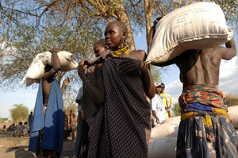
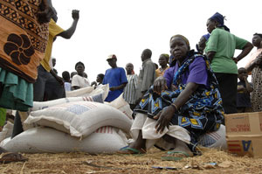
Above: Internally Displaced Persons (IDPSs) carry bags of food rations distributed by the World Food Programme (WFP) and other non-food items.
Below: IDPs gather to pick up food rations supplied by the World Food Program (WFP) and the United Nations Children's Fund (UNICEF), Sudan, 2008
(Source for both: UN Photos by Tim McKulka)

Slide 21:

Agriculture and the Food Crisis (cont'd)

The Food Crisis of Spring 2008
A combination of factors are at the root of this crisis: environmental, economic, social and demographic.
Environmental factors:
- A draught in Australia and monsoons in Asia affect production of rice and wheat.
Economic factors:
- Transformation of corn into biofuel creates shortage in corn as food.
- High price of petrol.
- International subsidies and competition.
Social factor:
- Changing food habits in various parts of the world.
Demographic factor:
- Increase in population.
Table right: Rice price indices (Source: Food and Agriculture Organization (FAO) of the United Nations)

Slide 22:

Agriculture and the Food Crisis (cont'd)

Results of the Food Crisis
The Food and Agriculture Organization (FAO) of the United Nations announced that 30 countries in the world suffered a food crisis, 12 of them acute. Seventy-five million people were added to the ‘under the hunger threshold’ list in 2007. The number of undernourished people reached 923 million at the end of 2007 (Source: FAO website, 18/09/2008)
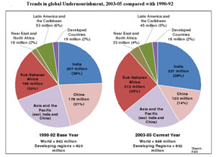  (Click on image to enlarge) | 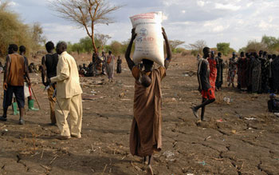
Trends in Global Undernourishment (Source: Briefing paper: Hunger on the Rise: Soaring Prices Add 75 Million People to Global Hunger Rolls, FAO,http://www.fao.org/) | One of the Internally Displaced Persons (IDPSs) carries a bag of food rations distributed by the World Food Programme and other non-food items (Source: UN Photo by Tim McKulka)

Slide 23:

Final Thoughts:

How and When did Agriculture Begin?
Listen to your professor explain how and when agriculture began.
(Video Length 06:39)
Click on Play to view the video.


Above: Neolithic grindstone for processing grain (Source: José-Manuel Benito, Wikipedia)
Below: Knap of Howar farmstead on a site occupied from 3500 BC to 3100 BC (Source: Wikimedia, Creative Commons)

Slide 24:

Final Thoughts:

Modes of Production Summarized
Food for thought: What is the effect of the production of surplus on the development of human societies?
The table on this slide summarizes the characteristics of the various modes of productions we have talked about in this lesson. Look at it carefully and pay attention to the socio-political characteristics associated with each mode of production. Keep them in mind as they will be explored further in the lessons that follow.
 | FOOD COLLECTORS | FOOD  PRODUCERS
 | Foragers | Horticulturalists | Pastoralists | Intensive Agriculturalists
Population density | Lowest | Low-moderate | Low | Highest
Maximum community size | Small | Small-moderate | Small | Large (towns & cities)
Nomadism/permanence of settlements | Generally nomadic or semi-nomadic | More sedentary: communities may move after several years | Generally nomadic or semi-nomadic | Permanent communities
Food shortages | Infrequent | Infrequent | Frequent | Frequent
Trade | Minimal | Minimal | Very important | Very important
Full-time craft specialists | None | None or few | Some | Many (high degree of craft specialization)
Individual differences in wealth | Generally none | Generally minimal | Moderate | Considerable
Political leadership | Informal | Some part-time political officials | Part- and full-time political officials | Many full-time political officials
(Source: Table 5-1: Variation in Food-Getting and Associated Features. In C. Ember & M. Ember, Cultural Anthropology (10th edition). Upper Saddle River: Prentice Hall, 2002)

Slide 2:

Part 1: The Study of Economic Systems
Listen to your professor explain economic systems.
(Video Length 03:01)
Click on Play to view the video.
Two women of wealth
 | 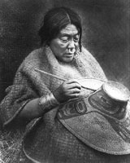

Read what Professor Pierre Beaucage has to say about the difference between substantive and formal rationality.
Interview Segment/Translation
Above left: Miss J. Skead, January 1915, Topley Studio portrait. William James Topley’s portraits reflected the rich and famous of Ottawa for a half-century (Source: Topley Studio/Library and Archives Canada)
Above right: Nakoaktok woman painting a hat. She is a woman of wealth and rank shown by the abalone shell nose ornament and gold bracelets. The Nakoaktoks were a Kwakiutl tribe residing at Seymour inlet, British Columbia, 1914 (Source: Glenbow Museum)

Slide 3:

Part 1: The Study of Economic Systems (cont'd)

Definition of an Economic System
Economics deals with things such as tools to produce goods, relationships between things and people, and people to one another in the process of producing, distributing and consuming goods. It also involves the relationships between them and the organization of the family, and relationships between political organizations and modes of production and the distribution of goods.  This means that economic systems will vary with cultural groups.  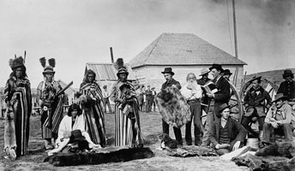  Mistahi maskwa (Big Bear c. 1825-1888), a Plains Cree chief, trading goods, Fort Pitt, NWT  (Source: O.B. Buell/Library and Archives Canada) |   New York Stock Exchange, New York City  (Source: Wikimedia Commons)
  To sum up: what do we call an economic system? An economic system is the part of a socio-cultural system that deals with production, distribution and consumption of goods and services within a particular society. In this lesson, we will focus on distribution and consumption.

Slide 4:

Part 1: The Study of Economic Systems (cont'd)

Definition of an Economic System (cont'd)
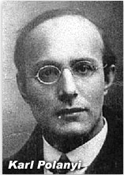  Hungarian and Canadian political economist Karl Polanyi (1886-1964) (Source: Creative commons) | In all societies, goods and services are exchanged. Some anthropologists, such as Marcel Mauss, have claimed that the exchange of goods and services is at the basis of exchange. Following that tradition, anthropologists conceive of distribution as systems of exchange.  The movement of goods from where they are produced to where they are consumed is called distribution. There are three major ways in which goods circulate: reciprocity, redistribution and market. Today, these three systems coexist in most societies, but often one of them predominates.  As political economist Karl Polanyi established, often the type of distribution that predominates is linked to the means of production and the social organization that exists locally. The social obligation to give, receive and reciprocate is at the heart of exchange. | 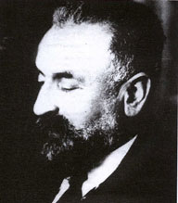  French anthropologist Marcel Mauss (1872-1950) (Source: Seoul University, Department of Anthropology)

Slide 5:

Part 1: The Study of Economic Systems (cont'd)

Types of Goods Exchanged

Items of Exchange
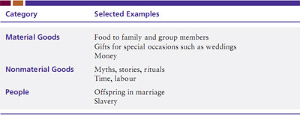
(Source: Table 4.1 - Items of Exchange, p. 104, Cultural Anthropology(2010). B. Miller, P. Van Esterik and J. Van Esterik. 4th ed. Toronto: Pearson.)
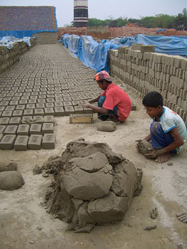
Child labour: brick building
(Source: Flickr photo by vipez)

Slide 6:

Part 1: The Study of Economic Systems (cont'd)

Types of Exchange
Keeping Track of Exchange
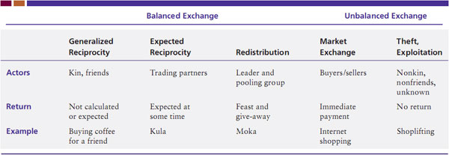
(Source: Table 4.2 - Keeping Track of Exchange, p. 108, Cultural Anthropology (2010). B. Miller, P. Van Esterik and J. Van Esterik. 4th ed. Toronto: Pearson.)

Slide 7:

Part 2: Reciprocity Exchange
The first type of exchange is reciprocity. Reciprocity is the mutual give-and-take between people of equal status.
Three types of reciprocity are distinguished from one another by the degree of social distance between the exchanging partners. They are: generalized reciprocity, balanced reciprocity and negative reciprocity. |  | 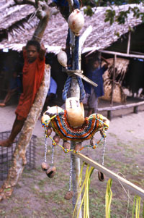
Example of  balanced reciprocity  Right: Kula arm bracelet from Nabwageta Island, Papua New Guinea (Source: Mila Zinkova, Wikipedia)  Extreme right: The much-traded bracelet with its own long history of "ownership" hanging in display in a Trobriand village, Papua New Guinea, Sept. 1999 (Source: Flickr photo by Brad Schram) | 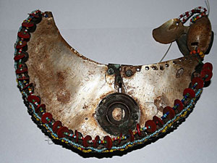

Slide 8:

Part 2: Reciprocity Exchange (cont'd)

Generalized Reciprocity
This form of reciprocity usually takes place among close kin, and carries the highest degree of moral obligation. No account is kept of what is given, no immediate return is expected. Assistance is given, and if possible, returned.
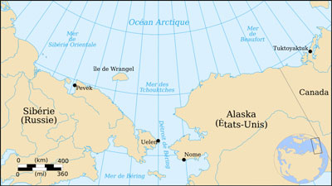  Click on map to enlarge | 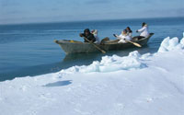
 | 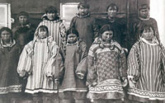
Above left: Map showing Siberia and Alaska (Source: Wikimedia Commons, French Version)
Above right: A traditional whaling crew and boat in Alaska (Source: Office of United States Senator T. Stevens, Alaska)
Below right: Tchouktches children (Wikipedia)

Slide 9:

Part 2: Reciprocity Exchange (cont'd)

Generalized Reciprocity and Sharing the Whale
Despite the generalized ethos of reciprocity, sharing outside of the immediate family is always frought with tension, given that reciprocity is not immediate. In sharing the proceeds of whale hunting, some rules about who gets what are rather intricate.
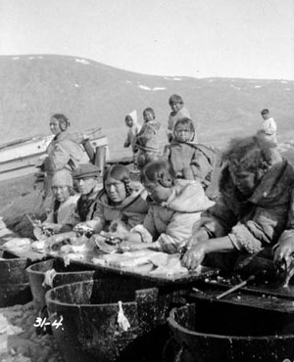 | For example: Hunting of whales by the Inuit involves ten to fifteen boats standing by. The first eight boats to reach and harpoon the whale receive stipulated portions fo the meat. The captain of each boat gets his traditional part of the body, and he shares his meat with his crew. The captain of the first boat gives the shaman a narrow strip cut from the belly between the eighth boat’s strip and the genitals. The top of the head is cut up and eaten at once by everyone in the village. Portions of the tail are saved for feasting in the spring and autumn.
 | 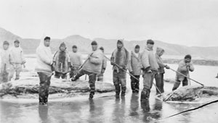
Inuit women cutting up whale fat (Source: A.G. McKinnon/Library and Archives Canada) | Inuit men (Source: A.L. Fleming/Canada. Indian and Northern Affairs/Library and Archives Canada)

Slide 10:

Part 2: Reciprocity Exchange (cont'd)

Balanced Reciprocity

Let’s listen to Dr. David Akinexplain the importance of the gift, from an anthropological perspective.
Watch the video (Length 01:08)
This form of reciprocity includes a clear obligation to return, within a specific time limit, goods of nearly equal value.
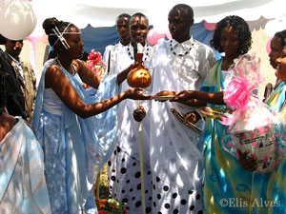 |  | 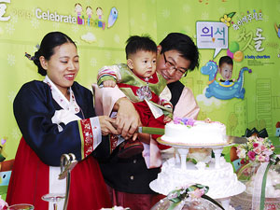
Gifts are a very important part of a Rwandan introduction ceremony (Source: Beauty of Africa, Flickr) |  | Gift giving for birthdays is a common form of exchange around the world (Source: Flickr photo by Katoole)

Slide 11:

Part 2: Reciprocity Exchange (cont'd)

Balanced Reciprocity and The Kula Ring
Listen to your professor explain the Kula Ring.
(Video Length 05:18)
Click on Play to view the video.
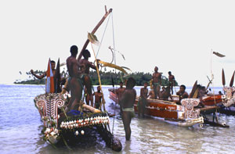
- For more photos of the Trobriand Islands and the Kula Trade, visit:Flickr photos by Brad Schram
- Check out a map of the Kula Ring(Source: Bronislaw Malinowski, Creative Commons)
Above: Kula canoes at rest, Kitava, Trobriand Islands (Source: Flickr photo by Brad Schram)

Slide 12:

Part 2: Reciprocity Exchange (cont'd)

Balanced Reciprocity and Bigmenship
Listen to your professor explain Bigmenship.
(Video Length 03:33)
Click on Play to view the video.
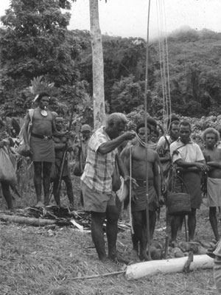
Picture of Jonathan Fifi’i offering shell money during an exchange ceremony, 1987 (Photo: C. Jourdan)

Slide 13:

Part 2: Reciprocity Exchange (cont'd)

Balanced Reciprocity and Exchange of Services
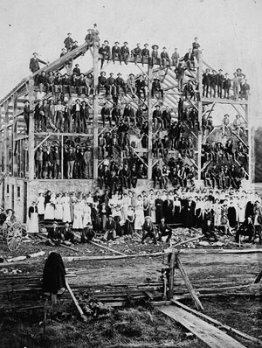 | Balanced reciprocity may also involve the exchange of services. Examples include barn raising in the U.S. during frontier days (and today among the Amish in Pennsylvania), where people come together to perform tasks that require much labour.  Reciprocal services in pre-Hispanic Quechua societies also fall into that category of reciprocal work obligations.  In many neighbourhoods in Montreal (and elsewhere in the world), women exchange baby-sitting hours; students help each other with homework, and so on.  In India, the jati system provided for the economic needs of every member of a caste community because everyone was obliged to provide each member with goods and services. For instance, farmers provided grain to everyone, while the millers milled the grain for everyone, and the weavers wove cloth for everyone and the barbers cut hair, and so on. Each occupation benefited from services rendered by other occupation in the community (See: Crapo, Richley H. 2002,Cultural Anthropology (5th edition). p. 404, New York: McGraw-Hill).  Left: An Amish barn raising in the area of Brampton, Ontario. Such community events were important in rural Canada until the turn of the 20th century. (Source: J.F. Cole/Library and Archives Canada)

Slide 14:

Part 2: Reciprocity Exchange (cont'd)

Negative Reciprocity
A refusal to receive or a failure to return the gift is taken as a withdrawal from the social relationship. Because the gift puts the receiver under obligation, most people like to pay off the debt by making a return gift. However, in balanced reciprocity, the return does not need to be immediate. In fact, repaying the gift immediately might be an indication of an unwillingness to be obligated, and therefore also an indication that a trusting social relationship is neither present nor desired. In the same manner, refusing a gift signals the refusal of the social relationship with the giver.
Silent trade is a form of negative reciprocity that is practiced between the Mbuti Pygmy of the Ituri forest and their horticulturalist neighbours.  Each group leaves goods that the other groups need in a designated location. The exchange takes place without requiring any communication and social engagement with trading partners.  Finally, it can be said that an extreme case of negative reciprocity is theft.  Right: Mbuti Pygmy man and child  Extreme right: Mbuti Pygmy man  (Source: Flickr photos by McMarcLouwes) | 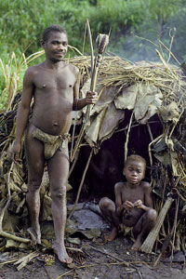 | 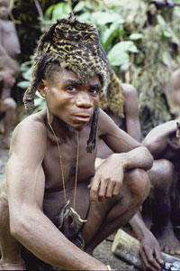

Slide 15:

Part 3: Redistribution Exchange
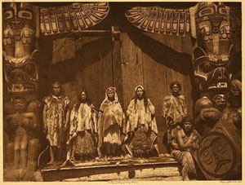
The second type of exchange is redistribution. Redistribution is the other type of distribution system that has interested anthropologists. Goods are collected or contributed from members of a group and then given out to the group in a new pattern.
Redistribution involves a ‘social centre’ to which goods are brought and distributed from. But redistribution is also an important mechanism of exchange in societies where political organization includes ‘chiefs’ and ‘big men’ who act as social centres, but it is also at the basis of their political power. To illustrate this, let’s have a look at a redistribution event called the Potlatch.
Right: Edward Curtis's photo of a Kwakwaka'wakw potlatch with dancers and singers, British Columbia on northern Vancouver Island
(Source: Wikimedia Commons)

Slide 16:

Part 3: Redistribution Exchange (cont'd)

Redistribution and the Potlatch
Amongst American First Nations of the Northwest Coast of North America including the Tshmshan, Tlingit, Haida, Nootka, Bella Coola, and Kwakiutl, the potlatch is an example of redistribution. Its primary function was to validate rank that was, typically, inherited.
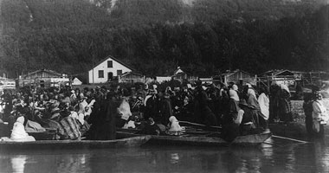 | 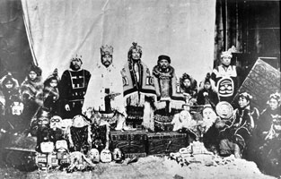
Click on image to enlarge  Aboriginal visitors attending Potlatch at Kok-wol-too village, Alaska (Source: New World Encyclopedia) | Click on image to enlarge  Aboriginal potlatch ceremony, West coast of North America (Source: Library and Archives Canada)

Slide 17:

Part 3: Redistribution Exchange (cont'd)

Redistribution and the State
When we pay taxes to the government and in exchange for these taxes we receive medicare, social services, unemployment insurance, scholarships, etc, this is redistribution. The government acts as the social centre that organizes the collection and redistribution of goods. Of course, as we know too painfully, some coercion exists. We cannot fail to pay the taxes, or else.
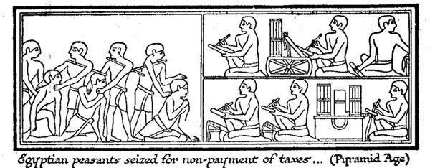
(Source: Wells, H. G. (1920). The Outline of History. Garden City, New York: Garden City Publishing Co., Inc.)

Slide 18:

Part 4: Market Exchange
Market exchange is the third major approach to exchange.
It is an unbalanced exchange and this lack of balance is linked to:
1 - the price of commodities is directly linked to supply and demand. | 2 - the buyer and the seller are not in a personal relationship and the transaction is not meant to foster one. | 3 - buyers and sellers do not need to be of equal status. | 4 - The seller is expecting to make a profit.

 | 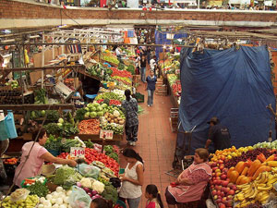
New York Stock Market Exchange  (Source: Wikimedia Commons) | San Juan de Dios Market in Guadalajara, Jalisco  (Source: Flickr photo by Christian Frausto Bernal)

Slide 19:

Part 4: Market Exchange (cont'd)

Prices of Goods in Farmers’ Markets
Farmers’ markets are public spaces where money is used to buy produce. Regulations vary cross-culturally as to whether and how the price of the goods are to be displayed.
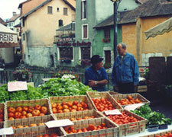 | 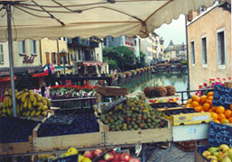 | In France, the price by 1 kilo of weight has to be visible for each product being sold except when they are sold by unit (1 melon or 1 cauliflower, for instance). This follows the logic of the French metric system that recognizes 1 kilo as the unit of measurement of weight.

In Montreal, at marché Jean-Talon, prices are indicated by units of items being sold (1 cauliflower, 1 cucumber) or by container. No weight is ever indicated, and one cannot really gage the price of the goods they are buying.  In Marrakesh, no price is indicated: it is customary for the buyer to try to negotiate the price of a good with the seller. The price may vary with customers. | 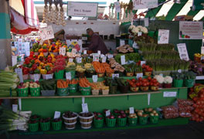 | 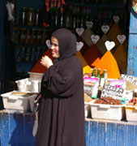
In all cases, goods are cheaper when they are plentiful (fruits in season, for instance) and more expensive when they are harder to find. But other factors affect the prices: location of the market, types of clientele, types of goods (exclusivity, brands), distance between place of production and market, fashion, etc.

Above: The weekly market in Annecy, a small town in the French Alps. Regulations require that prices be posted by weight, 2000
Below left: Jean Talon market, a permanent market in Montreal, where prices are posted per quantity or volume, 2008
Below right: Spice market in Marrakesh (Morroco) where no prices are indicated, 2006 (All photos: C. Jourdan)

Slide 20:

Part 4: Market Exchange (cont'd)

The Role of Money in Social Change
All-purpose money plays an important role in market exchange: it is a symbol that travels well and has a standard value set by governments against other international currencies.
Those of you who travel, or are interested in these issues, know how much the Canadian dollar fluctuates against the American dollar. Because the value of the Canadian dollar is ‘pegged’ on the price of petrol, it will fluctuate with the price of petrol.
 | 
Obverse side of the €50 banknote (Source: Wikimedia) | 200 kroner banknote from Norway (Source: Wikipedia)

Slide 21:

Part 4: Market Exchange (cont'd)

Special-Purpose Money
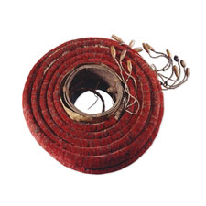
In many other societies, all-purpose money is not the universal medium of exchange. Other types of ‘money’ called special-purpose money also exist and are used for particular events or transactions only. For instance, in Melanesia, pigs can be bought with shell money. These are necklaces of about two metres long strung with small disks made out of the lips of valuable and rare shells. The process of making the tiny disk is very time consuming and some communities have become specialized in making them.
Other types of Melanesian special-purpose money include feather money (in the Santa Cruz archipelago): red feathers of the small scarlet honeyeater birds (Myzomela cardinalis) are plucked from the bird (the bird is captured and then released) glued into a large coil. Finally, porpoise teeth can also be strung as necklaces and used as valuables. Some of these valuables are also exchanged during marriage ceremonies, mortuary feasts (feasts held when an important person has died), and as a form of compensation in cases of insults or murder.
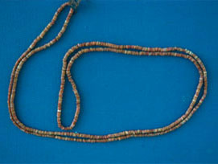 |  | 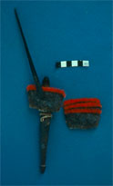
Top left: Red feather money from Santa Cruz, Solomon Islands. A double coil like this one may consist of up to 60,000 feathers (Source: The British Museum, length: 10.640 m, Collected by Ms Dorota Starzecka, Africa, Oceania, Americas)
Bottom left: Shell money necklace made with small disks carved in the outer lip of the red spondylus shell. The redder the shell, the more valuable the shell money (Source: C. Jourdan, 1982)
Bottom centre: Necklace made with dolphin teeth. Solomon Islands (Source: C. Jourdan, 1982)
Bottom right: Feathers from small scarlet honeyeaters are being glued onto platelets (Source: C. Jourdan, 1982)

Slide 22:

Final Thoughts
- All societies have economic systems (with or without all-purpose money) that allow them to regulate access to goods and services and to organize the labour force.
- They also have customary ways of transforming, through labour, resources into necessities and desired goods.
- They also have customary ways for distributing and sometimes also exchanging goods.

Slide 2:

Part 1: Stages of Development

Enculturation: Becoming a Social Person
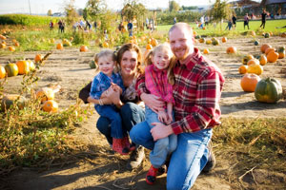
Above: Sidewalk socializing
(Source: Flickr photo by SpAvAAi)
Below: Family outing in the fall
(Source: Microsoft Clip Art)
More than any other animal, human beings depend on the social transmission of knowledge in order to survive. Human infants cannot survive without the help of people. In addition, the maturation process of the human child, i.e. the time period necessary for the child to become autonomous from her/his parents, is slower than that of any other animal offspring. In order for this to happen, the human children need support from others in the cultural environment in which they live. Social organization and cultural knowledge provide the necessary frame in which the child develops, is socialized and protected by others.
Scholars such as Serena Nanda (2002: 123) argue that ‘The long period of dependency is the price Homo Sapiens pay for their big brain and its enormous potential for learning’. Protected in such a way, the child becomes human. Not any human, but a particular human: a Japanese, a Spaniard, a Brazilian, culturally distinct from a Romanian, a Serb, or a Thai. The process by which children acquire their culture, either formally (through being told what to do or not do) or informally (i.e. through observation and imitation) is called enculturation. There exist cross-cultural variations in child rearing that are based on the locally constructed understanding of what a child is. In all human societies, raising a child is really an effort at socializing it, that is, to make it a socially adept human being.
In addition, a whole school of American anthropology, the so-called culture and personality school, sought to explain the relationship between child-rearing practices and personality on the one hand, and focused on the description of national character patterns. We will not deal with this here, but you can read a presentation of that school of thought in chapter 6 (pp. 148-151) of the textbook.

Slide 3:

Part 1: Stages of Development (cont'd)

Rites of Passage

Common Types of Rites of Passage
The most common types of rites of passage include:
- Naming ceremonies, which confer social existence to the new member of the society.
- Puberty celebrations, which confer adult status.
- Marriage, which legitimizes one's sexual relationship and child rearing obligations.
- Funerals, which proclaim the loss of life and allow society to restructure in different ways.
Rites of passage can be religious or non-religious.
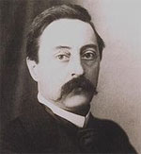
French anthropologist Arnold van Gennep (1873-1957) theorized rites of passage in an early work (1909) titledRites of Passage(Source: Wikipedia)
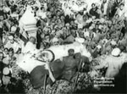
Watch
Mahatma Gandhi's funeral
(Length 01:43)
New Delhi,
January 31, 1948

Slide 4:

Part 2: Birth and Childhood
Listen to your professor explain the life course beginning with birthing.
(Video Length 03:41)
Click on Play to view the video.
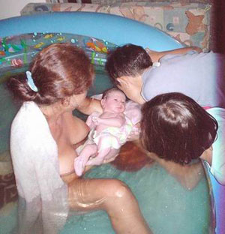
Childbirth in water. Home birthing in a pool in Tahiti (Source: Photo by Sébastien Fauvel, Wikimedia)

Slide 5:

Part 2: Birth and Childhood (cont'd)

Case Study: Nisa’s First Labour
Excerpt from Nisa: The Life and Words of a !Kung Woman by Marjorie Shostak.
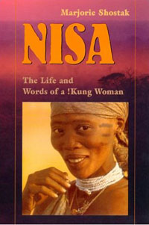
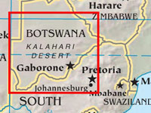
Click on map to enlarge
"‘I lay there and felt the pains as they came, over and over again. Then I felt something wet, the beginning of the childbirth I thought. ‘Eh hey, maybe it is the child’. I got up, took a blanket and covered Tashay (her husband) with it; he was still sleeping. Then I took another blanket and my smaller duiker (a small antelope) skin covering and I left. Was I not the only one? The only other woman was Tashay’s grand-mother, and she was asleep in her hut. So, just as I was, I left.
I walked a short distance from the village and sat down beside a tree. I sat there and waited: she wasn’t ready to be born. I lay down, but she still didn’t come out. I sat up again. I leaned against the tree and began to feel the labor. The pains came over and over, again and again. I felt as though the baby was trying to jump right out. Then the pains stopped. I said, ‘Why doesn’t she hurry up and come out?’ Why doesn’t it come out so I can rest? What does it want inside me that it just stays in there? Won’t God Help me to have it come out quickly?
As I said that, the baby started to be born. I thought: ‘I won’t cry out. I’ll just sit here. Look, it’s already being born and I’ll be fine’. But it really hurt! I cried out, but only to myself. I thought: ‘Oh, I almost cried out in my in-laws’ village.’ Then I thought: ‘has my child already been born?’ Because I wasn’t really sure; I thought I might only have been sick. That’s why I hadn’t told anyone when I left the village. After she was born, I sat there; I didn’t know what to do. I had no sense. She lay there moving her arms about, trying to suck on her fingers. She started to cry. I just sat there, looking at her. I thought, ‘Is this my child? Who gave birth to this child?’ Then I thought: ‘A big thing like that? How could it possibly have come out from my genitals?’ I sat there and looked at her, looked and looked and looked. The cold started to grab me. I covered her with my duiker skin that had been covering my stomach and pulled the larger kaross (a cloak made of sheepskin or other animal with the hair left on) over myself. Soon, the afterbirth came down and I buried it. I started to shiver. I just sat there, trembling with the cold. I still hadn’t tied the umbilical cord. I looked at her and thought: ‘She’s no longer crying. I’ll leave her here and go to the village to bring back some coals for a fire" (Source: Shostak 1981: 1).
Above: Book cover Nisa: The Life and Words of a !Kung Woman by Marjorie Shostak from Amazon.com
Below: Map of the Kalahari Desert (Source: Perry-Castañeda Library Map Collection)

Slide 6:

Part 2: Birth and Childhood (cont'd)

Social Birth
Social birth is often associated with naming ceremonies through which the child truly becomes a member of her/his society and is recognized by all. In places where infant mortality is high, a period of 9 days takes place before the birth of the child is announced.
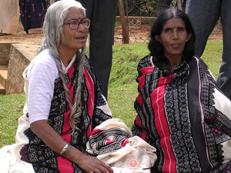 | 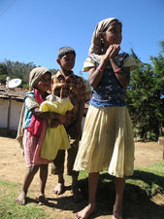 | Among the Toda in India (left), for instance, a child is not recognized as a person before she/he is 3 months old, at which stage a ‘face-opening’ ceremony takes place (Nanda and Walsh 2002: 124).  Amongst the Aranda of Australia, a premature child will not be recognized as a human until it is sure that it can live.  In 19th-century China, where infant mortality was very high, babies were not given a name, thus recognized as a member of a social group, until they reached the age of 1 month and showed signs of strength. In such places, people have learned to disengage from a child who seems too weak to survive.  Anthropologist Nancy Sheper-Hughes has studied motherhood in North Eastern Brazil, where mothers distance themselves emotionally from a child that is too sickly to survive.  Click on map to enlarge.
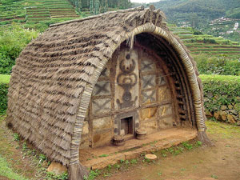 | 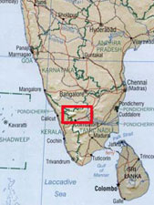
The Toda are a pastoral tribe of the Nīlgiri Hills (in the Nilgiris District) of southern India, state of Tamil Nadu
Above left: Toda women (Source: Flickr photo by nozomiiqel), Right: Toda tribe family (Source: Flickr photo by babsybou)
Below left: Toda hut (Source: Wikipedia), Right: Map of India including Toda tribe location

Slide 7:

Part 2: Birth and Childhood (cont'd)

Case Study: Death Without Weeping
Excerpt from Death Without Weeping by Nancy Sheper-Hughes
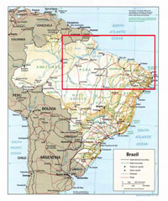
Click on map to enlarge
Map of North Eastern Brazil
(Source: Perry-Castañeda Library Map Collection)

"In the very poor area of North Eastern Brazil, people will not consider that a baby is a human being until it shows that it can survive. According to anthropologist Nancy Sheper Hughes (1992), women are often heading single-parent households. Being very poor and often socially isolated, they cannot rely on baby sitters to look after their children when they need to go to work. They have to leave their infants alone, or in the care of older children. Not knowing whether a weak child will survive under these conditions, the mothers learn to distance themselves emotionally from the vulnerable children, born small, wasted and weak, until they are sure that the child will survive. At the same time they also withdraw care.
A baby that is sickly, and shows no desire or strength to nurse, is said to have an ‘aversion’ to life. When such children die, their death is seen as ‘nature taking its course’. By allowing nature to take its course, very devote Catholic mothers allow God’s will to be done. The graves of such children are never visited. Infant death is routinized and mothers do not grieve over such children. According to Sheper-Hughes, the delayed recognition of a weak child unlikely to survive is a rational response to a desperate economic situation."
(Source: Nancy Sheper-Hughes. 1992. Death Without Weeping. Berkeley: University of California Press)

Slide 8:

Part 2: Birth and Childhood (cont'd)

Adoption
Adoption is the formal and permanent transfer of a child to the care of someone else. As with birthing, adoption varies cross-culturally and is often associated with the local conception of what a family is and where a child fits into it.
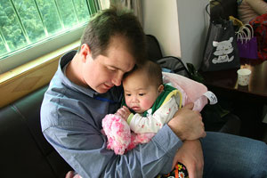 | 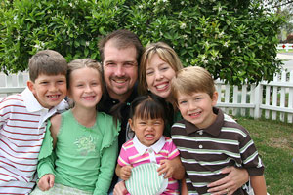
Adopted child from Asia with her new father  (Source: Flickr photo by endbradley) | Adopted child with her new family  (Source: Flickr photo by endbradley)

Slide 9:

Part 2: Birth and Childhood (cont'd)

Naming a Child
Listen to your professor discuss the symbolic act of naming a child.
(Video Length 02:53)
Click on Play to view the video.
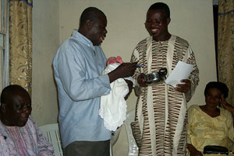
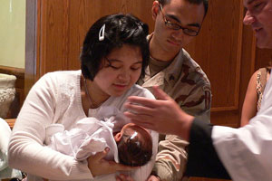
Above: Baby naming ceremony in Nigeria. The Ceremony begins and the names are called out. (Source: Flickr photo by ajbrowe)
Below: Child baptism (Source: Wikimedia Commons)

Slide 10:

Part 2: Birth and Childhood (cont'd)

Naming a Child (cont'd)
Names are sometimes the victims of fashion. Compare the most popular names in Anglophone Canada in 2008 with names that were popular at the end of the 19th century. | 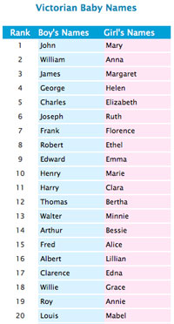
  Right: Popular names in Anglophone Canada for boys and girls in 2008, ranked in order from one to ten (Source: Today's Parent)  Far Right: Victorian baby names in Canada(Source: Baby Names Garden) | 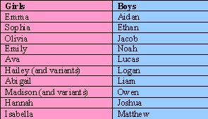
Check out the popular given names from around the world
- The following link contains a list of the most popular names in many countries around the world. The most popular given names vary nationally, regionally and culturally. Go to:http://en.wikipedia.org/wiki/List_of_most_popular_given_names

Slide 11:

Part 2: Birth and Childhood (cont'd)

Transition to Adolescence
The purpose of transition to adolescence through puberty rites (or not) indicates that the child is becoming a sexual being capable of reproduction. In some societies, reaching puberty is akin to becoming an adult.
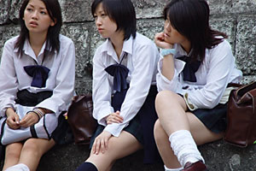 | 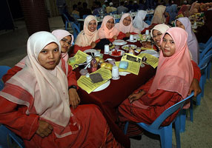
Japanese schoolgirls  (Source: Flickr photo by Café du Monde) | Muslim teenage girls in Malaysia  (Source: Flickr photo by Roslan Tangah (aka Rasso))

Slide 12:

Part 2: Birth and Childhood (cont'd)

Adolescent Fertility Rates
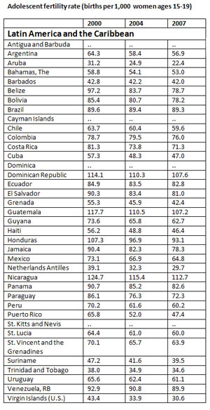 | Have a look at the adolescent fertility rates in Latin American and the Caribbean, both considered semi-restrictive societies (right)  Compare the Latin American and the Caribbean figures with the figures of adolescent fertility rates for North Africa and the Middle East, considered restrictive societies.  (Source for both tables: The World Bank Group,http://go.worldbank.org/0DWNXIQA30)  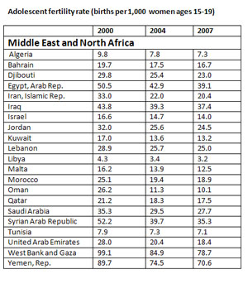

Slide 13:

Part 2: Birth and Childhood (cont'd)

Puberty Rituals
Aside from rituals that mark the union of two or more people (marriage), rituals that mark the coming of age are the most important. It seems that adolescence (defined here culturally, as opposed to puberty) is marked almost universally by an overt or covert recognition that the child is moving into another phase of life where reproduction and adulthood are part of life.
 | 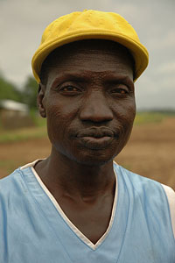
Young woman with tattoos and piercings (Source: Flickr photo by philippe leroyer) | Nuer man with facial scarification (Source: Flickr photo by bertrudestein)
The most important puberty rituals are found in societies where social control of the children is the stronger, in terms of the children being expected to perform tasks and assuming responsibilities associated with age. For instance, among the Nuer of the Sudan, the rites of male initiation involve deep scarification of the forehead during a period of seclusion. The facial markings, called gaar, symbolize the transition of the young boys into young men and their incorporation into other age groups. Female initiations, when they exist, usually take place at the time of menarche (the arrival of the first menses). They also may involve painful physical rites. We are talking here of ritual manipulation of the body.
Philosopher Michel Foucault has proposed (Discipline and Punish, 1975) that pain inflicted on the body may be a step towards the control of the mind. I contend that initiation rituals, with or without pain, act in the same manner. They encourage the individual that undergoes them to comfort and they make her or him part of the initiated group that now can impose the same rituals onto younger people.
Whether we are talking of getting one's first tattoo at 18 years of age, or going to the hairdresser for the first time to get streaks in one's hair, or getting one's first bra, these events act as individualized rites of passage. Yet, however individual they may be, they are connected to wider social issues, such as that of attractiveness of the initiate, the passage from girlhood to womanhood, and more general statements about gender relationship.

Slide 14:

Part 3: Marriage
Listen to your professor discuss marriage.
(Video Length 03:15)
Click on Play to view the video.
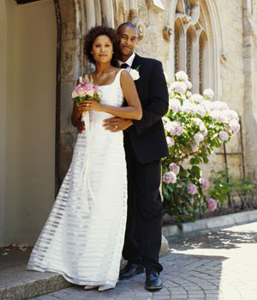
Above: A couple just married in a church
(Source: Microsoft Clip Art)

Slide 15:

Part 3: Marriage (cont'd)

Definitions of Marriage
Listen to your professor discuss various definitions of marriage.
(Video Length 03:12)
Click on Play to view the video.
- Marriage can be an important event for both the individuals getting married and their families, regardless of whether the ceremony is religious or not.
- Marriage is often, in many societies, considered the marker for adulthood.
- There is a great diversity in the types of marriages (i.e. ghost marriages – when individuals get married by proxy – same sex marriages, multiple partner marriages, love marriages or arranged marriages); marriages need not be monogamous, as most societies in the world have historically allowed for people to have multiple spouses.
- Marriage is characterized by long-lasting relationships (between the marrying individuals and their families) and is based on a contract with social obligations that go beyond the two individuals themselves.
- It is important to view marriage within a legal framework, in that it allows for the understanding of partnerships, the transfer of rights and goods, and the interests of those involved in the contractual arrangements.

Slide 16:

Part 3: Marriage (cont'd)

Definitions of Marriage (cont'd)
Definition no. 1: | Marriage is a transaction and resulting contract in which a woman and a man are recognized by society as having a continuing claim to the right of sexual access to each other, and in which the woman is elligible to bear legitimate children. | Problems with that definition are related to the bond between heterosexual partners, and to the fact that it is very much a patriarchal definition. In matrilineal societies, the question of the legitimacy of the children is of a different nature. Children are naturally the children of their mother, but not necessarily the biological children of the man married to the mother. In addition, this definition retricts the number of partners of either spouse to one and thus does not apply to societies where marriage routinely involves multiple spouses.
Definition no. 2: | Marriage is a publicly recognized social contract that establishes an economic contract, sexual rights, social identity of offspring and an alliance between kin groups. | Difficulties with this definition are related to the alliance between kin groups. This is certainly a factor in so-called tribal societies, where kinship organizes social life, but is not so relevant in industrial societies. On the other hand, one cannot deny that some marriages in industrial societies, notably among members of the nobility or wealthy segments of the population, are important political or financial associations between various families or kin groups.
Definition no. 3: | (3a) Marriage is an institutionalized form of relationship in which sexual relationships and parentage legitimately take place. | This is a very general definition that places emphasis on the legitimacy of the sexual relationship and on parentage. But, of course, there are marriages without children. And there are marriages that are non-sexual. Further, it does not talk about kinship ties.
Definition no. 3: | (3b) Marriage is an institutionalized form of relationship in which sex, parentage and economic exchange may legitimately take place and that creates socially recognized affinal kinship relations. | To the left (3b) is another version of the above definition (3a) and the one we shall retain for this course.

Slide 17:

Part 3: Marriage (cont'd)

Types of Marriages
Human societies are very creative when it comes to marriage: some prefer that people be married to one spouse at a time, while others prefer that they be married to many spouses at the same time. Whatever the form of marriage, it ensures that relationships are established between in-laws (called affinal kin).
 | 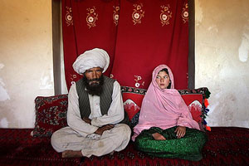
A Western couple just married  (Source: Microsoft Clip Art) | A child bride (Source: Unicef.org © Stephanie Sinclair/2007 (Unicef photo of the year 2007))
As we have seen previously, these links may involve rights over grand children or over the labour of one of the spouses. The marriage contract does not stop at the death of one of the partners and in some cases, a girl from the same family as the dead woman may replace her as a wife (this is called the sororate) or a boy from the same family as the man may replace him as a husband (this is called the levirate). This is an excellent example of the importance of the contractual dimension of marriage.
But just as importantly, remember that marriage comes in different forms in terms of the number of marriage partners one is allowed to have at any given time.

Slide 18:

Part 3: Marriage (cont'd)

Polygamy
However odd polygamy (which means many spouses) may be to us, we must remember that it is the most common form of marriage in the world (in terms of the number of societies that practice it and not in terms of individuals). We find two forms of polygamy: polyginy (marriage between one husband and two or more wives) and polyandry (marriage between one wife and two or more husbands).
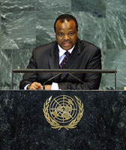
King Mswati III of the Kingdom of Swaziland (Source: UN Photo by Marco Castro) | Click on map to enlarge  Map of Swaziland in Africa (Source: Perry-Castañeda Library Map Collection)
Polygynous marriages are the normal marriage patterns in many African societies: they pose structural problems for families linked more to access to resources, relative power and conflicts of interest in relation to children than to sexual jealousy. However, strong solidarities develop among co-wives. They may be from the same lineage; they may even be sisters. Polygyny is practiced by men of high rank who can afford to have multiple spouses.
For instance, King Mwasti III of Swaziland has 14 wives, as custom demands that he marries one woman from each lineage of his kingdom. But his subjects are now complaining that the wives are too expensive to maintain for such a small and impoverished kingdom.

Slide 19:

Part 3: Marriage (cont'd)

Polygamy (cont'd)
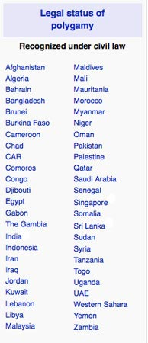
Polygyny is also practiced for religious reasons. Let us recall that Islam allows men to have up to four wives at a time, provided that he can keep them well. The Qur'an states that men who opt to have four wives must treat them fairly, spend as much time with each of them and give them the same amount of money. But a great degree of variation exists among Muslim countries regarding the 'rule' of polygyny. In some Muslim countries, polygyny is written into civil law. In others, such as Turkey, or Azerbaijan for instance, where Islamic marital law is not applied, polygyny is not allowed either.
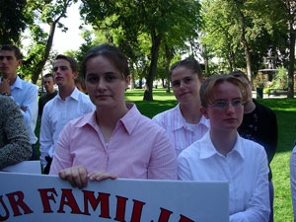 | The Mormon Church allowed its male members to practice polygamy, but in 1858 the U.S. Supreme Court declared that polygamy was not protected by the constitution. Most Mormon believers respect that decision to this day, but there are small groups of fundamentalist believers who do not. The elder (the male leader) is able to have many wives and to bear children with each of them.
Note that in these cases, social resistance to polygamy is linked to the young age of the bride and to the power relationships that force some young girl to assent to marriage with a much older man.
Above: A pro-plural marriage demonstration in the United States. A dozen teens from polygamous families along with over 200 supporters demonstrate at a pro-plural marriage rally in Salt Lake City in 2006 (Source: Wikipedia)
Right: List of countries that reconize the legal status of ploygamy (Source: Wikipedia)

Slide 20:

Part 3: Marriage (cont'd)

Monogamy
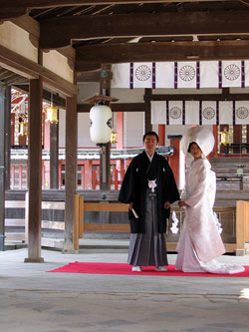
The most common form of marriage cross-culturally is monogamy and in many societies this is the only form of marriage.
Monogamy means that people are married to only one person at any given time, but some people practice serial monogamy: they are married to one person at any given time, but they will have a few marriages in their lifetime.
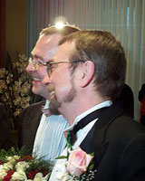 | Partners are usually heterosexual, but in some countries such as Canada, same-sex marriage is now legally accepted. Canada is among a small group of four countries in the world (and the first in the Americas) to accept same-sex marriages. The Civil Marriage Act was passed on July 20, 2005.  Left: Michael Hendricks and René Leboeuf, the first same-sex couple to legally marry in Quebec (Source: Montrealais, Wikipedia)  Right: Japanese wedding  (Source: Flickr photo by jpellgen)

Slide 21:

Part 3: Marriage (cont'd)

Marriage Choice

Who can I marry?
Who can I not marry? Who must I marry?
Ideally, in most Western societies, when considering marriage, social and economic considerations are often subordinated to the ideal of marrying for love.
What is just as interesting from an anthropological point of view is that cultural groups have defined the categories of people one can marry or one must marry, and more importantly, the category of people one must not marry.
 | 
A couple just married (Source: Flickr photo by mysim) | A Western wedding (Source: Microsoft Clip Art)

Slide 22:

Part 3: Marriage (cont'd)

Incest Taboo
Listen to your professor explain incest taboo.
(Video Length 03:31)
Click on Play to view the video.
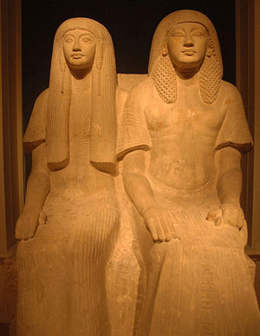
Husband and wife/Rijksmuseum van Oudheden (National Museum of Antiquities). An exception to the incest taboo, Eyptian pharoahs often married their siblings (Source: Flickr photo by jimforest)

Slide 23:

Part 3: Marriage (cont'd)

Exogamy
It can be said that exogamy is a sort of extension of the incest taboo, but whereas the incest taboo deals with sexual behaviour, exogamy deals with marriage. In societies where marriage matters, rules exist that govern the choice of marital partners. Exogamy rules force the individual to seek a marriage partner outside a specific social group, such as a clan or a lineage that one belongs to. In some societies, such as the Australian Aborigine societies, the social group is divided into moieties (half) so that people can marry people from the other moiety.  Anthropologist Claude Levi-Strauss proposed that exogamy is central to exchange and alliance between social groups and indeed many societies make exogamy the only possible form of marriage.  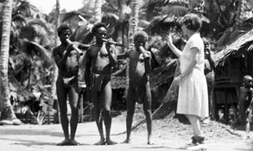 | Left: Margaret Mead conducting a group of three Arapesh men playing flutes in New Guinea, c. 1932 (Source: Library of Congress)
  Among the Arapesh of Papua New Guinea, the benefits of exogamy are captured in this short poem recorded by Margaret Mead in 1935.
  Your own mother,
  Your own sister,
  Your own pigs,
  Your own yams that you have piled up,
  You may not eat.
  Other people’s mothers,
  Other people’s sisters,
  Other people’s pigs,
  Other people’s yams that they have piled up,
  You may eat.
  Sources:
  Claude Levi-Strauss, 1969 (1949). The Elementary Structures of Kinship. Boston: Beacon Press.
  Margaret Mead, 1963. Sex and Temperament in Three Primitive Societies. New York:Dell (originally published in 1935)

Slide 24:

Part 3: Marriage (cont'd)

Endogamy
However much individuals want to marry out, they may be constrained in their choice of potential spouse by factors such as the incest taboo, social class, religion, ethnic affiliation, age, education, availability, and so on. In the end, one may have the impression that one has a large choice of marriage partners. In some ways this may be true, but practically people very often marry within their groups: social group, cultural group, age group, work group, etc. This is what we call endogamy (in-marriage). In some cultural groups, rules are strict: among the Bedouin of Arabia, it was expected that a boy would marry a close cousin. Endogamy, it is said, consolidates group solidarity and prevents the dispersion of wealth. Note that endogamy and exogamy require a clear definition of the type of group that you are marrying in and out of. Every society is endogamous in some ways, and exogamous in others.

Endogamous Marriage
Three types of endogamous marriages based on different criteria of endogamy
(from your professor's field notes in France)
1) Location: | - This couple was married in 1921.  - Their middle-class families resided in the same village and had been friends for a long time when the young people fell in love and decided to get married.  - After the wedding, the couple stayed in the village. | 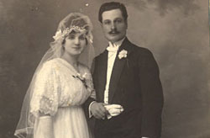
2) Social class: | - This couple got married in 1954 in Casablanca.  - Their families did not know each other, but the young people met through mutual friends.  - Both belong to middle-class families. | 
3) Education: | - This young couple was married in 1996.  - They met at university: he is from a middle-class family and was studying to be a lawyer.  - She is from a very upper-class French family and was studying to become a teacher. | 
Married couples (Source: Christine Jourdan)

Slide 25:

Part 3: Marriage (cont'd)

Arranged Marriages
In societies where the personal satisfactions of the married couple are subordinate to the needs and interests of the larger group, choosing a mate is a much less haphazard affair. The kin groups of both bride and groom have a strong vested interest in seeing that both parties will fulfill their obligations, and therefore have much more control over marriage arrangements. In these types of societies, arranged marriages are much more common. The bride and groom have no say in their choice of partner. This was the preferred form of marriage of royalty around the world.
An arranged Hindu marriage  (Traditionally, Hindu parents look for a prospective match for their son/daughter from their own community. This is known as an arranged marriage. Elders in the family and parents seek the prospective match through word of mouth within the community. The use of jathakam(astrological chart at the time of birth) of the son/daughter to match with the help of a priest is common, but not universal. Parents also take advice from the Brahmin (called panthulu in Telugu) who has details of many people looking to get married. Some communities, like the Brahmins in Mithila, use genealogical records (Panjikas) maintained by specialists.)  (Source: Jaisingh Rathore) | 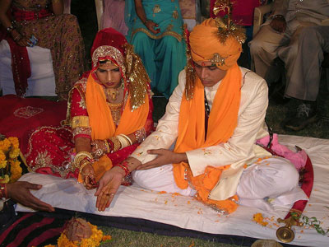

Slide 26:

Part 3: Marriage (cont'd)

Exchange, Gifts and Marriage
But what is bridewealth? It is a gift presented by the family of the groom to the family of bride. In patrilineal societies, bridewealth is understood to play four essential roles:
- It ensures that the rights over the bride's fertility will be transferred to the lineage of the groom, i.e. all children born in the marriage will belong to the father’s lineage.
- It is seen as a compensation to the bride's kin group for the loss of her work, service, presence and fertility.
- It is an acknowledgement of the girl’s personal value and distinction.
- It seals an alliance between the two families.
In some societies, marriage is certainly only defined as a contract that provides for the rights and obligations of each spouse. In Muslim societies, for instance, the Qur'an itself defines what marriage is, and what the nature of the contract is. As a contract, the legal bond of marriage gives rights and obligations to both parties.
Gift exchanges that take place at marriage sanction the marriage, but they also establish alliances between social groups. Anthropologists have observed that three main types of exchange take place at marriage: brideprice, dowry and gift exchange. Some types of exchange appear to be found in some societies more than in others. For instance, the practice of brideprice, which we prefer to call bridewealth, is found predominantly in pratrilineal descent systems of the type mostly associated with horticulture and pastoralism.
Why, in this type of society and not in foraging societies, or in class-stratified societies?
Well, the nature of labour and surplus production are crucial elements here. Men can use the production of surpluses to sustain prestige and political operation, but it puts a premium on the labour power of young men and women and on the physical reproduction of the labour force.

Slide 27:

Part 3: Marriage (cont'd)

Bridewealth Exchange
Listen to your professor explain bridewealth exchange.
(Video Length 04:29)
Click on Play to view the video.
Bridewealth exchange involves three types of transactions: one between the groom’s family and the groom himself, one between the father of the groom and the father of the bride, and one between the father of the bride and members of his lineage or clan.

Click on bridewealth exchange diagram to enlarge
The goods exchanged during bridewealth transactions need to be rare and since young men do not have access to such goods, they enlist the help of members of their lineage in order to secure a wife.
Research shows that most women are not aware of the value of the bridewealth given for them, which is subsequently distributed throughout the bride’s father’s family.
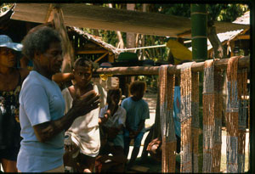
Above: Dafua’s father accepts the shell money valuables that are being given for her bridewealth (Source: C. Jourdan, 1991)

Slide 28:

Part 3: Marriage (cont'd)

Bridewealth in Pastoralist Societies
In pastoralist societies of East Africa, bridewealth is often associated with polygamy. Senior men in East Africa use control of prestige valuables and marital politics to accumulate multiple wives for themselves at the expense of young men (and hence control the labour power and fertility of young wives directly). It is this exchange of cattle which ensures that the children will be considered to belong to the husband's lineage and to his line of descent.
Samburu women in East Africa
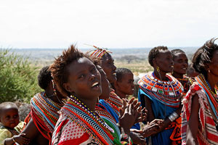 | 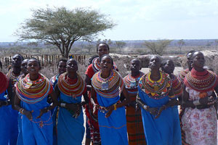
(Source: Flickr photo by Mainbube) | (Source: Flickr photo by Thumbling)

Slide 29:

Part 3: Marriage (cont'd)

Dowry
Dowry, which might appear on paper to be the reverse of bridewealth, is quite different in fact. Once common among European peasants, and widespread in Asia, dowry is characteristic of economies based on fixed-plot agriculture and feudal economic relations. It can be defined as: a payoff to an out-marrying daugther of her rights over the family estate. As Goody and Tambiah (1973) have shown, dowry is characteristically more important among higher strata of society, where status and property are centrally at stake. The bride brings into the conjugal relationship her share of her family’s estate; the husband brings corresponding wealth, inheritance chances, or high social status (or all three) and sometimes only a name, as his contribution to the newly established family.
The practical advantages of this system are twofold:
- The out-marrying daughter becomes financially independent, and with a good dowry, chances are that she will make a good (financially secure) marriage.
- The family estate will not be divided any further, and the heirs can count on land that will be theirs to develop and work. Many different types of goods make up the dowry in different parts of the world, and sometimes in combination: land, money, jewelry, household goods (such as the trousseau typical of some areas of Europe), houses, and so on.
We could summarize marriage as the following:
Marriage is: 1) an established social and economic contract; 2) it assigns and defines the social identity of children when they are born to it or adopted; and 3) it creates alliances between kin groups.
As you think about this summary, reflect on how each of these functions apply in your society.

Slide 30:

Part 4: Becoming a Parent

Cultural Understandings of Pregnancies
Not all societies understand pregnancies in the same way, nor do they have the same birthing patterns. While most people in all societies understand pregnancy as the result of sexual relationships, conception is explained in different ways. In all cases, the explanations relate to the overarching values in the society under study.
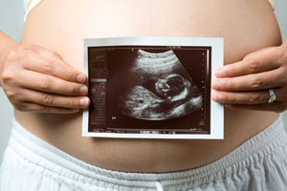 | 
Pregnant woman holding an ultrasound of her baby  (Source: Microsoft Clip Art) | Young girl kissing her mother's pregnant belly  (Source: Microsoft Clip Art)

Slide 31:

Final Thoughts
On death and dying: You can refer to your textbook for the section on death and dying.
Pay attention to the rituals surrounding funerals and to the functions they play in different societies.

Married couple with their newborn in the hospital
(Source: Microsoft Clip Art)

Concluding Remarks
Every step of life is marked by symbolic or practical events that aim at signaling that an individual is indeed part of a socio-cultural group.
As a member of that group, the child grows up, is socialized, and continues being socialized as she moves through life.
Studies of the life course of an individual which are now being conducted by anthropologists, offer important insights on the forces that shape the actual behaviour of individuals.

