Macro midterm review

Chapter 4: the market forces of supply and demand
- The terms supply and demand refer to the behavior of people as they interact with one another in a competitive markets
- Market: group of buyers and sellers of a particular good and service

- Markets can be organized (set time, place, auctioneer)

- Markets can be less organized (more often)

- Competitive market: a market in which there are so many buyers and sellers that each has a negligible effect on the price of good or service

- Perfectly competitive market: all goods and services are the same, each has negligible effect on the price (price taker)

- Monopoly: one seller and these sellers set the price

- Quantity demanded: the amount of a good that buyers are willing and able to purchase (negatively related to price)

- Law of demand: the claim that, other things equal, the quantity demanded of a good falls when the price of the good rises

- Demand schedule: a table that shows the relationship between the price of a good and the quantity demanded

- Demand curve: a graph of the relationship between the price of the good and the quantity demanded

- Increase/decrease in demand: shift of demand to the right/left

- Increase in quantity demanded: movement along the curve

variable | A change in this variable
Price of the good | Movement along the demand curve
Income | Shift (normal: demand falls when income falls) (inferior: demand rises when income falls)
Prices of related goods | Shift (substitutes: increase in price of one leads to the increase in demand of another) (compliments: increase in price of one, leads to decrease on demand for one)
Tastes | Shift
Expectations | Shift
Number of buyers | Shift

- Quantity supplied: the amount of a good that sellers are willing and able to sell
- Law of supply: quantity good rises, when the price of a good rises
- Supply schedule: a table that shows the relationship between the price of a good and the quantity supplied
- Supply curve: a graph of the relationship between the price of a god and the quantity supplied
Variable | Change
Price | Movement
Input | Shift
Tech | Shift
Expectations | Shift
Number of sellers | Shift
- Equilibrium: a situation in which the price has reached the level where quantity supplied equals quantity demanded
- Surplus: quantity supplied exceeds quantity demanded
- Shortage: quantity demanded is greater then quantity demanded
- Law of supply and demand: the claim that the price of any good adjusts to bring the quantity supplied and the quantity demanded for that good into balance
- A three step program for analyzing changes in equilibrium:
- Which curve sifts
- Which direction
- How does the shift change the equilibrium price and quantity
- Quantity supplied/ quantity demanded= shift

Shift in only supply
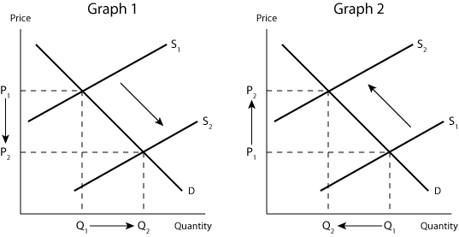

Shift in only demand
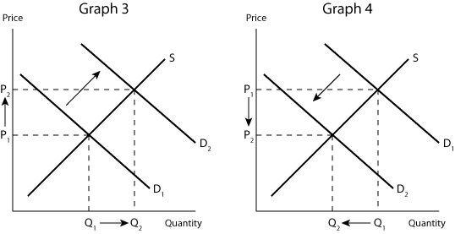

Shift in both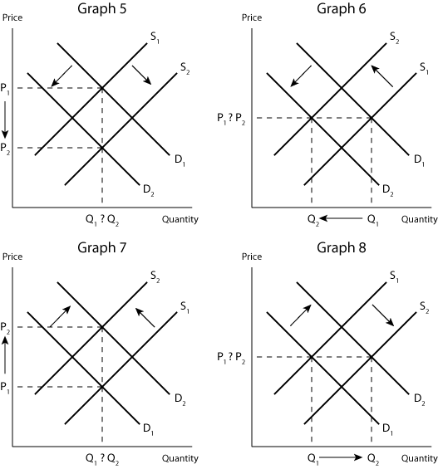
Chapter 5: Measuring a nations income
- The goal of macro economics is to determine economic changes that effect households, firms simultaneously
- GDP measures two things:
- The total income of everyone in the economy
- The total expenditure on the economy’s output of goods and services
- For an economy as a whole income must equal expenditure
- Every dollar of spending for some buyer is a dollar of income for a seller
- GDP, weather measured by as total income or total expenditure rises by the transaction cost
- GDP can be computed by adding up total expenditure of households or by adding up total income paid by firms.
- Regardless weather a household, firm, or government buys a good or service, the transaction has a buyer and a seller. Thus for the economy as a whole, expenditure and income are the same
- GDP: gross domestic product is the market value of all final goods and services produced within a country in a given period of time.
- GDP adds many different kinds of products together to measure the value of economic activity and it uses market prices to do this. If the price of one is twice the price of the other, the first will contribute to GDP twice as much…
- Market price: Measure the amount people are willing to pay for different products or services
- GDP is based on the assumption that the owner pays rent to themselves so that rent is included in both his rent and income (the government estimates its rental housing) pg 102
- GDP excludes products sold illicitly, and most items that are consumed and produced at home
- When you marry, GDP falls
- GDP can underestimate the true amount of productive activity taking place in the economy
- GDP includes only the value of final goods (because the price of the intermediate good is included in the final good). There is an exception to this principle when for example an intermediate good is added to the inventory of a company. Then the intermediate good is taken to be the final good for the moment until it is sold or used up
- GDP only includes items that are currently produced and not in the past (selling a used car vs a new car)
- GDP measures the value of production within a country
- GDP measures during a specific interval (usually a year)
- Annual rate: when the government reports GDP at a quarter, it will report it at an annual rate by multiplying by 4
- Seasonal adjustment: when the government reports quarterly GDP, it presents the data after they have been modified by a statically procedure (i.e seasonally adjusted)
- Components of GDP
- Y= C + I + G + NX
- Y is GDP
- C is consumption
- I is investment
- G is government purchases
- NX is net exports
- Consumption: spending by household on goods and services (post secondary education spending)
- Investment: the purchase of goods that will be used in the future to produce more goods and services. It is the sum of the purchases of capital equipment, inventories, and structures (expenditure on new housing). Investment means purchases of goods used to produce other goods
- When IBM purchases a computer and instead keeps it for inventory, IBM is assumed to have purchased the computer for itself. Pg. 106
- Government purchases: include spending on goods and services by local, territorial, provincial, and federal governments.
- Includes the salaries of government workers and spending on public works
- Transfer payment: Not made in exchange for a currently produced good or service. Transfer payments alter household income, but do not reflect the economy’s income (transfer payments are not counted as part of government purchases). Not calculated in GDP
- welfare (financial aid), social security. Subsidies are not transfer payments
- NX= purchases of domestically produced goods by foreigners (exports) – domestic purchases of foreign goods (import)
- Suppose that someone buys a volkswagon. Consumption increases by 30000 but it reduces net exports by 30000. Will not affect GDP. So net exports includes imports because it is also included in consumption, investment, and government purchases.
- If total sepnding rises from one year to the next two things must be true:
- The economy is producing larger output of goods and services (nominal, real)
- Goods and services are being sold at higher prices (nominal)
- Real GDP: what would be the value of the goods and services produced this year if we valued these goods and services at the prices that prevailed in some year in the past. The production of goods and services valued at current prices. (current output valued at base year)
- Nominal GDP: the production of goods and services valued at current prices. The sum of expenditure on the goods/services. (current output valued at current prices)
- To obtain a measure of the amount produced that is not affected by changes in the prices we use real GDP (because it is valued at constant prices)
- Nominal GDP= price x quantity for the market
- Real GDP= price of base year x quantity of original year
- Changes in real GDP reflect only changes in the amounts being produced
- The goal in computing GDP is to gauge how well the overall economy is performing. Because real GDP measures the economy’s production of goods and services, It reflects the economy’s ability to satisfy peoples needs and desires. Thus real GDP is a better gauge of economic well being than is nominal.
- When economists talk about the economy’s GDP they usually mean the real GDP. And when they talk about growth in the economy they measure that growth as a percentage change in the real GDP form one period to another
- GDP deflator: A measure of the price level calculated as the ratio of nominal GDP to real GDP times 100. Reflects what is happening to prices, not quantities
- NOMAINAL/ REAL x100
- Real GDP and nominal GDP must the same in base year
- GDP deflator for base year always equals 100
- The GDP measures the current level of prices relative to the level in the abse year
- Inflation rate in year 2= (GDP deflator in year 2- GDP deflator in year 1)/(GDP deflator in year 1) x 100
- Leisure is left out of GDP
- Also child car at daycares is in GDP but by parents is not, fancy restaurant meal is…
- Does not evaluate quality of environment (imagine the government got rid of all environmental constrains, GDP might rise)
- Says nothing about the distribution of income
- If we measure the difference between GNP and GDP, we get a measure of the difference between the value produced by foreigners in Canada and the value of output produced by Canadians in foreign countries
- Foreign direct investment (FDI): measure of how much of Canadian industry is owned by non-canadians
- CDIA Canadian direct investment abroad: show how much Canadians own a and control of industry in the rest of the world

Chapter 6: Measuring the cost of living
- The consumer price index: measure of the overall cost of the goods and services bought by a typical consumer. Monitors changes in the cost of living overtime
- How CPI is calculated
- Determine the basket (for products that are bought more, their prices should be weighted more heavily)
- Find the prices
- Compute the basket’s cost ( by keeping the basket of goods the same, we are isolating the effects of price changes from the effect of the quantity changes that may be occurring at the same time
- Chose a base year and compute the index: the choice of the base year is arbitrary
CPI= Price of basket of goods and services in the current year/price of basket in base year x100
- Index is always 100 in base year
- If CPI is 100 in base year and 175 in year 2:
- Year 2 is 175% of its price in base year
- A basket of goods that costs 100 in the base year, costs 175 in year 2
- Compute the inflation rate: percentage change in the price index from the preceding period
Inflation rate year 2= CPI year 2-CPI year 1/CPI year 1 x100
- Core inflation: a measure of the underlying trend of inflation. Thought to be the most useful in predicting the underlying trends of changes in CPI
- It excludes the most volatile components from the CPI basket of goods and services (volatile= changes rapidly or unpredictably, especially for the worst)
Problems of measuring the cost of living:
- The CPI tries to gauge how much income must rise to in order to maintain a constant standard of living
- Problems
- Commodity substitution bias: When prices change from one year to the next, they do not all change proportionately. Consumers respond to this by buying less of products that are more expensive and more of substitutes. CPI is calculated using a fixed basket of goods and it ignores the possibility of substitution, overstating the increase in the cost of living. (baskets are kept constant so that effects of price are isolated from the effect of any quantity changes)
- Introduction of new goods: Greater variety makes each dollar more valuable. Because the CPI is based on a fixed basket of goods and services, it does not reflect the increase in the value of the dollar that arises from the introduction of new goods.
- Unmeasured quality change: if the quality of a product deteriorates from one year to another the value of a dollar deteriorates. (i.e a car with more horsepower or is more fuel efficient)
- CPI is important because income tax deductions, government and social payments, private sector wage settlements are all adjusted using CPI
GDP deflator vs CPI
- Differences
- GDP deflator reflects the prices of all goods and services produced domestically where CPI reflects the prices of all goods and services bought by consumers (ex. Airplane bought by Bombardier and sold to the Canadian forces is part of GDP, but not the CPI) or (Volkswagon changes the price of it’s cars. They are made in Germany so the car is not part of GDP, but it is part of CPI)
- The CPI compares the price of a fixed basket of goods and services to the price in the base year. The GDP deflator compares the prices of the currently produced goods and services to the price of the same goods and services in the base year. This difference is not important when the prices are changing proportionately. But if the prices of different goods and services are changing by varying amounts, the way we weight the various prices matter to inflation.
Pg 130
- The purpose of measuring the overall level of prices in the economy is to permit comparisons between dollar figures at different times
- To compare prices:
- Determine CPI for both years
- Year 1: 14.8
- Year 2: 121.7
- Therefore the prices rose by a factor of 8.22 (121.7/14.8)
- Calculate: Price year 1 in year 2 dollars = price year 1 x (8.22)
- Ex. Price in year 1= 78.1 cents
- Price in year 2= $1.25
- So after adjusting for inflation the price is still considerably higher meaning that the price of gasoline has increased faster than the price of other goods and services
- Price indexes are used to correct for the effects of inflation when comparing dollar figures of different times
- Indexation: the automatic correction of a dollar amount for the effects of inflation by law or contract
- COLA: Cost of living allowance (partial or complete indexation of a wage to between firms and unions)
- Canada pension plans and old age security benefits are adjusted every year to compensate the elderly for increases in prices
- Interest represents payments in the future for past transfers
- Purchasing power change: quantity you can buy end.- quantity you can by at the beg/ quantity you can buy at the beginning x100
- If there is 2% deflation and the price is $10, new price is 10x(0.98)= $9.80. She can now buy (1100/9.80) 112 CD’s. Her purchasing power increased by (112-100/100)x100
- The higher the rate of inflation, the smaller the increase in purchasing power
- Nominal interest rate (interest rate): the interest rate as usually reported without a correction for the effects of inflation
- Real interest rate: the interest rate corrected for the effects of inflation
- Real interest rate= nominal interest rate – Inflation rate
- The nominal interest rate tells you how fast the number of dollars in your bank account rises over time.
- The rate of inflation tells you how fast the prices of things you want to buy are rising
- The real interest is the difference, it tells you how fast the purchasing power of the bank account rises over time

Chapter 7: Production and growth
- Productivity: The quantity of goods and services produced from each hour of a workers time
- Productivity is the key determinant of the growth in living standards.
- A nation can enjoy a high standard of living only if it can produce a large quantity of goods and services
- Ten principle: a country’s standard of living depends on its ability to produce goods and services
- Determinants of productivity: physical capital, human capital, natural resources, and technical knowledge
- Capital goods are the goods which are used to produce consumer goods. For example: machinery. In simple words we can also say that capital goods are the goods which make other goods
- Consumer goods are not used to produce other goods. Consumer goods are used or consumed by the consumer and they do not aid in further production. For example: Burger.
- Physical capital: the stock of equipment and structures that are used to produce goods and services
- Sometimes just called capital
- More tools allow work to be done more quickly
- Factors of production: The inputs used to produce goods and services- labour, capital, and so on
- Capital is a factor of productions but it is a produced factor of production
- Produced factor of production: capital is an input into the production process that in the past was an output from the production process
- Thus capital is a factor of production used to produce all kinds of goods and services, including more capital
- Human capital: the knowledge and skills that workers acquire through education, training, and experience
- Although human capital is not tangible, it is like physical capital in many ways:
- Raises a nations ability to raise capital
- Produced from factors of production (producing human capital requires the input of teachers, libraries, and student time. Students are viewed as workers who have the important job producing human capital
- Natural resources: Natural resources are inputs into production that are provided by nature, such as land, rivers, and mineral deposits
- Are renewable and non renewable (renewable forest, nonrenewable oil)
- Differences in natural resources are responsible for some of the differences in standards of living around the world
- But Japan is one of the richest countries in the world despite its lack of natural resources. It imports natural resources and exports its manufactured goods
- Technological Knowledge: society’s understanding of the best ways to produce goods and services
- Technological knowledge forms:
- Common knowledge: after it becomes used by one person, everyone uses it (assembly lines)
- Proprietary for a short time: drugs with patents
- Technological knowledge refers to a society’s understanding about how the world works (knowledge is the quality of society’s textbooks)
- Human Capital refers to the resources expended transmitting this understanding to the labour force (human capital is the amount of time that the population spends reading them)
- What can government policy do to raise productivity and living standards?
- Because capital is a produced factor of production, society can change the amount it has
- If today the economy produces a large quantity of new capital goods, then tomorrow it will have a larger stock of capital and be able to produce more of all types of goods and services. Thus, one way to raise future productivity is to invest in more current resources in the production of capital
- People face tradeoffs: Because resources are scarce, devoting more resources to producing capital requires devoting fewer resources to producing goods and services for current consumption. So for society to invest more in capital, it must consume less and save more of its current income
- A well functioning and carefully regulated financial market, one that quickly and efficiently brings savings and investments together with minimal risk is critical
- Transparent economy
- Encouraging and saving and investment is one way to that a government can encourage growth and, in the long run, raise the economy’s standard of living
- With the nation saving more, fewer goods are needed to make consumption goods, and more resources available to make capital goods. As a result the capital stock increases, leading to rising productivity and more rapid growth in GDP
- Capital is subject to diminishing returns: the property whereby the benefit from the extra unit of an input declines as the quantity of the input increases
- This means that when workers already have a large quantity of capital to use in producing goods and services, giving them an additional unit of capital increases their productivity only slightly.
- Because of diminishing returns, an increase in the saving rate leads to higher growth for only a while. As the higher saving rate allows for more capital to be accumulated, the benefits from additional capital become smaller and smaller over time, and so growth slows down.
- In the long run, the higher the saving rate leads to a higher level of productivity and income, but not to higher growth in these variables
- The diminishing returns to capital has another important implication: Other things equal, it is easier for a country to grow fast if it starts out relatively poor: catch up effect
- Catch up effect: the property whereby countries that start off poor tend to grow more rapidly than countries that start of rich
- This is because in poor countries, the workers lack the essential tools, and as a result, lack productivity. And in the more developed countries, workers already have a lot capital with which to work and therefore additional capital would not have much of an effect on their productivity.
- This can explain some things: Canada and south korea devoted a similar share of GDP to investment. Yet Canada only experienced a growth of 2% and Korea experienced a growth of 7%. Koreas GDP was one tenth that of Canada’s. With small initial capital stock, the benefits to capital accumulation is were much greater to Korea

Increasing living standards
- Saving by domestic residents is not the only way for a country to invest in new capital; the other way is investment by foreigners
- Two forms of investment abroad:
- Foreign direct investment: A capital investment that owned and operated by a foreign entity
- Foreign portfolio investment: an investment that is financed with foreign money but operated by domestic residents
- In both cases Canadians provide the resources necessary to increase the capital stock
- When foreigners invest in a country, they do so because they expect to earn a return on their investment
- GDP is the income earned within a country by both residents and non residents, where GNP (gross national product) is the income earned by residents of a country both at home and abroad
- If bombardier opens it’s assembly plant in Ireland, some of the income the plant generates is accrues to people who do not live in Ireland. As a result foreign investment in Ireland raises the income of Irish citizens (GNP) by less that in it raises the production in Ireland (GDP)
- Even though some of the benefits from the investment flow back to the foreign owners, the investment does increase the economy’s stock of capital, leading to a higher productivity and raised wages
- Poor countries can also learn for the richer countries
- Must remove restrictions that government have imposed on foreign ownership of domestic policy
- Education:
- Education is investment in human capital and is important in the long run
- Investment in education has an opportunity cost, students forgo the wages they could have been earning if they had worked
- Some argue that human capital is particularly important because it is important for economic growth because it conveys a positive externality
- For example, an educated person might generate new ideas about how to best produce goods and services. If these ideas enter the society’s pool of knowledge, then the ideas are an external benefit of education
- Brain drain: the emigration of many of the most highly educated workers to rich countries, where these workers can enjoy a higher standard of living
- Canada benefits from the drain suffered by poor countries
- Canada also suffers a brain drain as some of its highly educated workers are attracted to high paying jobs in the U.S
- Stress the need to cut taxes- in order to make the after taxe income of skilled workers more comparable to those of the U.S, or to improve Canada’s social programs
- Health and education
- Although the term human capital usually refers to education, it can also be used to describe expenditures that lead to a healthier population.
- Healthier workers are more productive
- Taller workers tend to earn more
- Policies that lead to a more rapid economic growth naturally improve health outcomes, which in turn would further promote economic growth
- Property rights and political stability
- Market economy’s achieve this coordination through prices
- Property rights: the ability of people to exercise authority over the resources they own
- Courts serve an important role because they reinforce property rights
- In underdeveloped countries, contracts are often un enforced and fraud is frequent
- To do business in some countries, firms are expected to bribe powerful government officials. Such corruption impedes the coordinating power of markets. It also discourages domestic saving and investment abroad
- A threat to property rights: political instability: when revolutions and coups are common there is doubt about weather property rights will be respected in the future
- Domestic residents have less interest to save, invest, and start new businesses. At the same time, foreigners have less incentive to invest in the country
- Economic prosperity depends on political prosperity
- Free trade
- Inward oriented policies: policies that are aimed at raising productivity and living standards within the country by avoiding interaction with the rest of the world
- Achieve more rapid economic growth
- Most economy’s today believe that poor countries are better off pursuing outward-oriented policies
- Trade is in some way a technology: when a country exports wheat and imports steel, the country benefits in the same way as if it had invented a technology for turning wheat into steel
- The amount that a nations trade with others is determined not only be government policy but also geography
- Research and Development
- Although most technological advance comes from private research by firms, there is a public interest in promoting these efforts because knowledge is a public good
- Encourages research through the patent system.
- A patent gives the inventor a property right of his invention which turning it from a public good to a private good
- The patent system enhances the incentive for individuals and firms to engage in research
- Population growth
- A large population means more workers to produce goods and services
- Famines are more often a result from unequal income distribution than overpopulation
- When population growth is rapid, a smaller quantity of capital leads to lower productivity and lower GDP per worker
- Having more people induces more technological advances

Chapter 8: The real economy in the long run
- Financial system: the group of institutions in the economy that help to match one person’s saving with another person’s investment
- Saving and investment are key components to the financial system because with saving a large portion of GDP, more resources are available for investment of capital
- The financial system moves the economy’s scarce resources from savers to borrowers
- Savers supply their money to the financial institution with the expectation that they will get it back with interest at a later date
- Borrowers demand money with the knowledge that they will have to pay it back in a future date with interest charges
- Financial institutions can be grouped into two categories: financial markets and financial intermediaries
- Financial markets: financial institutions through which savers can directly provide funds to borrowers
- Bond market: a certificate of indebtedness
- IOU
- Identifies the time a which the loan will be paid, called the date of maturity, and the rate of interest
- Term: the length of time until the bond matures
- The interest rate depends on it’s term (long term bonds usually pay higher than short term)
- Long term are risker than short term
- Credit risk: the probability that the borrower will fail to pay back its bond before the date
- The failure to pay is called default and borrowers can default on their loan by declaring bankruptcy
- When bond buyers think that credit risk is high, they will charge a larger interest
- The Canadian government is considered a safe credit risk because although it has a very large debt, the amount of debt is small relative to it’s capacity to finance the debt
- Revenues are more volatile for provincial and territorial governments
- The rate of interest paid for territorial is more expense and reflects the volatility of the revenues
- Financially shaky corporations raise money by issuing junk bonds, which as the name suggests pay considerably higher interest rates
- Stock Market
- Stock represents ownership to a in a firm, and is a claim to the profits that the firms make
- Equity finance: the sales of stock to raise money/ sales of bonds is called debt finance
- The owner of a bond is a creditor. If the company is profitable the bond owners get only the benefits of the interest while the shareholders get the benefits of the profit. But if the company runs into financial issues the bondholders get paid first
- Stock=shares so stock is a higher risk but higher return investment
- The prices at which shares are sold on the stock market is determined by supply and demand
- Stock index is computed as an average price of a group f stock prices

- Financial Intermediaries
- Financial institutions through which savers can indirectly provide funds to borrowers
- Banks
- Banks take in money that people want to save, and they loan them to others
- Banks pay depositors interest on their deposits and charge borrowers slightly higher interest
- Medium of exchange: item that people can easily use to engage in transactions
- Mutual funds
- Institution that sells shares to the public and uses the proceeds to buy a selection, or portfolio, of various types of stocks or bonds
- The primary advantage of mutual funds is that they allow people with small amounts of money to diversify
- People who own a diverse portfolio of stocks and bonds face less risks because there is only a small risk associated in bonds in the portfolio
- Mutual funds, called index funds,, which buy all the funds in a given stock index, perform better than by management of professionals of money management
- Accounting refers to how various numbers are defined and added up
- National income incudes GDP
- In this chapter we assume a closed economy, which is one that does not interact with other economies. So
- Y= GDP C=consumption I=investment G=government spending
- Y=C+I+G
- Or Gdp is the sum of consumption, investment, and government purchases
- I= Y-C-G The left hand side of the equation is the total income in the economy that remains after paying for consumption and government purchases which is called national saving or saving
- S=I (saving equals investment)
- S=Y-C-G
- S=(Y-T-C) + (T-G)
Where T equals the amount that the government collects from the household tax- amount paid back in the form of transfer payments
- Private saving = Y-C-T
- Public saving = T-G
- Private saving is the amount that households have left after paying taxes and paying for their consumption
- Public saving is the amount of tax revenues that the government has left after paying for its spending
- If T exceeds G, then the government runs a budget surplus because it receives more money than it spends
- If the government spends more than it receives in tax revenue, this is called a budget deficit
- For the economy as a whole, saving must equal investment
- What coordinates the people who are deciding how much to save, and how much to invest? The answer is the financial system. The bond market, the stock market, banks, mutual funds, and other financial market intermediaries stand between the two sides of the S=I equation.
- The meaning of saving and investment
- Investment refers to the purchase of new capital, such as equipment or buildings. When you borrow from the bank, you add to investment
- Saving can be greater or less than the investment for an individual, because you can use bank loans to cover shortfalls,
- The market for loanable funds
- To keep things simple, we assume that the economy has only one financial market, called the market for loanable funds
- It refers to all lending and saving
- There is also only one interest rate, which is the return to saving, and the cost of borrowing
- Supply and demand for loanable funds
- Governed by supply and demand
- The supply of the loanable funds comes form those people who have some extra income they want to save and lend out (directly or indirectly) but in either case, saving is the source of supply for loanable funds
- The demand comes from households and firms who wish to borrow money to make investments, investment is the source of demand for loanable funds
- The interest rate is the price of the loan. It represents the price that borrowers pay on the loan and the amount that sellers receive for the loan
- Pg 178

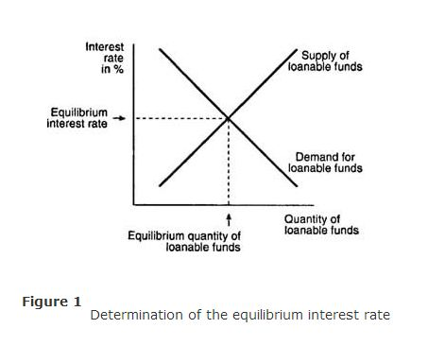
- If the interest rate were lower, the quantity of loanable funds supplied (saving) would be less than the quantity of loanable funds demanded (investment) This would encourage lenders to raise the interest rate they charge
- The supply and demand for loanable funds, depends on the real interest rate, and the equilibrium should be interpreted as determining the real interest in the economy.
- Policy 1: saving incentives
- Canadian Families generally save a smaller fraction of their income then their counterparts in many other countries. This is a major problem for Canada
- If Canada could somehow raise its saving rate to the level that prevails in other countries, the growth rate of GDP would increase over time
- Many economists believe that the low saving rate in Canada is at least partially attributable to tax laws that discourage saving
- The tax on interest substantially reduces the future payoff from current saving and, as a result, reduces the incentive for people to save
- Economists support the Tax Free Savings Accounts (TFSA) and give more incentives to save
- Policy 2: investment incentives
- Investment tax credit
- If a reform of the tax laws encouraged greater investment, the result would be higher interest rates and greater saving
- Policy 3: government budget deficits and surpluses
- Budget deficit is when the government spends more than it earns in tax revenue
- Budget balance is when it = exactly the amount is earns
- National saving is comprised of public and private saving
- Crowding out: a decrease in investment that results from government borrowing
- Increased borrowing from the government increases the supply curve, and increased borrowing by private investors shift the demand curve
- When the government reduces national saving by running a budget deficit, the interest rate rises, and investment falls
- A government budget deficit reduces the supply of loanable funds
- Loanable funds= flow of resources available from private savings
- Long strings of government deficits can push the economy into a viscous circle
- A budget surplus increases the supply of loanable funds, reduces the interest rate, and stimulates investment
- Virtuous circle pg 185
- By 2008, the effects of a financial crisis that significantly slowed the economic growth began to be felt in Canada. We fell into a deficit in 2009 and it may be a number of years before the economy improves sufficiently to return to the budget surplus
- The difference between the value of government financial liabilities and financial assets

Chapter 9: unemployment and its natural rate

How is unemployment measured

- Types of unemployment, length on average of a workweek, and the duration of unemployment
- Labour force survey: data from 54 000 households
- 3 categories: employed, unemployed, not in the labour force (15 years or older)
- Labour force: The sum of the employed and the unemployed
- Unemployment rate= number of unemployed/ labour force x100 (for entire or specific)
- Labour force participation rate: labour force/adult population x100 (for entire or specific)
- Measures the percentage of the adult population that is in the labour force
- In 2011 the unemployment rate for young men was much higher than that of young women. This is caused by a residual effect from the recession
- During mid to late 1980’s the unemployment rate increased to become roughly equal to the Canadian average – this is due to the fall in oil and natural gas prices (harmed the economies of western Canada but benefited the others)
- It can be misleading to make comparisons between different countries. i.e the u.s includes 16 and over

Does the unemployment rate measure what we want it to
- It is hard to distinguish between a person who is not in the labour force and someone who is unemployed
- Movements into and out of the labour force are common
- Also, not all unemployment ends with the worker finding a job at the end
- Also, some people may not be trying hard to find a job, or perhaps they are calling themselves unemployed because they would like to qualify for the employment insurance, or working and being paid under the table
- Discouraged searchers: individuals who would like to work but have given up looking for a job
- Discouraged searchers do not show up on the unemployment statistics
- It is important to view the unemployment rate as a useful but imperfect measure of joblessness
How long are the unemployed without work?
- Average spell of unemployment hides a lot including:
- The fact that unemployment varies across the country
- Wide dispersion of unemployment experiences across the individual. (by looking at the average we fail to see that unemployment can be a very long term and serious problem for one person, while it can be a very short term minor problem for another)
- Most people who are unemployed will soon find jobs. Policy solutions directed towards fixing the unemployment problem should be directed towards those suffering prolonged spells of unemployment
Why are there always some people unemployed?
- In most markets of an economy, prices adjust to bring quantity supplied and quantity demanded into balance. In an ideal labour market, wages would adjust to balance the quantity of labour supplied and labour demanded
- Natural rate of unemployment: the rate of unemployment to which the economy tends to return in the long run
- Canada is 6-8 percent
- Cyclical unemployment: the deviation of unemployment from its natural rate
- Cyclical unemployment arises due to the short-run economic fluctuations
- There are four ways to explain unemployment in the long run
- It takes time for workers to search for jobs that are best suited to them
- Frictional unemployment: unemployment that results because it takes time for workers to search for jobs that best suit their tastes and skills (is thought to explain relatively short spells of unemployment)
- The next three explanations for unemployment suggest that the number of jobs available in some labour markets may be insufficient to give a job to everyone who wants one. This occurs when labour supplied exceeds demand
- Structural unemployment: unemployment that results because the number of jobs available in some labour markets is insufficient to provide a job for everyone who wants one (explains longer spells of unemployment)
Job search
- One reason why economies experience unemployment is because of job search
- Job search: the process by which workers find appropriate jobs given their tastes and skills
Why some frictional unemployment is inevitable
- Often the result of changes in the demand for labour among different firms
- i.e when customers decided they like mac better than dell, mac increase employment and dell lays off resulting in a period of unemployment
- Changes in the composition of demand among industries is called sectoral shifts
- Sectoral shifts temporarily cause unemployment because it takes time for workers to search for new jobs in different sectors
- Each year there is a transition from contracting firms to expanding firms
Public policy and job search
- The internet facilities job search
- If policy can reduce the time it takes for unemployed workers to find work, it can reduce the natural unemployment rate
- Government tries to facilitate job search in many ways
- Government run employment agencies
- Public training programs
- Advocates believe that the program make the economy operate more efficiently by keeping the labour force more fully employed, and reduce the inequalities in a constantly changing market
- In certain circumstances, the private sector is incapable of helping those who lose their jobs, including when a natural disaster occurs
- It is argued that the virtual disappearance of the industry that is essential to the economy demand government involvement
- Should the government help with job search?: private market better matches workers with jobs, these decisions are best made privately by workers and employers
Employment insurance
- In Canada, the federal government maintains an employment insurance program: a government program that partially protects workers’ incomes when they become unemployed
- Argued that it an can cause the unemployment rare to be higher, increases frictional unemployment
- When/how long can someone collect EI benefits?
- The number of hours worked in the last year (more EI)
- The unemployment rate in the area of residence
- People respond to incentives, the unemployed would devote less effort to job search
- But it also, they not only earn a wage while working, but also become eligible to collect EI benefits should they leave the job
- Studies show that employers initiate layoffs only after workers become eligible for EI benefits and is done as a benefit to workers who accept lower wages
- The likelihood of finding new employment increase as EI recipients near the end of their benefits
- Many studies have conformed that joining the labour force is significantly influenced by the availability and generosity of EI benefits
- But the EI does achieve the primary goal of reducing income uncertainty faced by unemployed people, and allows people to conduct a more thorough job search, matches workers with the right job
- The unemployment rate is an imperfect measure of a nations economic well being
Minimum wage laws
- Structural unemployment results when the number of jobs is insufficient for the number of workers
- When a minimum wage law forces the wage to remain above the level that balances supply and demand, there will be excess labour supplied and will therefore result in unemployment
- It is important to note that minimum wage laws are not a predominant reason for unemployment because most workers earn well over the minimum wage
- Minimum wage laws are binding more often for the less experienced and younger workers of the economy
- If wage is kept above the equilibrium level for any reason, the result is unemployment
- Frictional vs. Structural = searching vs. waiting
Unions and collective bargaining
- Union: a worker association that bargains with employers over wages and working conditions
- Unionization is highest industries in the public sector and lowest in the food and accommodation union
The economics of unions
- A union is a type of cartel, a group of sellers acting together in the hope of exerting their joint market power
- Collective bargaining: the process by which unions and firms agree on the terms of unemployment
- When a union bargains with a firm, it asks for higher wages, higher benefits and better working conditions
- Strike: the organized withdrawal of labour from a firm by a union
- Unions workers typically earn 10 to 20 percent more than similar workers who do not belong to unions
- When a unions raises the wage above the equilibrium level, it raises the quantity of labour supplied and decreases the demand for labour resulting in unemployment
- Unions are often thought to cause conflict between two different types of workers: insiders who benefit from the increase wages, and outsiders who do not get the union job
- Outsiders respond by: waiting for a chance to become insiders, or they look for a job that is not unionized
- Thus when unions raise wages in one part of the economy, the supply of labour in other increases
- But this increase in supply reduces the wages in the other economy
- Various laws are designed to encourage the formation of unions
- The very threat of such attempts at unionization likely have the affect of causing firms to increase wages and improve the working conditions as a way of discouraging workers from joining a union
Are unions good or bad for the economy?
- Critics argue that they cause unemployment though the raise of wages and the resulting allocation of labour is inefficient and inequitable (high wages reduces unemployment, and some workers benefit at the expense of others
- Advocates: Reduces market power for a firm in a company town
- A union may balance the firms market power and protect the workers from being at the mercy of the firms owners
- Help firms respond efficiently to workers concerns, unions allow the firm to provide the right mix of job attributes
The theory of efficiency wages
- Efficiency wages: above equilibrium wages paid by firms in order to increase worker productivity, so it may be more profitable for firms to offer higher wages
Theory Types:
Worker health:
- Emphasizes the link between wages and worker health
- Better paid= better food= healthier= more productive
- This is not relevant for rich countries like Canada
Worker turnover:
- Emphasizes the link between wages and worker turnover
- The frequency with which workers quit jobs is dependent on the entire set of incentives they face including the benefits they face
- It is costly for firms to hire and train new workers
Worker effort:
- Emphasizes the link between wages and worker effort
- Firms pay above the equilibrium providing an incentive for workers not to shrink their job responsibilities
Worker quality:
- Emphasizes the link between wages and worker quality
- When a firm offers a higher wage, it attracts a better pool of workers to apply for the job and increases the quality of the workforce
- Results in profitability for the firm

Chapter 10: the monetary system
The meaning of money
- Money: the set of assets in an economy that people regularly use to buy goods and services from other people
The functions of money
- Functions
- Medium of exchange
- A unit of account
- Store of value
- These three functions distinguish money from other assets in the economy
- Medium of exchange: an item that buyers give to sellers when they wan to purchase goods or services
- Money is a commonly accepted medium of exchange
- Unit of account: the yardstick people use to post prices and record debts
- When we want to measure and record economic value, we use money as the unit of account
- Store of value: an item that people can use to transfer purchasing power from the present to the future
- Money is not the only store of value
- Wealth refers to the total of all stores of value, including both money and nonmonetary assets
- Liquidity: the ease with which an asset can be converted into the economy’s medium of exchange
- Stocks and bonds are liquid
- When people decide in what form to hold their wealth, they have to balance the liquidity of each possible asset against the asset’s usefulness as a store of value
- Although money is very liquid, it is far from a perfect store of value. When prices rise, your money loses value. The link between the price level and the value of money will turn out to be important for understanding how money affects the economy
The kinds of money
- Commodity Money: money that takes the form of a commodity with intrinsic value
- One example of commodity money is gold
- Gold standard: using gold as money
- Another example of commodity money is cigarettes
- Fiat money: money without intrinsic value that is used as money because of government decree
- Example: the government has decreed the dollars in your wallet to be valid money and the bills in the game of monopoly to not be valid
- To a large extent, the acceptance of fiat money depends as much on expectations and social convention as on government decree
- For example, the soviet government never abandoned the ruble to be the official currency while the people of Moscow preferred cigarettes to be the unit of currency
Money in the Canadian economy
- Money stock: the quantity of money circulating in the economy
- What is the quantity of money?
- The most obvious asset is to include currency: the paper bills and coins in the hands if the public
- Currency is clearly the most widely accepted medium of exchange in the economy
- Wealth held in your chequing account is almost as convenient for buying things as the wealth in your wallet is
- So to measure the money stock, you may want to include the demand deposits
- Demand deposits: balances in the bank account that depositors can access on demand by writing a cheque or using a debit card
- The important point is that the money stock for the Canadian economy includes not just currency but also deposits in banks and other financial institutions that can be readily accessed and used to buy goods and services
- The two types of money are M1+ and M2
- M1+: chequable deposits and currency
- M2: everything in M1, nonpersonal demand and notice deposits, and a few minor categories
The bank of Canada
- Whenever an economy relies on a system of fiat money, as the Canadian economy does, some organization must be responsible for controlling the stock of money, Bank Of Canada
- Central Bank: an institution designed to regulate the quantity of money in the economy
The Bank of Canada Act
- 12 chapter and firs ten pages of chapter 13
Monetary Policy
- The BOC has the power to decrease or increase the amount of money in circulation
- The BoC is important because changes in money supply can affect the economy
- Although BoC is responsible alone for the monetary policy, the central bank can control the supply of money only through it’s influence on the entire bank system
- Commercial banks- credit unions, caisse populaires, trust companies
- Reserves: bank deposits the bank has received but not yet loaned out
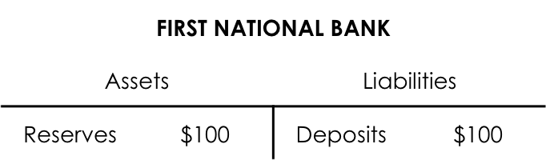

- Fractional reserve banking: a banking system in which banks hold only a fraction of reserves
- Reserve ratio: the fraction of deposits that banks hold as reserves
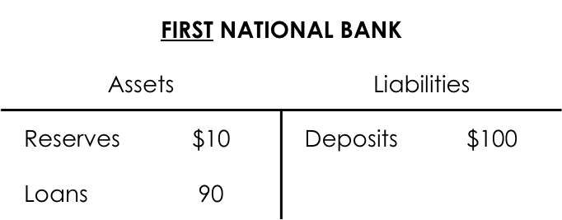

- Assuming a reserve ratio of 10 percent (only hold 10% of the reserves)
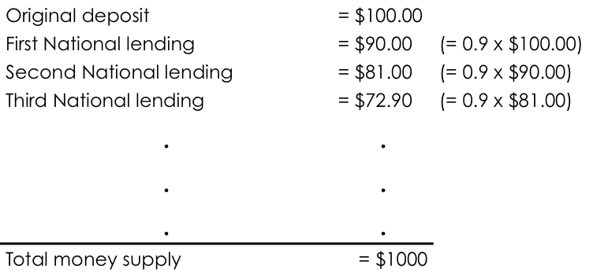
- Money multiplier: the amount of money the banking system generates with each dollar it receives = 1/Rov

Chapter 11
- Over the past 70 years, prices have rose over 4% per year
- 4 percent annual inflation leads to 16 fold increase in the price level
- inflation is not inevitable
- hyperinflation: extremely high rate of inflation
- The quantity theory of money: classical
- Economusts rely on this theory to explain the long run determinants of the price level and the inflation rate
The level of prices and the value of money
- Inflation is more about the value of money than the value of goods
- Inflation is an economy wide phenomenon that contains first and formost the value of the medium of exchange
- The economy’s price level can be viewed in two different ways:
- When the price level rises, people have to pay more for the good
- When the price level rises, people pay the same amount because the drop of value on money
- If P is the price of goods and services measured in terms of money
- 1/P is the value of money measured in terms of goods and services
- When the overall price level rises, the value of money falls
- Supply and demand determines the value of money
- When the overnight rate increase the bank of Canada discourages banks from borrowing reserves
- The demand of money represents how much wealth people hold in the most liquid form
- The quantity of money demanded depends on the interest rate that a person could earn by using the money to buy an interest-bearing bond rather than leaving it in a wallet or a low interest chequing account
- Although many variables affect the demand for money, one stands out: the average level of prices in the economy
- A higher price level (a lower value of money) increases the quantity of money demanded
- In the long run, the overall level of prices adjusts to the level at which the demand for money equals the supply
- When the value of money is high, the price level is low
- 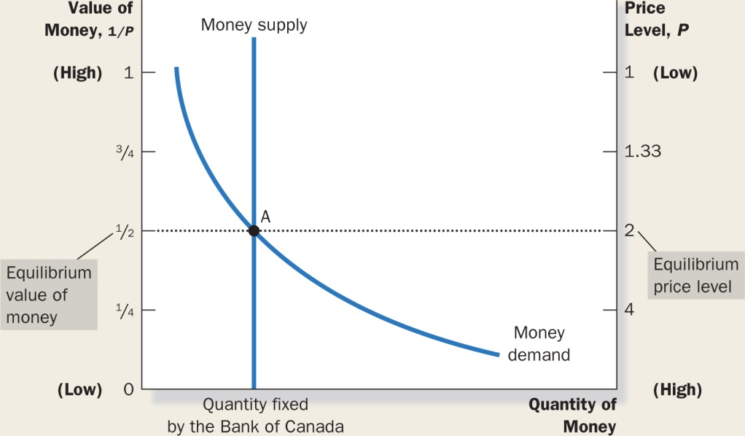
- Money supply is vertical because the bank of Canada has fixed the amount of money available
- The demand curve is sloping downward because when the value of money is low and price level high, people demand a larger quanity of it to buy goods and services
- The bank of Canada lowers the overnight rate and causes money supply to increase (monetary injection)
- 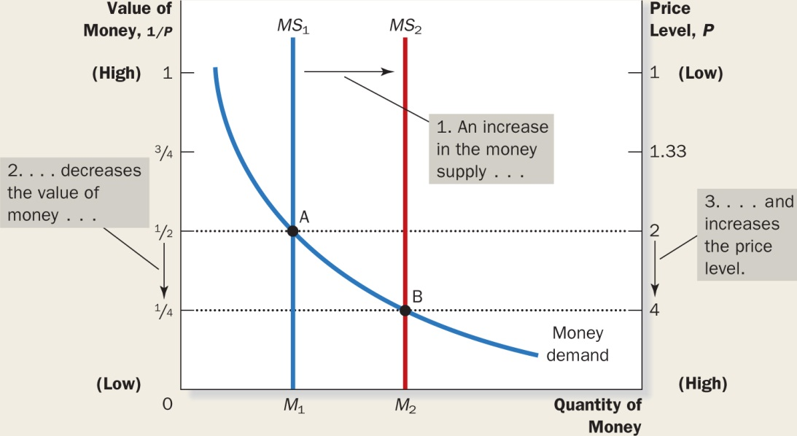
- Quantity theory of money: a theory asserting that the quantity of money available determines the price level and that the growth rate in the quantity of money available determines the inflation rate
- The immediate effect of a monetary injection is to create an excess supply of money. Before the injection, the economy was in equilibrium
- Quantity supplied exceeds quanityt demanded
- People get rid of excess money by spending or loaning
- The injection of money increases the demand of goods and services
- The economy’s ability to provide goods and services is not changed
- All economic variables should be divided into two groups:
- Nominal variables: variables measured in monetary units
- Real variables: variables measured in physical units
- For example nominal gdp is a real variable and real gdp is a real variable
- Classical dichotomy: the theoretical separation of nominal and real variables
- $100/tonne is real and nominal
- relative prices are real variables
- the real wage is a real variable because it expresses the rate at which the economy exchanges goods and services for each unit of labour
- the classical dichotomy is useful in analyzing the economy because different forces influence real and nominal variables
- changes in the supply of money affect nominal variables and not free variables
- monetary neutrality: the proposition that changes in the money supply do not affect real variables
- the velocity of money: the rate at which money changes hands
- in economics, the term velocity refers to the speed at which the typical dollar travels around the economy from wallet to wallet
- Velocity = (P x Y)/M
- Where P is the price level, Y is the quantity of output, and M is the quantity of money
- Quantity equation: M x V= P x Y
- The velocity of money is relatively stable over time
- Because the velocity is stable, when the central bank changes the quantity of money (M), it causes proportionate changes in the nominal value of output (P x Y)
- The economy’s output of goods and services (Y) is primarily determined by factor supplies (labour, capital, human capital…) and the available production technology. In particular because money is neutral, money does not affect output.
- With output (Y) determined by factor supplies and technology, when the central bank alters money supply (M) and induces proportional changes in the nominal value of output, these changes are reflected in the price level
- Therefore when the central bank increases the money supply rapidly, the result is a high rate of inflation
- Hyperinflation is defined by inflation that exceeds 50 percent per month
- Governments use money creation as a way to pay for their spending
- Normally the Gov. does this my levying taxes and and by borrowing from the public
- When the government raises revenue by printing money, it is said to levy an inflation tax
- When the government prints money, the price level rises, and the dollar in your pocket are less valuable. Thus, the inflation tax is like a tax on everyone who holds money
- In Canada, inflation tax is trivial (low importance)
- Nominal interest rate= the interest rate you hear at the bank
- The real interest rate= corrects the nominal interest rate for inflation
- Real interest rate= nominal-inflation
- Nominal interest rate= real interest rate + inflation rate
- When the bank of Canada increases the rate of money growth, the result is both a higher inflation rate and a higher nominal interest rate
- Fisher effect: the one-for-one adjustment of the nominal interest rate to the inflation rate
- The fisher effect does not hold in the short run
- The fisher effect states that the nominal interest rate adjusts to expected inflation. Expected inflation moves with actual inflation in the long run, but that is not necessarily true in the short run
- The fisher effect is crucial for understanding changes overtime in the nominal interest rate.
- Inflation itself does not in itself reduce people’s real purchasing power: when prices rise buyers ay more, but sellers receive more
- Costs associated with inflation:
- Shoeleather costs: the resources wasted when inflation encourages people to reduce their money holdings
- To avoid paying the inflation tax, a buyer should go to the bank more frequently and earn interest
- Menu costs: the costs of changing prices
- Firms change prices infrequently because there are costs of changing prices
- Menue costs include the costs of deciding on new prices, dealing with customer annoyance
- With low inflation rate annual price changes is a good strategy for firms, during hyperinflations, firms must change their prices daily
- Market economies rely on relative prices to allocate scarce resources. Consumers decisions become distorted
- Inflation tends to raise the tax burden on income earned from savings
- Capital gains: the profits made by selling an asset for more than its purchase price
- Inflation exaggerates the size of capital gains and inadvertently increases the tax burden on this type of income
- The income tax treats the nominal interest earned on savings as income, even though part of the nominal interest rate merely compensates for inflation
- The taxes on nominal capital gains and on nominal interest income are two examples of how tax interacts with inflation
- Unexpected changes in prices redistribute wealth among creditors and debtors
- Inflation is especially volatile and unpredictable when the average rate of inflation is high
- Deflation also causes the problem of relative price levels, and causes the redistribution of wealth towards creditors and away from debtors
- Because debtors are often poorer, this redistribution is harmful
- Costs of inflation: shoeleather costs, menu costs, increased variability of relative prices, redistribution of wealth, confusion and inconvenience, unintended changes in tax liabilities

Chapter 12
- Closed economy: economy that does not interact with others around the world
- Open economy: an economy that interacts freely with other economies around the world
- Net exports= value of country’s exports – value of country’s imports
- Trade balance: the value of a nation’s exports minus the value of its imports also called the trade balance
- Trade surplus: an excess of exports over imports
- Trade deficit: an excess of imports over exports
- Balance trade: a situation in which exports equal imports
- Spending 20 bucks on car is a flow of goods
- Spending 20 bucks to invest in Toyota, is a flow of capital
- Net capital outflow: the purchase of foreign assets by domestic residents minus the purchase of domestic assets by foreigners
- Foreign direct investment and foreign portfolio investment
- Variables that influence net capital outflow:
- Real interest rates being paid on foreign assets
- Real interest rates being paid on domestic assets
- Perceived economic and political risks of holding assets abroad
- Government policies that affect foreign ownership of domestic assets
- Net exports measure an imbalance between a country’s exports and its imports
- Net capital outflow measures an imbalance between the amount of foreign assets bought by domestic residents and the amount of domestic assets bought by foreigners
- Net capital outflow always equals net exports
- Gross domestic product= consumption, investment, governemtn purchase and net exports
- National saving= y-c-g or S= I+NX
- But because NCO = NX
- S= I + NCO
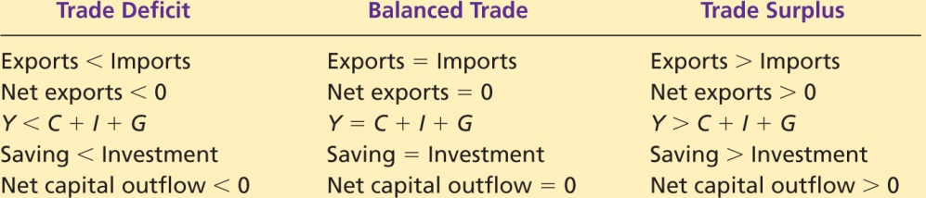

- Nominal exchange rates: the rate at which a person can trade the currency of one country for the currency of another
- Appreciation: an increase in the value of a currency as measured by the amount of foreign currency it can buy
- Depreciation: a decrease on the value of a currency as measured by the amount of foreign currency it can buy
- For example is it goes from 80 yen to 70 yen per dollar, the dolar depreciated and the yen appreciated
- When the currency appreciates it strengthens
- When a currency depreciates it weakens
- Real exchange rate: the rate at which a person can trade the goods and services of one country for the goods and services another
- Real exchange rate= nominal exchange rate x Domestic price/ foreign price
- The real exchange rate is a determinant of how much a country exports and imports
- To measure the real exchange rate they use price indexes.
- Price index for Canadian basket = P
- Price index for a foreign basket= P*
- Nominal exchange rate= e
- Real exchange rate= (e x P)/P*
- Purchasing power parity: a theory of exchange rates whereby a unit of any given currency should be able to buy the same quantity of goods in all countries
- Based on the principle of the law of one price
- This law asserts that a good must sell for the same price in all locations
- Arbitrage: taking advantage of prices differences
- Parity means equality
- Purchasing power parity states that a unit of all currencies must have the same real value in every country
- Purchasing power parity, tells us that the nominal exchange rate between the currencies of two countries depends on the price levels of those countires
- If the purchasing power of the dollar is always the same at home and abroad, then the real exchange rate- the relative price of domestic and foreign goods- cannot change
- The nominal exchange rate between the currencies of two countries must reflect the different price levels in those countries
- When the central bank prints large quantities of money, that money loses value both in terms of the goods and services it can buy and in terms of the amount of other currency it can buy
- The theory of purchasing power parity is not always completely accurate. That is exchange rates do not always move to ensure that the dollar has the same real value in all countries all the time
- Why does purchasing power parity not always hold in practice?
- Many goods are not easily traded
- Tradable goods are not always perfect substitutes when they are produced in different countries
- And for these reasons, real exchange rates fluctuate over time
- When we want to predict weather Canadian interest rates will rise or fall we look at the u.s
- Small open economy: an economy that trades goods and services with other economies and, by itself, has a negligible effect on world prices and interest rates
- Only has a negligible effect on prices…
- If r is the Canadian real interest rate and r^w is the world real interest rate: r=r^w
- As long as the Canadian and the foreign assets are close substitutes, the difference in interest rates provides an arbitrage opportunity for buyers or sellers
- Interest rate parity: a theory of interest rate determination whereby the real interest rate on comparable financial assets should be the same in all economies with full access to world financial markets
- The real interest rate in Canada is not equal to the real interest rate in the whole world
- Financial assets carry with them the possibility of default
- Financial assets offered in different countries are not always perfect substitutes

Chapter 13
- We focus on supply and demand in two markets
- Loanable funds saving and investment
- Second market is for foreign currency exchange
- S= I + NCO
- If the amount of national saving exceeds the amount needed to finance the purchase of domestic capital, the amount leftover can be used to finance the purchase of an asset abroad
- In Canada the supply of loanable funds from national savings has at some times not been sufficient to satisfy the demand for loanable funds for investment so we have S < I
- An appreciation of real of the real exchange rate reduces the quantity demanded of dollars demanded in the market for foreign currency exchange
- Conversely, if the real exchange rate was above the equilibrium level, the quantity of dollars supplied would exceed the the quantity demanded, the surplus of dollars would drive the value of the dollar down

Chapter 14
- Economic fluctuations are irregular and unpredictable
- Called the business cycle
- Most macroeconomic quantities fluctuate together
- As output falls, unemployment rises
- When GDP declines, unemployment rises
- Classical theory: money is neutral and classical dichotomy
- Describes the world in the long run
- In the short run, money affects both variables
The model of aggregate supply and demand
- Model of aggregate supply and demand: economists use to explain short run fluctauations in economic activity
- It uses both real gdp and gdp deflator (real and nominal) so abandon the classical theory
- The wealth effect: A decrease in the price level makes consumers wealthier and, which in turn encourages them to spend more. The increase in consumer spending means a larger quantity of goods and services demanded. Conversely, an increase in the price level means reduces the real value of money, in turn reducing wealth, consumer spending, and the quantity of goods and services demanded
- The interest rate effect: A lower price level reduces the interest rate, encourages greater spending on investment goods, and thereby increases the quantity of goods and services demanded. Conversely, a higher price level raises the interest rate, discourages the investment spending, and decreases the quantity of goods and services demanded
- The real exchange rate effect: A fall in the Canadian price level causes the real exchange rate to depreciate, and this depreciation stimulates Canadian net exports and increases the quantity of goods and services demanded. Conversely, an increase in the Canadian price level causes the real exchange rate to appreciate, and this appreciation reduces Canadian net exports and thereby decreases the quantity of goods and services demanded.
- Shifts arising from changes in consumption: any event that changes how much people want to consume at any given price level is a shift (taxes)
- Shifts arising from changes in investment: faster computers, tax credit (shifts to the right), increase in money supply means lower interest means more investment
- Shifts arising from changes in government purchases:
- Shifts arising from changes in net exports: decrease in purchase of goods foreign, shifts demand left
- Shifts arising from changes in labour: immigration/emigration of workers
- Shifts arising from changes in capital: increased capital, increases productivity
- Shifts arising from changes in natural resources
- Shifts arising from technological knowledge
- The quantity of output supplied deviates from its long run or natural level when the actual price level deviates from the price level that people expected to prevail
- The sticky wage theory: nominal wages are slow to adjust to changing economic conditions (long term contracts)
- The sticky price theory: prices of some goods and services also adjusts sluggishly in response changing economic conditions. This is because there are costs to adjusting prices called menu costs. Because the prices are high, the sales decline, and then they cut back on employees
- The misperceptions theory: changes in the overall price level can temporarily mislead suppliers about about what is happening in the individual markets in which they sell their output
- All three theories suggest that the output deviates from the from it’s natural rate when the price rate deviates from the price level people expect
- Quantity of output supplied = Natural rate of input + a(actual price level-expected price level)
- Short term: quantity of output supplied = natural rate of output
- Shifts in the short run aggregate supply: labour, capital, natural resources
- And changes in the expected price level: an increase in the expected price level reduces the quantity of goods and services supplied and shifts the short run supply curve to the left

