- Week 1:

- Two sense

- -Physical edge: where oceanic and terrestrial systems meet.

- - We are changing the worlds ways

- Jaws: Pacific Ocean (maui)
- Littoral zones are very important for human survivals.
- By 2050 everywhere in the world besides the artic will feel the intense pressure zones

- What’s in the water??
- Using oceans as garbage dumbs....
- Human activities are changing the properties of the ecosystem
- One of the enemies is plastic. Doesn’t break down in the environment

Nutrient pollution- dead zones.
- -Large rivers deliver heavy nutrients loads to oceans.
- - Creates anoxic water conditions
- -Kills fish

What we out into are water: Sewage into the oceans, Oil: storm drains. Deliberate spills from shipping. Accidental spills.

- Cleaning up oil spills take alot. U can use buoys to stop it or use chemicals to break it up or make it sink.

Ecological Impact

Not fully understood

Are they really accidental oil spills.
- - Exxon valdez spill occured because ship captain was drunk or sleep
- - Oil rig usually are faulty ( no relief well )

Littoral zone pollution
- - Prounced long term effects
- - Global enviromental challenges

Why worry about littoral zones?
- - Trasition zone between ecosystem
- - Extremely sensitive enviroments: high levels of biodivesity

Collapse
- - Human systems do collapse
- - Comsume more resources than the enviroment can provide
- - Render the enviroment toxic
- - Fail to adapt tp changing enviromental conditions
- ....human systems can and do collapse.

Week 2

Your definitions
- Enviroment: is the earth around us.
- Sustainability: something that can be maintained along time.

Are we doomed to collapsee?
- - the easter island example. In 1772 european explorer arrived at easter island. Remote island in South Pacific, less then 2000 people. No tress, only statues. After reasearch alot of evidence show there was a society that had boats n tools to make these statues. Island looked alot diff in the past. At some boat 1500 years ago it might of had a nice forest n prob 20000people on the island. Forests where cleared: used trees for buildings n transport of the statues. Clearence over time. More statues less trees. Caring copasity on the island declined. Quality of life declined.

island enviroment.

Overexploitation

Erosion

Degradation of soil and water: clality declined

Highly stratified society

Other colapses:
- pitcarin and Henderson
- ancient pueblo peoples: climate change, drouts.
- Fatehpur sikri: houseing. Abandoned after built. Lack of water n resources.
- Chernobyl: nuclear disaster evacuated.

Stressors
- Population growth
- Consumption of resources: forest, land, water
- Production of wastes: polution of oceans. Plastic debri
- = similar to Easter island
- Alteration of global-scale biophysical process: changing climate
- Introduction= additional stressors

Average temp at a global scale is being modified.
- Alien chemicals (cfc) made a huge impact on the ozone layer over the poles.
- Alien organisms

Rabbits in australia

Purple loosestrife (highway 7)- degrades wet lands. Clog erication and drainage ditches.

Emerald ash borer: eats ash trees. (seen in ottawa)

Enviromental changes in Canada:

Later winters, Blue green algy.

Earth is also an island....

Two categories of modern global enviromental change:

Systemic=human modification to a global scale system

Atmospheric systems

Ocean circulation: changing the belts moving around. Concerns of the belts might shut down. Can change climate and take c02 in.

Ecotone modification (where ecosystems meet)

Cumulative= change of similar typer of

Deforestation: in central n South America. Central africa. Asia. The forest are being cut down rapidly. If u change the forest in africa it wont affect the forest in South America. But if u cut the forest, it globaly affects, by reducing the forest u are modifying the climate.

Biodiversity loss

Desertification

Land degradation

Freshwater quality and availability

Toxicity

In this course what we are treying to do is see how the challenges threaten humans well-being.

Complexity=name of the game

Key premise: the earth functions as a set of complex, interconnected systems
- Enviromental studies: its not a new thing. Many years now people have been tryiong to undertsand all this for food, water etc.
- Nile river: people living next to the nile have to understand the flow of the nile. And study it to capture the flood water to have agriculture.
- Peru: terraced slotes, created these stones tereases to create plants on the mountains.

Reason and Enlightenment
- Newton etc.
- Science breaks from creationism in 19th century
- Darwin etc. humans evolved from non-human ancestors
- Malthus: human pop wont grow indef.

Environmental determinism

- Suggest that human behavior and activities are dictated by the physical environment. Rose and by the 1920s was wrong. Ex: tropical=lazy, variability=work ethic, rejected theories
- Post war quantitative science
- New tech: inc. scientific measurement of environmental features
- Cross-scale linkages

Interactions between systems
- Environmental social sci/ studies
- Understanding of feedbacks (eg. silent springs), effects
- Resurgence of Malthusian views (60s-70s) : pop couldn’t grow indef
- Sustainable dev.
- Political eco. Natural hazards
- Climate change impacts and adaptation
- Traditional env knowledge: people who live close o the land that knows alot about environment and how it works. Knowledge from experience. Passed down gen. this type of knowledge is also important to compliment scientific.

- We might learn about the environment thru paintings, pictures, songs, books, Week-end

Week 3

- Environmentalism
- Science is more the scientific solutions.
- Where as studies are more broader

North American eviromental
- Henry david thoreau: book walden. Harvard grad. 1800s
- 1800s: rapd european settlement. Many native where being moved. Plow thru n settle mentality. Set areas aside just for wilderness: he similated the clubs
- John Muir: travaled ontario. 1868 walked to indiana to florida. Pushed for the creation of national parks. And sierra club. After the preserationist movement, end 19th cent. The settlement was almost complete. Yellow stone natonal park. This was about protectin resources for the time.
- Gordon Hewitt: studied insects.
- Grey Owl: 1906. Married first nation woman. Subject of many fild. Wrote ook. Got public involved. People thinging of the wilderness and conservation. Used the name Grey owl.
- Aldo Leopold: ecology. Argliculture ecologist. Pioneered the mopvment of understanding the ecology.

Reform enviromentalism
- 1960s: confronting industries when they where doing negative things to the env. (green peace, WWf etc.)
- -Rachel Carson: 60s book silent springs. Marine bio. Sprayed chem DDT: she noticed the affect on birds. Fought agaisnt it. She wasactually was able to have a great influence on US policy. They banned DDT nation wide because of her effort.
- Recent dev.
- -Sustainabilty: 1980
- -Deep eco.: evi is a whole. Treated as a whole.
- -Eco fem
- -Eco theology: religious. Religion and nature. Context of env concerns.
- -Voluntary simplicity: rejected consumerism, material obsession. Live simply, change what we consum, try to deal with some issues.
- -Climate Change: recognition that its a major issue.

In other Contries
- -Green Dot: sticker on products that are enviromental that are removed smart
- -Green belt movement: foor in a sustainable way. Womens movement in east africa. Emviromental and for equality.
- Wangari: first women in EA to get a phd, noble peace price.

Sust. Dev.
- -The report Got us thinking of sus.dev
- -Doesnt inc the capcity of are needs
- -We shouldnt use the resorces now and maintain the resources for future gen.
- What is sus.
- -Process that can continue indefinitely without depleting the resources necessary to keep it going
- -Basic assumption: there are limits to human use or the env. Limit resources. Reduce the pressure on the resources and order to maintain are resources in the future.

- Economist: make sense money wise
- Ecologist: think of living and non-living entities. Not concern usually about cost.

- In order to be sustainable we ahve to think of three things: socially, Ecologically and Economically. You need a blance of these three things.

- Sustainable DEV.
- Take a small comunity that wants to buiod a water well.
- -Intra –generational : within the generation. Diff economical level.
- -Intre- gen. : future gens
- -Intergration

- Steward Ship
- -Being a steward. Being a care taker of the env.
- -Caring faithfully on something for someone else. For uture gens.

- What is science
- -The systemanic observation and interpretation of a phenomena. When u go about srudyign soemthing in a systemanic way.
- -Someone studying physic will use diff method then a wildlife biologist.
- Sond science: observations have to be replicable. Very detailed discribtion of what they did.

Two keys
- -Systematic
- -Repicable

- Policy and Politics
- -Do these political process use good science to make there decisions
- -In practice most envoromenal policies are responces to a crisis. No prevention, only protection. Not usually good. Its a reactive way and not a proactive

Globalization
- -Influencing of are ablity to deal with the enviromental chanllenges
- -Eneabled alot of people to deal better and to implement more sustainable – interenet etc.
- -Europe is working together now, where as before they where all working alone.
- -Alien organism. Issues and desease. Pantenmic
- -Globalized issues- pollution

Week 4

A.

How the world works: organic matter and ecosystems ctd.

Whats an ecosystem again?
- Distinctive biotic community and the abiotic system with which it interacts

Closed system
- Cycles where nutrients flowing back and forth between plants and animals
- Plants picking up energy and reusable for animals
- Nutrients in the crust of the earth

Simplified environmental chemistry, physics
- 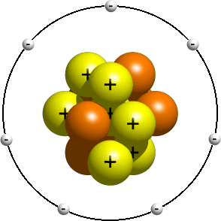Atoms: all matter breaks down ( pieces of lego ) u can put pieces of lego together. U can errange them together in certain ways. When u disassemble it, u don’t destroy the building blocs.

(insert picture)

Organic compounds
- Plants make it, from the sun

Sources of key elements
- H : water
- C : air
- O: air
- Remaining elements (N,P,S ) : soil
- Energy : sun

( insert diagram)

6CO2 + 6H20 - C6H1206 +602 (CHEMICAL PROCESS)

KEY points about energy
- Biggest input of energy is the sun
- U need energy to keep working

Laws of thermodynamics
- Nothing disappears
- Everything disperses (entropy) – move away from order
- When you convert energy from one form to another, the whole process allows energy to escape. You cant have 100% conversion on energy

Entropy
- =a state of disorder
- When you stop adding energy to a system, entropy increases and eventually the system stops.

Organic material stores energy

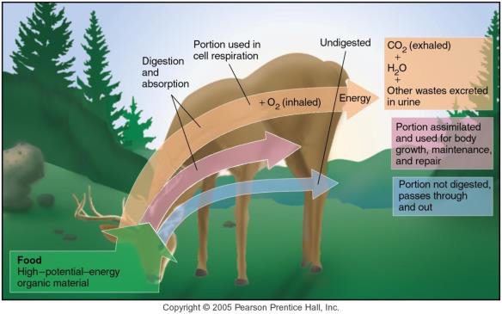

Only small portion is used for the growth of the animal

Energy transfers from autotrophs to heterotrophs:

C6H1206 +6xO2 -> 6xCO2 + 6xH2O + energy

Decomposition
- Deer produces solid waste: organic matter

Nutrient Cycling
- Atmosphere (air)
- Hydrosphere (water)
- Geosphere (land) – crust of earth
- Cryosphere (ice)
- Biosphere (life)
- Anthroposphere (humans)

Sinks: captures more nutrients then lets out ( reservoirs)

Sources: reservoirs that release more nutrients

Check out figure 3.13

Carbon Cycle
- Carbon can be found in the air, in solids and dissolver in water.
- Trees + plants = sinks, when burned it releases the carbon.

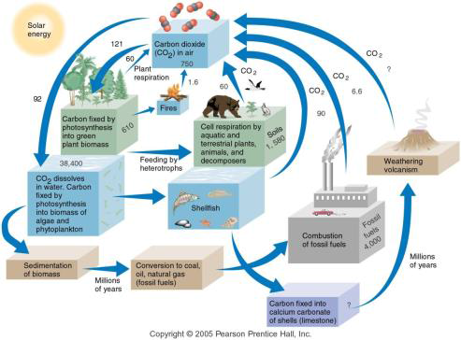

A Phosphorous cycle
- Plants require phos. To build tissues
- No gaseous ohase
- Can limit ecosystem development if not available

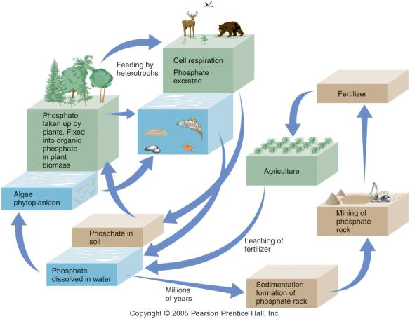

Nitrogen Cycle
- Gaseous form
- Plants must take N from soil via roots (inert gas, plants cant grab it out of the atmosphere) ( lightning )
- Certain soil bacteria convert nitrogen gas to mineral form
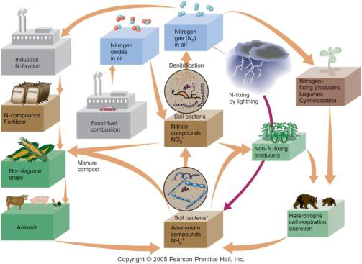

WHAT HUMANS ARE DOING

Carbon Cycle
- Human are inc. the amount of carbon in the atmosphere
- We take carbon fuels out of the ground and burn them

Different sinks: increasing amount in the atmosphere. Decreasing oceans as a sink. Can’t absorb much anymore

Phosphorous cycle.
- Humans dig out f the solid and transport it king distance
- Rivers and lakes have extra phos. Algae growth will be caused. It washes off into rivers

Nitrogen cycle
- Taking it from a sink, putting in on our soil. Washed away into rivers and lakes and fertilizes algae growth
- Fossil fuels may also contain traces of nitrogen
- When burned these are release to atmosphere as nitrogen oxides
- Creates smog

Implications
- By modifying these cycles, the end result is that we degrade ecosystem capital

Lake Winnipeg: largest algae growth - view diagrams on slide!!! (mutotriphication: blocking light and oxygen)

4b

Amphibians
- Dramatic declines in amphibian populations since 1980s
- Mass localized extinctions
- Locations around the world
Possible causes (not well understood)
-  Disease
-  Habitat destruction & modification
- Exploitation
- Pollution
- Pesticide use
- Introduced (alien) species
- Increased UV radiation
Population
- “A group of individuals of a particular species that live in the same area”
CHANGES IN POPULATION
-  # of organisms of any given species is not stable
- Fluctuates with environmental conditions
- Shifts may be dramatic
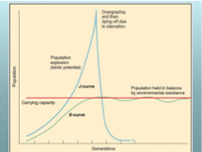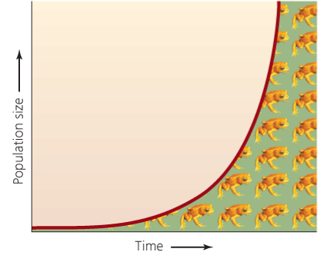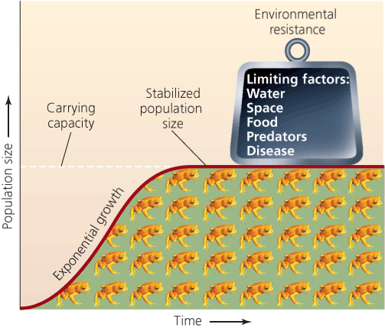

Biotic potential
- The capacity for a given species to increase its numbers given optimum conditions, through reproduction, geographical expansion of habitat or both
Environmental resistance
- The total sum of factors that limit the potential for a species to increase its numbers or its geographic range
Carrying capacity
- Describes the upper limit of the number of organisms that an ecosystem can support over the long term
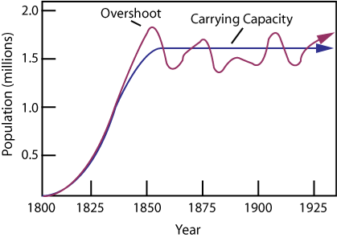
Questions...
- Which factors have increased Earth’s carrying capacity for people?
- What are the limiting factors for the human population?
- Are there any factors that might cause Earth’s carrying capacity for humans to decrease?

Critical number
- The lowest number of organisms required to ensure that a population may reproduce and continue
- Without human intervention, a species below the critical number will likely become extinct
Trumpeter swans (Cygnus buccinator)
- North America’s largest waterfowl
- Were common before European contact
- Hunted for feathers, skins
- Probably suffered as well from draining wet lands for farming (habitat loss)
- Believed extinct by 1900; some populations survived in remote parts of Canada, Alaska, Rockies
- Active programs to restore it to its historical range; still protected but no longer in peril
Whooping crane (Grus americana)
    - Tallest birds in North America
    - Migrate from northern Canada to Gulf of Mexico
    - Numbered in the thousands before European contact
    - By 1941, only 21 individual birds left; habitat loss in US key factor
    - Aggressive conservation efforts initiated in 1960s
    - Still endangered; today approx. 440 wild birds
Checks on population numbers
- Available habitat
- Availability of forage or prey
- Predation
- Disease
- Parasitism
Keystone species
- One that is critical to the functioning of the ecosystem
Sea stars as keystones
- Pacific sea star Pisaster ochraceus feeds on mussels and barnacles in the intertidal zone
- When Pisaster was removed from an experimental area, one barnacle population exploded and other species declined

Adaptation
- Biological or behavioural changes that facilitate the survival and proliferation of a species
Disturbance & recovery
- Ecosystems are never in a steady state but are constantly changing
- There is typically a range of disturbance with which the ecosystem can cope
- In some ecosystems, periodic disturbance is required for long term success r
Fire in western forests
- Periodic, small fires help forests reproduce
- Human fire suppression impacts ecosystem dynamics
Serotinous cones
- Develop in areas where fires are common  open only after being heated at high temperatures
- Some species have serotinous and free- opening cones, depending on local conditions
Disturbance and no recovery
- When the disturbance exceeds limits of ecosystem resilience...  original ecosystem replaced with a new
- one (regime shift)
Stable state = resilient system

Week 5a

Population growth

We could be on a J-curve or an s-curve
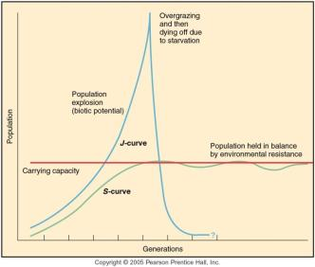
Estimates based on the future: science tent to do a high rage and lo range, and best estimate. Will taper off prob around 9-10billion in the next 20 years.
We cant be 100 percent certain, most this gen n the next one has kids, most of them, live long enough to be grandparents, that will equal that.

Human population growth
- due to our biotic potential, humans would continue reproducing at an exponential rate if there were no environmental resistance.
Limits to HPG
- Thomas Maltus: late 1700, argued that human population will inc exponential when we have plenty of food. Food production cant keep up with population growth. Assumed that human populations are stabilized by ‘positive checks’ which raises the death rate (famine, war, disease) and ‘preventive check’ which lower birth rates ( child policies, poor nutrition, cost of living, birth control)
- Karl Marx (1818-83): social change, Maltus was ridiculous. Its not too many people no food, its economics, resources to get the food, who controls the food. Remove the root causes (poverty).
- Paul Ehrlich: wrote population bomb, about how there where people going to starve to death in the 70s-80s
- Cornucopians: futurist, people who believe that all problems can be fixed by technology is the saving grace.
Food supply over time improvement!!

- Hybridization and genetic modification of crops
- Mechanization of agriculture
- Transition to monoculture production
- Agro chemistry-pesticides etc
- Food storage tech
- Transport tech
Green (agricultural) revolution
- Post ww2
- Led to creation and use of more robust crop variety, intense land use, increase use of pesticides and fertilizers in developing regions, especially Asia
- International research centers

What has led to human population explosion?
- Nutrition : more food available today, increases in caloric intake make human organism more robust Improvements in medicine
- lower infant mortality, fewer deaths during pregnancy, once fatal diseases now treatable
- Sanitation : Reduces outbreaks, we have better access to water, hand washing, just better resources
Most developed has declining GROWTH rates, and most developing nation have inc birth rates.
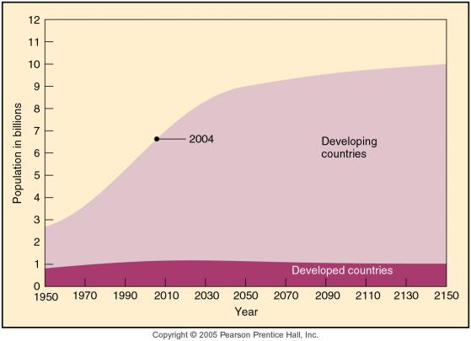
What Influences population growth rate?
- Fertility, how many kids
- Death rate of humans under 40
- Human longevity
Birth, Death and Fertility
- Crude birth rate (CBR)
- # births per 1000 living people per year
- (not adjusted fir population characteristics)

- Total fertility rate: # children born to an average woman in a population during her lifetime
- Replacement-level Fertility: a fertility rate that will replace 1 woman and her partner (2people)
In developed countries: on avrg 2.1 children, to replace each woman and their partner.
In developing countries: 2.5 children to replace and woman and her partner (higher death rates)
Fertility rates
Nigeria : 7.1
Italy: 1,2

Calculating Population Doubling-time
Rate of natural INC. (RNI)
- Natural rate of population change ( change caused by births and death alone, excluding migration)
- RNI=(CBR-CDR)/10
- Population doubling time =70/RNI

Week 5b
Population pyramids
- Increasing rapid: usually more developing countries. Don’t live so long but have a lot of kids
- Decreasing pop: not a lot of kids
- Madagascar, young population
- Canada, fewer young people, decreasing pop. If u take out immigration!!
Botswana: the blue part is what it would look like if aids were not an issue

The demographic Transition
- A model of economic and cultural change to explain the declining death and birth rates in industrializing nations
- Canada has gone thru this!
- Birth rate and death rates are low now. Gone thru all those 4 stages!
- Population dynamic and gender dynamics are different! Immigration etc.
- Not all countries can sustain the same standard of living as we can

Overall, globally as a trend are birthrates are coming down!]

IPATS model: inderstanding Population- envitonment linkages (look at text)
I = PxAxTxS
- Where I= impact, P= population, A = affluence, T= technology, S= sentivity
- Affluence< your consumption, finaces etc!
- Technology, positive and negative. Fossil fuel etc. vs. wind mill etc

In other words...
- The extent of human impacts on ecosystem capital is a function of:
- The # of humans,
- Their level of consumption,
- The technologies they use &
- The sensitivity of the environment in question
Another way to calculate it!
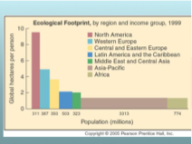
Carbon footprint! North America is the highest consumers.
We import goods from other countries! North Americans are consuming the ecosystem capital of Africa, Asia, South America

Why do people choose to have fewer children?
- Maternal health-care
- Reduction in childhood morbidity
- Household economic security
- Female education
- Male education
- Living in a stable political/social/economical environment
Key ingredients to a population stabilization program
- Diversity employment opportunities
- Provide reliable, affordable basic health care
- Provide education opportunities for all
- De-stigmatize contraception
This stuff is slowly playing out in many countries!

After Midterm

6b-nature

Week 7

Climbing Everest:
- Less oxygen
- Can only climb a period per year!
- First female 1975
- First climb without oxygen 1978
- Most summits 21 Ang Rita Sherpa

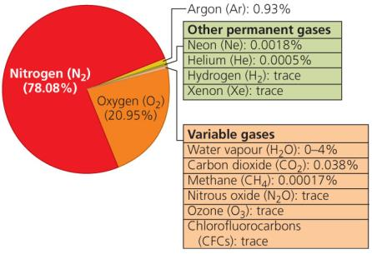
- Layer of gasses what surrounds the earth, consists mostly of nitrogen and oxygen.

Troposphere
- Where we live
- Precipitation cycle occurs here
- Temperature gets colder the higher you go
- Lots of mixing of the air
- Means that airborne pollution can make its way up to the tropopause fairly quickly
Stratosphere
- 12-50 km above the surface
- Air is thin, does not move around much
- Contains ozone (o3) which absorbs some radiation, causing the stratosphere to warm
- Higher up are the mesosphere, thermosphere and transition to outer space
Energy balance
- Energy passing through the atmosphere drives ecological systems
- The amount of energy arriving at the earth from solar radiation is balanced by a similar amount of radiation leaving the earth’s atmosphere
- 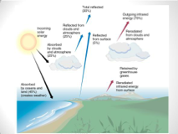

Human modification of the Stratosphere
Global environmental challenge: protecting the ozone layer
- why is the ozone layer important?
  - The ozone layer screens out incoming solar radiation in the ultra-violet range (10-400nm)
  - (a nanometer =one-billionth of meter)
Ultra-violet radiation
- A little UV is good for you, stimulates vitamin d production
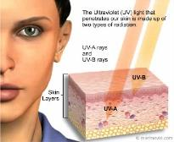
Too much UV damages the DNA proteins in living tissues

- If all radiation reached the earth’s surface, few organisms would survive
- >99% of UV radiation fails to penetrate the stratosphere

Oxygen Molecules
8p 8n

Stratospheric processes
- when oxygen molecules (o2) encounter UV radiation, they tend to split apart into two O atoms
- some free O atoms tend to quickly recombine with other O2 molecules to form ozone (O3)
- Ozone molecules may also combine with free oxygen atoms, creating two new O2 molecules
- When an ozone molecule encounters UV radiation, it splits into O2 and O
Stratospheric processes
- Dynamic interaction between oxygen and UV radiation are continually occurring in the stratosphere
O2 + UVB -> O +O
O+O2 -> O3
O+O3 -> O2 + O2
O3 + UVB -> O+O2

Stratospheric ozone
- Continually forming and being destroyed
- This dynamic process consumes most of the UV radiation that enters the Stratosphere
- Concentrations of ozone are highest at the equator, where incoming radiation is highest
- Concentrations vary seasonally as well; over Canada concentration is lowest during winter, highest during summer
Human Interference
- 20th century = CFCs
- non natural combinations of carbon fluorine and clorine
- These chemicals had numerous useful applications
- 1970s it was discovered that when CFCs make their way into stratosphere, they react with UV radiation
- The UV causes the CFC atom to release chlorine, which turns attacks ozone.

Human Interference with S-ZONE
- CL ordinarily does not leave the troposphere
- CFCs transport it to stratosphere
- Because CL lasts for decades in stratosphere a single CL atom can break down 100,00 ozone molecules
- In 195, “a hole” in the ozone layer was observed over the southern hemisphere
Panic ensues
- Why hadn’t scientist noticed the ozone hole sooner?
- Ozone depletion is a non-linear phenomeneon
Incorrect assumptions by scientist
- 1970s: scientist assmed that ozone depletion would be gradual process and occur uniformly across the stratosphere
- monitoring system were calibrated to reject data showing dropa of ozone concentration greater then 30%
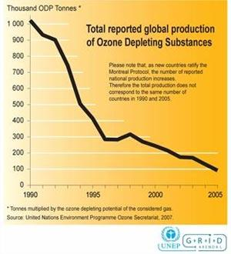
- the actual decrease over Antarctica was >50% by the time the error was realized
Montreal Protocol
- 1985: Intenational convention was created to address the causes of ozone depletion ( Vienna Convention)
  - Virtually every nation signed it
- 1987: follow-up Montreal Protocol
  - signatories agreed to scale back CFC production by 50% by 2000
  - 1st amendment: developed nations to phase out all CFCs by 2000, developing nations by 2010
  - 2nd amendment: developed nations to phase out all CFCs by 1996

Montreal protocol worked
- CFC production has been on a steady, dramatic decline world-wide
- While ozone holes continued to appear at the poles, further damage seems to have been halted
- We are starting to see signs of reversal of ozone depletion
- Full recovery not expected before 2050
Why has it worked?
- The speed of ozone depletion and the potential human health consequences were frightening
- Developed nations took the lead with aggressive reduction targets
- Alternatives to CFCs were quickly developed
- CFC substitutes are cheap and widely available

Missing 7a(part) and B.

Week 8a and 8b: Presentation Notes

Week 9a

What conditions are most likely to occur as a result of anthropogenic climate change?

- Warmer days
- Bigger storms
- More heat waves

Who should worry about climate change?
Vulnerability to climate change

- Vulnerability = potential for harm or loss
Is a function of:
- The nature of the physical changes to which a population if exposed
- The sensitivity of that populating to climate variability and change
- The adaptive capacity of that population

Vulnerability to climate change
Vulnerability (V) = potential for harm or loss
V=f(E,S,A)
Where
E= exposure
S=sensitivity
A= Adaptive capacity

Who is vulnerable to sea level rise?
- Costal cities
- Etc
Exposure to sea level rise

Sensitivity to sea level rise
- Fishery
- People who depend on the water near them for food, housing, money, jobs etc.
- People who are dependent on the sea etc.
Vulnerability to sea level rise
- The exposure and sensitivity are similar for Holland and Bangladesh: both rely on the coast for shipping etc.
- The adaptive capacity of Holland is very different from Bangladesh
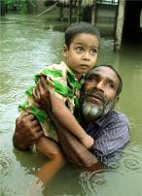 Blagladesh 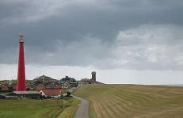 Holland

What is “climategate”?
- 2009: hackers stole emails from UAE scientists’ accounts
- Released email give the impression that:
  - Some scientists conspiring to refute skeptics arguments
  - Possible data manipulation
What the fuss?
- UEA: important center for climate research
- Not following fundamental tenets of good science?
- Ulterior motives of scientist?
- Timing: before 2009 Copenhagen climate change conference

Developments since climategate
- Independent studies of the research conducted
- Research in question all appears sound
- No one charged with data thelf
- Blogosphere and conspiracy theorists are having great fun
Net effects from Climategate
- Popular media portrays climate science as if there were great debates about basic scientific understanding
- Media now giving increasing coverage to skeptics
- Polling suggest that the public is less enthusiastic about actions to reduce GHG emissions, especially with economy struggling
Most vocal in opposing action to reduce GHGs?
- Oil and gas industry: making money off it
- Contries, states and provinces (Alberta) who receive large revenues from oil and gas
- Politicians beholden to oil industry
- Right-wing CAVE people, their blogs and the media that caters to them (CAVE= citizens against virtually everything)

Less Vocal, more thoughtful critics
- Some geologist
- Specialists in quantitative modeling

Reality
- GHG – global temperature relationship is not a wild new theory
- The increases in GHG accumulations, changes in land and sea surfaces temperatures, changes in sea levels are actual measurements
- The impacts being observed in high arctic (and elsewhere) are real
- Climatic variability affects human livelihoods and wellbeing on an ongoing basis, and will continue to do so
Where scholarly debate exists
- What will GHG emissions be like in the furture?
- What will impacts be in the future?
- What steps should be taken to mitigate GHG emissions?
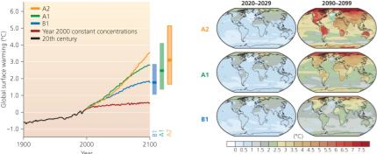

Responding to climate change
- 3 ways
  - Mitigation: dealing with GHG
  - Adaptation: any activity we do to help us adapt to the climate change. Ex. Building a sea wall, behavioral adaptation (moving etc.)
  - (Intervention): large scale intervention or geo engineering projects.
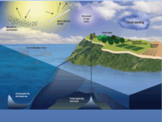

Mitigation: Key Instruments
- UN framework convention on climate change (UNFCCC)
- Kyoto Protocol
UNFCCC
Signatories agree to :
- Keep track of greenhouse has emissions
- Try to prevent dangerous accumulation of greenhouse gases
- Assist vulnerable countries in adapting to the impacts of climate change
- Meet each year to discuss how to implement the convention (called COPs)
Kyoto Protocol
- An agreement reached at COP-3 in Kyoto, 1997
- Annex 1 countries (richer countries) collectively agreed to reduce their emissions to 5% below 1990 levels by the period 2008-2012
- Each annex 1 country has an individual target
- Developing nations have no mandatory targets
- Not all UNFCCC signatories have ratified Kyoto
  - Committing to it
  - USA never did
  - Canada withdrew from Kyoto last year because we didn’t hit are target
- 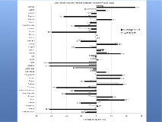

Rationale for Kyoto
- Similar to ozone depletion protocol
- Countries that created the problem should take the lead in fixing it

Comparing

Montreal Protocol (CFCs)
- Sets targets for reducing remissions of ozone-depleting substances
- All nations have mandatory targets
- Industrialize countries required to act first
- There are readily available substitutes for CFCs
- Changes in ozone layer are measurable
- The public health impacts of failure to act are certain
- All countries would suffer
- High level of compliance
- Emissions are falling globally
- Stratospheric ozone levels appear stable
Kyoto (GHGs)
- Sets target for reducing emissions of greenhouse gases
- Industrialized nations have mandatory targets
- There are presently no alternatives to fossil fuels that can produce similar amounts of energy
- Changes in carbon dioxide and other GHG concentration are measurable
- Failure to act results in climate changes that see difficult to forecast
- Impacts will not be felt by all countries equally
- Poor level of compliance
- Greenhouse gas emissions continue to rise globally
- Impacts of climate change beginning to emerge

KYOTO BIG FAIL
MONTREAL CFCs have been working in reducing

So what should we do?
- Wait and see?
- Renegotiate Kyoto?
- Defer emissions cuts another decade until new technologies emerge?
- Start cutting emissions drastically now?
- If we cut emissions, who should do so? Who should take the lead
- How? What are he costs of doing so?

Week9b

Food security!
- Food security exists when all people, at all times, have physical and economic access to sufficient safe and nutritious food that meets their dietary needs and food preferences for an active and healthy life. (1996 World Food Summit)
- 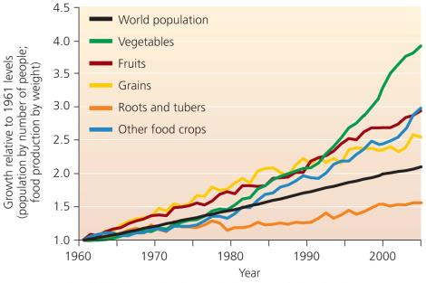
- Increase in grain production
- We are eating more meat

Keeping up with population growth: THE GREEN REVOLUTION
- 1940-1960s and beyond
- Technology transfer to developing nations
- Introduction of high yield hybrid varieties (HYVs) – wheat, rice, corn
- Still going on:
  - Development of new crops; pest resistance; expansion into other regions
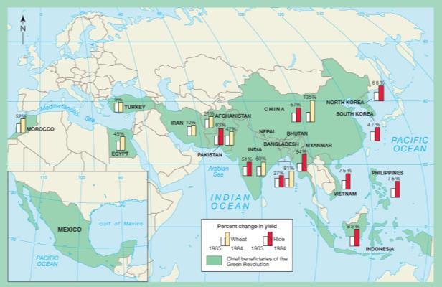
There has been a wheat and rice production increase in Asia, Mexico and in-between.
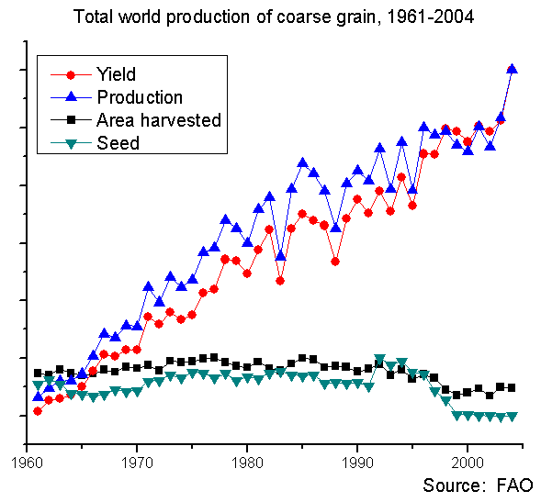
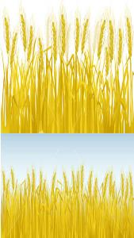
High yield variety can
be produced more on
the same land.

Threats to food security:
- Soil degradation
- Changing diets
- Food to energy
- Climate change
- Technology (e.g GMOs): new problems
- Conflict, politics and policies
Soil degradation
- 90% of worlds food from land-base agriculture
  - 38% of land surface dedicated to agriculture
- maintain of soil = cornerstone of civilization
What is soil?
- A mixture (system) of organic material inorganic material and living organisms
- Some places have lots of good soil, others may have none at all
- Soil is fragile
  - It takes decades or more to form a few inches of soil
  - Soil can be removed from poorly manage land in a single season
  - Soil is formed thru weather but can be removed thru weather
  - Mechanical weathering (physical): wind and rain chip of the rock. Breaks down the material
  - Chemical weathering: water can have a chemical reaction with the material. Temperature, moisture (acidic). Shift in the chemical output of that material
  - Biological weathering: worms, bacterial, mammals etc. changing the composition of the soil.

What does soil look like

What does soil look like…
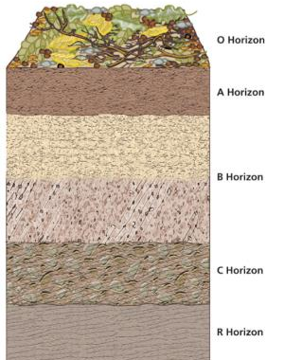
O Horizon: Humus (plant litter, other decomposing organic material)
A Horizon: Topsoil (mix of humus and leached mineral soil)
B Horizon: Subsoil (accumulation of leached minerals e.g. iron & aluminum oxides)
C Horizon: Weathered parent material (partly broken down)
R Horizon: Parent material (rock): unweather parent material.
Soil particle size
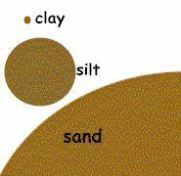
Clay: microscopic
Slit: 0.002-0.02mm
Sand: 0.02-2mm

Soil classification is based on the proportion of each type

Important characteristicts
- Larger soil particles have larger spaces between them (are more porous)
- Smaller particles have a greater proportion of surface area relative to volume
- Water and nutrients tend to cling to surfaces
Soil quality
- For agricultural production, a soild containing a mixture of particle size is desirable
- Ensures availability of nutrients, ability to hold water and is workable
- Compacted soil lacks pore space for movement of water, air
What makes soil fertile?
- Available of nutrient, minerals (P, also K, Ca)
- Ability to hold water (but not too much)
- Aeration
- PH near neutral (ie. Neither especially acid nor alkaline)
- Minimal amount of salt

Organisms in the soil
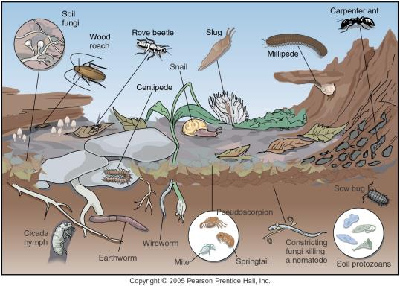
Break down the organic mater on the surface. Create the Humus. Help create concentrated particle. Improve soil structures. Some bacterial capture nitrogen for plants. Some not helpful (nematodes)

Soil Degradation
- Erosion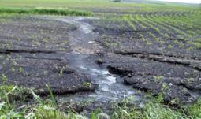 we lose 5-7 milion hectares of productive cropland annually. (China has been loosing there arable farm land, Africa has wind erosion. )
- Desertification 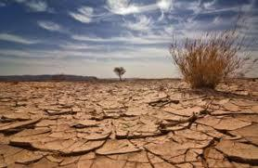

Global contribution to soil degradation
- Deforestation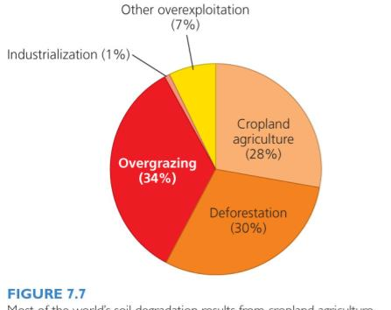
- Overgrazing
- Cropland agriculture
Erosion: Human Factors
- Removal of vegetative cover (eg. Deforestation)
- Over-cultivation
- Irrigation
- Overgrazing
Causes of soil degradation
- Removal of vegetative cover (deforestation)
- Removal of vegetative cover for construction

Causes of soil degradation
- To much plowing (over-cultivation)
Dust Bowl, Kansas 1930s
- Changed soild structure by working it (worked for abit)
- 1929, depression
- 1930s, drought
- All the native grass that protects the soil was removed for agriculture, in 1930s no money so no one could take care of the soil, was removed the nutrients by wind. Erosion
- Nutrient exhaustion from monoculture. Plants the same thing over n over again
- Too much degradation. Over-irrigation leads to salinization
- Overgrazing
Erosion: Associated problems
- Loss of soil fertility
  - Solution=fertilizers
    - Associated problems-eutrophication
- Sedimentation
- Desertification
  - Water-holding capacity is diminished or the coil
    - Related to erosion processes
  - Drylads cover 1/3 of earth’s land area
    - Home to 2 billion people
    - Defined by rain-fall not temperature
  - 19% earth’s land surface threatened

Desertification in W. China
- Immediate causes:
  - overgrazing + overplowing of marginal lands
  - inefficient water use
- Distal causes:
  - Remover controls on hear sizes
  - Population pressure
- Results
  - 1000 sq miles/ year lost to desert
  - Diminished productivity
  - Health impacts
  - Dust storms
Threats to food security
- Erosion and desertification = significant threats to food production globally
- Growing demand for food as population/ yield
- Continued effort to increase production/yeld
- But… food security is about more than just availability:
  - Recall: the 4 dimensions of food security:
    - Availability
    - Access
    - Ultilization
    - Stability

Changing Diets (p233-235)
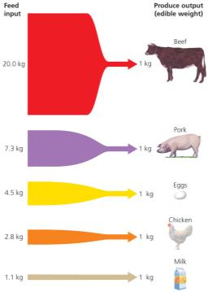
The lower on the food chain from which we take our food sources, the more people the earth can support
Changes in meat production in developed and developing countries
1960-2000
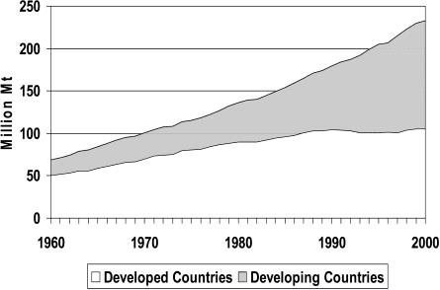

WEEK 10
Missing A.

10b
Virtual water, everything need water to be produces

Global Precipitation
- Access to water is linked to climate and geography
- Locations: where rivers and lakes are located, ground waters are located
The index uses five criteria- resources, access, capacity, se and environment.
Correlation between “water poverty” and “income poverty”
We have a lot of water but use it poorly, we waste.
Myth of Canadian Fresh water abundance
- Very little renewed on an annual basis
- Aggregated data (e.g. average annual precipitation and surface runoff) mask important variability in water supples
  - Spatial
  - Temporal: seasonal fluxes, 3rd are annual precipitation is snow, not rain. Unusable until melts in spring. A lot of rivers (saskachetoon river) rely on the snowmelt to flow.
Threats to water
- Water is threatened by wide range of human stresses
  - Overuse
  - Pollution
  - Climate change (look in book)
- Rain belt is moving more north, can affect crops
- Earlier spring, affecting animals, river flow
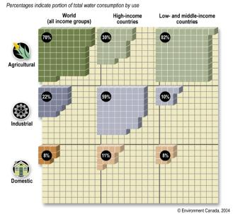
- Dryers summer

How we use water:
-Consumptive uses
- Irrigation, other agriculture: Industrial – making a car
- Residential – flushing a toilet
Non-consumptive uses
- Electric power production – not using all the water, kept in the system the water. Activities might pollute the water but we have control over it.
- Some industrial
- Some residential
Ottawa water comes from the Ottawa River.
Water sources: Surface water
- Reliance of surface water vs. groundwater
  - Highly variable by region/nation
  - Reflects environmental and economic circumstances
- Dams, canals, diversions, channelization
  - Harness surface sources for human uses

Three Gorges Dam (largest dam)
- Benefits
  - Power, flood control
  - Flood control
  - Navigation
- Negative impacts
  - GHGs (large methane producer)
  - Ecosystem
  - Heritage
  - People
Water sources: Groundwater
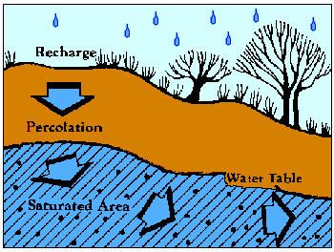
- =Approximately 98% of all liquid fresh water
Recharges through percolation, but…
  - In many areas it is “ non-renewable” – e.g. fossil groundwater
- Overdrawing is growing global problem
Ground water withdrawal
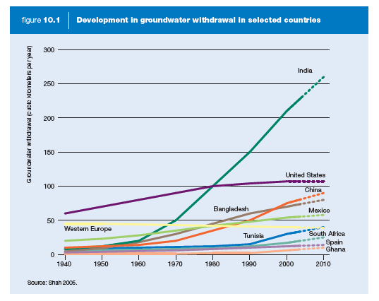
Consequences of overdrawing groundwater
- Falling water tables= depleted resources
And…
- Saltwater intrusion
- Diminishing surfaces waters
- Loss of wetland ecosystems
- Land subsidence (sink holes)
Solutions: Increase supply/access
- Ensure existing sources remain secure, clean etc. •
  - Watershed management (e.g. Oak Ridges Moraine) •
  - Polluter pay policies • -Prohibit bulk export
Get/store more water
- Dams
- Tapping more groundwater
- Desalinization
- International development aid
- Reduce ‘economic’ water scarcity
Desalinization “makes” more water
- desalin(iz)ation = the removal of salt from seawater or other water of marginal quality
  - Distilling = hastens evaporation and condenses the vapor
  - Reverse osmosis= forces water through membranes to filter out salt.
Solutions: reduce consumption / demand
- Agriculture: reduce use, subsidized water, less water intensive crops, making more efficient fields
- Municipal uses: regulations, taxes. Using dishwaters into our toilettes, water barrels for lawns.
- Industry
Economic approaches
- Appropriate water pricing/reduce subsidies
- Privatization (a good idea???)
- International aid

Part 2: Pollution
What’s in your drinking water?
- Ancient Rome: lead poisoning was common
- Lead-containing water pipes and glazed-pottery wine storage vessels
- Some historians argue it may have led to the downfall of Rome
Safe water
- Clean water is the most basic public health requirement
- 3 million people die from water illnesses.

Pollution
• Any undesirable thing that enters the environment
• Typically human-produced in origin
• Types: Air, water, land, soil, noise
What Goes down your drain?

- Food scraps
- Bath/shower water
- Soap
- Detergent
- Cleaning products

- Gas, oil
- Paint
- Road salt
- Personal waste
- Food grease
- Chemicals
- Toilet paper
- Sanitary products
- Dead fish

Where does it go?
- Lakes
- Water supplies
If you live in Ottawa, some of it gets spread on farmland

Undesirable things found in water
- Excess nutrients
- Pathogens and waterborne diseases
- Toxic chemicals
- Suspended matter
- Thermal pollution

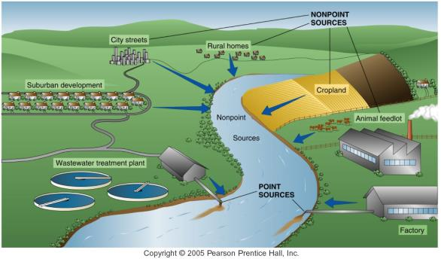
Point source -clear where the pollutants are coming from
Non-point-source- where you don’t know where the pollutants are coming from, fertilizers getting washed in, city streets.
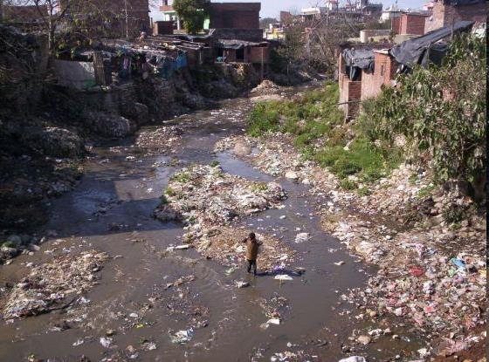
Water pollution in the developing world
-Non-treating water, no flush toilets, industries pollutes.

Global environmental challenge: Sanitation
- Direct linkages to public health–increased disease
- Links to environmental degradation–more toxins in environment
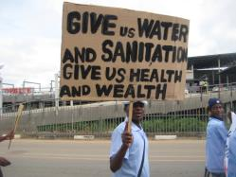
Access to sanitation in India
- Slums and factories discharge untreated waste into watercourses
- Contaminated groundwater
- Inadequate toilets
- Waterborne diseases an ongoing problem
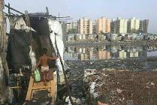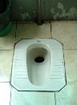

New Delhi: Toilet statistics
- 1990 survey in Delhi
- 440,000 residents of poor housing
- 270 toilets among them
- i.e. 1600 people per toilet -result in open defecation

Social impacts of inadequate sanitation
- Gastrointestinal illnesses
- Women’s health – safety concerns
- Quality of life
- Loss of productive time
- Harm to children
- Children kept out of school to collect water

Why do unsanitary conditions persist in India?
- Colonial government never bothered to invest in sanitation (manual collection of waste)
- Post-1948 politics dominated by middle-class
- Middle class does not see self-interest in sanitation for all
Why no self-interest?
  - Middle class already has access to sanitation
- No threat of organized action by lower classes
- Outbreaks dealt with on crisis basis
- Middle class has access to health care, antibiotics; outbreaks less severe, less fatal
Vulnerability to water-borne disease in urban India

 | Exposure(high/low) | Adaptive Capacity (high/low) | Vulnerability  (high/low)
Middle Class | low | high | low
Poorer Population | high | low | high
Dealing with water pollution
- Reduce production
- Collect and treat it
Typical evolution of sewage capture and treatment
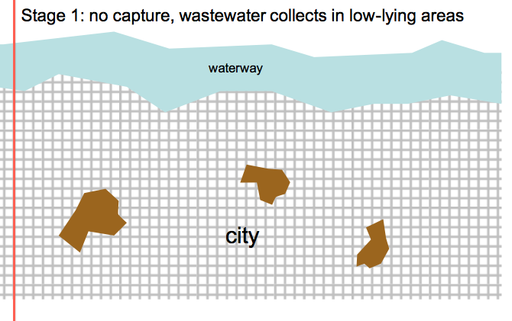
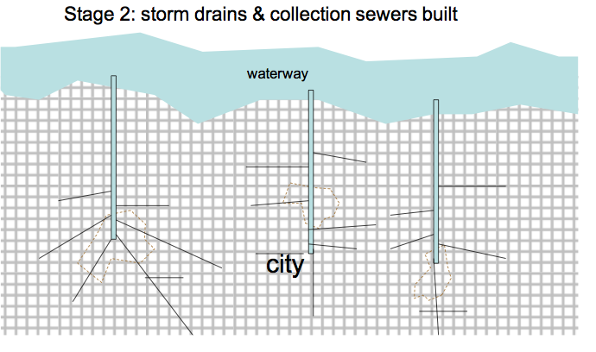
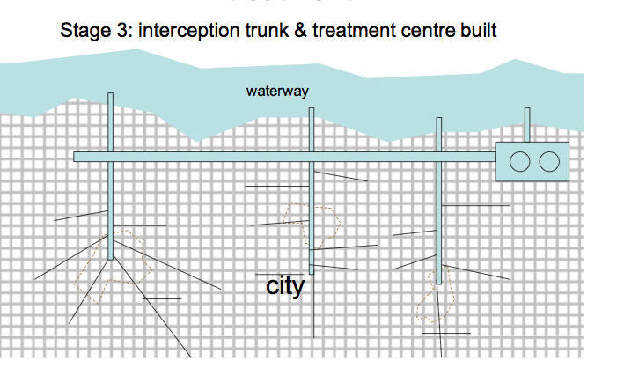
Sewage treatment in Ottawa
- 2,125km of sanitary sewers
- 40 sewage pumping stations
- Treatment centre receives industrial, commercial and domestic waste
- Treatment includes multiple stages (see text)

Sewage treatment in Ottawa
• 40-45 thousand tones of solid material (decomposed sludge) removed from wastewater each year
- – 65% is composted,
- – 30% applied to agricultural land as fertilizer,
- – 5% used in landfill
Wetlands are one thing that helps filter water
• The Arcata Marsh and Wildlife Sanctuary, California (a created wetland)

