Chapter 1 - Organizations and Organizational Theory
- Org theory helps us understand and explain what happened to an org in the past and what may happen in the future so that we can manage orgs more effectively.
- Important to choose the right change strategy and design the right structure depending on the changing environment and its impact on the org orgs are not static! Adapt to external env.
- *Theory: ideas about what something is, how it works; the key elements are generalizability, explanation, prediction!
- Large, successful orgs are still vulnerable; orgs are only as strong as their decision makers.

Current Challenges
- Challenges today are different from the past, so org theory is evolving.
- Top execs say that coping with rapid change is the most common problem in orgs.
- Globalization: world is shrinking with rapid advances in tech/communications takes less time to influence the world from remote locations.
- Today’s orgs must feel “at home” anywhere in the world.
- Contracting functions to orgs in other countries or partnering with foreign orgs gives global advantage can do the job for 50-60% less than other orgs.
- Growing interdependence environment becoming more complex and competitive because orgs must learn to cross lines of time, culture, and geography to survive.
- Ethics and Social Responsibility: there are more financial/ethical scandals. On almost any day, the news has some org ethical scandal.
- Public thinks all execs are crooks leaders are pressured from govt./public to hold high ethical/professional standards.
- Pursue business as a calling to address public concerns by role modeling ethical behaviours
- Speed of Responsiveness: respond quickly and decisively to environment/crises/changes
- For 20th century, orgs worked in stable environment so they focused on designing structures that kept org efficient. Today, orgs must make new products to stay competitive.
- Customers want things tailored to their exact needs need variations in mass production techniques and direct distribution from manufacturer to customer
- Employees (vs. production machinery) have the power and knowledge to keep org competitive information is super important
- Expect the unexpected, be ready for rapid change and potential crises tough economy, rocky stock markets, weakening consumer confidence, widespread ethical scandals, etc.
- The digital workplace: orgs are becoming enmeshed in electronic networks e-business, virtual teams, technology-driven workplace trend toward disintermediation (eliminating the middleperson, since communication is faster and direct) affects every industry
- Businesses today must either “Dell or be delled.”
- Leaders must be tech savvy and responsible for managing web of relationships that reach more than just physical org e-links between org and its workers/suppliers/customers
- Diversity: globalization makes workforce and customer base more diverse. South Asian/ Chinese population in Canada is growing. Population rises from immigration.
- Women’s style of doing business holds important lessons for success in 21st century!... but the glass/plastic ceiling persists, keeping women from reaching positions of top leadership.

WHAT IS AN ORG?
- Orgs are ubiquitous but hard to see we see outcroppings, but the whole org is vague/abstract, scattered among several locations
- Organizations: social entities (1) that are goal directed (2), designed as deliberately structured and coordinated activity systems (3), and linked to the external environment (4).
- Key element of an org isn’t to have policies. It’s about people and relationships to perform essential functions that help attain goals recent approaches empower workers
- Want more horizontal coordination, flexible boundaries to more quickly respond to changes

Types of Orgs
- Large, multinational vs. small, family-owned
- For-profit vs. nonprofit orgs directing activities toward earning $ for company vs. directing effort to generate social impact (difficult challenge =)
- Financial resources for nonprofits come from govt grants and individual/corp donations
- Nonprofit managers are committed to serving clients with limited funds focus on keeping org costs as low as possible and having efficient use of resources
- Nonprofit problem: securing a steady stream of funds to continue operating
- Nonprofit problem2: they don’t have conventional bottom line struggle with question of what makes org effectiveness? Measuring intangible goals is hard.
- Managers in nonprofits must attract clients AND volunteers/donors diverse stakeholders
- Some nonprofits create social enterprises to use business practices to achieve social missions 2-3 bottom lines: economic, social, environmental

Importance of Orgs
- Orgs we know are relatively recent; even in 19th century, very few orgs were important
- Corporation = 1st autonomous legal/social institution in society, independent of central govt
- E-business & computer-based manufacturing technologies help companies be innovative in producing/distributing goods/services more efficiently
- Orgs create drive for innovation vs. reliance on standard products
- Orgs exist to do:
- Bring together resources to achieve desired goals/outcomes
- Produce goods/services efficiently most efficient creator of goods/services
- Facilitate innovation
- Use modern manufacturing and into tech
- Adapt to and influence a changing environment
- Create value for owners, customers, employees turn ideas into customer benefits
- Accommodate challenge of diversity, ethics, and the motivation/coordination of employees

2 PERSPECTIVES ON ORGS
Open Systems
- Closed system: doesn’t depend on environment; autonomous, sealed from world cannot truly exist, but early org studies focused on internal systems
- Mgmt. would be easy since environment is stable and predictable
- Primary mgmt. issue would be to run things efficiently
- Open system: interacts with environment to survive; consumes/exports resources; adapts
- Internal efficiency, finding needed resources, interpret/act on environment changes, dispose of outputs, control/coordinate internal activities with environmental disturbances
- Ex: the human being, Earth, Air Canada, etc. are all open systems
- To understand the whole org, view it as a system: set of interacting elements that acquires inputs from environment, transforms, and discharges outputs to external environment
- Outputs include employee satisfaction, pollution, and other byproducts of transformation
- Subsystem: has specific functions for survival; boundary spanning, production, maintenance…
- Boundary subsystems: responsible for exchanges with external environment (purchases)
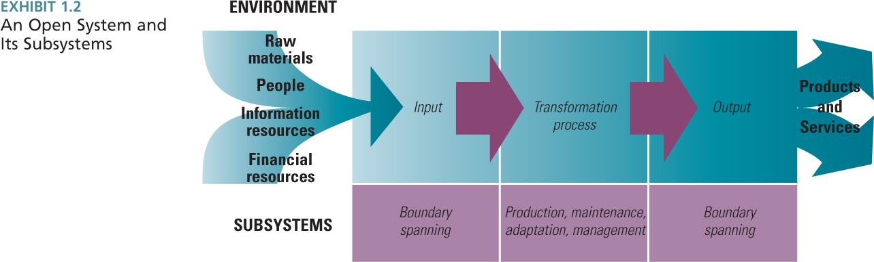
Org Configuration
- Framework by Henry Mintzberg every org has 5 parts that vary in size and importance
- The 5 parts are interrelated and can serve >1 subsystem function; several parts serve the boundary spanning function tech support works with external environment to learn about new tech developments, and admin support has HR working with environment to find workers.
- Technical core: people who do basic work of the org; production subsystem, actually produces output. Transformation from input to output is here. Production, teachers/classes, etc.
- Management: distinct subsystem for directing/coordinating parts of the org.
- Top mgmt. provides direction, strategy, goals, and policies for org/major divisions.
- Middle mgmt. implements and coordinates at dept level, mediates top mgmt. & tech core.
- Technical support: helps org adapt to environment; engineers and researchers scan environment for problems, opportunities, and tech developments. They create innovations.
- Admin Support: smooth operation and upkeep of the org, including physical and human elements. HR activities, training, maintenance activities (cleaning, repair), etc.
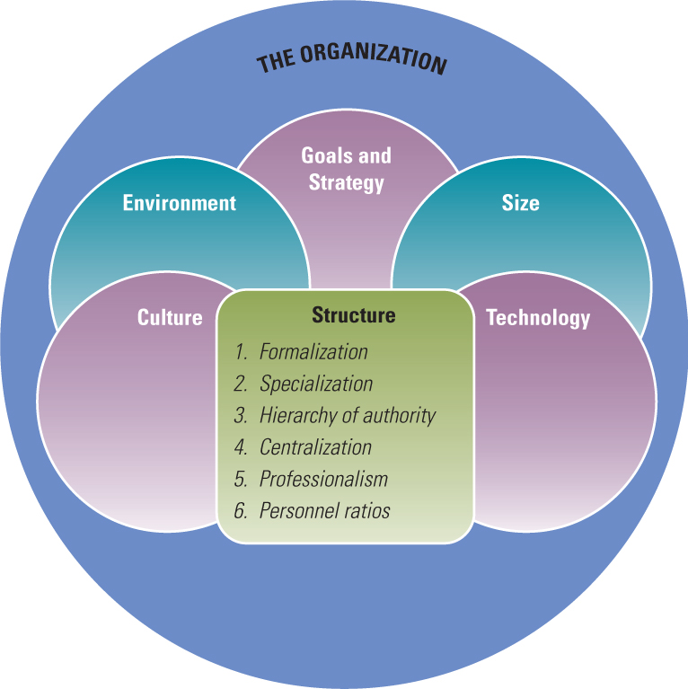
2 DIMENSIONS OF ORG DESIGN
Structural Dimensions
- Structural dimensions: describe internal characteristics of an org; for measuring/ comparing
- Formalization: amount of written documentation; they describe behaviour and activities. Measured by counting the # pages of documentation within the org.
- Specialization: degree to which org tasks are subdivided into separate jobs. Extensive specialization means each workers has narrow range of tasks.
- Hierarchy of authority: who reports to whom, span of control for each manager. Vertical lines on org chart! Span of control = # workers to a supervisor. Narrow spans of control means tall hierarchy (vs. wide = short)
- Centralization: hierarchical level that has authority to make decisions. If decisions are kept at top level, the org is centralized (vs. decentralized).
- Professionalism: level of formal education/training of workers avg. # years of education
- Personnel ratios: deployment of people to various functions and depmts. Measured by dividing the # employees in a classification by the total # of org employees ex: admin ratio

Contextual Dimensions
- Contextual dimensions: characterize the whole org (size, tech, environment, goals) describes org setting that influences the structural dimensions
- Represents the org AND the environment
- Goals & Strategy: purpose and competitive techniques that set the org apart; goals are written, and strategy is the plan of action describing resource allocation/activities for dealing with environment to reach the goals. They define scope of ops and relationships.
- Environment: all elements outside org’s boundary; industry, govt, other orgs, etc.
- Size: org’s magnitude as reflected in the #people in the org; for whole org or components typically measured as # employees or total sales, total assets, etc.
- Culture: underlying set of key values, beliefs, understandings, and norms shared by workers glue to hold org members together. Unwritten, but can be seen in stories, dress, layout, etc.
- Tech: tools, techniques, and actions used to transform inputs to outputs.
- All the dimensions (contextual+structural) are interdependent – ex: large size, routine tech, and stable environment means greater formalization, specialization, and centralization.

Performance and Effectiveness Outcomes
- Managers adjust dimensions and subsystems to most efficiently/effectively transform inputs
- Efficiency: amount of resources used to achieve org’s goals; “doing things right”
- Effectiveness: broader term; degree to which an org achieves its goals; “doing the right thing”
- To be effective, orgs need clear, focused goals and appropriate strategies for achieving them
- Stakeholder approach: managers carefully balance the needs and interests of many stakeholders in setting goals and striving for effectiveness
- Stakeholder: any group within/outside the org that has a stake in org’s performance
- Assessment of multiple stakeholder groups is an accurate reflection of org effectiveness
- Unreasonable to meet every stakeholder’s needs, but you should meet the major ones

EVOLUTION OF ORG THEORY AND DESIGN
- Org theory is a way of thinking, to analyze orgs better based on patterns and regularities
Historical Perspectives
- Modern mgmt. theory began with classical mgmt. perspective in late 19th/early 20th century
- The Industrial Revolution and the emergence of the factory system posed new problems
- Work was performed on larger scale by more workers need to raise productivity/efficiency
- Classical perspective: efficiency; associated with the development of hierarchy and bureaucratic orgs basis of modern mgmt. theory and practice
- Efficiency is everything: scientific mgmt. by Frederick Taylor decisions about orgs and job design should be based on precise, scientific study of individual situations with standard procedures. Carefully plan work, provide wage incentives to increase output.
- Mgmt. maintains stability/efficiency; top mgmt. thinks, & workers do what they’re told
- How to get organized: scientific mgmt. focused on technical core, but administrative principles were a broader subfield (classical) design and function of org matters.
- Development of bureaucratic orgs: emphasized designing and managing orgs on an impersonal, rational basis through clearly defined authority and responsibility, formal record keeping, and uniform application of standard rules
- Worked well in Industrial Age, but classical perspective didn’t consider social context!
- What about people? Psychology received little attention because of scientific mgmt., but Hawthorn studies concluded that positive treatment of workers improved motivation & productivity. But the hierarchical/bureaucratic system stayed until 1980s until there were problems due to global competition new org cultures valued lean staff, flexibility, rapid responses, motivated workers, caring for customers, and quality products
- Environment. Contingency means that one thing depends on others, and for orgs to be effective, there must be a goodness of fit between their structure and external environment. Contingency theory means “it depends” because the correct mgmt. approach is contingent on the org’s situation (uncertain environment)

Contemporary Org Design
- Orgs are still imprinted with the hierarchical, bureaucratic approach, but today’s challenges (ex: globalization, diversity, e-business) call for different responses from orgs.
- Shifting from a mindset based on mechanical systems to natural/biological systems
- In 20th century, orgs became large, complex. Internal structures became vertical and bureaucratic. Leadership was based on principles. Communication was through formal memos, letters, and reports. Managers did all the planning, and workers did the work.
- Chaos theory: relationships in complex, adaptive systems (orgs) are nonlinear and made of many interconnections and divergent choices that create unintended effects and render the universe unpredictable uncertainty, surprise, rapid change, confusion
- Occurs within certain larger patterns of order!
- Orgs should be seen as more natural systems (vs. well-oiled, predictable machines)
- Many managers are redesigning their companies into a learning org: promotes communication and collaboration so everyone is engaged in identifying and solving problems
- Based on equality, open info, little hierarchy, and culture that encourages participation and adaptability enable ideas from anywhere to help org seize opportunities & handle crises
- Essential value = problem solving (vs. efficient performance)

Efficient Performance vs. Learning org
- From vertical to horizontal structure: traditionally, activities are grouped together by common work. There’s little collaboration between functional departments, and whole org is coordinated through vertical hierarchy, with decision-making authority at upper-level mgmt.. Efficient production and in-depth skill development, sensible supervision/control
- But in a learning org, flatten the hierarchy more horizontal workflow boundaries between functions eliminated teams have members from many functional areas
- From routine tasks to empowered roles: a task is a narrowly defined work assigned to a person, broken down into specialized parts. Knowledge/control of tasks centralized at the top.
- Role: a part in dynamic social system; has discretion and responsibility (empowered). Roles that can be redefined. Few rules. Knowledge and control are with workers (vs. bosses)!
- From formal control systems to shared info: communication is informal and face-to-face in small orgs; there are few formal control/info systems because top leaders usually work directly with employees. BUT for large orgs, distance btwn top leaders and tech core increases, so there are formal systems to manage complex info and detect deviations from standards and goals.
- In learning orgs, widespread info sharing keeps org functioning at optimum level.
- Learning org strives to return to condition of a small, entrepreneurial firm where all workers have all info about org so they can act quickly.
- Managers must find ways to open channels of communication so ideas flow in all directions open communication with all stakeholders to enhance learning capability
- From competitive to collaborative strategy: traditional orgs wanted efficiency, so strategy was made by top mgmt. and imposed on the org. In learning orgs, the accumulated actions of an informed and empowered workforce contribute to strategy development.
- Be collaborators and competitors; based on relationships
- From rigid to adaptive culture: danger if culture becomes ossified/concrete from being successful in a stable environment. In learning orgs, culture encourages openness, equality, continuous improvement, and change. People are aware of whole system, how everything fits, how parts of the org interact whole-system mindset minimizes boundaries
- No company is a perfect learning org; struggle is to adapt while maintaining stability

FRAMEWORK FOR THE BOOK
Levels of Analysis
- 4 levels of analysis characterize orgs:
- Individual humans = basic building block of orgs
- Group or department: collections of individuals who work together to perform a group tasks
- Org: collection of groups/depts. That combine into the total org
- External env: interorganizational set & community, groups of orgs with which an org interacts
- Org behaviour is the micro approach; focuses on people within orgs, examines motivation, leadership style, personality, cognitive/emotional differences among people within org
- Org theory is a macro examination of orgs; focuses on org level of analysis, with concern for groups & environment considers behaviour of individuals in the aggregate (not main focus)
- Meso theory: new approach to org studies; “in between” = meso concerns the integration of both micro and macro levels of analysis. Individuals and groups affect the org, and vice versa.
- Org theory is directly relevant to top/middle mgmt. concerns, partly relevant to lower mgmt. org theory focuses on big picture and major departments, not so much lower mgmt.
- Middle mgmt. focuses on major depts. Decides how depts. relate to org, design depts. to fit work-unit technology and deal with issues of power/politics, intergroup conflict, etc.

