BCH3125

Protein Assignment

Crystal structure of human placental aromatase cytochrome P450 in complex with androstenedione, resolved at 2.9Å

PDB Accession code: 3EQM

PMCID: PMC282030

By Sarah Al-Zaidi
6422766

Section 1 and 2
Aromatase cytochrome P450 (i.e. aromatase) is an enzyme present in many areas in the human body, including the gonads, brain, skin, placenta, and blood vessels. It can also be found in tissue pertaining to endometriosis, uterine fibroids, endometrial cancer and breast cancer. Aromatase is classified under the cytochrome P450 family of enzymes – an enzyme class that requires a heme group as a cofactor in order to carry our oxidative degredation of various compounds. This renders aromatase a hemoprotein. The heme cofactor is illustrated in Figure 1B.
Aromatase is an endoplasmic reticulum membrane protein consisting of 503 amino acids. It is composed of 22 alpha-helices and 12 beta sheets that are configured in such a way as to yield the characteristic cytochrome P450 fold (Figure 1A).
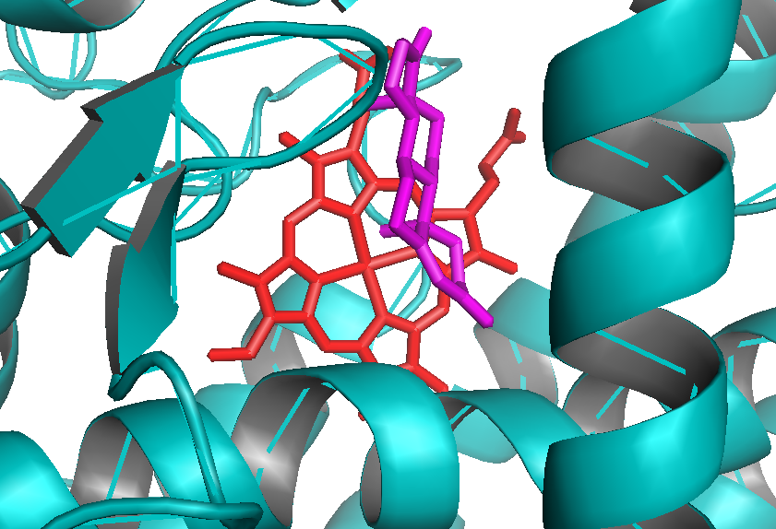
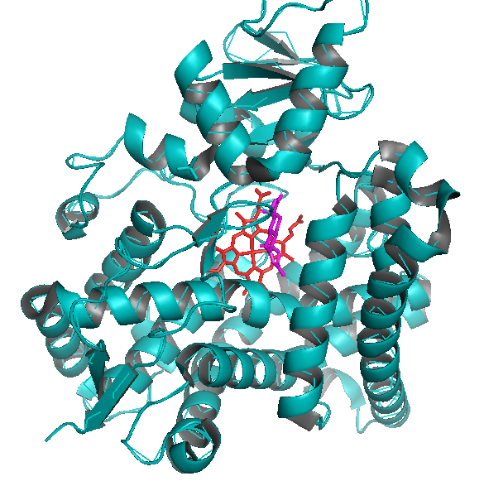
B)
A)
Figure 1. A) A cartoon diagram of aromatase cytochrome P450, in complex with the substrate androstenedione (magenta) and a heme group (red). B) A magnified view of androstenedione and the heme group in the interior of the enzyme.

It is the only enzyme known to catalyse the synthesis of all estrogens from androgens in vertebrate organisms. Three different reactions are catalysed by aromatase: the conversion of androstenedione to oestrone, the conversion of testosterone to 17β-oestradiol, and the conversion of 16α-hydroxytestosterone to 17β,16α-oestriol. Figure 1A illustrates structure of aromatase in complex with androstenedione. Unlike the active sites of other enzymes in the P450 class, the aromatase active site has considerable specificity for its substrate; this is facilitated by the androgen-specific pocket that interacts tightly with the androstendione molecule (Figure 2A). This pocket consists of Ile 305, Ala 306, Asp 309, Thr 310, Phe 221, Trp 224, Ile 133, Phe 134, Val 370, Leu 372, Val 373, Met 374, Leu 477, Ser 478 and Arg115 (Figure 2B).

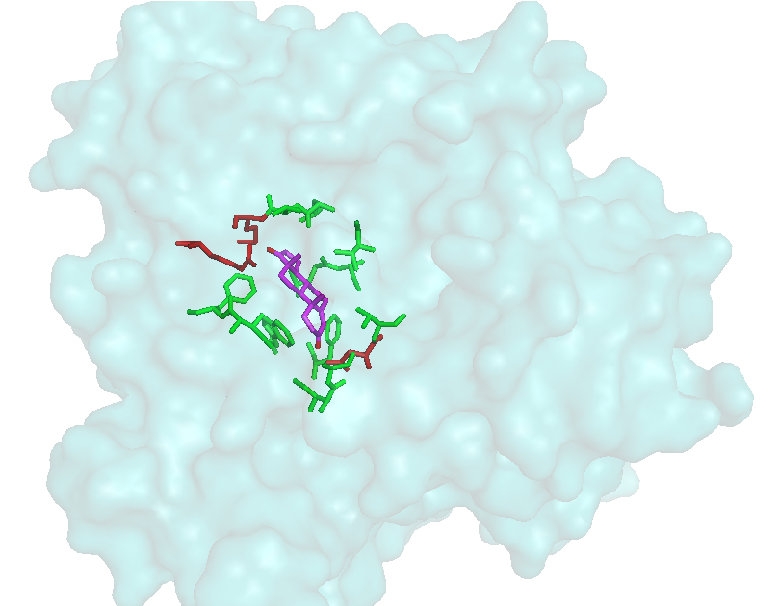
A)

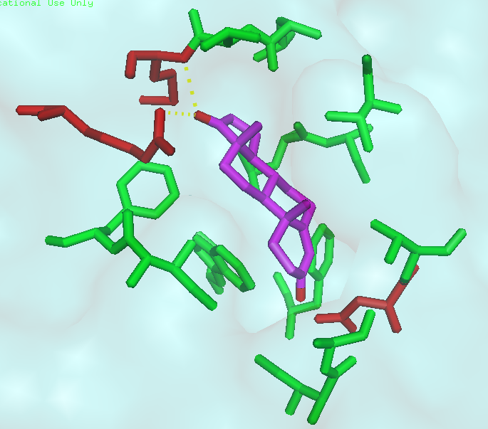
B)
LEU372
VAL373
MET374

VAL370

ARG115
LEU477

SER478
PHE134
THR310
PHE221
TRP224
ILE133
ASP309

ILE305
ALA306

Figure 2. A) A surface view of aromatase, illustrating the amino acid residues that form the active site. B) A magnified view of the amino acid residues that form the androgen-specific binding site. Polar residues are shown in red and non-polar residues are shown in green. The androstenedione is shown in purple, along with its two carbonyl groups shown in red. Hydrogen bonds are indicated by the yellow dotted lines and emphasized by the black boxes.
Androstenedione is a 19 carbon molecule featuring the distinctive multi-ring structure that is shared among all steroids. It consists of hydrophobic hydrocarbon ring structures in addition to two carbonyls at C1 and C15 (Figure 3).
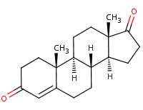
19
9
1
18
8
5
2
17
7
4
16
13
6
3
15
12
10
14
11

Figure 3. The structure of androstenedione. This is the overall structure of androstenedione, a substrate of aramatase. The carbons are numbered from 1 to 19, and the carbonyl oxygens are indicated in red.
Source: http://www.chemnet.com/dict/dict--571-36-8--en.html
There are 15 amino acid residues that form that active site, and the position and orientation of these residues serves to maximize androgen specificity. Arg115 contains a positively charged amino group that forms a hydrogen bond of length 2.8Å with the C1 carbonyl. Additionally, the N-H group pertaining to the peptide backbone of Met374 serves as an H-bond donor, forming a weak attractive interaction of length 3.4Å with the C1 carbonyl. The Asp309 is a mere 2.6Å away from the C1 carbonyl, suggesting an attractive interaction. This suggests that Asp309 is protonated in this environment, serving as the H-bond donor. The remaining residues are primarily non-polar in nature, forming Vanderwaals interactions with the multi-ring backbone of the steroid. The rings associated with the heme group are also tightly packed against the multi-ring backbone of the steroid (Figure 5). This binding pocket measures no more than 400Å, a small value compared to similar P450 enzymes, thus further increasing specificity on the basis of substrate size.
In this way, a cavity that is complementary in shape to the steroid is formed, and the androstenedione is held into place at a specific orientation in the active site, in preparation for reaction catalysis. The orientation of andeostenedione in the aromatase active site is of utmost importance in terms of the efficiency of the reaction. The following reaction is catalysed by aromatase:
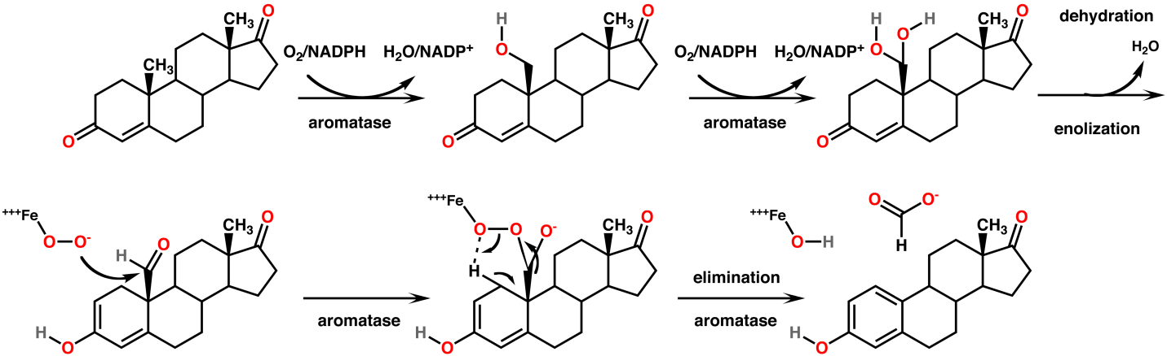
Figure 4. The steps involved in the enzymatic conversion of androstenedione to oestrone. There are 5 steps in the overall enzyme catalysed concersion of androstenedione to estrone. The first two steps require 2 oxygen molecules and two NADPH molecule. The third step is a dehydration and an enolization. The fourth step is a nucleophilic attack from the heme group followed by the fifth step, an elimination. Source: http://commons.wikimedia.org/wiki/File:Aromatase_mechanism.png

In order for the fourth step in this reaction to proceed with efficiency, the Fe-cation contained within the heme group must be in close proximity to the C18 methyl group. This specific orientation is facilitated by aromatase (Figure 5). The mechanism by which the remaining steps are carried out remains unclear.

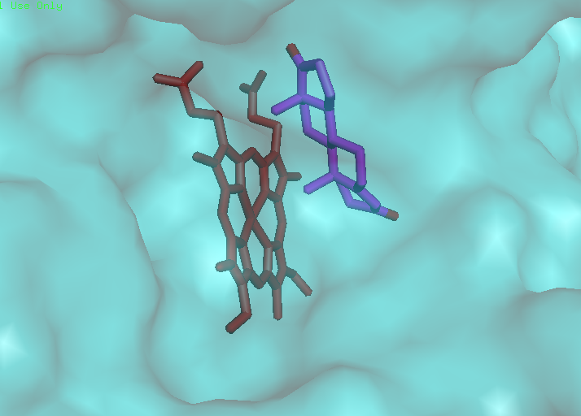

C18 methyl
Fe-cation

Figure 5. The heme group and androstenedione are in close proximity. The heme group (red) and androstenedione (purple) are in close proximity in the active site of the enzyme. The C15 methyl group of androstenedione is also in close proximity to the Fe-cation of the heme group. This complementary packing between the two molecules increases androgen specificity.
Another feature that is unique to aromatase alone is the Pro308 residue in one of its alpha-helices (Figure 6). This proline causes a shift in the alpha-helical backbone that is crucial for the formation of the androgen-specific binding site.
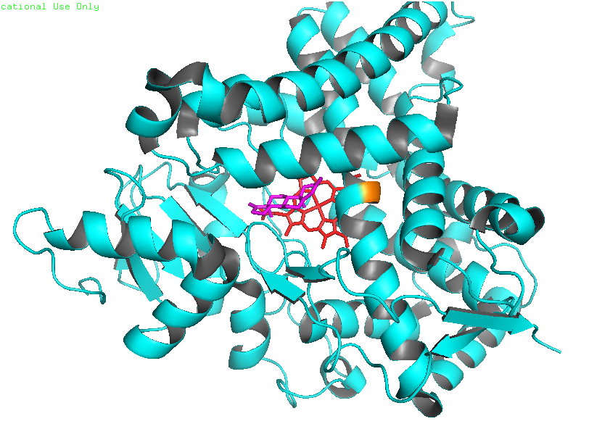
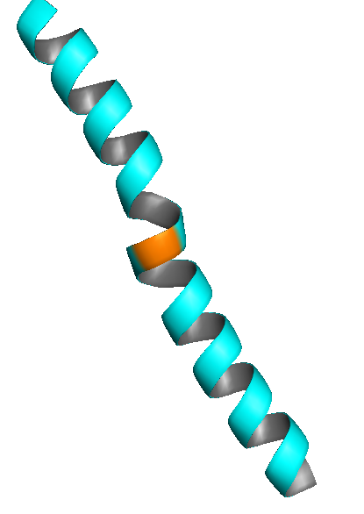
Figure 6. The distortion in the alpha-helical structure caused by Pro308. A distortion in the alpha-helical structure of the indicated helix is caused by the presence of a Pro308 residue (orange). There is a shift in the alpha-helical backbone, crucial for the formation of the androgen-specific binding site.

The location within the endoplasmic reticulum membrane is crucial, as the enzyme active site is only accessible to the exterior environment via a channel (Figure 7A-B). The channel is located on the surface of the bilayer, facilitating the entrance of androgens directly from within the bilayer.

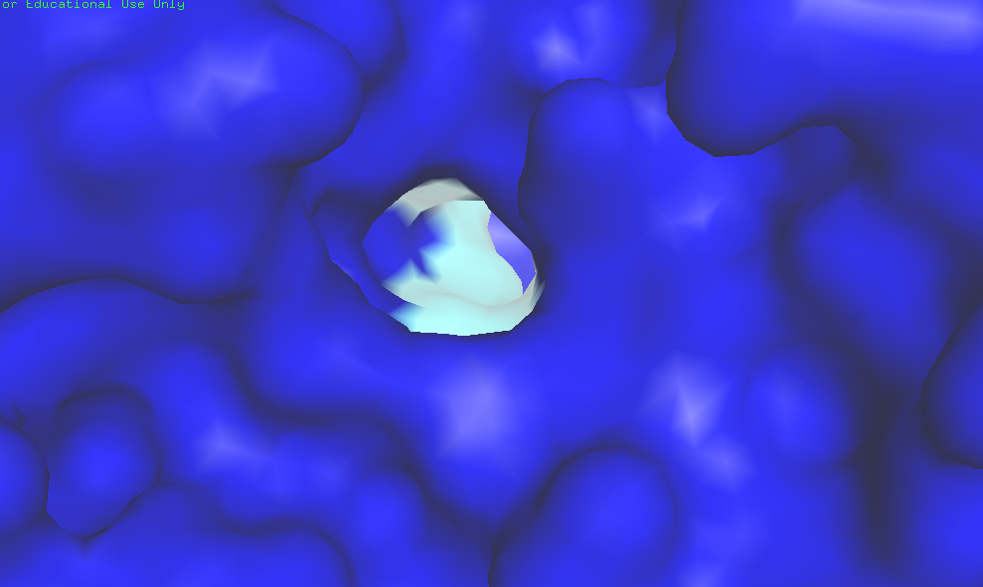
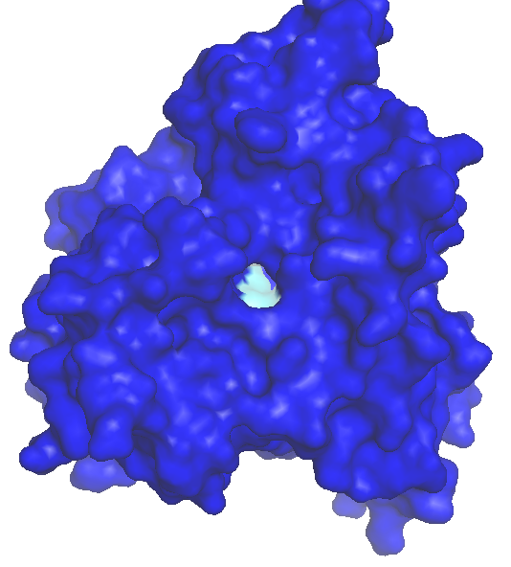
B)
A)
Figure 7. The active site of aromatase is exposed to the exterior environment via a channel. A) The binding site of aromatase is buried deep within the protein interior, and is made accessible to the exterior environment via a channel. B) A magnified view of the channel.

Section 3
The structure of aromatase was solved through molecular replacement. Aromatase was extracted in its active form from human placenta and purified through immune-affinity chromatography. It was then complexed with its substrate, androstenedione, and crystallized at 4^{O}C with polyethylene glycol 4000 as the precipitant.
The resolution of the crystallized structure is 2.9Å. This means that atoms that are 2.9Å apart are distinguishable. Ideally, the resolution should fall between 0.15 and 0.25Å, with higher values hindering the accuracy of the crystal. At a resolution of 2.9Å, the large side chains and the path of the polypeptide chain would be distinguishable. However, the locations of the individual atoms, as well as the precise location of most amino acid side chains, remains unclear. This moderate resolution is likely due to the fact that aromatase is a membrane protein, and thus, purification and crystallization is harder to achieve.
The R-factor of this structure is 0.215 and the R-free is 0.244. The R-factor is a measure of the discrepancy between x-ray diffraction data and the actual solved structure. The R-factor is a reflection of the accuracy with which the program has solved the structure, and should ideally fall within the 0.15 – 0.25 range. Thus, a value of 0.215 indicates that the solved structure has a high degree of agreement with the experimental x-ray diffraction data. The R-free is determined by setting aside a region of the protein and removing all parameters and constraints, thereby allowing unfavourable bond angles to take place. The R-factor of this region is then calculated (i.e. R-free). Ideally, the values of R-factor and R-free should be within 10%, however in this experiment, the values differed by 13.5%. This indicates that there may be too many parameters put into place, introducing bias during the process of solving the structure.

The unit cell parameters are
a = b = 140.2 Å, c = 119.3Å,
α = β = 90^{O}, γ = 120^{O}.
The possible space groups corresponding to these parameters are P3, P3₁, P3₂, P321, P312, P3₁12, P3₁21. The lattice type is classified as trigonal, and the possible Bravais lattices are classified as P.
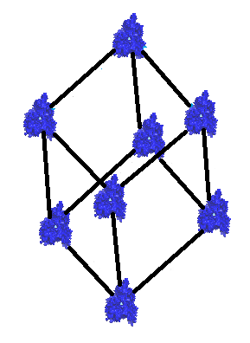

Figure 8. The Trigonal Bravais lattice associated with the crystal structure of aromatase. The parameters of the unit cell were obtained from Protein Data Bank and the corresponding Bravais lattice was determined. A schematic representation was then generated.

The Ramachandran plot displays the possible angles of rotation about the phi and psy angles, for each residue. Illustrated below is the Ramachandran plot for aromatase. According to the Ramachandran plot, there is a high percentage of right-handed alpha-helices, and to a lesser degree, beta-sheets. There is a very low percentage of left-handed alpha-helices, if any.
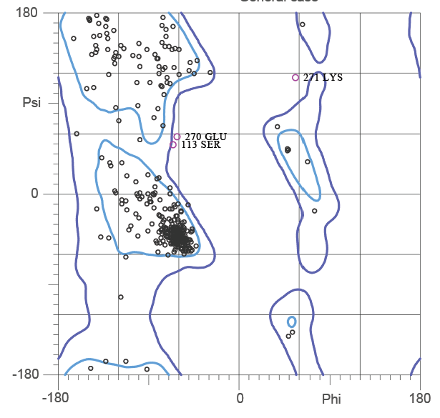
Figure 9. The Ramachandron plot corresponding to aromatase. All possible phi and psi angles were electronically determined and plotted for each amino acid residue. The psi angle is represented by the y-axis, and the phi angles are represented by the X-axis.
Source: http://www.rcsb.org/pdb/explore/explore.do?structureId=3EQM
The B-factor plot was unavailable, however, it is expected that the B-factors be greater for residues facing the exterior of the protein, as well as residues involved in the catalytic core (since they potentially undergo movement during catalysis). The residues buried within the enzyme interior would have comparatively lower B-factors. Since this is a membrane protein, the residues facing the cytosol are likely to have higher B-factors, whereas residues buried within the membrane bilayer are likely to have lower B-factors.

References:
- Ghosh, D., J. Griswold, M. Erman, and W. Pangborn. "Crystal Structure of Human Placental Aromatase Cytochrome P450 in Complex with Androstenedione." Protein Data Bank. Web. 3 Mar. 2015. <http://www.rcsb.org/pdb/explore/explore.do?structureId=3EQM>.
- Ghosh, D., J. Griswold, M. Erman, and W. Pangborn. "Structural Basis for Androgen Specificity and Oestrogen Synthesis in Human Aromatase." National Center for Biotechnology Information. Web. 15 Mar. 2015. <http://www.ncbi.nlm.nih.gov/pubmed/19129847>.

