CHAPTER 11 – LANGUAGE DEVELOPMENT
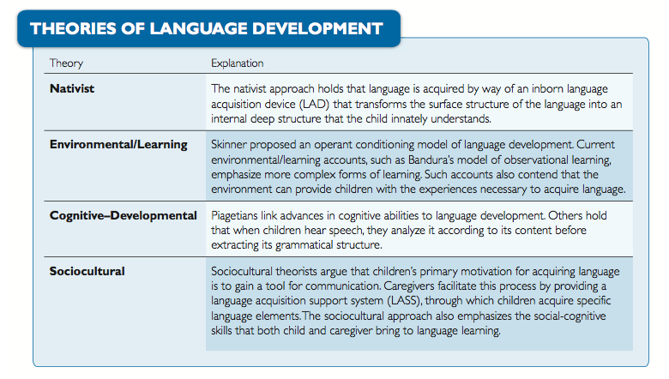
- Language – a system that relates sounds (or gestures) to meaning
  - Has both structure (grammar) and meaning (semantics)
- Phonology – studies the sounds of speech
  - Speech perception requires that an infant be able to discriminate the boundaries of phonemes in order to perceive different words (E.g. “car” vs. “core”)
  - Infants are able to make difficult phonemic discriminations (the sounds of “r” and “l”)
  - Cochlear implants improve language development in deaf children
- Phonemes = smallest speech units
  - Phonemes are sound that are the building blocks of language
  - 100 possible, English – about 40
  - Infants can hear all possible phonemes
  - As early as 1 month can distinguish between sound
  - Eventually lose the ability to distinguish unused phonemes (app. 4-12 months)
- Semantics – study of words and their meanings
- Morphemes = smallest unit of meaning
  - 50,000 in English, root words, prefixes, suffixes
- Grammar/Syntax: rules used to describe the structure of a language
- Pragmatics: how people use language to communicate effectively (social uses)
- 2 months: cooing (vowel-like sounds) – ah, oo – conveys positive emotions
- 6 months: reduplicating babbling (speech-like sound that has no meaning. Ex dadada)
- 8 to 11 months: babbling includes intonation (rising or falling pitch); loses duplication (ex. Da-doo)
- Babbling is very similar among infants of different language groups
- First words appear around first birthday
- Babbling drift: a hypothesis that infants’ babbling gradually gravitates toward the language they are hearing and soon will speak
- Deaf babies still display babbling later onset and a reduced number of well-formed syllables
- Deaf children learning sign language display a sort of gestural babbling
- When words first appear, gesture labelling and word labelling are positively correlated
- Early speech builds on babbling
- By 18 months, children possess an average vocabulary of about 100 spoken words and about 200 words that they understand
- Semantic development proceeds faster for comprehension than for production
- Referential style – vocabulary acquired involves a large proportion of nouns and object labels
  - Most likely to be girls, first borns and from middle to upper born classes
- Expressive style – vocabulary acquired emphasizes the pragmatic functions of language
- Language development:
  - 18-24 months – vocabulary spurt: children suddenly acquire words (especially labels) at a high rate
    - Fast mapping, over and under-extensions coining
    - Fast mapping: a process in which children acquire the meaning of a word after a brief exposure
  - End of second year – combine words
    - Telegraphic speech – speech from which nonessential function words (e.g., in, the, with) are omitted
  - End of third year – complex ideas, plural, past tense
    - Over-regularization – language error in which children apply inflectional rules to irregular forms (e.g. adding ed to go goed)
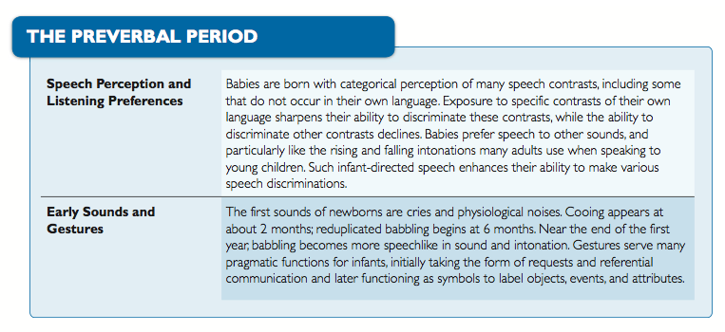
- Early Lexical Development
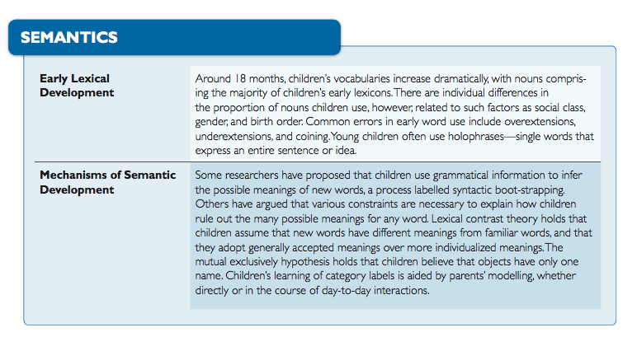
  - Children learn labels for categories that are then extended through experience
  - Children may use words differently than do adults – semantic errors
    - Over-extension – occurs when children use labels they know for things whose name they do not yet know (e.g. “dog” is used to label a cat or rabbit) – more common in word production than word comprehension
    - Under-extension – occurs when children fail to use labels they know for things for which the labels are appropriate – less common in production than are overproductions. Frequent in comprehension
    - Coining – children’s creation of new words to label objects or events for which the correct label is not known (ex. Nose beard for mustache)
    - Holophases – a single word used to express a larger idea; common during the 2nd year of life (ex. “Ball” might mean “I want the ball”)
- Constraints – implicit assumptions about word meanings that are hypothesized to narrow down the possibilities that children must consider and hence to facilitate the task of word learning
- Identifying words
  - Pay more attention to repeated words
  - Parents use infant-directed speech in which they speak slowly and exaggerate changes in pitch and volume (motherese)
    - May assist the infant in learning to discriminate phonemic categories
  - By 2 years, have a vocabulary of around a few hundred words
  - By age 6, know around 10,000 words
  - Learning based on joint attention
- Theories of language acquisition: behaviourist, nativist, interactionist
- Behaviourist – skinner
  - Learning of specific verbal responses
  - The acquisition of language as a function of learning
  - Child is reinforced for imitation of adult speech, punished for poor language effort
- Nativist: Chomsky – stresses innate mechanisms separate from cognitive processes ; must have a strong biological basis as cognitive abilities are still rather unsophisticated in young children
  - Chomsky’s criticism of the learning view:
    - Children are not reinforced for speech accuracy
    - Children learn to speak well even when exposed to poor models of speech
    - Children emit novel sentences
    - The rules of grammar are too complex for simple learning processes
  - Biological basis for language acquisition
    - Language consists of a complicated set of rules
    - Language has two structures:
      - Surface structure refers to the way that words are combined (varies with culture)
      - Deep structure refers to the inborn rules of language (these do not vary across culture)
    - Language acquisition device (LAD): brain mechanism that translates surface into deep structure
- Interactionist
  - Cognitive, social communication and emergentist theories
  - Cognitive: children acquire language forms that they can “map onto” cognitive concepts that already possess emphasize the active role of the learner In language acquisition
  - Social communication: children’s primary motivation for acquiring language is social interaction emphasis on pragmatics Language acquisition support system (LASS)
  - Nature and nurture are both important to language acquisition. Maturation is thought to drive language development directly and to influence indirectly by fostering cognitive development
  - Meanwhile, verbal exchanges with parents and others are also thought to play a critical role in moulding language skills
  - The complex bidirectional relationships shed some light on why there is room for extensive debate about the crucial factors in language acquisition
  - 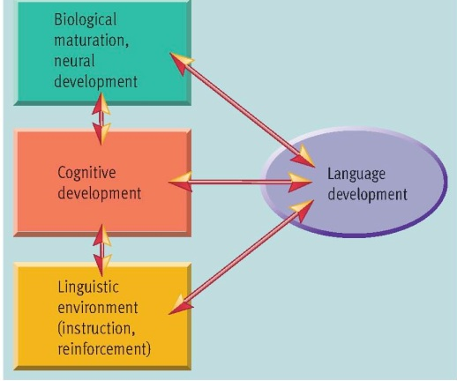
- “Wug” stimuli there is a wug. Now there is another. There are two of them. There are two ____.
- One possibility (favoured by cognitively oriented researchers): children’s early sentences are organized in terms of meaning-based, or semantic, categories
- Second possibility (favoured by nativists): even the earliest sentences reflect knowledge of abstract grammatical categories, such as subject, verb, and object
- Components of reading:
  - Word recognition: process of identifying unique patterns of letters (orthography) rely on content words
  - Comprehension: process of extracting meaning (semantics increases with WM and experience)
- Foundations of reading skill:
  - Knowledge of letter names
  - Phonological awareness: grapheme-phoneme correspondence (GPC
- Verbal Learning Disorders: Dyslexia
  - 1. Visual Processing Model: magnocellular/parvocellular systems
  - 2. Auditory (Phonological) Model
    - Grapheme-to-phoneme conversion (GPC)
    - Phonological awareness
    - Planum temporale (L=R, L<R, ectopias
    - CC/frontal cortex
- Mechanisms of Grammar Acquisition: Environmental Bases
  - Parental feedback supports language development
    - Expansions: involve repeating speech in which errors are corrected and statements elaborated
    - Recasts: responses to speech in which the parent restates it using a different structure
      - E.G. “Mouses runned in hole. Mommy” to “Didn’t those mice run into that hole!”
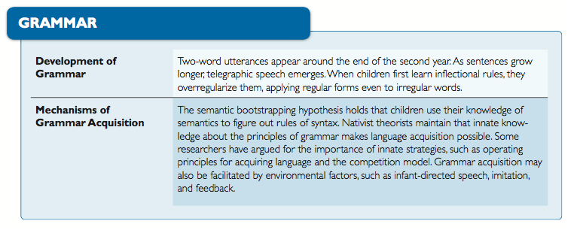
- Pragmatics – refers to the social use of language
- Language allows children to communicate their wishes and desires
  - Speech acts – used to perform pragmatic functions such as requesting or refusing
  - Discourse (conversation) refers to language used in everyday conversations (requires social skills)
  - Social referential communication – a form of communication in which a speaker sends a message that is comprehended by the listener assessment: speaker describes a target object in his set clearly enough so that the listener can pick the same object from her set
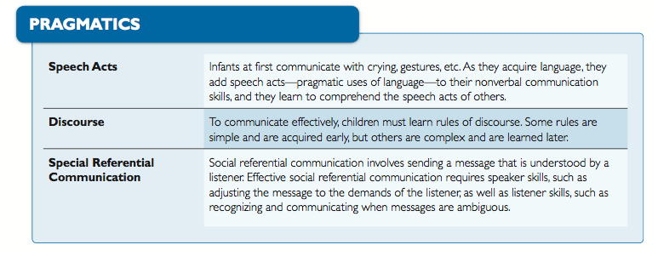
- Adults and even young children (as young as 4) tend to use the simplified infant-directed style of speech when addressing toddlers or infants
- Taking turns
  - Even before children speak, parents model turn –taking (not in all cultures)
  - By 2 years, spontaneous turn-taking occurs
  - By 3 years, children will try to elicit a response if listener fails to respond
CHAPTER 12 – EARLY EMOTIONAL DEVELOPMENT
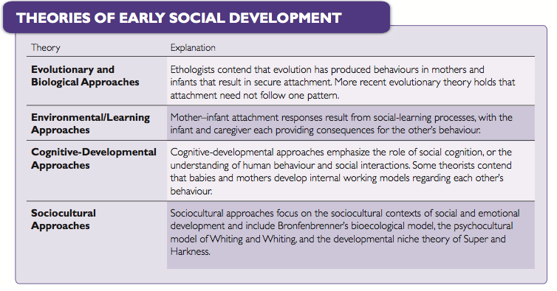
- A relationship with a primary caregiver (usually the mother) functions to keep the mother nearby and motivates her to provide adequate caregiving
- By 4 to 6 months, infants show basic emotions in facial expressions: joy, anger, surprise, interest, disgust, sadness, and fear (7 months)
- More complex affective responses (i.e. guilt, shame, embarrassment) are not apparent until the second year of life
- Emotion – an internal reaction or feeling, which may be either positive (joy) or negative (anger) and may reflect a readiness for action
- Affect – the outward expression of emotions, gestures, intonation, and the like
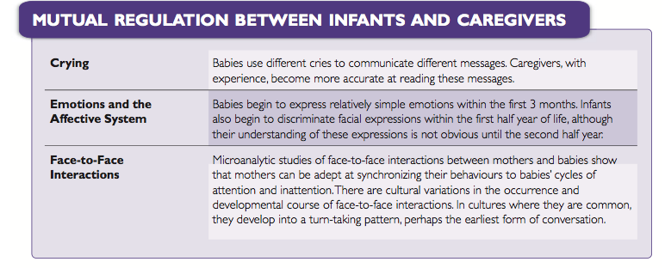
- Emergence of emotions in infancy is universal across cultures
- Emotions are socialized through modelling – babies tend to match the expressions around them (ex. Japan discourages negative emotions)
- Socialization of emotions also occurs through reinforcement processes
- Stranger wariness appears around 6 months
- Self-conscious (complex) emotions such as pride, guilt, embarrassment appear later (15-24 months)
- Cultures differ in degree of emotional expression – display rules (the expectations and attitudes a society holds toward the expression of affect)
- By 4 to 6 months, infants can identify facial expressions associated with different emotions
- Social referencing: in unfamiliar or ambiguous environment, infants look to parents for cues to interpret situation
- During elementary school, children understand that people can have mixed feelings (coincides with Piagetian decentration)
- Regulation of emotions begins in infancy (infants will look away or move close to parent when they encounter something frightening or confusing)
- With age, children develop even more effective strategies (self-talk, changing perspective)
- Children who don’t regulate their emotions (e.g. anger, worry, sadness) tend to have problems with peers
- Temperament - behavioural styles that are fairly stable across situations
  - Refer to biologically based differences in children’s emotional reactivity and self-regulation
  - Thomas and Chess identified 3 patterns: Easy, difficult, slow-to-warm
- Easy baby: regular patterns of eating, sleeping, and toileting; adapts to new situations and shows low intensity reactions (40% of babies)
- Difficult baby: less predictable schedules, withdraws from new situations, and reacts intensely to stimuli (10% of infants)
- Slow-to-warm-up (inhibited) baby: adapts poorly to changing situations, is less active (15% of infants)
- The degree of goodness of fit determines the degree of influence of infant temperament on later development
- Temperament moderately stable through infancy, childhood and adolescence
- Fearful preschoolers tend to be inhibited as older child and adolescent
- Inhibited children more likely to be introverted adults
- Research also reveals many instances where temperament is not related to adult personality
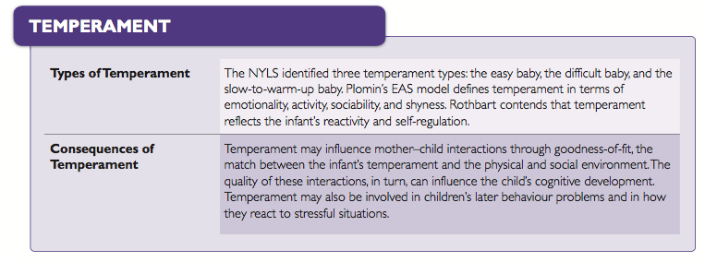
- Attachment – enduring social-emotional relationship between infant and parent
- By about 7 months, infants have identified a single attachment figure
- Usually first attach to mothers, then to fathers
- Prefer to play with fathers, but prefer mothers for comfort
- Harlow’s Monkeys
- Ainsworth’s Strange Situation task: assesses the strength of the attachment relationship by observing the infant’s reactions to a series of structured episodes involving the mother and a stranger
  - Baby is put through a series of situations
    - Parent present/absent
    - Stranger present/absent
  - In each situation, baby’s reactions to separation and reunion are measured to test quality of attachment
- Secure attachment – may be upset when parent leaves, but stops crying on return (65%)
- Insecure-avoidant – not upset when parent leaves, ignores parent on return (20%)
- Insecure-resistant – upset when parent leaves, angry and inconsolable on return (15%)
- Disorganized (disoriented) – confused when parent leaves, still confused on return
  - Maltreatment in infancy is associated with this style of attachment
- Positive consequences of secure attachment in later social relationships
- Predictable, responsible parenting is important for secure attachment
- Infant needs a consistent internal working model
  - An infant’s and a caregiver’s cognitive conception of each other, which they use to form expectations and predictions
  - Expectations of consistent availability and responsiveness during stress
- Parents’ attachment to their own parents may influence responsiveness to their children/
- Parents who are more sensitive to their infants’ needs and who adjust their behaviour to that of their babies are believed more likely to develop a secure attachment relationship respond more to crying
- Child can develop different attachment styles with different caregivers
- Temperament may directly affect the type of attachment relationship the child develops with the caregiver
- Cultural differences are apparent in patterns of attachment
  - Japanese – higher percentage of insecure-resistant attachment
  - Germany – higher percentage of insecure-avoidant attachment; less secure
- Securely attached children
  - become better problem solvers and show less negative affect in response to challenges that do insecure children
  - show more curiosity and explore more
  - strong sense of self, attentiveness in school, higher grades
  - more socially competent than insecure children
  - more cooperative
  - less likely to develop emotional or behavioural problems
- Children classified as insecure-avoidant have a greater tendency to isolate themselves and avoid contact
- Those classified as insecure-resistant, although interested in interaction, often have ineffectual interactional skills and tend to hover at the periphery of group activities
- Those classified as insecure-disorganized/disoriented tend to be more aggressive than their securely attached peers
- Insecure children may also interpret the behaviour os others
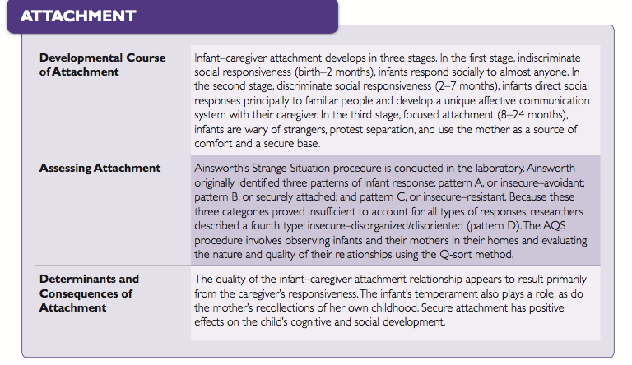
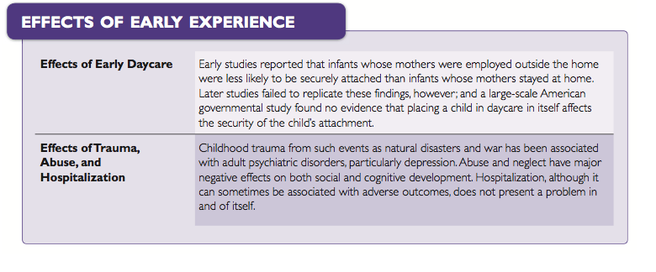
CHAPTER 14- MORAL DEVELOPMENT
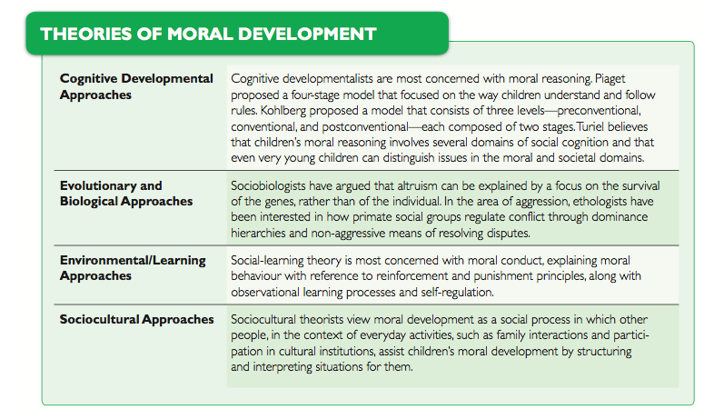
- Morality involves issues of right and wrong
  - Moral rules: Broad issues of fairness and justice
  - Social conventions: Rules used by society to maintain order
  - Morality has different components
    - Thought processes that underlie morality are assessed in moral reasoning studies
    - Behaviours governed by morality are assessed in studies of moral conduct
THEORIES OF MORAL DEVELOPMENT
Congitive-Developmental Approach (Piaget, Kohlberg, Turiel)
Piaget’s Stage Theory
- Piaget’s stage theory: used moral dilemmas to assess children’s thoughts on morality
    - Moral dilemmas- stories used by Piaget and others to asses childrens level of moral reasoning
  - Stage 1 (2–4 yrs): Children have no true conception of morality
    - Much of the childs behavior involves play and imaginative games that have no formal rules ( although at times they my make up restrictions)
  - Stage 2 (5–7 yrs): Children understand and use rules, but are not flexible in rule use (stage of moral realism)
    - Moral realism: children’s reasoning is based on objective and physical aspects of situation and is often inflexible
    - Objective responsibility: Children evaluate moral situations on the basis of amount of damage (ex. Ink stain example… child with doing something naughty makes a small ink stain and other child accidently makes large ink stain… children will say that child who made large ink stain is naughtier)
    - Immanent justice refers to inherent justice (refers to the expectation of the children in Piaget’s stage of moral realism that punishment much follow any rule violation, including those violations that go undectected).
      - Ex. Child steals cookie and the next day he loses his baseball glove. He feels that he is being punished for stealing the cookie.
  - Stage 3 (8–11 yrs): Children realize that rules are conventions and can be altered; children in this stage now consider intention in their evaluations of morality (stage of moral relativism)
    - Moral relativism – children view rules as agreements than can be altered and consider peoples motives or intentions when evalutating their moral conduct
  - Stage 4: children develop rules as needed and extend moral reasoning beyond their personal level
    - Also extend moral reasoning to larger societal and political concerns
- Moral reasoning develops as the cognitive structures of the child develop
  - Piaget emphasized the importance of social experiences in children’s moral development
Kohlberg Model
- Kohlberg’s model: presented children with moral dilemmas and asked them to explain their reasoning
- Kohlberg’s three levels of reasoning:
  - Preconventional: A person must meet his/her own needs
  - Conventional: Social systems must be based on laws and regulations
  - Postconventional: The value, dignity, and rights of each person must be maintained
LEVEL 1: Preconventional | Stage 1: Heteronomous morality (morality derives from power and authority) | - Child cannot consider more than one person’s perspective  - Egocentric and assume that their feelings are shared by everybody  - Equivalent to Piagets Moral Realism (stage 1)  - Evaluations of morality are absolute  - Morality is defined by authority figures, whose rules must be followed
LEVEL 1: Preconventional | Stage 2: Individualism and instrumental purpose (Morality means looking out for yourself | - Child understand than people have different needs but, can’t emphaze  - Other people are assumed to serve their own self-interests  - Moral behavior is valuable ONLY if it serves one’s own purpose  - Children obey rules and get along with peers with an eye toward what they will get in return  - Social interactions are viewed as deals and arrangments than involve concrete gains
LEVEL 2: Conventional | Stage 3: Interpersonal Conformity (morality means doing what makes you liked) | - People an view situations from another’s perpectivve  - They understand that an agreement between two people can be more important than each individual’s self-interest  - Focus is on conformity to what most people believe is right behavior  - Rules should be obeyed so people you care about will approve of you  - Rule: Do unto others…
LEVEL 2: Conventional | Stage 4: Law or order (what’s right is what’s legal) | - People view morality from the perspective of the social system and what is necessary to keep it working  - Individual needs are not considered more important than maintaining social order  - Adherence to law and performing one’s duty  - Laws apply to everyone equally
LEVEL 3: PostConventional | Stage 5: Social contract ( human rights take precedence over laws) | - People take the perspective of all individuals living in a social system  - Understand that not everyone shares their own values  - Morality is based on protecting each individual’s human rights  - Emphasis is on maintaining a social system that will do so  - Laws are created to protect individual freedoms
LEVEL 3: PostConventional | Stage 6: Univerisal ethical pricinpals (morality is a matter of personal conscience) | - People will view moral decisions from the perspective of personal principles of fairness and justice  - Personal worth should be respected  - Move from Stage 5 to Stage 6: social directed inner directed perspective  - Assumed there are universal principles of morality that are above the lar, such as justice and respect for human dignity
- Kohlbergs model resembles Piagets in assuming the moral development of the development results from a component, which is assumed to be more strongly influenced by the child’s experience with moral situations
  - And that moral development results from a combo of improving cognitive development and repeated encounters with moral issues
  - Each stage forms a structured whole, with the children in that stage generally responding consistantly to different dilemmas and situations
Turiel’s Model
- Like Piaget and Kohlberg, gave children hypothetical situations and assessed response
  - Meant to assess child reasoning in moral and social domains
- Turiel’s model: Children’s moral reasoning involves several different domains
  - Moral domain is concerned with people’s rights and welfare
    - Prohibitions against lying, cheating, stealing
  - Societal domain involves rules that guide social relations
    - Being polite, wearing appropriate clothing
  - Matters of personal choice
    - In which individual preferences take priority
    - These issues do not violate the rights of others or harm others, and they are not social regulated (or weakly so)
    - Ex. Hairstyle, choice of friends, leisure activities
- Children’s understanding of moral and societal issues is influenced by context
- Central premise of this model is that children can distinguish amoung these domains from a very early age
- Interest in the distinction between moral rules and social conventions

Evolutionary and Biological Approach
- Altruism
  - Paradox of altruism: the logical dilemma faced by ethological theorists who try to reconcile self-sacrificial behaviour with the concepts of natural selection and survival of the fittest
    - According to Darwin, more selfish behaviour equals greater chance of survival and passing on their genes
  - Kin selection: a proposed mechanism by which an individual’s altruistic behaviour toward kin increases the likelihood of the survival of genes similar to those of the individual
    - Mother is more likely to act to save her child than her husband; child has more of her genes
  - Reciprocal altruism: a proposed mechanism by which an individuals altruistic behaviour toward members of the social group may promote the survival of the individual’s genes through reciprocation by others or may ensure the survival of similar genes
- Aggression
  - Aggression is another focus of the evolutionary approaches
    - Dominance hierarchy: a structured social group in which members higher on the dominance ladder control those who are lower, initially through aggression and conflict, but eventually simply through threats
    - Aggression is involved in predation, defending the nest (home) against intruders, and defending valuable territory
    - The evolutionary view is that aggression is an inevitable part of human nature
    - Aggression may lead to dominance hierarchies

Environmental/Learning Approaches
- Social-learning view is that the social behaviours we traditionally label in terms of moral development are acquired and maintained through the same principles that govern most other behaviours
- Although social-learning theorists agree that these processes are affected by developmental advances in cognitive abilities, they emphasize environmental mechanisms, such as reinforcement, punishment, and observational learning (modelling and imitation
  - Observations/learning become internalized and children learn to use them to regulate their own behaviour
- Stage of development when moral behaviours emerge according internal timetable that is universal for all children
- Most research within the social-learning traditional has involved moral conduct
  - Moral conduct – both prosocial and antisocial behaviour (rather than moral reasoning)
Sociocultural Approaches
- Moral development focuses on how children come to understand moral and social rules and abide by them in the context of everyday activities
- View moral development as a process of socialization
  - Interactions with parents, mature adults, scaffold children’s moral development
  - Sometimes children get feedback on their actions through explicit references or the parents reactions to transgressions
- Much of the research is focused on children’s involvment in moral situations that naturally arise during everyday life

MORAL REASONING
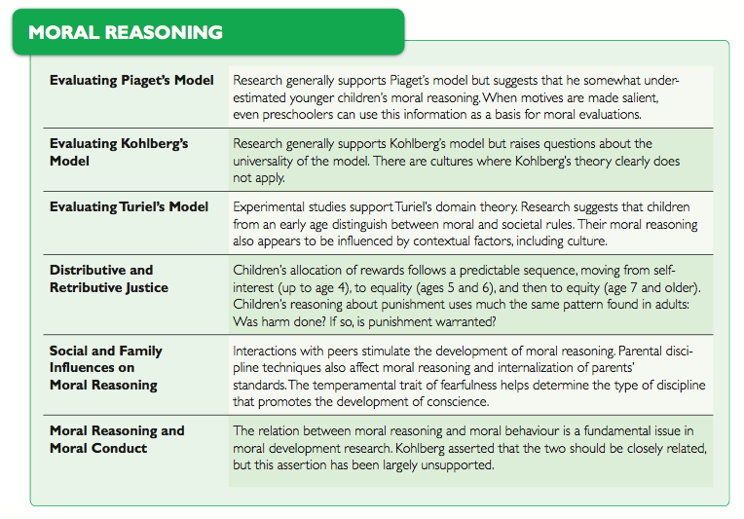
Evaluating Piaget’s Model
- Piagets account of childrens moral development has fared well empirically
  - Studies show that children increasly consider motives and intentions when evaluating morality
  - Many cognitive measures have been associated with children;s moral judgement (ie. Prescpective taking and mental state understanding)
  - Research supports Piaget- that children can achieve advance in moral reasoning via discussions with peers
    - Children with punitative parents who reinforce strict adherence to rules tend to display less mature moral reasoning and behaviour
  - These points contradict Paiget
    - The amount the parents involvement as an affect on moral reasoning
    - Underestimated the moral reasoning in young children
      - Ex. Piaget’s dilemma’s are presented with the intentions as salient features ( presented them at the end)- even young children will take the intentions into account
    - Other research shows that children take into account other actors in addition to motives when assessing a character’s morality
      - Ex. Young children believe taking a toy from a friend is worse than taking a toy from a non-friend
Evaluating Kohlberg’s Model
  - Invariant sequence is generally supported (nevertheless the individuals level of reasoning is not always consistent – depends on personal experiences and the issue at hand)
  - Longitudinal study of boys from 10 to adulthood found that from 14-24 the stage 3 reasoning predominanted. Even at age 36, only a few were reasoning at the post conventional stages
  - Cultural critique
    - Non-technological countries show that individuals rarely progress to the fifth stage, while many people in more technologically advanced cultures do make this progression
    - Suggests that Kohlbergs moral dilemmas do not adequately address certain moral issues and concepts found in other cultures
      - Ex. Chinese cultures – the conflict between individual and societal needs are reconciled by compromised (can’t do this with the dilemmas- have to pick one option)
      - Ex. Hindus believe that the fact a person is in a moral dilemma is an indication of prior sins and negliances, which he will not escape by committing further sinful actions
    - The universality of Kohlberg’s stages
    - The applicability of some moral dilemmas
      - Applicability should be universal not only across cultures, but between sexes as well
  - Gender critique
    - Justice vs. care
    - Early Kolhberg study, states that females have less advanced moral reasoning than male
    - Research can’t find a difference between male and female moral dilemma
Evaluating Turiel’s Model
- Supported by research
- Generally, preschool children generally believe breaking the rules is wrong but, breaking social norms is ok
- When dilemma is presented as a story, breaking the rules is always deemed wrong. If the dilemma is presented as a real-life situation, then other factors are considered
  - Consist with Turiels belief that moral reasoning will be influenced by context
- Children in Western societies appear to reason in ways consistent with Turiels model
  - Researchers than use culturally specific dilemmas have replicated Turiels results

Distributive Justice and Retributive Justice
- Distributive justice
  - Question of how to distribute a limited amount of resources amoung a group of deserving people
  - Usually assessed using a reward-allocation task
  - Reasoning regarding distributive justice tends to develop in different stages
  - 0-4yrs: children’s reward distribution is characterized by self-interest
  - 5-6yrs: children begin to divide rewards according to an equality principle with everyone getting the same share regardless of input
  - 7+ : children start to use equity as the basis for reward allocation (more work= more share)
- Retributive justice
  - Determining what factors children use in assigning blame or responsibility
  - Even young children appear to approach such problems in essentially the same way as adults
  - If there is no harm or damage, typically they do no pursue the issue of responsibility and justice
  - When damage is perceived to have occurred, people in both age groups then attempt to determine whether the story character was responsible
  - If the character is deemed responsible for the harm, both children and adults proceed to question whether the punishment is warrented and if so, how much?
  - These findings indicate that children’s moral reasoning in situations involving responsibility for damage does not represent a simple imitation of what they expect from adults

Social and Family Influences on Moral Reasoning
- Peer interactions force children to wrestle with moral issues
  - Interaction with a peer whose level of moral reasoning is higher (usually by one level) can improve moral reasoning in a child
- Social learning theory suggests that moral reasoning can be influenced by modelling and imitation

- Parents’ Disciplinary Practices
  - Power assertion involves the use of commands, threats, and physical force
  - Love withdrawal involves the use of disapproval and withholding of affection
  - Induction refers to reasoning with the child to explain why certain behaviours are prohibited
  - The induction approach leads to higher moral reasoning, power assertion leads to lower levels of moral reasoning

Moral reasoning and Moral Conduct
- A central issue in the study of moral development is the relationship between moral reasoning and moral behaviour
- Paiget: believed that thought follows from action, and so anticipated that children’s behaviour should initially at least, be more advanced than their reasoning
- Kohlberg: believed that moral thought and moral action should be more consistent and he claimed that the evidence shows that they are
- Social learning theorists: make a different prediction, they argue that moral reasoning and conduct may show some correspondence, but that the correspondence need not b very strong because because what children say and what they do involve different process
PROSOCIAL BEHAVIOUR
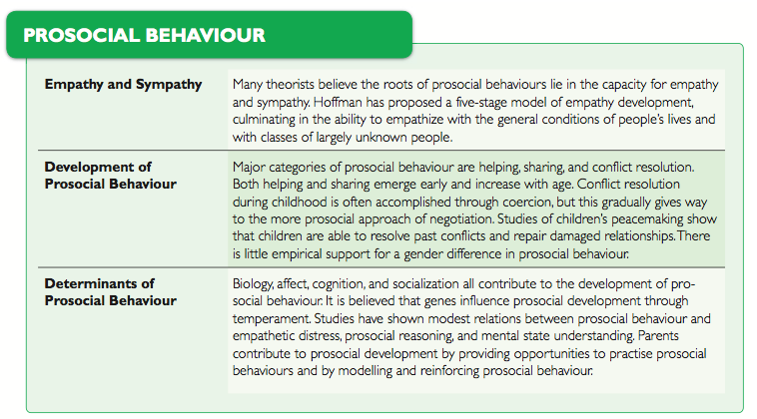
- Prosocial behaviour: the aspect of moral conduct that includes socially desirable behaviours, such as sharing, helping and cooperating; often used interchangeably with altruism by modern researchers
Empathy and Sympathy
- Empathy: the ability to vicariously experience another’s emotional state or condition
  - Hoffman’s five stages of empathy
- Sympathy: feeling of concern for another in reaction to the other’s situation or emotional state, not necessarily involving and experience of the other’s emotional state
Development of Prosocial Behaviour
- Helping – development of early helping behaviour are largely consistent with Hoffman’s five-stage theory of the development of empathy
- Sharing
- Conflict resolution
  - Peacemaking: a friendly post-conflict reunion between former opponents, often characterized by invitations to play, hugs, apologies, object sharing, and silliness
Biological Determinants of Prosocial behaviour
- Some evidence that genetic factors do contribute to individual differences in prosocial behaviour
- Twin studies- found greater similarity in self-reported altruism dn empathy in identical twins than fraternal twins
- Inhibited or cautious children may not always be able to bring themselves o help someone even if they want to

Cognitive and Affective Determinants of Prosocial Behaviour
- Empathy
- Currently, the assessment of empathy is based on physiological responses (facial expressions, emotional arousal)
- Greater response= more likely to share to show prosocial behaviours
- Prosocial dilemmas: stories differ from those of Piaget and Kohlberg in that they place less emphasis on breaking laws/rules. Instead, they must decide whether character must help someone, often at their personal expense.

Sociocultural and Family Determinants of Prosocial Behaviour
- Opportunities for prosocial behaviour
  - Practice prosocial behaviour is the home
- Communication of values
  - Parents may foster a prosocial orientation is through the values they communicate to children
- Modelling
  - Children model parental behaviours
- Reinforcement
  - Reinforcement of altruist behaviour will promote it
AGGRESSION
- Aggression: Behavior that is intended to harm persons or property and that is not socially justified
- Forms of aggression include
  - Verbal: Name calling, teasing, threats
  - Physical: Hitting, kicking, biting
  - Hostile: Purpose is to Inflict pain or harm
  - Instrumental: Purpose is to obtain something (e.g. a toy)
  - Relational: Purpose is to damage or manipulate social relationships
Determinants of Aggression
- Biological
  - Aggression is influenced by level of testosterone
  - Aggression is genetically mediated
  - Aggression is related to early difficult temperament
- Social influences
  - Family processes and peer interactions
  - TV and video game violence
  - Violent environments
- Cognitive and affective influences
  - Development of social cognition and empathy
- Different interventions for treating antisocial behaviour are employed
  - Catharsis refers to the belief that aggression can be reduced by viewing aggression or by engaging in high-energy activities
  - Targeting parents’ child-rearing methods
  - Teaching children problem-solving strategies, empathy, and perspective taking and rethinking the attributions they make of others
  - Education

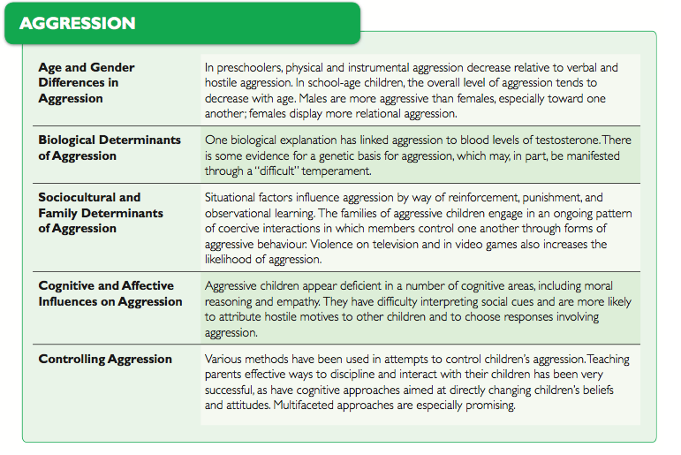

CHAPTER 15 –FAMILY RELATIONSHIPS
- Families form a system of interacting elements that mutually influence each other
- Families also part of a much larger system that includes extended family, friends, and teachers as well as institutions
- Systems view exemplified by Brofenbrenner, who saw developing child embedded in a series of complex and interactive systems
- Dimensions of parenting: (1) warmth (involvement) (2) Control
  - Children of warm parents feel secure, happy and are more well-behaved
  - Children of hostile or uninvolved parents may be anxious and less controlled
  - Children’s Contributions: Reciprocal influence
- 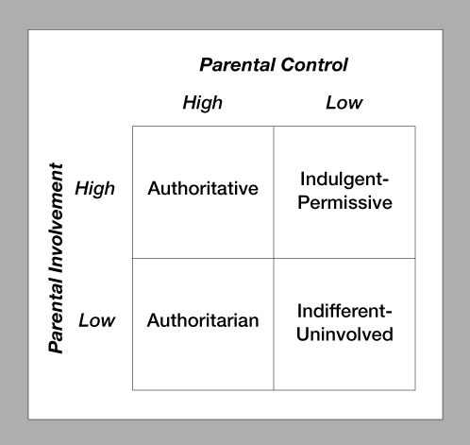
- Authoritarian patenting: a style of parenting characterized by firm control in the context of a cold and demanding relationship
  - children have lower self-esteem, less skilled socially, anxious; react with anger and aggression when frustrated
- Authoritative parenting: a style of parenting characterized by firm control in the context of a warm and supportive relationship
  - children are more responsible, self-reliant, and friendly more positive outcomes
- Indulgent-permissive: a style of parenting characterized by low levels of control in the context of a warm and supportive relationship
  - children often impulsive and easily frustrated, immature, and disobedient; heightened probability of various forms of rebellious, antisocial behaviour
- Indifferent-uninvolved: a style of parenting characterized by low levels of both control and warmth
  - children have low self-esteem, are aggressive, impulsive, moody most negative outcomes
  - form insecure attachments; show low social and academic competence as they develop; heightened risk for substance abuse and delinquency
- The benefits of authoritative rearing – and the superiority of this style to other methods of child rearing - are often smaller or less consistent in populations other than middle-income Western Caucasians
- Fathers’ interactions with children tend to center around play
- Characteristics of the chid can influence parenting style
- Development proceeds most successfully when parents are able to match their caregiving practices to the nature and needs of the child
- Reinforcement: a stimulus or event that strengthens or increases the probability of the response that it follows **the negative reinforcement trap**
- Punishment: a stimulus or event weakens or reduces the probability of the response that it follows
- Negative side-effects of punishment
  - Risk of injury
  - Inducement of fear and hostility
  - May result in aggression as a means to resolve disputes with other children
  - Child only learns which response not to make, & effects are temporary
  - Punishment does not teach the child desirable responses
  - Maybe reinforcing behaviour
- Effective punishment
  - Immediate, consistent, informative (feedback, direction instruction & why)
  - Administered by a person with whom the child has a warm and affectionate relationship
  - Failure tolerance, promotes valuating (motivation vs. obedience)
- Major types of child abuse – physical abuse, sexual abuse, psychological abuse, neglect
- Who are abusing parents? Culture, the stress of poverty, infants, preschoolers, and those frequently ill
- Effects of abuse
- Prevention (early intervention)
- When children are abused, their social, emotional, and intellectual development is often affected
- As adults, children who were abused are more prone to depression and anxiety, are more likely to think about or attempt suicide, and are more likely to be abusers themselves
- Divorce affects children’s conduct, school achievement, adjustment, self-concept, and relationships with parents
- Divorce may affect development because of loss of a parental role model, economic hardship, and conflict between parents
- Divorce more harmful when it occurs during childhood and adolescence or when children interpret events negatively
- Firstborns are more adult- and achievement-oriented
- Laterborns are more sociable and more innovative
- “onlies” have more academic success, higher levels of intelligence, leadership, autonomy, and maturity
- Adopted children are similar to non-adopted in terms of temperament, attachment, and cognitive development
- Problems are more likely to occur if the child was older when adopted and his/her pre-adoption care was poor

