Cell Signalling or Transduction (Part 2)
Objectives
- Define what is cellular signalling and transduction
- Know the basic signalling pathways
-Intracellular
-Ion channels
-Enzymatic receptors (particularly RTK/Tyr-k)
- Identify and define the type of cellular responses
- Describe in detail an example of cellular response with its signal transduction cascade
- Regulation and modulation
-Specificity and coordination
- Recognize and describe the mechanisms (6) that can terminate a cellular response.
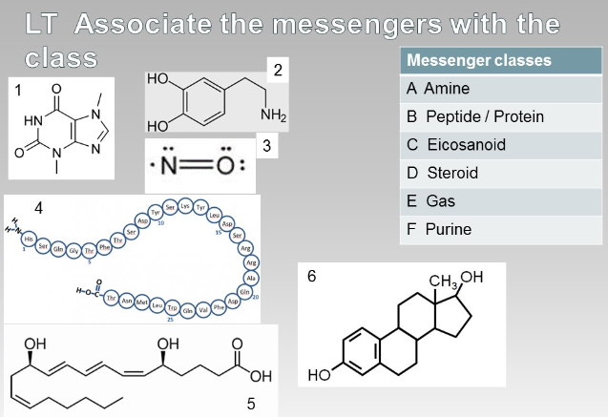
- Amine, 2
- Peptide/protein, 4
- Eicosenoid, 5
- Steroid, 6
- Gas, 3
- Purine, 1
Receptors:
- In all cases there is an area within the cell that can bind to the ligands, this initiates a change in the structure that allows it to carry on different tasks (intracellular) or it grants a certain activity which gives it its ability to relay the message in order to retain a response.
- Ligands don’t enter the cell unless they are relaying information. The amplification stands from an active receptor interacting with more than one second receptor. This relationship can trigger many second messengers to amplify the signal. This depends on how long the relationship lasts.
- As long as the second messengers are available the amplification is continuous but, this can also be the rate limiting factor (insulin is a primary messenger). Things that are already present in the cytosol (kinases, GTP and calcium).
Intracellular receptors:
- Freely pass the membrane through diffusion, so they are lipophilic (ex. Steroids). It will pass through the membrane and reach an intracellular receptor in the membrane, or one that is present in the cytoplasm.
- The steroid binds to it and changes its conformation and forms a complex inside the nucleus. This complex has gained properties that act as gene transcription factors.
- The genes are specific with sequences or promoters. A promoter is a switch on the gene, just ahead of the gene with a sequence of DNA that allows to turn on or off the gene (under control of the promoter). There are parts of the promoter that are response elements that activate the promoter turning the gene on or off. This is called a steroid response element, they are named for class or specifically for the hormone. They all act the same way when the transcription factor binds to a specific gene, controlling it. It will only affect this particular gene which is responsive for this messenger class.
- Next it will transcribe to mRNA and translate into a protein. This changes the amount of genes that the cell produces.
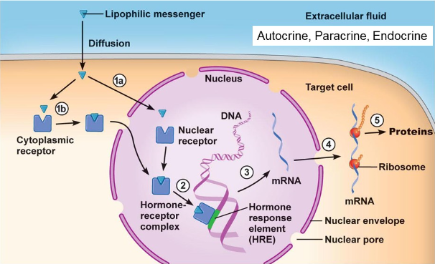
Glucocorticoids:
- Cortisol, is a stress hormone for prolonged stress (physical or emotional not chronic stress). It is part of the glucocorticoids produced by adrenal glands and one of its main roles is to reduce the amount of insulin produced by the pancreas.
- When cortisol binds to the response site of the gene for insulin and inhibits the production, the levels of insulin in the body decrease. The responsive element is a specific sequence recognized by the hormone to its structure.
TM receptors 1: Ligand gates ion channels
- Very important for nervous system-used by many NTs
- Some ion channels are specific to certain ions, others are simply open passage.
- Means that there is going to be a ligand messenger binding to s specific area of a TM protein. The TM is often a collection of subunits and when the ligand binds to specific subunit, it creates an opening or closes the opening. Sometimes there needs to be more than one ligand messenger.
- The structure is changed allowing the exchange of ions or an open gate. If the channel is opened and ions start going through the result is the electrochemical gradient depending on the direction and charge of the ion.
- The electrochemical gradient, when changed could create an action potential if it is excitable. It has an impact on the permeability by facilitating or hinder the messengers by diffusion. Calcium binding proteins might store some as well as the mitochondria, and the Ca2+/Na+ pump.
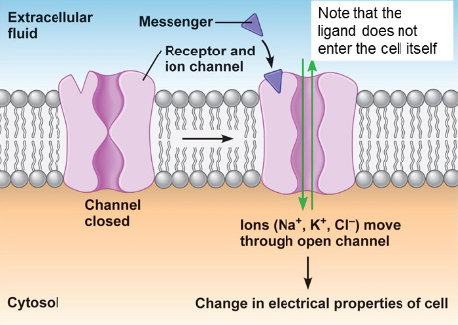

Mitochondria:
- Acetylcholine (Ach) is a very important neurotransmitter
- Excitatory or inhibitory depending on tissue
- Can use 2 types of receptors (AChR): ligand-gated ion channels (nicotinic receptors) or GPCRs (muscarinic receptors)
- One of the elements getting into the mitochondria involved pyruvate dehydrogenase producing acetyl-CoA that can be used along with choline to produce a neuron transmitter acetyl-choline which allows the neuron to speak to the muscle cell for contraction. It depends on what receptor it binds to g-couple receptors or ligand gated channels.
Acetylcholine: Ligand gated ion channels
- Acetylcholine is released from a pre-synaptic vesicle that binds to a ligand-gated ion channel in the sarcolemma cell.
- When binding sites are filled, conformation changes, pore opens and lets ions through; mostly Na+ and Ca2+ in to cell some K+ out.
- Changes the electrochemical gradient=membrane potential (the membrane becomes more positive).
- Subunits bound together (2 alpha, gamma and a beta). The neuron transmitter binds to the two alpha protein subunits and allows the passage of sodium and calcium inside the cell. Calcium comes into the neuron because the channels are voltage gated, calcium binds on the surface of pre-packaged vesicles storing acetylcholine which are hydrophilic. The calcium binds to the surface and triggers exocytosis and releases the acetylcholine. One the muscles cell surface sodium rushes in and the triggering element for contraction carried out by actin and myosin.
- The myosin motor proteins pull, acetylcholine doesn’t get into the cell, and the message is relayed by an elements of membrane potential with ATP. This element is tropomyosin is a protein on actin blocking the binding sites between actin and myosin.
- Calcium must bind to troponin. Troponin changes shape causing Tropomyosin to moves away from the myosin binding sites on actin which allows myosin head to bind on actin. The myosin head is activated by the hydrolysis of ATP. As long as the binding sites on actin remain closed the process will repeat.
- Sarcoplasmic reticulum is the equivalent of the endoplasmic reticulum. Myosin binds to actin pulling it to create the contraction. The relaxation of the muscle stops the increase of calcium stopping the voltage gated channel. When the concentration drops enough calcium will drop form troponin returning the proteins to their initial state.
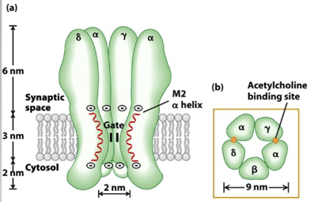
TM receptors 2: Receptor enzymes
- Intracellular catalytic domain acts as an enzyme
- Initiates a cascade of phosphorylation-dephosphorylation that amplifies the ligand’s impact on target cell.
- 3 main classes-focus on tyrosine kinase receptors
- There is going to be a section within the membrane that gains activity when the ligand bond forms. This is to gain enzymatic activity. When ligand is outside the cell it acts like an enzyme to convert GTP to phosphorylate tyrosine, guanylate, or serine/threonine elements.
- Tyrosine /kinase receptors are the main focus-there are other classes that do enzymatic activities.
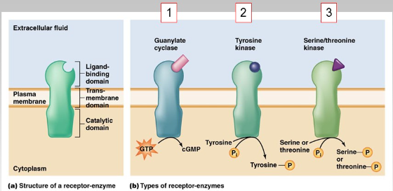
Tyrosine kinase receptors (Tyr-k; RTK)
- Largest family of enzyme receptors (over 20 types)
- Involved in pathways linked to survival, growth proliferation and metabolism
- Ligand examples
-Insulin
-Growth factors (NGF, EGF, VEGF, PDGF)
- Phosphorylates specifically on tyrosine amino acids.
- Tyrosine kinase receptors should be associated with two monomers of ligands. The cellular response with these types of receptors is growth factors and allow the cell to thrive.
- The SH2 and SH3 domains stand for src-homolgy, they are areas on protein that are important because they can fit with the phosphorylated areas of the catalytic domain of the receptors.
- The dimer formed by the monomers triggers the catalytic activity and allows the domain to become phosphorylated on the tyrosine’s hence tyrosine kinase receptor. They can phosphorylate between 6-8 tyrosines.
- Depending on which tyrosine is phosphorylated, it is going to orient which second messenger that will be recruited to interact with the dimer with the activated receptor, this initiates the transduction. The requirement to interact with the phosphorylated receptor is that the recruited protein must have the proper conformation to fit with the phosphorylated tyrosines. This conformation area is the SH2 domain.
- There are main categories of single cascades but they all involve PI3 kinase and gap activating proteins like Ras or phospholipase c. These are proteins that have the ability to interact with phosphorylated tyrosine kinase receptors due to the SH2 domains. In addition they also have another region called an SH3 domain that allows them to carry out the next step of transduction.
- A general cascade:
-Receptors are inactive in the membrane as monomers
-ligand binds and a growth factor complex forms
-bind to each of these monomers that induces a change in conformation to form a dimer
- Autophosphorylation can take place (no kinase involved). The dimerization allows the catalytic activity in this region to autophosphorylate 6-10 tyrosines.
- There is a structure to the receptor that allows them to interact with proteins on the intracellular side of the membrane. Ras is one of these proteins but it doesn’t have the SH2 domain so it requires adaptor proteins.
- These proteins are sos and GRB2. Sos and GRB2 come bound together and interact with the receptor. Sos activates Ras and Ras is a small g-protein because it has GTPase activity. In its inactive form, it is bound to GDp with a certain 3D shape when sos binds to it changes its conformation to exchange GDP to GTP (not phosphorylating GDP). Now it is activated and it changes shape and severs the bond with sos. It can now relay the message in the cell.
- Phospolipases do not need adaptor proteins because they have the SH2 domain.
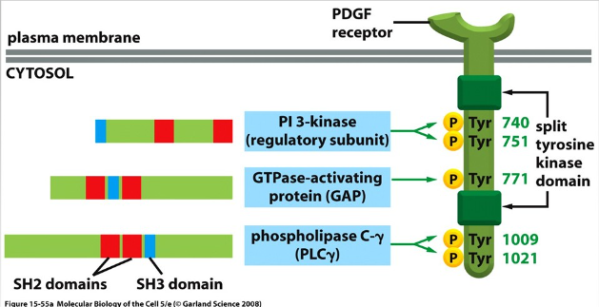
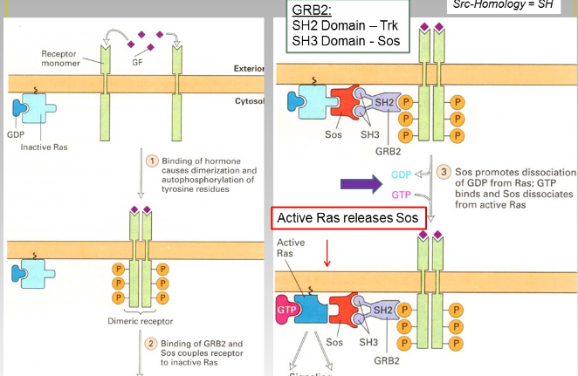
The case of NGF
- Discovered by Rita Levi-Montalcini.
- Mouse embryos with growth on neuronal tumours at a fast rate. She used embryos and tumour models to apply to healthy tissue to observe nerve growth factor. The nerve growth factor will need to bind to two dimers, phosphorylate and bind to a secondary receptor to relay the message.
Growth factor of NGF
- Nerve growth factor, the cells are growing tremendously to divide. She applied these principles to healthy tissue and it is now a family of growth factors. They need to bind to two monomers, dimerize autophorylate and recruit proteins to relay the message.
- General cascade:
-Bind monomers to form a dimer, autophosphorylate and recruit adaptor proteins (GRB2 and two others GRB2 and ras). Ras exchanges GDP for GTP becomes active and ungergoes a series of activations and phosphorylate other proteins in the cell. One protein called MAP kinase activates transcription factors that will go on into the nucleus and trigger gene transcription and makes sure that BCl2 remains active because it is anti-apoptotic protein.
-At the same time another pathway is taking place when the receptors are activated because many tyrosines are phosphorylated, and they maximize the benefit of the ligand. On other phosphorylated tyrosines on the activated receptor have the NGF process occurring it can interact with a kinase called phosphotidyl inositol 3 kinase or PI3. PI3 doesn’t need an adaptor protein because it has a SH2 domain and can interact with the phosphorylated tyrosines. PI3 kinase when activated after binding to the receptor it relays the info from the nerve growth factor and it makes sure that BAD (promotes apoptosis) remains phosphorylated so that it remains inactive. The NGF are using different paths within the cell to keep pro-apoptotic proteins inactive.

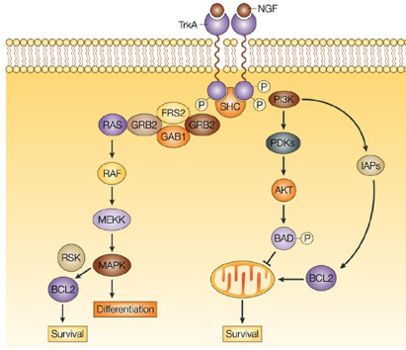
The Ras (MAPK) pathway
- Activate GRB2 and sos and activate the Ras pathway to activate MAPK and then gene transcription. The tyrosine kinase receptors can bind to phospholipase c when it becomes activated can activating on phosphotidyl inositol bis phosphate (PIP2).
- PIP2 is anchored to two phospholipids and when it becomes activated it will relay the message that the epithelial growth factor has brought and it will cleave the large compound into two things diacylglycerol which is a dimer a part of two fatty acid chains (part of the membrane lacking a polar head-can produce eicosanoids or arachidonic acid). The second cleaved portion is inositol triphosphate IP3 that regulates calcium by binding to a receptor on the ER by binding to a ligand-gated ion channel.
- The calcium acts as the second messenger to activate kinases and different protein and trigger the release of vesicles by exocytosis. The primary messenger is ligand and the second is phospholipase c and calcium so there is many amplifications.
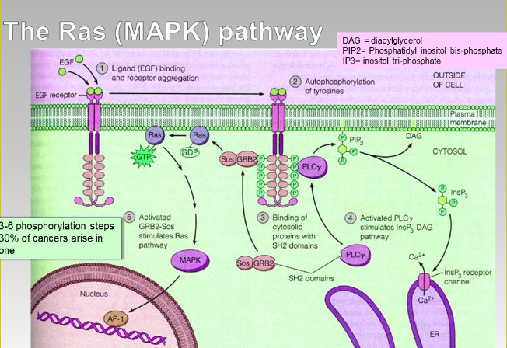
G-protein Coupled Receptors
- Largest family of receptors (Metabotropic), they can interact with all types of ligands for cellular responses ex. Hormones or triggered by photons of light.
- Multiple ligands-some bind to many different GPCRs
-Acetylcholine can bind to 5 different GPCRs
-Adrenaline (4 main receptors)
- Mediate responses to a diverse range or ligands (neurotransmitters, hormones, odorants, tastants, and photons)
- Diversity of receptors for given ligand translates to multiple responses
- There are volatile molecules are chemical messengers that can bind to g-coupled proteins that go to the memory centers in the brain. Photons of light are for the rods and cones of the eyes. The photons trigger the rods to have activity.
- They interact with GTP-activating proteins (g-proteins)
- 2 main pathways
-cAMP
-PIP (IP3)
TM receptors 3: GPCRs
- Elucidating the mystery of how adrenaline leads to many responses in the body based on cell type.
- Brian kobilka-structure of amino acids and 3d arrangement also the interactions using x-ray crystallography. Robert Lefkowits-working on the different protein activations made by adrenaline.
X-ray crystallography
- X-ray crystallography: take sample and form a crystal without changing its structure. Technique provides information in regards to structure. Bombarding the crystal with x-rays and seeing how the refraction rays behaves to determine the 3D shape.
cAMP Pathway
- GPCRs have seven transmembrane domains with ligands binding outside of the cell and the intracellular side of the receptors have areas that recruit g-proteins when ligand binds to the receptor.
- They are three sub-units that bind together. The alpha subunit is a molecular switch it is inactive when bound to GDP and a trigger will induce it to exchange for GTP which gives it its active status and dissociate from the other subunits.
- In the cAMP pathway the target is adenylate cyclase which is a membrane bound enzyme. When the alpha subunit activates adenylate cyclase it turns the catalytic activity on by converts ATP to cyclic amp that can act on the main target (second messenger is cAMP).
- CAMP binds to the regulatory subunits of protein kinase a phosphorylate various proteins and it is always present, but its activity is regulated by the equivalent of a protein cap.
- To remove this protein cap so that kinase a can become active cyclic AMP. When cAMP starts to dwindle the cell will want to re-establish the concentration level cAMP will dissociate from the regulatory protein cap and attach to protein kinase a shutting down its activity.
- GPCRs can activate inhibitory alpha subunits, but instead of activating the receptor enzyme of kinase a it is shutting it down to stop producing cAMP. The alpha subunit is geared towards inhibition instead of activation. Protein kinase a can also translocate to the nucleus so it’s able to act as a transcription factor at regulatory elements that depends on cAMP but it doesn’t get to these elements directly.
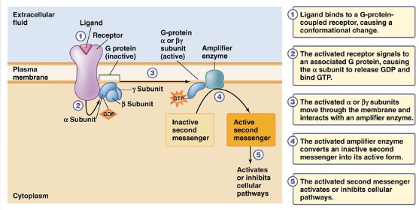
Second Messengers-
- Cyclic AMP
- Cyclic GMP
- Diacylglycerol
- (IP3)
- Calcium ion
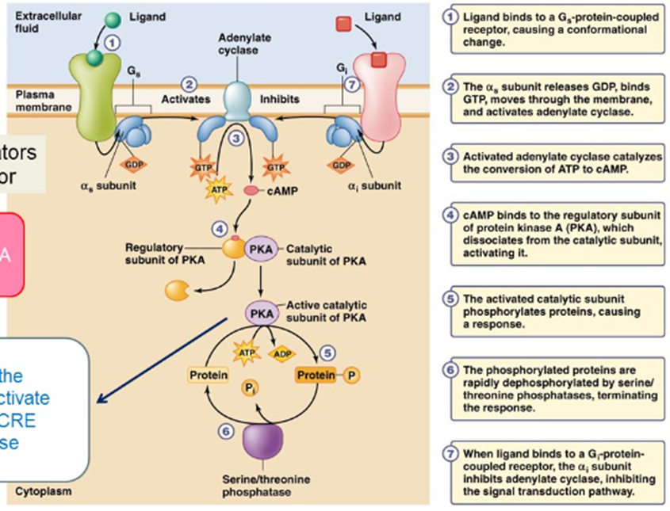
The PIP/ IP3 pathway
- Tyrosine kinase receptors and Phospholipase c becomes activated when the alpha subunit binds to it. Phospholipase cleaves the polar head and release free phosphate inositol triphosphate. Calcium can activate different enzymes in the cell, it can also be a part of the mechanism to activate protein kinase c. It depends upon calcium. Protein kinase c can activate different targets and receptors which changes the diffusion rate at which the solutes go through.
- DAG can be used to produce arachidonic acid that leads to eicosanoids. Two contradictory events in the cell are growth and death.
One ligand-many responses
- Norepinephrine (NE) is a catecholamine (NT and hormone) and is responsible for concentration. It binds to adrenergic receptors.
- Stimulate nervous system and activates glycogenolysis and gluconeogenesis. Maximizes blood flow to skeletal muscle and survival organs.
- Ligands and obtaining multitude of responses. One same messenger can lead to different responses. Messengers can produce a variety of responses based on what receptor they bind to that starts the cascade of events.
- NE can bond to diff receptors with subunits activated by the same mechanism. If NE binds to alpha 1 it activates the PIP cascade. A calcium channel on the plasma membrane becomes phosphorylated and activated. Calcium entering the cell from the plasma membrane would increase the intracellular concentration triggering the interaction between myosin and actin. No protein kinase a means that the calcium channel cannot be activate which favors relaxation of the muscle.
Specificity of responses
- Using the same ligand and the same receptor can have different responses depending on the cell. There are similar cells that still has different proportions of these receptors. This is an example of how an organism can attain the maximum amount of responses while maintaining receptors.
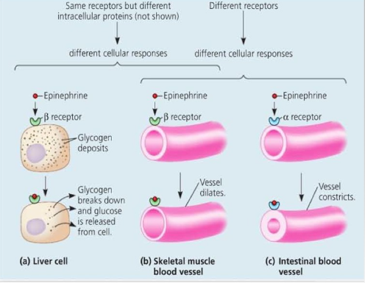
Coordination of response
- Cell growth and death cannot be triggered at the same time. At the level of an organism, cells adjust their permeability, facilitative diffusion helps trigger certain processes. When the glucose levels are too high, the pancreas will release insulin which binds to tyrosine kinase receptor to reduce the sugar levels in the body.
- When the glucose concentration is back to normal this pathway is shut down and they are internalized by endocytosis. Insulin is not produced by the pancreas anymore. Glucagon is the hormone that tells cells to break down glycogen into glucose. Glucagon uses g-protein and the cyclic amp receptors. When these two pathways are linked, but only one functions at a time this is called antagonism. This is the coordination of cell activity.
- Antagonism between insulin and glucagon on the pancreas avoids a ftile cycle of increasing and dropping blood concentration and maintain homeostasis.
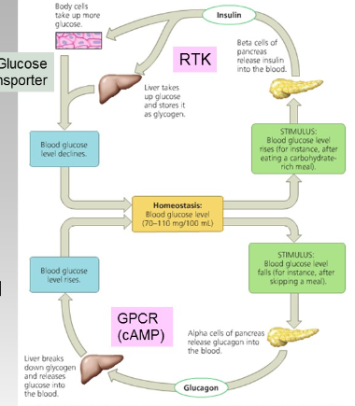

Ending the response
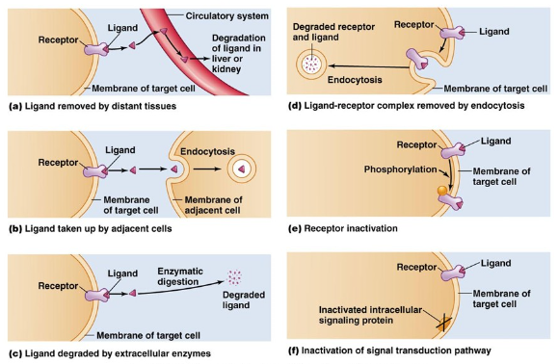
- The cell has to end the cycles because of all the different steps of amplification. There are 6 shut down processes:
- Ligand can be removed from the endocrine pathway. It binds to the receptor by diffusing and local chemical concentration at the receptor will control this.
- There are also enzymes will degrade ligand while it is bound to the receptor.
- It can be swallowed by an adjoining cell by endocytosis.
- The entire receptor complex can be entirely swallowed, both get sent to the degradation by the lysosome. The receptor can be recycled as the ligand is degraded.
- Or the receptor is dephosphorylated deactivating it.
- If one of the signalling steps is deactivated even through ligand is bound the signal will stop and communication will cease.
- These can be manipulate by facilitating these events, pharmacology dpends upon this. Drugs will promote or change the affinity for the ligand by interrupting it (antagonistic or protagonistic).

