- Eukaryotic cell organelles
  - Subcellular compartments within the cytosol surrounded by a membrane
  - Single subcellular compartment without a membrane: Ribosomes
  - Their functions are varied, and depend on the cell’s role
The cell is not a plastic bag full of organelles
  - cell is constantly renewing itself... even the membrane changes constantly! degraditon and synthesis
  - costco cashiers

LOCATION STRUCTURE FUNCTION

Nucleus:
  - eukaryotic organelle
Structure:
  - larger than all organelles
Regions: 1) Nuclear Envelope
        - double membrane barrier: outside is rough ER
        - inside lined with nuclear lamina (netlike lamins composed of intermediate filaments)
– (function: maintains shape and organizes DNA in nucleus.
        - Nuclear pore complex- made of proteins, allows materials in & out of NUCLEOPLASM (like cytosol, contains dissolved salts)
          - Who wants to go in ? Transcription factors
        - Nucleolus: masses of fibers where the information in rRNA genes to make ribosomes is copied into rRNA molecules, they exit via nuclear pore complex and combine with mrna
  - FUNCTION: Genetic library- codes for all the body’s proteins
allows cell to produce mRNA to make proteins
while mitochondria carries its own genetic info, nucleus is the CELL’s genetic library
  - euk. Need steroids, hormones, enzymes for activation and inactivation.. a lot of recipes!
so we need LARGE CELL GENOME! 10⁶-10⁹ bP
**bP: nucleotides together lined up as double helises dna is beans on a string wrapped around each other, with the help of histoproteins, then become chromosomes... during diffusion they have to unwind...

Ribosomes:
Structure:
- two globular subunits : small subunit, large subunit,
granules composed of proteins and ribosomal RNA
- not surrounded by membrane
Location:
- attached to membrane, rough endoplasmic reticulum or cytosol
Function:
- site of protein synthesis, translation
  - make mRNA Protein
- free ribosome make soluble proteins that function in cytosol and others imported in mitochondria
attached ribosomes make proteins for
  - cell membrane
  - lysosomes
  - for export from cell
- our alphabet.. we know 26 letters, but we combine them.. RNA vs DNA, same building blocks but organized so that they mean different things (different words) so they function differently. 20AA
- where do ribosomes stand? the closer the sequence of RNA , the similar the species

Endoplasmic reticulum: umbrella term

Structure
- Tubes and parallel membranes with fluid filled cavities “membrane tubing” cisterns
- half of cells membrane
Review of the story of a protein:
Mrna protein modification (fold them ) lipids OR phosphorylation OR thiol OR sugar
rough ER- studded with ribosomes, ribosome proteins are packaged in vesicles to golgi apaaratus or stay in RER (post translational modification
function: cell’s membrane factory... manufactures proteins and phospholipids.
great for cell types that ship things out of the cell
in RER lumen—chemical addition of carbohydrates
Smooth ER: no ribosomes, tubular vs flat...
Function: task follows its structure.
- Metabolize lipids.. synthesize cholesterol
synthesize components of lipoproteins
synthesise steroid-based sex hormones (balls)
synthesizes lipids (which become part of cell membrane), converts toxic metabolites
has enzymes that catalyze these reactions! eg. busy liver cell – toxic metabolite conversion
- absorb, synthesize and transport fats (intestinal cells)
- detoxify drugs, pesticides, cancer-causing chemicals.. the cell’s liver
- break down glycogen 2F glucose (liver cells mostly)
why lipid?
1- cell membrane needs lipids, 2- hormones like steroids need lipids

sarcoplasmic reticulum:
stores and releases calcium ions during muscle contraction... skeletal and cardiac muscles.
Golgi apparatus: traffic director for cellular proteins, post office, it finishes off the protein!
receives full translated but not mature or specialized protein...
near RER
Structure:
- pancake structure—membranous sacs, vessels,
(membrane is flattened by protein complexes that pulls sacs filled with new proteins ..off of golgi)
function
-Story time:
proteins from RER—vesicles fuse at golgi’s convex (cis face)
CIS modify, and package receiving side.. (post office, stamping)
protein’s modification: sugars trimmed, added phosph. group etc.
TRANS:
Structure: concave face
Function- Shipping side
- LEAVE THE CELL .. GO OUT INTO THE REAL WORLD
exocytosis- proteins for export pinch off as secretary vesicles migrate to PM
- HELP AN ORGANELLE... stay and help our father
vesicles go to PM or other organelles, lipids and transmembrane proteins
- Become an Organelle : become your father
digestive enzymes are packaged and sent off to membranous lysosomes to become part of that structure
- post translational modification of proteins begins in ER but golgi is like the post office, it sees what type of proteins, stamps it and sends it off to appropriate organelle
- each sac does different sorting properties, adding sugar, phosphorylating it as the proteins pass through.
Cell is Dynamic : Costco Cashiers.. remember membrane contains integral membrane, transports, receptors cell-cell recognition, receptors. .. costo analogy- you don’t always have the same number of cashiers working, so you don’t need transporters to work at the membrane all the time! if we don’t need transporters, it gets degraded and returns to cis FACE.

lysosome
Structure: + Location
Quick facts:
-- lysosmes bud out of golgi, they are born as endosomes (inactive enzymes, spherical, membranous organelles
--has a more acidic pH than cytosol
--contain activated digestive enzymes that degrade, recycle and reuse etc..
Function : might grab and further break down molecules but not huge vesicle like transporter proteins.. so what does it break down?
Due to its enzymes... it digests:
- particles brought in the cell
- worn out organelles
  - non-useful tissues
autolysis: when lysosmes rupture due to cell injury, oxygen deprivation or too much VITAMIN A.
- Glycogen break down== a form of metabolic function!
- Breaks down bone to release calcium ions into blood. ... lysosmes in osteoclasts
http://www.ncbi.nlm.nih.gov/pubmed/23966172

Mitochondria
Quick facts: arose from bacteria: endosymbiosis. powerhouse (ATP synthesis, metabolic function and non-metabolic function!!). cristae
structure: own DNA, RNA , ribosomes, e so....
- When cellular requirements for ATP increase, the mitochondria synthesize more cristae or simply pinch in half (a process called fission) to increase their number, then grow to their former size.
- enclosed by two membranes
- cristaue- inner emembrane that protrudes in matrix (gel-like substance
function:
- metabolism
higher surface area, greater intake of nutrients, jmore space or electron transport chain, more ATP. enzymes outside mitochondria break down fuels such as glucose... end result is water an carbon dioxide. aerobic respeiration: energy released from oxidizing and breaking down the metabolites ^^ is caputered and used to attach phosphate groups to ADP and forms ATP.
- response to stress- stressors cold, hunger, banging your toe, responses begin with mitoc
- cell death- tadpole loses its tail- programmed cell death, apoptosis
- calcium storage
location cluster where the action is sperm has the highest number of mitochondria, has a lot at the head. inside busy organelles kidney, liver,

endomembrane system
- ER
- GOLGI
- SECRETORY VESICLES
- LYSOSOMES
- NUCLEAR MEMBRANE
these organelles work together to REPORDUCE, DEGRADE, STORE AND EXPORT BIOLOCAL MOVLECUESL..
PASMA functions with the system
story time:
Examples where these interact.. vesicles born in the ER can fuse with golgi, then fuse and become part of plasma membrane, can exit the cell exocytosis (secretary vesicles or can become lysosmes.
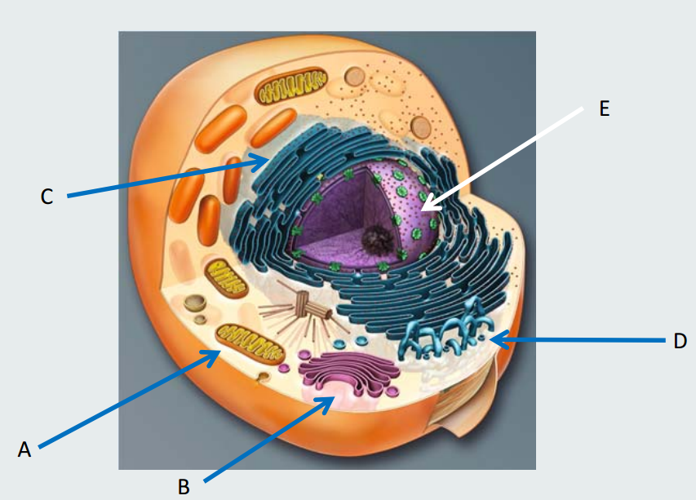

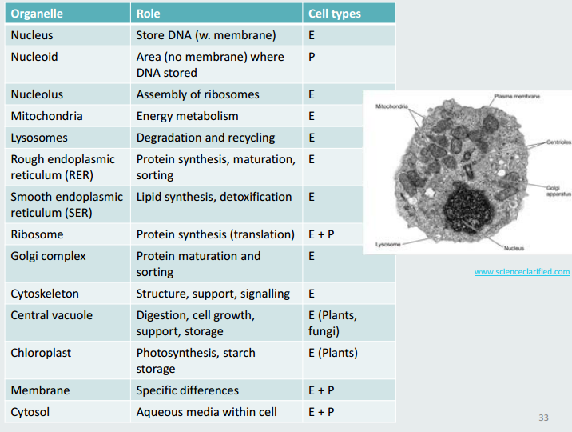

What distinguishes eukaryotes from bacteria and archea?
1. Nuclear envelope (separating DNA from rest of intracellular components)
2. Membranous compartments with specific roles (ER, mitochondria, etc.)
• All eukaryotic cells have some sort of energy‐ transforming unit (mitochondria, chloroplasts)
• Could this be the key to evolving from the common ancestor?

Membranes part 1
1. Boundary; selective permeability
2. Organize and scaffold
3. Regulate solute transport
4. Receive signals
5. Communication
The chemical properties of the cell are creating that boundary permeability barrier
quick types of membranes & uniqueness
#1) bacteria due to peptidoglycan 2) mitochondria hint: electron trasnport. 3) neuron myelin sheath... plasma membrane wrapped around axon
Various types of membranes; due to various Types of lipids and proteins Glycolipids and glycoproteins
Our focus: Plasma membranes: What was once a theory...
Model defined in 1972 by Singer and Nicolson
Fluid lipid molecules with embedded, free‐floating or anchored proteins.
Arranged in sheets, non‐covalently bound
Two facing sheets/fluid lipid layers – provide structure Mosaic of different proteins
– allow various functions (specificity)

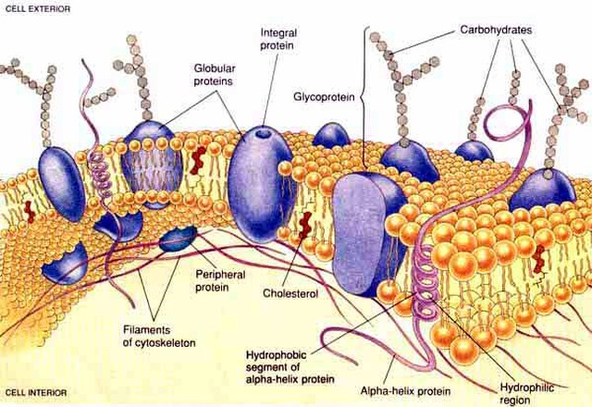
Bilipid Layer Composition & Function:
Composition of the lipid layers
  - Phospholipids are the most abundant lipids in the membrane bilayer, interact with each other because both non-polar so it doesn’t take energy to ♥ each other . Polarity is guiding the interaction. (like how in unhealthy relationships s** keeps it going, same shit)
lots of vanderwalls, some H-bond
    - 1 polar head, 2 hydrocarbon tails. this double personality makes it Amphipathic
Let’s Talk Head
All have glycerol backbone phosphate polar head group
outside layer: special polar head groups that attribute positive and neutral charge
interior layer-- more negative... because you have different type of phosopho heads
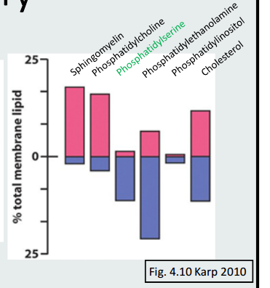
flipase helps reorient these phosphoheads, maintain asymmetry
      - 4 main PLs:
      - fPhosphatidyl ethanolamine – more polar!!
      - (-) Phosphatidyl choline
      - Sphingomyelin—no glycerol back bone, but sphingosine backbone
      - Phosphatidyl serine
CONVERS A more NEGATIVE CHARGE- HIGHLY CONCENTRATED ON INTERIOR SIDE OF CELL

Presence of unsaturated double bond produces “kink” and influences fluidity of the membrane.
these help with Property #2 of PM: Fluidity
- fatty acids are different saturation
- within each layer, they can shift, change place
  - pretty quick! 1 micrometre per second
  - ROTATION, FLEXION, Lateral Diffusion
  - rare: flip-flop! requires energy, from one membrane to the next
    - requires enzyme, used ATP... flipase enzyme... in particular circumstances-- both layers are very different... there is a different of phospholipids
- these polar heads contribute to the membrane being asymmetric – both layers are different!
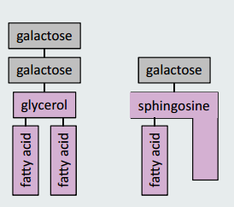
Decorations: how do they contribute to membrane’s properties?
Glycolipids (glycosphingolipids) – no polar! no phosph! no PP!
are 1 or 2 fatty acid chains with-- single --or –multiple-- sugar groups attached via glycerol or sphingosine
Function: Important for cellular recognition, antigens, blood types, glycocalyx.
on the outside only, so contribute to membrane asymmetry
Sterols:
- 4‐ring hydrocarbons
- Present only in eukaryotes
- Play an important role in fluidity (they increase the rigidity etc.); both in terms of arrangement and in relation to temperature (buffers)
3 Subtypes:
Animals, some protists: cholesterol
Fungi: Ergosterol... athlete’s foot is caused by fungi! to treat it, attack fungi membrane
Plants: Phytosterol
The plasma membrane is made of a phospholipid bilayer. Why are there proteins in the membrane?

Membrane’s properties:
thanks to the lipid bi layer we get :
1. Membrane asymmetry (both layers are different)
.--remember that it is necessary to maintain and flip flopping is hard.. when a cell dies, the distribution is not maintained
2. Membrane fluidity (ease of flexion, lateral diffusion, rotation etc.)
how do we achieve this membrane property?
- Length and saturation of fatty acid chains
short chain- high fluidity, vice versa
unsaturation—high fluidity
- Polar head groups (variable polarity)
- Sterols (buffering effect- resists any changes!) how much sterol you introduce to the membrane will retain fluidity
- –Temperature ( SHOWS DYNAMICNESS OF PM)
NEEDS TO BE SATURATED.. more double bonds= unsaturated ???
A desaturase is an enzyme that introduces a double bond
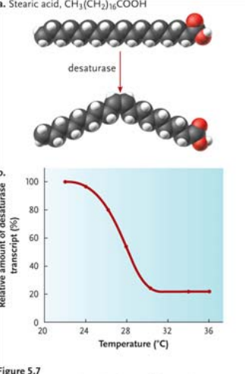
When it is hot, the membrane becomes more fluid (kinkiness overload)
the amount of desaturase enzymes transcripted and made into their active form REDUCES, we do not need more fluidity
As you make the temperature colder, the amount of desaturase enzymes increases because the PM becomes rigid and we need to maintain the fluidity of the membrane
BUTTT when it’s cold – low temperature—cell PM needs to br rigid and not let heat escape, --
*saturated means, saturated with hydrogen
who’s in charge of this?? Homeoviscous adaptation: The ability to change the membrane’s lipid composition in response to the environment in order to maintain membrane fluidity.
Fish starting in 2 different temperatures,
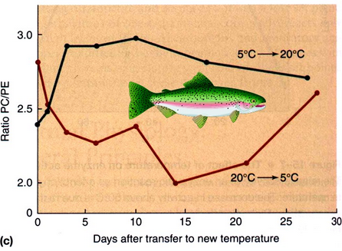
- 5 and 20˚C
- They have different PC/PE ratios (PE = more polar & confers more fluidity than PC)
- They are switched to different temperatures
- The PC/PE ratio will change and over time, they become very similar

Main functions of proteins in the membrane:
a) Transport b) Enzymes (catalytic activity) c) Signal transduction d) Attachment / Recognition
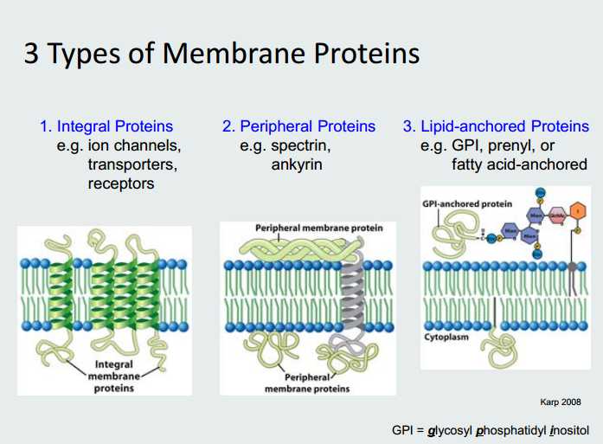
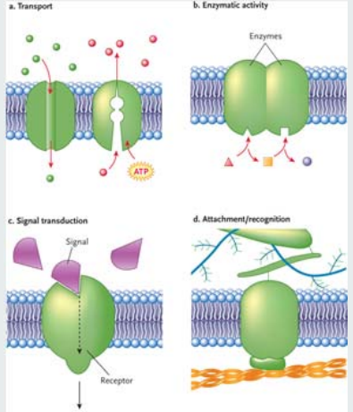
a) facililtated diffusion- leaky channel
active transport
b) enzymatic activity
c) signal transduction – protein acts as a receptor, informs a messenger
d) attachement – microfilaments, collagen fibers , polysaccharides
recognition—as a result of unique sugar coating etc.

- Integral proteins
• AKA transmembrane proteins
• Span the membrane once or more (single pass, double pass or multipass) (squiggly lines!)
• N or C terminus can face inside or outside cell
when making an integral protein:
inside and outside portion the membrane should be polar or charged amino acids, within the membrane should be non polar amino acids.
- peripheral proteins
interact with something that does span membrane but they do not
3. lipid-anchored proteins
lipid tail allows it to be on inner or outer membrane.
bound to lipid portion that spans one layer of the membrane!!
  - Proteins can be anchored (covalently) on the outside or inside of the cell
  - There 2 types of anchors:
    - Extracellular proteins: GPI anchors (glycosyl phosphatidyl inositol)
    - 7glycolipids part of the lipid bilayer and used to anchor proteins
why not on inner? the class of glycolipids is always on the outerlayer
    - Intracellular proteins: Fatty acid or prenyl groups

2. Peripheral proteins
• Can be on the inside or the outside of the cell membrane
• Non‐covalently bound to another element (integral protein or cytoskeleton)
advantage: can easily change peripheral protein location... membrane is dynamic! molecules must shift.
RBC- must be easily compressible, flexible, membrane must be flexible elastic, as well.
change easily where those interactions occur: what interactions?
actin microfilaments with some integral proteins and in between you have peripheral proteins - spectrin, ankyrin
• Can serve to provide structural support (elasticity) or mediate binding
- does it matter if in or out??
    - Extracellular proteins will be useful for cell adhesion: binding cells to a substrate, a surface etc.
      - signalling, recognition ?
    - Intracellular proteins are involved in mediating cell division and cell growth
-signal transduction
    - -interacts with cytoskeleton
How do we study membranes?
  - Microscopy
  - Freeze‐fracture
    - Useful to study inside the membrane
Freeze cells using liquid nitrogen (‐196°C) (kills cell)
      - Split using knife
      - View under electron microscope
      - -allows you to see spanning membrane, which ones covalently bound etc.
  - Fluorescence Recovery after Photobleaching (FRAP)
- Useful to study the ability of molecules to move within membrane
1. label the cell surface using fluorescent dye..
- laser beam bleaches area because the photos emitted from the laser are so strong, they force the photons of the cell surface no longer emits photofluoresence
3. fluerescent labllebed molecules diffuse into bleached area because that part of the membrane is high fluidity.. regains fluorescence
- **if anchored proteins are bleached, the bleach spot would remain**
EXAM QUESTION:

MAIN differences between prok and euk membrane:

Movement across membranes
A few general principles:
Relative permeability of molecules.
(high permeability- urea, water, glycerol, tryptophan, glucose..)
    - *Charged ions are relatively impermeable
Concentration gradients vs. electrochemical gradients.
  - what is the difference?
concentration deals with the amount of ion or molecule present on either side of the membrane, the concentration gradient is the difference of those amounts- can be higher in or out
electrochemical gradients: difference of concentration and charge!
  - can you have electrochemical gradient by glucose? no it is not charged.
sodium? yes. charged and chemical concentration.
Gradients store potential energy.
Whether conc. or elec. GRADIENTS has energy stored within it, AND YOU CAN HARNESS THAT ENERGY!
(secondary active transport takes advantage of the energy and gradient caused by the primary active transport to cause another type of molecule to cross.
Passive (simple) diffusion
diffusion no matter what type : you follow a gradient, not against it!
so no energy required
- Spontaneous, random and down their gradient
- Small lipophilic molecules
- Uncharged solutes (Concentration gradient)
- Water: (Osmotic gradient)
- Ions: (Electrochemical gradient)
- Gases: (Partial pressure gradient)
Facilitated diffusion Channel mediated
• Water, ions soo.... Electrochemical gradients highly selective
• Ex: Aquaporins... allow passage of water.. remember alpha helix structure of integral protein with hydrophillic passage through it and hydrophobic outer layer
• Inhibition voltage‐gated ion channels ligand-gated-- chemical messenger changes its conformation and opens it! or mechanical trigger sensed by cytoskeleton
faciliated transport is SATURATABLE!
--approaches maximum rate when all tranporters are occupied. there is a limit.
Carrier mediated
- Ions, large polar molecules
Ex: Na+/Ca2+ exchanger
glucose transporter
  - Highly selective
  - Uniporters, co‐transporters, exchangers
  - Driven by solute gradients
• Inhibition-- triggers allow the carrier to close and open!
experiment: bring in ligand and see if the compound's transport rate decreases or not!
if simple diffusion, you won't be able to affect the rate, it will be constant!

Active transport
- Only type of transport across membranes that goes against the concentration gradient; thus
- This requires energy and a carrier protein
- Two possible sources of energy:
- using an input, such as ATP: we call this primary transport
- Use the concentration gradient of another solute: we call this secondary transport
1) same direction ,
using the electrochemical or concentration gradient of one molecule to drag someting else 2 ) opposite direction!
2 types of Secondary transport
Symport:
- Both the driving ion and transported solute travel in same direction
- Ex: Na‐glucose symporter in intestinal microvilli
glucose is going against its concentration gradient, but we want to extract allll sugar possible. soo.. energy of sodium gradient drives the transport of glucose
if glucose wants to exit the cell... it can go by facilitated diffusion, no worries,
sodium out of the cell? needs atp cause against concentraiton gradient. (high outside cell)
• Antiport:
– The driving ion and transported solute travel in opposite directions
– Ex: Na‐Ca exchanger (3:1)
PRIMARY ACTIVE TRASNPORT PUMPS|!
P-type for pumps! V-type – vesicles F-type - anywhere... hydrogen pumps! used in mitochondria sodium, calcium etc ^
- ABC - ATP binding casettes.
  - Large molecules shuttling...
  - drugs and toxins

Sodium Potassium pump
- creates ELECTROCHEMICAL GRADIENT...how we establish resting membrane potential
- pump spans PM
- at resting config. the opening is facing the inside ...sodium robbers trying to exit..
weak bond at affinity site between sodium and pump
- ATP cleaved into ADP AND P ... which it changes conformation and is able to spit those ions out.
- why do we even need this? we are working against its concentration gradient
  - outside cell is normally high in Na+.. opposite for Potassium
- phosphate is still bound, when it is cleaved, that allows potassium inside the cell
- SUMMARY we're using one ATP molecule to do two actions,,.. changing the conformation TWICE
- electrogenic exchange.. in addition to maintaining the electrochemical gradient, but keeping the charges relatively different on either side of the membrane
NOT ELECTRONEUTRAL (which means .. 1;1 2;2 ETC)
Class of ATP ase | Locaton | Function
ABC |  | solutes: ions, sugars, AA, proteins
F-Type ATPase | mitochondria | PUMPS H+ INTO VESICLE LUMEN
P-type ATPase | plasma membrane
Ca2+  Na+/ K + |  | Toxic calcium OUT
 |  | sodium out, potassium in
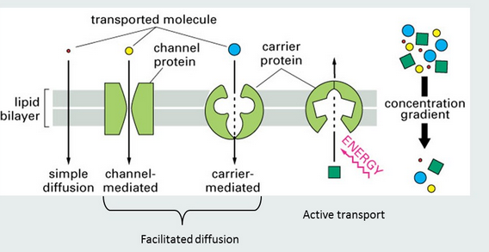

what could be in that vesicle?
large macromolecules... lipids, anythign not soluble... neurotransmitters...
how does it travel? along the cytoskeleton
which motor protein ? kinesin along microtule --> microflament --> myosin then the membrane forming the vesicle becomes part of the plasma membrane
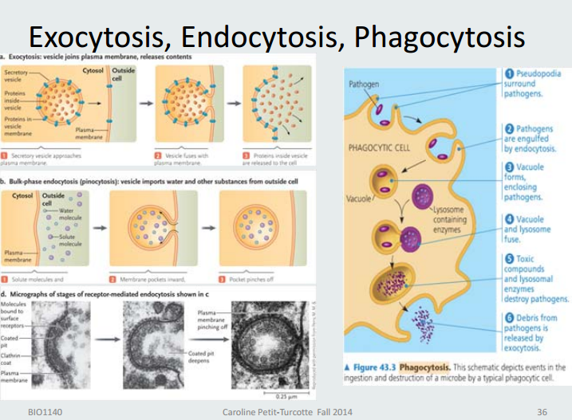
membrane fluidity increases when you perform exotycosis!
endocytosis: engulfs what ever is close to the membrane ..what ever is in the ECF...
Pinocytosis! just swallowing whatever is in the outside
is pino just liquids? and phago solids? yes
how? proteins within the membrane folding in and create a depression .. it's not a smooth line.. there are anchor proteins, integral etc... intergral proteins interacting with peripheral proteins..
Receptor-mediated endoytosis:
ligand is your chemical messenger.. bind to receptors outside the cell.. on the binding sites of peripheral proteins.
internalizes vesicle and whatver is bound to it.
where is it going? lysosome to degrade it! if you want to keep your receptors...trans face in golgi!
lysosome': we dont even want to keep anything... so either degraded or either spitted out
answer these questions
which motor protein is transporting each vesicle? how is being handed off?... flow chart
hwo is this quick PM change achieved? microfilaments and intermediate filaments
Membrane Potential: Summary
Membrane potential • Distribution of ions is unequal with more + charge outside and so the inside is less positive • This uneven distribution creates potential energy • This can be measured in V • As excitable cells are stimulated, channels allow passage of ions, changing this ionic distribution, potential energy and hence V • This is called Action Potential
- difference in overal charge on both sides because the quanitity is different
- membrane is not charged, but the environment on both sides is different.. relative difference
- when you have this difference you are able to generate potential energy.. we call that current. and allowing the electrons to travel that distance because of this difference
- Measurement of current: volts... (potential energy in volts)
- great distances and great speed: the membrane is lined with ion channels open and close sequentially allowing the electrochemical gradient to be produced and you're able to create that current.
- soidium potassium pump, reestablises the equlibrium... whhcih is resting membrane potential
  - more positive outside, negative inside
- na+ flushes in, cell responds by spitting out potassiium
  - calcium's role in this release:
    - neurochemical signals (vessicle containing neurotrasmitter) snet to muscle cells
thorugh exocytsois and then it will travel to neuromuscular junction
      - successive events that lead to contraction

