Biol 240 Notes

Topic 6: Culture and Control
Metabolism
- Catabolism: Releases energy
- Anabolism: Consumes energy
- Microbial Nutritional Requirements
  - Macronutrients
    - Required by ALL cells to build macromolecules
    - C, N, P, S, O
  - Micronutrients
    - Required by SOME cells
    - Includes Fe, Cu, Na, Mg, Mn, and others
- Fundamentals of Nutrition
  - Energy Source – For oxidation, electrons for ETC
    - Light (Photosynthetic)
    - Chemical (Organic or Inorganic)
      - Organic – Organo
      - Inorganic – Litho
    - Chemoorganotrophs
      - Energy from oxidation of organic compounds
    - Chemolithotrophs (only Prokaryotes)
      - Energy from oxidation of inorganic compounds
    - Phototrophs
      - Energy from light captured by pigments
      - Oxygenic or Anoxygenic
  - Carbon Source – For cell maintenance and division
    - Fixed organic (C-C bonds)
      - Heterotroph
        - Use organic molecules formed by autotrophs
    - Gaseous inorganic (CO₂)
      - Autotroph
        - Primary producers
        - Fix Carbons directly from CO₂
  - Naming
    - Energy Source + Electron Source + Carbon Source + troph
Photo  Chemo | organo  litho | Hetero  Auto | troph
  - Acquisition of Nitrogen
    - Critical to making amino acids and nucleic acids
  - Conserving Energy: All different energy paths lead to the formation of ATP
  - Nutrient Concentration
    - Growth rate depends on amount of nutrients in environment
    - Key nutrient available in the lowest amount will as a limiting factor (nutrients or space)
Growth Conditions
- Effects of O₂
  - Aerobic Growth (depends of O₂)
    - Obligate Aerobes require O₂
    - Microaerophiles grow best in low levels of O₂
  - Anaerobic Growth (without O₂)
    - Aerotolerant Anaerobes indifferent to O₂
    - Obligate Anaerobes will die in presence of O₂
    - Facultative Anaerobes can grow without O₂ but thrive in its presence
  - Toxic Oxygen Species
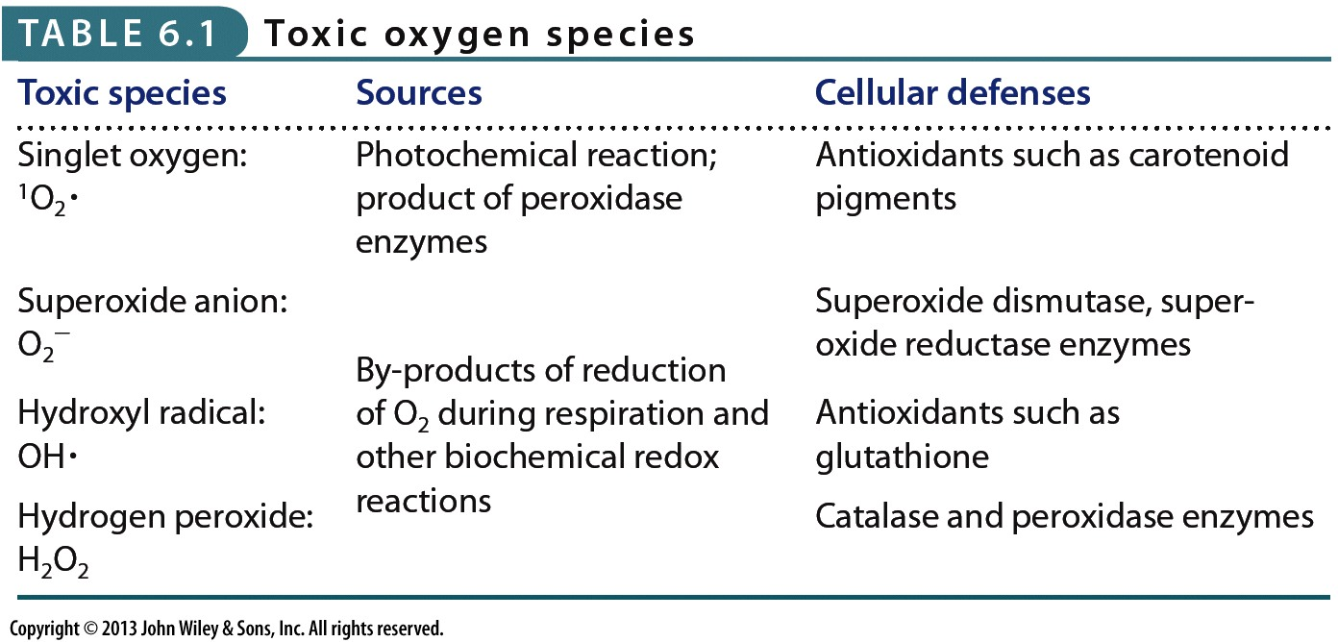
    - Effects of O₂ on a cell depends on its defenses

    - Catalase Test
      - Negative: no bubbles
      - Positive: bubbles form
      - Bubbles are the O₂ gas formed from the reaction of H₂O₂ facilitated by catalase
- Effects of pH
  - Affects macromolecule structures and transmembrane gradients
  - Intracellular pH is always somewhat neutral
  - Each microbe has an optimal pH range (acidophiles/neutrophils/alkalophiles)
- Osmotic Pressure and Water Availability
  - Solute concentrations can results in influx/efflux of water
    - Causes stress to the cell
  - Water must be available for biochemical reactions
    - Measured as water availability, a_{w}
      - $a_{w} = \frac{v_{p} of air with substance}{v_{p} of air with pure water}$
    - Solutes decrease a_{w} values
      - i.e. pure water = 1.0; sea water = 0.98
    - most bacteria require a_{w} > 0.9
  - Water activity
    - Cytoplasm maintains hypotonic environment to ensure water moves into the cell
      - Pumping ions from environment
      - Synthesis/concentration of organic solutes
- Temperature
  - Affects macromolecular structures, membrane fluidity, enzyme function, microbial growth
  - 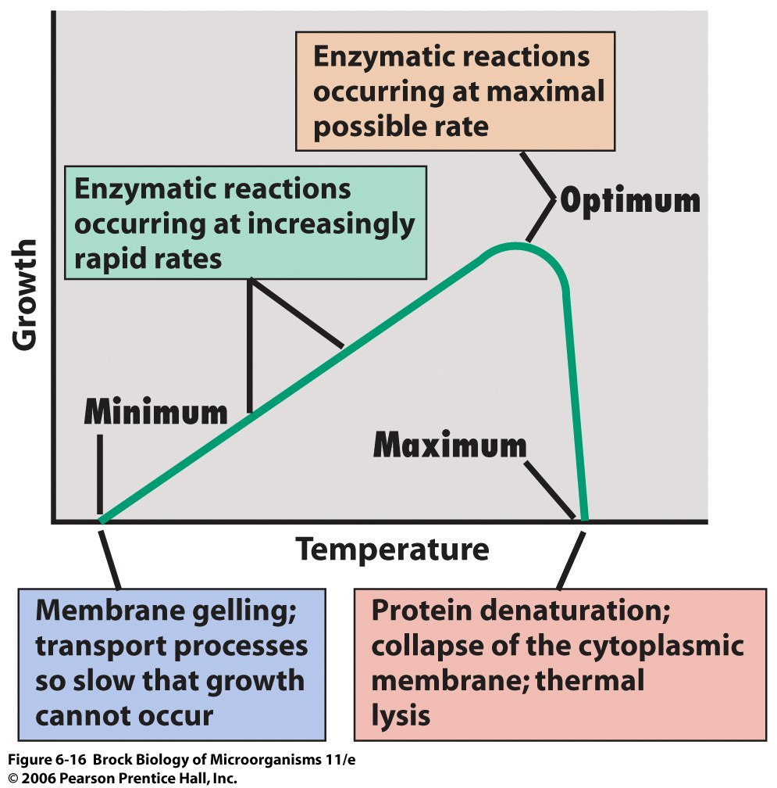
  - Psychrophiles
    - Min: < 0 ; Opt: < 15 ; Max: < 20
    - Enzymes denature at moderate temperatures
    - Higher proportion of unsaturated fatty acids in membrane
  - Psychrotolerance
    - Able to grow at low temperatures
    - Many mesophiles are psychrotolerant
  - Hyperthermophiles
    - In volcanoes
  - Molecular Adaptations
    - Favouring enzymes that function @ high temperatures
    - Features that give thermal stability
      - Amino acid substitutions in key locations
      - Increase ionic bonds between acidic and basic residues (resists unfolding)
      - Some solutes stabilize proteins
    - Modifications in cytoplasmic membrane
      - Sat. fatty acids in bacteria
      - Phospholipid monolayers in Achaea
Medium
- Media Types for Microbial Growth
  - Solid Media (Agar)
  - Liquid Media (Broths)
  - Culture Media
    - Agar
      - Polysaccharide
      - Not degraded by most microbes
  - Complex Media
    - Unknown chemical composition
  - Defined Media
    - Known chemical composition
  - Specialized Media
    - Selective
      - Isolation of microbes with specific properties
    - Differential
      - Microbes to be recognized based on visual reactions in the medium
    - Enriched
      - To increase a population of microbes with a specific property
- Obtaining a Pure Culture
  - Solid mediums allows separation of a mixture of cells into a pure population
  - 3 methods to separate cells on a plate
    - Streak Plate Method – purify cells from a background (isolate colonies)
    - Spread Plate Method (counting)
      - Bacteria colonies on surface of agar
    - Pour Plate Method (counting)
      - Bacteria colonies on surface and inside agar
- Quantifying Microbes
  - Direct count
    - Known volume on slide with a grid and counted under microscope
    - Cheap, fast
    - Can’t differentiate between viable/dead cells
  - Viable cell count
    - Serial dilutions (gradually diluting bacterial broth) step by step
      - I.e. 1/10 then 1/10 then 1/10 , etc.
      - What if cells are too diluted?
        - Filter apparatus can concentrate the cells
    - CFU/mL (colony forming units)
      - Equals #colonies/ 1 mL x inverse of the dilution factor
  - Turbidity (optical density) measurements
    - Observe difference of optical density (how much light is absorbed) of a sample of bacteria using a spectrophotometer
    - Microbial Growth Curve
      - Spectrophotometer can determine the 4 basic phases of a microbe’s growth curve over time
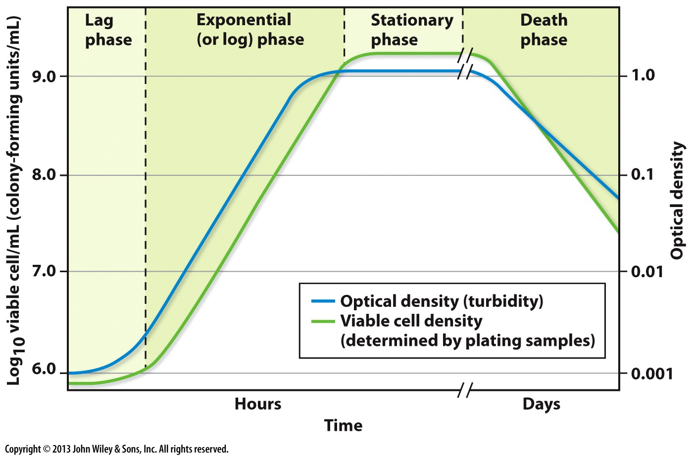
      - May not be able to differentiate between viable and dead cells
      - Lag Phase
        - Preparation for steady growth
      - Log Phase
        - Replication at constant and steady exponential rate
      - Stationary Phase
        - Replication equals death rate
      - Death Phase
        - Nutrients depleted, waste levels high, cells die at steady exponential rate
      - Extrapolating Data
        - Generation time: time to double the population in exponential phase
        - Growth rate: #generations/unit of time (inverse of the generation time)
        - Growth yield: max population density and/or amount of cellular material produced
- Continuous culture
  - Keeping microbes in their exponential phase to continuously harvesting their products
  - Chemostat flows in fresh medium and removes old medium
Control of Microbial Growth
- Filtration
  - Physical removal of microbes through filters with small pore sizes
    - Viruses can be removed by ultrafiltration
  - Problems:
    - Large particles clog filters
    - Viscous liquids don’t filter well
  - Ideal when material is heat/radiation sensitive
  - 2µm common for sterilization
  - Filters
    - Depth filters
      - “pre-filter”
      - Fibrous sheet /mat
        - E.g. paper, cotton, glass
      - Uses a trapping action
    - Conventional membrane filter (sterilization)
      - Polymer filter
      - Sieve like action
    - Nucleopore filters
      - Thin polycarbonate film prepared by radiation exposure
      - Useful for microscopy and capturing cells for observation
- Temperature control
  - Heat
    - Denatures proteins & nucleic acids
    - 100C kills most microbes
  - Problems
    - Hyperthermophiles
    - Endospores
    - Some materials can’t be heated
  - Autoclave adds pressure to increase the temperature while keeping fluids liquid
      - Creates moist heat
      - Temperature kills microbes, not pressure
  - Pasteurization
    - Reduces microbial load
      - Destroys pathogens
      - NOT sterilization
    - Quickly heating and cooling
      - Maintains the flavour by not denaturing proteins and macromolecules
  - Freezing cells
    - Can damage cells by forming ice crystals
    - Stops biochemical reactions
- Radiation
  - Electromagnetic Radiation
    - UV radiation of 260-280nm
    - Damages DNA by forming thymine dimers
    - Controls growth on non-living surfaces and in water
  - Protein damage
  - DNA damage
    - Double strand breaks
    - Stray electrons
    - OH ions
    - Hydride radicals
  - Very expensive and hazardous
- Chemical control
  - Anti-microbial action
    - Agents target different groups (bacteriocidal, fungicidal, algicidal, viricidal)
    - Vary with respect to selective toxicity
      - Non-selective (affect sulfhydryl groups)
        - Non-internal use
      - Selective(penicillin)
        - Useful for treating disease
  - Bacteriostatic: growth inhibition
  - Bactriocidal: kills cells
  - Bacteriolytic: causes cell lysis (soap)
  - Disinfectants: on non-living surfaces to kill potentially infectious microbes
  - Antiseptics: used on living tissue (topically)
  - Good microbe killer?
    - Kills wide range of microbes
    - Not corrosive/toxic
    - Cheap
    - Temperature stable
    - No residue/fumes
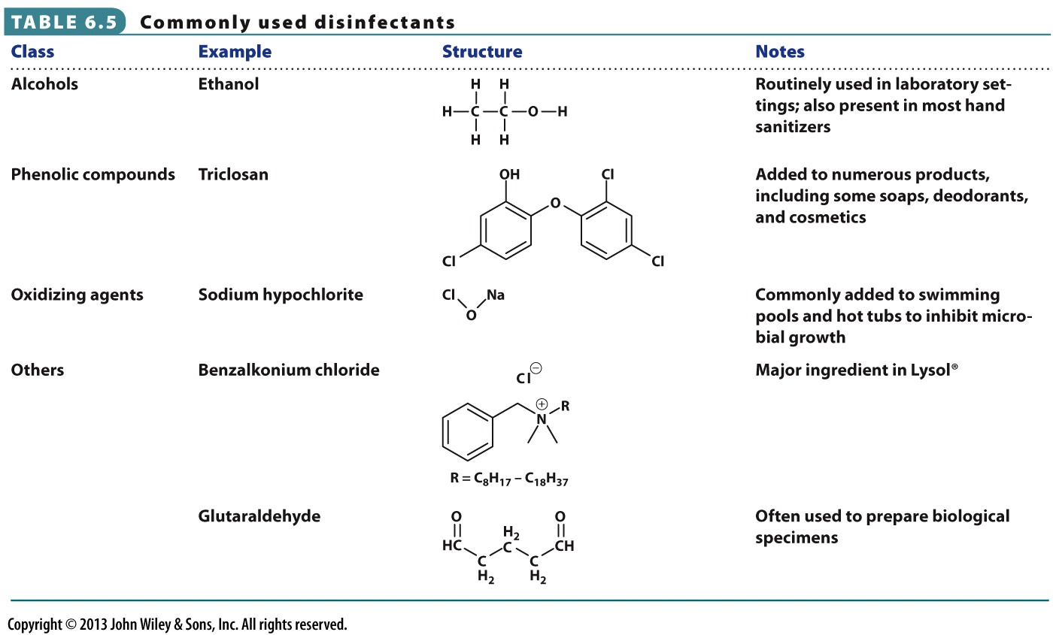
  - Common Disinfectants

  - Antimicrobics/Antibiotics
    - Microbial/synthetic agents produced by microbes
  - Can be cidal or static
  - Works by binding to proteins or cellular organelles and disrupts essential functions for microorganisms
  - Broad spectrum (tetracycline)
  - Narrow spectrum (penicillin)
  - Inhibition of cell wall synthesis (penicillin), protein synthesis (tetracycline), disruption of cell outer membrane (polymyxin B)
  - Choosing a Method
    - Type, quantity of microbes
    - Do they all need to die?
    - Toxicity, location of infection
    - Duration/intensity
  - Measuring Effectiveness
    - Decimal reduction time (D value)
      - Time needed to kill 90% of target in specific conditions

Topic 7: Bacterial MVP’s
Proteobacteria
- Metabolically Diverse
  - Chemolithotrophs
  - Chemoorganotrophs
  - Phototrophs
- Morphologically diverse
- 5 phylogenetic groups
  - Alpha, Beta, Gamma, Delta, Epsilon
- Anoxygenic Photosynthesis
  - Photosynthesis inhibited by O₂
  - Wavelengths determined by specific bacteriochlorophylls and carotenoids
- Purple Sulfur Bacteria blooms
  - Photoautotrophs of gammaproteobacteria
  - Oxidize H₂S to S during photosynthetic CO₂ reduction in anoxic lake water
  - Stored in periplasm or outside cells, disappear after oxidized to sulfate
- Winogradsky Column
  - Order top to bottom
    - Cyanobacteria
    - Purple non-sulfur bacteria
    - Purple sulfur bacteria
  - Light as energy
  - CO₂ as carbon source
Methanootrophs/Methylotrophs
- Methylotrophs oxidize C1 compounds
  - Non organic (no C-C bonds) compounds
- Methanotrophs are methylotrophs capable of oxidizing methane to methanol
  - Obligate C1 utilizers
  - Obligate aerobes
- Environments
  - Aquatic and terrestrial
  - Interface between anoxic and oxic zones (swamps, lakes)
Nitrifiers
- Use reduced N compounds as energy sources (electron donors)
- Autotrophic growth
  - Chemolithoautotrophs
- Nitrosococcus, Nitrosomonas
  - Ammonia Oxidizers
  - Have ammonia monooxygenase
- Nitrobacter
  - Nitrite Oxidizers
  - Have Nitrite oxidase
- FISH method
  - Detecting nitrifying bacteria
  - Fluorescent dyes
    - Red: ammonia oxidizing bacteria
    - Green: Nitrite oxidizing bacteria
Pseudomonads
- Heterogeneous
- Aerobic chemoorganoheterotrophs
  - Polar flagella (distinguishes from enterics)
- Nutritionally and ecologically versatile
- Fluorescent
  - Pyoverdin produced as a siderophore
N₂ fixers
- Fix N₂ aerobically; strict aerobes
- Nitrogenase (reduces N₂ to NH₃) is irreversibly inhibited by O₂
- Thick capsule slime layer
- Very high respiration rate to maintain low internal concentration of O_{2.}
- Agrobacterium & Rhizobia (alphaproteobacteria)
  - Gram negative, aerobic rods
  - Plant associated
  - Agrobacterium
    - Crown Gall disease (paratism)
      - Crown is where the root meets the stem
      - When the crown is damaged, bacteria infect the plant and integrates itself within it causing tumours
  - Rhizobium, -bium (mutualism)
    - Symbiotic nitrogen fixers
    - Forms Root nodules
      - Process
        - Nod genes are expressed in presence of plants
        - Infection thread formed to invade root
        - Nodule forms, creating low O₂ environment
          - Root cells form leghemoglobin to assist
        - Plant provides carbon compounds to the bacteria, while bacteria provide ammonium
Enterics
- Gammaproteobacteria (E coli, Salmonella)
- Facultative, oxidase negative, peritrichous flagella
- Coliforms
  - Gram negative
  - non-spore forming
  - lactose fermenting
  - produces acid and gas at 37C
- many enterics are pathogens
Deltaproteobacteria
- Bdellovibrio bacteriovorus
  - Leech
  - Small, highly motile (vibroid)
  - Preys on other bacteria
  - Virus like life cycle
    - Infects host bacteria then grows then lyses the host bacteria
- Gliding Myxobacteria
  - Very large
  - Intercellular communication
  - Gliding motility
  - Lyse other cells for nutrients
  - Chemoorganoheterotrophs
  - Nutrient limits lead to differentiation, cooperation for nutrients (requires quorum)
    - Forms fruiting bodies filled with myxospores
    - Multicellular
- Myxococcus xanthus life cycle
  - Requires starvation and quorum
Gram-positive Bactera (non-sporulating)
- Staphylococcus & Micrococcus
  - Aerobic, catalase positive
  - Pigmented
  - Resistant to drying and high salt
  - Staphylococcus
    - Firmicutes division (low GC)
    - Found on animals
  - Micrococcus
    - Actinobacteria division (high GC)
    - Isolated from inanimate objects, dust, skin
- Lactic Acid Bacteria
  - Rods and Cocci
  - Aerotolerant anaerobes
    - Fermentation
    - No ETC
  - Complex nutritional requirements
    - Have limited biosynthetic capacity
  - Homofermenters (produce lactic acid)
  - Heterofermenters (produce lactic acid, ethanol, CO₂)
Gram-Positive Bacteria (sporulating)
- Bacillus group (facultative/obligate aerobes)
  - Can degrade polymers
  - Produce antibiotics (sporulation)
  - Produce crystal toxins
    - Kill insect larvae
    - Bacillus thuringiensis (BT toxins)
  - Some can infect humans, other animals
    - Bacillus anthrax
- Clostridium Group (strict anaerobes; no ETC)
  - Diverse fermentation substrates and products
  - Important for industry
    - Acetone
    - Butanol
  - Can fix N₂
    - No need to protect nitrogenase from O₂ (anaerobic)
  - Can produce toxins that cause human disease
    - Clostridium botulinum (BOTOX)
  - Position of endospores
    - Terminal (cadaveris)
    - Subterminal (sporogenes)
    - Central (bifermentans)
Actinobacteria (high GC Gram Positive)
- Mycobacterium
  - Contain lipids called mycolic acids in cell wall
    - Exhibit acid fastness
  - Human pathogens
    - Leprae (leprosy)
      - Cannot be cultured in the lab
      - Humans and armadillos only hosts
    - Tuberculosis
  - Resistant to many chemicals
    - High lipid content in cell wall
  - Exhibit cordlike growth
- Filamentous Actinobacteria
  - Streptomyces and relatives
  - Filamentous, branching mycelia
  - Dessication-resistant spores
    - Conidia formed in sporophores
  - Has Geosmins which smell like soil
  - Produce antibiotics
- Sporophores into spores
  - Growth phase
  - Tip curls
  - Partitioning of tip
  - Cell walls thicken and constrict
  - Spores mature
- Types of sporebearing structures (can be used to classify Streptomyces groups)
  - Straight
  - Flexous
  - Fascicled
  - Monoverticillate, no spirals/with spirals
  - Hooks
  - Open spirals
  - Closed spirals
  - Biverticillate, no spirals/with spirals
- 50% of Streptomyces produce antibiotics
Cyanobacteria
- Phylogenetic relationship with Gram-positive
- Cell wall similar to Gram negative
- Oxygenic phototrophs
- Gliding motility
- Division
  - Possess chlorophyll a
  - Possess phycobilins
    - Phycocyanins (blue)
    - Phycoerythrin (red)
  - Photosynthetic pigments within thylakoid membrane
- Can be unicellular, colonial, filamentous with heterocysts, filamentous, filamentous branching
  - Heterocysts
    - Differentiated cells capable of N₂ fixation, thick wall

Topic 8: Regulation
Review
- Role of DNA
  - Replication, Transcription, Translation
  - DNA repair
- Transcription in Bacteria
  - Sigma factors bound to RNA pol core enzyme bring it to a promoter
  - Transcription
- Translation in Bacteria
  - Rho-dependant
    - Rho protein follows RNA pol and removes it at termination
  - Rho-independent
    - RNA hairpin forms, dissociating RNA pol
  - Small ribosome unit and SD-sequence align machinery to correct locations
    - Multiple SD-sequences make the bacterial mRNA polycistronic
Regulation
- Copes with different environmental conditions
  - Changes in nutrients/availability of nutrients
  - Changes in competition
- Permits condition specific responses
  - Substrate specificity
  - Metabolism and transport
  - Sporulation
- Cellular enzymes are constitutive (Kreb’s Cycles, ATP synthase) –ongoing
- Other enzymes are not made all the time
- Do not need all gene products at all times
  - Constitutive genes always on
  - Inducible genes only on at some times
  - Control of gene expression controlled by activity of enzymes
Proteins
- Regulating protein activity
  - Allosteric regulation
    - Allosteric activation
      - Effector reconfigures enzyme to fit the substrate
    - Allosteric inhibition
      - Effector reconfigures enzymes to no fit the substrate
    - Often end product of a multi-step pathway
  - Covalent modifications
    - Phosphorylation (+ phosphate)
    - Acetylation (+ acetyl group)
    - Methylation (+ methyl group)
    - Glycosylation (+ carbohydrate group)
Transcription
- Operon
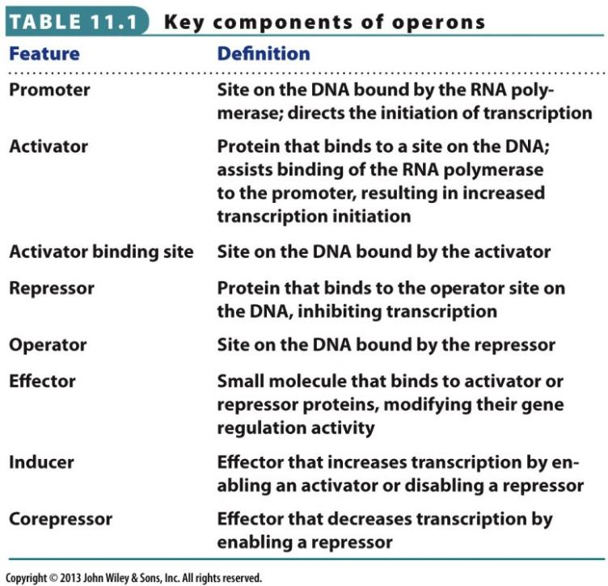

- Regulating Transcription
  - Controls synthesis of enzymes
  - Positive Control
    - Allosteric protein activates synthesis
    - Activate binding of RNA polymerase to DNA (bind to activator site)
    - Maltose catabolism
      - Maltose activator protein only binds DNA in presence of maltose
    - Positively controlled promoters only weakly bind RNA polymerase
  - Negative Control
    - Allosteric protein inhibits synthesis
    - May involve repression or induction
      - Repression
        - Inhibits in response to a signal
        - Affects anabolic enzymes
      - Induction
        - De-repression of enzyme production in response to a signal
        - Affects catabolic enzymes
        - Enzymes made only when substrates are available
  - Effectors (allosteric molecules)
    - Interact with DNA binding proteins
    - Co-inducer/co-activator: turns on enzyme production
    - Co-repressor: binds and activates a repressor
- Lac Operon
  - Not expressed until all glucose is consumed
    - Diauxic growth (2 phases)
  - Inducible expression
  - Negative control
    - Repressor protein (LacI) binds to operator, blocks RNA polymerase, inhibits transcription
    - Effector molecule (allolactose) induces transcription by inhibiting binding of repressor to operator
      - Can also inhibit transcription by binding to repressor protein and enhancing ability to bind to operator
  - Positive Control
    - Activator protein (cAMP receptor protein, CRP) binds and increases transcription rate when effector present (cAMP) – low glucose
    - Effector induces conformational change in activator, which increases affinity for binding site, increases RNA polymerase affinity for Lac Operon promoter
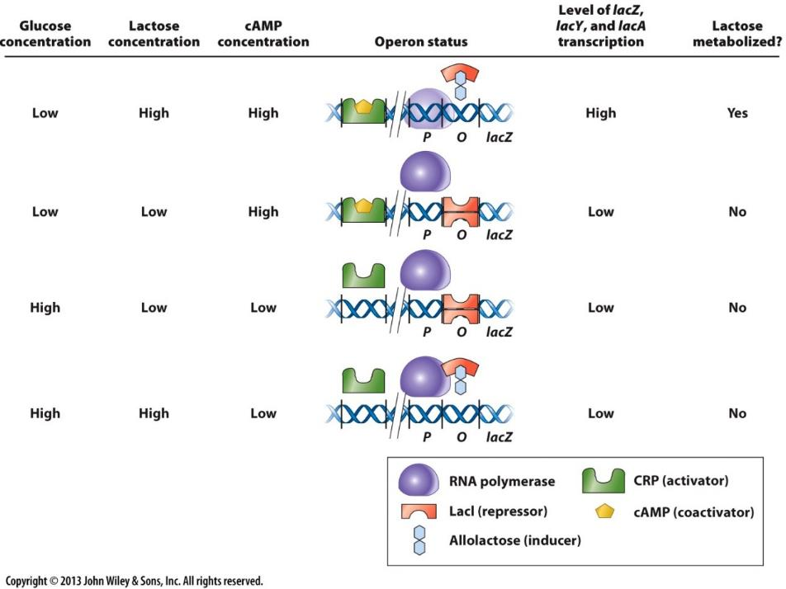
  - Control of Lac Operon

Transcription/Translation
- Attenuation
  - Interruption of transcription after initiation but before termination
  - Control by mRNA secondary structure
  - Interactions between translation and transcription
    - If Ribosome quickly follows RNA polymerase, rho-independent hairpin are formed in the leader sequence
    - Stalling out of ribosome in mRNA leader sequence allows transcription to continue (not enough aa loaded in tRNA)
  - Does not occur in eukaryotes
    - Nucleus
Quorum Sensing
- Quorum: members of a group that must be present in order to conduct business
  - Chemical signalling system that allows communication between microbes
  - Regulation of gene expression based on population density
    - Autoinducer molecules released as population density increases
    - Change in autoinducer levels cause regulation of gene expression
  - Quorum sensing
    - Based on population density
    - Positive feedback
    - Rapid induction
    - Links behaviour to population density
    - Coordinates expensive, additive processes
    - Has a role in interactions with eukaryotes
  - Ex. A. fischeri – lux system
    - Live in symbiosis with the bobtail squid
      - Cells only emit light when in the light organ of the squid
        - When high population density, cells produce AHL – stimulates luminescence
        - luxI protein catalyzes AHL synthesis
        - luxR (regulatory transcriptional activator), interacts with AHL in high concentration
          - binds lux box DNA activator
          - causes transcription of luciferase protein and luxI, creating more AHL
  - quorum mechanisms
    - motility
    - conjugation
    - biofilm formation
    - pathogenesis
  - autoinducers can play a role in competition by interrupting/inhibiting a control pathway in other organisms
2 component regulatory systems
- can use one protein as a sensor and another to control transcription
- allows for response to changes to environment
- signal transduction induced in the cell alters it to respond appropriately
- systems involve
  - sensor kinase (i.e. HPK): detects environmental stimulus
  - response regulator (RR): regulates transcription
- virulence of A. tumefaciens
  - vir genes found on the Ti plasmid only expressed conditions such as a plant wound site
  - virA/virG are required for expression of other virulence genes
- different 2 component systems can allow microbes to respond differently to environmental stimuli
  - can pair certain HPKs and RRs to better control gene expression
Chemotaxis
- bacterial behaviour modulated by protein activity shifts
- can sense changes in chemical gradients
- changes directed and duration of flagellar motion
- Study of Chemotaxis using Mutants
  - Chemotaxic microbes move into capillary tube
  - Non chemotaxic microbes will remain out of the tube
- Regulation
  - Response to Signal
    - MCPs sense specific attractants/repellants
      - Initiate signal transduction (or doesn’t)
  - Control of Flagella rotation
    - CheY protein
      - Phosphorylated by CHeA-P when attractants are low
      - CheY-P initiates flagellar reversal (tumbling)
  - Adaptation
    - Feedback loop
      - Allow system to reset itself
      - Allows temporal detection of signal concentration
      - Requires modification of MCPs by methylation
        - During periods of very high attractant levels
        - Only highly methylated MCPs
          - If not high levels of attractant, phosphorylation of CheA/B will lead to demethylation
        - results in greater sensitivity to attractants, avoid saturation
  - Che Proteins
    - CheA: sensor kinase, becomes phosphorylated
      - Phosphorylates CheY (RR protein)
    - CheY binds to flagellar motor, changing the activity
  - By interacting with CHeW proteins, autophosphorylation of CheA is modulated
    - Attractants decrease phosphorylation
    - Repellants increase phosphorylation
    - Provides for longer sustained runs of direction motion when attractants are present
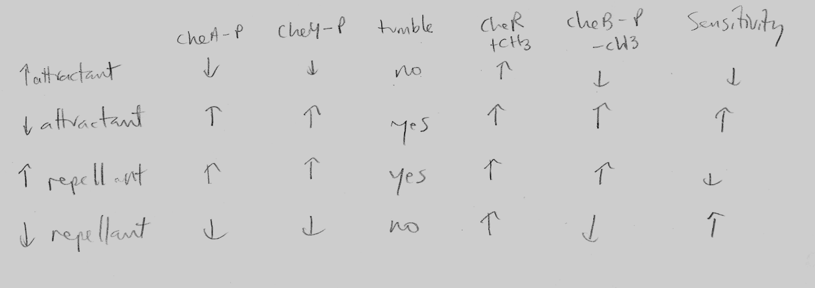
- In Summary

Regulons
- Sets of genes that are coordinated together (respond to same systems)
- Catabolite repression: shutdown of several systems that use nutrients in presence of glucose
- SOS response: multi gene system for wide scale DNA repair for serious DNA damage
  - RecA & lexA most important proteins
- Alternative Sigma Factors
  - Different sigma factors direct RNA polymerase to different genes
  - E. coli promoters are recognized by sigma 70
  - Sigma 54: nitrogen use regulator
  - Sigma 32: heat shock regulator
  - Sigma 38: general stress response regulator

Topic 9: Genetics
Introduction
- Organization of Bacterial Genomes
  - Single chromosome and plasmids
  - Replicon
  - Plasmid copy number in cell is closely regulated
  - Bacteriophage DNA can also be present
- Microbial Genetics
  - Model systems very important ( E. Coli, Salmonella)
Mutations
- Bacteria are ideal genetic research candidates
  - 1 chromosome – easy to detect mutations
- Terminology
  - Allele
    - Can be gain/loss/change of function
  - Auxotroph
    - Mutant unable to make a compound
    - Mutation in amino acid synthesis
  - Prototroph
    - Wild type that doesn’t need any additional growth supplement
    - Auxotroph’s parental strain
- Studying Mutants
  - Changes in genes are often visible by changes in phenotype or growth patterns
  - Selection
    - Isolation of cells with particular genotype on the basis of growth
    - Can select for His+ on basis of growth but can’t directly select His-
    - Selectable mutations generally grant a growth advantage under specific conditions (conditions that kill wild type)
    - Non-selectable mutations
      - Neither advantageous nor disadvantageous
      - Detection requires screening
    - Phenotypic selection
      - Use a growth medium that will inhibit microbes lacking desired genes
        - Generally an antibiotic medium
  - Screening
    - Identification of cells with a phenotype
    - Colour, morphology, no growth”
    - Can select His- by screening
    - Replica plating
      - 2 different growth mediums are made from a master plate
    - Phenotypic screening
      - Duplicate plates are created (one lacks a nutrient)
      - Mutation occurs where colony grows on full support plate but not on partial support plate
  - Patching
    - Transferring colonies to gridded plate manually one by one
Mutations
- Reversion
  - Mutation that corrects mutant back to wild type
  - To avoid, use double/triple auxotroph mutant strains
- Spontaneous Mutations
  - Lederberg experiments showed it occurs without selective pressure
    - Cells not exposed to antibiotics can still become resistant even without exposure
  - Luria and Delbruck showed variable resistance to phage infection arises without selective pressure
Restriction Enzymes and Cloning
- Restriction Enzymes
  - Cut DNA at palindromic recognition site
    - Similar ends of cut DNA can be paired and ligated
- Modification Enzymes
  - Pair with REs
    - In a single operon
    - Referred to as R/M systems
    - Same recognition site as paired RE
  - Methyltransferase activity protects DNA from endonuclease activity
- Cloning Vectors
  - REs allow researcjers to stitch together useful DNA into recombinant molecules
    - Recombinants can be used to clone bacteria of interest
  - Used to insert a recombinant DNA molecules into a recipient
    - Plasmids
    - Phages
    - Cosmids
  - Plasmid Cloning Vectors
    - Cut fragments from 2 plasmids with antibiotic resistance with same RE
    - Transformed strain has both traits
    - Desired plasmid traits
      - Origin of replication
      - Selectable marker gene
      - Multiple cloning site
      - Small size
      - High copy number
  - Shuttle Vector Plasmids
    - Have multiple types of origins
      - Expands the range of host cell types the plasmids can be inserted into
- Screening for Transformed cells
  - X-gal system
    - Visual blue/white colony growth
- Phage Vectors
  - Mix viral DNA with fragment of interest
  - Carry 20kb fragments
- Cosmids
  - Phage genomes that omit nearly all the phage DNA, leaves more room for the fragment
  - Only critical phage cos packaging recognition sites remain
  - Multiple cloning site
  - Antibiotic selection marker
  - Carry 35-45 kb fragments
DNA Transfer
- Transformation
  - Introduction of extracellular DNA directly into an organism
  - No cell-cell contact
  - Some bacteria are naturally competent
    - Others can be artificially induced
      - Treatment with calcium cations
      - Electroporation
- Conjugation
  - Transfer of DNA from cell to cell via direct contact/sex pilus formation
  - Mechanism
    - F plasmid carries gene to form sex pilus bridge
    - F plasmid can be copied and sent across bridge into recipient cell
    - Turns an F-cell into an F+ cell capable of conjugating another F- cell
    - tra genes in a group next to oriT gene
  - F plasmid can integrate into the host by homologous recombination
    - Its an episome (can integrate in DNA or exist autonomously)
  - Hfr (high frequency of recombination) strain DNA transfer
    - Can be used to map the location of genes in host chromosome
  - Generation of F plasmids
    - Incorporated F plasmid excises itself and some of host DNA
    - Conjugates itself as well as host DNA
  - Uses of conjugation
    - Triparental conjugation
      - Using recombinant plasmid lacking tra gene and a helper plasmid with the gene
      - More room for desired DNA fragment

- Transposition
  - Movement of DNA via mobile genetic elements
  - Can move within and between genomes
  - Found in corn by McClintock
  - Subdivided into
    - Insertion sequences
      - Encode only proteins needed for transposition
    - Transposons
      - Contain other genes with those needed for transposition
  - Mechanism
    - Requires transposase and resolvase genes
    - Replicative transposition
      - Copies the element and moves the copy to another location
    - Non-replicative transposition
      - Cuts and pastes the elements into a new location
  - Can be used to disrupt functional genes and observe phenotypic changes
  - Suicide vector plasmid carrying the transposon
    - Recipient cell gets the plasmid, but plasmid can’t replicate
    - Transposition still occurs at random
    - Screening/selection for desired disruption follows
- Transduction
  - Virus accidentally packages a fragment of host cell DNA
    - Delivers that fragment instead of viral DNA
    - Now unable to replicate because it lacks the viral genome
    - Homologous recombination must occur
  - Co-transduction frequency was used to map bacterial genomes
    - Genes close to a marker gene would be transduced more frequently than ones further away from the marker
    - Can also be used to modify bacteria
      - Only performed in vitro

Topic 10: Microbial Genomics
Genomics
- Genome: entire complement of genetic info.
  - Genes, regulatory sequences, non-coding sequences
- Genomics: discipline involving mapping, sequencing, analyzing, and comparing genomes
- Functional Genomics: assigning function to unknown genes by analyzing biochemical and physiological effects of mutants
- Sanger/Dideoxy DNA Sequencing
  - 3 steps
    - Cloning gene fragment of interest
    - DNA synthesis
    - Electrophoresis
  - DNA polymerase requires a free 3’ OH to continue synthesis
  - Placing dideoxynucleotides into DNA synthesis mixture terminates process with a labeled end-point nucleotide
  - Gel electrophoresis separates the fragments and detects which labeled nucleotide is on the end of each fragment, providing a sequence
  - Automated methods use fluorescent labels rather than radioactive labels
  - Longer sequences obtained by primer walking
    - Using repeated rounds of sequencing with primers complementary to the end of the last segment sequenced
- Shotgun Sequencing
  - Attempting to sequence entire genome in one setup
  - DNA fragments are sheared, cloned, then sequenced
  - Software aligns/assembles sequences
- Pyrosequencing
  - Detects addition of a nucleotide to the end of a strand of DNA by production of light
  - Faster/cheaper than Sanger Method
  - DNA doesn’t need to be cloned, only fragmented
  - Sequencing reactions carried out at once in well format
  - Software analysis evaluates the reaction results
Bioinformatics
- Use of tools to analyze, compare, assemble, and store DNA & protein sequences
- Annotation of genomes helps people identify open ready frames (ORFs)
  - Allows to better determine the start and stop points for a given gene
Transcriptomics
- Transcriptome: collection of transcribed mRNA molecules in a cell
- A library of expressed mRNA molecules of a cell can be formed as a cDNA library using reverse transcriptase
- Can be sequenced directly, or analyzed by microarrays
- RNA sequencing
  - Performed by conversion of mRNA into cDNA by reverse transcriptase
  - cDNA then sequenced using rapid automated methods
  - used to study Saccharomyces cerevisiae
- microarrays
  - method to simultaneously examine transcriptional activity of all genes in a cell
  - probe DNA fragments are amplified by PCR and placed on a glass slide
  - total cell mRNA is converted to cDNA by reverse transcriptase, labelled with fluorescent molecule, and passed over the microarray slide
  - more intensely a spot on the microarray lights up, more cDNA present
  - uses:
    - global gene expression
    - expression of specific gene classes under different conditions: regulons
      - includes mutants
    - expression of genes with unknown function
      - discover clues
    - comparison of gene content in related organisms
    - species identification
Proteomics
- Proteome: collection of expressed proteins in a cell
- Methods of study
  - 2D PAGE
    - Allows separation of proteins on a gel based on
      - Isoelectric point (pH with protein has no charge)
    - Mass
  - Mass spectrometry
    - Can determine amino acid sequences of the polypeptides from 2D PAGE
    - Comparison of sequence to known protein sequences can determine identity
  - X-ray crystallography
    - X ray beam shot a crystallized protein
    - Diffraction pattern used to discern protein shape
  - Nuclear magnetic resonance (NMR)
    - Measures distances between atomic nuclei
    - Can measure proteins in solution
    - Limited to proteins of about 30 kDa
Metagenomics
- Involves construction and analysis of gene libraries from DNA extracted directly from complex microbial communities
- Can help discover new organisms in
  - Acid mine drainage
  - Deep sea thermal vents
  - Wastewater treatment areas
- Some genes discovered have possible applications in biotechnology and nanotechnology
- Method
  - Obtain DNA
  - Sequence
  - Analyze
    - Eliminate known sequences that to find new genes, potentially from new organisms

