- The Anatomical Position of the Human Body (see Table 1.1)
- - To describe body parts/positions precisely & with as few words as possible:
  - a) an initial reference point = body in standard anatomical position
  - b) an indication of direction - remember that “right” and “left” refer to the patient or the cadaver, not the observer

- Regional Terms
  - The two fundamental divisions of our body are its axial and appendicular parts.
  - The axial part, which makes up the main axis of our body, includes the neck, head, and trunk. The appendicular part consists of the appendages or limbs, which are attached to the body’s axis.
  - The Regional Terms used to designate specific area used to designate specific areas within the axial or appendicular part of the body

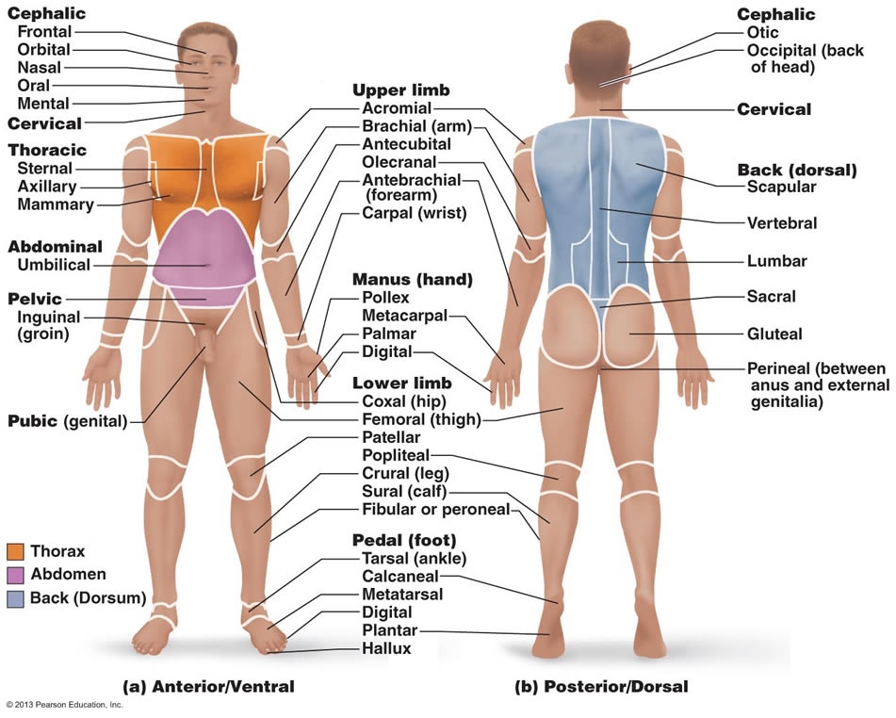

Body Planes and Sections
- - 3 common body planes - 2 are vertical & 1 is horizontal
  - A sagittal plane “arrow” is a vertical plane that divides the body into right and left parts. The sagittal plane that lies exactly in the midline is the median plane or midsagittal plane. All other saggital planes offset from midline are parasagittal planes (para=near).
  - Frontal planes, like sagittal planes, lie vertically. Frontal planes, however, divide the body into anterior and posterior parts. A frontal part is also called a coronal plane. “Crown”
  - A transverse or horizontal plane runs horizontally from right o left, dividing the body into superior and inferior parts. Of course, many different transverse planes exist, at every possible level from head to foo. A transverse section is also called a cross section.
  - Oblique sections are cuts made diagonally between the horizontal and the vertical planes. Because oblique sections are often conducing and difficult to interpret, they are seldom used.
- 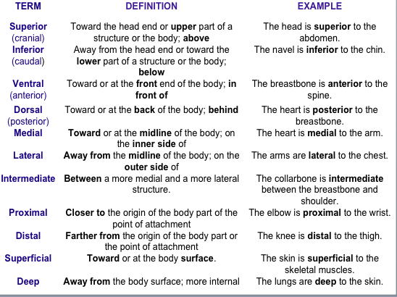

- Dossal Body Cavity
  - The dorsal body cavity, which protects the fragile nervous system organs, has two subdivisions. The cranial cavity, in the skull, encases the brain. The vertebral, or spinal cavity, which runs within the bony vertebral column, encloses the delicate signal cord. The spinal cord is essentially a continuation of the brain, and the cranial and spinal cavities are continuous with one another.

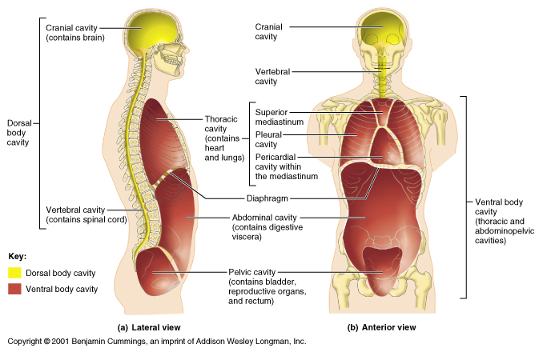

Ventral Body Cavity
  - The more anterior an larger of the close body cavities is the ventral body cavity. Like the dorsal cavity, it has two major subdivisions, the thoracic cavity and the abdominopelvic cavity. The ventral body cavity houses internal organs collectively called viscera, or visceral organs.
  - The superior subdivision, the thoracic cavity, is surrounded by the ribs and muscles of the chest. The thoracic cavity is further subdivided into lateral pleural cavities each enveloping a lunch and the medial mediastinum. The mediastinum contains the pericardial cavity, which encloses the heart, and it also surrounds the remaining thoracic organs.
  - The thoracic cavity is separated from the more inferior abdominopelvic cavity by the diaphragm, a dome-shaped muscle important in breathing. The abdominaoelvic cavity, as it names suggest, has two parts. However, these regions are not physically separated by a muscular or membrane wall. Its superior portion, the abdominal cavity, contains the stomach, intestine, spleen, liver, and other organs
  - The inferior part, the pelvic cavity, lies in the bony pelvis and contains the urinary bladder, some reproductive organs, and he rectum.

- Abdominopelvic Quadrants

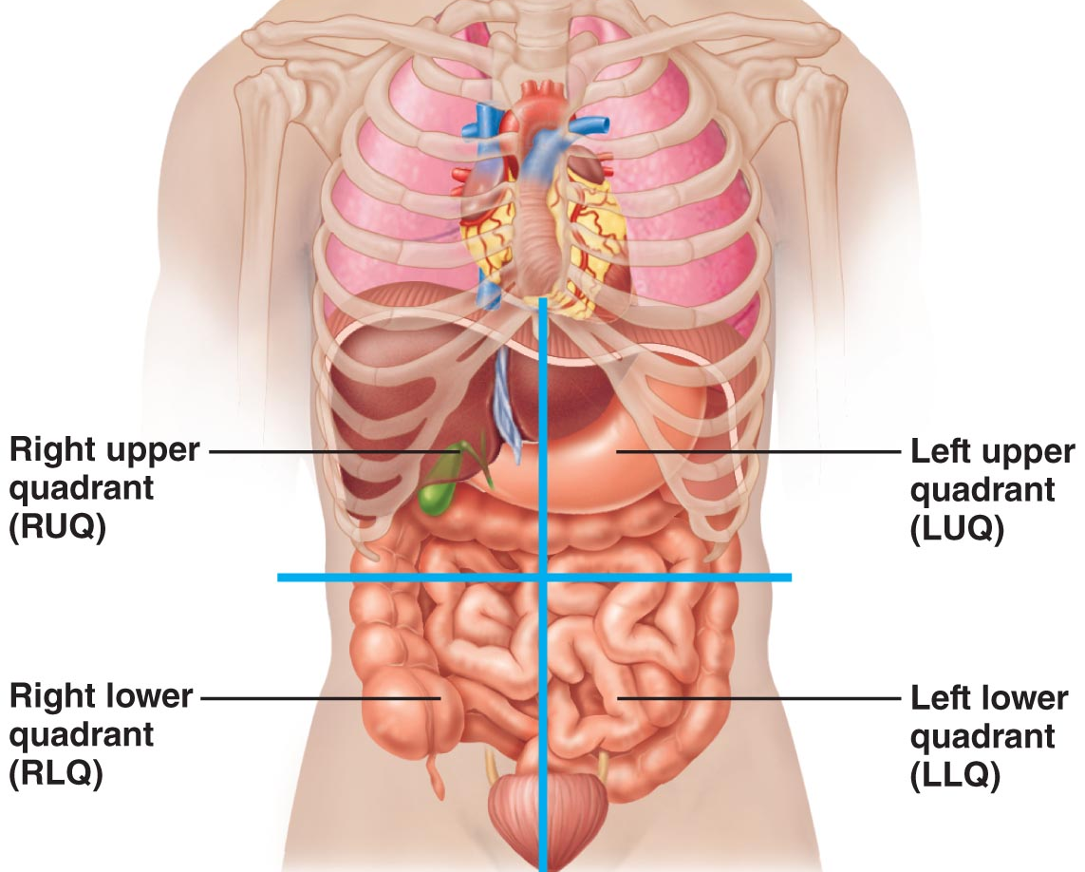

- Nine abdominopelvic regions
- 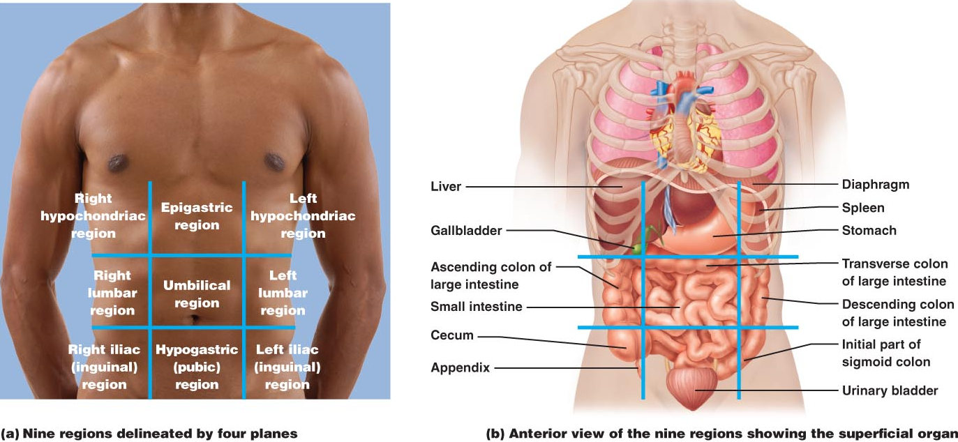

- The Structure of Skin
- • 2 distinct regions: epidermis (epithelial layer - thick, keratinized stratified squamous epithelium) and dermis (CT)

Epidermal cells (4 types):
  - Keratinocytes: The chief role of keratinocytes is to produce keratin, the fibrous protein that helps give the epidermis its protective properties. Millions of dead keratinocytes rub off every day, giving us a totally new epidermis every 25-45 days, but cell production and keratin formation is accelerated in body areas regularly subjected to friction, such as hands and feet.
  - Melanocytes: The spider shaped epithelial cells that synthesise the pigment melanin, are found in the deepest layer of the epidermis. AS melanin is made, it accumulates n membrane-bound granules called melanosomes that motor proteins move along actin filaments to the ends of the melanocytes processes. From there they are transferred to a number of nearby keratinocytes. The melanin granules accumulate on the superficial or “sunny”, side of the keratinocyte nucleus, forming a pigment shield that protects the nucleus from the damaging effects of ultraviolet radiation in sunlight.
  - Dendritic Cells: the star-shaped dendritic cells arise from bone marrow and migrate to the epidermis. Also called landerhans cells after a German anatomist, they ingest foreign substances and are key activators of our immune system. Their slender processes extend among the surrounding keratinocytes, forming a more or less continuous network.
  - Tactile Cells: Occasional tactile (Merkle) cells are present at the epidermal-dermal junction. Shaped like a spiky hemisphere each tactile ell is intimately associates with a disclike sensory nerve ending. The combination, called a tactile or Merkle disc, functions as a sensory receptor for touch.

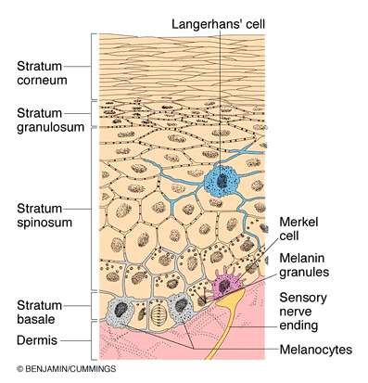

The main structural features of the skin epidermis

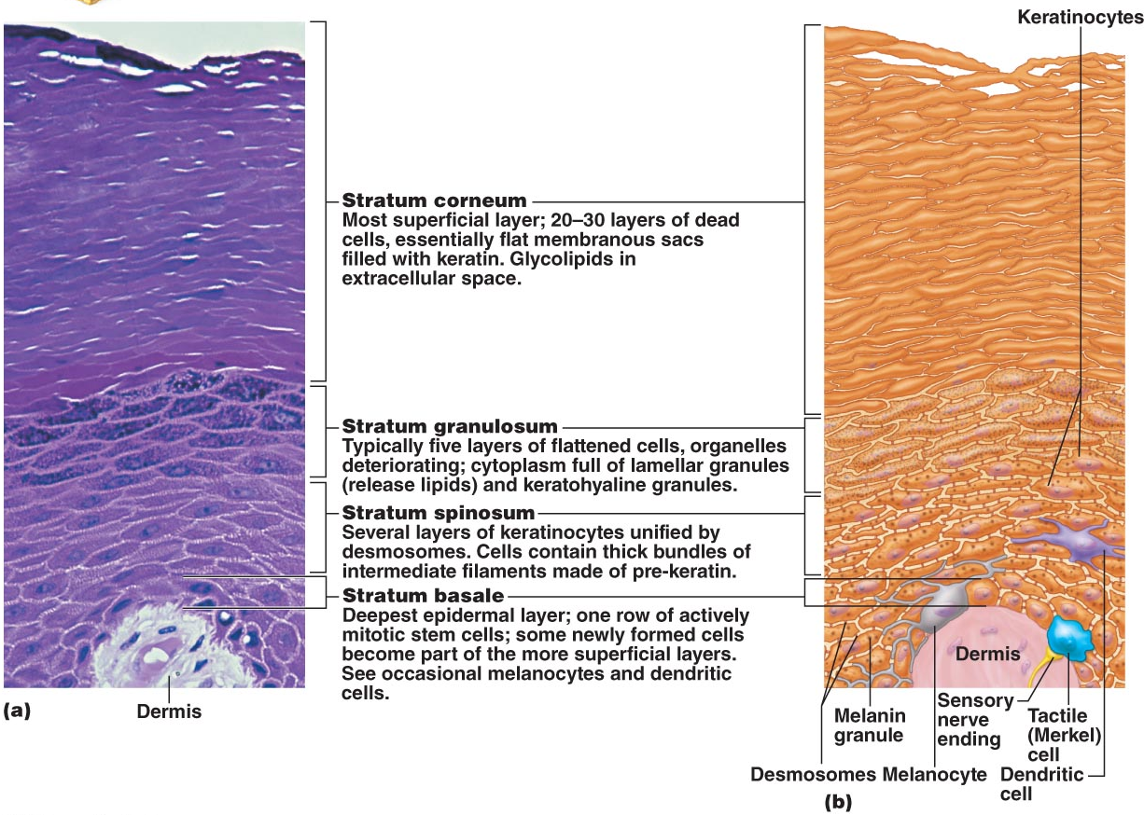

Layers of Epidermis
  - Thin Skin: which covers areas subject to abrasion – the palms, fingertips, and soles of the feet – the epidermis consists of five layers, or strata (“bed sheets”).
  - Thin Skin: which covers the rest of the body, the stratum lucidum appears to be absent and the other strata are thinner.
  - Note: The thickets skin in the body is on the upper back

- Stratum Lucidum (Clear Layer)
  - Visible only in thick skin
  - Is a thin translucent band just above the stratum granulosum. Considered by some to be subdivision of the superficial stratum corneum, it consist of two or three rows of clear, flat, dead keratinocytes with indistinct boundaries.

Describe the layers of the dermis
  - Cell types typical of CT: fibroblasts, macrophages, some mast cells, WBCs
  - semi-fluid matrix heavily embedded with collagen, elastin & reticular fibers
  - richly supplied with nerve fibers, blood & lymphatic vessels
  - also hair follicles, oil & sweat glands

- Papillary Layer:
  - thin, areolar connective tissue in which fine interlacing collagen and elastic fibers form a loosely woven mat that is heavily invested with small blood vessels.
  - The looseness of this CT allows phagocytes and other defensive cells to wander freely as they patrol the area for bacteria that have breached the skin.
  - Peglike projections from its surface, called dermal papillae, indent the overlying epidermis. Many dermal papillae contain capillary loops. Others house free nerve endings (pain receptors) and touch receptors called tactile or Meissners corpuscle.
  - Friction ridges are assumed to enhance the gripping ability of the fingers and feet like tire tread help grip the road.

- Reticular Layer:
  - Deep layer, accounting for about 80% of the thickness of the dermis irregularly arranged, is coarse, dense fibrous CT.
  - source of lines of cleavage/tension lines
  - The collagen fibers of the dermis give skin strength and resiliency that prevent most jabs and scrapes from penetrating the dermis. In addition, the collagen binds water, helping to keep skin hydrated. Elastic fibers provide the stretch-recoil properties of skin.
  - Fixture Lines, a third type of skin is a dermal fold that occur at or near joints, where the dermis is tightly secured to deeper structures. Also visible on the wrists, fingers, soles and toes.

- Extreme stretching of the skin, such as during pregnancy, can tear the dermis, leaving silvery white scars called striae, commonly called “stretch marks”. Short term but acute trauma can cause a blister a fluid-filled pocket that separates the epidermal and dermal layers.

- What is the hypodermis?
  - superficial fascia, subcutaneous tissue
  - areolar CT + blood vessels & adipose tissue
  - anchors skin to underlying structures with ability to slide
  - shock absorber & insulation
  - stores fat

Skin Color
  - Melanin is a polymer made of tyrosine amino acids. Its two forms range in color from reddish yellow to brownish black. Its synthesis depends on an enzyme in melanocytes called tyrosinase and as noted earlier it passes from melanocytes to the basal keratinocytes. Eventually, lysosomes break down the melanosomes, so melanin pigment is found only in the deeper layers of the epidermis.
  - When we expose our skin to sunlight, keratinocytes secrete chemicals that stimulate melanocytes. Prolonged sun exposure causes a substantial melanin buildup, which helps protect the DNA of viable skin cells from UV radiation by absorbing the rays and dissipating the energy as heat.
  - Despite melanin’s protective effects, excessive sun exposure eventually damages the skin. It causes elastic fibers to clump, which results in leathery skin; temporarily depresses the immune system; and can alter the DNA of skin cancer less often than fair-skinned people and get it in areas with less pigment attests to melanin’s effectiveness as a natural sunscreen.
  - Carotene: is a yellow to orange pigment found in certain plant products such as carrots. It tends to accumulate in the stratum corneum and in fatty tissue of the hypodermis. Its colour is most obvious in the palms and soles, where the stratum corneum is thicket and most intense when large amounts of carotene rich foods are eaten.
  - Haemoglobin: the pinkish hue of fair skin reflects the crimson color of oxygenated pigment haemoglobin in the red blood cells circulating through the dermal capillaries.
  - Cyanosis: dark blue, when haemoglobin is poorly oxygenated both the blood and the skin of Caucasians appear blue.

- Appendages of the Skin
  - Along with the skin itself, the integumentary system includes several derivatives of he epidermis. These skin appendages include hair and hair follicles, nails, sweat glands, and sebaceous (oil) glands. Each plays a unique role in maintaining body homeostasis.

- Hair Follicles and Hair
  - functions of hair:
    - sense insects on skin
    - guard head for physical trauma, heat loss, sun
    - shield eyes, filter particles from inhaled air
    - hard keratin (more durable, doesn’t flake)

Structure of Hair
  - The medulla “middle” ,its central core, consist of large cells and air spaces. The medulla, which is the only part of the hair that contains soft keratin, is absent in fine hairs.
  - The cortex, a bulky layer surrounding the medulla, consists of several layers of flattened cells.
  - The outermost cuticle is formed from a single layer of cells overlapping one another like shingles on a roof. This arrangement helps separate neighbouring hairs so the hair does not mat. The most heavily keratinized part of the hair, the cuticle provides strength and helps keep the inner layers tightly compacted.
  - Because it is subjected to the most abrasion the cuticle tends to wear away at the tip of the hair shaft, allowing keratin fibrils in the cortex and medulla to frizz out, creating “Split ends”.
  - When melanin production decreased and air bubbles replace melanin in the hair shaft, hair turns grey or white.

- Hair structure:
  - Shaft: part that projects from skin - has 3 layers indicated on previous slide
  - root: part embedded in skin (contained within hair follicle)
  - bulb: expanded deep end of follicle - has papilla & root hair plexus
  - follicle: outer CT root sheath & inner epithelial root sheath; hair matrix
  - arrestor pili muscle: 1/follicle; contract to pull hair up & dimple skin
  - sebaceous gland: holocrine gland that secretes sebum (oily - lubrication & waterproofing; bactericidal)
- 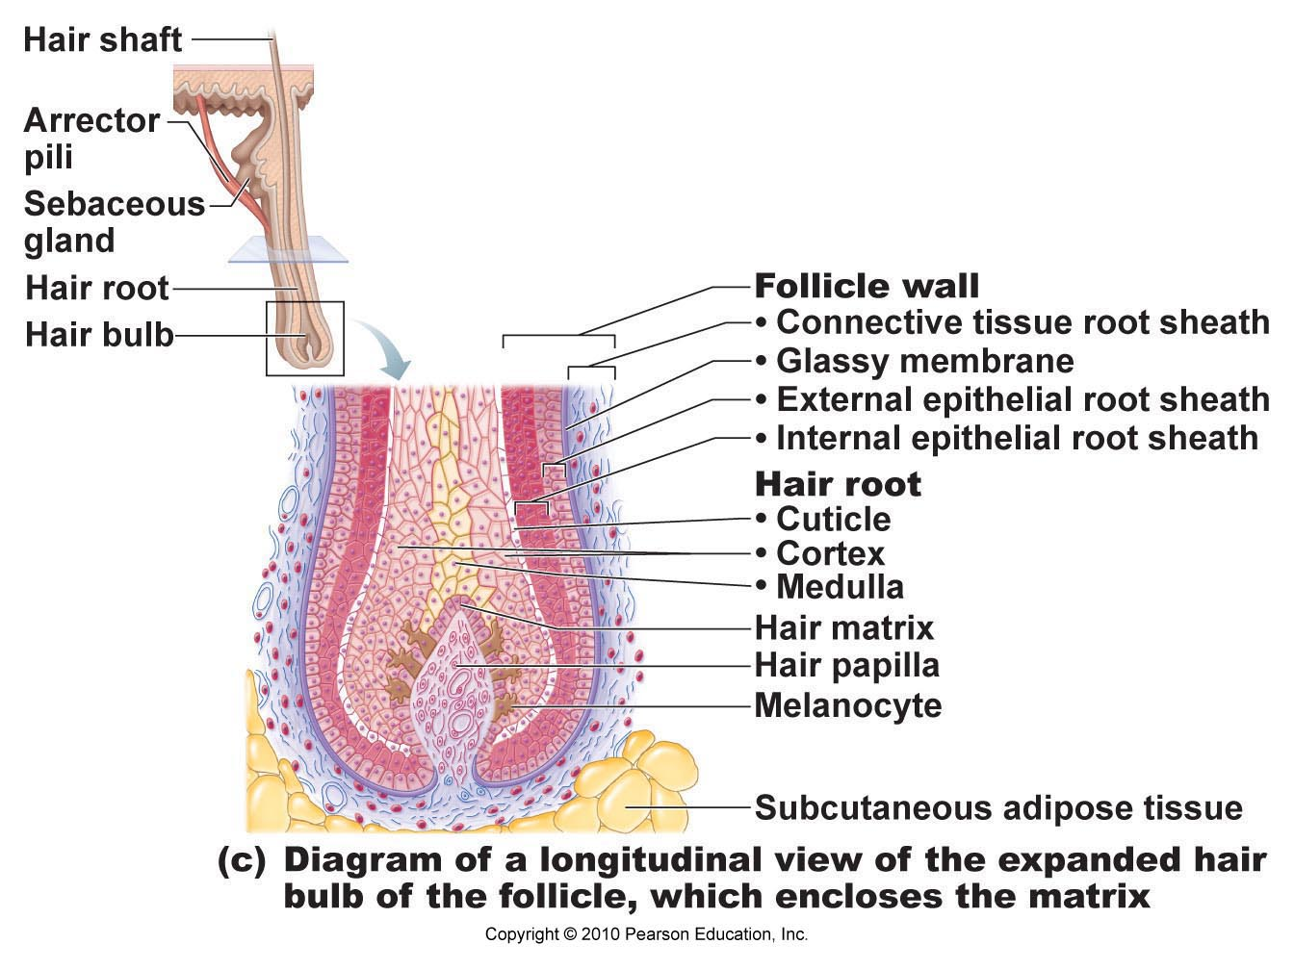

- Types and Growth of Hair
  - Hair comes in various sizes and shapes, but as a rule they can be classified as vellus or terminal. The body hair of children and adult females is pale, fine vellus hair. The coarser, longer hair of the eyebrows and scalp is terminal hair, which may also be darker.
  - Hirsutism: excessive hairiness, as well as other signs of masculinization for a women, may result from an adrenal gland or ovarion tumour that secretes abnormally large amounts of androgens.
  - The rate of hair growth varies from one body region to another and with sex and age, but it averages 2.5 mm per week. Each follicle goes through growth cycles. In each cycle, an active growth phase, ranging from weeks to years, is followed by a regressive phase. Drying the regressive phase, the hair matrix cells die and the follicle base and hair bubble shrivel somewhat, dragging that hair papilla upward to abut the region of the follicle that does not regress.
  - The life span of hairs varies appears to be controlled a slew of proteins. The follicles of the scalp remain active for six to ten years before becoming inactive for a few months. Because only a small percentage of the hair is shed at any one time, we lose an average of 90 scalp hairs daily. The follicles of the eyebrow hairs remain active for only three to four months, which explains why your eyebrows are never as long as the hairs on your head.

Hair thinning and baldness:
  - Alopecia: hairs are shed faster than they are replaced leads to hair thinning and some degree of baldness
  - Male pattern baldness: is a genetically determined, sex-influced condition.

- Nails:
  - Nail: is a scale like modification of the epidermis that forms a clear protective covering on the dorsal surface of the distal part of a finger or toe.
  - In contrast to soft keratin of the epidermis, nails contain hard keratin. Each nail has a free edge a nail plate or body and a proximal root.
  - The region that lies over the thick nail matrix appears as a white crescent called the lunule.
  - The nail apparatus consists of a horny "dead" product, the nail plate, and four specialized epithelia: the proximal nail fold, the nail matrix, the nail bed, and the hyponychium.

- Nails can provide some clues as to health status:
  - Yellow-tinged: fungal infection or a serious respiratory or thyroid gland disorder
  - Thickened: a fungal infection
  - Spoon nail: possible iron deficiency
  - Beau’s lines (horizontal): malnutrition (sporadic stoppage of matrix growth)

Sweat Glands
  - Also called sudoriferous glands, are distributed over the entire skin surface except the nipples and parts of the external gentilia. There number is staggering- up to 3 milllion per person
- Eccrine (Merocrine) SG:
  - Also called merocrine sweat glands, are far more numerous and are particularly abundant on the palms, soles of the feet and forehead. Each is a simple, could, tubular gland.
- Apocrine Swear Glands:
  - Approx. 2000 of them, are largely confined to the axillary and anogential areas.
  - Larger than the eccrine gland, they lie deeper in the dermis or even in the hypodermis, and their ducts empty into hair follicles.
  - Apocrine secretion contains the same basic components as true sweat, plus fatty substances and proteins.
  - The secretion is odourless, but when bacteria on the skin decompose its organic molecules, it takes on a musky and generally unpleasant odour, the basis of BO.
  - Apocrine glands being functioning at puberty under the influence of the male sex hormones and play little role in mainting a constant body temp.
  - Ceruminous glands: are modified apocrine glands found in the lining of the external ear canal. Their secretion mixes with sebum produced by nearby sebaceous glands to form a sticky, bitter substance called cerumen, or earwax, that is thought to deter insects and block entry of foreign material.
  - Mammary glands, another variety of specialiexed sweat glands, secrete milk. Although they are properly part of the integumentary system.

- Functions of the Integumentary System
- 1. Protection: 3 types of barriers
  - Chemical: secretions, melanin
  - Physical: barrier to trauma & bacterial invasion; also waterproofing
  - Biological: Langerhans cells of epidermis & macrophages in dermis
  - Not impermeable to: gases, fat-soluble vitamins & steroids, plant oleoresins, organic solvents, salts of heavy metals, penetration enhancers for drug administration

- 2. BODY TEMPERATURE: sweating (0.5-12 L fluid/day). When the external environment is cold, dermal blood vessels constrict. Their constriction causes the warm blood to bypass the skin temporarily and allows skin temperature to drop to that of the external environment. This slows passive heat loss from the body, conserving body heat.

- 3. CUTANEOUS SENSATION: The skin is richly supplied with cutaneous sensory receptors, which are actually part of the nervous system. The cutaneous re- ceptors are classified as exteroceptors (ek0ster-o-sep9torz) because they respond to stimuli arising outside the body. For example, tac- tile (Meissner’s) corpuscles (in the dermal papillae) and tactile discs allow us to become aware of a caress or the feel of our clothing against our skin, whereas lamellar (also called Pacinian) corpuscles (in the deeper dermis or hypodermis) alert us to bumps or con- tacts involving deep pressure. Hair follicle receptors report on wind blowing through our hair and a playful tug on a pigtail. Free nerve endings that meander throughout the skin sense painful stimuli (irritating chemicals, extreme heat or cold, and others).

- 4. METABOLIC: eg: vitamin D, carcinogens, conversion of topically-applied cortisone to hydrocortisone. Among its other metabolic functions, the epidermis makes chemical conversions that supplement those of the liver. For example, keratinocyte enzymes can
- “Disarm” many cancer-causing chemicals that penetrate the epidermis
- Convert some harmless chemicals into carcinogens
- Activate some steroid hormones—for instance, they can transform cortisone applied to irritated skin into hydrocorti- sone, a potent anti-inflammatory drug

- 5. BLOOD RESERVOIR: The dermal vascular supply is extensive and can hold about 5% of the body’s entire blood volume. When other body organs, such as vigorously working muscles, need a greater blood sup- ply, the nervous system constricts the dermal blood vessels. This constriction shunts more blood into the general circulation, making it available to the muscles and other body organs.

- 6. EXCRETION: The body eliminates limited amounts of nitrogen-containing wastes (ammonia, urea, and uric acid) in sweat, although most such wastes are excreted in urine. Profuse sweating is an impor- tant avenue for water and salt (sodium chloride) loss.

- Burn
  - A tissue damage inflicted by intense heat, electricity, radiation or certain chemicals, all of which denature cell proteins and kill cells in the affected areas.
  - First degree burns: only the epidermis is damaged.
  - Second Degree Burns: injure the epidermis and the upper region of the dermis.
  - Third Degree Burns: are full-thickness burns, involving the entire thickness of he skin.

- Treatment to Burns:
  - To prepare a burned area for a skin graft, the eschar or burned skin, must first be debrided (Removed). To present infection and fluid loss, the area s then flooded with antibiotics and covered temporarily with a synthetic membrane, animal (pig) skin, cadaver skin, or “living bandages” made from the thin amniotic sac membrane that surrounds a fetus.
- 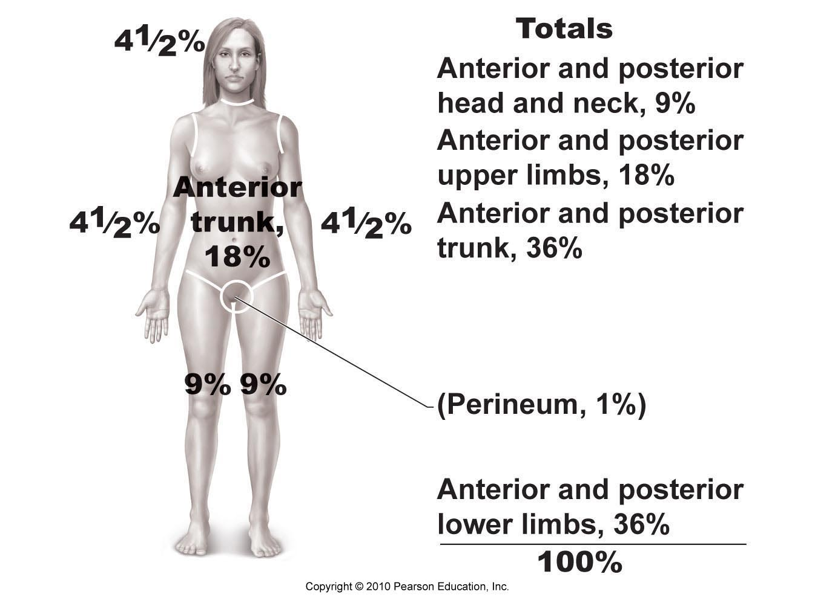
- BONES & SKELETAL TISSUES
- Bone is a living dynamic tissue which responds to its environment:
  - 1) Bone reacts to amount of force applied by increasing both the density & amount of roughening on bone or decreasing density when force is reduced or eliminated (eg: paralysis) (deposition vs resorption)
  - 2) Bone stores calcium – resorbed & transferred to bloodstream when needed

- FUNCTIONS OF BONE
  - Support: Bones provide a framework that supports the body and cradles its soft organs. For example, bones of lower limbs act as pillars to support the body trunk when we stand, and the rib cage supports the thoracic wall.
  - Protection: The fused bones of the skull protect the brain. The vertebrae surround the spinal cord, and the rib cage helps protect the vital organs of the thorax.
  - Movement: Skeletal muscles, which attach to bones by tendons, use bones as levers to move the body and its parts. As a result, we can walk, grasp objects, and breathe. The design of joints determines the types of movements possible.
  - Mineral and growth factor storage: Bone is a reservoir for minerals, most importantly calcium and phosphate. The stored minerals are released into the bloodstream in their ionic form as needed for distribution to all parts of the body. Indeed, “Deposits” and “Withdrawals” of minerals to and from the bones go on almost continuously. Additionally, mineralized bone matrix stores important growth factors.
  - Blood Cell Formation: Most blood cell formation, or hematopoiesis occurs in the red cavities of certain bones
  - Triglyceride (fat) storage: Fat, a source of energy for body, is stored in bone cavities.
  - Hormone Production: Bones produce osteocalcin, a hormone that not only help regulate bone formation, but also protects against obesity, glucose intolerance, and diabetes mellitus.

- CARTILAGE features between dense CT & bone tough, but flexible
  - (i) Avascular, devoid of nerve fibers
  - (ii) Ground substance contains lots of the GAGs chondroitin sulfate & hyaluronic acid - also chondronectin, (adhesive protein)
  - (iii) Collagen fibers (can have some elastic fibers)
  - (iv) Up to 80% H₂O
  - chondroblasts: immature cartilage cells - actively form cartilage
  - Chondrocytes: mature cartilage cells maintain cartilage
  - Lacunae: localized clusters of chondrocytes in cartilage
  - Perichondrium “around the cartilage” contains no nerves or blood vessels and is surrounded by a layer of dense irregular CT.

Hyaline Cartilages:
  - Look like forested glass when freshly exposed; provide support with flexibility and resilience. They are the most abundant skeletal cartilages. Their chondrocytes are spherical and the only fibber type in their matrix is fine collagen fibers.
    - Articular Cartilages, which cover the ends of most bones moveable joints
    - Costal cartilages, which connect the ribs to the sternum (breastbone)
    - Respiratory Cartilages, which form the skeleton of the larynx (voice box) and reinforce other respiratory passageways
    - Nasal Cartilages, which support the external nose.

- Elastic Cartilages:
  - Resemble hyaline cartilages, but they contain more stretchy elasticfibers and so are better able to stand up to repeated bending. They are found in only two skeletal locations, the external ear and the epiglottis.

Fibrocartilages:
  - Highly compressible with great tensile stretch
  - Consists of roughly parallel rows of chondrocytes alternating with thick collagen.
  - Occur in sees that are subjected to both pressure and stratum such as the pad like cartilages of the knee and the discs between vertebrae.

- BONE calcium salts give hardness & strength for support/protection of softer tissues; cavities for fat storage & synthesis of blood cells

- Cells of Bone Tissue:
- Osteoblasts: Are bone forming cells that secrete the bone matrix. Like their close relatives, the fibroblasts and chodnroblasts, they are actively mitotic. The mineralized bone matrix they secrete includes collagen and calcium-binding proteins that make up the initial mineralized bone, or osteoid. When actively depositing matrix, osteoblast are cube shaped. When inactive, them resemble the flattened osteopenia cells or may differentiate into bone lining cells. When the osteoblasts become completely surrounded by the matrix being secreted, they become osteocytes.
- Osteocytes: spidery, mature bone cells that occupy spaces that conform to their shaped. They monitor and maintain the bone matrix. IF they die the surrounding matrix is respired. Osteocytes also act as stress or strain “sensors” and respond to mechanical stimuli. They communicate this information to the cells responsible for bone remodelling so that bone matrix can be made or degraded as necessary to preserve calcium homeostasis.
- Osteoclasts: Derived from the same hematopoietic stem cells that differentiate into macrophages, they are giant multinucleate c ells located at sites of bone resportion. When actively resorbing bone, the osteoclasts rest in a shallow depression called a resportion bay and exhibit a distinctive ruffled border, which directly contacts the bone. The deep plasma membrane infolding’s of the shuffled border tremendously increase the surface area for enzymatically degrading the bones and reseal off that area from the surrounding matrix.
- 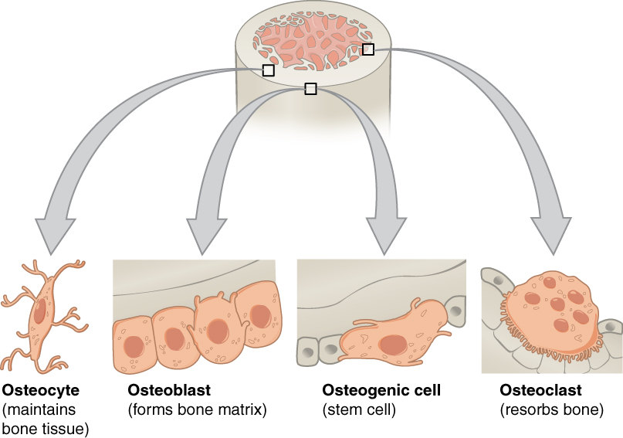

- Calcified tissue:
  - Compact bone: dense, outer layer
  - Spongy bone: trabecular (red marrow found in spongy bone)
- Linings:
  - periosteum: outer fibrous layer + inner osteogenic layer
  - endosteum: covers trabeculae of spongy bone & lines canals of compact bone
- 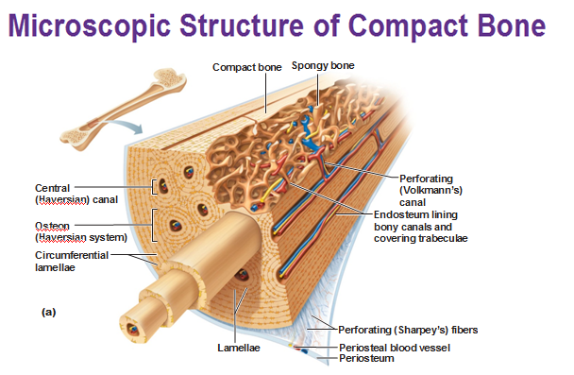

- CLASSIFICATION OF BONES
- • lots of variation in size/shapes of bones (eg: pisiform bone vs femur)
- Unique shape of each bone fulfills a particular need (eg: femur maximum strength with minimum weight - achieves this with hollow cylindrical design)
- Bones classified by their SHAPE and not SIZE (long, short, flat, irregular)
- • Structure the same for all bone shapes:
- » Compact bone provides the external surface
- » Spongy (trabecular) bone- a honeycomb of trabeculae

- Bone Structure
- 1) LONG BONES:
  - Much longer than wide; a shaft + 2 ends
  - Mostly compact bone with hollow center (marrow cavity); spongy bone near joint ends
- 2) SHORT BONES:
  - Roughly cube-shaped; eg: wrist, ankle, sesamoid bones
  - Primarily spongy bone + thin outer layer of compact bone
- 3) FLAT BONES:
  - Thin, flattened & sometimes curved
  - Include skull bones, ribs & breastbone
- 4) IRREGULAR BONES:
  - Leftovers: e.g. vertebrae & hip bones
  - Complicated shapes: primarily spongy bone + thin covering layer of compact bone
- 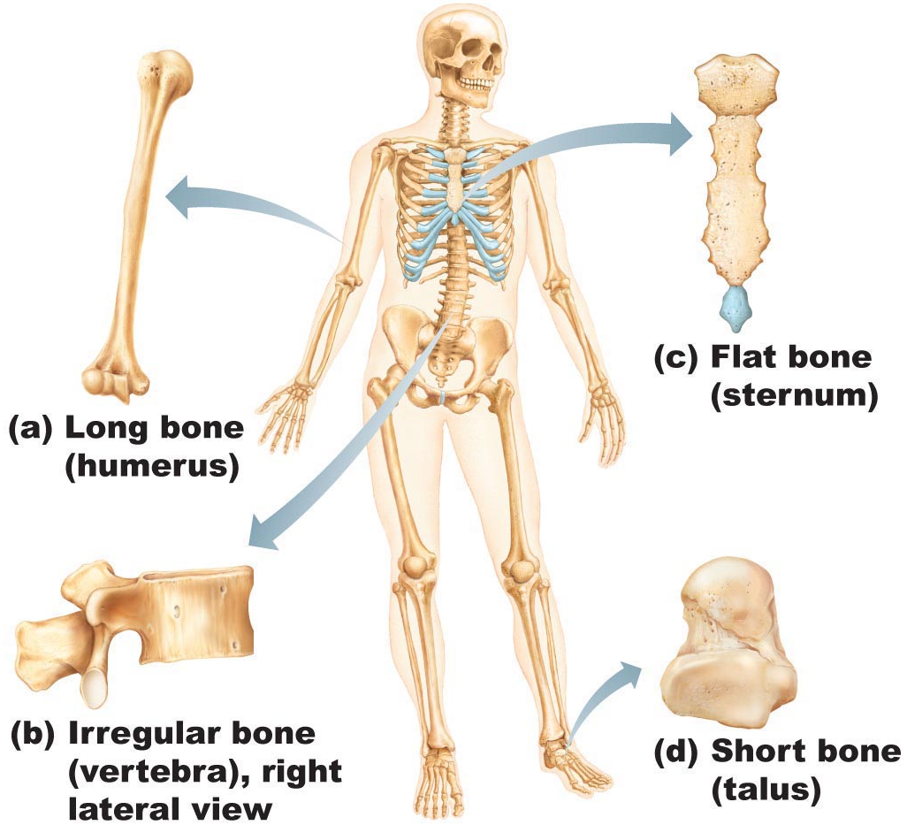

- Long Bone:
- Diaphysis: A tubular diaphysis or shaft forms the long axis on the bone. It is constructed of a relatively thick collar of compact bone that surrounds a central medullary cavity, or marrow cavity. In adults, the medullary cavity contains fat and is called the yellow marrow cavity.
- Epiphyses: are the bone ends. They are broader than the diaphysis. An outer shell of compact bone forms the epiphysis exterior and their interior contains spongy bone. A thin layer of articular cartilage covers the joint surface of each epiphysis, cushioning the opposing bone ends during movement and absorbing stress.
- Epiphyseal line: between the diaphysis and each epiphysis of an adult long bone, a remnant of the epiphyseal plate, a disc of hyaline cartilage that grows sudirn childhood to length the bone The flared portion of the bone where the diaphysis and epiphysis meet, whether it is epiphyseal plate or line, is sometimes called the metaphysis “between”.
- Membranes: A glistening white, double-layered membrane caked the periosteum coverts he external surface of the entire bone except the joint surfaces. The outer fibrous layer of the peirosteum is dense irregular CT. The inner osteogenic later, abutting the bone surface, consist primarily of primitive stem cells, osteogenic cells, that give rise to all bone cells except bone destroying cells. A delicate Ct membrane called the endosteum covers internal bone surfaces. The endosteum covers the trabeculae of spongy bone and lines the canals that pass through the compact bone. Like the periosteum, the endosteum contains osteogenic cells that can differentiate into other bone cells.
- 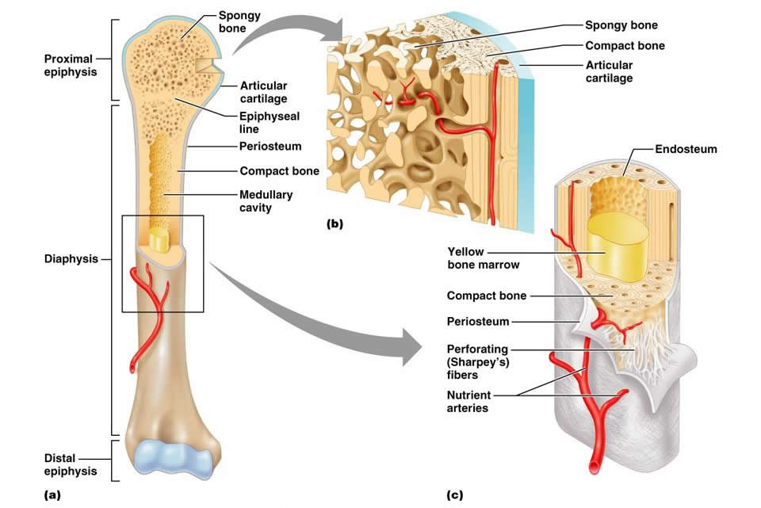

- STRUCTURE OF OTHER BONE TYPES
- • All 3 other types have similar structure
- • Compact bone outside; spongy bone inside
- • compact covered with periosteum & spongy lined with endosteum
  - Not cylindrical so no shaft, marrow cavity or epiphyses - but do contain bone marrow between trabeculae

- Microscopic Anatomy of Bones
- Compact Bone:
  - Osteon (Haversian System): The structural unit of compact bone is called either the osteon or the Aversion system. Each osteon is an elongated cylinder oriented parallel to the long axis of the bone. Functionally, osteons are tin weight-bearing pillars.
  - An osteon is a group of hallow tubes of bone matrix, one placed outside the next like the growth rings of a tree trunk. Each matrix tube is lamella, and for this reason compact bone is often called lamellar bone. Although all of the collagen fibbers in a particular lamella run in a single direction, the collagen fibers in adjacent lamellae always run in different directions.
  - OSTEOCYTES: mature bone cells; sit within small cavities (lacunae) within bony matrix in areas where adjacent lamellae meet
  - Canals and Canaliculi: Running through the core of each osteon is the central canal, or Haversian Canal, containing small blood vessels and nerve fibers that serve the osteons cells. Canals of a second type called perforating canals or Volkmanns canals lie at right angles to the long axis of the bone and connect the blood and nerve supply of the medullary cavity to the central canals.
  - Spider shaped osteocytes occupy lacunae at the junctions of the lamellae. Hairlike canals called canaliculi connect the lacunae to each other and to the central canal.
  - Interstitial and Circumferential Lamellae: Not all lamellae in compact bone are part of the complete osteons. Lying between intact osteons are incomplete lamellae called interstitial lamellae. They either fill the gaps between forming osteons or are remnants of osteons that have been cut through by bone remodelling. Circumferential lamellae, located just deep to the periosteum and just superficial to the endosteum, extend around the entire circumference of the diaphysis and effective resist twisting of the long bone.

- MICROSCOPIC STRUCTURE OF SPONGY BONE
- • Contains trabeculae, lamellarly arranged osteocytes & canaliculi
- • trabeculae arranged along lines of stress; helps bone to resist stress
- • trabeculae only a few cell layers thick; contain irregularly arranged lamellae & osteocytes interconnected by canaliculi
- • There are no osteons
- • Nutrients diffuse through canaliculi from the marrow spaces between the
- trabeculae to reach the osteocytes
- 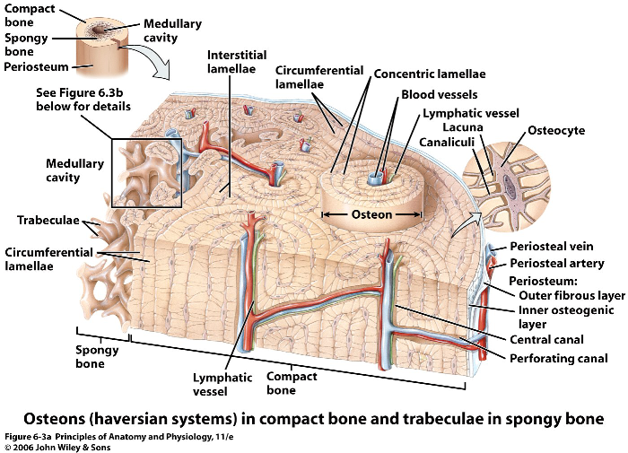

- = osteogenesis or ossification
- includes formation of bony skeleton in embryos, growth of bones during childhood & adolescence & remodelling/repair of bones in adults

- Intramembranous Ossification
- Intramembranous ossification forms the cranial bones of the skull (frontal, parietal, occipital, and temporal bones) and the clavicles. Most bones formed by this process are flat bones. At about week 8 of development, ossification begins within fibrous connective tissue membranes formed by mesenchymal cells.

- Endochondral Ossification
- Except for the clavicles, essentially all bones below the base of the skull form by endochondral ossification (en0do-kon9dral). Beginning late in the second month of development, this pro- cess uses hyaline cartilage “bones” formed earlier as models, or patterns, for bone construction. It is more complex than in- tramembranous ossification because the hyaline cartilage must be broken down as ossification proceeds.

- When secondary ossification is complete, hyaline cartilage remains:
- 1) on the epiphyseal surfaces as the articular cartilages
- 2) at the junctions of diaphysis and epiphyses where it forms the epiphyseal plates, this is the area where long bones continue to grow
- 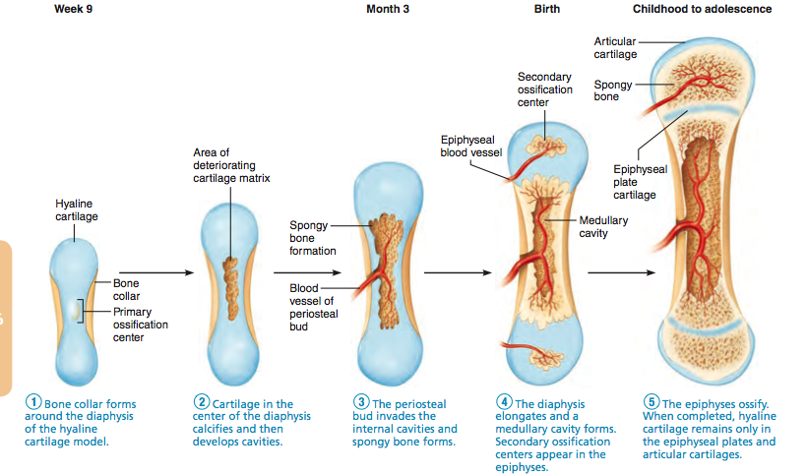

- MECHANISMS OF BONE GROWTH
  - during infancy & youth, long bones lengthen entirely by interstitial growth of the epiphyseal plates and all bones grow in thickness by appositional growth
  - most bones stop growing during adolescence or in early adulthood - some facial bones (eg: nose & lower jaw) continue to grow (almost imperceptibly) throughout life

- Figure 6.10 Growth in length of a long bone occurs at the epiphyseal plate.
- 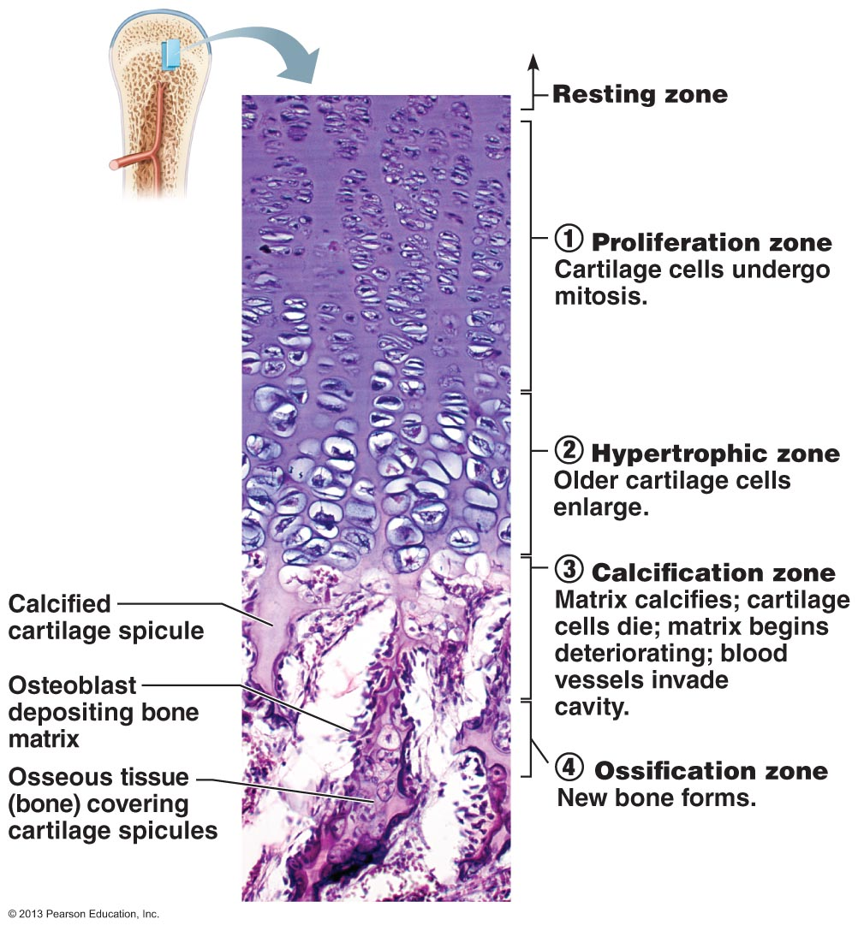
- The side of the epiphyseal plate facing the epiphysis contains resting cartilage cells. The cells of the epiphyseal plate proximal to the resting cartilage area are arranged in four zones—proliferation, hypertrophic, calcification, and ossification— from the region of the earliest stage of growth 1 to the region where bone is replacing the cartilage 4 (1153).

- Figure 6.11 Long bone growth and remodeling during youth.
- 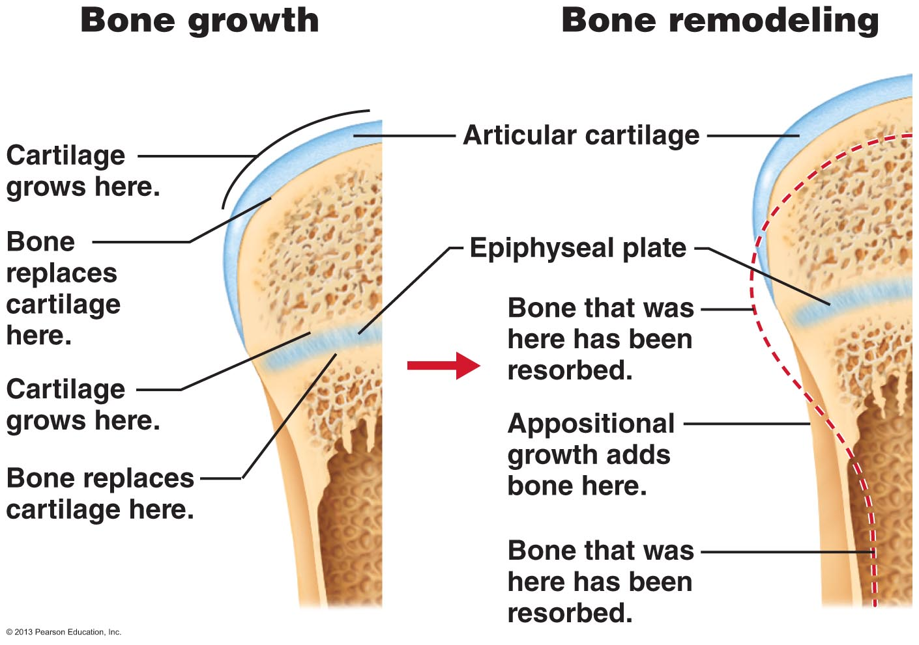

- Growth in Width (Thickness)
- Growing bones widen as they lengthen. As with cartilages, bones increase in thickness or, in the case of long bones, diameter, by appositional growth. Osteoblasts beneath the periosteum secrete bone matrix on the external bone surface as osteoclasts on the endosteal surface of the diaphysis remove bone (Figure 6.11). However, normally there is slightly more building up than break- ing down. This unequal process produces a thicker, stronger bone but prevents it from becoming too heavy.

- Bone Remodeling
  - In the adult skeleton, bone deposit and bone resorption occur at the surfaces of both the periosteum and the endosteum. To- gether, the two processes constitute bone remodeling. “Pack- ets” of adjacent osteoblasts and osteoclasts called remodeling units coordinate bone remodeling (with help from the stress- sensing osteocytes).
  - In healthy young adults, total bone mass remains constant, an indication that the rates of bone deposit and resorption are essentially equal. Remodeling does not occur uniformly, how- ever. For example, the distal part of the femur, or thigh bone, is fully replaced every five to six months, whereas its shaft is altered much more slowly.

- Figure 6.12 Parathyroid hormone (PTH) control of blood calcium levels.
- 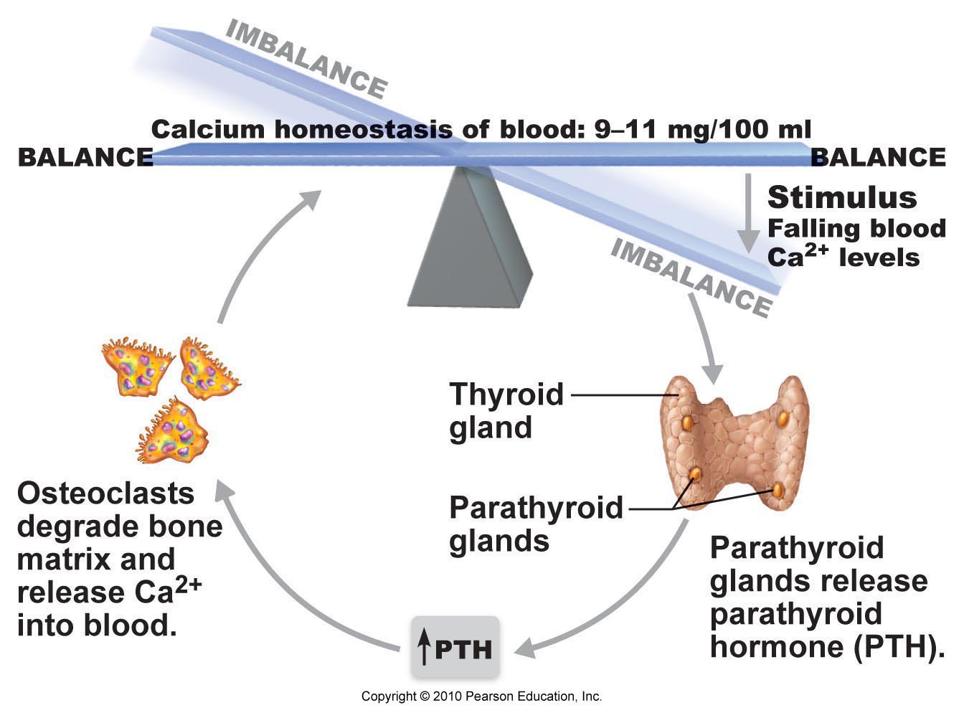

- CLINICAL NOTE: Osteoporosis
- bone resorption outpaces bone formation, bone becomes porous
- • some areas of skeleton especially vulnerable: spine, neck of femur
- • age a factor: estrogen & testosterone promote bone health by restraining osteoclast activity and promoting deposition of new bone
- • other contributing factors include: insufficient exercise, diet poor in calcium & protein, abnormal vit D receptors, smoking (reduces estrogen levels)

- Define the following terms:
- compact bone
- spongy bone
- epiphysis
- diaphysis
- osteoblast
- osteocyte
- osteon
- Haversian canal
- Volkmann’s canal
- interstitial versus circumferential lamella
- canaliculus
- periosteum versus endosteum
- epiphyseal line
- red versus yellow marrow

- • 206 bones in human skeleton - make up about 20% of body weight
- • grouped into axial and appendicular skeletons
- axial skeleton = bones of skull, vertebral column, rib cage
- appendicular skeleton = bones of upper & lower limbs + pectoral/pelvic girdles (attach limbs to axial skeleton)

- Skull
  - The skull is the body’s most complex bony structure. It is formed by cranial and facial bones, 22 in all. The cranial bones, or cranium (kra9ne-um), enclose and protect the fragile brain and furnish attachment sites for head and neck muscles. The 7 facial bones (1) form the framework of the face, (2) contain cavities for the special sense organs of sight, taste, and smell, (3) provide openings for air and food passage, (4) secure the teeth, and (5) anchor the facial muscles of expression, which we use to show our feelings. As you will see, the individual skull bones are well suited to their assignments.
  - Most skull bones are flat bones. Except for the mandible, which is connected to the rest of the skull by freely movable joints, all bones of the adult skull are firmly united by interlock- ing joints called sutures (soo9cherz). The suture lines have a saw-toothed or serrated appearance.
- 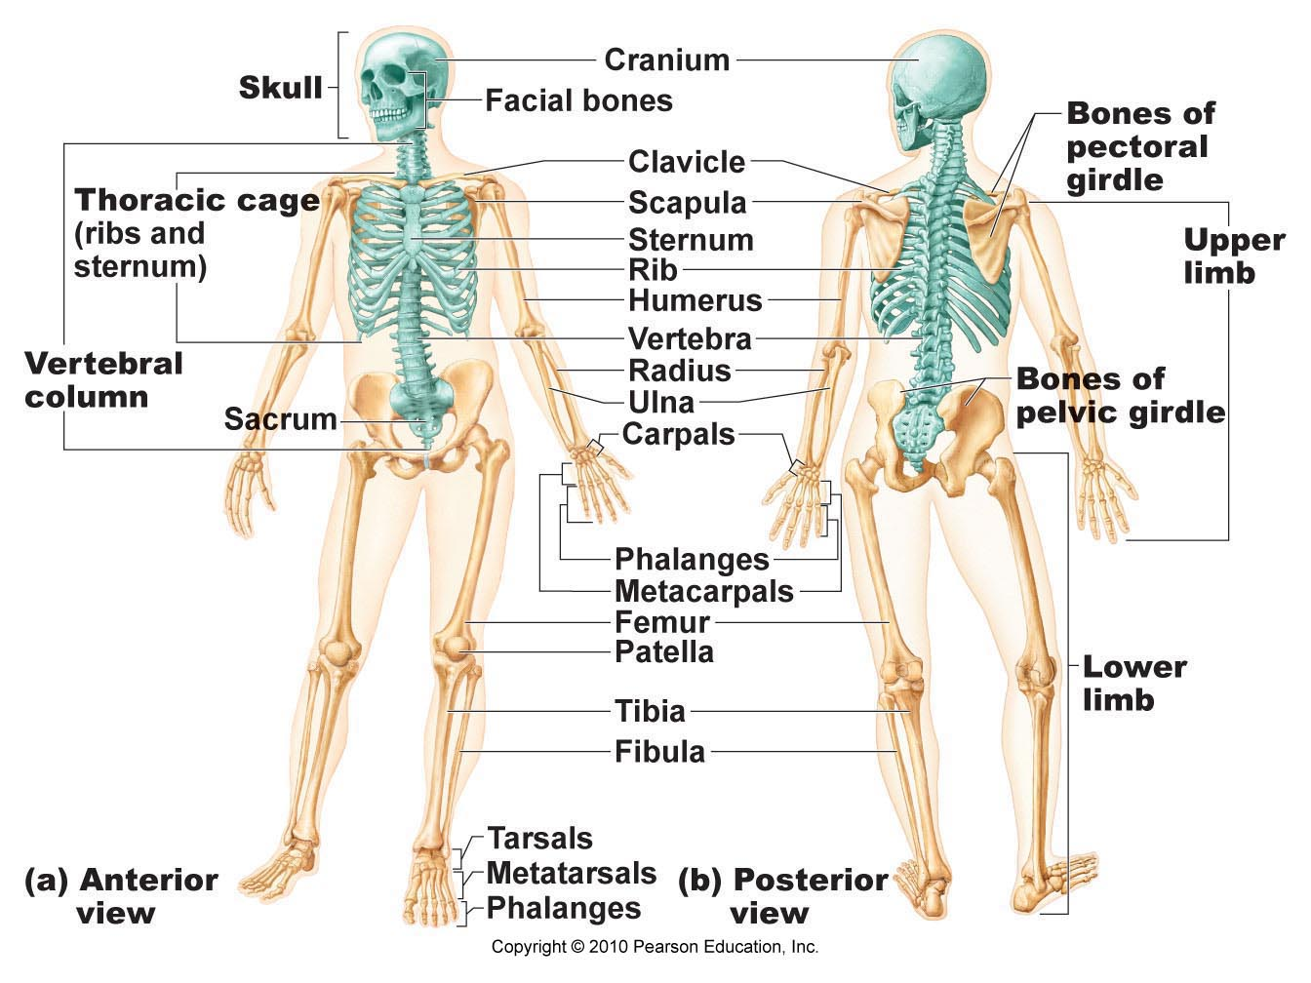

- Overview of Skull Geography
- The cranium can be divided into a vault and a base. The cra- nial vault, also called the calvaria (kal-va9re-ah; “bald part of skull”), forms the superior, lateral, and posterior aspects of the skull, as well as the forehead. The cranial base forms the skull’s inferior aspect. Internally, prominent bony ridges divide the base into three distinct “steps” or fossae—the anterior, middle, and posterior cranial fossae (Figure 7.2b and c). The brain sits snugly in these cranial fossae, completely enclosed by the cranial vault. Overall, the brain is said to occupy the cranial cavity.

Facial bones or Face:
  - form framework of the face
  - contain the cavities for the sensory organs of sight, smell & taste
  - provide openings for passage of air & food
  - secure the teeth
  - anchor the facial muscles that we use to show our feelings

- Frontal Bone
  - The shell-shaped frontal bone (Figures 7.4a, 7.5, and 7.7) forms the anterior cranium. It articulates posteriorly with the paired parietal bones via the prominent coronal suture.
  - The most anterior part of the frontal bone is the vertical squamous part, commonly called the forehead. The frontal squamous region ends inferiorly at the supraorbital mar- gins, the thickened superior margins of the orbits that lie under the eyebrows. From here, the frontal bone extends posteriorly, forming the superior wall of the orbits and most of the anterior cranial fossa (Figure 7.7a and b). This fossa supports the frontal lobes of the brain. Each supraor- bital margin is pierced by a supraorbital foramen (notch), which allows the supraorbital artery and nerve to pass to the forehead (Figure 7.4a).
  - The smooth portion of the frontal bone between the orbits is the glabella (glah-bel9ah). Just inferior to this the frontal bone meets the nasal bones at the frontonasal suture (Figure 7.4a). The areas lateral to the glabella are riddled internally with sinuses, called the frontal sinuses (Figures 7.5c and 7.3).

- Parietal Bones and the Major Sutures
- The two large parietal bones are curved, rectangular bones that form most of the superior and lateral aspects of the skull; hence they form the bulk of the cranial vault. The four largest sutures occur where the parietal bones articulate (form a joint) with other cranial bones:
  - The coronal suture (kŏ-ro’nul), where the parietal bones meet the frontal bone anteriorly (Figures 7.2a and 7.5)
  - The sagittal suture, where the parietal bones meet superiorly at the cranial midline (Figure 7.4b)
  - The lambdoid suture (lam’doid), where the parietal bones meet the occipital bone posteriorly (Figures 7.2a, 7.4b, and 7.5)
  - The squamous suture (one on each side), where a parietal and temporal bone meet on the lateral aspect of the skull (Figures 7.2a and 7.5)

- Occipital Bone:
  - single bone at base of skull;helps form post aspect of skull
  - also forms walls of the post cranial fossa
  - attaches anteriorly to the 2 parietals & 2 temporals & attaches to sphenoid
  - large hole at base = foramen magnum (passage for spinal cord)
  - occipital condyles on each side of foramen magnum = site of articulation with first cervical vertebra
  - external occipital protuberance = projection at back of skull - more prominent in males

- Temporal Bones
  - paired; form inferior & lateral aspects of skull and parts of the cranial floor
  - located just below the 2 parietal bones; have 3 very different areas or regions

- Each temporal bone has a complicated shape (Figure 7.8) and is described in terms of its three major parts, the squamous, tympanic, and petrous parts.
  - The flaring squamous part abuts the squamous suture. It has a barlike zygomatic process that meets the zygomatic bone of the face anteriorly. Together, these two bony structures form the zygomatic arch, which you can feel as the projection of your cheek (zygoma 5 cheekbone). The small, oval mandibular fossa (man-dib9u-lar) on the inferior surface of the zygomatic process re- ceives the condylar process of the mandible (lower jawbone), form- ing the freely movable temporomandibular joint.
  - The tympanic part (tim-pan9ik; “eardrum”) (Figure 7.8) of the temporal bone surrounds the external acoustic meatus, or external ear canal, through which sound enters the ear. The external acoustic meatus and the eardrum at its deep end are part of the external ear. In a dried skull, the eardrum has been removed and part of the middle ear cavity deep to the external meatus can also be seen.
  - The thick petrous part (pet9rus) of the temporal bone houses the middle and internal ear cavities, which contain sensory receptors for hearing and balance. Extending from the occipital bone posteriorly to the sphenoid bone anteriorly, it contributes to the cranial base.
  - A conspicuous feature of the petrous part of the temporal bone is the mastoid process (mas9toid; “breast”), which acts as an anchoring site for some neck muscles (Figures 7.5, 7.6, and 7.8). This process can be felt as a lump just posterior to the ear.
  - The needle-like styloid process (sti9loid; “stakelike”) is an attachment point for several tongue and neck muscles and for a ligament that secures the hyoid bone of the neck to the skull (see Figure 7.15). The stylomastoid foramen, between the sty- loid and mastoid processes, allows cranial nerve VII (the facial nerve) to leave the skull (Figure 7.6).
- 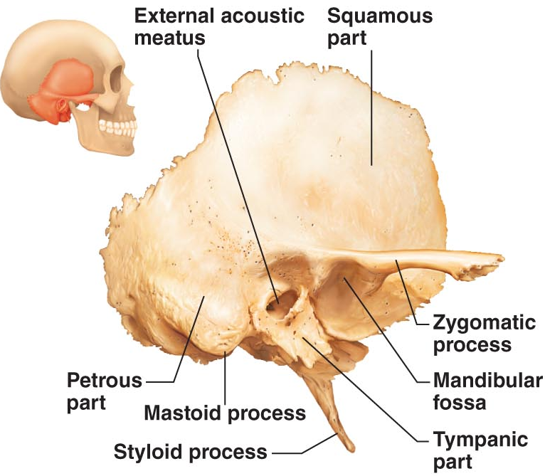

- Sphenoid Bone
  - The bat-shaped sphenoid bone (sfe9noid; sphen 5 wedge) spans the width of the middle cranial fossa (Figure 7.7). The sphenoid is considered the keystone of the cranium because it forms a central wedge that articulates with all other cranial bones. It is a challenging bone to study because of its complex shape.
  - As shown in Figure 7.9, it consists of a central body and three pairs of processes: the greater wings, lesser wings, and pterygoid processes (ter9ĭ-goid).
  - Within the body of the sphenoid are the paired sphenoidal sinuses (see Figures 7.5c and d, and 7.14).
- 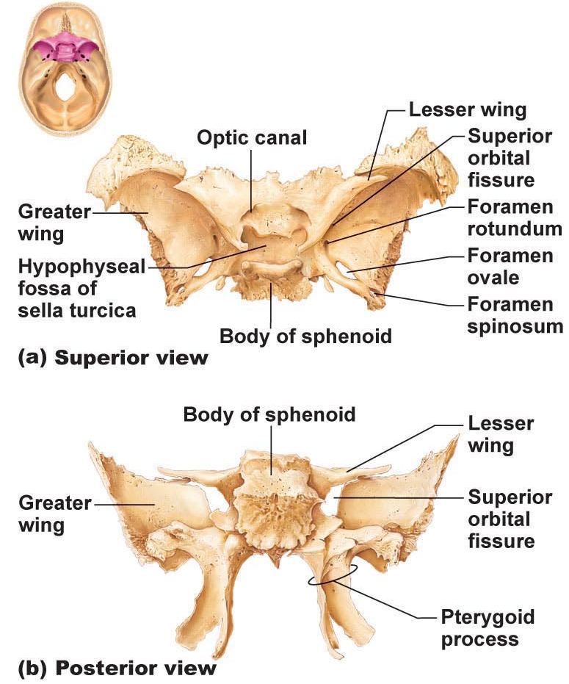

- Ethmoid Bone
  - Like the temporal and sphenoid bones, the delicate ethmoid bone has a complex shape (Figure 7.10). Lying between the sphenoid and the nasal bones of the face, it is the most deeply situated bone of the skull. It forms most of the bony area between the nasal cavity and the orbits.
  - The superior surface of the ethmoid is formed by the paired horizontal cribriform plates (krib9rĭ-form) (see also Figure 7.7), which help form the roof of the nasal cavities and the floor of the anterior cranial fossa. The cribriform plates are punctured by tiny holes (cribr 5 sieve) called cribriform foramina that al- low the filaments of the olfactory nerves to pass from the smellreceptors in the nasal cavities to the brain.
  - Projecting superiorly between the cribriform plates is a triangular process called the crista galli (kris9tah gah9le; “rooster’s comb”). The outermost covering of the brain (the dura mater) attaches to the crista galli and helps secure the brain in the cranial cavity.
  - The perpendicular plate of the ethmoid bone projects inferiorly in the median plane and forms the superior part of the nasal septum, which divides the nasal cavity into right and left halves (Figure 7.5c and d). Flanking the perpendicular plate on each side is a lateral mass riddled with sinuses called ethmoidal air cells (Figures 7.10 and 7.14), for which the bone itself is named (ethmos 5 sieve).
  - Extending medially from the lateral masses, the delicately coiled superior and middle nasal conchae (kong9ke; concha 5 shell), named after the conch shells found on warm ocean beaches, protrude into the nasal cavity (Figures 7.10 and 7.13a).
  - The lateral surfaces of the ethmoid’s lateral masses are called orbital plates because they contribute to the medial walls of the orbits.
- 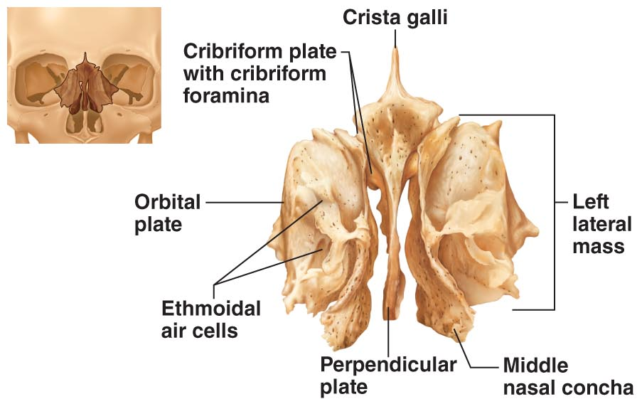

- Major Cranial Sutures:
- • bones of the adult skull are firmly united by sutures
- • 4 main sutures that connect the cranial bones
- (1) Coronal suture: frontal bone & 2 parietal bones
- (2) Squamous suture: parietal bone & temporal bone
- (3) Lambdoid suture: occipital bone & 2 parietal bones
- (4) Sagittal suture: 2 parietal bones
- Sutural bones: tiny irregular bones; can occur within cranial suture
- additional ossification centres that appeared rapidly during fetal development
- 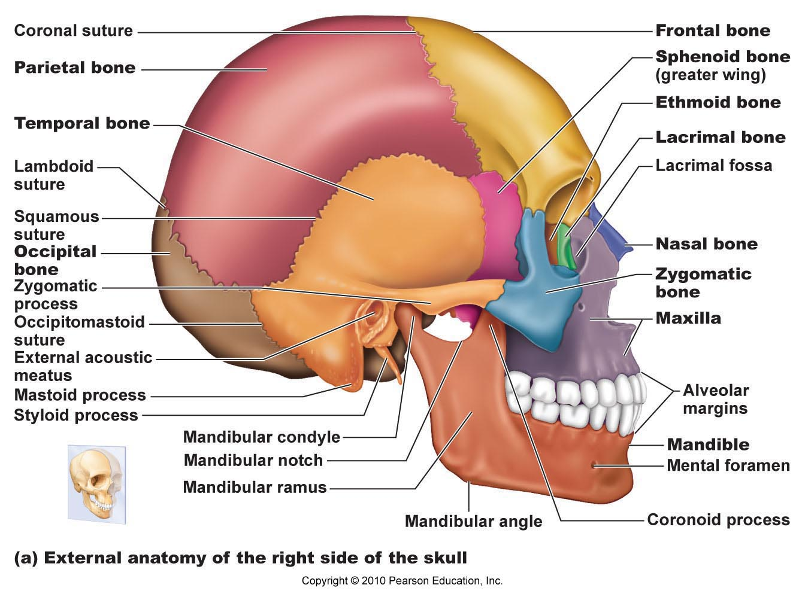

- Facial Bones
  - The facial skeleton is made up of 14 bones (see Figures 7.4a and 7.5a), of which only the mandible and the vomer are unpaired. The maxillae, zygomatics, nasals, lacrimals, palatines, and inferior nasal conchae are paired bones. As a rule, the facial skeleton of men is more elongated than that of women. Women’s faces tend to be rounder and less angular.

- Mandible
  - The U-shaped mandible (man9dĭ-bl), or lower jawbone (Fig- ures 7.4a and 7.5, and Figure 7.11a), is the largest, strongest bone of the face. It has a body, which forms the chin, and two upright rami (rami 5 branches). Each ramus meets the body posteriorly at a mandibular angle.
  - note: mandibular notch, coronoid process (insertion of temporalis muscle), mandibular condyle, alveolar margin (contains tooth sockets), mandibular foramina (nerves to teeth in lower jaw) & mental foramina (blood vessels & nerves to chin & lower lip)

- Maxillary Bones
  - The maxillary bones, or maxillae (mak-sil9le; “jaws”) (Fig- ures 7.4 to 7.6 and 7.11b and c), are fused medially. They form the upper jaw and the central portion of the facial skeleton. All facial bones except the mandible articulate with the max- illae. Hence, the maxillae are considered the keystone bones of the facial skeleton.
  - The maxillae carry the upper teeth in their alveolar processes. Just inferior to the nose the maxillae meet medially, forming the pointed anterior nasal spine at their junction. The palatine processes (pa ̆9lah-tīn) of the maxillae project posteri- orly from the alveolar processes and fuse medially at the inter- maxillary suture, forming the anterior two-thirds of the hard palate, or bony roof of the mouth (Figures 7.5c and d and 7.6).
  - note: (incisive fossa) (passage of blood vessels & nerves), frontal processes & zygomatic processes
    - The frontal processes extend superiorly to the frontal bone, forming part of the lateral aspects of the bridge of the nose (Figures 7.4a and 7.11b). The regions that flank the nasal cavity laterally contain the maxillary sinuses (see Figure 7.14), the largest of the paranasal sinuses. They extend from the orbits to the roots of the upper teeth. Laterally, the maxillae articulate with the zygomatic bones via their zygomatic processes.
  - main portion of bone on each side has maxillary sinus - these are the sinuses that get infected

- Zygomatic Bones
  - The irregularly shaped zygomatic bones (Figures 7.4a, 7.5a, and 7.6) are commonly called the cheekbones (zygoma 5 cheekbone). They articulate with the zygomatic processes of the temporal bones posteriorly, the zygomatic processes of the frontal bone superiorly, and with the zygomatic pro- cesses of the maxillae anteriorly. The zygomatic bones form the prominences of the cheeks and part of the inferolateral margins of the orbits.

- Nasal Bones
  - The thin, basically rectangular nasal bones (na9zal) are fused medially, forming the bridge of the nose (Figures 7.4a and 7.5a). They articulate with the frontal bone superiorly, the maxillary bones laterally, and the perpendicular plate of the ethmoid bone posteriorly. Inferiorly they attach to the cartilages that form most of the skeleton of the external nose.

- Lacrimal Bones
  - The delicate, fingernail-shaped lacrimal bones (lak9rĭ-mal) contribute to the medial walls of each orbit (Figures 7.4a and 7.5a). They articulate with the frontal bone superiorly, the eth- moid bone posteriorly, and the maxillae anteriorly. Each lac- rimal bone contains a deep groove that helps form a lacrimal fossa. The lacrimal fossa houses the lacrimal sac, part of the passageway that allows tears to drain from the eye surface into the nasal cavity (lacrima 5 tears).

- Palatine Bones
  - Each L-shaped palatine bone is fashioned from two bony plates, the horizontal and perpendicular (see Figures 7.13a and 7.6a), and has three important articular processes, the pyrami- dal, sphenoidal, and orbital. The horizontal plates, joined at the median palatine suture, complete the posterior portion of the hard palate. The superiorly projecting perpendicular (vertical) plates form part of the posterolateral walls of the nasal cavity and a small part of the orbits.

- Vomer
  - The slender, plow-shaped vomer (vo9mer; “plow”) lies in the nasal cavity, where it forms part of the nasal septum (see Fig- ures 7.4a and 7.13b). It is described below in connection with the nasal cavity.

- Inferior Nasal Conchae
  - The paired inferior nasal conchae are thin, curved bones in the nasal cavity. They project medially from the lateral walls of the nasal cavity, just inferior to the middle nasal conchae of the ethmoid bone (see Figures 7.4a and 7.13a). They are the largest of the three pairs of conchae and, like the others, they form part of the lateral walls of the nasal cavity.

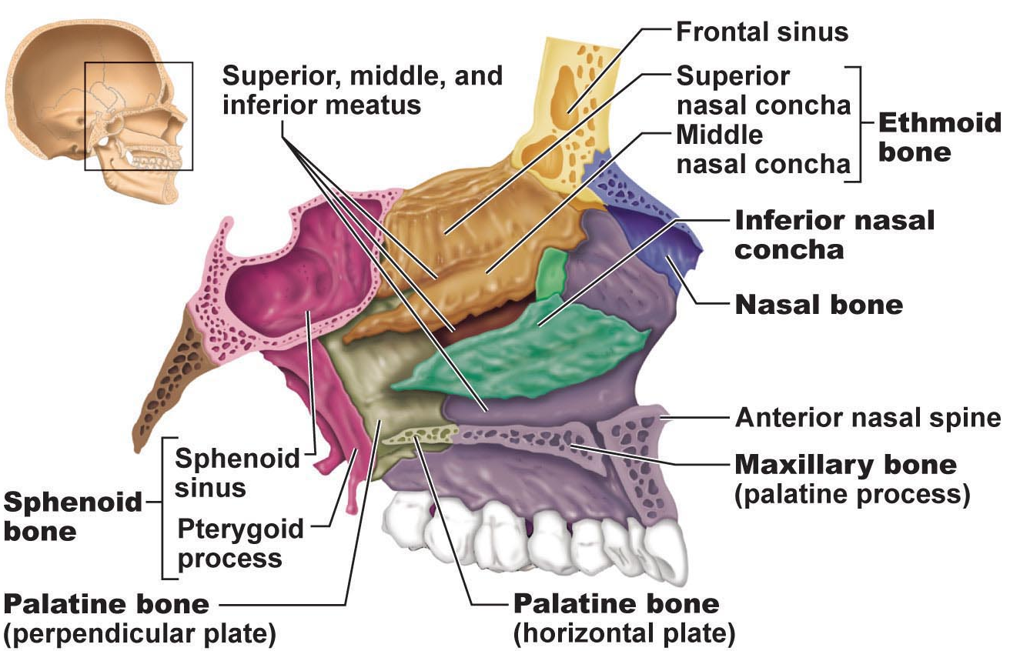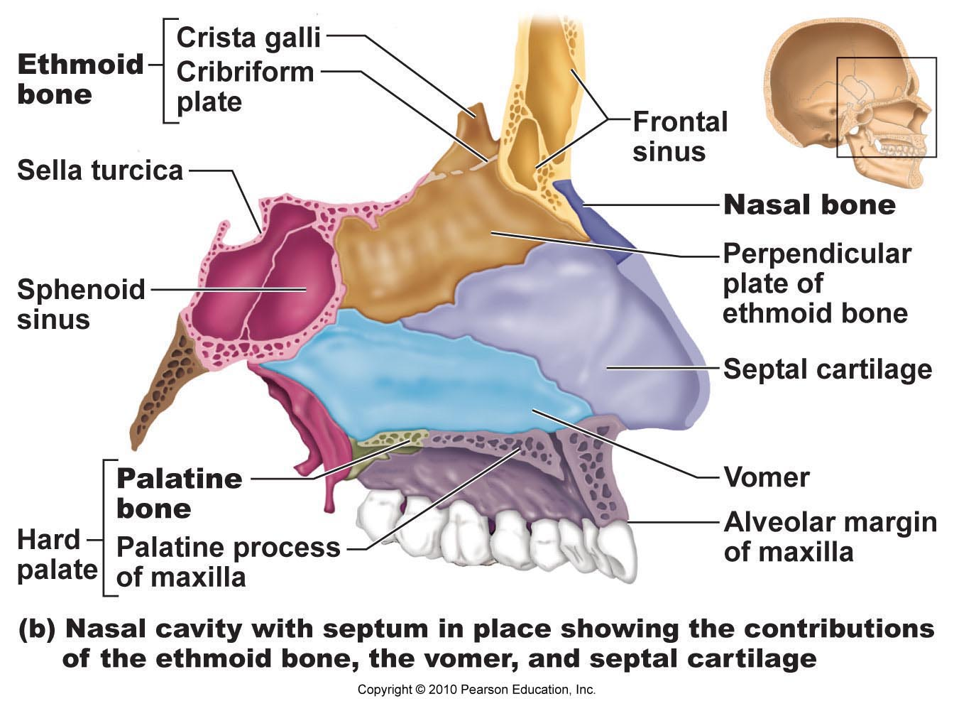

- Paranasal Sinuses
  - Five skull bones—the frontal, sphenoid, ethmoid, and paired maxillary bones—contain mucosa-lined, air-filled sinuses that give them a rather moth-eaten appearance in an X-ray image. These particular sinuses are called paranasal sinuses because they cluster around the nasal cavity (Figure 7.14).
  - Small openings connect the sinuses to the nasal cavity and act as “two-way streets”: Air enters the sinuses from the nasal cavity, and mucus formed by the sinus mucosae drains into the nasal cavity. The mucosa of the sinuses also helps to warm and humidify inspired air. The paranasal sinuses lighten the skull and enhance the resonance of the voice.

- The Vertebral Column
  - Some people think of the vertebral column as a rigid supporting rod, but this is inaccurate. Also called the spine or spinal column, the vertebral column consists of 26 irregular bones connected in such a way that a flexible, curved structure results (Figure 7.16).
  - Serving as the axial support of the trunk, the spine extends from the skull to the pelvis, where it transmits the weight of the trunk to the lower limbs. It also surrounds and protects the delicate spinal cord and provides attachment points for the ribs and for the muscles of the back and neck.
  - In the fetus and infant, the vertebral column consists of 33 separate bones, or vertebrae (ver9tĕ-bre). Inferiorly, nine of these eventually fuse to form two composite bones, the sacrum and the tiny coccyx. The remaining 24 bones persist as individual vertebrae separated by intervertebral discs.

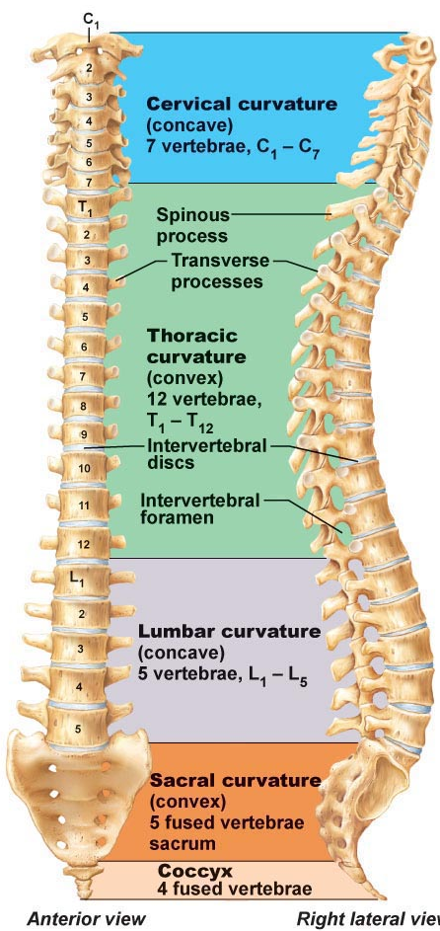

- Ligaments
  - Like a tall, tremulous TV transmitting tower, the vertebral col- umn cannot possibly stand upright by itself. It must be held in place by an elaborate system of cable-like supports. In the case of the vertebral column, straplike ligaments and the trunk mus- cles assume this role.
  - The major supporting ligaments are the anterior and pos- terior longitudinal ligaments (Figure 7.18). These run as continuous bands down the front and back surfaces of the verte- brae from the neck to the sacrum. The broad anterior ligament is strongly attached to both the bony vertebrae and the discs. Along with its supporting role, it prevents hyperextension of the spine (bending too far backward). The posterior ligament, which resists hyperflexion of the spine (bending too sharply forward), is narrow and relatively weak.
  - It attaches only to the discs. However, the ligamentum flavum, which connects ad- jacent vertebrae, contains elastic connective tissue and is espe- cially strong. It stretches as we bend forward and then recoils when we resume an erect posture. Short ligaments connect each vertebra to those immediately above and below.
- 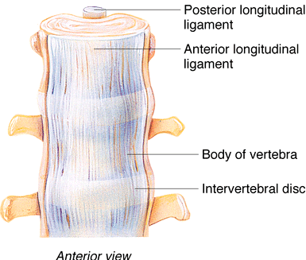

- Intervertebral Discs
  - Each intervertebral disc is a cushionlike pad composed of two parts. The inner gelatinous nucleus pulposus (pul-po9sus; “pulp”) acts like a rubber ball, giving the disc its elasticity and compressibility. Surrounding the nucleus pulposus is a strong collar composed of collagen fibers superficially and fibrocartilage internally, the anulus fibrosus (an9u-lus fi-bro9sus; “ring of fibers”) (Figure 7.18a, c). The anulus fibrosus limits the expansion of the nucleus pulposus when the spine is compressed. It also acts like a woven strap to bind successive vertebrae together, withstands twisting forces, and resists tension in the spine.
  - A herniated (prolapsed) disc (commonly called a slipped disc) usually involves rupture of the anulus fibrosus followed by protrusion of the spongy nu- cleus pulposus through the anulus (Figure 7.18c, d). If the pro- trusion presses on the spinal cord or on spinal nerves exiting from the cord, numbness or excruciating pain may result.

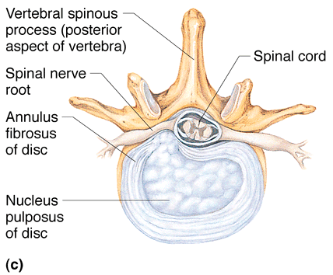

- General Structure of Vertebrae
  - All vertebrae have a common structural pattern (Figure 7.19). Each vertebra consists of a body, or centrum, anteriorly and a vertebral arch posteriorly. The disc-shaped body is the weight- bearing region. Together, the body and vertebral arch enclose an opening called the vertebral foramen. Successive vertebral foramina of the articulated vertebrae form the long vertebral canal, through which the spinal cord passes.
  - The vertebral arch is a composite structure formed by two pedicles and two laminae. The pedicles (ped9ĭ-kelz; “little feet”), short bony pillars projecting posteriorly from the vertebral body, form the sides of the arch. The laminae (lam9ĭ-ne), flattened plates that fuse in the median plane, complete the arch posteriorly. The pedi- cles have notches on their superior and inferior borders, providing lateral openings between adjacent vertebrae called intervertebral foramina (see Figure 7.16). The spinal nerves issuing from the spinal cord pass through these foramina.
  - Seven processes project from the vertebral arch. The spinous process is a median posterior projection arising at the junction of the two laminae. A transverse process extends laterally from each side of the vertebral arch. The spinous and transverse pro- cesses are attachment sites for muscles that move the vertebral col- umn and for ligaments that stabilize it. The paired superior and inferior articular processes protrude superiorly and inferiorly, respectively, from the pedicle-lamina junctions. The smooth joint surfaces of the articular processes, called facets (“little faces”), are covered with hyaline cartilage. The inferior articular processes of each vertebra form movable joints with the superior articu- lar processes of the vertebra immediately below. Thus, successive vertebrae join both at their bodies and at their articular processes.

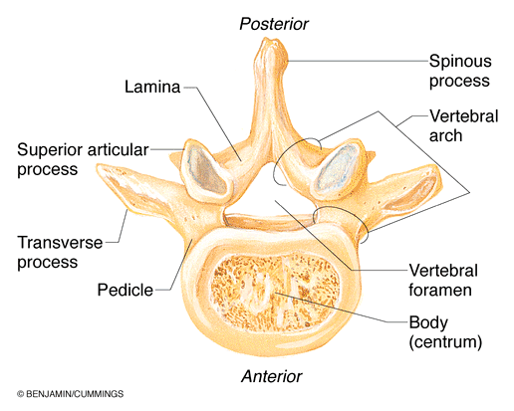

- Cervical Vertebrae
  - The seven cervical vertebrae, identified as C1–C7, are the small- est, lightest vertebrae (see Figure 7.16). The first two (C1 and C2) are unusual and we will skip them for the moment. The “typical” cervical vertebrae (C3–C7) have the following distinguishing features (see Figure 7.21 and Table 7.2):
    - The body is oval—wider from side to side than in the antero- posterior dimension.
    - Except in C7, the spinous process is short, projects directly back, and is bifid (bi9fid), or split at its tip.
    - The vertebral foramen is large and generally triangular.
    - Each transverse process contains a transverse foramen through which the vertebral arteries pass to service the brain.
  - The first two cervical vertebrae, the atlas and the axis, are somewhat more robust than the typical cervical vertebra. They have no intervertebral disc between them, and they are highly modified, reflecting their special functions. The atlas (C1) has no body and no spinous process (Figure 7.20a and b). Essentially, it is a ring of bone consisting of anterior and poste- rior arches and a lateral mass on each side. Each lateral mass has articular facets on both its superior and inferior surfaces. The superior articular facets receive the occipital condyles of the skull—they “carry” the skull, just as Atlas supported the heavens in Greek mythology. These joints allow you to nod “yes.” The inferior articular facets form joints with the axis (C2) below.
  - The axis, which has a body and the other typical vertebral processes, is not as specialized as the atlas. In fact, its only unusual feature is the knoblike dens (denz; “tooth”) projecting superiorly from its body.

- Thoracic Vertebrae
  - The 12 thoracic vertebrae (T1–T12) all articulate with the ribs (see Table 7.2, Figure 7.16, and Figure 7.21b). The first looks much like C7, and the last four show a progression toward lumbar vertebral structure. The thoracic vertebrae increase in size from the first to the last. Unique characteristics of these vertebrae include the following:
    - The body is roughly heart shaped. It typically bears two small facets, commonly called demifacets (half-facets), on each side, one at the superior edge (the superior costal facet) and the other at the inferior edge (the inferior costal facet). The demifacets receive the heads of the ribs. (The bodies of T10– T12 vary from this pattern by having only a single facet to receive their respective ribs.)
    - The vertebral foramen is circular.
    - The spinous process is long and points sharply downward.
    - With the exception of T11 and T12, the transverse processes have facets, the transverse costal facets, that articulate with the tubercles of the ribs.
    - The superior and inferior articular facets lie mainly in the frontal plane, a situation that prevents flexion and extension, but which allows this region of the spine to rotate. Lateral flexion, though possible, is restricted by the ribs.

- Lumbar Vertebrae
  - The lumbar region of the vertebral column, commonly referred to as the small of the back, receives the most stress. The enhanced weight-bearing function of the five lumbar vertebrae (L1–L5) is reflected in their sturdier structure. Their bodies are massive and kidney shaped in a superior view (see Table 7.2, Figure 7.16, and Figure 7.21). Other characteristics typical of these vertebrae:
    - The pedicles and laminae are shorter and thicker than those of other vertebrae.
    - The spinous processes are short, flat, and hatchet shaped and are easily seen when a person bends forward. These pro- cesses are robust and project directly backward, adaptations for the attachment of the large back muscles.
    - The vertebral foramen is triangular.
    - The orientation of the facets of the articular processes of the lumbar vertebrae differs substantially from that of the other vertebra types (see Table 7.2). These modifications lock the lumbar vertebrae together and provide stability by prevent- ing rotation of the lumbar spine. Flexion and extension are possible (as when you do sit-ups), as is lateral flexion.

Sacrum
  - The triangular sacrum, which shapes the posterior wall of the pelvis, is formed by five fused vertebrae (S1–S5) in adults (Figure 7.22, and see Figure 7.16). It articulates superiorly (via its superior articular processes) with L5 and inferiorly with the coccyx. Laterally, the sacrum articulates, via its auricular surfaces, with the two hip bones to form the sacroiliac joints (sa0kro-il9e-ak) of the pelvis.
  - The sacral promontory (prom9on-tor0e; “high point of land projecting into the sea”), the anterosuperior margin of the first sacral vertebra, bulges anteriorly into the pelvic cavity. The body’s center of gravity lies about 1 cm posterior to this landmark. Four ridges, the transverse ridges, cross its concave anterior aspect, marking the lines of fusion of the sacral ver- tebrae. The anterior sacral foramina lie at the lateral ends of these ridges and transmit blood vessels and anterior rami of the sacral spinal nerves. The regions lateral to these foramina expand superiorly as the winglike alae.
  - In its posterior midline the sacral surface is roughened by the median sacral crest (the fused spinous processes of the sac- ral vertebrae). This is flanked laterally by the posterior sacral foramina, which transmit the posterior rami of the sacral spi- nal nerves, and then the lateral sacral crests (remnants of the transverse processes of S1–S5).
  - The vertebral canal continues inside the sacrum as the sacral canal. Since the laminae of the fifth (and sometimes the fourth) sacral vertebrae fail to fuse medially, an enlarged external open- ing called the sacral hiatus (hi-a9tus; “gap”) is obvious at the inferior end of the sacral canal.

- Coccyx
  - The coccyx, our tailbone, is a small triangular bone (Figure 7.22, and see Figure 7.16). It consists of four (or in some cases three or five) vertebrae fused together. The coccyx articulates superi- orly with the sacrum. (The name coccyx is from the Greek word meaning “cuckoo” and was so named because of its fancied re- semblance to a bird’s beak.) Except for the slight support the coccyx affords the pelvic organs, it is a nearly useless bone.

- The Thoracic Cage
  - Anatomically, the thorax is the chest, and its bony underpinnings are called the thoracic cage or bony thorax. Elements of the tho- racic cage include the thoracic vertebrae posteriorly, the ribs lat- erally, and the sternum and costal cartilages anteriorly. The costal cartilages secure the ribs to the sternum (Figure 7.23a).
  - Roughly cone shaped with its broad dimension positioned in- feriorly, the bony thorax forms a protective cage around the vital organs of the thoracic cavity (heart, lungs, and great blood ves- sels), supports the shoulder girdles and upper limbs, and providesattachment points for many muscles of the neck, back, chest, and shoulders. The intercostal spaces between the ribs are occupied by the intercostal muscles, which lift and then depress the thorax dur- ing breathing.

- Sternum
  - The sternum (breastbone) lies in the anterior midline of the tho- rax. Vaguely resembling a dagger, it is a flat bone approximately 15 cm (6 inches) long, resulting from the fusion of three bones: the manubrium, the body, and the xiphoid process. The manubrium (mah-nu9bre-um; “knife handle”) is the superior portion, which is shaped like the knot in a necktie. The manubrium articulates via its clavicular notches (klah-vik9u-lar) with the clavicles (col- larbones) laterally, and just below this, it also articulates with the first two pairs of ribs. The body, or midportion, forms the bulk of the sternum. The sides of the body are notched where it articu- lates with the costal cartilages of the second to seventh ribs. The xiphoid process (zif9oid; “swordlike”) forms the inferior end of thesternum. This small, variably shaped process is a plate of hyaline cartilage in youth, but it is usually ossified in adults over the age of 40. The xiphoid process articulates only with the sternal body and serves as an attachment point for some abdominal muscles.

- 3 important anatomical landmarks:
- (1) Jugular notch: indentation you can palpate; in line with disc between T₂ & T₃; lt common carotid artery from aorta
- (2) Sternal angle: cartilagenous hinge between manubrium & body of sternum
- (3) Xiphisternal joint: fusion of sternal body & xiphoid process - opposite T₉

- Ribs
  - Twelve pairs of ribs form the flaring sides of the thoracic cage (Figure 7.23a). All ribs attach posteriorly to the thoracic ver- tebrae (bodies and transverse processes) and curve inferiorly toward the anterior body surface. The superior seven rib pairs attach directly to the sternum by individual costal cartilages (bars of hyaline cartilage). These are true or vertebrosternal ribs; remaining 5 are false ribs.

» ribs 8-10 attach to sternum indirectly via costal cartilages & rib 7

» ribs 11 & 12 are not attached anteriorly = floating ribs
  - The ribs increase in length from pair 1 to pair 7, then de- crease in length from pair 8 to pair 12. Except for the first rib, which lies deep to the clavicle, the ribs are easily felt in people of normal weight.
  - A typical rib is a bowed flat bone (Figure 7.24). The bulk of a rib is simply called the shaft. Its superior border is smooth, but its inferior border is sharp and thin and has a costal groove on its inner face that lodges the intercostal nerves and blood vessels.
  - In addition to the shaft, each rib has a head, neck, and tu- bercle. The wedge-shaped head, the posterior end, articulates with the vertebral bodies by two facets: One joins the body of the same-numbered thoracic vertebra, the other articulates with the body of the vertebra immediately superior. The neck is the constricted portion of the rib just beyond the head. Lateral to this, the knoblike tubercle articulates with the costal facet of the transverse process of the same-numbered thoracic vertebra. Beyond the tubercle, the shaft angles sharply forward (at the angle of the rib) and then extends to attach to its costal cartilage anteriorly. The costal cartilages provide secure but flexible rib attachments to the sternum.
  - tubercle articulates with transverse process of same-numbered thoracic vertebra

The Appendicular Skeleton
  - Bones of the limbs and their girdles are collectively called the appendicular skeleton because they are appended to the axial skeleton that forms the longitudinal axis of the body (see Figure 7.1). The yokelike pectoral girdles (pek9tor- al; “chest”) attach the upper limbs to the body trunk. The more sturdy pelvic girdle secures the lower limbs. Although the bones of the upper and lower limbs differ in their func- tions and mobility, they have the same fundamental plan: Each limb is composed of three major segments connected by movable joints.

- The Pectoral (Shoulder) Girdle
  - The pectoral girdle, or shoulder girdle, consists of the clavicle (klav9ĭ-kl) anteriorly and the scapula (skap9u-lah) posteriorly (Figure 7.25 and Table 7.3 on p. 233). The paired pectoral girdles and their associated muscles form your shoulders. Al- though the term girdle usually signifies a beltlike structure en- circling the body, a single pectoral girdle, or even the pair, does not quite satisfy this description. Anteriorly, the medial end of each clavicle joins the sternum; the distal ends of the clavicles meet the scapulae laterally. However, the scapulae fail to complete the ring posteriorly, because their medial borders do not join each other or the axial skeleton. Instead, the scapulae are attached to the thorax and vertebral column only by the muscles that clothe their surfaces.
  - The pectoral girdles attach the upper limbs to the axial skeleton and provide attachment points for many of the muscles that move the upper limbs. These girdles are very light and allow the upper limbs a degree of mobility not seen anywhere else in the body. This mobility is due to the following factors:
    - Because only the clavicle attaches to the axial skeleton, the scapula can move quite freely across the thorax, allowing the arm to move with it.
    - The socket of the shoulder joint (the scapula’s glenoid cavity) is shallow and poorly reinforced, so it does not restrict the movement of the humerus (arm bone). Although this arrangement is good for flexibility, it is bad for stability: Shoulder dislocations are fairly common.

- Clavicles: (= collarbones)
  - S-shaped
  - insertion points for muscles, also a brace to push arms laterally
  - curvature ensures outward fracture, away from subclavian artery

- Scapulae
  - The scapulae, or shoulder blades, are thin, triangular flat bones (Figure 7.25a and Figure 7.26). Interestingly, their name derives from a word meaning “spade” or “shovel,” for ancient cultures made spades from the shoulder blades of animals. The scapulae lie on the dorsal surface of the rib cage, between ribs 2 and 7.
  - Each scapula has three borders. The superior border is the shortest, sharpest border. The medial, or vertebral, border parallels the vertebral column. The thick lateral, or axillary, border abuts the armpit and ends superiorly in a small, shallow fossa, the glenoid cavity (gle9noid; “pit-shaped”). This cavity articulates with the humerus of the arm, forming the shoulder joint.
  - note spine acromion (articulates with acromial end of clavicle), coracoid process (biceps muscle)

- Arm
  - The humerus (hu9mer-us), the sole bone of the arm, is a typical long bone (Figure 7.27). The largest, longest bone of the upper limb, it articulates with the scapula at the shoulder and with the radius and ulna (forearm bones) at the elbow.
  - At the proximal end of the humerus is its smooth, hemispheri- cal head, which fits into the glenoid cavity of the scapula in a man- ner that allows the arm to hang freely at one’s side. Immediately inferior to the head is a slight constriction, the anatomical neck. Just inferior to this are the lateral greater tubercle and the more medial lesser tubercle, separated by the intertubercular sulcus, or bicipital groove (bi-sip9ĭ-tal). These tubercles are sites of attach- ment of the rotator cuff muscles. The intertubercular sulcus guides a tendon of the biceps muscle of the arm to its attachment point at the rim of the glenoid cavity (the supraglenoid tubercle). Just distal to the tubercles is the surgical neck, so named because it is the most frequently fractured part of the humerus.
  - 2 condyles:
    - trochlea: articulates with ulna
    - capitulum: articulates with radius
    - ulnar nerve behind medial epicondyle

Foream
  - Two parallel long bones, the radius and the ulna, form the skeleton of the forearm, or antebrachium (an0te-bra9ke-um) (Figure 7.28). Unless a person’s forearm muscles are very bulky, these bones are easily palpated along their entire length. Their proximal ends articulate with the humerus; their distal ends form joints with bones of the wrist. The radius and ulna ar- ticulate with each other both proximally and distally at small ra- dioulnar joints (ra0de-o-ul9nar), and they are connected along their entire length by a flat, flexible ligament, the interosseous membrane (in0ter-os9e-us; “between the bones”).

- Ulna
  - The ulna (ul9nah; “elbow”) is slightly longer than the radius. It has the main responsibility for forming the elbow joint with the hu- merus. Its proximal end looks like the adjustable end of a monkey wrench: It bears two prominent processes, the olecranon (elbow) and the coronoid process, separated by a deep concavity, the trochlear notch (Figure 7.28c). Together, these two processes grip the trochlea of the humerus, forming a hinge joint that allows the forearm to be bent upon the arm (flexed), then straightened again (extended). When the forearm is fully extended, the olecranon “locks” into the olecranon fossa (Figure 7.27d), keeping the fore- arm from hyperextending (moving posteriorly beyond the elbow joint). The posterior olecranon forms the angle of the elbow when the forearm is flexed and is the bony part that rests on the table when you lean on your elbows. On the lateral side of the coronoid process is a small depression, the radial notch, where the ulna articulates with the head of the radius.
  - Distally the ulnar shaft narrows and ends in a knoblike head (Figure 7.28d). Medial to the head is the ulnar styloid process, from which a ligament runs to the wrist. The ulnar head is sepa- rated from the bones of the wrist by a disc of fibrocartilage and plays little or no role in hand movements.

- Radius
  - The radius (“rod”) is thin at its proximal end and wide distally—the opposite of the ulna. The head of the radius is shaped somewhat like the head of a nail (Figure 7.28). The su- perior surface of this head is concave, and it articulates with the capitulum of the humerus. Medially, the head articulates with the radial notch of the ulna (Figure 7.27c). Just inferior to the head is the rough radial tuberosity, which anchors the biceps muscle of the arm. Distally, where the radius is expanded, it has a medial ulnar notch (Figure 7.28d), which articulates with the ulna, and a lateral radial styloid process (an anchoring site for ligaments that run to the wrist). Between these two markings, the radius is concave where it articulates with carpal bones of the wrist.
  - The ulna contributes more heavily to the elbow joint, and the radius is the major forearm bone contributing to the wrist joint. When the radius moves, the hand moves with it.

Hand
  - 27 bones in total
  - includes bones of carpus, metacarpus & phalanges

- Carpus (wrist)
- • 8 carpels
- • only scaphoid & lunate articulate with radius
- “So Long To Pittsburgh” (scaphoid, lunate, triquetrum, pisiform)
- “Time To Call Home” (trapezium, trapezoid, capitate, hamate)
- “Sally Left The Party To Take Cathy Home”

- Metacarpus (Palm)
  - Five metacarpals radiate from the wrist like spokes to form the metacarpus or palm of the hand (meta 5 beyond). These small long bones are not named, but instead are numbered I to V from thumb to little finger. The bases of the metacarpals articulate with the carpals proximally and each other medially and laterally (Figure 7.29). Their bulbous heads articulate with the proximal phalanges of the fingers. When you clench your fist, the heads of the metacarpals become prominent as your knuckles.
  - Metacarpal I, associated with the thumb, is the shortest and most mobile. It occupies a more anterior position than the other metacarpals. Consequently, the joint between metacarpal I and the trapezium is a unique saddle joint that allows opposition, the action of touching your thumb to the tips of your other fingers.

- Phalanges (Fingers)
  - The fingers, or digits of the upper limb, are numbered 1 to 5 beginning with the thumb, or pollex (pol9eks). In most peo- ple, the third finger is the longest. Each hand contains 14 mini- ature long bones called phalanges (fah-lan9jēz). Except for the thumb, each finger has three phalanges: distal, middle, and prox- imal. The thumb has no middle phalanx. [Phalanx (fa9langks; “a closely knit row of soldiers”) is the singular term for phalanges.]

Pelvic (hip) Gridle
  - The pelvic girdle, or hip girdle, attaches the lower limbs to the axial skeleton, transmits the full weight of the upper body to the lower limbs, and supports the visceral organs of the pelvis (Figures 7.30 and 7.31 and table 7.4, p. 237). Unlike the pec- toral girdle, which is sparingly attached to the thoracic cage, the pelvic girdle is secured to the axial skeleton by some of the strongest ligaments in the body. And unlike the shallow glenoid cavity of the scapula, the corresponding sockets of the pelvic girdle are deep and cuplike and firmly secure the head of the femur in place. Thus, even though both the shoulder and hip joints are ball-and-socket joints, very few of us can wheel or swing our legs about with the same degree of freedom as our arms. The pelvic girdle lacks the mobility of the pectoral girdle but is far more stable.
  - The pelvic girdle is formed by the sacrum* (a part of the axial skeleton) and a pair of hip bones, each also called an os coxae (ahs kok9se), or coxal bone (coxa 5 hip). Each hip bone unites with its partner anteriorly and with the sacrum posteri- orly (Figure 7.30).
  - Each large, irregularly shaped hip bone consists of three sep- arate bones during childhood: the ilium, ischium, and pubis (Figure 7.31). In adults, these bones are firmly fused and their boundaries are indistinguishable. Their names are retained, however, to refer to different regions of the composite hip bone.
  - At the point of fusion of the ilium, ischium, and pubis is a deep hemispherical socket called the acetabulum (as0ĕ-tab9u- lum; “vinegar cup”) on the lateral surface of the pelvis (Fig- ure 7.31). The acetabulum receives the head of the femur, or thigh bone, at this hip joint.
- 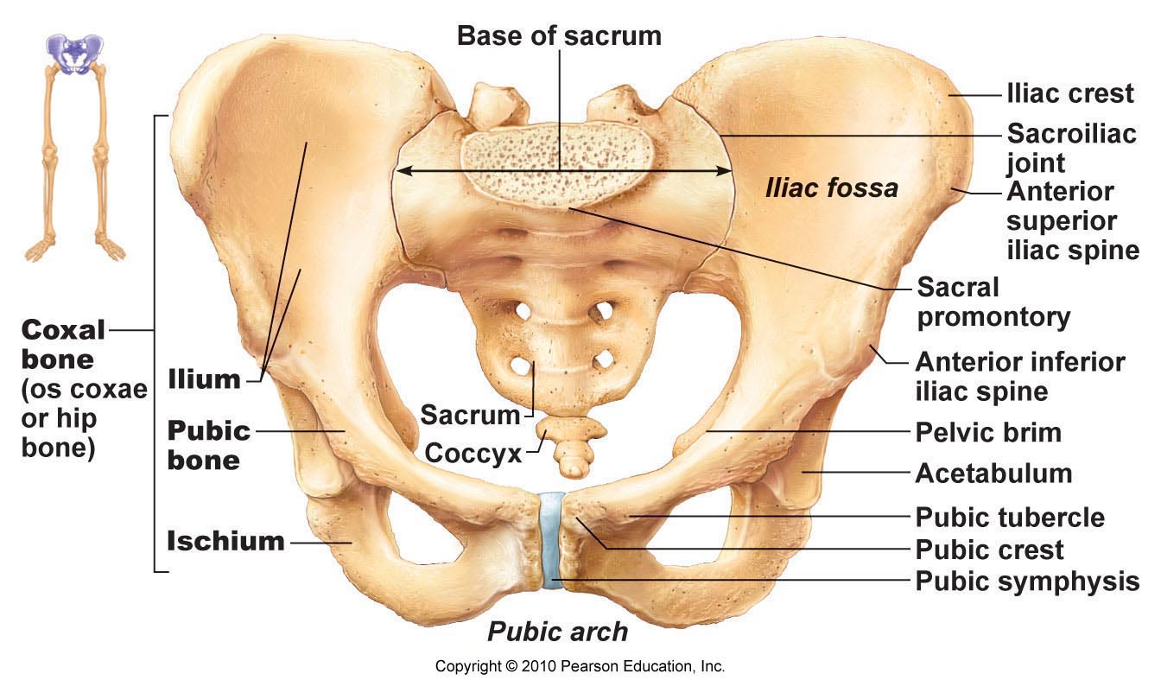

- Ilium:
- • large flaring bone that forms most of os coxa
- • note iliac crest (superior border); iliac spines (attachment of muscles)
- • pelvic brim is superior margin of true pelvis
- • anteriorly, the body of the ilium joins the ischium and the pubis

- Ischium:
  - postero-inferior part of hip bone
  - superior body joining ilium and thinner, inferior ramus
  - The inferior surface of the ischial body is rough and grossly thickened as the ischial tuber- osity. When we sit, our weight is borne entirely by the ischial tuberosities, which are the strongest parts of the hip bones.

- Pubis:
  - anterior part of ox cosa
  - 2 pubic bones unite at pubis symphysis
  - note pubic crest, obdurator foramen (blood vessels & nerves)

- Thigh
  - The femur (fe9mur; “thigh”), the single bone of the thigh (Figure 7.32), is the largest, longest, strongest bone in the body. Its durable structure reflects the fact that the stress on the femur during vigorous jumping can reach 280 kg/cm2 (about 2 tons per square inch)! The femur is clothed by bulky muscles that prevent us from palpating its course down the length of the thigh. Its length is roughly one-quarter of a person’s height.
  - The ball-like head of the femur has a small central pit called the fovea capitis (fo9ve-ah ka ̆9pĭ-tis; “pit of the head”). The short liga- ment of the head of the femur runs from this pit to the acetabulum, where it helps secure the femur. The head is carried on a neck that angles laterally to join the shaft. This arrangement reflects the fact that the femur articulates with the lateral aspect (rather than the inferior region) of the pelvis. The neck is the weakest part of the femur and is often fractured, an injury commonly called a broken hip.
  - Inferior to the intertrochanteric crest on the posterior shaft is the gluteal tuberosity, which blends into a long vertical ridge, the linea aspera (lin9e-ah as9per-ah; “rough line”), inferiorly. Distally, the linea aspera diverges, forming the medial and lateral supracondylar lines. All of these markings are sites of muscle attachment. Except for the linea aspera, the femur shaft is smooth and rounded.
  - Distally, the femur broadens and ends in the wheel-like lateral and medial condyles, which articulate with the tibia of the leg. The medial and lateral epicondyles (sites of muscle attach- ment) flank the condyles superiorly. On the superior part of the medial epicondyle is a bump, the adductor tubercle. The smooth patellar surface, between the condyles on the anterior femoral surface, articulates with the patella (pah-tel9ah), or kneecap (see Figure 7.32 and Table 7.5).

- Leg: 2 parallel bones: tibia & fibula
- • interosseus membrane + proximal & distal tibiofibular joints (rigid)
- • fibula not contributor to knee joint
- Tibia: transfers weight from femur to foot; next largest & strongest bone
- NB: med & lat condyles, anterior crest, tibial tuberosity (patellar ligament)
- Fibula: The fibula (fib9u-lah; “pin”) is a sticklike bone with slightly expanded ends. It articulates proximally and distally with the lateral aspects of the tibia. Its proximal end is its head; its distal end is the lateral malleolus. The lateral malleolus forms the conspicuous lateral ankle bulge and articulates with the talus. The fibular shaft is heavily ridged and appears to have been twisted a quarter turn. The fibula does not bear weight, but several muscles originate from it.
- 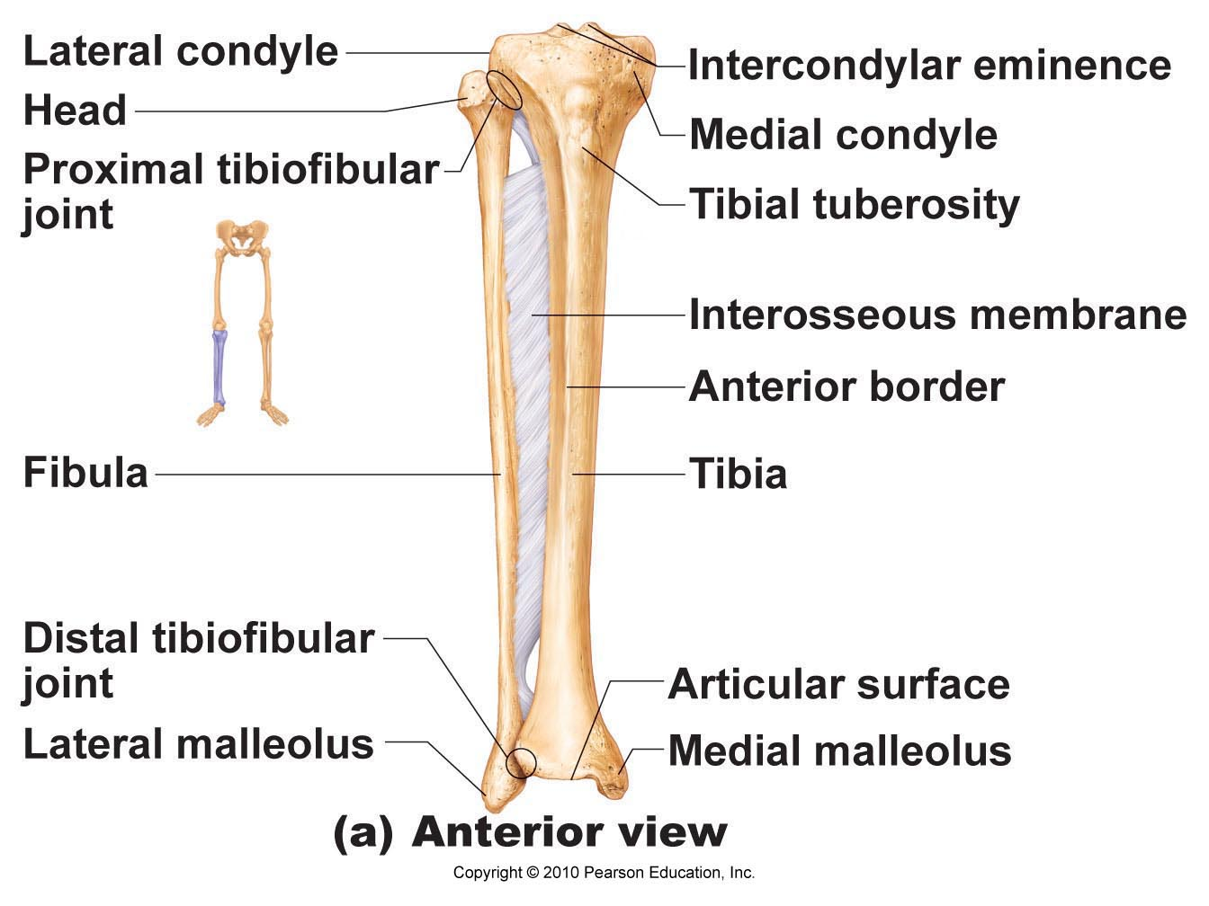

- Foot:
- • total of 26 bones: tarsus (ankle bone), metatarsus & phalanges

- Tarsus:
- • 7 tarsal bones: largest is the calcaneus (heel bone) and second largest is the talus (part of ankle joint)

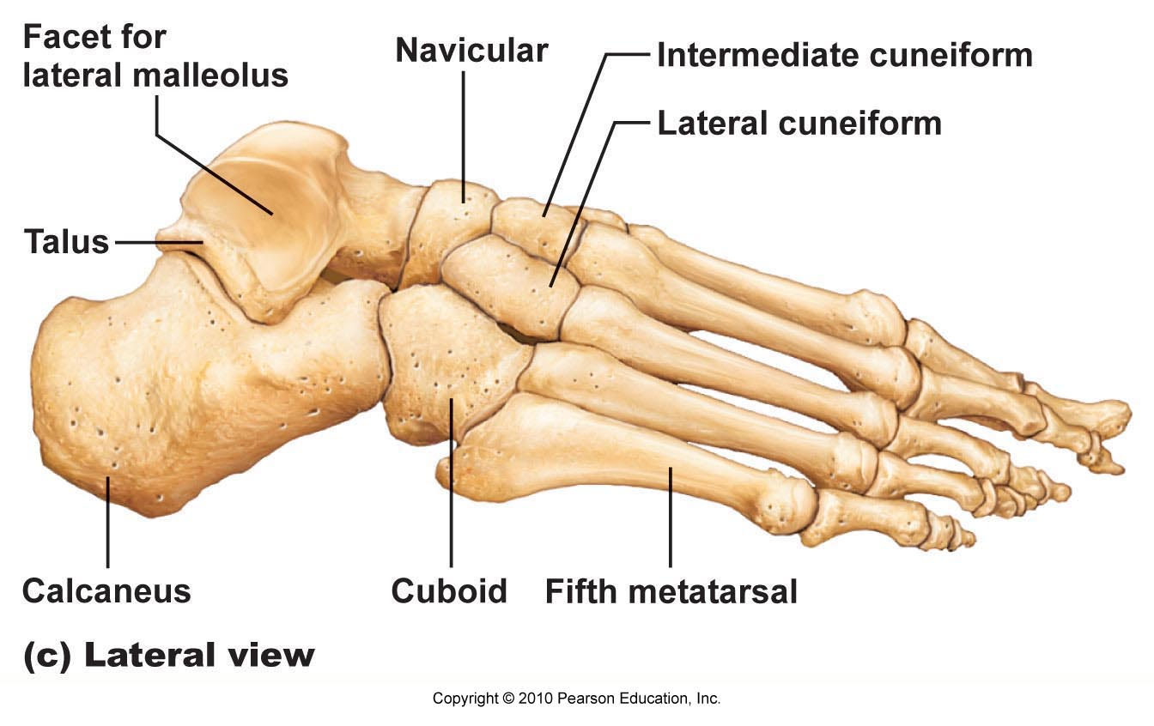

- Metatarsus
  - The metatarsus consists of five small, long bones called meta- tarsals. These are numbered I to V beginning on the medial (great toe) side of the foot. The first metatarsal, which plays an important role in supporting body weight, is short and thick. The arrangement of the metatarsals is more parallel than that of the metacarpals of the hands. Distally, where the metatarsals articulate with the proximal phalanges of the toes, the enlarged head of the first metatarsal forms the “ball” of the foot.
- Phalanges (Toes)
  - The 14 phalanges of the toes are a good deal smaller than those of the fingers and so are less nimble. But their general structure and arrangement are the same. There are three phalanges in each digit except for the great toe, the hallux. The hallux has only two, proxi- mal and distal.

- INTRODUCTION TO JOINTS (Chapter 8)

- Classification of Joints:
- • a joint is a site where 2 or more bones meet
- • In fibrous joints, the bones are joined by fibrous tissue, namely dense fibrous connective tissue, and no joint cavity is present.
- • The amount of movement allowed depends on the length of the connective tissue fibers uniting the bones. Most fibrous joints are immovable, although a few are slightly movable.
- • structurally – 3 types:
- fibrous
- cartilaginous
- synovial
- • functionally – 3 types:
- synarthroses
- amphiarthroses
- diarthroses

- FIBROUS JOINTS:
- bones joined by fibrous CT; no joint cavity so very little to no movement at joint
- Sutures (=Synostose; NO movement):
- • seams only found between bones of skull
- • overlapping or interlocking of 2 bones; junction filled with very short CT fibers
- Syndesmoses (very LIMITED movment):
- cord (ligament) or sheet (interosseous membrane) of fibrous CT
- Gomphoses: (gompho = nail [Greek])
- • peg-in-socket; only example = tooth in bony socket
- 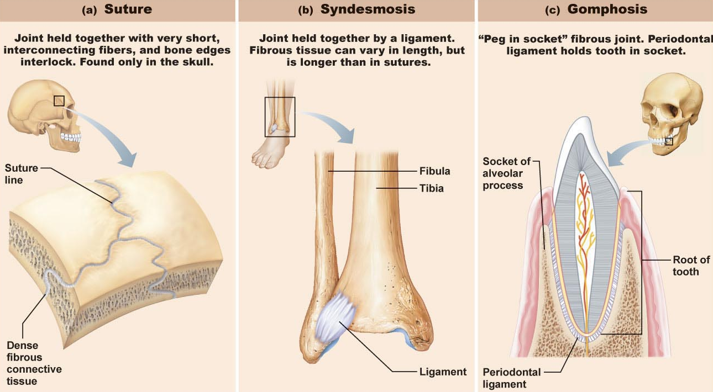

- CARTILAGENOUS JOINTS: bones are united by cartilage (no joint cavity)
- Synchondroses:
- • areas of growth: eg: epiphyseal plates, between each of 1st 7 ribs & sternum
- Symphysis:
- • articular surfaces covered with hyaline cartilage - linking plate of fibrocartilage
- • strength with flexibility: eg: pubic symphysis, intervertebral joints
- 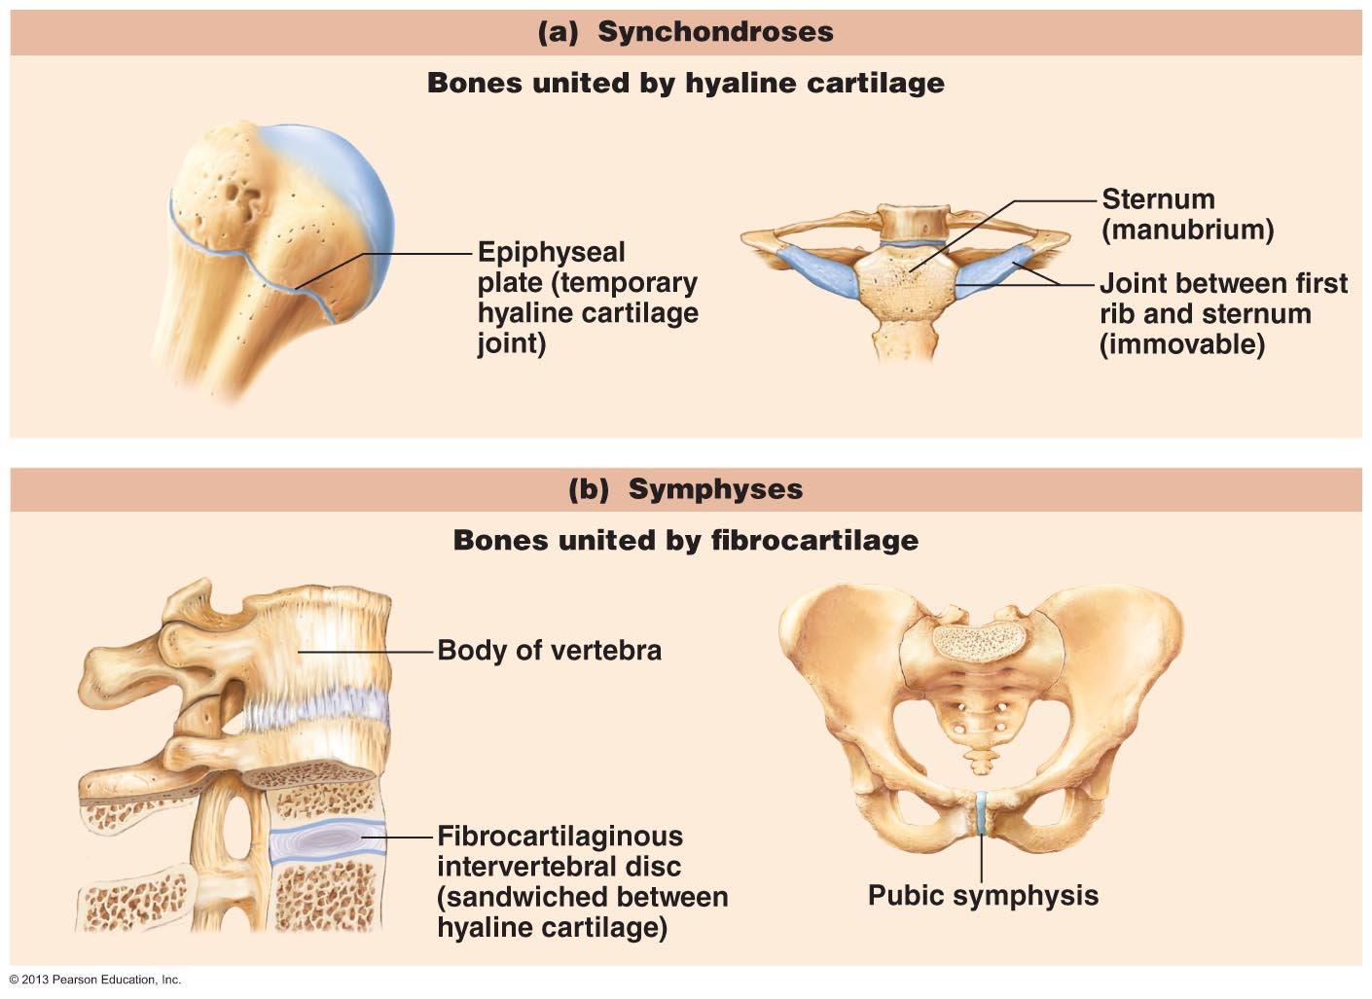

- Synovial Joints
- Synovial joints have six distinguishing features (Figure 8.3):
  - Articular cartilage. Glassy-smooth hyaline cartilage covers the opposing bone surfaces as articular cartilage. These thin (1 mm or less) but spongy cushions absorb compression placed on the joint and thereby keep the bone ends from being crushed.
  - Joint (articular) cavity. A feature unique to synovial joints, the joint cavity is really just a potential space that contains a small amount of synovial fluid.
  - Articular capsule. The joint cavity is enclosed by a two-layered articular capsule, or joint capsule. The tough external fibrous layer is composed of dense irregular connective tissue that is continuous with the periostea of the articulating bones. It strengthens the joint so that the bones are not pulled apart. The inner layer of the joint capsule is a synovial membrane composed of loose connective tissue. Besides lining the fi- brous layer internally, it covers all internal joint surfaces that are not hyaline cartilage. The synovial membrane’s function is to make synovial fluid.
  - Synovial fluid. A small amount of slippery synovial fluid occupies all free spaces within the joint capsule. This fluid is derived largely by filtration from blood flowing through the capillaries in the synovial membrane. Synovial fluid has a viscous, egg-white consistency (ovum 5egg) due to hy- aluronic acid secreted by cells in the synovial membrane, but it thins and becomes less viscous during joint activity. Synovial fluid, which is also found within the articular cartilages, provides a slippery, weight-bearing film that re- duces friction between the cartilages. Without this lubricant, rubbing would wear away joint surfaces and excessive fric- tion could overheat and destroy the joint tissues, essentially “cooking” them. The synovial fluid is forced from the car- tilages when a joint is compressed; then as pressure on the joint is relieved, synovial fluid seeps back into the articular cartilages like water into a sponge, ready to be squeezed out again the next time the joint is loaded (put under pressure). This process, called weeping lubrication, lubricates the free surfaces of the cartilages and nourishes their cells. (Re- member, cartilage is avascular.) Synovial fluid also contains phagocytic cells that rid the joint cavity of microbes and cel- lular debris.
  - Reinforcing ligaments. Synovial joints are reinforced and strengthened by a number of bandlike ligaments. Most of- ten, these are capsular ligaments, which are thickened parts of the fibrous layer. In other cases, they remain distinct and are found outside the capsule (as extracapsular ligaments) or deep to it (as intracapsular ligaments). Since intracapsu- lar ligaments are covered with synovial membrane, they do not actually lie within the joint cavity.

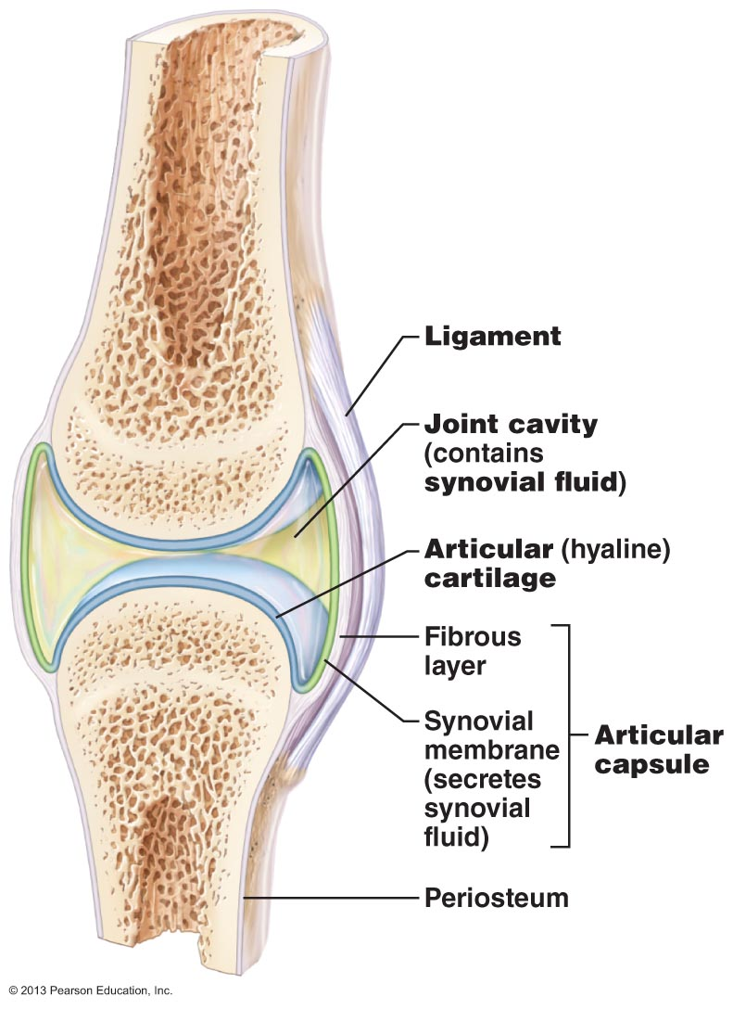

- Bursae and Tendon Sheaths
  - Bursae and tendon sheaths are not strictly part of synovial joints, but they are often found closely associated with them (Figure 8.4). Essentially bags of lubricant, they act as “ball bearings” to reduce friction between adjacent structures during joint activity. Bur- sae (ber9se; “purse”) are flattened fibrous sacs lined with synovial membrane and containing a thin film of synovial fluid. They occur where ligaments, muscles, skin, tendons, or bones rub together.
  - A tendon sheath is essentially an elongated bursa that wraps completely around a tendon subjected to friction, like a bun around a hot dog. They are common where several tendons are crowded together within narrow canals (in the wrist region, for example).

- Factors that influence stability of synovial joints
- • synovial joints allow lots of movement, so not as stable as fibrous/cartilaginous joints
- 3 factors influence joint stability:
- (1) articular surfaces:
- • shape of articular surfaces of many joints such that don’t contribute stability
- • deep ball & socket joints have good shape for stability
- (2) ligaments:
- • more ligaments = more strength
- • ligaments can only stretch ~6% of length before they break - stretched ligaments stay stretched
- (3) muscle tone:
- • tendons of muscles crossing joints usually most important stabilizing factor - kept taut by muscle tone
- • esp: shoulder, knee, arches of foot

- Common Joint Injuries
- Sprains:
  - partially torn ligaments repair themselves (slowly due to poor vascularization)
  - completely torn ligaments require surgery
- Cartilage injuries:
  - usually the knee - because cartilage has no blood supply, cannot repair itself
  - pieces break off / interfere with joint function »» arthroscopic surgery
- Dislocations:
  - bones forced out of their normal positions at a joint; need to be reduced
  - repeat dislocations common because ligaments get stretched
- 

