Cancer
Cancer Critical Genes
- Proto-oncogenes/ oncogenes are the wild type of genes:
  - Promotes cell proliferation
  - Identified by gain of function mutations (increased activity)
  - Dominant trait
  - An example is the activation of Bcr/Abl gene in CML
- Tumour suppressor genes:
  - Inhibit proliferation
  - Identified by loss of function mutations
  - Recessive trait
  - An example is the loss of Rb function in retinoblastoma
- There are two main categories of cancer-critical genes:
  - Overactivity mutation (gain of function)
    - Single mutation creates oncogene
    - Activating mutation enables oncogene to promote cell transformation
  - Underactivity mutation (loss of function)
    - Mutation event inactivates tumour suppressor gene
      - No effect of mutation in one copy
    - Second mutation event inactivates second gene copy
      - Two inactivating mutations functionally eliminate the tumour suppressor gene, promoting cell transformation
- Activation of a single oncogene is not sufficient for tumour development
- Studies in transgenic mice have shown that one mutation does not lead to cancer
  - It is an accumulation of several mutations in the same cell that leads to cancer
- There is proof that the incidence of cancer increases with age in an individual
- There is also proof that the development of cancer increases with an increased in time from the initial exposure to a carcinogen
- This shows a long incubation period and further supports the fact that multiple changes need to occur for a cell to be cancerous
Retinoblastoma
- Retinoblastoma is caused by the loss of retinoblastoma tumour repressor function
- Occurs mainly in the eye of young children
  - Can be hereditary
- In a normal healthy individual:
  - Occasional cell inactivates one of its two good Rb genes
  - Active form of Rb protein binds the transcriptional factor E2F and prevents it from activating transcription of G1/S and S cyclins
    - Regulates entry in to S-phase
    - There is no tumour as a result
- Hereditary retinoblastoma:
  - Inherited mutant Rb gene
  - Occasional cell inactivates its only good copy of the Rb gene
  - Excessive cell proliferation leading to retinoblastoma
    - All cells in body lack one of the functional copies of the Rb gene
    - Unregulated S-phase
    - There are multiple tumours affecting both eyes
      - If they are “cured” they can still get other types of cancer later on in life
      - The retinas are the most sensitive
- Nonhereditary retinoblastoma:
  - Occasional cell inactivates one if its two good Rb genes
  - The second copy of Rb is very rarely inactivated in the same line of cells
  - Excessive cell proliferation leading to retinoblastoma
    - Defect in Rb gene originates in a single retinal cell
    - Results in one single tumour in one eye
The Role of Rb and p16 Proteins in Cell Proliferation
- P16 is an inhibitor of Cdk
- G1- Cdk is an inhibitor of Rb
- Rb is an inhibitor of E2F ( a gene regulatory protein)
- E2F allows transcription of target genes that control entry in to S-phase
- In a non-proliferating cell:
  - P16 inhibits formation of G1-Cdk complex
  - Active Rb inhibits the entry in to S-phase by inactivating E2F
- In a proliferating cell:
  - Inactivation or absence of p16 allows the G1-Cdk complex to form
  - This complex phosphorylates Rb inactivating it
  - This allows the E2F protein to become active and the expression of S-phase genes is activated
- Activation or overactivity of G1-Cdk promotes cell division
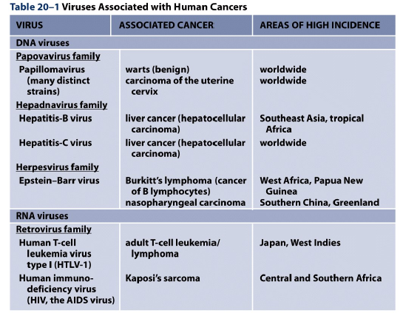
The Role of Viruses in the Development of some Cancers
- Hepatitis B is associated with chronic hepatitis B infection
- The Human Herpes Virus (HHV8) is associated with AIDS infection
- The papillomavirus can give benign warts and malignant tumours
  - Luckily there is a vaccine for this type of virus
The Role of Papillomavirus in Cervical Cancer
- Viral proteins required for controlled replication of the virus
  - Disrupt the cell cycle control of host cells
- After replication this results in a small increase in proliferation of cells in the outer layer of the cervical epithelium
- However accidental integration of viral DNA fragment in to host of chromosome
  - Unbalanced production of viral proteins that disrupt cell cycle control of host cells
- After replication this results in a large increase in the proliferation of cells in outer layer of the cervical epithelium
  - Viral infection spreads to the cells located in the basal layer
The Role of Two Papillomavirus Proteins E6 and E7
- In an uninfected epithelial cell:
  - The Rb protein binds to cell proliferaction factor E2F
    - This renders it to be inactive
    - G1/S cyclin blocked
  - Active p53 protein provides safety brake on cell proliferation
    - The p53 is a regulator for the gene p21 protein
  - The activation of this gene means that p21 is made
  - This causes the inhibition of G1/S and S cyclin-Cdk complexes
    - Therefore cell proliferation is blocked
- In an affected epithelial cell:
  - The viral protein E7 binds to Rb
    - This allows for the transcription of cyclin
  - Viral protein E6 binds to p53 making it inactive
    - Since p21 is not transcribed there is no inhibitor of the cyclins
  - The sequester of Rb and p53 mean the cell enters S-phase
    - Thus, making the cell proliferation active
- There is a vaccine called Gardasil which uses the recombinant form of the major structural protein (L1) of the virus
  - Immunodominant protein the can form virus like particles (VLP)
  - The body responds by producing antibodies which it will use if the virus attacks
Progressive Stages of Colon Cancer
- Colon cancer is responsible for 11% of all cancer deaths in the US
- 90% of cases are not diagnosed in an individual until after the age of 55
  - A colon check was launched in Ontario in 2008 where individuals who are 50+ years old get a free screening
- Originates as a small benign tumour or adenoma
  - Visible as a protruding mass of tissue called a polyp
- Larger polyps frequently can be divided in to two subsections:
  - One that have almost normal appearance of epithelial cells
  - Undifferentiated cells in abnormal organisation- undergone more mutations
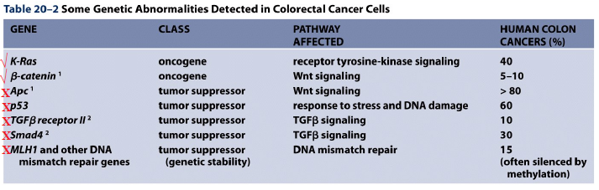
- ticks- activation or over expression of oncogene
- Crosses- inactivation of tumour suppressor
How are these Genes Identified?
- Screen tumours for mutations in genes known/suspected to be involved in other cancers
- Examine colorectal tumours to look for common genetic alterations
- Examine families with genetic predisposition to colorectal cancers
  - Familial Adenomatous Polyposis coli (FAP)
FAP
- Multiple polyps are associated with FAP
- FAP is due to the deletion or inactivation of both alleles of the APC (Adenomatous Polyposis Coli) gene located on chromosome 5
- The normal APC protein is inhibitory component of the Wnt signalling pathway
- If the APC protein is missing or non-functional, an overgrowth of the colonic epithelium will occur polyps
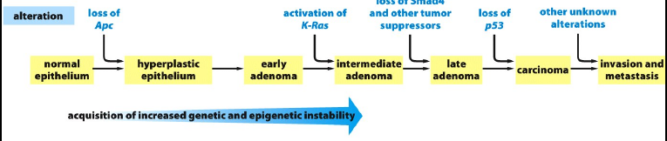
- Possible genetic changes associated with the development of a colorectal carcinoma
- Sequence of mutations are inferred by frequency of observed mutations in small benign polyps and large malignant tumours
- Mutations found in both polyps and malignant tumours are likely to occur at an early stage
- Mutations found only in malignant tumours are likely to occur at a later stage
Metastasis of Cancer Cells
- Cells grow as benign tumour in epithelium in a localised region
  - Local invasion
- Cells become invasive and enter the capillary
  - Breakdown of cell-cell adhesion causes the tumour to cross the basal lamina
- The cells enter the bloodstream or lymphatic system and travel
  - Fewer than 1 in 1000 cells will survive
- Adhere to blood vessel wall
- Escape from blood vessel to form micrometatasis
- The establishment of a new sight relies on the induction of angiogenesis
  - Growth of blood vessels
- Growth of metastasis
Angiogenesis
- Judah Folkman was a cancer surgeon who introduced research in to this new field
- Angiogenesis is controlled by factors released by surrounding tissues
- One factor is hypoxia inducible factor (HIF)
  - In well oxygenated tissues HIF is kept at low levels by its continual degradation
    - Dependent on protein encoded by VHL
  - In the case of low oxygen HIF stimulates transcription of genes encoding the vascular endothelial growth factor (VEGF)
    - VEGF stimulates endothelial cells to sprout
- Von Hippel-Lindau (VHL) syndrome is a rare genetic disorder where individuals have only one functional copy of the VHL gene in all cells
  - If one cell loses the remaining copy:
    - HIF would accumulate in the cell
    - Overproduction of VEGF
    - Development of hemangioblastomas- tumours containing dense masses of blood vessels
The Molecular Basis of Chronic Myelogenous Leukemia (CML)
- This disease usually happens in the bone marrow around the early 20s
- The Bcr gene on chromosome 22 encodes a protein with serine/threonine kinase activity
- The Abl gene on chromosome 9 encodes a protein tyrosine kinase involved in cell signalling
- The translocation of these two genes causes a hybrid chromosome- fused Bcr/Abl
  - This is also known as the Philadelphia chromosome
  - The scientist that discovered this noted the 95% of patients with CML have this translocation in their affected white blood cells
- This fused gene gets transcribed and translated to form a protein which is constituently active
  - Abl kinase domain becomes hyperactive as the regulatory part of the gene is missing
  - This stimulates excessive proliferation of the white blood cells made in the bone marrow
- This creates a unique target for chemotherapy
  - As this protein is not found in non-cancerous cells
- Gleevec is an identified compound which is used
  - Identified after high throughput screen for inhibitors against tyrosine kinases
  - Also known as (STI571) – Signal Transduction Inhibitor
- The good news for the drug:
  - Drugs can be given orally
  - Tolerable side effects
  - Obtained good reduction in WBC counts in patients in chronic stage of disease
- Bad news:
  - Patients in acute stage had good reduction at first but relapsed later
    - Affected cells have increased mutation rate due to genetic instability
  - Expensive
- In a cell without Gleevec:
  - The binding of ATP on to the Bcr/Abl protein allows the tyrosine residue of a protein substrate to be phosphorylated
    - This activates the signal for cell proliferation and survival
      - This results in leukemia
- In a cell with Gleevec:
  - The binding of Gleecvec in ATP binding site prevents ATP from binding
    - Therefore there is an inactivated substrate
    - No signal is produced
      - This results in no leukemia
Effects of Ionizing Radiation
- In a normal cell:
  - When DNA damage occurs, the induction of p53 causes cell cycle arrest (allows the cell to repair damage)
  - Either:
    - The damage is too extensive to repair and so apoptosis
    - The damage is repaired and normal cell division continues- Most frequent result
- In a cancer cell:
  - The tumour cell is lacking p53 due to a mutation
  - Cell division with damaged chromosomes occur which leads to either:
    - Massive mitotic failure and cell death – Tumour regresses and most frequent result
    - Continued mutation, selection and tumour evolution- cancer
- Although radiotherapy selectively targets cancer cells
  - It can cause death in normal cells
  - And some cancer cells may survive

