Respiration John Leddy

Anatomy:
- Respiration based on diffusion of gas down concentration gradients facilitated by
  - High volume of air flow
  - Large surface area of gas exchange
  - Closed circulatory system
- Air entering through nose is warmed and humidified 100% water saturation
  - Terminae warms air very quickly
- Foreign particles filtered by cilia which transport the debries towards the pharynx
- PATH : nasopharynx oropharynx laryngopharynx glottis trachea bronchus primary/secondary bronchus bronchiole alveole
  - Bronchioles can constrict (resistance)
- Right lung 3 lobes, left 2 lobes
  - Right bronchus more vertical than left
  - Swallow something goes into right lung
- Lung completely surrounded by pleura
  - Parietal pleural in contact with thoracic wall
  - Visceral pleura inside
  - Interpleural fluid filled cavity between the two allows sliding of pleura during breathing.
- At alveolar level S.A. so high that flow stops, only diffusion works (RESPIRATORY ZONE)
  - The rest of lung referred to as conduction zone
- Trachea and bronchi surrounded by cartilage, which prevents them from collapsing.

Mechanics of breathing: Lung volumes
- Tidal Volume (TV) 0.5 L
  - Effortless breathing
- Inspiratory Reserve Volume (IRV): 3.3 L
  - Maximum volume that can be inhaled from tidal volume.
- Inspiratory Capacity (IC = TV + IRV): 3.8 L
- Expiratory Reserve Volume (ERV) 1.0 L
  - Max vol that can be expired from end-respiratory position
- Residual Volume* (RV) : 1.2 L
  - Air in lung after max expiration
- Functional Residual Capacity*
(FRC = ERV + RV) : 2.2 L
  - Air in lungs after end-respiratory position
  - Cannot be measured directly with spirometer
- Vital Capacity (VC = TV + IRV + ERV): 4.8 L
- Total Lung Capacity*
(TLC = VC + RV): 6.0 L

Question : friend runs up stairs, freq of breathin inc. At same time
- greater volume of breath than at rest.

Some Gas Laws :
- Ideal gas law PV=nRT
  - Either at BTPS or STPDry
- Boyle’s Law
  - Used to calculated P and V changes
  - Understand pressure changes that drive breathing
  - Used to mesure residual volulme using helium dilution method.
- Charles Law:
  - V1/V2=T1/T2 at constant P

Helium Dilution Method:
- Hook up person to helium tank
- Measure initial C and V of helium tank
- Open valve to let helium flow into lung, calculated new C of helium
- Desired Lung volume V2 isolated for.
  - If you want to measure residual volume, you open the valve once maxmum expriation is attained.
  - C1V1=C2 (V1+V2)
- Helium used because it will not cross into the blood.

Body plethysmograph:
- Can measure FRC
- Use’s boyles law P1V1= P2V2
- Sealed room
- Person inspires as they do, P dec and V inc in there lungs.
  - At same time sealed box P will inc, and V will decrease.
  - Changes used to calculated FRC
- Closed shutter = measure FRC
  - Open shutter = airway resistance

Lung-Chest Wall Unit:
- Lung elastic, resists change
  - Would collapse if there was no resisting pressure keeping it up
- Lung held to chest wall prevents it from closing
  - Held by interpleural fluid surface tension
- Thorax wants to expand
- Creates a negative vaccum pressure at the interpleural space
  - Negative in relation to ATM pressure.
- Intrapleural pressure more negative towards top of standing lung
  - Gravity working against expanding chest wall here
  - Lungs hanging off the chest wall- feel more pull.
  - Elasticity +weight

Intrapleural pressure:
- Measured by injecting air or fluid to separate two pleura
- Can also be measured using thin balloon into esophagus
  - Works because esophagus between lungs
  - Thin tube, without tone and little resistance

Lung-Chest Wall Unit
- At FRC, lung and Chest wall are at equilibrium.
  - Point at end of relaxed experiation
- Lung on its only shrink to RV
  - Unemptyable volume of lung.
- Chest wall on its own would expand.

Pathology:
- Obstruction = Asthma. Difficult for air to flow out
  - Air tends to stay inside the lungs
  - Equilibrium volume higher than normal (FRC)
  - Easier to get air in because it’s an active process
  - Expiration is passive (not much work) so air stays trapped
- Emphysema= elasticity of lung removed
  - Less tendency to recoil
  - Will not deflate quickly when exhale
  - Leathery balloon
  - Tends to have much larger volume
  - Problem is lots of air in lungs, makes it difficult to inhale.
- Peneumothroax: collapsed lung.
  - Thoracic cavity expands
  - Air gets between chest wall and lung
  - No more negative pressure pulling on chest wall.
- Blebs: Alveoli at the surface that create little air pockets, where they are, lung collapses.
  - Lung collapses but chestwall expands

Lung-Chest Wall unit:
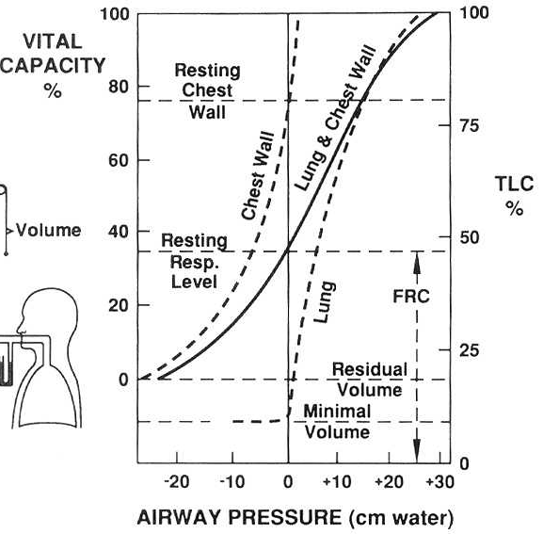
Y axis=volume
Figure shows how the lung acts by itself, how the chest wall acts by itslef, and how the two act together.

X axis: at 0, you are at equilibrium, no tendency to expand/collapse. FRC at center for chest-lung. At FRC of the chest-wall, the lung is wanting to collapse (+ve pressure, because you have to push air in for the FRC to happen). Also, the chest is wanting to expand ( -ve pressure bcz you have to suck air out for this to happen).

Residual volume is not in minumum of graph i.e. its not a equilibrium, you have to force to get there.

Above the top line, breathing hurts because working against stretchyness of lung AND chestwall.

Inspiration and expiration :

- Contraction of muscles overcomes
  - Elasticity and surface tension in lung
  - Resistance of airways
  - Resistance between lung ahd chest wall
- Diaphragm = 75% of inspiration
  - Fatigue of the respiratory muscles can result in a paradoxal movement, ie. abdomen draws in with inspiration (snorting)
  - Sick and having difficulty breathing, diaphragm is so tierd tha stomach is sucked in while breathing in.

Inspiration

- Inflation depends on pALV < pATM
  - By expanding thoracic cavity. Boyle’s Law.
- Need to create lower alveolar pressure to allow air to move in
- External intercostal muscle contract raising rib cage, and expands thoracic cavity
  - Antero-posterio direction
- As chest wall pulls away from lungs, the pressure in the intrapleural space becomes more negative, results in expansion of lungs
  - Drop in pressure in alveolar sacs
- Depends on :
  - Diaphragm (1-10cm) 75%
  - External intercoastal muscles 25%
  - Can use shoulder, mouth nostrils. Built up muscles in neck and shoulders shows we use them to breath

Expiration :
- Usually passive due to cessation of contraction
- Alot easier.
- pALV>pATM
- muscles used
  - relax diaphrahm
  - contracting abs
  - contract internal intercostal muscles.

Pulmonary pressures :
- measured inside – outside.
  - If +ve expanding
  - If –ve collapsing
- Atmospheric pressure (body surface)
- Alveolar pressure pALV
- Intrapleural pressure pPL
  - Cant be measured directly
- Transpulmonary pressure: pALV - pPL
- Transthoracic pressure: pPL – pATM

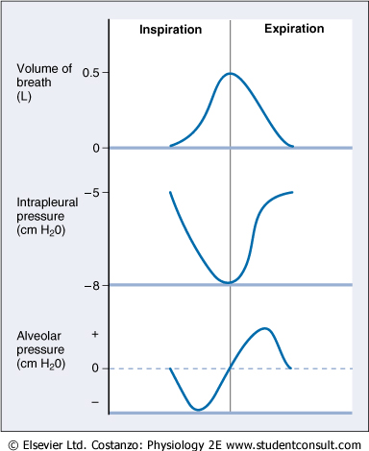

Alveolar pressure: 3 moments where there is no airflow (i.e. pressure the same as atmosphere)
Start at 0, breathe in and then stop again ( zero), and then expire. At end of expiration (zero again).

Intrapleural pressure most negative when lung expanding.

Equal pressure point:
- Point at which transmural pressure is 0
  - Above that point –ve transmural pressure could cause lung colapse
- As we move up pressure inside airway goes down
  - Due to resistance
- As long as the equal pressure point is high enough, there is cartillage to keep the lungs from collapsing.
- COPD: resistance in the airways. On the way out you encounter some resistance.
  - Air pressure on the way out encounters an obstacle, pressure drops quicker. Equal pressure point comes down, there is no cartillage to protect the lungs, lungs drop.
  - To fight this blow air through closed lips. This creates back pressure that keeps the airways open during expiration.

Elasticity and compliance:
- Something perfectly elastic has linear relationships between force and length change.
- Greater elasticity means less change per unit force
- Works against blowing up lungs
- Compliance : volume change/ unit pressure
  - Floppy ballon will be more compliant than a stiff balloon.
  - Lung very compliant at operational volumes.
  - Ventilation optimized by range were tiny change in pressure causes large volume change. AT MEDIUM VOLUME.
  - At higher volume, lung becomes less compliant

Clinical:
- Elevated compliance
  - Emphysema (grocery bag lungs)
    - Very small pressure causes big change
  - Age
- Decreased compliance
  - Oedema
  - Pneumonia
  - Fibrosis (liquid in lung)
  - Arthritis, obesity (chest)

Hysteresis:
- Generate pressure vs. Volume curve
  - Create vaccum around lung
  - Dropping pressure causes lung to inflate.
  - If you release vaccum curve will take different path
  - Pressure during expriation less that pressure during inspiration
- Difference between insp pressure curve and exp. Pressure curve is hysteresis.
  - Difference: inflating working against more resistance.
  - One of the resistances that’s not there is surface tension

Resistance:
- Elastic components
  - Tissue elasticity of lung
  - Surface tension in lung. Molecules at surface tend to pull towards each other and make the surface contract.
- Non elastic components
  - Airway resistance
  - Friction between pleural surfaces

Atelectasis:
- Collapse of alveoli
- If you have broken rib pain no deep breath, alveoli can collapse
- No deep breaths collapse
- Prevent collapse by normalizing pressure
  - Only thing you can manipulate though istension.
- In small radius tension must be reduced.
  - Answer is surfactant.

Surface tension:
- At air liquid interface
- Laplace’s Law … P=pressure, T= tension, r=radius of sphere. P= 4T/r (if soap
  - Bcz soap bubble has 2 air/watter interfaces
- P= 2T/r if not soap bubble
- If T is constant, the small alveoli will empty into large alveoli.
- Surface tension inside alveoli causes pressure towards inside.
- Makes it more difficult to inflate the lung
- Favours emptying of small alveoli into larger ones (atelectasis)
  - Pressure is driving the movement. In small alveoli pressure of gase is higher.
  - Empties into big one
- If all smaller alveoli collase into larger alveoli
  - Lung will collapse
  - Loose potential surface area.
- *** if filling lungs with saline solution only fighting tissues elasticity
- if filling with air (bcz it is non polar), must also fight surface tension ***

Surfactant:
- phospholipids and proteins secreted by type 2 alveolar pneumocytes
- SP-A, B, C, and D.
- Increases surface tension with larger radius
- Larger effect on smaller alveoli. Because larger alveoli will have less surfactant density
- Reduces surface tension, act as emulsifiers at apolar/nonpolar layers
- Premature babies do no produce enough surfactant and suffer from respiratory distress syndrome (IRDS)
- The alveoli can expand only as long as the surfactant density is high enough for it to overcome the brake caused by surface tension.
- Prevents alveoli collapse by dynamic action which changes with surface area.

Non elastic Resistance:
- Mostly caused by airway resistance
- Poiseulle’s law… Flow = dP/R = Ppir^4/8nL
- Most resistance occurs in medium-sized tubes of conduction zone because they see the greatest rate decrease in radius. Also because of there smooth muscle.
- Caused by, obstructive disease, smooth muscle contraction (parasympathetic)
- Reynolds number= 2rvrho/n
  - Predicts turbulent flow
  - High turbulence in medium sized tubes.
  - Bigger the number more likely turbulent
  - Bigger radius and highest velocity highest resistance at top
- He/O2 used in obstructive disease. Reduces resistance caused by turbulent flow by reducing the density of inspired air.
- Biggest effect is radius
  - Pulling lungs open with CT decreases resistance

Work of Breathing:
- Overcomes elastic and non elastic resistnace
  - Most work against eleasti ristance.
- Area within volume pressure loop of lung
- 2-3% at rest, 20% during exercise energy cost of breathin.
- Ve= Breath rate * TV
  - About 6L/min

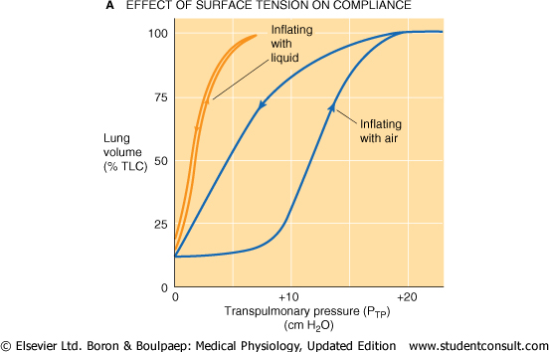

- Ve can be tweaked to optimized work with minimal energy use
- Deep breathing
  - Much work performered against elastic resitance
- Elevated respiratory rate
  - Much work against airway resistnace
- In a disease where lung’s compliance is decreased (restricte)
  - High respiratory rate , small TV is best
- In a disease where high airway resistance (obstructive)
  - High tidal volume, low frequency

Time constant (tau)
- Time required to observe pressure change in respiratory system
- T= R * Compliance.
- Longer time required to move gas in and out of lungs
- In certain disease Tau is so high that you don’t have time to empty lungs between breaths..
  - Airway collapsed
  - Hyperinflation.
  - Increased work of breathing, muscles less efficient when overstretched.

Pulmonary Function Tests:
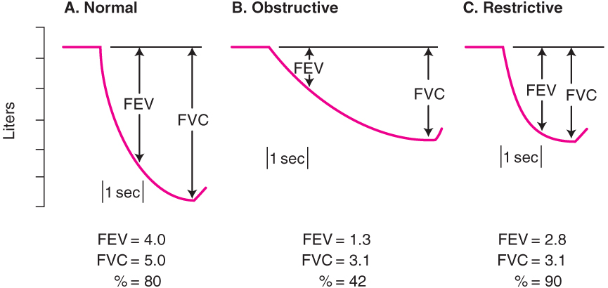
- FEV = forced expiratory volume in one second. Normally, we can exhale 80% of our vital capacity within that first second.
- Normal= 80% out in the first second.
- Obstructive= takes longer for air to leave. Much less air out in the first second. Also won’t get as much air out bcz equal pressure point is lower in the lungs.
- Restrictive = really hard to get air in, but very easy to get it out. Total volume is less because you started off with less air.

RESPIRATORY PHYS 2:

Henry’s Law solubility of gases:
- Gas and liquid in contact, volum of gas in liquid proportional to partial pressure of gas above liquid
- Air in alveoli equilibrium with blood if blood weren’t moving
- Bcz air in body is humidified we have to remove water vapor from total in measurement
- PAtm – pWatervapor (always 47)
- Air in lungs has pO2 of 150 after being humidified.

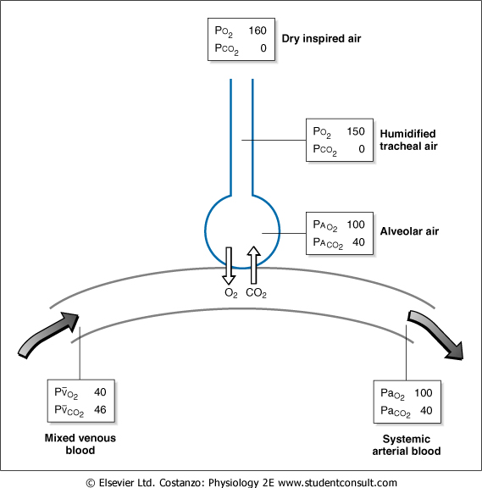
Dalton and partial pressures:
- pO2 air is 160 at sea level. pO2 as it enters body and in alveoli are different
- pCO2 in air around 0. Assume hardly CO2 in air we breathe

Effect of altitude on inspired O2:
- as altitude increases atm pressure goes down, so will pO2
- going higher than Everest pO2 atm will be less than 40 (i.e. pO2 in tissues)
  - bad idea to breathe there

Gas exchange Fick’s Law:
- transfer of gas molecule requires pressure gradient
- transfer across short distances i.e. diffusing capacity of lung is independent of driving pressure.
- rate of diffusion depends on = Area*diffusibility*deltaP /Thickness.
  - Diffusion of CO2 20x greater due to high solubility

Diffusing capacity in lung:
- Measured using tint amount of CO
- Gives info on the SA, diffusibility and thciking of lung.
  - Also on interaction with hemoglobin
- CO used bcz of its high affinity.
- Alv water lining (surface tension)alv membraneintermembrane space artery wall blood RBC memb Hb.

Causes of reduced diffusing capacity
- Thick alv membrane.
  - Fibrosis, sarcoidosis, asbestosis.
  - Restricktive disease.
- Dec. S.A.
  - Oedema, emphysema, tumor.
- Dec. RBC absortion
  - Anemia, low Blood volume, embolism.

Uptake of oxygen along capillary:
- Time between blood and lung is 0.75sec normally.
  - Even w/ .25 sec can still saturate.
- Blood pO2 Very quickly reaches equilibrium with alveolar gas
  - At equi. Further o2 binding limited by blood flow.
- Blood wont get to pO2 100. Limited by perfusion.

Pathology:
- Impairing diffusion dec. ability of pO2 blood to reach pO2 alveolar.
  - Especially when contact time is reduced during exercise.
- During exercise transfer of O2 limited by diffusion
  - Blood going to quickly = short contact time.

Gas transport: oxygen:
- Body needs 250 mls of O2/ min at rest.
- Dissolved oxygen in blood cannot satisfy o2 requirement of body
  - Solution is hemoglobin.
- About 1.34mL of O2 per gram of Hb at 100% saturation
- In 100mL of blood 20mL O2 19.7 in Hb .3mL dissolved.
  - i.e. total O2delivery potential of blood is CO* Hbsat
  - 6l/min *200ml/L = 1200mL/min
- Hb saturation measured by pules oximetry
  - Tissues have 75% saturation, arteries have almost 100%.

Oxygen dissociation curve:
- pO2 in blood vs. hemoglobin saturation.
- Once one O2 binds to an iron of hemoglobin, affinity for 2nd and 3rd iron spots greatly increases.
- Binding of 4th iron spot is more difficult
- This gives the oxygen dissociation curved an S shape
- At 100mmHg O2 saturation almost 100%
- pO2 of tissues is 40mmHg 75% saturation in blood.
  - i.e. 25% of Hb O2 donated to tissues.
At 80 , O2 st almost maximal.
- In cells working hard, pO2 is lower. In these cells Hb releases O2 to them very quickly.
  - Steepest part of curve is at places where pO2 is lowest.
  - pO2 can fall as low as 15mmHb O2 sat of 20%. That means 80% of the O2 in Hb becomes available to tissues.
- of the 20mL/100mL O2 in arterial blood, 5 mL is given to tissues
  - moves to 16mL in enercise

Affinity shifts of Hb for O2
- pH dec curve shifts to right. Greater amount of O2 dissociation
  - makes sense bcz. High metabolic activity = high pCO2 = more acid.
  - i.e. O2 delivery increased and at same time CO2 removal inc.
  - known as Bohr effect.
- temp to right
- hypoxia low O2.
  - RBC use glucose as their main energy source, metabolized to lactate
  - Possible shunt of this pathway produces 2,3DPG.
  - Shunt favored in low [O2]
  - 2,3DPG stabilizes deoxyHb, making it harder for it to bind O2.
  - Encourages delivery of O2 to tissues in hypoxia.

Gas transport CO2:
- Deoxygenated blood has pCO2 of 45 when it arrives in pulmonary capillary.
- Decreases to 40mm on venous side
- Very soluble, crosses membrane into alveolus easily.
- Majority of CO2 transported as bicarbonate
  - Some in hemoglobin
  - And even less in blood (4mL/100mL) 20x more than O2.
  - Bicarbonate allows pH regulation of blood.

Exchange at tissues:
- CO2 that enters RBC can:
- 1)RBC has anhydrase so that when CO2 diffuses from tissue into RBC it gets converted to bicarbonate. Bicarbonate moves down concentration gradient into plasma to keep electrical gradient Cl ion moves from plasma into RBC. Chloride shift.
- The increase in acidity in RBC facilitates O2 unloading
  - Removal of O2 inc. affinity for CO2 by Hb.--> Haldane effect
  - HbO2 Hb-H. Holds H+ proton
- 2) CO2 will then bind hemoglobin.

Exchange at lungs:
- O2 binds Hb releases H+ from Hb. H+ reacts with bicarbonate to form H2CO3.
  - HCO3- comes into RBC in exchange for Cl counter ion (reverse chloride sgift).
- H2CO3 converted to CO2, diffuses to lung exhaled.
- CO2 also follows its concentration gradient off of Hb and into alveolus where pCO2 is lower than that of blood.

pH and CO2:
- Lvl of CO2 vs. lvl of HCO3 controls pH of blood
- To get [CO2] blood multiply pCO2 by 0.3
- pH=pKa +log[bicarb/CO2]

Ventilation:
- part of air we breathe never reaches alveoli useless for gas exchange. Called dead space.
- Deeper we breather more useful ventilation we get.
- Vol of anatomical dead space doesn’t change. So higher proportion of air reach alveoli.
Anatomical deadspace
- No gas exchange because it doesn’t reach gas exchange area.
- Conduction zone. 1ml/lb.
- About 150mL of your Tidal volume never mixes with alveoli, stays in trachea and bronchi.
- Measured by breathing in pure O2. Air will the mix in lung
  - “useful” air with get diluted with N2.
  - Measure time between beginning of exhale and mixture

Physiological Dead space:
- Anatomical + alveoli not participating in gas exchange
- True alveolar ventilation substracts this deadspace from T.V.
- Can be caused by pulmonary embolism
  - Blood supply to some alveoli blocked off.
- Ask person to breathe in regular air.
  - Looking for alveoli that are ventilating but not exchanging gases. i.e. no CO2 coming out of them.
  - Phys. Deadspace measured from beginning of expiration till detection of CO2 of expired air.

Alveolar gas equation:
- Estimation of O2 in alveoli
- pAO2= piO2 – pACO2/R
  - oxygen inspired – oxygen consumed
  - oxygen inspired = 21%*(pATM-pH2O)
- more CO2=less space for O2
- R= metabolic quotient =0.8
  - Amount of CO2 produced for O2 consumed.
- Alveolar CO2 lvl inc. with CO2 product by body, and decreases with alveolar ventilation
- Test: after hyperventilating you can hold breath much longer.
  - Removes CO2
  - Dec. CO2 decreases trigger for hyperventilation
- Hypoventilation: high pCO2 low pO2
  - Correct low pO2 by inc. inspired air.
  - Only ventilation can decrease pCO2.
- Hyperventilation: low pCO2 and high pO2
  - Raising pO2 over 100 inc. O2 in blood but not by much.
  - You will inc. dissolved in blood but not in Hb already at 100% saturation

Ventilation and perfusion:
- Local control due to sensitivity of smooth muscle of bronchioles and blood vessels.
- Inequality of V/P ratio by either airway obstruction or change in blood flow.
- At apex, less ventilation and perfusion bcz alveoli larger, lower blood pressure, and less blood flow.
  - Standing up, bcz of gravity.
- Ventilation= change in volume, you will be able to change volume most in lower region of lung which is compressed.
- At atpex less blood flow bcz alveolar pressure higher than arterial pressure, low perfusion
  - Middle lung has intermediate perfusion, palveolar is higher than venous.
  - Bottom alveolar pressure is lower than both, high perfusion.
- Perfusion mitigated by gravity.
  - Difficult to get blood flow at top bcz hard to get thorough filled alveoli.
- Ventilation perfusion ration high at top of lung, and low at bottom
  - Bottom has most ventilation but there is an immense amount of perfusion.
  - Ration increases as u go up in lung.
  - Perfusion and ventilation are going in same direction but blood flow has steeper change.
- V/Q=infinity mismatch. Deadspace.
- High V/Q=
- Low V/Q= caused by mucus
- Extreme shunt= blood never sees lung
- Because of V/Q ration, different parts of lung have different pO2 and pCO2
  - Bottom has lowpO2, top has higher pO2.
  - Overall pO2 more reflective of bottom’s pO2 because it has more blood.

Hypoxic Pulmonary Vasoconstriction:
- Lung hypoxic bcz of obstruction or alveolar collapse causes lowered pO2 of veinous blood going to heart.
- Mixed venous blood diverted away from poorly ventilated area by shunting vessels.
  - Sent to better ventilated areas. Increases workload of right heart bcz inc. resistance.
- Hypoxia inhibits K+ current cause depolarization Ca enter cell constriction
  - K channel in blood vessel detect O2. No O2, channel closes.

Control of ventilation:
- Can be voluntarily controlled.
- Usually parameters of spontaneous discharge of neurons in medulla.
- Inputs from receptors chemo and stretch to control centre.

Respiratory centers:
- 1) dorsal resp. group
  - inspiration. Diaphragm and EIM by phrenic nerve.
- 2) ventral resp. group
  - inspiration and expiration (abs and IIM via. Spinal nerves) + forced expiration
- pons pneumotaxic center
  - controls filling phase
- apneustitc center in pons
  - regulation depth of inflation
- input from muscles, chemoreceptors, cortex, pain and anus receptors is +ve
  - input from stretch receptors of lungs and irritant receptors (cough/sneeze) is –ve.
  - Chemoceptors are either peripheral (arteries, pO2 changes has to go really low to kick in), or central (medulla, rise inpCO2 inc acidity)
  - Accumulation of CO2 drives breathing
  - Ill person:chronically high pCO2, CCR desensitized. PCR drives breathing. If you give them 100% O2 PCR stop activating, they die.

Ten causes of hypoxia:
Hypoxemia + pO2 lovwer than 100 Hypoxia o2 cant get to cells.
- O2 deficit high altitude
- Hypoventilation
  - Wont breathe: head trauma
  - Cant breathe: disease
- Alveoli are not in contact with the blood/ V/Q mismatch.
- oxygen is not diffusing into the bloody because of a damage to alveolar membranes. DIFFUSION problem
- Oxygenated blood leaving the lungs is being mixed with deoxygenated blood (e.g. coming from the right side of the heart). Shunt, congenital
- Oxygen is diffusing successfully to blood but there is lack of available hemoglobin to carry O2. anemia
- Blood is oxygenated appropriately but heart cannot circulate the blood. Ischemic hypoxia
- Oxygen cannot reach the cells as there is too much liquid in the tissues as a result of oedema.
- Oxygen cannot be consumed as cyanide is poisoning electron transport chain in mitochondria. Histotoxic.
- Oxygen is low due to extraordinarily high rates of cellular consumption. Overuse.

