THE CELL CYCLE

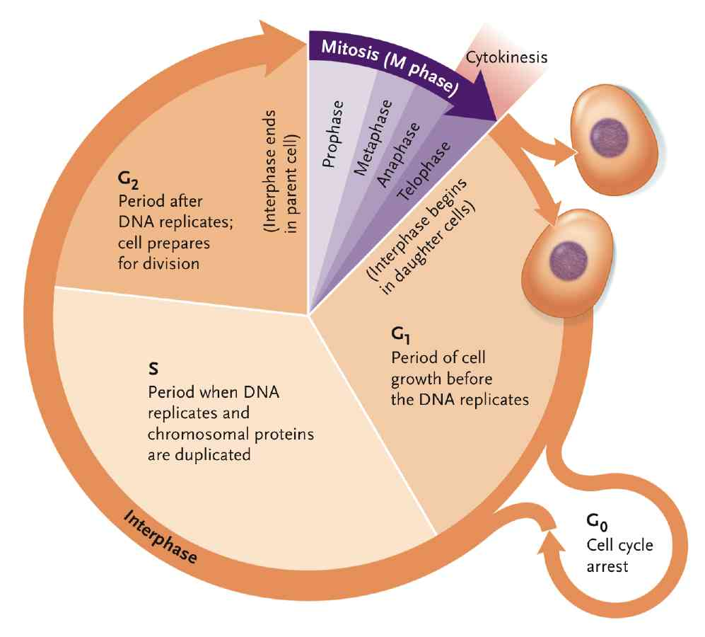

THE CELL CYCLE STAGES:
Interphase: the cell grows at a steady rate
- G₀ : a resting phase where the cell has left the cycle and has stopped dividing
- G1: during G1 (gap 1) the cell is metabolically active and continuously grows but does not replicate its DNA
- S: during S phase DNA replication takes place
- G2: cell growth continues and proteins are synthesized in preparation for mitosis
REGULATION:
As part of the internal controls, the cell cycle has built-in checkpoints to prevent critical phases from beginning until the previous phases are completed. Hormones, growth factors, and other external controls coordinate the cell cycle with the needs of an organism by stimulating or inhibiting division.
Cyclin-dependent kinases (CDKs) are major players in regulation of cell division, directly affecting the progression through the cell cycle. CDKs are protein kinases, enzymes that add phosphate groups to target proteins. CDK enzymes are called cyclin dependent because they are “switched on” only when combined with another protein called cyclin. Cyclins and CDKs are internal controls.
Maturation promoting factor (MPF) is a heterodimeric protein that is composed of cyclin B and cyclin A and CDK1, that stimulates the mitotic and meiotic cell cycles.
Several different cyclin:CDK combinations regulate cell cycle transitions at different checkpoints. For example, the cyclin:CDK combination controls at the G1-to-S check point. At that checkpoint, cyclin E has reached a concentration high enough to form a complex with CDK2 and activate it. The CDK2 then phosphorylates a number of cell cycle control target proteins, which trigger the cell to make the transition into the S phase. After the transition is made, the cyclin E is degraded, less available for binding to CDK2, and therefore kinase activity decreases. CDK2 becomes activated again when cyclin E levels rise at the next G1-to-S checkpoint, after mitosis. Similar events with different cyclin:CDK combinations occur to release the G2- to- M checkpoint.
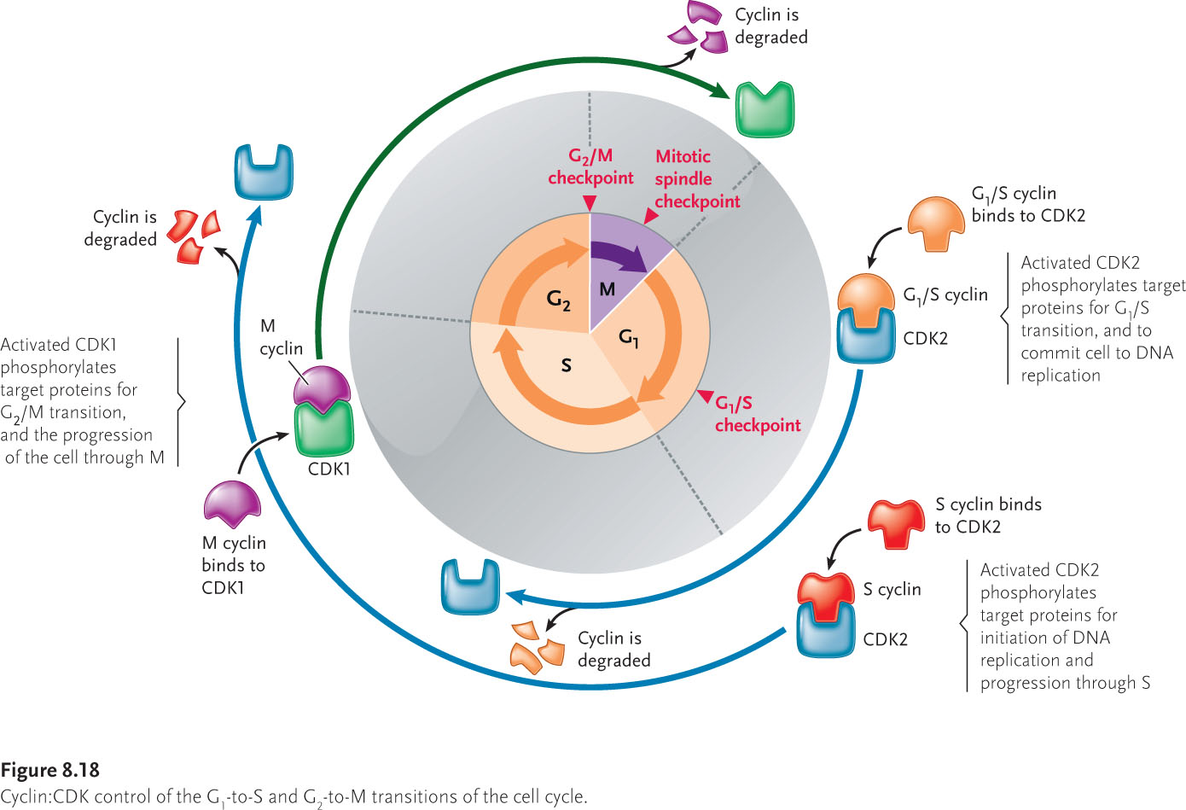

Internal checkpoints stop the cell cycle if stages are incomplete: the cyclin:CDK combinations directly control the cell cycle, but other factors within the cell act as indirect controls by altering the activity of the cyclin:CDK complex from triggering the associated cell cycle transition until the actions of the previous phase are transition until the actions of a previous phase are successfully completed.

External controls coordinate mitotic cell cycle of individual cells within the overall activities of the organism: the internal controls that regulate the cell cycle are modified by signal molecules that originate from outside the dividing cells. In animals, these signal molecules include the peptide hormones and similar proteins called growth or death factors. Many of these external factors bind to receptors at the cell surface, which respond by triggering reactions inside the cell. These reactions often include steps that add phosphate groups to the cyclin:CDK complexes, thereby affecting their function. The overall effect is to speed, slow, or stop the process of the cell division, depending on the particular hormone or factor and the internal pathway that is stimulated. Some growth factors are even able to break the arrest of cells shunted into the G0 stage and return them to active division.
Surface receptors recognize and bind these types of signals:
- Peptide hormones and growth factors
- Cell-surface molecules
- Molecules of the extracellular matrix

Cyclin cycle:
Entry into M is initiated by MPF, which as kinase and regulatory subunits. The level of the regulatory subunit (cyclin) determines activity. MPF increases during mitosis. According to the diagram below, cyclin is increased before it is needed; therefore, when you need it, it is already there. All in all, cyclin increases during interphase.
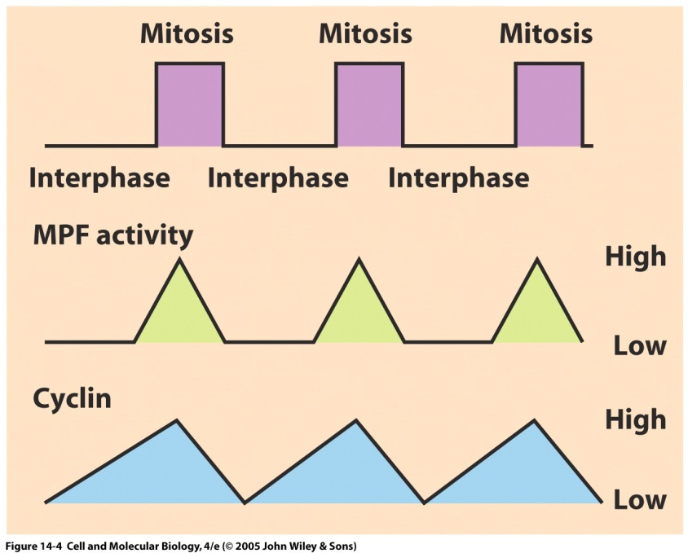

CELL CYCLE CONTROL: CYCLIN:CDK CONTROL
- Cyclins control the cell cycle via MPF, but what controls cyclins?
- Cyclin concentration (the amount of genes that need to be transcribed)
- CDK phosphorylation state ( the products of the two genes, the kinase weel and the phosphorylase cdc25 CONTROL phosphorylation)
- CDK inhibitors
- Controlled proteolysis ( “ubiquitin-mediated proteolysis underlies the regulation of the cell cycle”)
- Subcellular localization
Ubiquitin:
It underlies the regulation of the cell cycle.
- it modifies a targeted protein that is targeted for degradation
- Ub-protein is then degraded by proteasome and recycled via enzymes that conjugate ub
- The protein constituents are then recycled.
p-27: is a CDK1 inhibitor.

