REGULATION:
The lac operon is a classic example of negative regulation and positive regulation.
Gene regulation:
Why is regulation the key to life?
- it regulates changes in environment or changes in nutrients
- it regulates changes in cellular response to signals
- it regulates cellular differentiation in multicellular organisms
- and they help regulate energy conservation

Gene regulation refers to the regulation of activity and may occur at any level. While the main control is at the level of transcription additional controls are at the posttranscriptional, translational and posttranslational levels. At the level of transcription, “trans-acting” proteins interact with “cis-acting” DNA sequences.
So, all in all, gene regulation controls gene expression.

Regulation of Gene expression in prokaryotes:
Unlike multicellular euks, pros typically undergo rapid and reversible alternations in biochemical pathways that allow them to adapt quickly to changes in their environment.
During transcription, typically RNA polymerase would bind to a DNA sequence 5’ to the gene called the promoter (TATA box). If a gene needed to be prevented from being expressed, due to an over saturation of the protein that that gene codes for, a repressor regulatory protein binds to other regulatory DNA sequences to prevent the gene from being expressed. If a gene needed to be expressed, due to a lack of the protein that the gene codes for, an activator regulatory protein would bind to other regulatory DNA sequences to turn on the expression of the gene so it can be transcribed.
Note: repressors and activators may regulate the same gene.
In prokaryotes many genes are organized into clusters (transcriptional units: cluster of genes transcribed into a single mRNA) that are implicated in a single function. At a smaller scale, many genes are organized into operons (one or more operons may be found within a transcriptional unit). The operon itself can be considered as a unit of transcription with several genes controlled by a single promoter. In effect, an operon is a cluster of genes and DNA sequences involving in their regulation.
RNA polymerase binds at the promoter and transcribes all the genes in the operon into one mRNA (called polycistronic because it contains several cistrons [genes] )
Another regulatory DNA sequence in the operon is the operator, a short segment that is a binding sequence for the regulatory protein.
Note: regulatory gene is NOT part of the operon. The promoter, operator, and transcriptional unit are all in the operon.
Lac operon for Lactose Metabolism:
On a lac operon there is a transcriptional unit of three structural genes: lacZ, lacY, and lacA.
- The lac Z gene encodes the enzyme beta-galactosidase, which catalyzes the conversion of the disaccharide sugar, lactose, into monosaccharide sugars, glucose and galactose.
- The lac Y gene encodes a permease enzyme that transports lactose actively into the cell
- Lac A gene encodes a transacetylase enzyme, the function of which is more relevant to metabolism of compounds other than lactose.
All in all, these enzymes take part in lactose metabolism. The regulatory gene (lacI) encodes for the lac repressor.
NEGATIVE REGULATORY SYSTEM:
If lactose is absent: structural genes expressed at very low levels
- Active lac repressor expressed from lacI gene binds to the operator
- RNA polymerase is then prevented from binding to the promoter because it is blocked by the binding of the lac repressor with the operator
- Transcription of structural genes occurs rarely, (repressor occasionally falls off the repressor, allowing very low rate of transcription, resulting in a few molecules of each enzyme being made) but generally transcription is blocked.

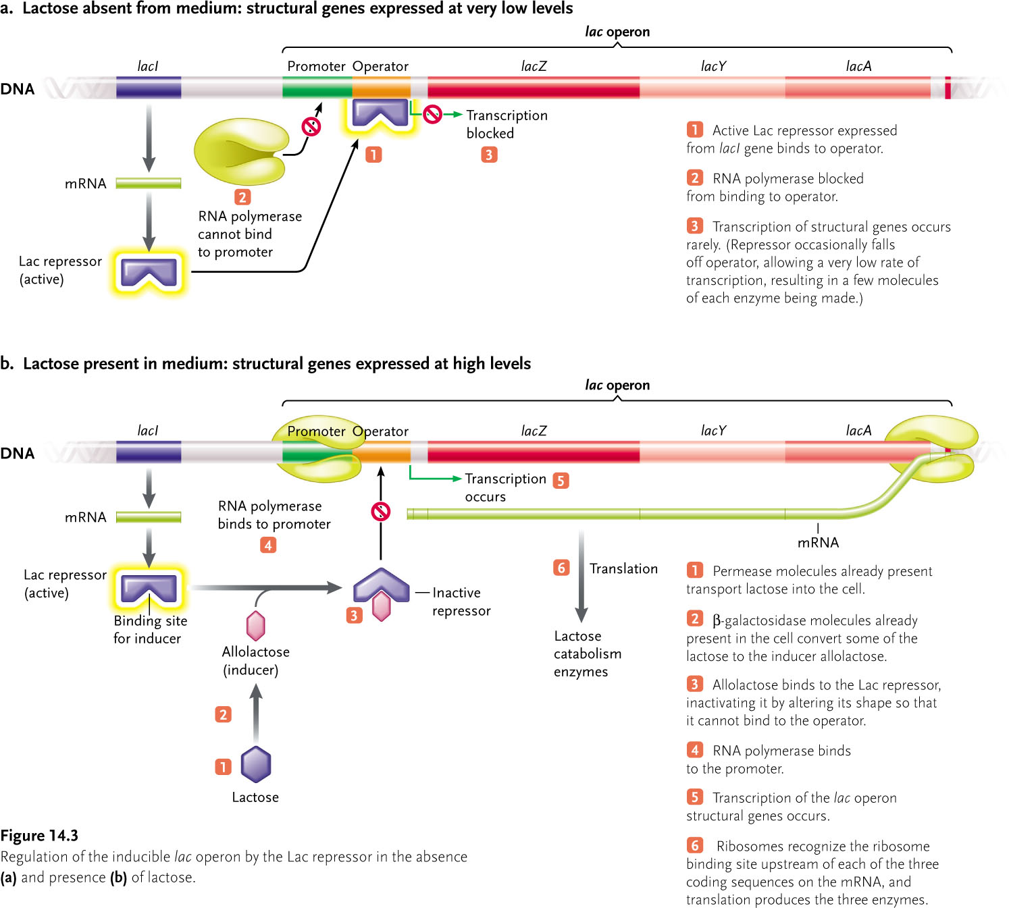

If lactose is present: structural genes expressed at very high levels
- Permease molecules, that are already present, transport the lactose into the cell
- Beta-galactosidase molecules, that are already present within the cell, convert some of the lactose to the inducer allolactose
- Allolactose binds to the lac repressor, inactivating it by altering its shape so that it cannot bind to the operator
- RNA polymerase binds to the promoter
- Transcription of the lac operon structural genes then occurs
- Ribosomes recognize the ribosome binding site upstream of each of the three coding sequences on the mRNA, and translation produces the three enzymes

Inducer: a molecule that binds to the repressor preventing it from binding to the operator
Since an inducer molecule increases its expression, the lac operon is called an inducible operon.

POSITIVE REGUALTORY SYSTEM:
Lactose present and glucose low or absent: structural genes expressed at very high levels
- Lactose is converted to the inducer allolactose, which inactivates the Lac repressor
- Active adenylyl cyclase synthesizes cAMP to high levels. cAMP binds to activator CAP, activating it activated CAP binds to CAP site in the promoter
- RNA polymerase binds efficiently to the promoter
- Genes of operon transcribed to high levels
- Translation produces high amounts of enzymes
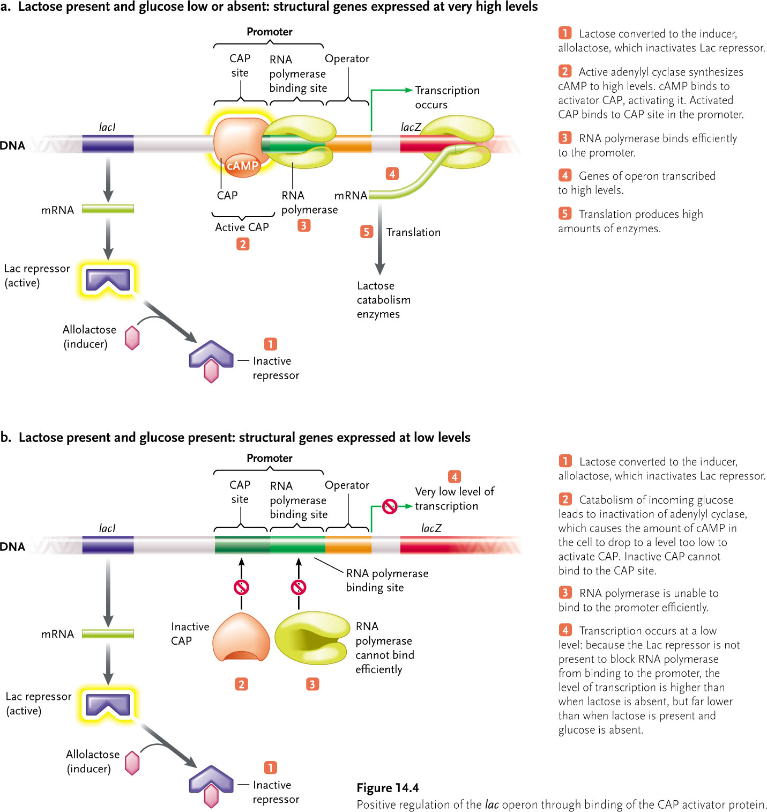
Lactose present and glucose present: structural genes expressed at low levels
- Lactose converted to the inducer, allolactose, which inactivates the Lac repressor
- Catabolism of incoming glucose leads to inactivation of adenylyl cyclase, which causes the amount of cAMP in the cell to drop to a level too low to activate CAP. Inactive CAP cannot bind to the CAP site
- RNA polymerase is unable to bind to the promoter efficiently
- Transcritption occurs at low level: bc the lac repressor is not present to block RNa polymerase from binding to the promoter, there level of transcription is higher than when lactose is absent, but far lower than when lactose is present and glucose is absent

NOTE: Lactose can transform into glucose
CAP: catabolite activator protein. It is activated by cAMP and cAMP is only abundant when glucose levels are low.
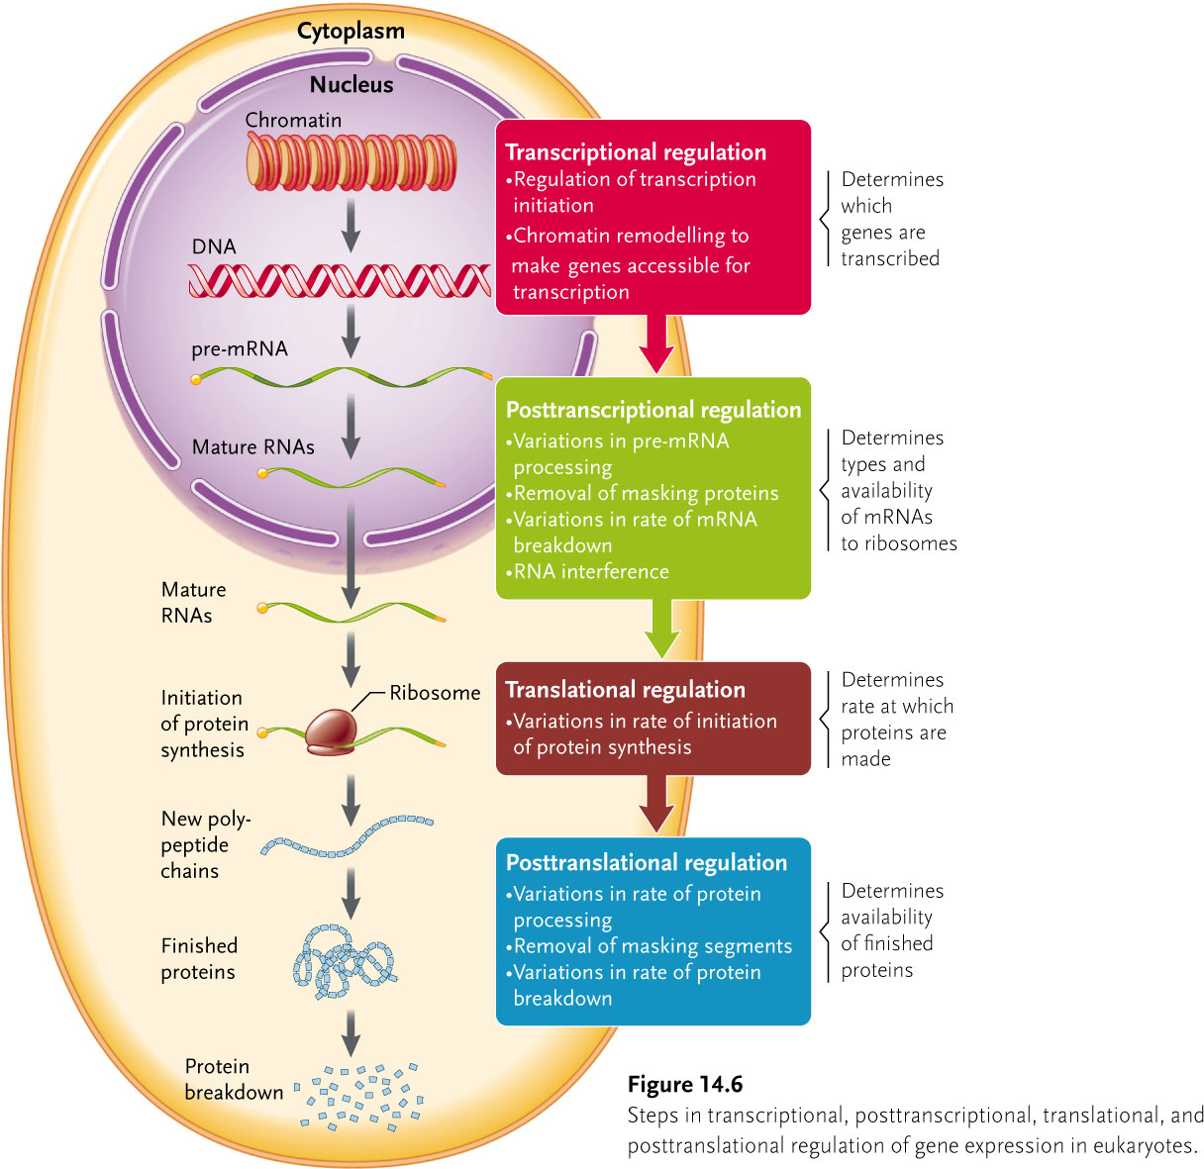
Regulation of transcription in eukaryotes:
In euks, regulation of gene expression occurs at several levels: transcriptional, posttranscriptional, translational, and post-translational.
Organization of eukaryotic protein coding gene:
- The transcriptional unit is the segment that is transcribed into the pre-mRNA it contains 5’UTR (untranslated region), exons, introns, and 3’UTR.
- Immediately upstream of the transcription unit is the TATA box (located inside the promoter)
- Adjacent to the promoter and farther upstream o the transcription unit is the promoter proximal region, which contains regulatory sequences called promoter proximal elements (regulatory proteins that bind to promoter proximal elements may stimulate or inhibit the rate of transcription initiation.
- More distant from the gene is the enhancer, which contains regulatory sequences that control the rate of transcription of the gene.
- Transcription of the gene produces a pre-mRNA molecule with a 5’ end cap and 3’ poly (A) tail; processing of the pre-mRNA to remove introns generates the functional mRNA

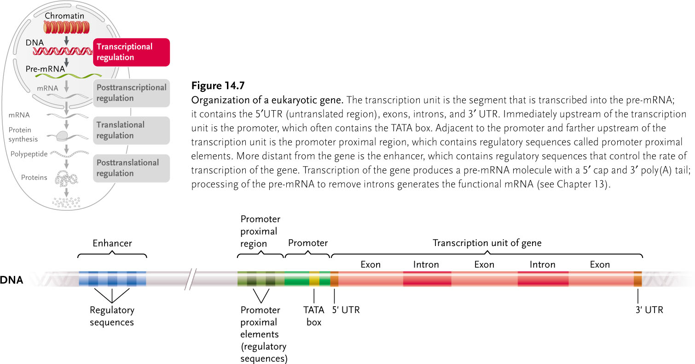

The TATA box has 7-bp consensus sequence
5’-TATAAAA-3’
3’-ATATTTT-5’

RNA polymerase itself cannot recognize the promoter sequence. Instead, proteins called transcription factors recognize and bind to the TATA box and then recruit the polymerase. Once the RNA polymerase II transcription factor complex forms, the polymerase unwinds the DNA and transcription begins.
Activation of transcription:
To initiate transcription, proteins called general transcription factors bind to the promoter in the area of the TATA box. These factors recruit the enzyme RNA polymerase II, which alone cannot bind to the promoter, and orient the enzyme to start transcription at the right place.

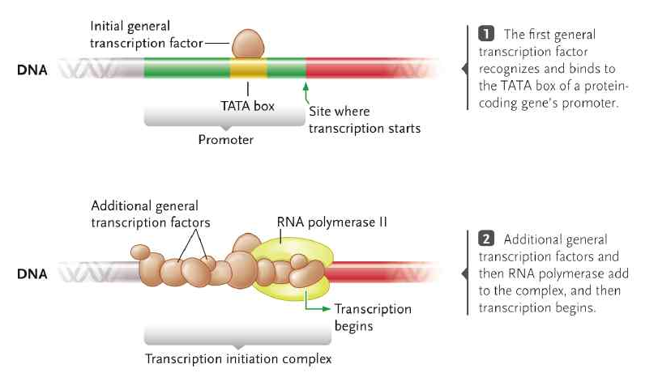

Activators:
They are regulatory proteins that play a role in a positive regulatory system that controls the expression of one or more genes. Activators that bind to the promoter proximal elements interact directly with the general transcription factors at the promoter to stimulate transcription initiation so many more transcripts are synthesized in a given time.
COACTIVATOR:
It is a large multiprotein complex that forms a bridge between the activators at the enhancer and the proteins at the promoter and promoter proximal region, causing the DNA to form a loop. The interactions between the activators at the enhancer, the coactivator, the proteins at the promoter, and the RNA polymerase II greatly stimulate transcription up to its maximal rate.
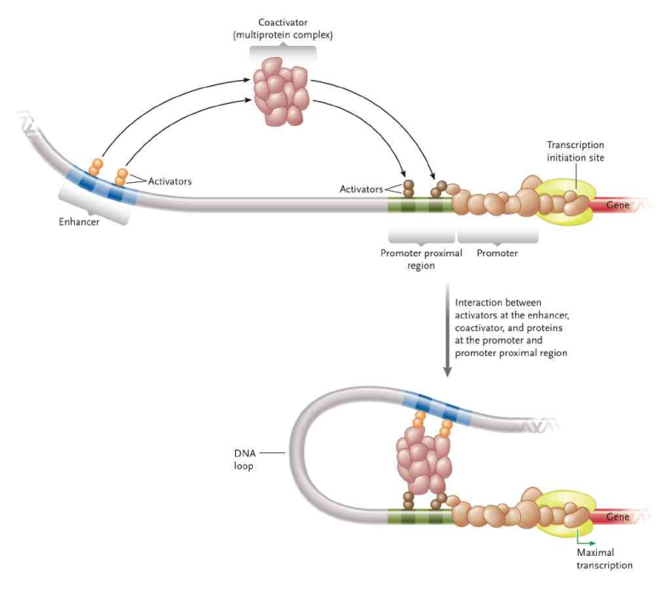
Repression of transcription:
Repressors oppose the effect of activators. In euks, repressors work is several different ways. Some repressors bind to the same regulatory sequence to which activators bind, thereby preventing activators from binding to that site. Other repressors bind to their own specific site in the DNA near where the activator binds and interact with the activator so that it cannot interact with the coactivator. Yet other repressors bind to specific sites in the DNA and recruit corepressors, multiprotein complexes analogous to coactivators except that they are negative regulators, inhibiting transcription initiation. Or repressors could increase the association with histones.
Combinatorial gene regulation:
A relatively small number of regulatory proteins control transcription of all protein-coding genes. Different combinations of activators bind to the enhancer regulatory sequences to control the rate fo transcription of each gene.
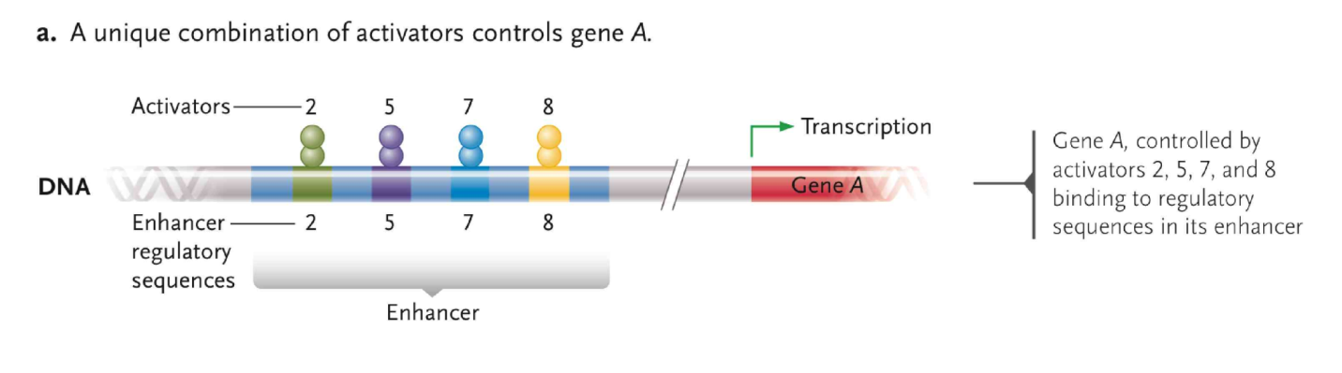
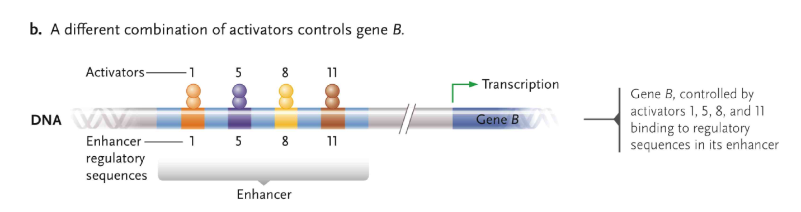

TYPES OF SILENCING:
Silencing: transcription of genes is controlled by promoters is greatly reduced
Methylation of DNA: DNA methylation adds a methyl group to cytosine. The gene is silenced when DNA methylation is located in the promoters
Genomic imprinting: when permanent silencing of a maternal or paternal allele occurs due to inherited methylation. The methylation is maintained as DNA and is replicated.

STEROID HORMONE REGULATION OF GENE EXPRESSION:
A steroid hormone enters the cell and forms a complex cytoplasm with a steroid hormone receptor that is specific to the hormone. Steroid hormone-receptor complexes migrate to the nucleus, bind to the steroid hormone response element next to each gene they control, and affect transcription in those gene.
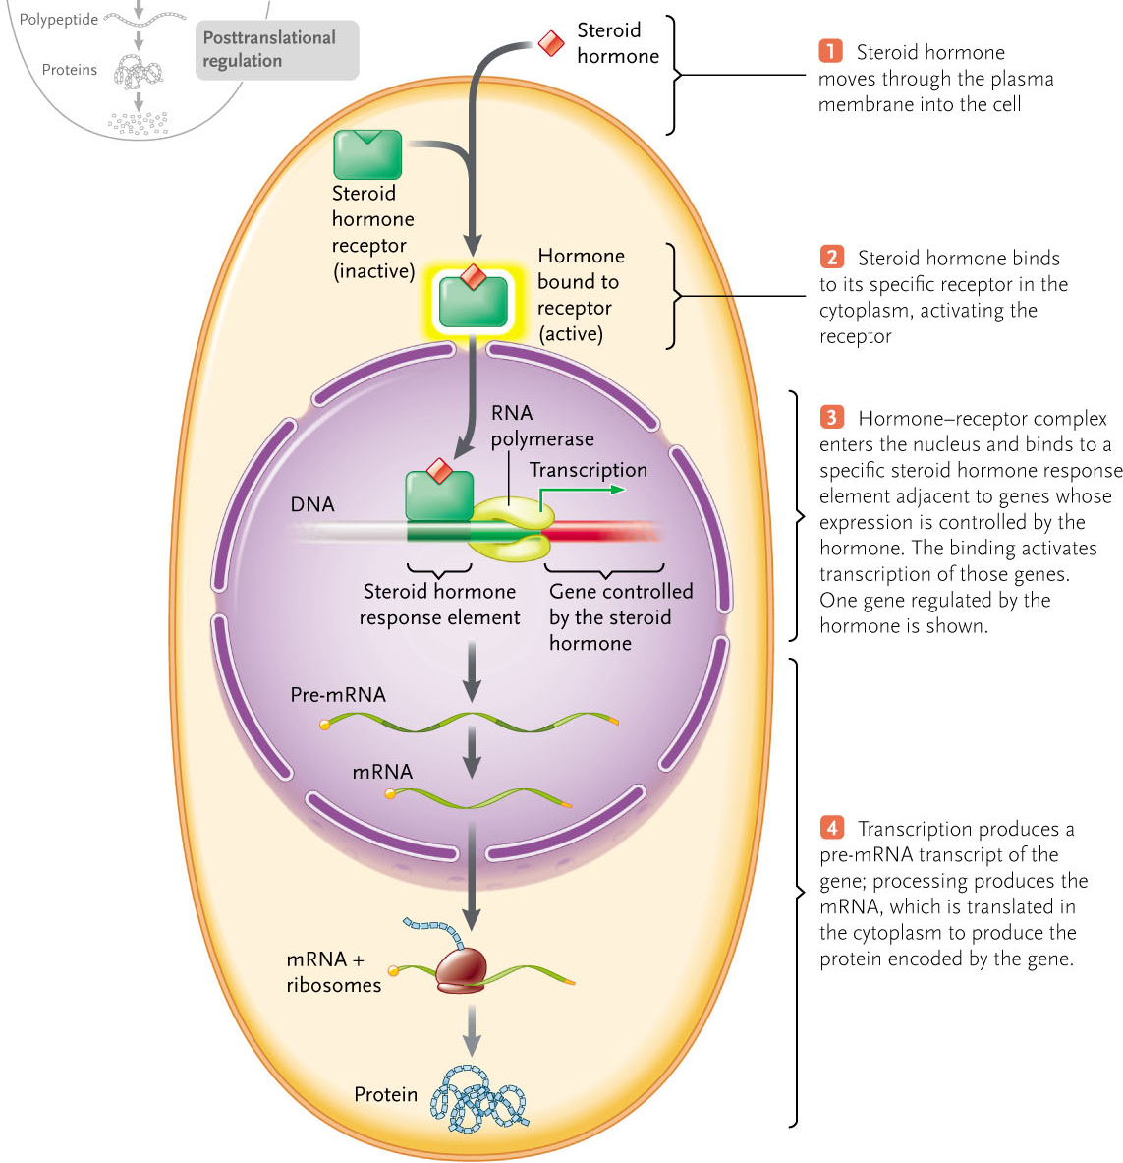

Posttranscriptional, translational, and posttranslational regulation:
- Posttranscriptional regulation controls mRNA availability
- Pre-mRNA processing changes which proteins are made: alternative splicing of introns and exons, and RNA editing.
- Variations of mRNA breakdown rates. Hormones such as steroids can regulate breakdown rates of nucleotides
- Masking proteins bind to mRNA to prevent translation. A signal for mRNA activation removes the masking proteins during development
- RNA can silence an expression in a particular gene, this is called RNA interference (RNAi). Two major groups of small regulatory RNAs are involved in RNAi are: microRNAs (miRNAs) and short interfering RNAs (siRNAs). The miRNA, in a protein complex called miRNA-induced silencing complex (miRISC), binds to a sequences in the 3’UTRs of target mRNAs. If the miRNA and mRNA pair imperfectly, the double stranded segment formed between the miRNA and the mRNA blocks ribosomes from translating the mRNA. So mRNA is silenced. The siRNA (unlike miRNA) is produced from double-stranded RNA that is NOT encoded by nuclear genes. When the siRNA is in its siRNA-induced silencing complex (siRISC) the siRNA acts like the miRNA, the single stranded complementary RNA sequence is targeted then cleaved and degraded. (often used by viruses)
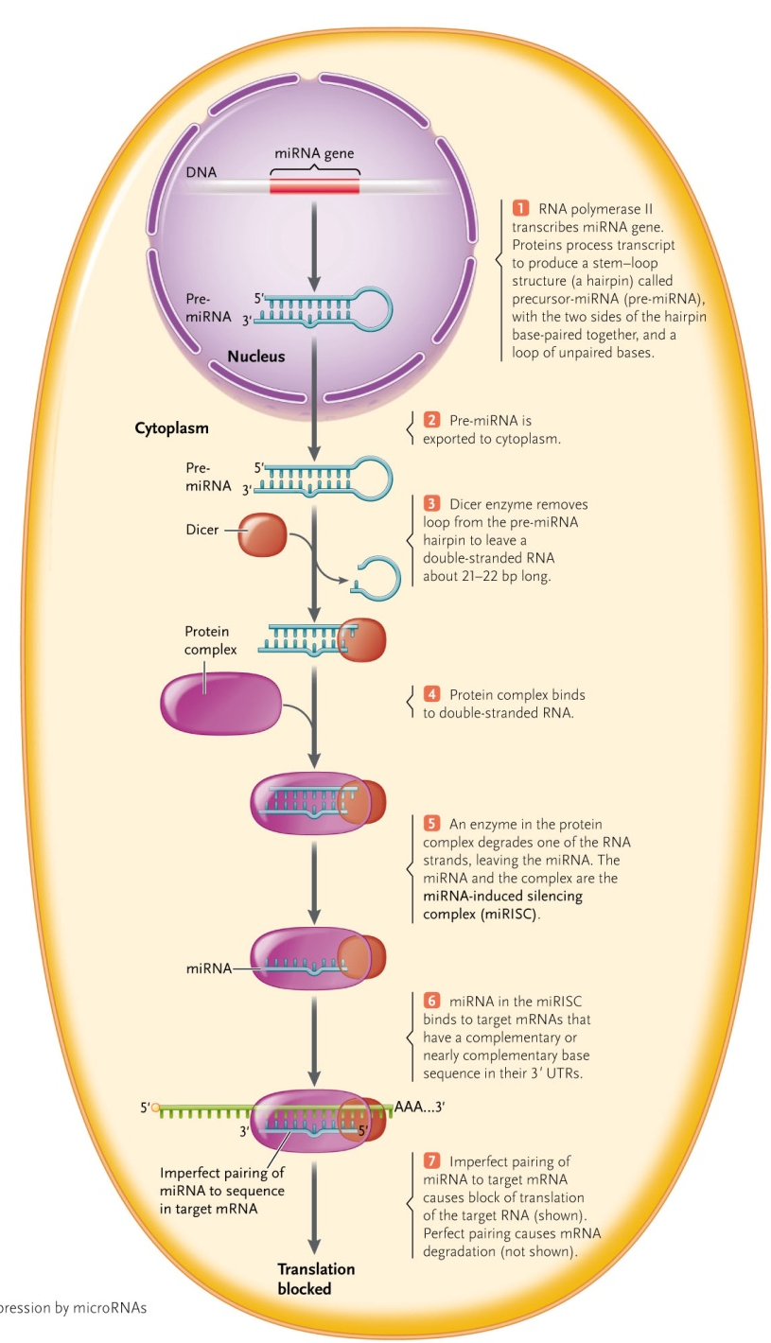

- Translational regulation controls rates at which mRNAs are used in protein synthesis. Example: increasing length of poly (A) tail increases translation of mRNA
- Posttranslational regulation controls functional proteins
- Chemical modification alters activity of protein
- Processes inactive percursers to active proteins
- Rate of degradation, ubiquitin pathway

