- Organizations as Systems

- What is an organization?

- A social entity
  - People, their activities, and interactions
  - A collective with an identity
- Goal-directed
  - An organization exists to achieve one or more purpose(s)
  - Collective goals versus sub-group or stakeholder goals
- A structured activity system
  - Division of activities and people into roles, departments/groups, cliques, communities, etc.
  - Coordination of activities through authority, relationships, teams, culture etc.
- Linked to the external environment
  - Interacts with elements beyond its formal boundaries

- Different parts, configurations, and dimensions of organizations

- Structural Dimensions
- - Formalization
- - Specialization
- - Hierarchy of authority
- - centralization
- - professionalism
- - personnel ratios

- 2. Contextual dimensions
- - Goals and strategy
- - Environment
- - Size (number ppl in organization)
- - Culture
- - Technology

- The evolution of organizational theory

- Organizational theory: How organizations function and how they affect and are affected by people and by the context in which they operate.
  - There are many different theories about how organizations function
  - Different theories provide different lenses through which to view and understand organizations as systems
  - A way to see and anaylze organizations more accurately and deeply

- What is a system?

- An organization is a system:
  - A set of interrelated parts performing various tasks
  - Parts tend to be specialized & integrated
  - The whole is more than the sum of its parts
  - Open System: Interaction with the external environment os
  - Tendency toward growth and self-regulation
  - System Functioning
    - Adaptation & survival
    - Integration & coordination
    - Performance
    - Meaning & identity

- Different system attributes, processes, and outcomes (PP)

- Think of an organizations as a machine. What are some attributes of a machine that provide insight about how the organization operates?
  - Clear purpose to perform a specific task
  - Predictable and reliable parts and performance
  - Known parts, processes, and mechanisms that connect to each other
- Now think of the organizations as a living biological organism such as animal – what additional insights can you generate about how it operates?
  - Self-regulation through sensory perception
  - Self-maintenance
  - Adaptive and responsive to external conditions
  - Driven by survival and growth
- Now think of the organization as a temple representing a faith – what additional insights can you generate about how it operates?
  - Self-awareness, history, and identity
  - Shared values, beliefs, and meanings
  - Social organization (hierarchy, sub-groups, roles)
  - Represents a reality that defines everyday experience
  - Use of symbols
  - An anchor point for member attachment and loyalty

- Understanding organizations as systems through different lenses (PP)

- The Formal Structure Lens
  - Organization as a formally designed system, like a machine built and operated for some specific purpose
  - Focus on formal division of labour, planned control & coordination, and task performance
- The Network Lens
  - Organization as a naturally evolving system, like a living organism that grows and adapts for survival
  - Focus on informal relationships to build community, solve problems, exercise influence, and coordinate informally.
- The Symbolic/Culture Lens
  - Organization as a cultural system, like a temple that represents a meaningful way to understand the world
  - Focus on symbolism and shared values & beliefs that constitute culture and foster group identity

- Types of organizational goals (CP)

- Culture/symbolic lens: Official goals/mission
  - Expressions of organization’s identity, its vision, its reason for existence. JMSB
- Key Activity: Symbolic Management
- Establish general legitimacy
  - Acceptability of organizational purpose and right to operate
- Create unity of effort
  - A common point of focus for collective effort
  - Build commitment

- Network lens: Stakeholder approach
  - What expectations do specific stakeholders have for organizational performance?
  - Parties that affect and are affected by organizations
- Inside Stakeholders: Employees & Managers, owners
- Outside Stakeholders: Customers, suppliers, communities, governments, etc. SH
- Key activity: Stakeholder relationship management
  - Build support and legitimacy for specific expectations

- Formal Structure lens: Operative goals
  - What the organization and its divisions formally set out to do in attaining official goals
  - Detailed and measurable ends to be achieved through operations.
- Key activity: Evaluate performance effectiveness
- Build Motivation: Encourage effort, challenge & reward
- Give Direction: Guide strategic decisions

- Different types of strategies

- Porter Strategy

- Miles and Snow Strategy Typology
  - Prospector: Innovate, take risks, seek out new opportunities, and grow. Suited to a dynamic, growing environment, where creativity is more important than efficiency.
  - Defender: Concerned with stability or even retrenchment. Suited for companies in a declining industry or stable environment
  - Analyzer: Maintains stable business while innovation on the periphery.
  - Reactor: Respond to environmental threats and opportunities in an ad hoc fashion. Can go both ways good or bad.

- Organizational stakeholders (CP)

- Organization
- 1. Owners and Stockholders
  - financial return
- 2. Employees
  - satisfaction
  - pay
  - supervision
- 3. Customers
  - High-quality goods, services
  - service
  - value
- 4. Creditors
  - Creditworthiness
  - fiscal responsibility
- 5. Management
  - Efficiency
  - effectiveness
- 6. Government
  - obedience to laws and regulations
  - Fair competition
- 7. Union
  - worker pay
  - benefits
- 8. Community
  - good corporate citizen
  - contribution to community affairs
- 9. Suppliers
  - satisfactory transactions
  - revenue from purchases
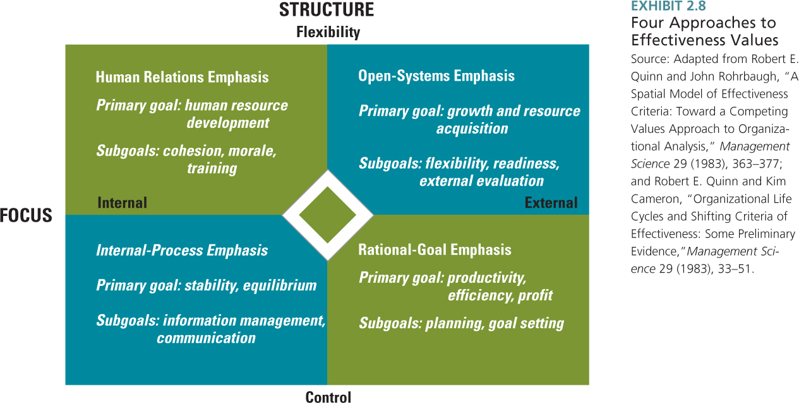

- Different approaches of measuring effectiveness

- A system outcome that answers the question: How well are we performing?
  - Are we achieving our goals?
  - How good are we at achieving our goals?
- Internal Approaches: Focus on how the organization performs inside its boundaries
  - Efficiency: Use of resources/productivity
  - Human relations: Internal well-being and harmony
- Resource Approach: Obtaining and managing inputs
- Goal Approach: Achievement of operative output goals
- Stakeholder Approach: Meet different stakeholder expectations.

- Corporate Social Responsibility, Sustainability, and the Value Matrix (R, PP)

- The Principle: Business organizations exist to create value and acceptable outcomes for all their stakeholders
- Exchange relationships:
  - With Society: Business is given the power to profit from producing goods/services in exchange for societal growth & development
  - Based on the trust that power is exercised responsibly
  - With specific stakeholders: Business maintains exchange of contributions and inducements
  - A conceptual tool for thinking about CSR strategy
  - Distinguishes between currently practiced CSR in the civil foundation and potential future CSR in the frontier.
- Civil foundation includes rule of law and societal norms:
  - CSR is instrumental because it is performed in response to legal prescription and normative obligation
  - Benefits societal stakeholders and shareholders
- Frontier includes voluntary initiatives:
  - CSR is intrinsic because it is performed for its own sake (i.e., it is the right or moral thing to do
  - Has no immediate payoff for shareholders or uncertain long-term pay-off.
  - Successful CSR actions in the strategic frontier lead to shareholder benefits, are copied by others, and may become part of the civil foundation

- Ethics considerations: Managers of organizations have an obligation to make choices that uphold right and prevent wrong in relationships with its stakeholders
  - Build ethical values into culture
  - Implement formal structures that promote ethical behavior

- From a business perspective, an organization prioritizes exchange with its important stakeholders
- Important Stakeholders have:
  - Power: A stakeholder who can achieve desired outcomes by
  - Force/threat (e.g., fines, sabotage)
  - Withholding material rewards (e.g., $, goods & services)
  - Legitimacy: A stakeholder with a socially acceptable claim
  - Urgency: A stakeholder whose claims demands immediate attention

- From a societal perspective, a business organization meets the needs of the present in relation to all stakeholders and without compromising the ability of future generations to meet their needs
- (Brundtland Commission, 1987)
  - Sustainable corporate social performance is assessed in three spheres (triple bottom line):
    - Environment
    - Society
    - Economy

- Formal Organizational Structure Lens

- Horizontal, vertical, and spatial differentiation (PP)

- The vertical division into hierarchical levels (parts)
  - Decision making: technical/factual or value/judgment
  - Centralization: Are judgment decisions made at higher or lower levels of the hierarchy?

- The horizontal division into departments & subunits (parts)
  - Work tasks: common work responsibility Slide 6
  - Spatial differentiation: Different physical locations (parts)

- Vertical and horizontal integration through information linkages

- Integration of Activities
- Coordination and control among divided activities is achieved through vertical and horizontal information linkages

- Vertical information linkages: Emphasis on control and predictability
- Hierarchical referral (the chain of command)
  - Rules & Plans: Standardization and/or formalization of work process, skills, and/or inputs/outputs
  - Information systems: Reports, memos, & paperwork
  - Additional roles: Middle managers

- Horizontal information linkages: Emphasis on coordination
- Information systems: Schedules & databases
  - Direct contact
  - Formal Positions: Liaison & integrator
  - Formal groups: Task-forces & teams

- Organizational design alternatives

- Work Activities: range of functions that help the org accomplish its goals. As companies grow more and more functions need to be performed. (HR recruiting employees, purchasing department obtaining supplies/raw materials)
- Reporting relationships: Chain of command, vertical lines on an organization chart
- Departmental grouping options: functional (most popular), divisional (most popular), multifocused, horizontal, virtual.

- Organizational Design: How work activities and coordinating/control mechanisms are grouped into formal units that are strategically important and share a common task identity.
- Functional Structure: Grouping based on basic business functions D1
- Divisional Structure: Grouping based on primary outputs, customers, or geographic location D2
- Multi-focus Structure: Grouping based on combination of functions, outputs/location, and/or processes
- Matrix Structure: Simultaneous grouping D3
- Hybrid Structure: Parallel grouping D5

- Control versus Adaptability design logic
- ????????????????????????

- Meaning and symbolism in organizations (PP, CP, R)

- An organization is a cultural system, consisting of assumptions, beliefs, and values
- Culture is manifest through symbols that identify meanings and express valued means/ends for members & stakeholders
- Symbolism is important because it helps people interpret events or objects that are ambiguous
- Meaning is not given but made by people
- “What is important is not what happens but what it means”

- Observable and unobservable levels of organizational culture (PP, CP)

- Definition: A set of beliefs, values, and assumptions that are shared by the members of an organization

- Unobservable Level of Culture:
  - Organizational Values
  - Terminal values: Identify desired end states
  - Instrumental values: Identify desired modes of behavior
  - Organizational Belief/Assumptions
  - A true “way of life” for organizational members
  - Taken-for-granted as real

- The observable level of culture

- The observable level of culture
- Visible artifacts: Practices, events, expressions, pictures, etc. are used to communicate and signal culture

- Norms & rules (ritual): Patterns of daily, routine activity.
- “How things are done around here”
- Expectations for normal behaviour, what to do to fit in

- Stories and Myths: Anecdotes about true or fictional events or people that circulate among organizational members.
  - Provide a “deep level” principle that demonstrates the correct way of acting or being

- Rites & Ceremonies: Elaborate events & activities that are deliberately planned, infrequent, and carried out in public.
- Rite of Passage:
  - Facilitate role and status transitions
  - Example: Initiation
- Rite of Enhancement:
  - Boost status perceptions and identities of members
  - Example: Annual awards night
- Rite of Integration:
  - Encourage and revive feelings of common bond
  - Example: Office Christmas Party
- NB: Rite of Renewal
- Language: A unique jargon or non-verbal expressions
- Espoused Values:
  - Explicit expressions of organizational values (e.g., Mission statements, Annual Reports, websites)
- Physical Symbols:
  - Graphical illustrations that represent important company attributes (e.g., corporate logos)
  - Physical structure & space: Buildings, offices

- Values and beliefs (PP, CP)

- Values are the social principles, goals, and standards that cultural members believe have intrinsic worth. What is right and wrong, and is equated with its moral code.
- Beliefs are firmly held opinions or convictions

- Organizational culture and coordination/control (PP)

- Culture affects organizational coordination and control
  - Internalized conviction and value inspiration guide member behavior through self-discipline
  - Identification generates loyalty and commitment
- Culture strength: Degree of agreement and depth of conviction about culture

- Culture and integration (PP)

- Integration: Culture can facilitate working together and being a group
  - What are the criteria for organizational membership?
  - What does it take to get ahead?
  - What is our collective identity – “Who are we?”

- Culture and adaptation (PP)

- Adaptation: Culture can facilitate achieving goals and dealing with outsiders
  - How do we achieve our purpose in the market?
  - What image of who we are do we want our key external stakeholders to have?

- Strategic focus on the external environment through flexibility and change to meet customer needs. Encourages entrepreneurial values, norms, and believes that support the capacity of the org to detect, interpret, and translate signals from the environment to behaviour responses.

- Different types of cultural artifacts (PP, CP, R)

- Artifacts are manifestations or expressions of the same cultural core that produces and maintains the values and norms.

- 1. Objects
- - Art/Design/Logo
- - Dress/costume/uniform
- - Architecture/decor
- - Posters/photos/cartoons
- 2. Verbal Expressions
- - Jargon/names/nicknames
- - stories/myths/legends
- - Superstitions/rumours
- - Humor/jokes
- 3. Activities
- - Ceremonies/rituals/rites of passage
- - Parties/meetings/retreats
- - rewards/punishments
- - Play/recreation/games

- Fit between culture and formal structure

- Compatibility: Culture and formal systems should reinforce and support each other
  - Formal structures should encourage the same behaviors and meanings as culture
  - Examples of cultures/formal systems combinations
- Perceived need of environment: Focus on stability (efficiency) or flexibility (adaptation)
- Strategic orientation: Focus on internal or external competitive strengths

- Organizational ethics, ethical values, and systems that safeguard ethics

- Ethics: code of moral principles and values that governs the behaviors of a person or group with respect to what is right or wrong.
- Ethical Values: set standards as to what is good or bad in conduct and decision making.

- Systems that safeguard ethics

- 1. Structure: Managers assigned responsibility for ethical values to a specific position
- - Ethics committee
- - Ethics Hotline

- 2. Disclosure mechanisms: policies and procedures to support and protect whistle blowers.

- 3. Code of Ethics: formal statement of the company’s values concerning ethics and social responsibility; it clarifies to the employees what the company stands for and its expectations for employee conduct.
- Formal versus informal organization (R, PP)

- Formal Organizational Design:
  - The skeleton
  - Deliberate: Engineered, formal goal directed, rational
  - Impersonal positions, roles, and relations
  - Normative: What should take place & how

- Informal Organization of Networks:
  - The central nervous system
  - Spontaneous: Organic, fluid, and pragmatic
  - Personal positions, roles, and relationships
  - Behavioral: What actually takes place & how

- Informal networks in action (R, PP)

- Lubricating the formal system
  - Quality of interpersonal relations in formal hierarchy
  - Horizontal interaction in team structures
  - Horizontal communication that cross-cut the formal structure

- Implementing new initiatives and change
  - Generating support and building coalitions
  - Resolving or mediating conflict across groups

- Generating social capital (see textbook, p. 355)
  - Developing norms and values for high quality of interaction and a common perspective among system members
  - Respect, trust, and goodwill

- Types of informal network relationships in formal organizations (PP, R)

- Advice: Flow of expertise & problem solving

- Trust: flow of confidential/political information & mutual confiding

- Communication flow of every-day information (work, gossip)

- Friendship: flow of affect and social support

- Relationship quality: strong or weak relationships (PP, R)

- Dyadic level: The quality of relationships
  - Closeness: Strong versus weak ties
  - Mutual trust, liking, & social obligation nw
  - Strong relations: Influence and communication quality

- Network Structure: Network closure and network bridges (PP, R)

- Ego level: Network surrounding one person
- Network Shape: Closure (cohesion) or bridging
  - Closure: social capital nw
  - Bridging: Access to resources and new ideas
  - Power, influence, control
  - Controlling the flow of information
  - “Divide and conquer”

- Network composition

- Ego level: Network composition
  - Attribute profiles of network members nw
  - Diversity of members may generate new ideas but also make communication and coordination more difficult
  - Homogeneity of members may generate social capital but also produce tunnel vision and groupthink

- Network positions: Centrality (PP, R)

- Ego level positions: Network centrality
  - The number of relationship choices made or received deg
  - Influential people in the network
  - Prestige, visibility, involvement

- Informal networks in formal design for learning and adaptability (PP)

- Whole network level:
  - All actors and all relationships
  - Network sub-groups nw
  - Formal horizontal design for learning and adaptability
  - Cohesive informal networks within groups
  - Bridges across groups
  - Bridges to the external to the organization
  - Silo subcultures (closure within subgroups but no bridges between them)
  - Reliance on bridge actors: Bow-ties nw
- Theoretical network mechanisms: Resource Access,

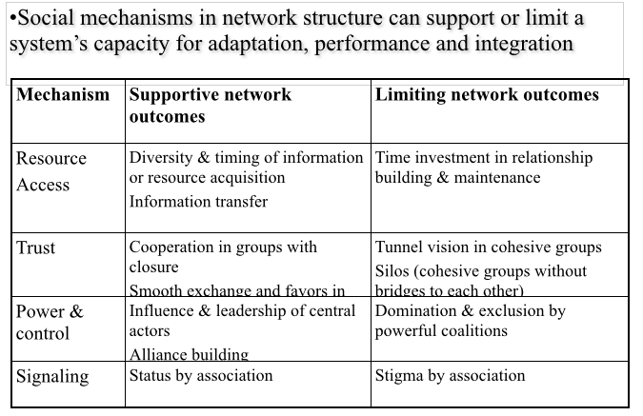

- Organizational Environment

- Different Views through different lenses:
- Formal Structure Lens: Organizations respond to information and resource conditions in a given environment by implementing formal structures
- Network Lens: Organizations establish a network of collaborative relationships with other organizations and stakeholder groups to access resources and capabilities
- Culture/Symbolic Lens: Organizations respond to external stakeholder expectations by conforming with societal beliefs about rational organizations and values about desirable organizations in order to obtain legitimacy

- What is the organizational environment?
  - Set of forces outside the organization’s formal boundary that can affect its operations and access to resources

- Sectors of the organizational environment
  - Industrial sector
  - Industry sector
  - Raw materials sector
  - Human resources sector
  - Financial resources sector
  - Market sector
  - Technology sector
  - Economic conditions sector
  - Government sector
  - Sociocultural sector

- Organizational Environment and Uncertainty
  - Organizations need information in order to survive uncertain environments
  - Complexity and stability both contribute to uncertainty
    - Complexity: the number and variety of elements in an organization’s domain.
    - Stability: the amount of change in the environment: frequency of change; size of changes; regularity of changes

 | Simple+ Stable = Low uncertainty | Complex + stable = low-moderate uncertainty
Stable change | - small number of similar external elements  - elements remain the same or change slowly | - large number of dissimilar external elements  - elements remain the same or change slowly
Unstable change | - small number of similar external elements  - elements change frequently and unpredictably | - large number of dissimilar external elements  - elements change frequently and unpredictably
 | Simple environment | Complex environment

- 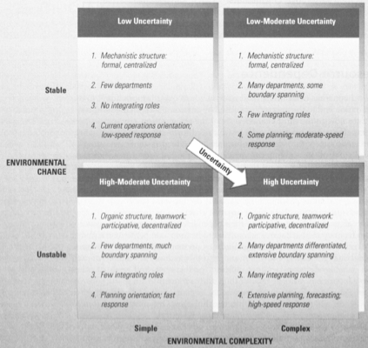

- Structural Contingency Responses for Adapting to Uncertainty
  - Mechanistic vs. organic structure
    - Control/efficiency vs. learning and adaptability design
  - Differentiation and integration
    - Horizontal specialization and coordination
  - Boundary spanning
    - Collecting/sending information from/to the environment
  - Formal planning and forecasting systems to prepare for uncertainty

- Resource dependence theory
  - Organizations need scarce resources that are controlled by other organizations in the environment
  - Dependence is the opposite of power: other organizations control the resources you need so you depend on them
  - To minimized dependence, organizations should secure better access to resources
  - Dependence can be assessed using two factors:
    - How important is the resource to the organization?
      - How much of the resource do we need?
      - Can we function without the resource?
    - How difficult it is to attain independent access to the resource?
      - Availability of alternatives
      - Formally sanctioned control by other organizations over the recourse

- Managing Resource Dependence
  - Establish inter-organizational linkages
    - Connect with source of resource dependence
    - Price can be loss of autonomy
  - Ownership
    - Two organizations become one (merger/acquisition)
  - Strategic alliance
    - Two or more organizations make a formal inter-organizational agreement
    - Non-equity alliance (long-term contracts)
    - Mutual equity investments
    - Joint ventures
    - Formal alliances must be accompanied by collaborative efforts
  - Symbolic management
    - Advertising and public relations
  - Cooperation
    - Interlocking directorates
  - Controlling the environment
    - Altering the external context that create resource dependence
      - Select/change environmental domain
      - Influence regulatory environment

- Organizational ecosystem
  - Communities of organizations that interact with their environment
  - Collaborative network perspective
    - Two or more independent organizations cooperation closely to support and complement each others activities
    - Cooperative relationships between organizations
    - Strategic alliances
    - Memberships in industrial or trade associations
    - Network organizations and industrial districts

- Collaborative Network Approach
  - Build the formal framework: Maintain accountability
    - Quality assurance protocols for production standards (e.g., raw material certification; quality control, production expectations, employee working conditions)
    - Transition protocol/milestones for switching to outsourced production
    - Alliance manager position and training for managing collaboration
  - Build the informal network:
    - Trust: Start with small requests, make contributions, then slowly grow investments after partner responds & reciprocates
    - Exchange resources: Transfer know-how and expertise to help partner perform according to your needs
    - Provide information partner needs to perform (but don’t give away your core competency)
    - Share risks with partners
    - Learn about civil foundation abroad to adjust expectations
    - Exert soft influence rather than apply hard pressure

  - Key outcomes of collaboration in networks:
    - Learning & adaptation through exchange of knowledge and expertise
    - Market access (global reach, new product development)
    - Market power through resource sharing & risk pooling
  - Coordination in collaborative networks:
    - Managing not within but across organizations requires:
    - Trust and commitment to shared benefits and long-term relations, not arm’s length economic transactions
    - Mutual involvement and rich information exchange
    - Engage other firms as partners, rather than adversary

- Inter-Organizational Outsourcing Relationships
  - Having a comprehensive policy on quality control and environmental practices is an important start, but it won't prevent a foreign plant from bending the rules when its partner isn't looking.
  - Companies face a variety of potential risks when they outsource processes. These include:
    - A loss or disruption of services if either the company or vendor cannot meet its obligations under the service agreement;
    - Unforeseen costs, which often arise when unexpected issues need to be resolved, especially when processes are being transitioned to a new vendor;
    - Compliance risks and litigation costs if disrupted services result in the company being unable to meet contractual commitments; and
    - Damage to the company’s reputation, since customers and suppliers will blame the company if the vendor is unable to meet service delivery targets

- Network Organization
  - A concentration of specialized industries in a particular locality
  - Examples: Silicon Valley
  - Small, locally owned and specialized firms
    - Includes manufacturing and ancillary production (e.g., machinery, supplies, services)
  - Extensive cooperation between buyer & supplier firms
    - Alternative to vertical integration of the value chain
  - Culture of cooperation in local community
    - People work and live together in the same location
  - Supported by local institutional infrastructure
    - Other organizations (unions, funding agencies, universities) and institutions (family, schools, church)
  - Flexible and committed labour market
    - Pool of skilled local workers
  - Importance/risks of network closure
    - Collaboration but also tunnel vision
  - Bridging with other clusters and to outsider firms
    - Meta-clusters
    - Focus on high-end manufacturing and design

Population ecology
  - Focuses on organizational diversity and adaptation within a population or organizations
    - A population is a set of organizations engaged in similar activities with similar patterns or resource utilization and outcomes.
  - Organizations within a population compete for similar resources or customs
  - Innovation and change in a population of organizations take place through the birth of new forms and kinds of organizations more so than the reform and change or existing organizations.
  - Large established companies often fail to innovate and adapt to rapidly changing environment
    - New organizational forms emerge and take away business
    - Heavy investments in plants, equipment and personnel prevent rapid change
  - According to the population ecology view, when looking at an organizational population as a whole, the changing environment determines which organizations survive or fail
    - Individual organizations suffer from structural inertia and find it difficult tot adapt to environmental changes – when rapid changes occur, old organizations are likely to decline or fail and new organizations emerge that are better suited to the needs of the environment.

- Formal organization as ritual, ceremony, and theater (PP, CP)
  - From a symbolic perspective, organizations are judged primarily by appearance. The right image provides a ceremonial stage, projecting to the audience the dramatic performance they expect. The drama reassures, fosters belief in the organization’s purpose and cultivates faith
  - Organizations stage dramatic performances of ritual and ceremony to express their conformity with societal norms and stakeholder expectations
    - Visible formal structure and systems not instruments, but symbols of rational/modern organization
    - The drama symbolizes a normal/appropriate organization
    - Formal structure/system is “decoupled” from actual work
  - Myths
    - “all is well” in organizations that have expected formal structures/systems
    - conformity with expectations builds confidence
    - Confidence yields legitimacy

- Organizational institutionalism (PP, CP)
  - The organizational environment contains cultural norms based on values and beliefs by which the organization must abide
  - Cultural norms shape societal myths and stakeholder expectations about affective and appropriate organizational systems/structure

- Organizational legitimacy (PP, CP, R)
  - A general perception that an organization is desirable, proper and appropriate with regards to the environments system or norms, values and beliefs
  - Organization pursue legitimacy because it:
    - Generates support and goodwill for the right of the organization to exist and operate;
    - Becomes basis for material resource flows;
    - Lack of legitimacy invites criticism, questioning and inspection

- Organizational Isomorphism (PP)
  - Organizations that experience similar pressure/expectations from the environment to appear legitimate tend to become similar to each other
  - What drives isomorphism?
    - Coercive Isomorphism: We have to do this because of legal/political pressure/prescription and resource dependence
    - Normative isomorphism: we should do this because of professional standards and techniques and perceived duty/obligation
    - Mimetic isomorphism: Everyone else is doing it so we should copy what successful others are doing and to reduce uncertainty (management fad)

- Management Fads/Trends (PP)
  - Organizations adopt a new managerial practice that diffuses like fashion through a bandwagon effect: More and more organizations adopt the trend until a peak of popularity is reached and adoption starts to decrease.
  - Fads typically appear simple & prescriptive, resonate with current times or management philosophy, come with special lingo and techniques, and are advocated by business consultants & management gurus
  - Most organizations adopt fads with the desire to improve performance under conditions of uncertainty
  - Fads produce legitimacy because they appear modern and innovative
  - Fads produce legitimacy because stakeholders expect adoption
  - Cons:
    - Simple, “one-size fits all” prescription neglects contingencies and can lead to misinterpretation and misapplication
    - Superficial implementation and vague outcome criteria
  - Pros:
    - Increased public confidence and acceptance
    - Improve morale, “shake things up,” get people talking
    - Some fads evolve into vernacular of management practice or develop into lasting management practice (e.g., outsourcing, globalization)

  - Technology: The combination of work processes (including skills and knowledge), machines, techniques, and actions used to convert organizational inputs into outputs
  - Core technology: Work processes related to mission activities
    - Product/Service
  - Workflow interdependence: Extent to which core and non-core work activities in organizational groupings depend on each other for resources and materials
  - Key contingency insight: As uncertainty in the use of technology increases, formal structure and systems become more organic

- Manufacturing Technology: Complexity and structural design (PP)
  - Technical complexity: The extent to which the production process is mechanized
  - Uncertainty is created by the relation between people and the use of machinery
  - Unit/Small batch production
    - Customized items, complex assembly, small batch output
    - Production process is organized around people
    - Uncertainty is created by people’s skill, experience, and conception of work tasks
  - Large batch/Mass production
    - Large volume output, standard products, assembly line
    - Production process is organized around machinery
    - Uncertainty is created by timing of production run and switch-over of machinery
  - Continuous process
    - Unlimited output of standardized products
    - Ongoing & fully automated production process
    - Uncertainty is created by analysis of production data output and decision making about machinery adjustment

- Flexible and Lean Manufacturing technology and structural design
  - Lean manufacturing: uses highly trained employees at every stage of the production process and they take a painstaking approach to details and problem solving to cut waste and improve quality
  - Lean/flexible manufacturing has paved the way for mass customization
    - Using mass-production technology to quickly and cost-effectively assemble goods that are uniquely designed to fid the demands of individual customers
  - Technology alone cannot give organizations the benefits of flexibility, quality, increased production, and greater customer satisfaction. Flexible manufacturing systems (FMS) only work if organizational structures and management processes are redesigned to exploit the new technology.

Characteristic | Mass Production | FMS
Structure  - Span of control  - Hierarchical levels  - Tasks  - Specialization  - Decision making  - overall | 1. Wide  2. Many  3. Routine, repetitive  4. High  5. Centralized  6. Bureaucratic, mechanistic | 1. Narrow  2. Few  3. Adaptive, craft-like  4. Low  5. Decentralized  6. Organic, self-regulating
Human Resources  - Interactions  - Training  - expertise | - Standalone  - Narrow, one time  - Manual, technical | - Teamwork  - Broad, frequent  - Cognitive, social, solve problems
Inter-organizational  - Customer demands  - suppliers | - Stable  - Many, arm’s length | - Changing  - Few, close relationships

- Service versus Manufacturing Technology and structural design
  - Service technology
    - Intangible output
    - Production and consumption tale place simultaneously
    - Labor and knowledge-intensive
    - Customer interaction generally high
    - Human element very important
    - Quality is perceived and difficult to measure
    - Rapid response time is usually necessary
    - Site of facility is extremely important
  - Manufacturing technology
    - Tangible product
    - Products can be inventoried for later consumption
    - Capital asset-intensive
    - Little direct customer interaction
    - Human element may be less important
    - Quality is direction measured
    - Longer response time is acceptable
    - Site of facility is moderately important

Structural Characteristic | Service | Product
Separate boundary roles  Geographical dispersion  Decision making  Formalization | Few  Much  Decentralized  Lower | Many  Little  Centralized  Higher
Human Resources  Employee skill level  Skill emphasis | Higher  Interpersonal | Lower  Technical

- Different types of service technology and management implications (PP)

- 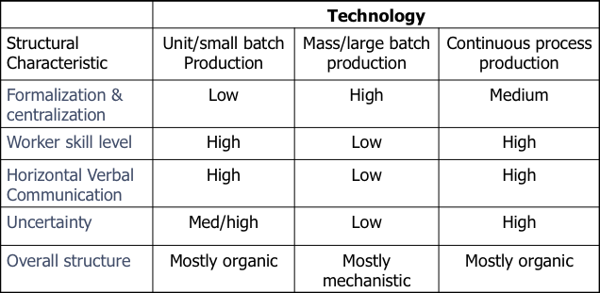

- Workflow interdependence and structural design (PP)
  - Workflow interdependence: Extent to which core and non-core work activities in organizational groupings depend on each other for resources and materials.
  - Uncertainty is created by exchange of resources/materials

- 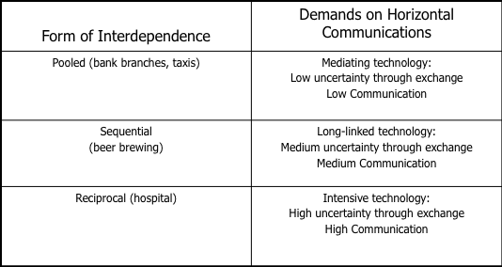
- 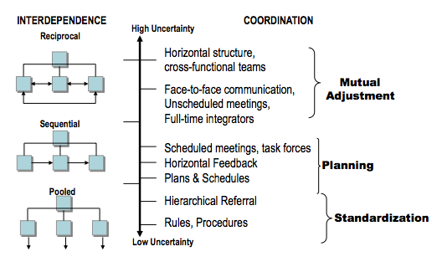

- Noncore departmental technology and structural design
  - Two dimensions of departmental activities that are relevant to organizational structure and process
    - Task variety and analyzability
  - Task variety: the frequency of unexpected and novel events that occur in the conversion process – concerns whether work processes are performed the same way every time or differ as organization’s input converted to outputs
  - Analyzability: when the conversion process can be analyzed, the work can be reduced to mechanical steps and participants can follow an objective, computational procedure to solve problems.
  - These two dimensions form the basis for four major technology categories
    - Routine technologies: little task variety, use of objective computational procedures
    - Craft technologies: fairly stable stream of activities, but the conversion process is not analyzable or well understood
    - Engineering technologies: complex due to substantial variety in the tasks performed
    - Non-routine technologies: high task variety, conversion process is not analyzable or well understood

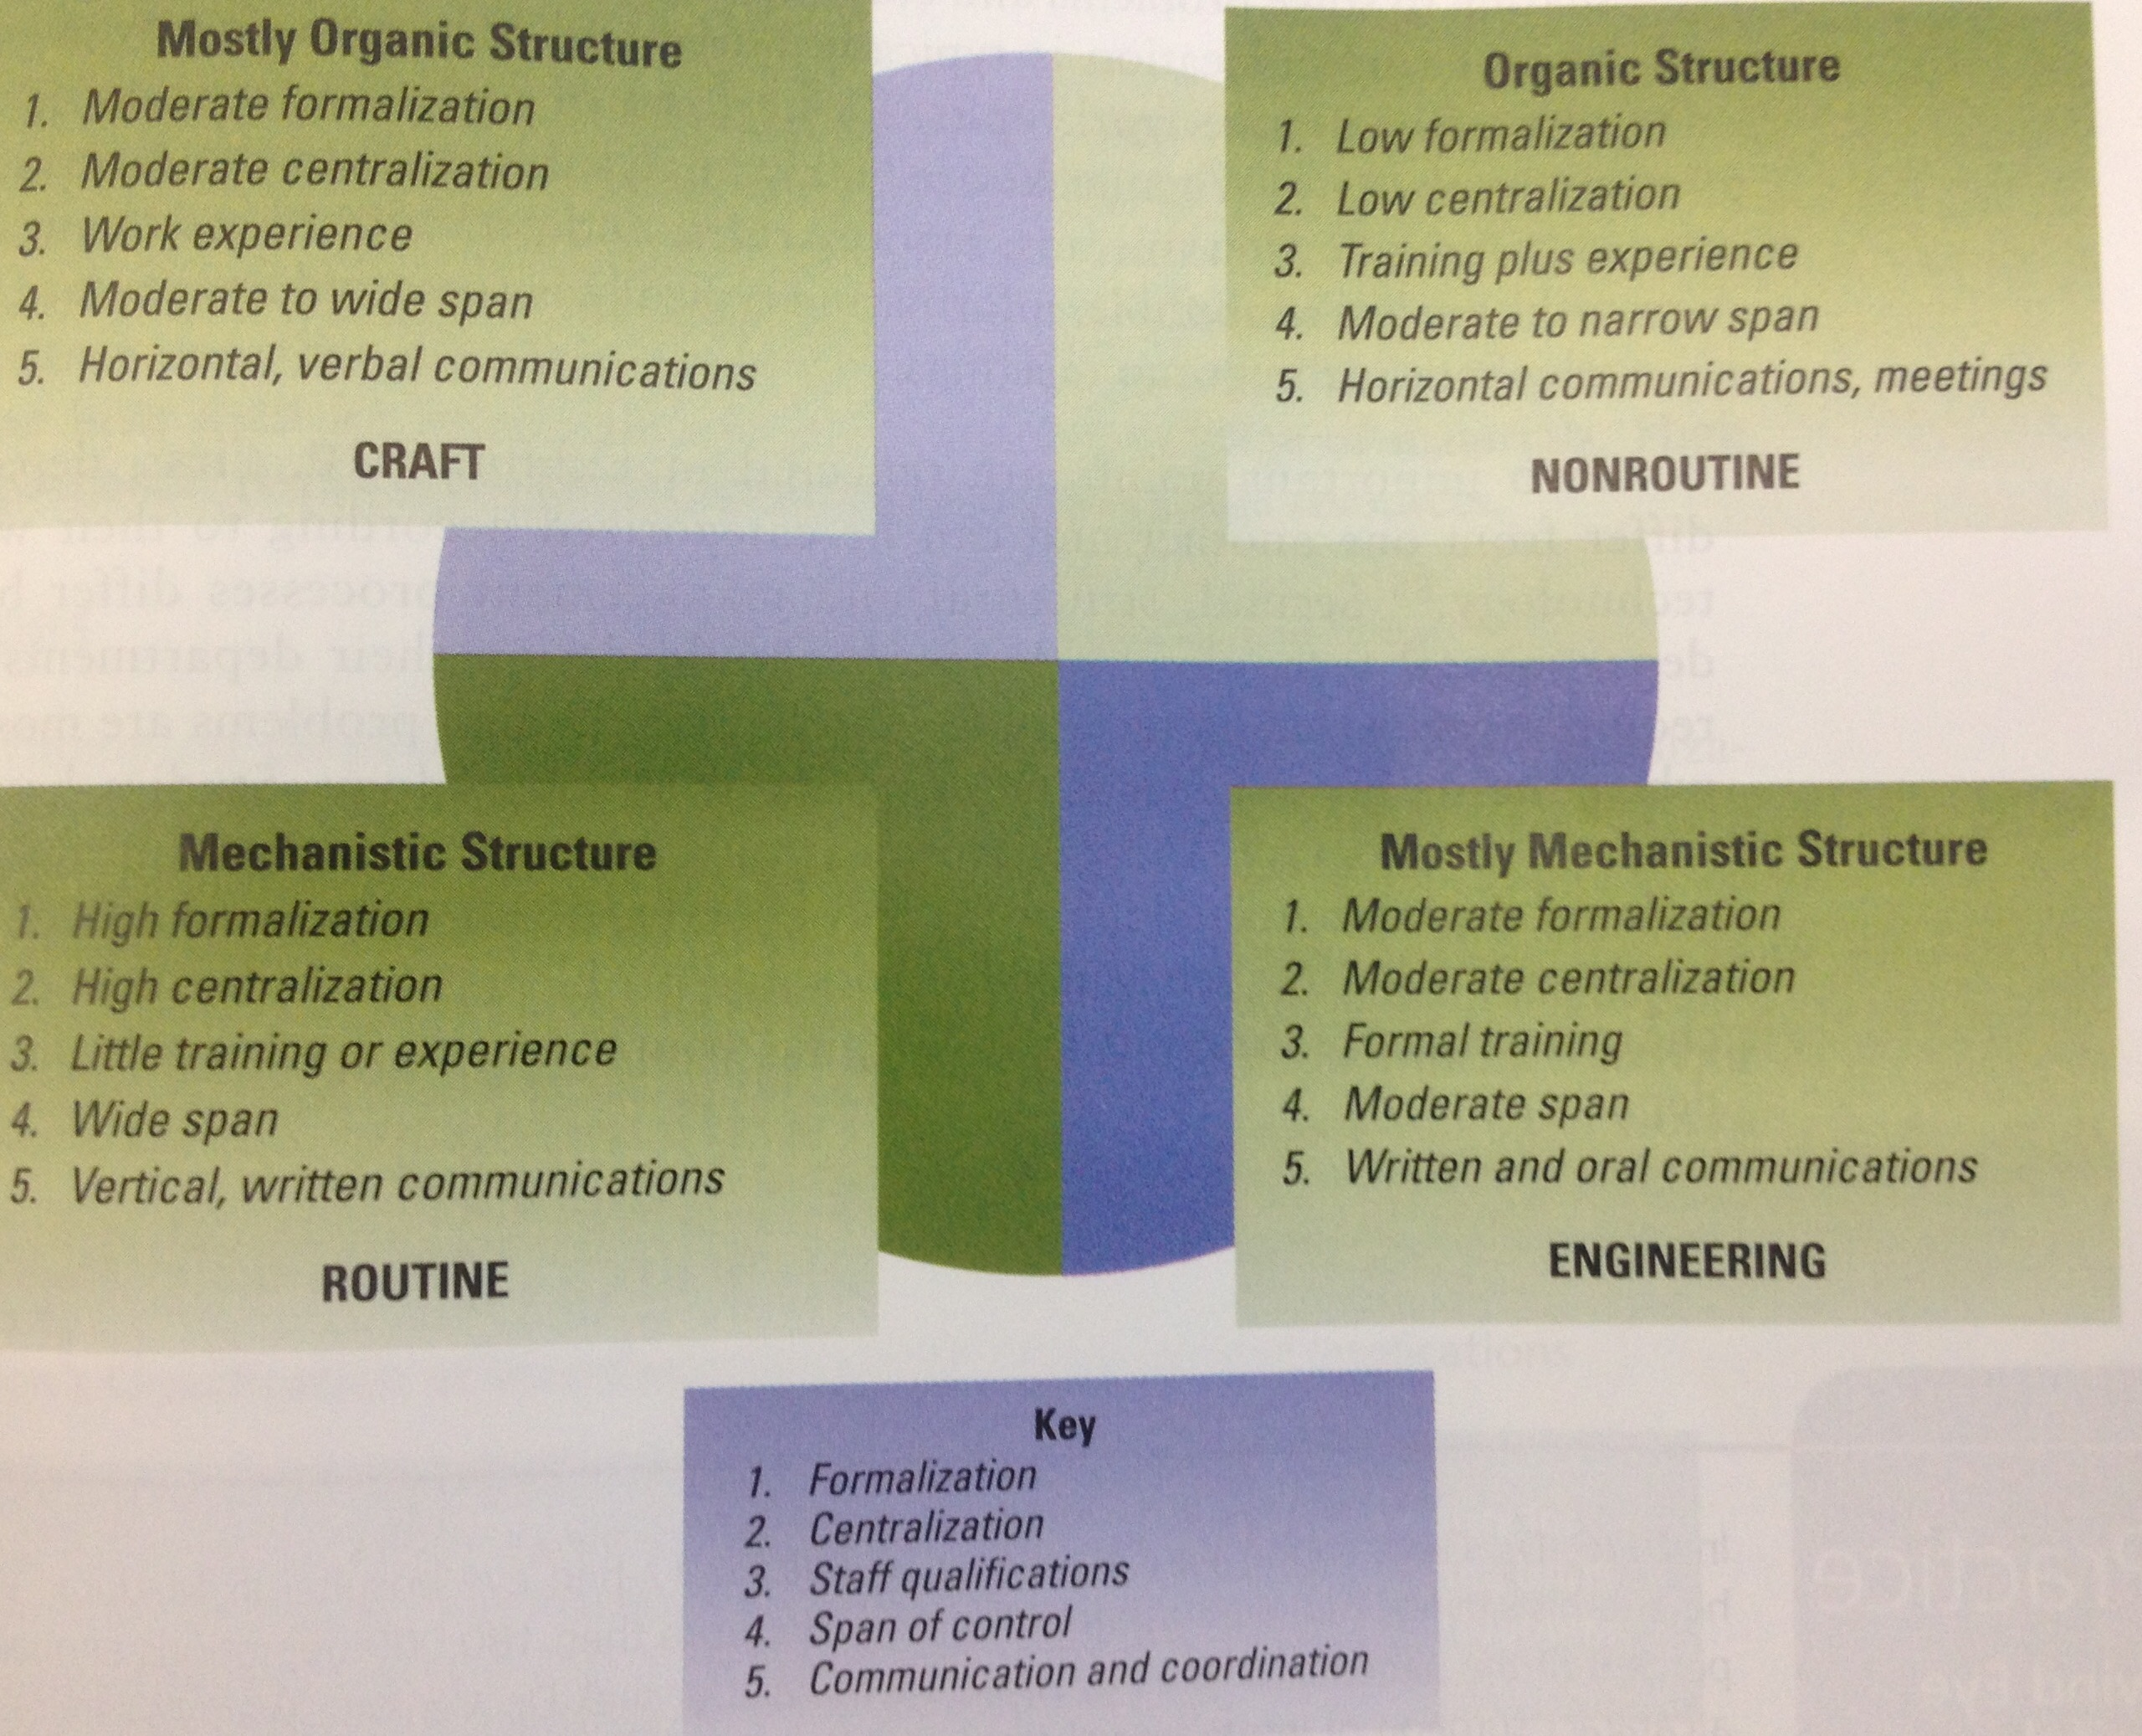

- Technology and Job design
  - Job design: the assignment of goals and tasks to be accomplished by employees
  - Job rotation: moving employees from job to job to give them a greater variety of tasks

mass production technology tends to produce job simplification (variety and difficulty of tasks are reduced)
  - advanced technology causes job enrichment (job provides greater responsibility, recognition and opportunities for growth and development)
  - FMS technology can contribute to job enlargement (expansion of the number of different tasks performed by an employee) fewer workers needed with new technology so each employee has to be able to perform a greater number and variety of tasks.

Organizational birth & the liability of newness (PP)
  - Traditional ways to assess organizational size
    - Network lens: Depends on the stakeholder
      - Financial Indicators
      - The number of employees
      - Number of products or markets Q
  - Organizational Birth
    - Culture lens: Imitation and organizational “recipes”
    - The Liability of Newness
      - New organizations are prone to fail Q

- Reasons for organizational growth (PP)
  - Large companies are standardized, often mechanistically run and complex. Complexity offers many functional specialties within the organization to perform multifaceted tasks and produce varied and complicated products
    - Can be a presence that stabilizes markers for years which provide longevity, raises and promotions
  - Small companies have a flat structure and an organic, free-flowing management style that encourages entrepreneurship and innovation. Personal involvement of employees in small firms
- Large organizations compared to small organizations (PP)

- 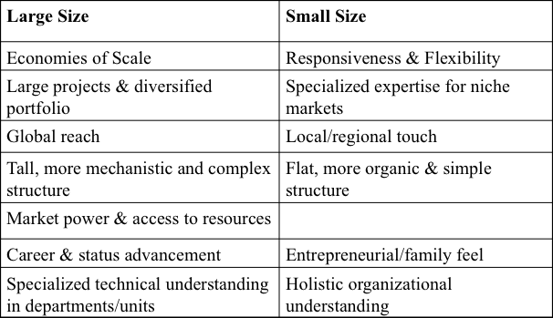
- Organizational life-cycle model

- 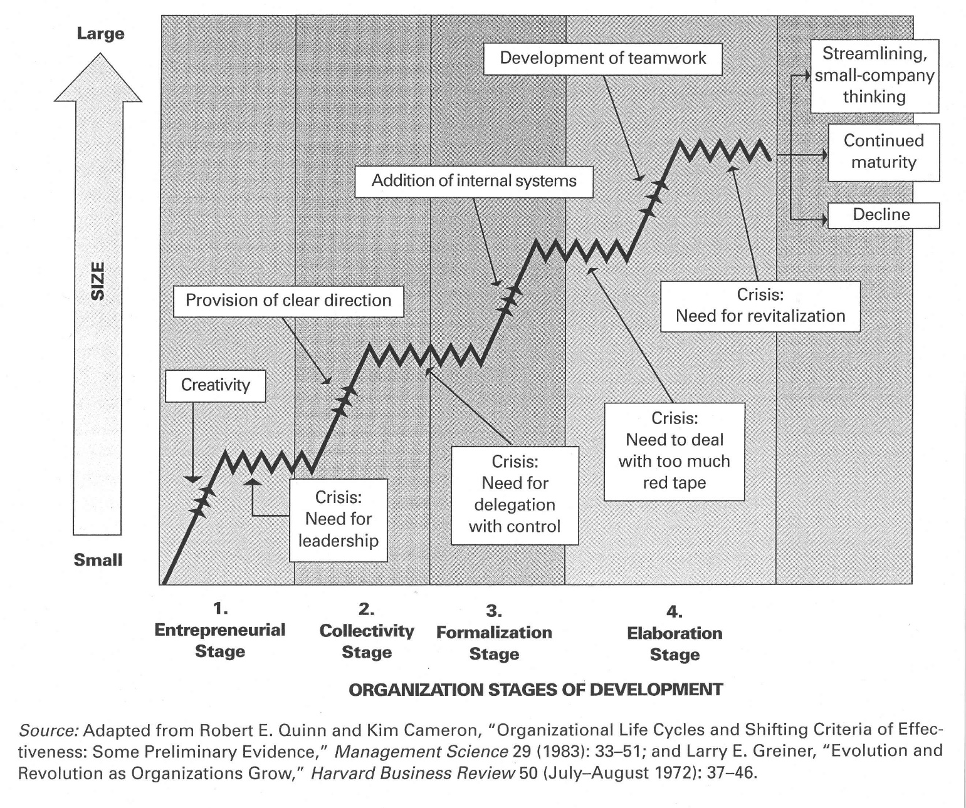

- Bureaucracy
  - Rules and standard procedures enable organizational activities to be performed in a predictable, routine manner.
  - Characteristics of a bureaucracy:
    - Rules and procedures
    - Specialization and division of labour
    - Hierarchy of authority
    - Technically qualified personnel
    - Separate position from position holder
    - Written communications and records
- Organizational control strategies
  - Bureaucratic control is the use of rules, policies, hierarchy of authority, written documentation, standardization, and other bureaucratic mechanisms to standardize behaviour and asses performance
  - As organizations progress through the life cycle and grow larger, they become more formalized and standardized
    - To make bureaucratic control work, managers must have the authority to maintain control over the organization
  - Three types of authority that can explain the creation and control of large organizations
    - Rational-legal authority: based on employees beliefs in the legality of rules and the right of those elevated to positions of authority to issue commands (most common base of control in organizations worldwide)
    - Traditional authority: belief in traditions and in the legitimacy of the status of people exercising authority through those traditions.
    - Charismatic authority: based on the devotion to the exemplary character or to the heroism of an individual person and the order defined by him or her

- Organizational decline
  - Organizational decline is used to define the condition in which a substantial, absolute decrease in an organization’s resource base occurs over a period.
    - Often associated with environmental decline in the sense that an organizational domain experiences either a reduction in size (shrinkage in customer demand or erosions of a city’s tax base) or a reduction in shape (shift if customer demand)
  - Three factors cause organizational decline
    - Organizational atrophy: organizations grow older and become inefficient and overly bureaucratic. Adaptability decreases, atrophy usually after long period of success
    - Vulnerability: reflects an organization’s strategic inability to prosper in its environment – often happens to small organizations that are not yet fully established, vulnerable to shifts in consumer tastes on in economic health of environment
    - Environmental decline or competition: refers to reduced energy and resources available to support an organization – environment has less capacity to support organizations, the organization has to either scale down operations or shift to another domain.

- Organizational downsizing (PP)
  - Downsizing: The planned elimination of positions and/or reorganization of work processes
    - Culture Lens: Downsizing as legitimate practice
    - Pressure to downsize stems in part from North-American business culture
      - Expectation of linear growth & belief that goals always have to be adjusted upward.
      - Short-run shareholder wealth maximization is valued over balanced stakeholder interests
      - Belief that labour costs involve only wages and salaries
  - Responsible downsizing:
    - Layoffs need to be combined with restructuring
    - Removing levels of the hierarchy
    - Removing or combining functions/divisions
    - Making the organization more responsive
  - Restructuring should address long-term strategic considerations
  - Implement not only by command from the top down but also with initiative from the bottom up.
    - Avoid loosing personnel with critical skills/knowledge
  - Pay special attention to those employees who lose their job, and those who remain
    - Avoid survivor syndrome: loss of trust and morale
    - Consider alternatives to layoffs
  - Techniques to help remaining employees after a downsize:
    - Communicate more, not less
    - Provide assistance to displaced workers
- Helper the survivors thrive

