Experiment 2: The Kinetic Study of Nucleophile Substitution

Lab Day:
Tuesdays

Students:
Katherine Lawless 7238517
Ryan Ewing 7560748

Demonstrator:
Shahrokh Ghobaloo

Date:
Tuesday September 30th 2014

Organic Chemistry II Lab
CHM 2123
Introduction:
Chemical reactions are just the behaviour of molecules that transition from reactants to products. Products are normally favoured, but they are only produced at a certain rate. This is known as kinetics. Kinetics is the study of the rate of reactions. The rate of a reaction depends on many different parameters. The most common is the concentration of the reagents. The General formula of the rate of a reaction is represented by:
$$r=k{[A]}^{x}{[B]}^{y}$$
The r represents the rate of the reaction, [A] represents the concentration of reagent A and [B] represents the concentration of reagent B. The “x” and “y” exponents represent the order of the reaction with respect to each reagent.
The different types of reaction orders are: Zero, first, and second. Zero order, is quite uncommon, it is represented by this equation:
$$\left[A\right]={[A]}_{0}-kt$$
It can be determined when plotted [reagent] vs. Time. If the graphed line is linear and with a slope = -k (k= the rate constant) then the reaction is of zero order. If a reaction is of first order, the rate of reaction can be represented / calculated with this equation:
$$r= \frac{d\left[A\right]}{dt}= -kt+\ln\left({\left[A\right]}_{0}\right)$$
If one plotted ln([A]) vs. time and the graphed line was linear and had a slope= -k, then the reaction would be considered of first order. Second order, is the formation of two products whose concentrations depend on each other or the formation of products whose square root of one of the reactants. All in all, the second order reaction is represented by this equation:
$$r= \frac{d\left[A\right]}{dt}= -k\left[A\right]\left[B\right]= -k{\left[A\right]}^{2} → \frac{1}{{\left[A\right]}_{t}}=kt+ \frac{1}{{\left[A\right]}_{0}}$$
If one plotted 1/[A]₀ vs. time and the graphed line was linear and had a slope = k, then the reaction would be considered second order.
Many organic reactions involve a nucleophile and an electrophile. A nucleophile (to which will be focused more on for this experiment) carried a lone pair of electrons and attacks an electrophile’s empty orbital to form a new bond. The electrophile during a substitution reaction bears a leaving group and an alpha carbon. In a Sn2 reaction the nucleophile attacks the electrophile while the leaving group simultaneously breaks off. This all occurs in one step, unlike a Sn1 reaction. The nucleophile attacks the electrophile 180º to the leaving group; this is because Sn2 reactions depend highly upon stereochemistry.
What is the difference between Sn1 and Sn2 in terms of rate and concentrations? Sn1 is independent of the concentration of the nucleophile, meaning that the rate of reaction only depends on the concentration of the electrophile. For a Sn2 reaction, it is depended on the concentration of the electrophile and the nucleophile.
How can one predict the mechanism of a reaction that can be either Sn1 or Sn2? The alpha carbon. If the alpha carbon is primary then the reaction will favour Sn2 because the carbocation will be too unstable; therefore, needing a strong and charged nucleophile. If the alpha carbon is tertiary then the reaction will favour Sn1 because the carbocation will be very stable; therefore, needing a weak un-charged nucleophile.
The leaving groups that are present on the electrophile increase polarization of the bond between the leaving group and the carbon. This decreases its activation energy and therefore the overall rate of the reaction. Larger leaving groups depart faster than smaller ones.
For part A of the experiment the goal is to perform a substitution reaction involving the nucleophile KOH and 1-bromobutane. Using titration, the rate of the concentration of KOH through a period of time will be determined. By the end of the experiment the order of the reaction must be determined, the rate constant, and the type of reaction (Sn1 or Sn2).
For Part B of the experiment the goal is to perform a hydrolysis of tert-butyl chloride. The overall goal of this experiment is to determine the rate of the concentration of tBuCl with different percent conversions over time using two different solvents. By the end of the experiment the order of the reaction must be determined, the rate constant, and the type of reaction (Sn1 or Sn2).

Mechanism of the Reactions:

Table of Reagents:
Compound | Mol. Mass (g/mol) | Quantity (g or mL) | Density (g/mL) | mol
0.1 M HCl | 36.5 | 24.6 mL | 1.49 | 0.674
0.5 M 1-bromobutane | 137 | 200 mL | 1.23 | 1.46
2.0 M KOH in EtOH | 46.1 | 50.0 mL | 0.789 | 1.08
0.02 M of NaOH | 39.1 | 30.0 mL | 2.13 | 0.767
0.10 M of tBuCl | 92.6 | 24.0 mL | 0.840 | 0.259
Distilled water | 18.0 | 94.0 mL | 1.00 | 5.22
Acetone | 58.1 | 12.0 mL | 0.791 | 0.207

Experimental Procedure:
Please refer to the CHM 2123 Organic Chemistry II Lab manual on pages 35-37.
Results:
Table 1: Results for Part A
Reaction Time | 2 Minutes | 15 Minutes | 30 Minutes | 45 Minutes | 60 Minutes
V aquilot (mL) | 4.95 | 5.10 | 4.95 | 4.95 | 5.00
V_{i} HCl (mL) | 0.0 | 3.5 | 11.5 | 0.0 | 3.9
V_{f} HCl (mL) | 3.0 | 11.5 | 17.2 | 3.9 | 6.9
ΔV HCl (mL) | 3.0 | 8.0 | 6.7 | 3.9 | 3.0
mol HCl titrated (cΔV) | 0.0003 | 0.0008 | 0.00067 | 0.00039 | 0.0003
Mol KOH neutralized | 0.0003 | 0.0008 | 0.00067 | 0.00039 | 0.0003
[KOH] | 0.0606 | 0.1569 | 0.1354 | 0.0788 | 0.0606
ln([KOH]) | -2.803 | -1.852 | -1.9995 | -2.541 | -2.803
1/[KOH] | 16.50 | 6.373 | 7.386 | 12.690 | 16.50

Part B:
Table 2: 85:15 H₂O:acetone
% Conversion | 10% | 20% | 30% | 40%
0.10 M tBuCl in acetone (mL) | 3.0 | 3.0 | 3.0 | 3.0
0.02 M NaOH in water (mL) | 1.5 | 3.0 | 4.5 | 6.0
Distilled Water (mL) | 15.5 | 14.0 | 12.5 | 11.0
Time to colour change #1 (s) | 25 | 42 | 90 | 124
Time to colour change #2 (s) | 18 | 37 | 109 | 117
Time to colour change #3 (s) | 18 | 26 | 87 | 103
Average time of trials 1-3 (s) | 20.333 | 35 | 95.333 | 114.666
[tBuCl] in solution (M) | 0.0135 | 0.012 | 0.0105 | 0.009
ln([tBuCl]) | -4.305 | -4.23 | -4.56 | -4.71
1/[tBuCl] | 74.074 | 83.33 | 95.24 | 111.11

Table3: 70:30 H₂O:acetone
% Conversion | 10% | 20% | 30% | 40%
0.10 M tBuCl in acetone (mL) | 3.0 | 3.0 | 3.0 | 3.0
0.02 M NaOH in water (mL) | 1.5 | 3.0 | 4.5 | 6.0
Distilled Water (mL) | 12.5 | 11.0 | 9.5 | 8.0
Acetone (mL) | 3.0 | 3.0 | 3.0 | 3.0
Time to colour change #1 (s) | 83 | 143 | 413 | 1140
Time to colour change #2 (s) | 29 | 159 | 567 | 777
Time to colour change #3 (s) | 148 | 148 | 539 | 679
Average time of trials 1-3 (s) | 86.67 | 150 | 506.33 | 865.33
[tBuCl] in solution (M) | 0.0135 | 0.012 | 0.0105 | 0.009
ln([tBuCl]) | -4.305 | -4.23 | -4.56 | -4.71
1/[tBuCl] | 74.074 | 83.33 | 95.24 | 111.11

Table 4. Rate constant Values
 | Part A rate constant values (-k) |  | Part B rate constant values (-k)
Order number | 1-bromobutane | 1-chlorobutane | 85:15 H₂O:acetone | 70:30 H₂O:acetone
zero | 0.002805 | 0.0002673 | 3.268x10^-5 | 8.705 x10^-6
One | 0.01481 | 0.0008751 | 0.004153 | 0.001181
two | -0.08284 | -0.002867 | N/A | N/A

Observations:
Step | Observation
Part A Step 6 | Solution is clear and colourless. It is boiling rapidly while the heat source is used.
Part A Step 8 | When the phenolphthalein is added, the solution turns from clear and colourless to a light pink colour.
Part A Step 9 | During the titration, as HCl is added, the solution changes to a pale white colour but after being swirled returns to its original pink colour. After more HCl is added, the solution changes and remains white, indicating that the neutralization reaction is complete. This process requires less acid as more time passes in the experiment.
Part B Step 3 | When the bromothymhol blue indicator is added, the solutions went from clear and colourless to a light blue.
Part B Step 4 | Over time, the solutions began to turn a light shade of blue before rapidly changing to a clear beige-yellow when the reaction was complete.

Sample Calculations:
Part A
*All Data used is from the sample taken at the 15 minute mark.*
Mol HCl titrated = CΔV Mol KOH neutralized
=0.1M x 0.008L = 1:1 mol KOH : mol HCl
=0.0008mol HCl =0.0008mol KOH

[KOH] = $\frac{mol KOH neutralized}{Volume of aliquot}$ ln[KOH] = ln (0.1969) = -1.8562
=$\frac{0.008}{0.0051}$
=0.1969M 1/[KOH] = 1/0.1969 = 6.373
$$∴The concentration of KOH is 0.1969M for Order 0, -1.8562M for Order 1, and 6.373M for Order 2$$
Part B
*All data used is from the 20% conversion*
[tBuCl] that wasn’t converted:
c₁v₁ = c₂v₂
(0.1)(0.003) = (c₂)(0.02)
C₂ = 0.015M
C₂ (% of tBuCl that was not converted) = [tBuCl] that was not converted
(0.015)(0.80) = 0.012M
$∴the concentration of tBuCl left over in the solution with 20\% conversion for Order 0 is 0.012M$
$$ln\left(\left[tBuCl\right]\right)=ln\left(0.012M\right)=-4.42 M$$
$$\frac{1}{\left[tBuCl\right]}= \frac{1}{0.012M}=83.2 M$$
$$∴The first order concentration tBuCl is-4.42Mand the second order concentration of tBuCl is 83.2 M$$

Graphs:
*”Correlation” on the linear fit boxes represents R²*
Part A: n= 32 for 1-bromobutane for all graphs, and n= 27 for 1-chlorobutane for all graphs
Graph 1.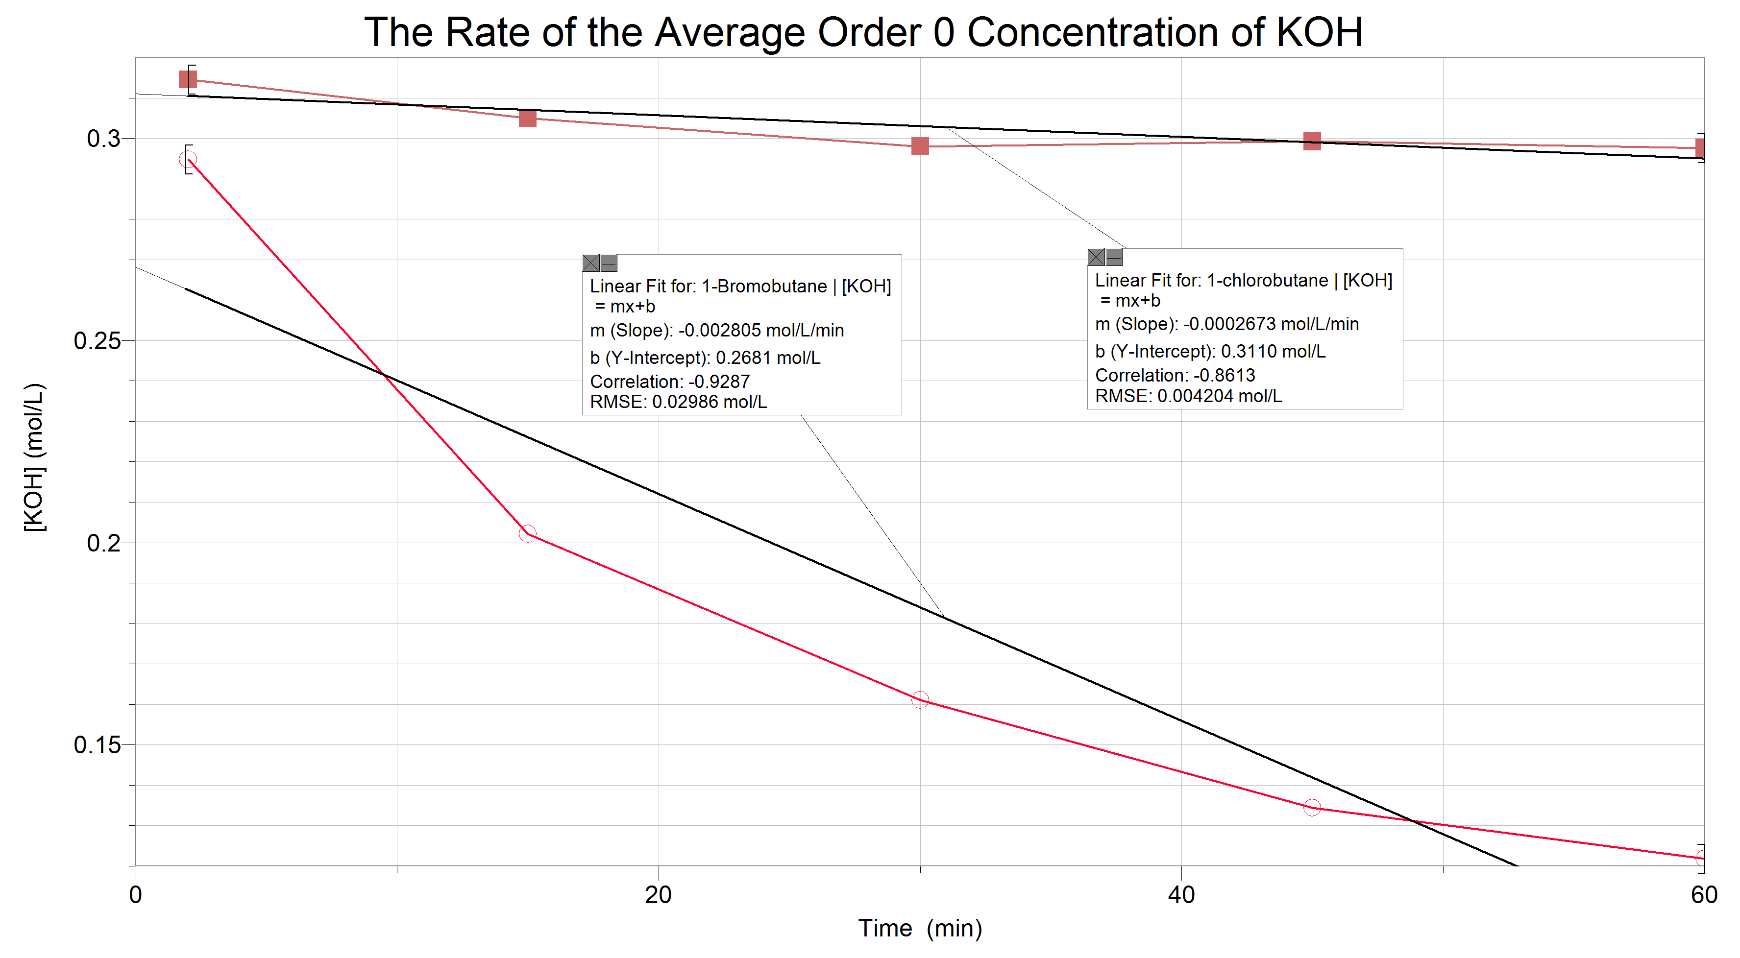
Graph 2.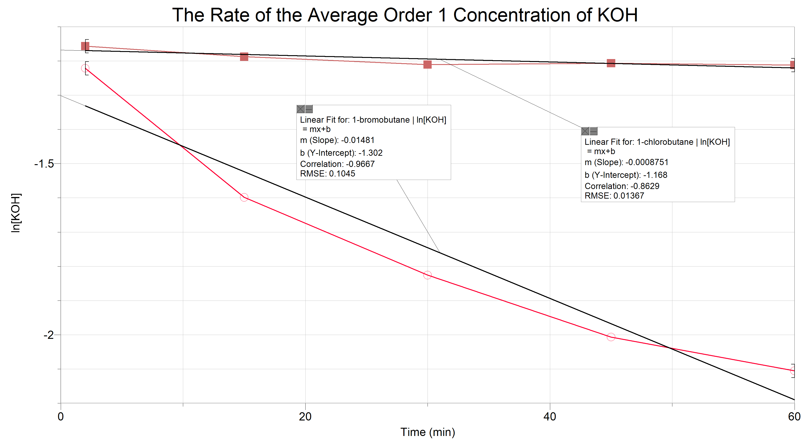
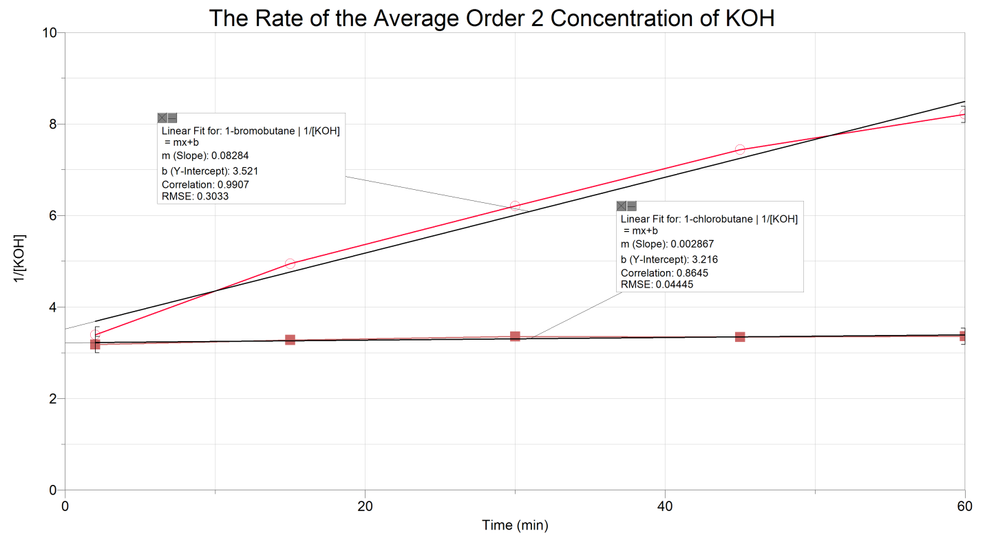
Graph 3.
Part B: n= 65, for all graphs
Graph 4.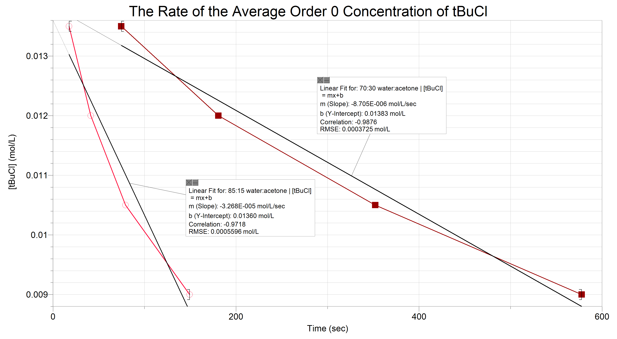

Graph 5.
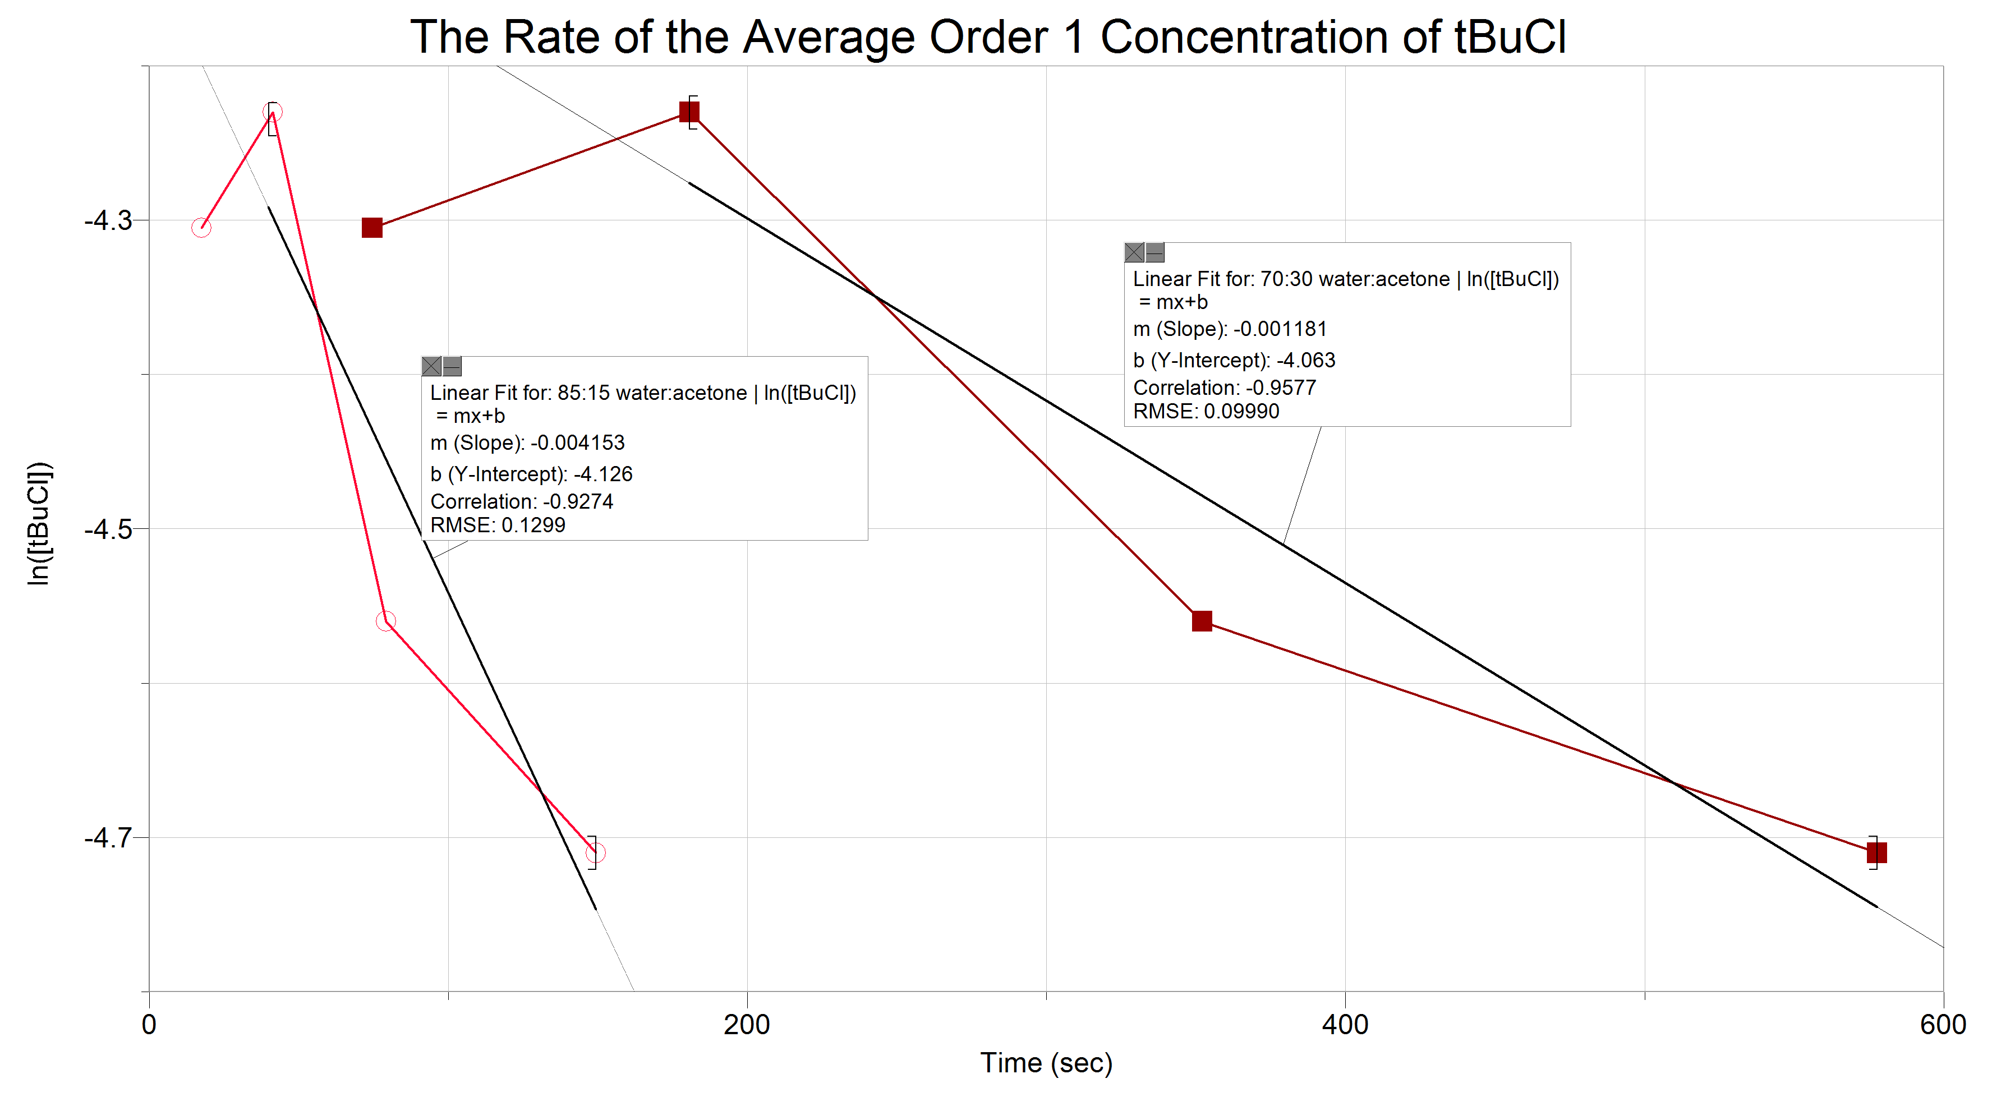

Discussion:
In this lab, the objective of part A was to see the rate of a S_{N}2 reaction using titration. The starting material we used in this portion of the lab was 0.5M 1-bromobutane. The 1-bromobutane is added to a round bottomed flask and attached to a reflux condenser. Then, it is heated until the 1-bromobutane starts to reflux. Once this begins, 10mL of KOH is added and the reaction begins. Now the reaction begins. It is a S_{N}2 reaction, meaning that it occurs all in one step, or is concerted. The alpha-carbon on the 1-bromobutane develops a partial positive charge from the nucleophilic Br molecule. This allows the negatively charged OH in solution to attack the alpha-carbon and form a new bond. This ejects the Bromine from the molecule.
After 2 minutes, about 5mL of the solution is taken, 2 or 3 drops of phenolphthalein are added, and it is titrated against 0.1M HCL. At this point, a relatively large amount of HCL should be required. Since the reaction has not been going on for a very long time, most of the KOH is still present in the solution. This means that the concentration of KOH is still very high and more acid is required to neutralize the KOH.
This process is repeated at the 15, 30, 45 and 60 minute mark. As the reaction progresses, less KOH is present in the solution, meaning that the concentration has dropped. This also means that the amount of HCl required to titrate against the solution drops.
We were asked to calculate the rate constant of each reaction using a graphing software. Referring to the graph using the 0 order reaction formula, we see that the points form a curve. This indicates that this reaction is not a 0 order reaction. This also means that unlike a 0 order reaction, the rate of the reaction is reliant on one or more of its reagents. Now, referring to the graph made using the first order reaction formula, we can also see that the points form a curve. This means that the reaction is not a first order reaction. This also means that the rate of the reaction is determined by the concentration of more than one of the reactants. Finally, looking at the graph that was made using the second order reaction formula, we can see that the points form a straight line. This means that the reaction in part A of the lab was indeed a second order reaction. This means that the rate of this reaction is determined by both of the reactants. This also means that this reaction is an S_{N}2 reaction. Using the data from all of the lab sections, we see that the rate of this second order reaction is 0.08284. Our data however, possessed an error, or an outlier, at the 2 minute mark. The titration took way less HCL than it was supposed to. This resulted in a reading for the [KOH] that was much lower than it was supposed to be. This may have been a result of not allowing the solution to reflux sufficiently before adding the KOH and starting the timer. This would also explain why the solution went from clear and colourless to white during the titration, rather than the other way around at every other part in the experiment. Other sources of error in this part of the experiment include the brief period when the reflux condenser is removed from the round bottomed flask in order to get some of the solution. This brief time would allow some of the solution to escape. Since the two compounds have different boiling points, more of one of the reagents would escape than the other, changing the overall concentration in the solution.
The goal of part B of the experiment was to determine the exact time that would take tBuCl to hydrolyze in 10%, 20%, 30%, and 40% completion within two different solvent systems of 85:15 water:acetone and 70:30 water:acetone. During the experiment different volumes of water and NaOH were added for each percent conversion trail for both solvent systems. The different volumes of the NaOH, the nucleophile for the reaction, and water (solvent) contribute to the different percent conversions. This is because water is a polar protic solvent and it will hinder the leaving group on the tBuCl, the chlorine, to allow it to easily break off so it can react faster with the nucleophile. Since tBuCl’s alpha carbon is tertiary a Sn1 reaction will be favoured; therefore, the first step of the reaction will be the breaking of the bond between the leaving group (Cl) and the alpha carbon. Chlorine is an okay leaving group, however, not as strong as bromine or Iodine. So, in order to quickly have the leaving group leave during that rate determining step, the water solvent hinders the leaving group through solvation allowing it to be easily broken off so the reaction can occur faster, since the rate determining step is the slowest step to this two- step reaction. For each percent conversion the volume of the nucleophile (NaOH) increases while the volume of water decreases. Three drops of bromothymol blue indicator was added to each trail for each percent conversion experiment to give the solution of NaOH and water ( and acetone for 70:30 water:acetone) a blue colour so one could tell when the reaction had occurred due to the colour change. The time was recorded immediately after 3 mL of tBuCl was added to the different trail flasks, indicating the start of the reaction. The colour changes due to change in pH once the products are formed. The pH changes due to the hydrolyzation of tBuCl, the OH present on the product makes the product quite acidic which lowers the pH level. Since the volume of water decreased for each percent conversion experiment, the time for the solution to change colour increased due to the hindering effect of the water solvent on the leaving group. 10% conversion took the quickest to change colour because of it contained the greatest amount of water. Now, in terms of comparison for the two different solvents used (85:15 water:acetone, and 70:30 water:acetone) the solvent that contained 85:15 water :acetone had reactions occurring faster than 70:30 water:acetone. This is due to the polar protic water solvent that hinders the leaving group due to its high polarity by having the leaving group pull it’s electrons towards it allowing it break off easily and allowing the carbocation to be stabilized. Since there is more water present in the 85:15 than 70:30, the reactions will occur faster in the 85:15 solvent to which the data in table 2 shows.
The concentration of tBuCl was calculated and the average from the class was plotted in zero rate order and first rate order. After analyzing the data from the graphs the reaction seemed to be more linear with a reaction rate order of 1 (shown on Graph 5.) Graph 5, also shows a small error in the first calculated concentration of tBuCl, to which is why a “dip” is shown on the graph. However, if the other averages for the other percent conversions were looked at the rate would be linear. Therefore, the rate of the reaction is of order 1, which makes sense since the reaction was also determined to be Sn1. This is because the reaction rate of a Sn1 reaction does not depend on the concentration of the nucleophile, it only depends on the concentration of the reagent. Graph 5 and table 2 and 3 of part b indicate that only the concentration of tBuCl affects the rate of the reaction because as more tBuCl is converted the slower the rate because so many leaving groups need to be broken (rate-determining step) before the reaction can proceed further. Errors that could have occurred during the experiment to which could have altered the results of the rate of concentration for the tBuCl, would be errors in the measurements with the gradulated cylinder for the water, acetone, NaOH, and tBuCl. These measurement errors, due to the inaccuracy of the gradulated cylinder, could have slightly altered the percent conversion of the tBuCl.
In terms of comparison with the global data from each lab day and Tuesday’s lab data, it seems that the data for the solvent 85:15 for order 1 had very similar rate constants. Monday’s morning lab had a rate constant of 0.00427, Monday’s evening lab had a rate constant of 0.00379, Tuesday’s lab had a rate constant of 0.00415, Thursday’s lab had a rate constant of 0.00496, and Friday’s lab had a rate constant of 0.00623. For the solvent 70:30 water:acetone, Monday’s morning lab had a rate constant of 0.000918, Monday’s evening lab had a rate constant of 0.000994, Tuesday’s lab had a rate constant of 0.00118, Thursday’s lab had a rate constant of 0.00156, and Friday’s lab had a rate constant of 0.00624. For both solvent systems the Tuesday lab class shared very similar rate constants (except Friday’s lab class for the 70:30 water:acetone solvent system). These results prove that the reaction with tBuCl is indeed a first order reaction for all the lines of the global data were linear when graphed as a first order reaction. This also proves that the polar protic water solvent does affect the time of the reaction due to the similarity in the rate constants. The last proof that this comparison gives, is that the rate is not affected by the NaOH nucleophile but is only affected by the concentration of the tBuCl.

Conclusion:
The goal of part A and B was to determine the order of the reaction in each part. Using the rate equations for each order, we determined that the reaction between bromobutane and KOH is an S_{N}2 reaction and the reaction between tBuCl and NaOH is an S_{N}1 reaction.

Questions:
- A)
b)

c)
d)

- Out of the following chemicals (a) will have the fastest rate of reaction with NaOH in and Sn2 because the alpha carbon is of 1º; therefore, Sn2 is favoured. Secondly, the Nucleophile is charged and strong; therefore, Sn2 is favoured. Lastly, the leaving group (Br) is polar protic; therefore, Sn2 is favoured.

- A) b) in order to increase yield, the student could begin with 1-Iodopentane or 1-bromopentane. This would increase yield because Br is a stronger leaving group than Cl and I is even stronger than Br. Using a solvent that is polar and aprotic (eg. Acetone) will also drive the reaction forward. These would lower the amount of energy required to react the two reagents and drive the reaction forward.

- Usually, polar protic solvents hinder Sn2 reactions. In this situation, however, the nucleophile reactant is missing a proton. As the reaction travels forward, and the Br is ejected, it is left in solution with a (-) charge. This attaches to a H⁺ in solution and is neutralized. This solution is also chosen because it matches the nucleophile reactant after it dissolves and can go on to react with the 1-bromopentane

- This reaction would be Sn2 because OH is strong and charged nucleophile, the molecule is non-hindered, and the leaving group is polar protic and strong. In terms of reaction kinetics, Sn2 is bimolecular; therefore, it depends on the concentration of both the nucleophile and the molecule. So to determine this, an experiment would have to be made to test out this theory. One way of doing this would be to change the concentration of the nucleophile (OH⁻) during different trails during the experiment. If the rate of the reaction is not affected then the reaction is Sn1 if the rate of the reaction is affected then the reaction is Sn2.

