INTRO TO MARCOECONOMICS FINAL EXAM REVUE

CHAPTER 4: SUPPLY AND DEMAND

Supply and demand are the forces that make the market economies work. They determine the quantity of each good produced and the price at which it is sold.

Market: a group of buyers and sellers of a particular good or service.

Competitive market: market in which there are many buyers and sellers so that each has negligible impact on the market price.

Demand:
- Behaviour of buyers
- Quantity demanded: amount of a good that buyers are willing and able to buy
- Law of demand: all other things equal, the quantity demanded for goods falls when the prices rise.
- Market demand: the sum of all individual demands for a particular good.

Shifts in the demand curve:
- Income
  - Normal good: increased income increases demand for this type of good.
  - Inferior good: increased income decreases demand for this type of good.
- Prices of related goods:
  - Substitutes: increase in the price of one leads to an increase for the demand of the other.
  - Complements: 2 goods for which an increase in the price of one leads to a decrease in demand of the other.

Supply:
- Behaviour of sellers
- Quantity supplied: amount of a good that sellers and willing and able to sell
- Law of supply: all other things equal, the quantity supplied of a good rises when the price of a good falls.
- Market supply: sum of all individual supplies for a particular good or service

Shifts in supply curve:
- Input prices: prices of inputs rise, price of producing rises, people do not produce as much.
- Technology: advances raise the Q supplied of a good with technological advancements.
- Expectations: future higher expectations of prices forces sellers to put some supply on hold for later.
- Number of sellers: number of suppliers producing the same kind of good.
Supply and demand together:
- Equilibrium: a situation in which the price has reached the level where the quantity demanded in the market equals the quantity supplied.
- Equilibrium price: the price that balances the quantity demanded and supplied.
- Equilibrium quantity: the quantity supplied and demanded at the equilibrium price.

Surplus:
- A situation in which quantity supplied is greater than quantity demanded in the market for a particular good.
- The price level is then above equilibrium and the market forces the price down.

Shortage:
- A situation in which quantity demanded is greater than quantity supplied in the market for a particular good.
- The price level is then below equilibrium and the market forces the price up.

Law of supply and demand:
- The price of any good adjusts to bring the quantity supplied and the quantity demanded for that good into balance.

INTRO TO MARCOECONOMICS FINAL EXAM REVUE

CHAPTER 5: MEASURING A NATIONS INCOME

Microeconomics: the study of how individuals and firms make decisions and how they interact with markets.

Macroeconomics: the study of economy wide phenomena including inflation, unemployment and economic growth.

Gross domestic product (GDP):
- Measures the total income of a nation.
- The market value of all final goods and services produced within a country in a given period of time.
- Best measure of a society’s economic well being.

The components of GDP:

$$Y=C+I+G+Nx$$

Y= GDP
C= Consumption
I=Investment
G= Government purchases
Nx = Net exports

Consumption: spending by households in goods and services
Investment: spending in capital equipment, inventories and structures
GVT purchases: spending in goods and services by local, provincial and federal gvts.
Net exports: the value of a nations exports- value of imports

Real GDP versus Nominal GDP:
- Nominal GDP: use the prices and quantities that change and are updated each year.
- Real GDP: use the same base year prices but use the changing quantities each year.

GDP deflator:
$$GDP deflator=\frac{Nominal GDP}{Real GDP}×100$$

$$Inflation rate year 2=\frac{deflator year 2-deflator year 1}{deflator year 1}×100$$

INTRO TO MACROECONOMICS FINAL EXAM REVUE

CHAPTER 6: MEASURING THE COST OF LIVING

Consumer price index (CPI)
- The overall measure of the costs of the goods and services bought by a typical consumer.
- The CPI is used to monitor changes in the cost of living over time.
- When the CPI rises, the typical family has to spend more to maintain the same standard of living.

Calculating the CPI:
- Basket: goods and services bought by the typical consumer

$$CPI=\frac{Price of basket in current year}{Price of basket in base year}×100$$

$$Inflation rate year 2=\frac{CPI year 2-CPI year 1}{CPI year 1}×100$$

Problems in measuring the cost of living:
- Commodity substitution bias
- Introduction of new goods
- Unmeasured quality change
** These problems tend to make economists overstate the cost of living.**

Correcting economic variables for effects of inflation:
- Indexation: the automatic correction of a dollar amount for the effects of inflation.
- COLA: tool that automatically raises the wage when CPI rises.

Example: dollar figures from different times: (1940 gas prices in 2012 dollars)

$$1957 gas price=\frac{CPI 2012}{CPI 1940}$$

Real and nominal interest rates:
- Nominal interest rate: the rate that is usually reported without a correction for the effects of inflation.
- Real interest rate: the interest rate that is corrected for the effects of inflation.
- $Real interest rate=Nominal interest rate-Inflation$

INTRO TO MARCOECONOMICS FINAL EXAM REVUE

CHAPTER 7: PRODUCTION AND GROWTH

Living standard vary widely from country to country. We explain these variations around the world using productivity.

Productivity: the quantity of goods and services produced from each hour of a workers time.

Importance of productivity:
- Key determinant in living standards
- Growth in productivity = growth in living standards
- High standard of living = High productivity

4 determinants of productivity:
- Physical capitol
- Human capital
- Natural resources
- Technological knowledge

Physical Capitol: stock of equipment and structures that are used to produce goods and services.

Human capitol: knowledge and skills that workers acquire through education, training and experience.

Natural resources: inputs into the production of goods and services that are produced by nature and land.

Technological knowledge: society’s understanding of the best ways to produce goods and services.

Importance of saving and investment:
- It is important to always be investing in capitol so that society can furthermore produce goods and services more effectively.
- When the government encourages saving and investment, this encourages more production of goods and services, and therefore promotes economic growth and raises the standard of living.

Diminishing returns: the benefit from an extra unit of input declines as the quantity of input increases.

Catch up effect: Countries that start off poor tend to grow more rapidly than countries that start off rich.

Investment from abroad: (acquires new capitol)
- Foreign direct investment: capital investment that is owned and operated by a foreign entity.
- Foreign indirect investment: investment that is financed with foreign money and operated by domestic residents.
- Foreign portfolio investment: liquid investment finances with foreign money and operated by domestic residents.

- Foreign investment in Canada raises the GNP by less than it raises the GDP.
- GDP raises because the investment raises Canadian capitol stock
- GNP raises less because the profits go back to the foreign country.

Investment from abroad helps poor countries grow and promotes the flow of capitol to poor countries. This promotes economic prosperity around the world.

Education:
- Investment in human capitol is just as important as any other determinant of productivity.
- More education = higher wages and salaries
- GVT policy can improve standards of living by providing adequate education
- Education generates positive externalities

Externality: effect of one person’s actions on the well being of a bystander.

Brain Drain: Immigration of many of the most highly educated workers to rich countries where they can enjoy a higher standard of living.

Health and nutrition:
- There is a casual link between health and wealth.
- Healthier workers = higher productivity

Property rights and political instability:
- For the market and the invisible hand to work, there must be implanted property rights.
  - Property rights: ability of people to exercise their authority over the resources they own.
- Political instability (communist, socialist) is a threat to property rights.
- Countries with a good court and government system will typically have a higher standard of living.

Free trade:
- Poor countries are better off pursuing outwards and integrating themselves with the world economy in order to grow quickly.
- Countries that eliminate trade restrictions grow.

Research and development:
- Living standards are higher because of technological development.
- Knowledge is a public good.

Population growth:
- A large population means that there is the possibility of more goods and services to be produced.
- However, this does not mean that there will always be a higher standard of living.
- The large population stretches the distribution of goods and services and natural resources.

Theory Robert Malthus:
- People are doomed, the population will keep on growing and everybody in the future will live in poverty.

Diluting capitol stock:
- High population growth reduces GDP per worker because rapid growth in the number of workers forces the capitol stock to be spread more thinly.
- Smaller quantity of capitol per worker leads to low motivation and therefore lower productivity.
- If some countries were to reduce their population growth, they would be able to raise their standard of living.

Promoting technological progress:
- Population growth = more people= more engineers = more inventors = better technology.

INTRO TO MARCOECONOMICS FINAL EXAM REVUE

CHAPTER 8: SAVING, INVESTMENT AND THE FINANCIAL SYSTEM

Financial system: group of institutions in the economy that help to match one person’s savings with another person’s investment.

2 categories of financial institutions:
- financial markets
- financial intermediaries

Financial markets: financial institutions through which savers can directly provide funds to borrowers.

Bond market:
- Bond: a certificate of indebtness that specifies the obligation of the borrower to the holder of the bond.
- Debt finance: the sale of a bond to raise money
- Characteristics:
  - Bond’s term
  - Bond’s credit risk (higher risk = higher reward)

The stock market:
- Stock: represents ownership in a firm and is therefore a claim to its profits
- Equity finance: the sale of a stock to raise money
- The prices at which shares trade on stock exchanges are determined by the supply and demand for the stock.
- Stock index: an average of a group of stock prices
  - Stock indexes are watched closely to predict or indicate future economic conditions.

Financial intermediaries: financial institutions through which savers can indirectly provide funds to borrowers.

- Bank: the primary function of a bank is to take deposits to make loans to people who want to borrow.
- Mutual funds: institution that sells shares to the public and uses the proceeds to buy a portfolio of stocks and bonds

Accounting: refers to how various numbers are defined and added up.

The national income accounts include:
- GDP (Y)
- Many related statistics

Y = C + I + G + NX

In a closed economy, NX = 0….. therefore

Y = C + I + G …………… I = Y – C - G

Some important identities:
- Y- C – G = I (investment)
- Y – C – G = Savings (S)
- S = I

National saving: the total income in the economy that remains after consumption and government purchases.
- Let ‘’T’’ denote taxes collected by government minus transfer payments (money that the government is collecting from the economy).
- National saving can be expressed in either 2 ways
  - S = Y – C – G
  - S = (Y - T – C) + (T – G)

Private saving: the income that households have left after paying for taxes and consumption.
- Private saving = Y – T – C

Public saving: the tax revenue that the government has left after paying for it’s spending.
- Public saving = T – G
  - Budget surplus: tax revenue higher than spending
  - Budget deficit: spending higher than tax revenue

Market for loanable funds: market in which those who want to save supply funds and those who want to borrow demand funds.
- Saving: source of supply for loanable funds
- Investment: source of demand for loanable funds
- Interest rate: price of a loan

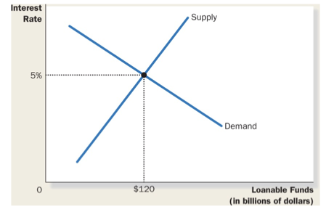
Policy 1: saving incentives
- A higher saving rate could lead to a higher rate of growth of GDP
- People respond to incentives
  - RRSP’s
  - TFSA
  - RESP
  - Consumption tax

Increase in supply of loanable funds:
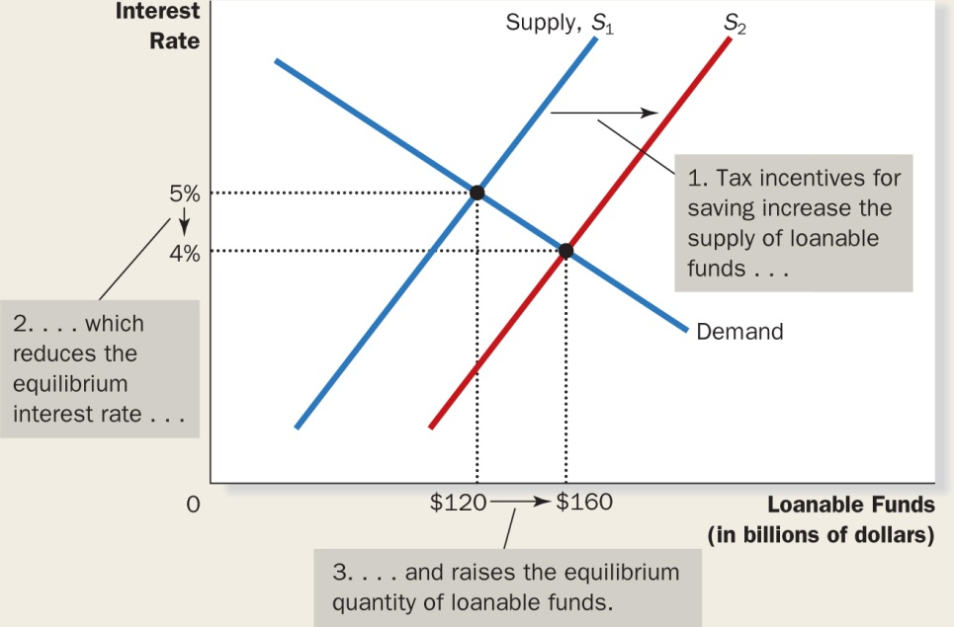

Policy 2: investment incentives
- An investment tax credit gives tax advantage to any firm building a new factory or buying a new piece of equipment.
- Increased demand for loanable funds

Increased demand for loanable funds:
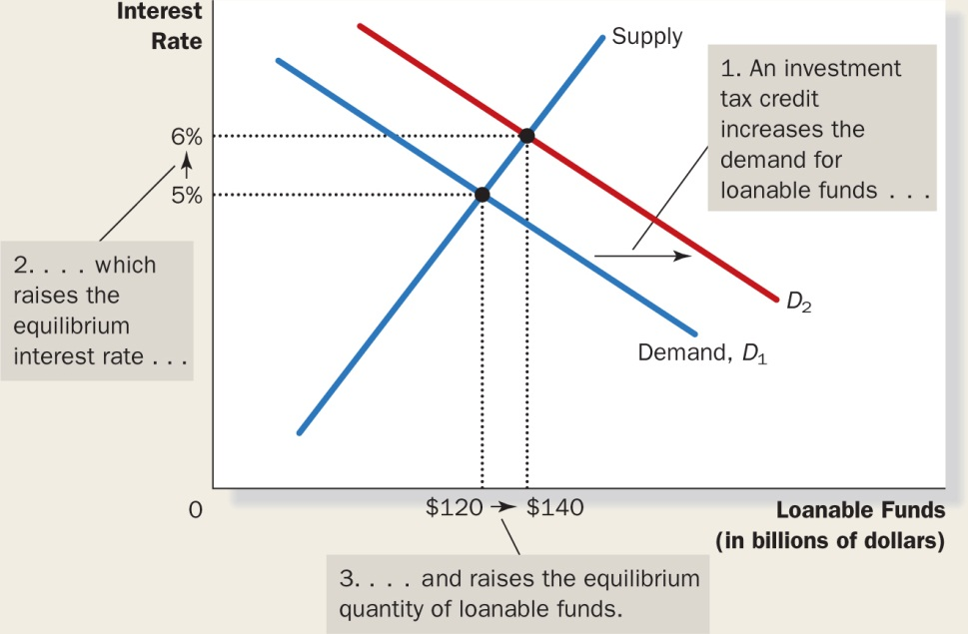

Policy 3: government budget surpluses and deficits

- Government debt: the sum of past budget deficits and surpluses

Effect of a government budget deficit:
(increases interest rate and decreases loanable funds available)
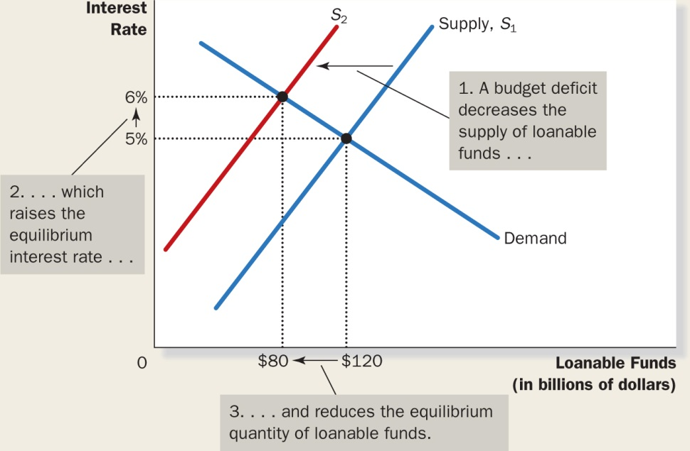

Crowding out: a decrease in investment that results from government borrowing.

INTRO TO MARCOECONOMICS FINAL EXAM REVUE

CHAPTER 9: UNEMPLOYMENT

Problem of unemployment divided into 2 categories:
- Long run
- Short run

Natural rate of unemployment:
- Amount of unemployment the economy normally experiences

Cyclical unemployment:
- Year to year fluctuations in unemployment around the natural rate.

Measuring unemployment:
- Labour Force = # of employed + # of unemployed
- $Unemployment rate= \frac{\# of unemployed}{Labour Force} X 100$
- $Labour force participation rate= \frac{Labour Force}{Adult population} x 100$

Problems with measuring unemployment:
- Some people work hard to find a job.
- Some people are saying they are unemployed to get insurance
- Some people work under the table

Discouraged searchers: individuals who want a job but have given up looking

Long run unemployment:
- Natural unemployment: rate of unemployment to which the economy tends to return to in the long run
- Cyclical unemployment: deviation of unemployment from it’s natural rate
- Frictional unemployment: unemployment that results because it takes time for workers to search for jobs that best suit their skills
- Structural unemployment: unemployment that results because the number of jobs available in some labour markets is insufficient to provide a job for everyone who wants one
  - This occurs when wages are set above equilibrium by laws and unions

Frictional unemployment is inevitable sometimes because the economy is always changing. Jobs created in one industry destroy jobs in another constantly.

Public policy and job search:
- gvt programs try to facilitate job search
  - unemployment agencies
  - public training programs
Employment insurance: government program that partially protects workers incomes when they become unemployed.

Minimum wage laws:
- Examin how structural unemployment results when the number of jobs is insufficient for the # of workers.
- Higher minimum wage leads to unemployment.

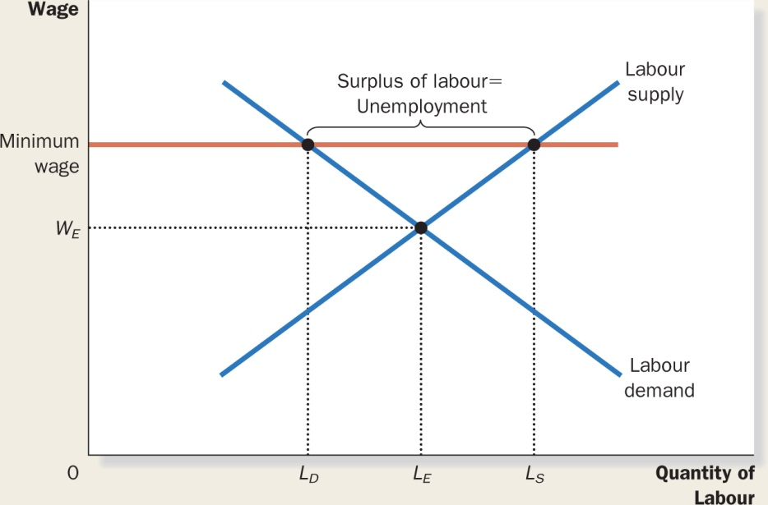

Unions: a worker association that bargains with employers over wages and working conditions.

Economics of unions:
- Collective bargaining: the process by which unions and firms agree on the terms of employment
- Strike: organized withdrawal of labour from a firm by a union
  - Unions cause issues:
    - Raise min wage = raise unemployment
    - Cause conflict between insiders and outsiders

Efficiency wages: above equilibrium wages paid by firms in order to increase worker productivity (eventually leads to unemployment)
- Worker health
- Worker turnover
- Worker effort
- Worker quality

INTRO TO MARCOECONOMICS FINAL EXAM REVUE

CHAPTER 10: THE MONETARY SYSTEM

Money: set of assets in the economy that people regularly use to buy goods and services from other people.

Functions of money:
- Medium of exchange: an item that buyers give to sellers when they want to purchase goods and services.
- Unit of account: the yardstick people use to post prices and record debts
- Store of value: an item that people can use to transfer purchasing power from the present to the future.
- Wealth: total of all stored of value, including both monetary and non monetary assets
- Liquidity: describes the ease with which an asset can be converted into a medium of exchange
  - Money is the most liquid of assets

Kinds of money:
- Commodity money: money that takes the form of a commodity with intrinsic value.
- Flat money: money without intrinsic value that is accepted as money because of a government decree.
- Non personal demand: companies and banks that hold deposits
- Notice deposits: deposits made in bank that the users must notice the bank of before taking them out (high interest rate accounts)

Money in the Canadian economy:
- Money stock: money circulating in the economy
- Currency: paper bills and coins in the hands of the public

2 measures of money stock in the economy:
- Chequable deposits and currency
- Non personal demand, notice deposits and everything in 1

Central bank:
- Institution designed to regulate the Q of money in the economy
- Bank of Canada is a central bank
  - BOC is managed by the governor and senior deputy governor of finance, plus 12 directors

4 main functions of the Bank of Canada:
- Issue currency
- Banker to commercial banks (last resort for commercial banks)
- Banker to the Canadian government
- Controls the money supply

Money supply: quantity of money available in the economy

Monetary policy: setting of the money supply by policy makers in the central bank.

100 percent reserve banking:

Assumptions:
- Economy has no banks
- Currency is only a form of money
- Initial supply of money is 100$

Reserves: deposits that banks have received and have not loaned out.

Assets | Liabilities
Reserves 100$ | Deposits 100$

Money creation through fractional reserve banking

Fractional reserve banking: banking system in which banks hold only a fraction of the deposits as reserves and loan out the rest.

Reserve ratio: fraction of deposits that banks hold as reserves

Ex: 10% reserve ratio

Assets | Liabilities
Reserves 10$  Loans 90$ | Deposits 100$

Money Supply = Currency + Deposits
Money Supply = 90$ + 100$
Money Supply = 190$

Assets | Liabilities
Reserves 9$  Loans 81$ | Deposits 90$

Money supply = 190 + 81 = 271$
Money multiplier: amount of money the banking system generates with each dollar it receives

- Reciprocal of the reserve ratio = $\frac{1}{R}$

Bank capital: resources the bank owners put into an institution from issuing equity (stock)

Leverage: the use of borrowed money to supplement existing funds for purposes of investment.

Leverage ratio: ratio of assets to bank capitol

Capital requirement: government regulation specifying a minimum amount of bank capital.

BOC’s tools of monetary control:
- Open market operations
- Changes in reserve requirements
- Changes in the overnight rate (uses this to control money supply)

Bank rate: interest rate charged by BOC on loans to the commercial banks

Overnight rate: interest rate on every short term loans between commercial banks

- The BOC alters the money supply by changing the bank rate, which causes the overnight rate to change equally.
- The overnight rate discourages banks from borrowing reserves from BOC, thus, reducing the reserves in the banking system.
- Changes in the overnight rate are posted 8 times per year.

Open market operations:
- Purchases or sales of government of Canada bonds by the BOC
  - To increase money supply, BOC buys bonds from the public
  - To decrease money supply, BOC sells bonds to the public

Quantitative easing:
- Purchase and sale by the central bank of non-government securities or government securities with long maturity terms.
  - Used when money supply is too small.

Foreign exchange market operations:
- Purchase or sale of foreign money by the BOC
  - BOC buys 100 M US$ for 150M$ CAD. Canadian money supply goes up by 150$.
Sterilization:
- Process of offsetting foreign exchange market operations with open market operations so that the effect on the money supply is cancelled out.

Reserve requirements:
- Minimum amount of reserve that banks must hold against deposits.
  - Higher reserve requirements = more reserves
  - More reserves = higher reserve ratio
  - Higher reserve ratio = lower money multiplier
  - Lower money multiplier = lower money supply

Problems in controlling money supply:
- BOC does not control the amount of money households choose to hold as deposits in banks.
- BOC does not control the amount of money that banks choose to lend.

INTRO TO MARCOECONOMICS FINAL EXAM REVUE

CHAPTER 11: MONEY GROWTH AND INFLATION

Inflation: increase in overall level of prices

Deflation: fall in the overall level of prices

The economy’s overall price level can be viewed in 2 ways:
- Price of a basket of goods and services
- Measure of the value of money

The value of money is determined by the supply and demand for money.

The demand for money reflects how much people will want to hold in liquid form.
- Liquidity preference

Factors that influence the demand for money = level of prices
- In the long run, the overall level of prices adjusts to the level at which demand for money = supply of money

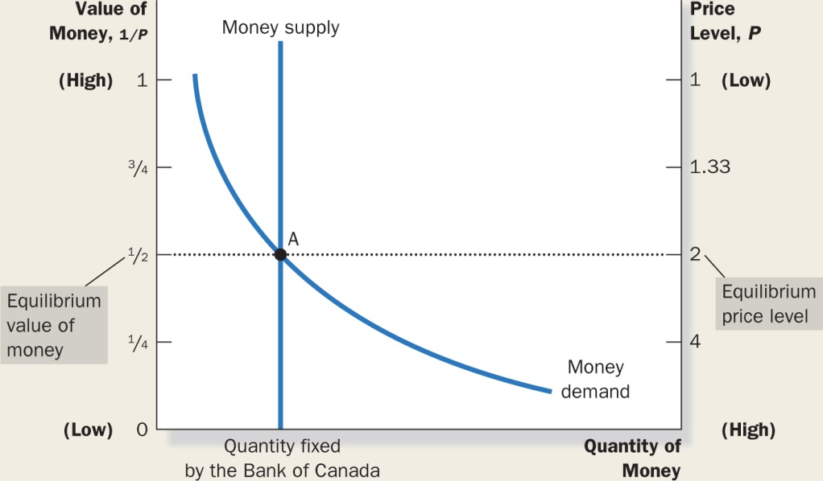

Effects of a monetary injection (BOC drops cash from a plane)

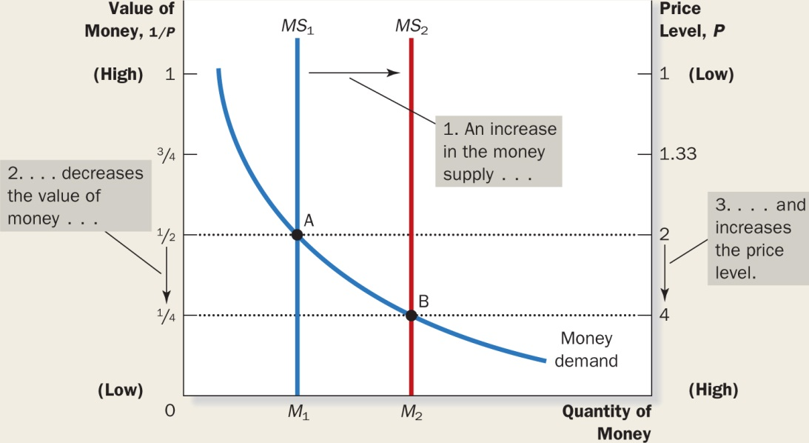

- Increase in the money supply
- Decreases the value of money
- The price level goes up

Explanation of how price level is determined:
Quantity theory of money:
- The quantity of money available determines the price level and that the growth rate in the quantity of money available determines the inflation rate.

Steps from old equilibrium to new equilibrium:
- Initial equilibrium
- Injection of money
- Excess supply of money at prevailing price level
- Demand for goods and services increases because people have more money to spend
- Upward pressure on prices because more things are in demand
- Demand for money increases
- New equilibrium is reached

- Economic variables are divided into 2 groups:
  - Nominal variables: measured in monetary units
  - Real variables: measures in physical units

Classical dichotomy: theoretical separation of nominal and real variables

Monetary neutrality: proposition that changes in the money supply that does not affect real variables.

Velocity of money: the rate at which money changes hands

- $V=\frac{\left(P×Y\right)}{M}$

V(velocity) … P(price level) … Y(real GDP) … M(q of money)

Quantity equation: equation that relates the quantity of money, velocity and dollar value of the economy’s output of goods and services.

- $M×V=P×Y$

Elements for explaining the equilibrium price level:
- V is stable over time
- Because V is stable, when the central bank changes the Q of money (M), it causes a proportionate change in the nominal value of output (P x Y)
- The economy’s output of goods and services (Y) is primarily determined by factor supplies and technology. Because money is neutral, money does not affect output.
- With output (Y) determined by supplies and technology… when the central banks alter money supply (M), and induces some change in nominal value of output (P x Y), these changes are reflected in the price level.
- Therefore, when the central bank increases the money supply, the result is a high rate of inflation.

Inflation tax: the revenue the government raises by creating money.

The fisher effect: the one for one adjustment of the nominal interest rate to the inflation.
- Real rate = Nominal rate – Inflation
- Nominal rate = Real rate + Inflation

Costs of inflation:
- Inflation does not reduce people’s purchasing power.
- If nominal incomes keep pace with the rising prices, inflation is not a problem.
- However, there are costs associated with inflation.

Shoeleather costs: the resources wasted when inflation encourages people to reduce their money holdings.

Menu costs: cost of changing prices.
Unexpected inflation:
- Unexpected inflation redistributes wealth among the population in a way that has nothing to do with merit or need.
- These occur because many loans in the economy are specified in terms of the unit of account: money.

Deflation: some costs of deflation mirror those of inflation
- Menu costs
- Relative price variability
- Redistribution of wealth towards creditors
- Sign of broader macroeconomic difficulties

INTRO TO MARCOECONOMICS FINAL EXAM REVUE

CHAPTER 12: OPEN ECONOMY MACROECONOMICS (BASIC CONCEPTS)

Closed economy: an economy that does not interact with other economies around the world.

Open economy: an economy that interacts freely with other economies around the world.

International flows of goods and capital:
- Exports: goods and services produced domestically and sold abroad
- Imports: goods and services produced abroad and sold domestically
- Net exports: exports minus imports
- Trade surplus: excess of exports over imports
- Trade deficit: excess imports over exports
- Balanced trade: imports = exports

The flow of financial resources:
- Net Capital Outflow (NCO): the purchase of foreign assets by domestic buyers minus the purchase of domestic assets by foreigners

Variables that influence NCO:
- Real interest rates being paid on foreign assets and domestic assets
- Perceived economic and political risks of holding assets abroad.
- Government policies that affect foreign ownership of domestic assets

Net exports and NCO:
- NX = NCO
- When NX is bigger than NCO… the country is selling more goods and services to foreigners than the foreign entity is buying from them… Capital is flowing out of the country
- Vice versa for when NCO is bigger than NX… capital is flowing into the country

Saving, Investment and International capital flows:

$$Y=C+I+G+NX$$
$$Y-C-G=I+NX$$
$$S=I+NX$$
$$S=I+NCO$$

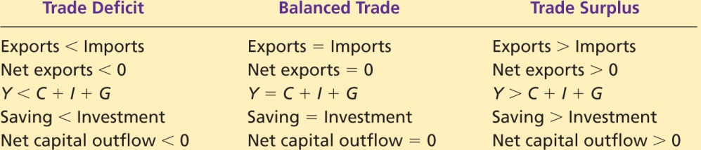

Prices for international transactions:
- Nominal exchange rate: rate at which a person can trade the currency of one country for the currency of another.
- Appreciation: increase in the value of a currency as measured by the quantity of foreign currency it can buy
- Depreciation: decrease in the value of a currency as measures by the quantity of foreign currency it can buy
- Real exchange rate: rate at which a person can trade the goods and services of one country for the ones of another

$$Real X Rate= \frac{Nominal rate x Domestic price}{Foreign price}$$

$$Real X Rate= \frac{e x P}{P*}$$

Purchasing Power Parity (PPP): a theory ox exchange rates whereby a unit of any given currency should be able to buy the same quantity goods in all countries.

PPP is based on LOP

LOP – Law of one price: a good must sell for the same price in all locations

- According to PPP, a currency must have the same purchasing power in all countries

Implications of PPP:
- The nominal exchange rate depends on the price levels in the 2 implicated countries

$$\frac{1}{P}=\frac{e}{P*}$$

$$1= {eP}/{P*}………………e=\frac{P}{P*}$$

Formula for countries with the same PPP.
Interest determination in a small open economy with perfect capital mobility:
- Interest rates in Canada and USA move up and down together at the same time.

Small open economy: An economy that trades with other economies, and, by itself, has negligible effect one the world prices and interest rates.

Perfect capital mobility: full access to the world’s financial markets
- The real interest rate should equal the world interest rate
- R = Rw

Interest rate parity:
- Theory of interest rate determination whereby the real interest rate on comparable financial assets should be the same in all economies with full access to the worlds financial markets.

Limitations to interest rate parity:
- The real rate in Canada is not always equal to the real interest rate in the rest of the world.
- Financial assets carry with them the possibility of default.
- Financial assets offered for sale in different countries are not necessarily perfect substitutes for one another.

INTRO TO MARCOECONOMICS FINAL EXAM REVUE

CHAPTER 13: MACROECONOMIC THEORY OF A SMALL OPEN ECONOMY

Assumptions for a small open economy:
- Level of GDP is a given
- Price level is fixed
- Real interest rate = World interest rate

Supply and demand: (focus on 2 markets):
- Market for loanable funds
- Market for foreign currency exchange

Important Identity:

$$S=I+NCO$$

Market for loanable funds:

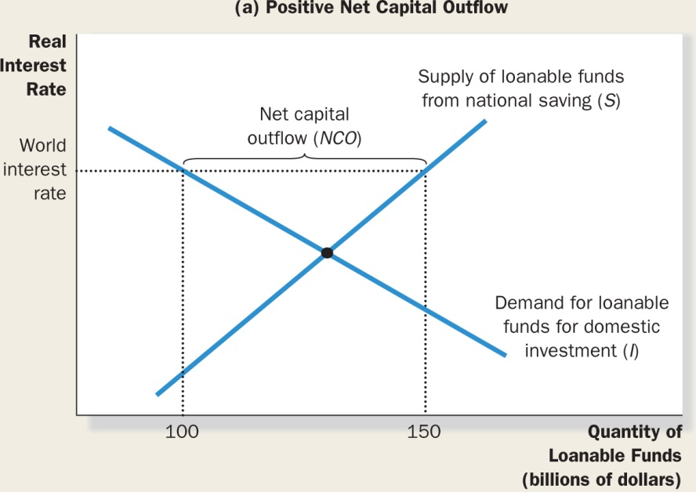

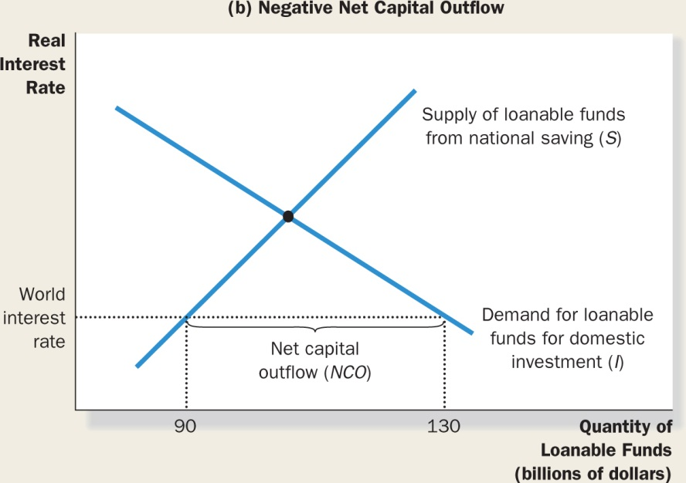

Demand: demand of loanable funds
Supply: supply of loanable funds

The quantity of loanable funds made available by the savings of Canadians does not have to equal the quantity of loanable funds demanded for domestic investment.

The difference between those 2 amounts equals NCO.

Market for foreign exchange currency:
- This market exists because people want to trade goods, services and financial assets with people from other countries, but they want to be paid for these things in their own currency.
- Remember that S = I + NCO and that NCO = NX
- We can show both sides of this identity as representing the 2 sides of the market for currency exchange.
- The difference between national saving and domestic investment represents the quantity of money supplied in the market for foreign currency exchange for the purpose of buying foreign assets.
- The real exchange rate balances supply and demand for foreign currency exchange.
- At equilibrium real x rate, the demand for money to buy net exports = the supply of money to be exchanged into foreign currency to buy assets abroad.

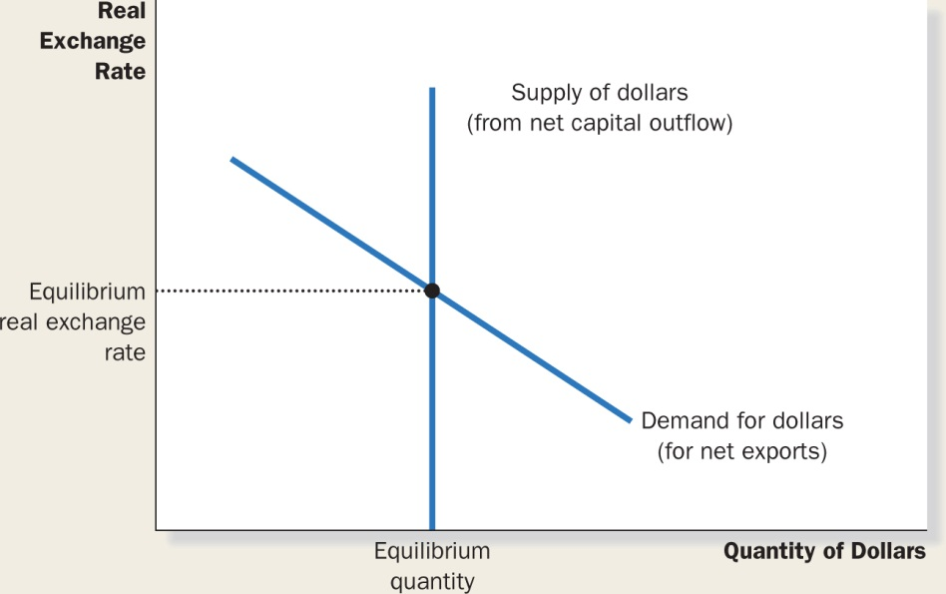

In this model:
- NCO is the source of supply of money
- NX is the source of demand for money

How these markets are related:
Important variables;
- NATIONAL SAVING (S)
- DOMESTIC INVESTMENT (I)
- NET CAPITAL OUTFLOW (NCO)
- NET EXPORTS (NX)
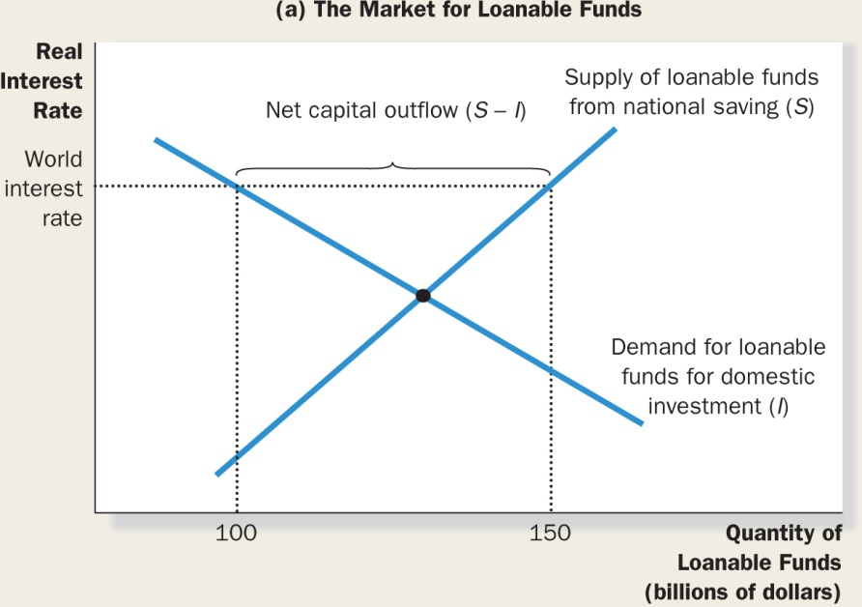

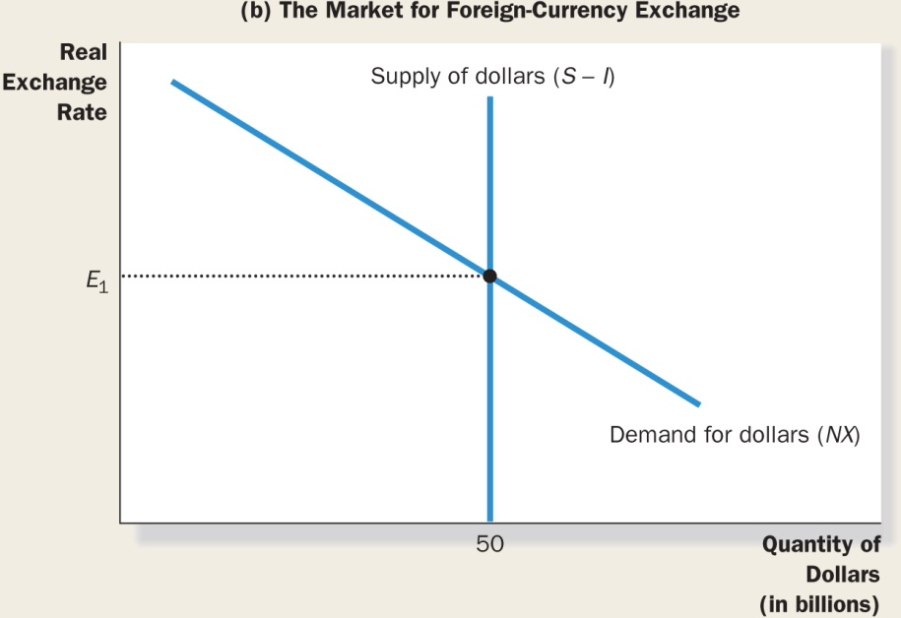

- NCO IN THE MARKET FOR LOANABLE FUNDS = SUPPLY OF DOLLARS FOR FOREIGN EXCHANGE IN THE CURRENCY EXCHANGE MARKET.
- THIS ALSO EQUALS THE DEMAND.
- THE SUPPLY OF DOLLARS (NCO) THEN DETERMINS THE EXCHANGE RATE

INTRO TO MARCOECONOMICS FINAL EXAM REVUE

CHAPTER 14: AGGREGATE SUPPLY AND DEMAND

Recession: period of falling incomes and rising unemployment

Depression: a severe recession

- The model of aggregate supply and demand is used to analyze short run fluctuations in the economy.

Economic fluctuations:
- Fluctuations are irregular and unpredictable
- Most macro quantities fluctuate together
- As output falls, unemployment rises

Assumptions of classical economies:
- Classical view = money is a veil
- The important part is the real variables and the economic forces that determine them

New model: focus on how real variables and nominal variables interact

Model of aggregate supply and demand:
- Model used to explain short run fluctuations in economic activity around its long-run trend.

Aggregate demand curve:
- Curve that shows the quantity of goods and services that households, firms, and the government want to buy at each price level.

Aggregate supply curve:
- Curve that shows the quantity of goods and services that firms choose to produce and sell at each price level.

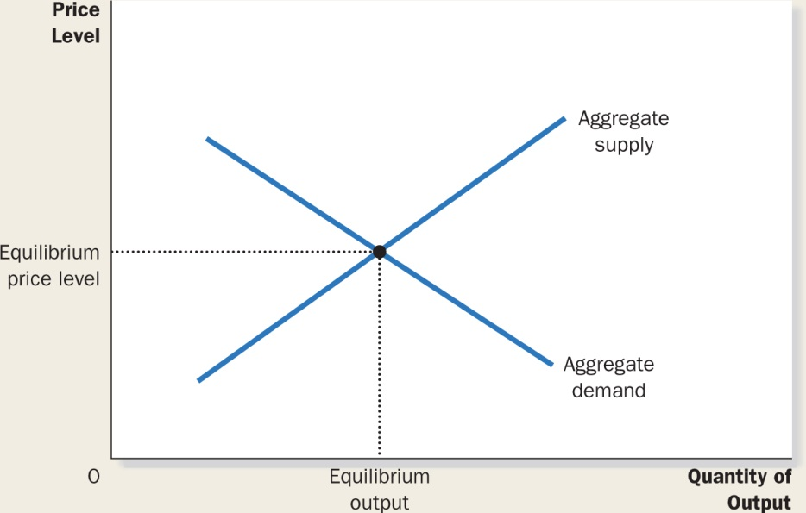

- When the price falls, the quantity demanded rises.

Why the aggregate demand curve is sloped downward:
- Y = C+I+G+NX
- Price level and consumption: wealth effect
- Price level and investment: interest rate effect
- Price level and net exports: Real x rate effect

Why the aggregate demand shifts?
- Changes in consumption
- Changes in investment
- Changes in government purchases
- Changes in net exports

** Fluctuation of GDP variables**

Aggregate supply curve:
- Long run aggregate supply is vertical.
- In the long run, an economy’s production depends on:
  - Supply of labour
  - Supply of capitol
  - Supply of technology
  - Supply of natural ressources
- A change in the price level does not affect the quantity of goods and services supplied in the long run.

Long run Aggregate supply shifts:
- Natural rate of output: production of goods and services that an economy achieves in the long run when unemployment is at it’s normal rate.
  - Potential output
  - Full-employment output

Reasons for Aggregate supply shifts:
- Changes in labour
- Changes in capitol
- Changes in natural resources
- Changes in technological knowledge

Long run growth and inflation:

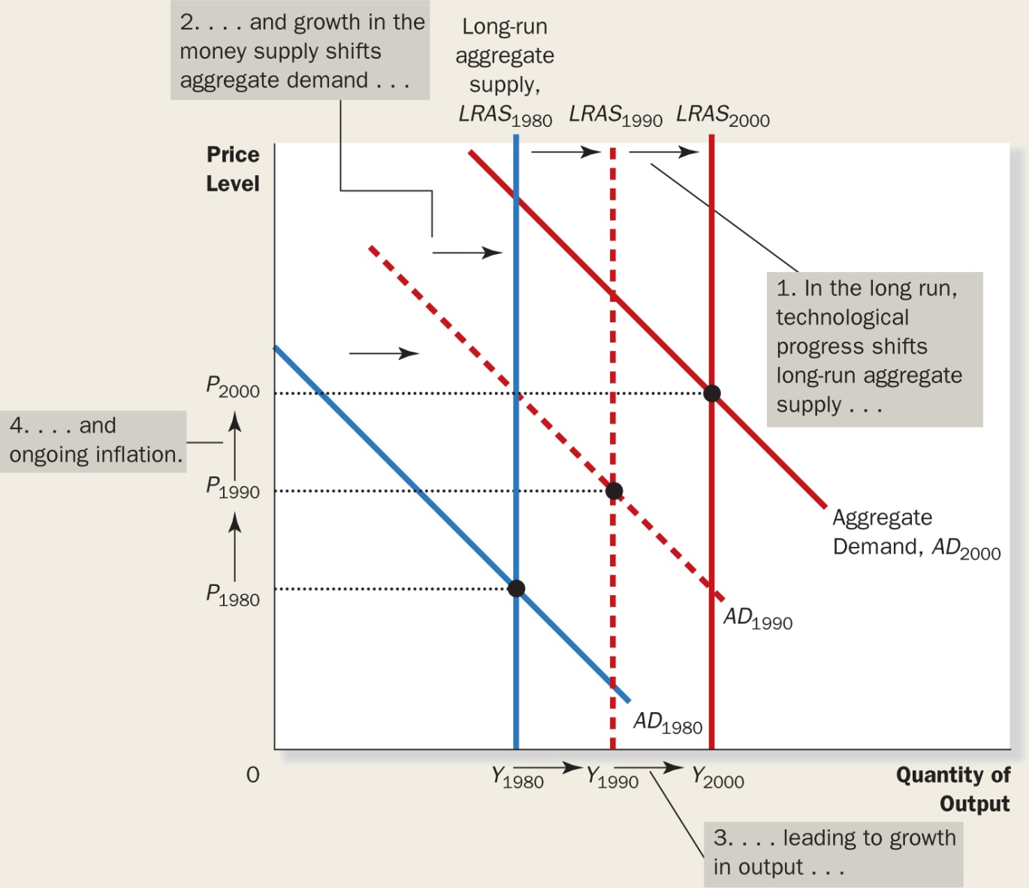

Short Run Aggregate Supply:
- Prices have an effect on output.
- Increase in prices = Increase in quantity supplied

Why is it sloped upward in the short run?
- Sticky wage theory
- Sticky price theory
- Misperception theory

All 3 of these suggest that output deviates from its natural rate when the price level deviated from the expected one by people.

‘’a’’ determines how much output responds to unexpected differences in the price level.

Quantity of output supplied = Natural rate of output

Combining long run and short run aggregate supply with demand:
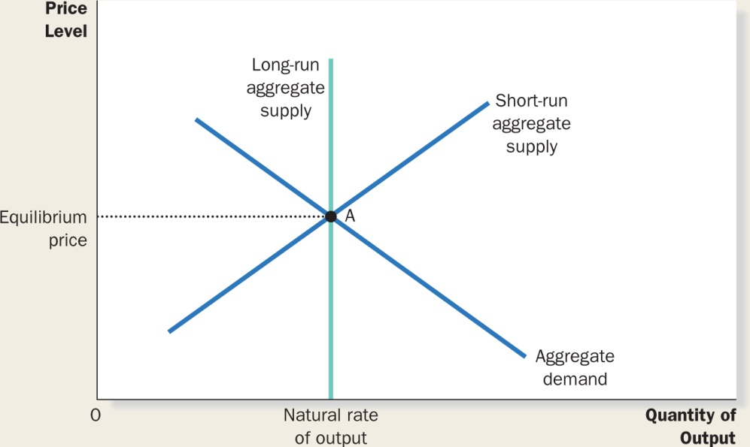

Shifts in aggregate supply and demand:

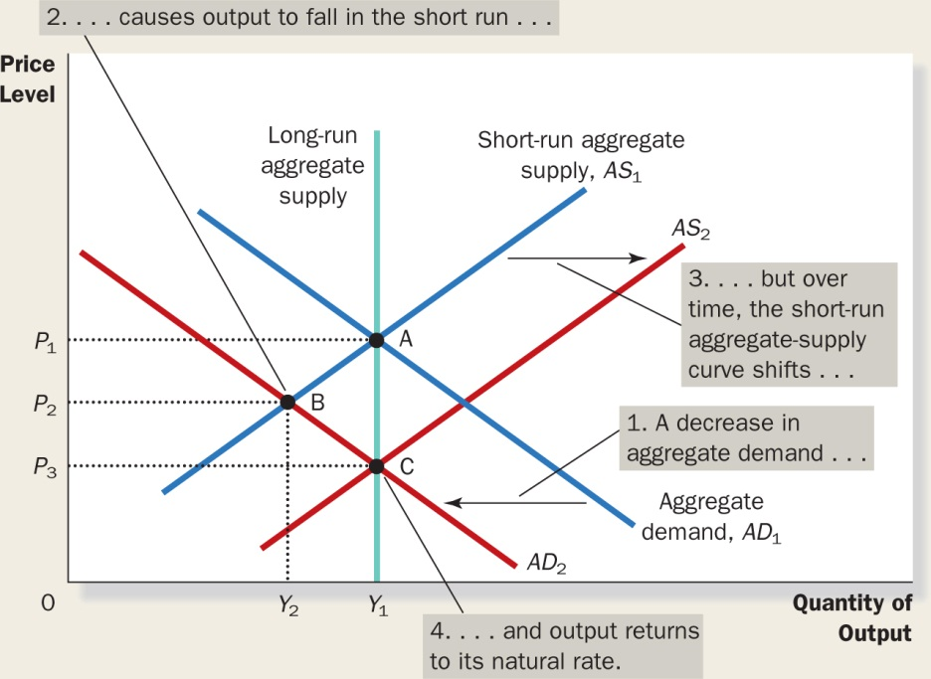

- Decrease in demand
- Fall in output in the long run
- Over time, short run supply shifts
- Output returns to natural rate

Important lessons:
- In the short run, shifts in Aggregate demand causes fluctuations in the economy’s output of goods and services (GDP)
- In the long run, shifts in Aggregate demand affect overall price level but does not affect level of output.
- Policy makers who influence Aggregate demand can potentially mitigate the severity of economic fluctuations.

Shifts in Aggregate supply:
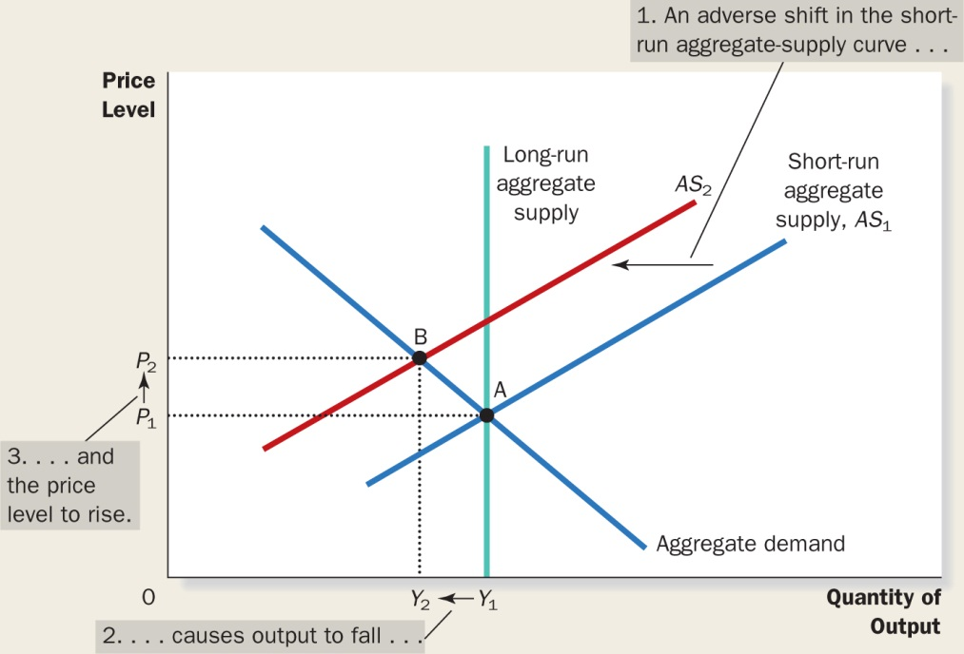

- Shifts in aggregate supply (decrease)
- Decrease in quantity of output in long run
- Price level rises

Important lessons:
- Shifts in aggregate supply can cause stagflation
  - Recession and inflation
- Policy makers who can influence aggregate demand can potentially mitigate the adverse impact on output but only at the cost of exacerbating the problem of inflation.

