Chapter 1 “Information Systems and Business Strategy”

Section 1.1 - Information Systems in Business:
- Everywhere in business.
- Impact on business operations:
  - Functions receiving greatest benefit from I.T: Customer service, finance, sales/marketing, IT operations, Operations mgmt., HR, and Security.
  - Project goals as a result of IT: Reduce costs/improve productivity, improve customer satisfaction/loyalty, create competitive advantage, growth, streamline supply chain, and global expansion.
  - Organizations typically operate by functional areas or functional silos that act independently of one another.
Information Systems Basics:
- Information Systems (IS): Any computer-based tool that people use to work with information and that supports the information and information-processing needs of an organization.
  - An information system can be an important enabler of business success and innovation.
- Management Information Systems (MIS): The function that plans for, develops, implements, and maintains IS hardware, software, and applications that people use to support the goals of an organization.
  - MIS is a business function, similar to accounting, finance, operations, and human resources.
- When beginning to learn about information systems it is important to understand the following: The difference between data, information, and knowledge, IS resources, and IS cultures.
Data – Information – Knowledge:
- Data: Raw facts that describe the characteristic of an event.
- Information: Data converted into a meaningful and useful context.
- Knowledge: Information that can be enacted upon i.e. “actionable information.”
IS Resources: People use information systems to work with information.
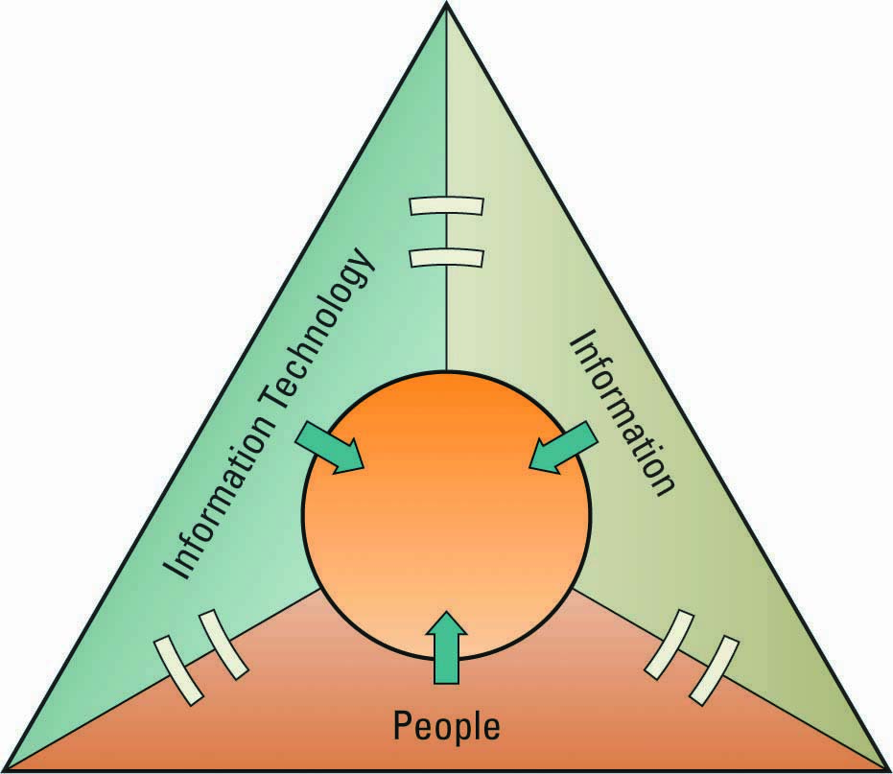
IS Cultures:
- Information-Functional Culture: Use information as a means of exercising influence or power over others.
- Information-Sharing Culture: Departments trust each other to use information (especially about problems and failures) to improve performance.
- Information-Inquiring Culture: Search for information to better understand the future and align themselves with current trends and new directions.
- Information-Discovery Culture: Open to new insights about crisis and radical changes and seek ways to create competitive advantage.
Roles and Responsibilities in IS:
- Chief Information Officer (CIO): Oversees all uses of IS and ensures the strategic alignment of IS with business goals and objectives.
- Broad CIO Roles:
- Manager: Ensuring the delivery of all IS projects, on time, and within budget.
- Leader: Ensuring the strategic vision of IS is in line with the strategic vision of the organization.
- Communicator: Building and maintaining strong executive relationships.
- Chief Technology Officer (CTO): Responsible for ensuring the throughput, speed, accuracy, availability, and reliability of IS.
- Chief Security Officer (CSO): Responsible for ensuring the security of information systems.
- Chief Privacy Officer (CPO): Responsible for ensuring the ethical and legal use of information.
- Chief Knowledge Office (CKO): Responsible for collecting, maintaining, and distributing the organization’s knowledge.
Skills Pivotal for Success in Executive IS Roles:
- Ability to communicate effectively.
- Strategic thinking and planning.
- Understanding business processes and operations.
- Negotiation/sales skills.
- Through knowledge of technology options.
- Technical proficiency.
The Gap between Business Personnel and IS Personnel:
- Business personnel possess expertise in functional areas such as marketing, accounting, and sales, while the IS personnel have the technological expertise.
  - This typically causes a communications gap between the business personnel and IS personnel.

Improving Communications:
- Both groups, business and IS, must seek to increase their understanding of one another.
- It is the responsibility of the CIO to ensure effective communication between business personnel and IS personnel.
Efficiency and Effectiveness Metrics:
- Efficiency IS Metric: Measures the performance of the information system itself including throughput, speed, and availability.
- Effectiveness IS Metric: Measures the impact IS has on business processes and activities including customer satisfaction, conversion rates, and sell-through increases.
- Benchmarking – Baselining Metrics:
  - Regardless of what is measured, how it is measured, and whether it is for the sake of efficiency or effectiveness, there must be benchmarks – baseline values the system seeks to attain.
  - Benchmarking: A process of continuously measuring system results, comparing those results to optimal system performance (benchmark values), and identifying steps and procedures to improve system performance.
Interrelationships of Efficiency and Effectiveness Metrics:
- Efficiency IS metrics focus on information systems and include: Throughput, transaction speed, system availability, web traffic, and response time.
- Effectiveness IS metrics focus on:
- Usability: The ease which people perform transactions and/or find information.
- Customer Satisfaction: Measured by such benchmarks as satisfaction surveys, percentage of existing customers retained, and increases in revenue.
- Conversion Rates: The number of customers an organization “toughes” for the first time and persuades to purchase its products or services.
- Financial: Such as return on investment, cost-benefit analysus, and break-even analysis.
- Security is an issue for any organization offering products/services over the internet.
- It is inefficient for an organization to implement internet security, since it slows down processing. However, to be effective, it must implement internet security.
  - Secure internet connections must offer encryption and Secure Sockets Layers (SSL denoted by the lock symbol in the lower right corner of a browser).
Section 1.2 – Business Strategy
Identifying Competitive Advantages:
- Competitive Advantage – a product or service that an organization’s customers place a greater value on than similar offerings from a competitor
- First-Mover Advantage – occurs when an organization can significantly impact its market share by being first to market with a competitive advantage
- Organizations watch their competition through Environmental Scanning:
  - The acquisition and analysis of events and trends in the environment external to an organization.
- Three common tools used in industries to analyze and develop competitive advantages include:
- Porter’s Five Forces Model
- Porter’s Three Generic Strategies
- Value Chains
Porter’s Five Forces Model:
- Determines the relative attractiveness of an industry.
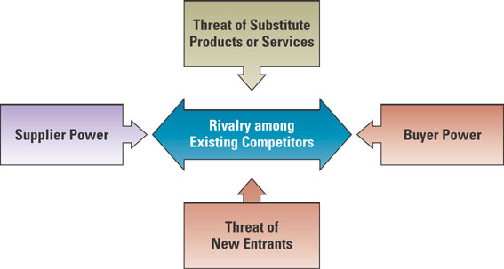
- Buyer Power: High when buyers have many choices of whom to buy from.
  - Loyalty Programs: Rewards customers based on the amount of business they do with a particular organization. Reduces buyer power.
- Supplier Power: High when buyers have few choices of whom to buy from.
  - Supply Chain: Consists of all parties involved in the procurement of a product.
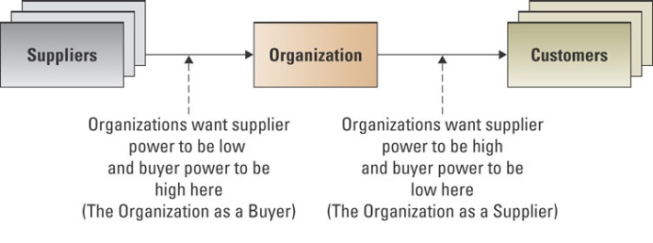
  - Organizations that buy goods and services in the supply chain can create a competitive advantage by locating alternative supply sources through B2B Marketplaces.
  - B2B Marketplace: An internet-based service that brings together many buyers and sellers.
- Private Exchange: A single buyer posts its needs and then opens bidding to any supplier who would care to bid.
- Reverse Auction: An auction format in which increasingly lower bids are solicited from organizations willing to supply the desired product/service at an increasingly lower price.
  - Value Creation: Once an organization chooses its strategy, it can use tools such as the value chain to determine the success or failure of its chosen strategy.
- Business Processes: A standardized set of activities that accomplish a specific task, such as processing a customer’s order.
- Value Chain: Views an organization as a series of processes, each of which adds value to the product or service for each customer.
- Threat of Substitutes: High when there are many alternatives to a product or service.
  - Switching Cost: Costs that can make customers reluctant to switch to another product.
- Threat of New Entrants: High when it is easy for new competitors to enter a market.
  - Entry Barrier: A product or service feature that customers have come to expect from organizations in a particular industry and must be offered by an entering organization to compete and survive.
- Rivalry Among Existing Competitors: High when competition is fierce in a market.
  - Although competition is always more intense in some industries than in others, the overall trend is toward increased competition in just about every industry.
Porter’s Three Generic Strategies:
- Broad Cost Leadership
- Broad Differentiation
- Focused Strategy

Chapter 2 “Decision Making and Business Processes”

Decision Making:
- Reasons for the growth of decisions-making information system:
- People need to analyze large amounts of information.
- People must make decisions quickly
- People must apply sophisticated analysis techniques, such as modeling and forecasting, to make good decisions.
- People must protect the corporate asset of organizational information.

Transactional Data and Analytical Information:
- Transactional Data: Encompasses all the raw facts contained within a single business process or unit of work and their primary purpose is to support the performing of daily operational tasks.
- Analytical Information: Encompasses all summarized or aggregated transactional data, and its primary purpose is to support the performing of analysis tasks.
- Moving up through the organizational pyramid, users move from requiring transactional information to analytical information.
  - Transactional Proceesses Analystical
  - Fine Granularity Coarse
  - Analysts Managers Executives
  - Online Transaction Processing Processing Online Analytical Processing
- Transactional Processing System (TPS): The basic business system that serves the operational level (analysts) in an organization.
- Online Transactional Processing (OLTP): The capturing of transaction and event information using technology to (1) process the information according to defined business rules, (2) store the information, (3) update existing information to reflect the new information.
- Online Analytical Processing (OLAP): The manipulation of information to create business intelligence in support of strategic decision-making.
  - Consolidation: Involves the aggregation of information and features simple roll-ups to complex groupings of interrelated information.
  - Drill-Down: Enables users to view details and information.
  - Slice-and-Dice: The ability to look at information from different perspectives.

TPS, DSS, and EIS:
- Transaction Processing System (TPS): The basic business system that serves the operational level (clerks and analyst) in an organization. Ex: Payroll system.
- Decision Support System (DSS): Models information to support managers and business professionals during the decision-making process.
- Sensitivity Analysis: The study of the impact that changes in one (or more) parts of the model have on other parts of the model.
- What-if Analysis: Checks the impact of a change in an assumption on the proposed solution.
- Goal-Seeking Analysis: Finds the inputs necessary to achieve a goal such as a desired level of output.
- Executive Information System (EIS): Specialized DSS that supports senior-level executives within the organization.
  - Digital Dashboard: Integrates information from multiple components and tailor the information to individual preferences.
- Market Pulse: Daily sales numbers, market shares, and subscriber turnover.
- Customer Service: Examples include problems resolved on the first call, call center wait times, and on-time repair calls.
- Cost Driver: Examples include number of repair trucks in the field, repair jobs completed per day, and call center productivity.

Artificial Intelligence (AI):
- The ultimate goal of AI is the ability to build a system that can mimic human intelligence.
- Four most common categories of AI include:
- Expert System: Computerized advisory programs that imitate the reasoning processes of experts in solving difficult problems.
- Neural Network: Attempts to emulate the way the human brain works.
  - Fuzzy Logic: A mathematical method of handling imprecise or subjective information.
- Genetic Algorithm: An artificial intelligent system that mimics the evolutionary, survival-of-the-fittest process to generate increasingly better solutions to problems.
- Intelligent Agent: Special-purposed knowledge-based information system that accomplished specific tasks on behalf of its users.
  - Shopping Bot: A software that will search several retailer web sites and provides a comparison of each retailer’s offerings, including price and availability.
- Multi-Agent Systems: Groups of intelligent agents have the ability to work independently and to interact with each other.
  - Biomimicry: Learning from ecosystems and adapting their characteristics to human and organizational situations.
    - Learn how people-based systems behave.
    - Predict how they will behave under a given set of circumstances.
    - Improve human systems to make them more efficient and effective.

Artificial Intelligence vs. TPS, DSS, and EIS:
- AI systems are intelligent systems designed to provide optimal answers to problems and determine the best decisions to make.
- TPS, DSS, and EIS systems are designed to support end-users in their decision-making, as opposed to making decisions for them.

Business Processes:
Understanding the Importance of Business Processes:
- Business Process: Standardized set of activities that accomplish a specific task, such as processing a customer’s order.
- Customer Facing Processes: Result in a product or service that is received by an organization’s external customer. Ex: Order processing, customer service, sales process, customer billing, and order shipping.
- Business Facing Processes: Invisible to the external customer but are essential to the effective management of the business. Ex: Strategic planning, tactical planning, budget forecasting, training, and purchasing raw materials.

Business Process Improvement: Attempts to understand and measure the current process and make performance improvements accordingly.
- Business processes should drive information system choices.

Business Process Reengineering: The analysis and redesign of workflow within and between enterprises. BPR relies on a different school of thought than business process improvements.
- BPR assumes the current process is irrelevant, does not work, or is broken and must be overhauled from scratch.
- Finding Opportunity Using BPR:
  - A company can improve the way it travels the road by moving from foot to horse and then horse to car.
  - BPR looks at taking a different path, such as an airplane which ignores the road completely.
- Process Change Spectrum:
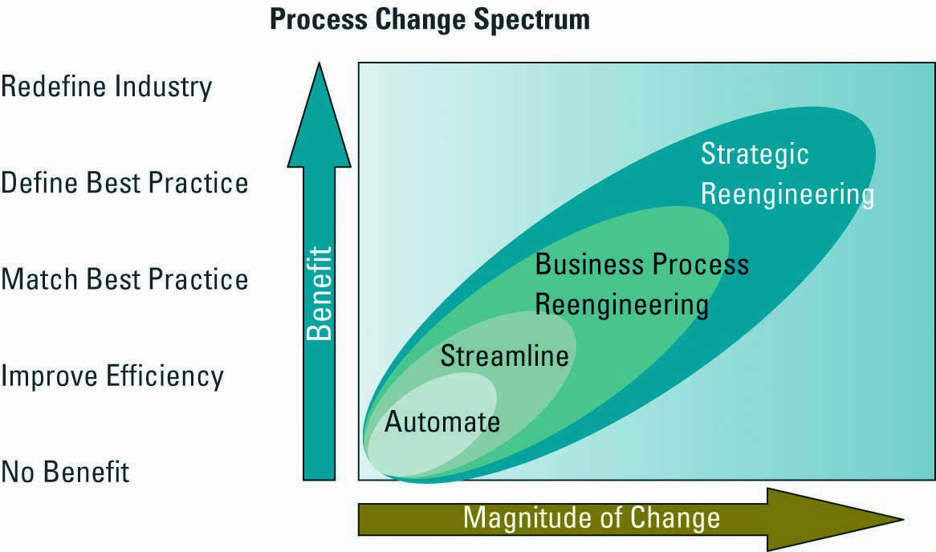
- BPR Pitfalls: One hazard of BPR is that the company becomes so wrapped up in fighting its own demons that it fails to keep up with its competitors in offering new products/services.

Business Process Modelling: The activities of creating a detailed flow-chart or process map of a work process showing its inputs, tasks, and activities, in a structured sequence.
- Business Process Model: A graphic description of a process, showing the sequence of process tasks, which is developed for a specific purpose and from a selected viewpoint.
Business proves Management: Integrates all of organizations business processes to make individual processes more efficient.
- Key Reasons for Using BPM:

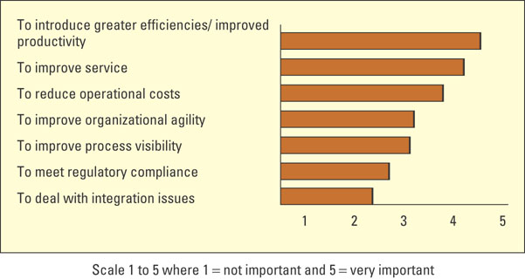
- Opportunities:
    - Bringing processes, people, and information together.
    - Breaking down barriers between business areas and finding owners for the processes.
    - Managing business processes within the enterprise and outside the enterprise with suppliers, business partners, and customers.
    - Looking at automation horizontally instead of vertically.

Chapter 3 “The Internet and E-Business”

Section 3.1 – Business and the Internet:
- E-Business: The conducting of business on the internet, not only buying and selling, but also serving customers and collaborating with business partners.

Disruptive Technology:
- Digital Darwinism: Implies that organizations which cannot adapt to the new demands placed on them for surviving in the information age are doomed to extinction.
- Disruptive vs. Sustaining Technology:
  - Disruptive Technology: A new way of doing things that initially does not meet the needs of existing customers.
  - Sustaining Technology: Produces an improved product customers are eager to buy.
  - Innovator’s Dilemma: Discusses how established companies can take advantage of disruptive technologies without hindering existing relationships with customers, partners, and stakeholders.
- The Internet – Business Disruption:
  - One of the biggest forces changing business is the internet.
  - Organizations must be able to transform as markets, economic environments, and technologies change.
  - Focusing on the unexpected allows an organization to capitalize on the opportunity for new business growth from a disruptive technology.

Evolution of the Internet:
- The internet began as an emergency military communications system operated by the U.S. Department of Defence.
- Gradually the internet moved from a military pipeline to a communication tool for scientists to business.
  - Internet: Computer networks that pass information from one to another using common computer protocols.
  - Protocol: Standards that specify the format of data as well as the rules to be followed during transmission.
- Many entities oversee the internet and set standards:
- Internet Engineering Task Force (IETF): The protocol engineering and development arm.
- Internet Architecture Board (IAB): Overall architecture and provides guidance to IETF.
- Internet Engineering Steering Group (IESG): Technical management of IETF activities.
- Evolution of the World Wide Web (WWW): A global hypertext system that uses the internet as its transport mechanism.
  - Hypertext Transport Protocol (HTTP): The internet standard that supports the exchange of information on the WWW.
  - Two Main Events:
- Tim Berners-Lee built the first web site on August 6, 1991 (http://info.cern.ch/)
- Marc Andreeson developed the NCSA Mosaic program (lead to more accessibility).
  - Digital Divide: Occurs when those with access to technology have great advantages over those without access to technology.
  - Reasons for Growth on the WWW:
- The microcomputer made it possible for an average person to own a computer.
- Advancements in networking hardware/software/media made it possible for business PCs to be inexpensively connected to larger networks.
- Browser software such as IE and Netscape gave PC users an easy to use graphical interface to find, download, and display web pages.
- The speed, convenience, and low cost of e-mail have made it crucial.
- Basic web pages are easy to create and extremely flexible.

Web 2.0: A set of economic, social, and technology trends that collectively form the basis for the next generation of the internet.
- Technological Drivers:
- Billions of people around the globe now have access to the internet.
- Mobil devices outnumber desktop computers three to one.
- Over 60% of all US internet access is now via always-on broadband connections.
- Laws of Social Networks:
- In the first quarter of 2006, MySpace signed up 280,000 new users each day.
- By the second quarter, 50 million blogs had been created – new ones added (2/second).
- In 2005, eBay conducted 8 billion API-based web service transactions.
- Mashups: A web site/application that uses content from more than one source to create a completely new service.
  - Application Programming Interface (API): Set of routines, protocols, and tools for building software application.

The Future – Web 3.0: Term that has been coined with different meanings to describe the evolution of web usage and interaction among several separate paths.
- (1) encompasses the web into a database; (2) an evolutionary path into AI; (3) the realization of semantic web and service-orientated architecture; (4) evolution toward 3D.
- Semantic Web: An evolving extension of the WWW in which web content can be expressed not only in natural language, but also in a format that can be read and used by software agents.
- Service-Orientated Architecture: Business-driven IS architectural approach that supports integrating a business as linked, repeatable tasks or services.

Accessing Internet Information:
- Intranet: Internalized portion of the internet, protected from outside access, for employees.
- Extranet: An intranet that is available to strategic allies.
- Portal: Web site that offers a broad array of resources and services.
- Kiosk: Publicly accessible computer system that allows interactive information browsing.

Providing Internet Information:
- Internet Service Provider (ISP): Provides individuals and other companies access to the internet.
  - Wireless ISP (WISP): Allow subscribers access to a server over hotspots or access points.
- Online Service Provider (OSP): Offers an extensive array of unique web services.
- Application Service Provider (ASP): Offers access over the internet to systems and related services that would otherwise have to be located in organizational computers.
  - Service Level Agreement (SLA): Define the specific responsibilities of the service provider and set the customer expectations.

Section 3.2 – E-Business:
- E-Commerce: The buying and selling of goods and services over the internet.

E-Business Models: An approach to conducting electronic business on the internet.
- Business to Business (B2B): Applies to businesses buying from and selling to each other over the internet.
  - Electronic Marketplace: Interactive business communities providing a central market where multiple buyers and sellers can engage in e-business activities.
- Business to Consumer (B2C): Any business that sells its products or services to consumers over the internet.
  - E-Shop: A version of a retail store where customers can shop any time without leaving their home.
  - E-Mall: Consists of a number of e-shops; it serves as a gateway through which a visitor can access other e-shops.
- Brick-and-Mortar: A business that operates in a physical store without an internet presence.
- Pure-Play: A business that operates on the internet only.
- Click-and-Mortar: A business that operates in a physical store and online.
- Consumer to Business (C2B): Any customer that sells a product or service to a business over the internet.
- Consumer to Consumer (C2C): Applies to sites primarily offering goods and services to assist consumers interacting with each other over the internet.
  - Auctions:
- Electronic Auctions: Sellers and buyers solicit consecutive bids from each other and prices are determined dynamically.
- Forward Auction: An auction that sellers use as a selling channel to many buyers and the highest bidder wins.
- Reverse Auction: An auction that buyers use to purchase a product or service, selecting the seller with the lowest bid.
  - Communities:
- Interest: People interact with each other on specific topics.
- Relations: People come together and share certain life experiences.
- Fantasy: People participate in imaginary environments.
Organizational Strategies for E-Business:
- Marketing/Sales:
- Online Ad: Box running across web page that contains advertisements.
- Pop-Up Ad: A small web page containing an advertisement.
- Associate Program: Businesses generate commissions or royalties.
- Viral Marketing: Technique that induces web sites or users to pass on a marketing message.
- Mass Customization: Gives customers the opportunity to tailor products or services.
- Personalization: A web site can fashion offers that are more likely to appeal to that person.
- Blog: Web site in which items are posted on a regular basis.
- Real Simple Syndication (RSS): A web feed format used for web syndication of content.
- Podcasting: The distribution of audio or video files over the internet to play on mobile tech.
  - Search Engine Optimization (SEO): A set of methods aimed at improving the ranking of a web site in search engine listings.
    - Spamdexing: Uses a variety of deceptive techniques in an attempt to manipulate search engine rankings.
- Financial Services:
  - Types of Online Consumer Payments:
- Financial Cybermediary: Internet based company that facilitates payments over the internet. Ex: PayPal.
- Electronic Cheque: Mechanism for sending a payment from a chequing or savings account. Ex: Online Banking
- Electronic Bill Presentment and Payment: A system that sends bills over the internet and provides an easy-to-use mechanism to pay the bill.
- Digital Wallet: Both software and information. The software provides security for the transaction and the information includes payment and delivery information.
  - Online Business Payments:
- Electronic Data Interchange: Standard format for exchanging business data.
    - Value Added Network (VAN): Private network, provided by third-party, for exchanging information through a high-capacity connection.
- Financial EDI: A standard electronic process for B2B market purchase payments.
- Procurement:
  - Maintenance, repair, and Operations (MRO) Materials: Materials necessary for running an organization but do not relate to the company’s primary business activities.
    - E-Procurement: The B2B purchase and sale of supplies and services over the internet.
    - Electronic Catalogue: Presents customers with information about goods and services offered for sale, bid, or auction on the internet.
- Customer Service:
  - Customer service is the business process where the most human contact occurs between buyer and seller.
  - E-Business strategists are finding customer service via the web is one of them most challenging and potentially lucrative areas of e-business.
  - The primary issue facing customer service departments using e-business is consumer protection.
- Consumer Protection:
  - Issues:
- Unsolicited goods and communication
- Illegal or harmful goods, services, and content.
- Insufficient information about goods or their suppliers.
- Invasion of privacy.
- Cyber fraud.
  - E-Business Security:
- Encryption: Scrambles information into an alternative form that requires a key or password to decrypt the information.
- Secure Socket Layer (SSL): (1) creates a secure and private connection between a client and server computer; (2) encrypts the information; (3) sends the information over the internet.
- Secure Electronic Transaction: Transmission security method that ensures transactions are secure and legitimate.
- Intermediaries: Agents, software, or businesses that bring buyers and sellers together that provide trading infrastructure to enhance e-business.
  - Re-intermediation: Using the internet to reassemble buyers, sellers, and other partners in a traditional supply chain in new ways.

Measuring E-Business Success:
- Most companies measure the traffic on a web site as the primary determinant of the web sites’ success. However, a large amount of web site traffic does not equate to large sales.
  - Many organizations with high web site traffic have low sales volumes.
- Web Site Metrics:
  - Interactivity: Measures the visitor interaction with the target ad.
  - Cookie: A small file deposited on a hard drive by a web site containing information about customers and their web activities. (No consent from customers).
  - Click-Through: A count of the number of people who visit one site and click on an advertisement that takes them to the site of the advertiser.
  - Click-Stream Data: Tracks the exact pattern of a consumer’s navigation through a web site. Reveals: # of page views, pattern of visited sites, duration, date/time, and # of customers with/without shopping carts.
  - Types of Metrics: Visitor (I.D), Exposure (Reach), Visit (Time), and Hits (Requests).
E-Business Benefits and Challenges:
- Benefits: Accessibility, customer loyalty, improved information content, convenience, global reach, and decreased cost.
- Challenges: Protecting customers, leveraging existing systems, increasing liability, providing security, and adhering to taxation rules.
- E-Business Revenue Models:
- Transaction Fees
- Licensing Fees
- Subscription Fees
- Fees for Value-Added Services
- Advertising Fees.

New Trends:
- M-Commerce: The ability to purchase goods and services through a wireless internet enabled device.
- E-Government: Involves the use of strategies and technologies to transform governments by improving the delivery of services and enhancing the quality of interaction between the citizen-consumer within all branches of government.

Chapter 4 “Enterprise Computing Trends and Enterprise Resource Planning”

Section 4.2 – Enterprise Resource Planning:
- Integrates all departments and functions throughout an organization into a single IT System so that employees can make enterprise wide decisions by viewing enterprise-wide information on all business operations.
- Reasons ERP Systems are Powerful Organizational Tools:
- ERP is a logical solution to the mess of incompatible applications that had sprung up in most businesses.
- ERP addresses the need for global information sharing and reporting.
- ERP is used to avoid the pain and expense of fixing legacy systems.

Enterprise Resource Planning:
- The Heart of ERP: At the heart of ERP systems is a database; when a user enters or updates information in one module, it is immediately and automatically updated throughout the entire system.
  - Central database that collects data from and feeds data into all the ERP system’s individual application components (called modules), supporting diverse business functions such as accounting, manufacturing, marketing, and HR.
  - ERP enables employees across the organization to share data across a single, centralized database.
- The Evolution of ERP:
- ERP: Originally, ERP solutions were developed to deliver automation across multiple units of an organization, to help facilitate the manufacturing process and address issues such as raw materials, inventory, order entry, and distribution.
  - However, ERP was unable to extend to other functional areas of the company, such as sales, marketing, and shipping.
  - It could not tie in any customer relation management, nor did it work with web applications or portals used for customer service.
- Extended ERP: From its beginning as a tool for materials planning, it has extended to warehousing, distribution, and order entry.
  - With its next evolution, ERP expands to the front office, including customer relationship management. Now all functional departments can share a tool that is truly enterprise-wide.
- ERP II – Core and Extended:
  - Core ERP Components: Traditional components included in most ERP systems and they primarily focus on internal operations.
  - Extended ERP Component: Extra components that meet the organizational needs not covered by the core components and primarily focus on external operations.

Core ERP Components:
- Accounting and Finance ERP Components: Manages accounting data and financial processes within the enterprise with functions such as general ledger, accounts payable, accounts receivable, budgeting, and asset management.
- Production and Materials Management ERP Components: Handles the various aspects of production planning and execution such as demand forecasting, production scheduling, job cost accounting, and quality control.
- Human Resource ERP Components: Track employee data, payroll, benefits, performance, etc. and assure compliance with legal jurisdiction and tax authorities.

Extended ERP Components:
- Business Intelligence Components: Describes information that people use to support their decision-making efforts.
  - E-Logistics: Manages the transportation and storage of goods.
  - E-Procurement: The B2B purchase and sale of supplies and service over the internet.
- Customer Relationship Management Components: Involves managing all aspects of a customer’s relationship with an organization to increase customer loyalty, retention, and profitability for the organization.
- Supply Chain Management Components: Involved managing data flows between and among stages in a supply chain to maximize total supply chain effectiveness and profitability.

Integrating SCM, CRM, and ERP:
- Breakdown: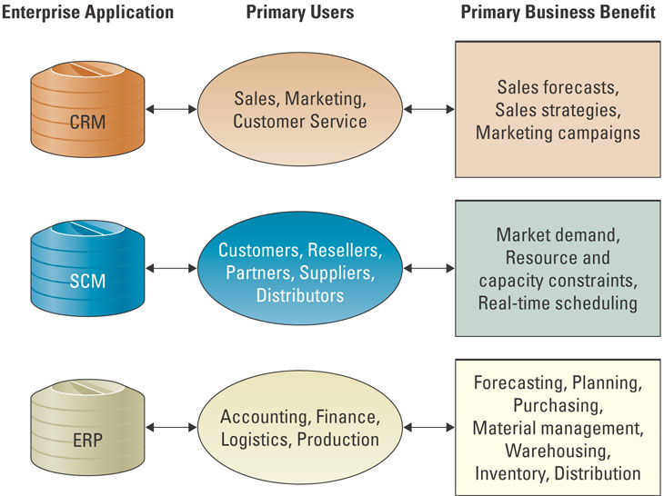
- Integration Tools: Many companies purchase modules from an ERP vendor, an SCM vendor, a CRM vendor, and must integrate the different modules together.
  - Middleware: Several different types of software which sit in the middle of and provide connectivity between two or more software applications.
  - Enterprise Application Integration (EAI) Middleware: Packages together commonly used functionality which reduced the time necessary to develop solutions that integrate application from multiple vendors.

Measuring ERP Success:
- Balanced Scorecard: A management system, in addition to a measurement system, that enables organizations to clarify their vision and strategy and translate them into action.
  - Financial, Internal Business Processes, Learning and Growth, and Customers.
- Finding the Right ERP Solution:
- Overall Fit: This refers to the degree of gaps that exist between the systems and the business process.
- Proper Business Analysis: The best way to determine which fit strategy is right is to conduct a thorough business analysis.
- Solid Implementation Plans: Like the installation of any successful process or piece of machinery, a plan is needed to monitor the quality objectives and timelines.

ERP and SME Markets: ERP is no longer the purview of large organizations.
- In hopes of expanding their client base, many large-scale ERP vendors, such as SAP and ORACLE are attempting to enter the small to medium enterprise (SME) markets.
- However, what many ERP vendors are finding is that SMEs constitute a different marketplace than what these large-scale ERP vendors are traditionally accustomed for four primary reasons:
- SMEs demand affordability and easy to use, more so than their large organizational cousins.
- Large-scale ERP vendors are relatively unknown to most SME organizations.
- In Canada, several large-scale ERP vendors have missed the mark when attempting to market their ERP solutions to SME companies.
- Most important, the SME market space demands the use of partners (resellers) to sell software solutions.

Chapter 5 “Operations and Supply Chain Management”

Section 5.1 – Operations Management:
- Production: The creation of goods and services using the factors of production: land, labour, capital, entrepreneurship, and knowledge.

Operations Management Fundamentals:
- Productions Management: Describes all the activities managers do to help companies create goods.
- Operations Management: The management of systems or processes that convert or transform resources (including human resources) into goods and services.
- Transformation Process: Often referred to as the technical core, especially in manufacturing organizations, and is the actual conversion of inputs to outputs.
  - To ensure that the desired outputs are obtained, an organization takes measurements at various points in the transformation process (feedback) and then compares them with previously established standards to determine whether corrective action (control) is needed.
- Value-Added: The term used to describe the difference between the cost of inputs and value of price of outputs

OM in Business:
- Forecasting: Estimating demand, growth, or reduction.
- Capacity Planning: Key essential metric to maintain cash flow and increase revenues.
- Scheduling
- Managing Inventory
- Assuring Quality: Reduce unexpected issues and put emphasis on efficiency and courtesy.
- Motivating/Training Employees
- Locating Facilities: Where to host maintenance facilities, major/minor hubs.

Information Systems’ Role in OM:
- Key Questions: What, When, Where, How, and Who?
- Hierarchy of Operational Planning:
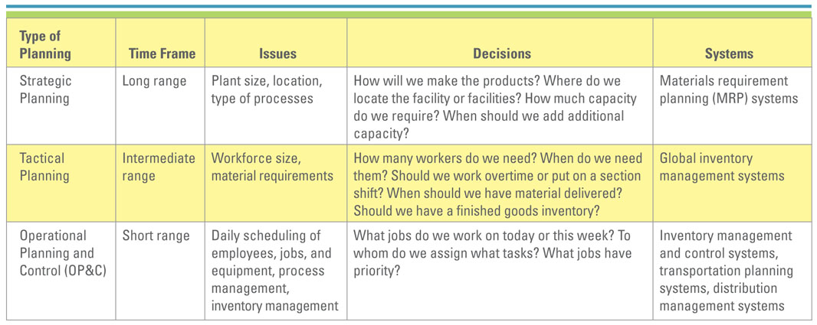
- Strategic Business Units (SBUs): When companies become really large, they are thought of as being composed of a number of businesses.
- Strategic Planning: Long range planning
  - Material Requirement Planning (MRP) Systems: Use sale forecasts to make sure that needed parts and materials are available at the right time and place in a specific company.
- Tactical Planning: Focuses on producing goods and services as efficiently as possible within the strategic plan.
  - Global Inventory Management Systems: Provide the ability to locate, track, and predict the movement of every component or material anywhere in the production process.
- Operational Planning and Control (OP&C): Deals with day-to-day procedures for performing work, including scheduling, inventory, and process management.
  - Inventory Management and Control Systems: Provide control and visibility to the status of individual items maintained in inventory.
  - Transportation Planning Systems: Track and analyze the movement of materials and products to ensure the delivery of materials and finished goods at the right time/place, and lowest cost.
  - Distribution Management Systems: Coordinate the process of transporting materials from a manufacturer to distribution centers to the final customers.

Competitive OM Strategy:
- Cost: Being the low-cost producer does not guarantee profitability. Products sold strictly on the basis of cost are typically commodity-like products.
- Quality: Can be divided into two categories.
- Product: Quality levels vary as to the particular market.
- Process: Critical in every market segment. Produce error-free products.
  - Six Sigma Quality: Prevent the occurrence of problems and achieve no more than 3.4 defects per million opportunities.
  - ISO 900: A nongovernmental organization established in 1947 to promote the development of world standards to facilitate the international exchange of g/s.
  - ISO 14000: Certification in ISO 14000 displays that a firm has a world-class management system in both quality and environmental standards.
  - CMMI: Capability Maturity Model Integration is a framework for best practices.
- Delivery: The ability of a firm to provide consistent and fast delivery allows it to charge a premium price for its products.
- Flexibility: Refers to the ability of a company to offer a wide variety of products to its customers. Also is a measure of how fast a company can convert its processes from an old product line to a new product line.
- Service: Customer service can add tremendous value to an ordinary product.

OM and the Supply Chain:
- Supply Chain: Consists of all parties involved directly or indirectly, in the procurement of a product or raw material.
- Supply Chain Management: Involves the management of information flows between and among stages in a supply chain to maximize total effectiveness and profitability.
- Strategy: Managing all the resources required to meet customer demand for all g/s.
- Partners: Chosen to deliver finished products, raw materials, and services, including pricing, delivery, and payment processes along with partner relationship monitoring metrics.
- Operation: The schedule for production activities, including testing, packaging, etc.
- Logistics: The product delivery process and elements, including orders, warehouses, carriers, defective product returns, and invoicing.

Section 5.2 – Supply Chain Fundamentals:
- The average company spends nearly half of every dollar that it earns on production.
- Three Main Links:
- Materials flow from suppliers and their “upstream” suppliers at all levels.
- Transformation of materials into semi-finished and finished products through the organization’s own production process.
- Distribution of products to customers and their “downstream” customers at all levels.
- Organizations must embrace technologies that can effectively manage supply chains.
- The Five Basic SCM Components:
- Plan: Strategic portion of SCM. The company must have plans for managing all the resources that go toward meeting customer demand for products or services.
- Source: Companies must carefully choose reliable suppliers that will deliver goods and services required for making products.
- Make: This is the step where companies manufacture their products or services.
- Delivery/Logistics: Set of processes that plans for and controls the efficient and effective transportation and storage of suppliers from suppliers to customers.
- Return: Companies must create a network for receiving defective product.

Information Systems’ Role in the Supply Chain:
- IS’s primary role is to create integrations or tight process and information linkages between function within a firm.
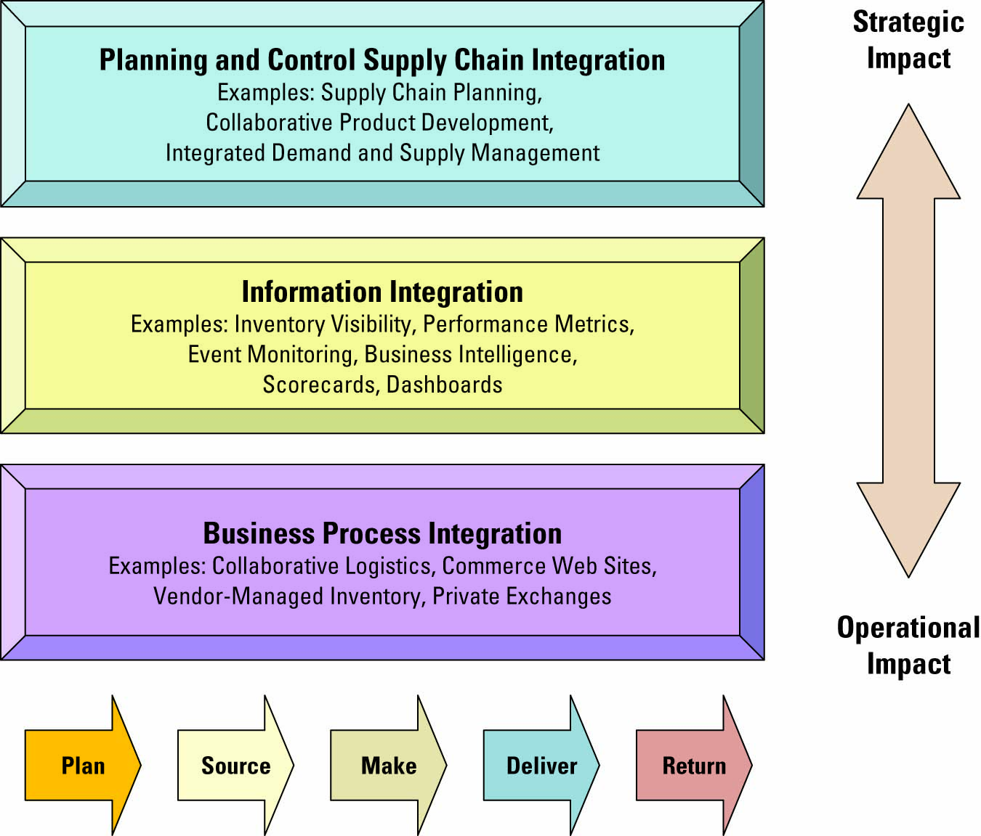
- Visibility: The ability to view all areas up and down the supply chain.
  - Bullwhip Effect: Occurs when distorted product demand information passes from one entity to the next throughout the supply chain.
- Consumer Behaviour:
  - Companies can respond faster and more effectively to consumer demands through supply chain enhances.
  - Demanding Planning Software: Generates demand forecasts using statistical tools and forecasting techniques.
- Competition:
  - Supply Chain Planning (SCP) Software: Uses advanced mathematical algorithms to improve the flow and efficiency of the supply chain.
  - Supply Chain Execution (SCE) Software: Automated the different steps and stages of the supply chain.
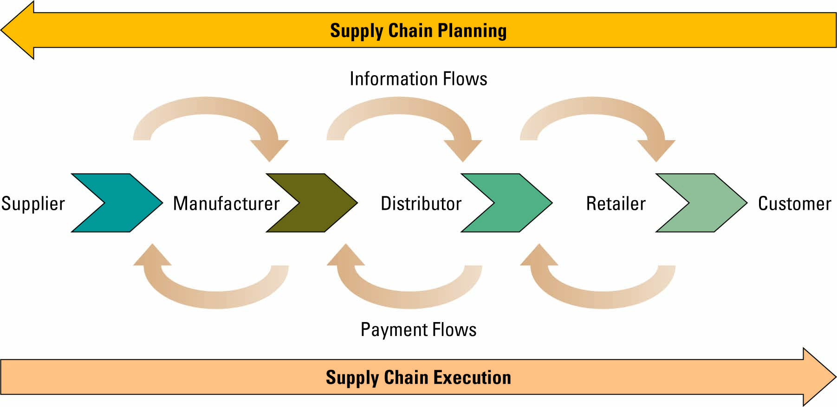
- Speed: During the past decade, competition has focused on speed.
  - Three Factors Fostering Speed:
- Pleasing customers has become a corporate obsession. Serving the customer in the best, most efficient/effective manner has become critical.
- Information is crucial to manager’s abilities to reduce inventory and human resource requirements to a competition level.
- Information flows are essential to strategic planning for and deployment of resources.

Supply Chain Management Success Factors:
- SCM Success Metrics:
- Back Orders: An unfilled customer order. Demand against an item whose stock level is INSF.
- Customer Order Promised Cycle Time: Gap between order creation and requested delivery.
- Customer Order Actual Cycle Time: Average time it takes to fill customer purchase order.
- Inventory Replenishment Cycle Time: Measure of manufacturing/distribution cycle time.
- Inventory Turns: # of times a firm’s inventory cycles or turns over per year.

- Seven Principles of Supply Chain Management:
- Segment customers by service needs, regardless of industry, and then tailor services to those particular segments.
- Customize the logistics network and focus intensively on the service requirements and profitability of the pre-identified customer segments.
- Listen to signals of market demand and plan accordingly
- Differentiate products closer to the customer, since companies can no longer afford to hold inventory to compensate for poor demand forecasting.
- Strategically manage sources of supply, by working with key suppliers to reduce overall costs of owning materials and services.
- Develop a supply chain information technology strategy that supports different levels of decision making and provides visibility.
- Adopt performance evaluation measures that apply to every link.
- SCM Industry Best Practices Include:
- Make the sale to suppliers
- Wean employees off traditional business practices.
- Ensure the SCM system supports the organizational goals.
- Deploy in incremental phases and measure and communicate success.
- Be future-oriented.

Future Supply Chain Trends:
- Supply Chain Event Management (SCEM): Enables an organization to react more quickly to resolve supply chain issues. SCM software increases real-time information sharing among supply chain partners and decreases their response time to unplanned events.
- Selling Chain Management: Applies technology to the activities in the order life cycle from inquiry to sale.
- Collaborative Engineering: Allows an organization to reduce the cost and time required during the design process of a product.
- Collaborative Demand Planning: Helps organization reduce their investment in inventory, while improving customer satisfaction through product availability.

