Dyer

Uncontestable claims:
- Independent of interpretation
- Experience & observations
- Agreement among experts
- Strongly supported

Contestable claims:
- Not commonly accepted; new ideas
- Cannot stand on their own evidence must be provided

Dimensions of critical thinking:
- Claim central idea
- Evidence supports
- Underlying assumptions reality, value
- Causal claims
- Techniques of persuasion language

Testing evidence: APSRAC
- Accuracy errors, grammar
- Precision use of numbers and direct quotes
- Sufficiency how much evidence?; importance of claim (fallacy of hasty generalization)
- Representativeness variety of sources to match variety of population (fallacy of hasty generalization)
- Authority credentials, experience, context-dependent (fallacy of argumentation ad populum: bandwagon)
- Clarity of expression interpretation of quantitative data and direct quotations

Underlying assumptions: logic between evidence and claim
IMPLICITLY stated (not obvious; not written)
- Reality assumptions beliefs about what has taken place, what exists or how things work
- Values assumptions ideals, standards or right and wrong, the way things ought to be

How to find underlying assumptions:
- What must be true if the claim is to follow form this evidence?
- What general principal might link this particular claim to this particular evidence?
- What beliefs might I expect from this type of person?
- Could someone believe this evidence and still disagree with the claim?

Causal Claims:
- Cause & effect relations
- Rival cause: same evidence can be consistent with different interpretations
  - Types: difference between groups (other relevant differences? Correlation between characteristics (reverse causation)

Techniques of Persuasion:
- Audience is crucial
- Anticipate objections:
*Destruct:
- Negative evidence that refutes your claim
- Rival causes that are consistent with your evidence.
- Debatable assumptions that the reader could disagree
- Counter argue objections explicitly
- Use rhetoric language
  - To convince, use full detail
  - Authoritative vs. emotive tone
  - Be vivid and concrete to draw attention

Writing a persuasive essay:
- Make an outline of claims and sub claims, list reasons
- Arrange evidence for each sub claim (use subtitles)
*Do not rule out negative evidence
*Refer to readers’ objections & alternative viewpoints
- Write first draft:
  - Put ideas down
  - Clean up
- Revise work: organization, clarity
- References

Alfred Chandler

Two key concepts:

Economies of scale large plants can produce products at a much lower cost than smaller ones because the cost per unit drops as the volume of output rises

Economies of scope large plants can use many of the same raw and semi-finished materials and intermediate production processes to make a variety of different products

**Key to everything: low cost you win**

Major claims: In order for firms to benefit from these economies
- Flow of materials must be kept constant
- National (and international) marketing and distribution functions must be created
- Teams of lower and middle managers need to be recruited

Secondary claims:
- Once a firm loses the opportunity to be a first mover, it is difficult to regain competitive advantage
- Entrepreneurial companies that do not make investments to create organizational capabilities cannot achieve long-term success
- Growth through unrelated diversification is a poor corporate strategy
- Business ownership patterns have dimished the likelihood of many firms’ long-term success

**Successful firms capitalize on economies of scale & scope, create management structures and invest in research & development*

Concept Map:

Marketing & Distribution
Top & Middle Managers
R&D
Scope
Scale
Invest
Low Cost
Managerial enterprises
Long Term Success

**Establishing first Mover Advantage**

Unrelated Diversification
Short-term thinking
Stock Market Pressure

**Losing first mover advantage**

Larry Greiner

**A theory of organizational cycle, with a focus on growth**

Major Claims:
- Organizational growth is characterized as a series of developmental phases
- Management practices that work well in one phase bring on a crisis in the next

Five key features – How organizations grow:
- Age management problems and principles are rooted in time
- Size problems & solutions change as number of employees and sales volume increase
- Stages of evolution evolutionary period; prolonged growth
- Stages of revolution periods of revolution; upheaval of management practices
- Growth rate speed related to market environment

Evolutionary periods: characterized by the dominant management styles used to achieve growth * prolonger growth*
- Creativity (creating products & market)
- Direction (sustainable growth, directive leadership)
- Delegation (separation of management between top & lower)
- Coordination (formal systems top managers taking responsibility)
- Collaboration (no more formal systems, teamwork, interpersonal collaboration, flexible approach)

Revolutionary periods: Characterized by the dominant management problem that must be solved before growth can continue *turbulence, crisis, companies must adapt, make changes*
- Leadership (unwanted management responsibilities manager to solve)
- Autonomy (lower levels dislike hierarchy must work toward delegation)
- Control (top managers losing control seek to regain over company)
- Red tape (conflict between line & staff & headquarters, criticism of system)
- “?” (Exhausted psychology of employees from teamwork & innovation)

Five phases of growth:
- Creativity creating product & market
- Direction sustained growth, functional organizational structure, job assignment, incentives, budgets and work standards adopted
- Delegation greater responsibility to managers, motivation, larger markets and new products
- Coordination formal systems & top-level executives for control
- Collaboration interpersonal collaboration, teams, more flexible behavioral approach to management

Guidelines for growth:
- Know where you are in the developmental sequence
- Be aware of the stages
- Leaders at the top should be ready to work with the flow rather than against it
- Platforms for change and introduction of new practices
- Realize that solutions breed new problems
- Past actions determine much of the future
- Prepare solutions and coping strategies before revolutions get out of hand

**Different management styles are appropriate in different phases of an organizations’ life cycle**

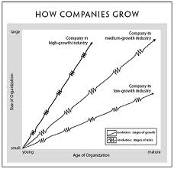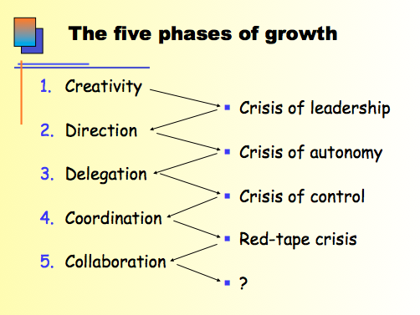

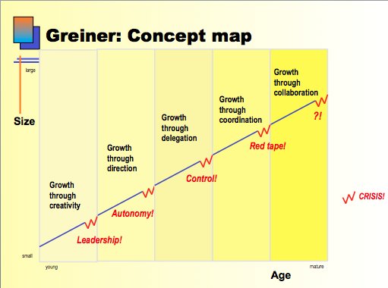

Tannenbaum & Schmidt: New Concept Map

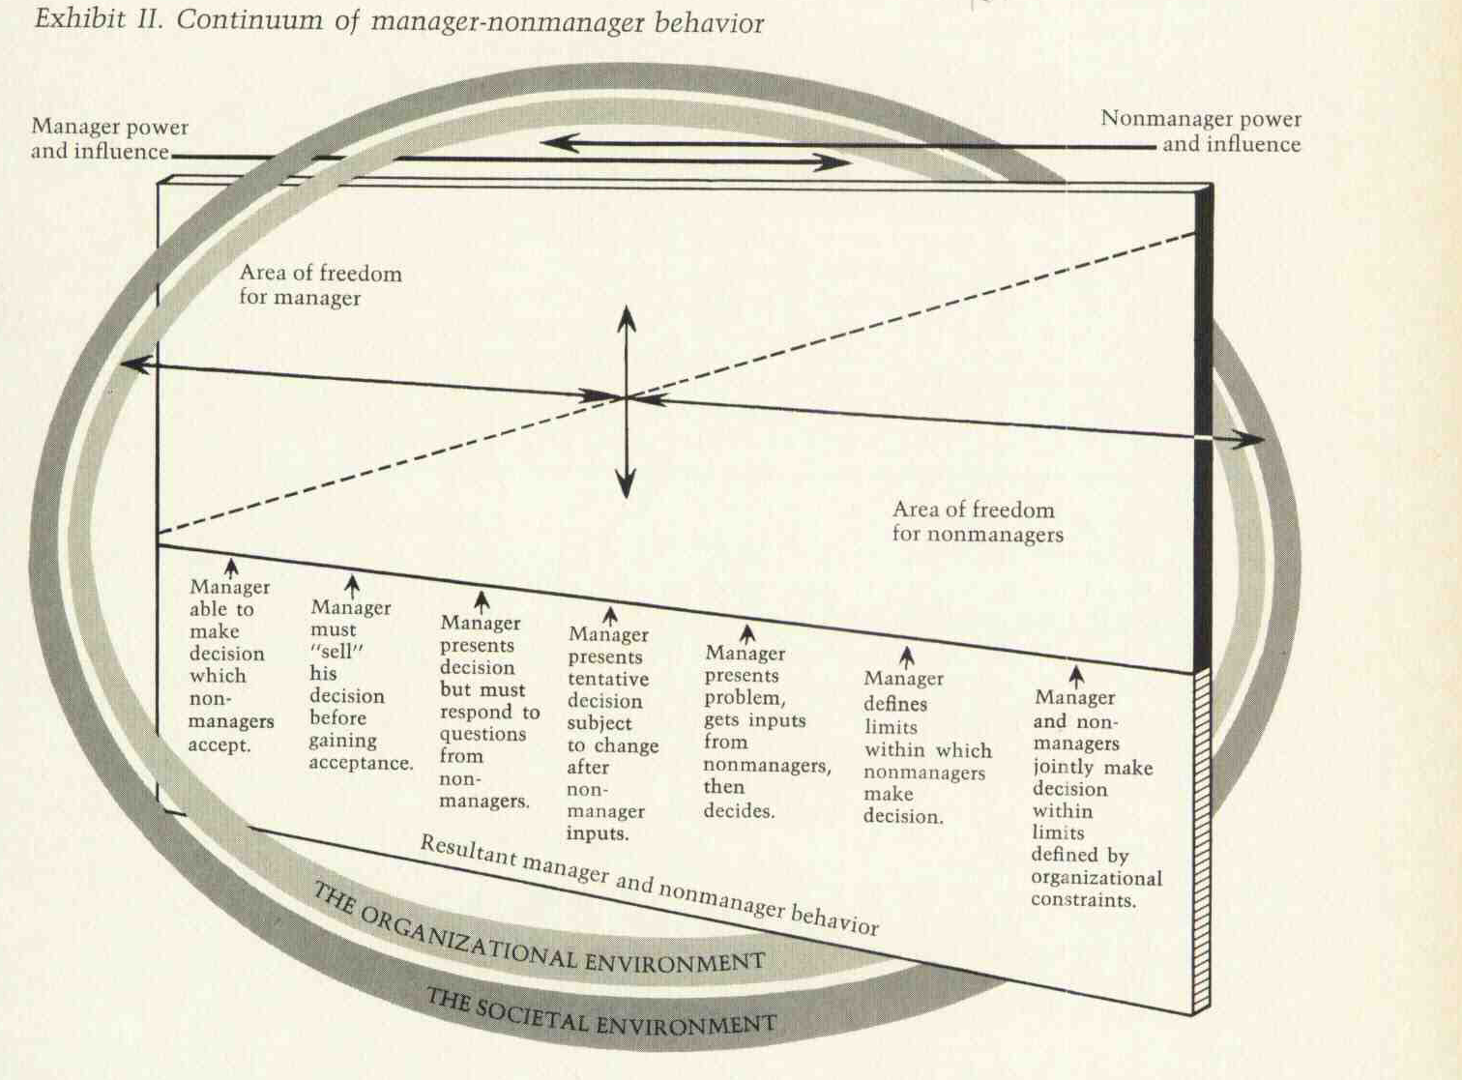
How to lead:
- Forces in the Manager
  - Value system
  - Confidence in subordinates
  - Own leadership inclinations
  - Feelings of scrutiny
- Forces in the Subordinate (More democratic)
  - High need for independence
  - Readiness to assume responsibility
  - High tolerance for ambiguity
  - Identify with the organization’s problems and goals
  - Have knowledge and experience
  - Learned to be part of decision making
- Forces in the Situation
  - Type of organization
  - Group effectiveness
  - Nature of the problem
  - Time pressures
  - Long-run strategy
  - Objectives to be attained
Collins & Porras

Major Claim: Successful companies have fixed core purposes and values AND adopt their strategies and practices to the changing world
Achieve Superior long-term performance

**Vision provides guidance about what core to preserve and what future to stimulate progress toward**

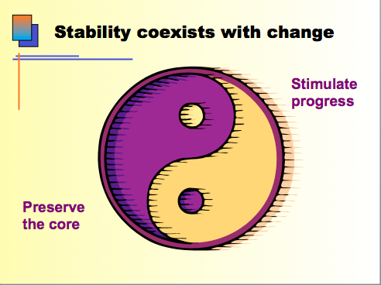

Core ideology:
- Defines what we stand for and why we exist
- The enduring character of an organization
- Consistent identity that transcends product or market life cycles, technological breakthroughs, management fads & individual leaders
- Glue that holds organization together

**It is important to know who you are rather than where you are going, for where you are going will change as the world around you changes**

**Core ideology source of guidance and inspiration
- Core values essential enduring, timeless guiding principles define for us what we stand for
*a company must change its market so that it suits its core values*
- Core purpose reason for being, soul of organization, reflects people’s idealistic motivations for doing work. Cannot be reached but inspires change and progress
How to reach purpose fundamental purpose will eventually be highlighted

Major claim: Companies more than ever need to have a clear understanding of their purpose in order to make work meaningful and thereby attrack, motivate and retain understanding people
**CORE IDEOLOGY is discovered, not set. You understand it by looking inside – must motivate & inspire people inside company

**Core competence is a strategic concept that defines your organization’s capabilities

Envisioned future: Something visible, vivid, real
- BHAGs Huge challenge, clear and compelling finish line, engages people, tangible, energizing, focused, requires 10-30 years of effort to complete
- Vivid description vibrant, engaging and specific description of what it will be like to achieve the BHAG. Passion, emotion, conviction essentials
**Requires confidence and commitment

Major claim: Success lies in building the strength of an organization as its primary way of creating the future
*Avoid the we’ve arrived syndrome

Major claim: Preserving the core and stimulating progress is the primary engine of enduring companies.
- It is brought upon by vision

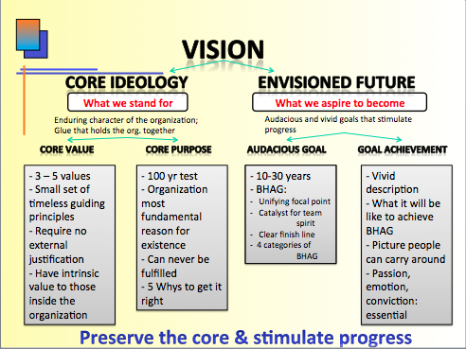

Zaleznik

Major claim:
- “Managers embrace process, seek stability and control, and instinctively try to resolve problems quickly… Leaders in, contrast, tolerate chaos and lack of structure and are willing to delay closure in order to understand the issue more fully” (p.74)
- Vision versus Execution and results

Sub-claims:
- “Business leaders have much more in common with artists, scientists, and other creative thinkers than they do with managers” (p.74)
- Do you recall the Forbes excerpt from class 1?
- “Organizations need both managers and leaders to succeed” (p.74)
- “Leaders work in the opposite directions. Where managers act to limit choices, leaders develop fresh approaches to long-standing problems and open issued to new options” (p.77)
- “Leaders work from high risk positions” (p.77)
- “For those who become managers, a survival instinct dominates the need for risk, and with that instinct comes an ability to tolerate mundane, practical work” (p.77)
- “Managerial personalities form moderate and widely distributed attachments. Leaders, on the other hand, establish, and also break off, intensive one-to-one relationships

Jay B. Barney (strategy)

Sustained competitive advantage:
SWOT analysis framework: efficiency
Internal attributes resources & capabilities
External environment businesses & social trend: industry conditions and competitive environment
Exploit resources rare, valuable, socially complete
Neutralize threats imitability

Major claim: in order to gain sustainable competitive advantage, a firm must adjust to:
- Changes in consumer tastes
- Changes in the industry structure
- Changes in technology

Tangible resources:
Financial cash, assets, capacity to raise equity, borrowing
Physical modern plant & facilities – favorable machinery and equipment, buildings
Technological trade, innovative production processes
Organizational effective strategic planning processes, evaluation and control systems

Intangible resources:
Human experience, knowledge, judgment, trust, skills, capabilities, specific practices & procedures of employee
Innovation & creativity technological & scientific skills, capabilities
Reputation brand name, customers: quality, reliability, suppliers: fairness

Organization capabilities: history, relationships, trust, organizational cultures, skills to transfer inputs to outputs, capacity to combine tangible & intangible resources to attain goal

VRIO questions of:
Value Exploit opportunities & neutralize threats
Rarity difference from competition
Imitability advantages / disadvantages
Organization organized to fully exploit

Challenge of management: look inside their firm for valuable, rare, and costly-to-imitate resources and exploit these resources through their organization

*Many small decisions focus on development, nurturing and exploiting resources

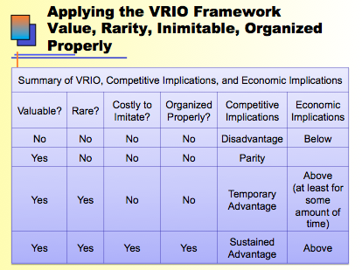

Frederic Herzberg

Needs:
- Hygiene
- Motivation

KITA:
Negative punishment
- Physical (visible
- Psychological (not visible, leads to movement / example: reduction of hours)
Positive reward
- Motivation, incentive status, promotion, seduction (example: employee of the month)

Hygiene factors: primary cause of job dissatisfaction
*Absence = dissatisfaction
- Working conditions (atmosphere)
- Salary
- Status
- Security
- Policy & administration
- Relationships (supervisors, subordinates & peers)
- Personal life

Motivators: primary cause of job satisfaction
- Achievement
- Recognition for achievement
- Interest in the work itself
- Responsibility for tasks
- Growth/advancement to higher levels
- Personal growth

Job enrichment: opportunity for employee’s psychological growth
Job enlargement: failure makes a job structurally bigger
Job loading:
- Attempts to enrich certain jobs
- Enlarges meaningless of the job
- Horizontal: reduces personal contribution of employee rather than giving opportunities for growth
- Vertical: provides motivator factors

Kaplan & Norton

*Measurable objectives
*An organization’s movement system strongly affects the behavior or managers and employees
* Managers want a balanced presentation of both financial and operational measures

Balanced scorecard: set of measures that give top managers a fast but comprehensive view of the business

4 crucial measures:
- Financial measures (HOW) to ensure profitability
- Operational measures on customer satisfaction (WHO)
- Internal processes (WHAT) to do to improve
- Innovation and learning (constant) or new to improve

Financial  - How to ensure profitability?  - “Bottom-line” improvement  - Shareholder values  ex: net profit must increase by 8% per year, the debt to equity must decrease by 15% per year | Operational  - How to product to meet customer expectations? What to excel that?  - Customer satisfactions, actions to satisfy customer needs  - Measure that reflect satisfaction due to improvement  Ex: reducing expenses by at least 10% per year, sending survey to employees and receiving 85% positive feedback
Customer  - What matters most to customers  - Measures reflecting customer satisfaction due to improvements  Ex: sending online surveys to consumers aim to receive 70% positive feedback per month | Innovation & learning  - How to make continuous improvement?  - Parameters most important for competitive success  - Innovate, improve, learn grow  Ex: the increase in income due to sales of new products aim to receive $30000 per month minimum

Charles Handy

*New strategy, Right timing

The Sigmoid Curve
*Key to effective growth

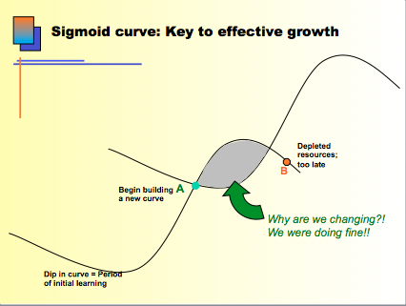

*KAIZEN: continuous improvement

*Start something new innovate, change strategy BEFORE you experience failure in what you are currently doing

Essential: let go of your past. New curve. New cycle, New life

Paradox of time: if you continue and remain the same, you will miss the road to the future. You cannot predict the future like we can explain past by the time you know what you want, it is too late

Paradox of success: what got you to succeed will not keep you where you are. Must think for the next generation ahead of time. How to keep succeeding? CHANGE

*SAME CORE IDEOLOGY – VALUES & PURPOSE REMAIN

2nd curve:
- New product (different people)
- New way of operating (different people)
- New strategy (different people)
- New culture (different people)

*New ideas and new people must co-exist with the old until the second curve is established

*New directions needed every 2-3 years

4-stage cycle of discovery:
- Questions 2) Ideas 3) Test & experiments 4) Review
Curiosity Possibilities Strategies Results
hypotheses development

*2nd curve is always different but builds & grows on 1st curve

Second-curve thinking: the past is not for the future, there must be another way that will help succeed

Henry Mintzberg

Classical view: managers organize, coordinate, plan, control
*Field of management: devoted to progress and change

Managerial work facts:
- Managers work at an unrelenting pace
- Their activities are characterized by brevity, variety & discontinuity
- Managers are oriented to action & dislike reflective activities
- Performing many regular duties PLUS ritual ceremonies, negotiations, and processing information that links organization & its environment
- Managers favor verbal media, telephone calls, meetings
- Managers’ programs: schedule time, process information, make decisions, remains in their brains

Manager’s Roles: 10 roles
*Manager: formal authority and status

- Interpersonal
- Figure head: perform ceremonies
- Leader: hiring, training, motivate, encourage, influence
- Liaison: making contacts external information
- Informational nerve center
- Monitor: scans environment for information verbal form
- Disseminator: manager gives information to subordinates
- Spokesperson: manager gives information to outsiders
- Decisional
- Entrepreneur: many small decisions initiate change
- Disturbance handler: “fire-fighter” acting, dealing with pressures
- Resource allocator: responsible for dividing tasks, unit structure, makes decisions before they are implemented
- Negotiator: ultimate representative & decision-maker

Danger: managers keep the organization’s data in their mind so if and when they keave, they take it with them. This leaves the company at an informational disadvantage.
*Manager is challenged to find ways to share privileged information*

*Effective managers turn obligations into advantages

Skills for managers:
- Developing peer relationships
- Carry out negotiations
- Motivating subordinates
- Resolving conflicts
- Establishing information networks
- Making decisions
- Allocating resources
- Continue learning on the job

French & Raven

*Power = relationship

Bases of social power:
- Reward: based on ability to reward positive KITA
- Coercive:
- Based on ability to threaten negative KITA
- Giving tough, undesirable jobs to do
- Making things unpleasant
- Making work difficult
- Legitimate:
- Based on title or position
- Reminding workers of commitments to meet
- Making workers recognize tasks to accomplish
- Referent:
- Based on attracting and building loyalty
- Making them feel approved, personally accepted
- Making them feel important
- Expert:
- Based on knowledge, perception
- Sharing experiences & special skills
- Providing good technical suggestions
- Providing good task-related advice

