THE CONTACT BETWEEN THE PRECAMBRIAN SHIELD AND THE PHANEROZOIC SEDIMENTARY ROCKS
Lab Report (Lab #2)

Submitted to:
Professor Simone Dumas

For the course
Introduction to Earth Materials
(GE01115)

By:
Gabriella Carrier
Student # 8005071
Section 2

University of Ottawa
September 25, 2014
INTRODUCTION
On the morning of September 18, 2014 the GEO115 Section B lab travelled to Lac Beauchamp Park in Gaitneau, QC for the second lab exercise. We experienced low temperatures, mild wind, and no precipitation during the trip. At Lac Beauchamp we examined an outcrop on the side of the road directly next the body of water within the park. This outcrop consisted of two principal rocks. The class recorded observations from the base, side, and surface of the outcrop. These observations were used to piece together a geological history of the outcrop.

OBJECTIVES
- Recognize the presence and significance of unconformities
- Combine pieces of evidence to deduce the age of the rock as well as the type of environment the rock existed in

- Describe the characteristics of the roadside outcrop and its two visible rock units (size and geometry of the outcrop, rock types, rock names, name of formations, age of rock units, mineralogy, weathering level, grain sorting, trace fossils, depositional and deformational structures, etc.)
The bottom geological unit visible on the roadside outcrop is a type of metamorphic rock known as Grenville gneiss. Grenville gneiss is approximately one billion years old and is mostly made of quartz, indicating chemical alteration. Heat and humidity are required to chemically alter rocks. From this we can deduce that the rock was once south of the equator. It took 17 strides, each stride averaging 70 cm, to walk from one end of the principal to the other. The rock is roughly 11.9 meters long. A classmate who is a 176 cm tall stood at the base of the rock. Standing back from the rock I opened my fingers to the height of my classmate. The principal rock was roughly three times my peer’s height (5.28m). The metamorphic rock is softer and has obviously endured more weathering in contrast to its sedimentary counterpart above it.
The top rock is a sedimentary rock known as Nepean Sandstone. It is estimated to be 500 million years old. An unconformity between these principal rocks account for the large time gap between them. The sandstone is rough and mostly white with patches of red. The white area of rock is composed of quartz. The red area of Neapean Sandstone is iron that has been exposed to oxygen and oxidized into rust. Fine grains of sand can be seen in this rock. Cross-bedding, trace fossils, stylolites, and lag deposits were pieces of evidence found on the Nepean Sandstone that made it possible to create a geological timeline for the rock.

- Draw a labelled sketch of the outcrop. Be sure to include a legend of symbols, scale, etc.

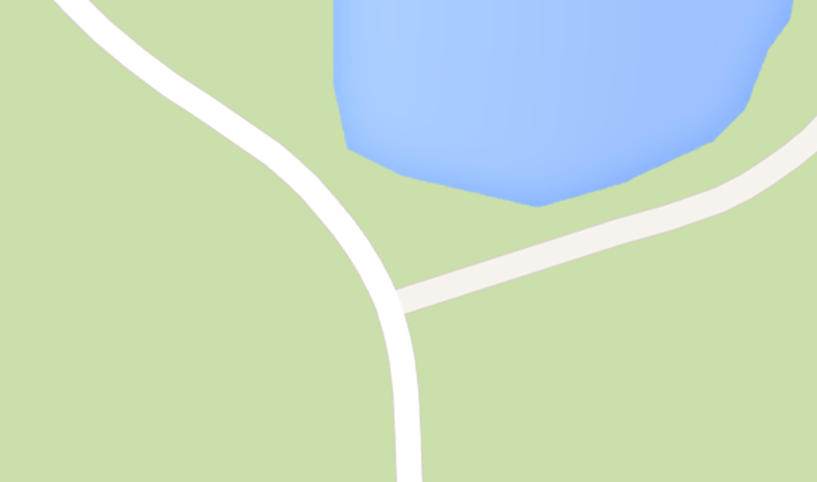

- Name and briefly define the term used to describe the surface that separates the two principal rock units, and discuss its significance.

Unconformity

The surface that separates the Grenville gneiss from the Nepean Sandstone is an unconformity. Geological unconformities represent a period of time when deposition of rock stopped (Schieber, Jurgen). Erosion, sea level change, and crust movement are examples of events that can cause an unconformity to form. During these events the top layers of sediment that were forming a rock are removed. The layers of sediment closest to the top of an unconformity represent when deposition resumed.
These breaks in geological record can be categorized as one of the following: angular unconformities, disconformities, and nonconformities and paraconformities. Angular unconformities are relatively easy to identify because one section of sediment is titled due to uplift. Above the titled sediment is younger sediment that deposited flat layers, creating a visible angle between the two rocks (Schieber, Jurgen). Disconformities separate two parallel sedimentary rocks. A disconformity is more difficult to distinguish because no uplift occurred to change the direction of sediment but slight evidence of erosion is present (Schieber, Jurgen). Nonconformities are different than the previous types of unconformities because it separates an igneous or metamorphic rock from a sedimentary rock rather than being between sedimentary rocks. Lastly, the most difficult unconformity to identify is a paraconformity. Paraconformities separate two parallel rocks but there is no sign of sediment removal (“Conservapedia”). A drastic age difference between rocks indicates the presence of a paraconformity.

- Based on your observations, outline the chronological order of geological events. In other words, what is the sequence of geological events that led to the formation of the outcrop as we see it today?
One billion years ago protolith rock, the beginning stages of the metamorphic gneiss portion of the outcrop, was part of a mountain range. The high metamorphic degree of the protolith rock tells us that the rock was under immense heat and pressure, meaning it was located approximately 50 kilometers deep within the mountain range. Over time the tops of the mountain range weathered, eroded, and exposed the gneiss. This strip of gneiss is known as Greenville Gneiss. Roughly 1,000 million years ago an event known as the Greenville Orogeny took place. Grenville was the last orogeny of the Precambrian Era. During this time tectonic plates were converging, forming the super continent Rodinia. This super continent was orientated in such a way that placed the gneiss approximately 15 degrees south of the equator. We know this because Greenville Gneiss is primarily quartz, a mineral attained through warm, humid climates. The lithosphere where the Greenville Gneiss is located responded to a pressure change and caused the rock to return to deeper depths and become covered with sediment. This process is known as isostatic rebound.
Over time sediments on top of the metamorphic rock lithified and created Nepean Sandstone. The sediments that formed Nepean Sandstone were the product of mountain erosion. Rivers carried the particles of eroded mountain to coastlines where they were covered by more sediments. Eventually these buried layers formed Nepean Sandstone. Sedimentary rocks found in the Ottawa/ Quebec region are from the Cambrian Period (the time frame proceeding the Phanerozoic Eon). Particles that did not dissolve during lithification created stylolites between the two rocks. Trace fossils from the outcrop tell us that marine life was present, meaning the sea level rose causing both rocks to be underwater for a period of time. However, evidence tells us that the sandstone resurfaced. Chatter marks found on the Neapean Sandstone indicate that a glacier was moving across the sedimentary rock. The sandstone emerged from the water and was at the surface when a glacier moved across its location.

- Briefly discuss two lines of geological evidence observed in the Nepean Sandstorm that support the idea that it was deposited under relatively high energy conditions. Also, what suggests a marine environment, and why?

    - Angled lines can be seen in the Nepean Sandstone. These lines are known as cross-bedding. Cross-bedding is formed from strong wind or waves (examples of high energy conditions). These currents carry sediments with them. When moving particles meet a dune they are pushed up the dune. The cross-bedding lines are layers of sediment that moved over-top a dune, eventually to the other side. Over time the entire dune migrates as a result.

    - Fossils in Nepean Sandstone support the idea that the rock was at located in a high energy environment. Vertical tube-like rocks and empty cylinder holes can be found in the sandstone. These holes are trace fossils. Trace fossils do not contain an organism but rather a cast of the feature the organism lived in. The Nepean Sandstone examined at the outcrop is 500 million years old. The only form of life present during this time was aquatic. From this information we can conclude that any evidence of life found at the Nepean Sandstone is from a marine environment.

The fossil’s shape and direction supply evidence confirming high energy conditions. Vertical tubes would have been found on the sea floor. Their height indicates a feeding strategy required for stationary marine creatures living in high energy environments. The majority of the food available in a high energy aquatic environments is suspended in the water column. A tall slender tube shape can sway with currents and is capable of capturing food more effectively than organisms that remain on the sea floor.

- Using the cross-section, do the following:

  - In point form, reconstruct the geological history, listing both the sequence of letters and the geological events that affected this area.

1) Deposition of L
2) Deposition of F
3) Deposition of M
4) Deposition of K
5) Deposition of J
6) Deposition of C
7) Deposition of T
8) All layers currently present are tilted due to tectonic plate movement
9) Intrusion of A
10) Formation of unconformity (1)
11) Deposition of R
12) Erosion of A creating inclusions in R
13) Deposition of N
14) Formation of unconformity (2)
15) Deposition of B
16) Deposition of Q
17) Deposition of S
18) Fault O
19) Layers to the left of the fault are vertically pushed upward, causing Q and S to erode.
20) Intrusion of G
21) Formation of unconformity (3)
22) Deposition of I
23) Erosion of G creating inclusions in I
24) Deposition of D
25) Deposition of H
26) H exposed to high energy environment (wind) creating dunes
27) Deposition of P in lowest points of dunes
28) Deposition of E
29) E exposed to high energy environment (wind)

  - Identify all the unconformities and specify the type(s) for each one

Two types of unconformity were created when deposition resumed with the lithification of rock R. For labelling purposes we will call this entire break in geological history Unconformity 1. Unconformity 1 separates angled sedimentary layers L, F, M, K, J, C, and T from sedimentary layer R. These portions of Unconformity 1 are angular unconformities because R deposited horizontally against the titled layers beneath it. Igneous rock A is separated from sedimentary rock R by Unconformity 1 as well. This division of sedimentary from igneous rock is a nonconformity.
Chronologically, the next unconformity to form exists between rocks N and B (Unconformity 2). There is no visible unconformity present between these two parallel sedimentary rocks, but the rocks differ in age by 590 million years. Geological change was taking place during this time gap but evidence of this change was destroyed by a combination of natural processes/events. Unconformity 2 is an example of a paraconformity because N and B are parallel and there is no physical evidence or sediment removal.
Rock B lithified approximately 210 million years. Rock I, the next rock to form above rock B, was created only 50 million years ago. The 160 million year gap indicates another series of sediment removing events. I and B parallel to each other and are both sedimentary rocks, making Unconformity 3 a disconformity. Fault O divides unconformity 3, with rock B on one side and rocks S and G on the other. Rock G, a metamorphic

Works Cited
"Paraconformity." - Conservapedia. N.p., 7 Nov. 2010. Web. 24 Sept. 2014. <http://www.conservapedia.com/Paraconformity>.
Schieber, Jurgen. "Unconformities." Unconformities. N.p., n.d. Web. 23 Sept. 2014. <http://www.indiana.edu/~geol105b/images/gaia_chapter_6/unconformities.htm

