Lecture 14: Introduction to Metabolism
Definitions
- Metabolism is a highly integrated cell activity involving hundreds of enzyme-catalyzed reactions by which biomolecules are produced, maintained, and destroyed and by which energy is obtained and used the overall process through which living systems acquire and use free energy to carry out their various functions
- Metabolism is divided in two parts:
  - Catabolism (or degradation) is the sum of reactions of degradation in which nutrients and “own biomolecules” of the cell are broken down to produce energy and monomers necessary for the syntheses of biopolymers
  - Anabolism is the sum of reactions of biosynthesis in which biological molecules are synthesized from the smaller components
- Many specific metabolic reactions are common to all organisms.
- Variations in metabolic reactions are mainly due to differences in the source of the free energy
Autotrophs and Heterotrophs
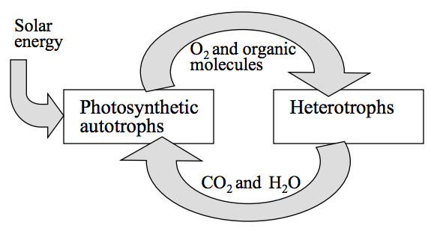
- Living organisms are divided into autotrophs and heterotrophs depending on how they obtains free energy and carbon
- Autotrophs use CO₂ from atmosphere as the sole source of carbon.
- Photoautotrophs (e.g., higher plants) obtain energy from the sunlight.
- Chemolitotrophs obtain free energy through oxidations of inorganic compounds
- Heterotrophsobtain carbon and energy from autotrophs

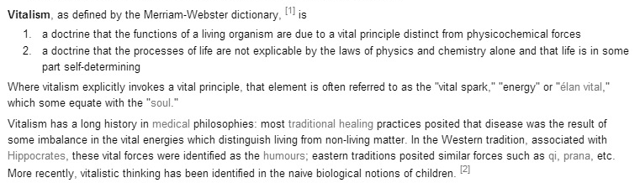
Antoine Lavoisier
- Antoine Lavoisier (1743-1749) is known as the father of modern chemistry
  - Demonstrated the nature of combustion
  - Proposed the term “oxygen”
  - Developed a new system of chemical nomenclature
  - Wrote the first modern textbook of chemistry
- Lavoisier was also a government official responsible from agricultural reform, tax collection and the government’s manufacture of gunpowder. Lavoisier was executed during the Reign of Terror
- “In general, respiration is nothing but a slow combustion of carbon and hydrogen, which is entirely similar to that which occurs in a lighted lamp or candle, and that, from this point of view, animals that repair are true combustible bodies that burn and consume themselves”
Metabolic Pathways
- Metabolic pathway a series of connected metabolic reactions that make a specific product
- Metabolites reactions, intermediates, and product of metabolic pathways
- In catabolic pathways, complex metabolites are exergonically broken down to simple metabolites
  - Cells obtain free energy from catabolic pathways
- In anabolic pathways, bipolymers are endergonically synthesized from simple metabolites (cells use and invest free energy in these pathways)
Energy Flow in Metabolism
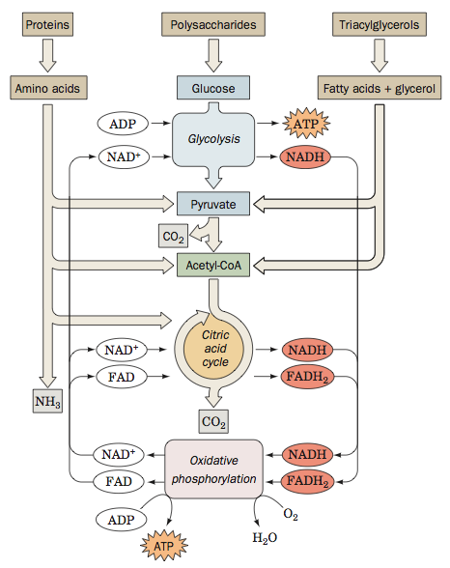
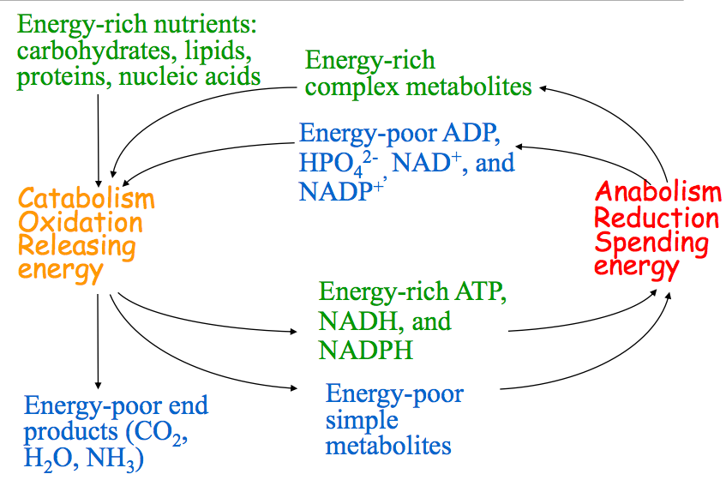

Overview of Catabolism
- Complex metabolites (carbohydrates, proteins, lipids) are decomposed to monomeric units (glucose, amino acids, fatty acids, glycerol)
- In many cases, the monomeric until are further decomposed in two-carbon acetyl unit (-CO-CH3) linked to CoA to form acetyl-CoA
- Carbons of acetyl unit are oxidized to CO2 in the citric acid cycle yielding reduced (energy- and electron-rich) coenzymes NADH, FADH₂.
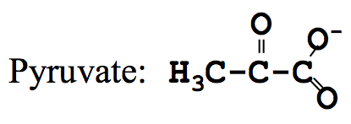
- In the process of oxidative phosphorylation, the reduced NADH and FADH₂ pass their electrons to O₂ to produce H₂O. Simultaneous phosphorylation of energy-poor ADP yields energy-rich ATP

High Energy Compounds
- The complete oxidation of glucose releases the free energy of -2850kJ/mol
  - C₆H₁₂O₆ + 6 O₂ —> 6 CO₂ + 6 H₂O
- In oxidative metabolism, the energy is released in a step-wise fashion and “deposited”
ATP
- Repulsion of negative charges in ATP is the primary mechanism of energy storage (ATP is a “compressed spring”
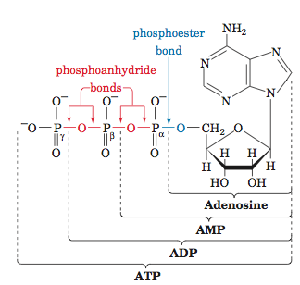
Other High Energy Compounds
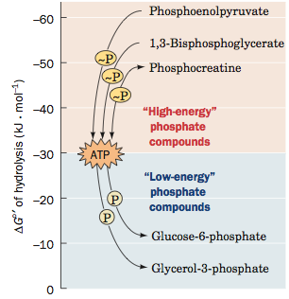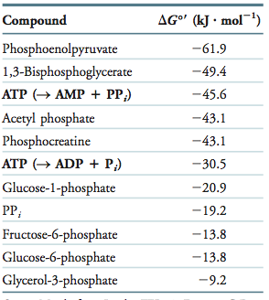
Locations of Metabolic Pathways
- Different metabolic pathways run in different locations of the cell
  - Glycolysis (glucose degradation) cytoplasm
  - Oxidative phosphorylation matrix of mitochondria
- Proteins that transport substances between the locations are essential components of metabolic processes
- Certain organs and tissues have metabolic specialization
  - Synthesis of glucose from non-carbohydrates liver
  - Storage of triacylglycerols adipose tissue
- Tissue/organelle specialization requires isozymes (enzymes that catalyze the same reaction but have different structure, kinetics and regulatory properties)
- M-type and H-type isozymes of lactate dehydrogenase (LDH) are specific for the skeletal and heart muscle, respectively
  - N skeletal
  - H heart muscle
- During a heart attack, H-type LDH is released into the blood. This is used to diagnose the disease
Control of Metabolic Reactions
- Allosteric controlModulation of the enzyme activity by small effectors (such as substrates, products, or coenzymes)
- Phosphorylation and dephosphorylation of enzymes
- Genetic controlconcentration of an enzyme may be regulated by its expression
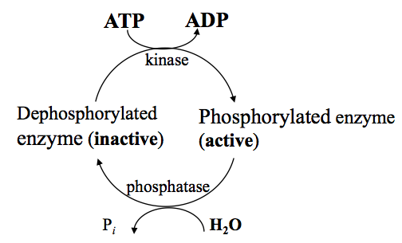

Lecture 15: Oxidation Reduction Reactions
Flow of Electrons do Work via Electrical Motor
- Electric motors convert electrons flow into mechanical motion.
- A battery has two electrodes with different affinity to electrons.
- Electrons move from the low-affinity electrode to the high- affinity electrode via macroscopic circuit.
- A chemical energy inside the battery moves electrons from high-affinity to the low-affinity electrode.
- In a “biological circuit”, the sources of electrons are reduced compounds in the food.
- They have atoms with low affinity to electrons.
- As the reduced compounds are enzymatically oxidized, electrons are released.
- Electrons flow to the substance with high affinity to electrons (O₂).
- The resultant electromotive force is transduced to biological work.
Electron Flow in Mechanical and Biological Systems
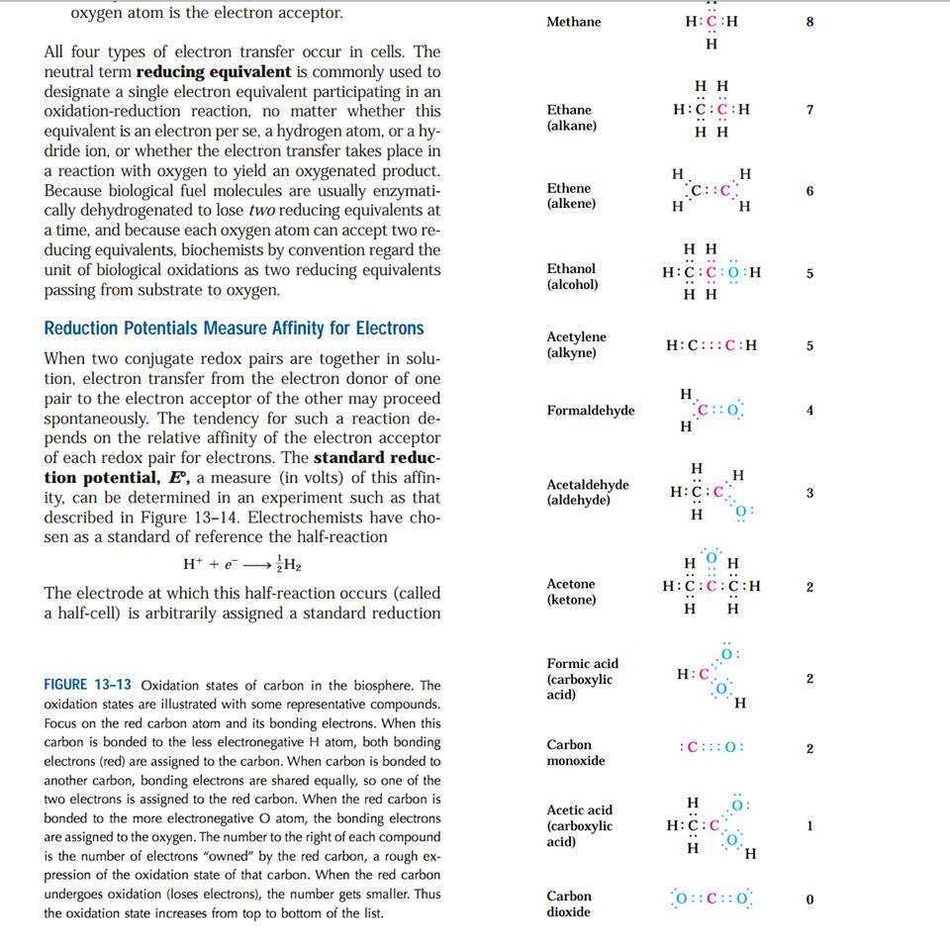
- Numbers at the right indicate how many electrons are “owned” by the red carbon

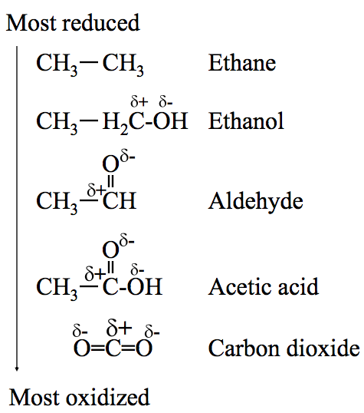

Five Oxidation States of Carbon
- In ethane, charges at electrons counterbalance charges at nuclei so that each atom has a near-to-zero partial charge
- In oxidized compounds, electrons shift from carbon to oxygen, the oxidized carbon bears a positive partial charge, while oxygen a negative partial charge.
  - The whole molecules remain electro neutral.
- If electrons withdraw from an atom or leave it, the atom is said to be oxidized even if oxygen is not involved in this process
Redox Reactions
- In oxidation-reduction reactions (redox reactions), electrons are transferred from a donor to an acceptor.
- Oxidation is the loss of electrons
- Reduction is the gain of electrons.
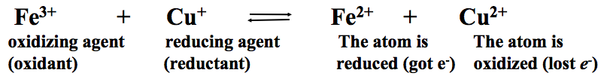
- The above reaction may be considered as a sum of half of two reaction
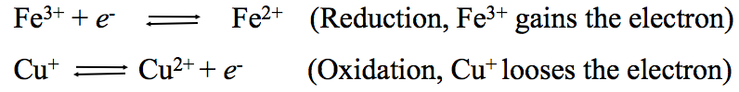
- Half reactions always occur in pairs because free electrons do not exist in living organisms (electrons move by changing carriers).

Reduction of NAD+ to NADH
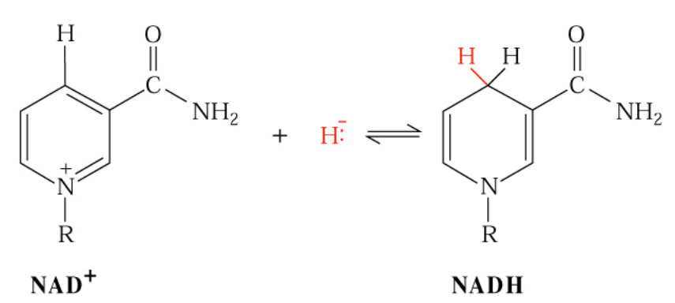
Four Ways of Electron Transfer
- Direct transfer: Fe³⁺ + Cu⁺ ⇔Fe²⁺ + Cu²⁺
- Transfer in the form of hydrogen atoms: AH₂ ⇔ A + 2e⁻ + 2H⁺
- In the form of hydride ion H⁻ (H⁺ + 2e-) ex. NAD+ to NADH
- Direct combination of an organic reductant with oxygen:
- R-CH₃ + ½ O₂ ⇔ R-CH₂-OH

Redox Reactions Involving NADH
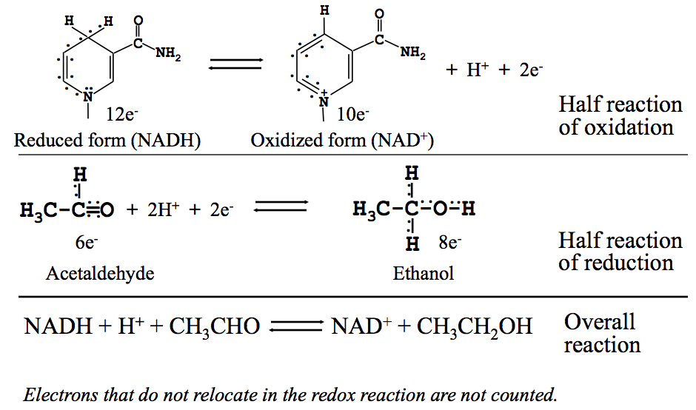

NADH and NADPH are Soluble Electron Carriers
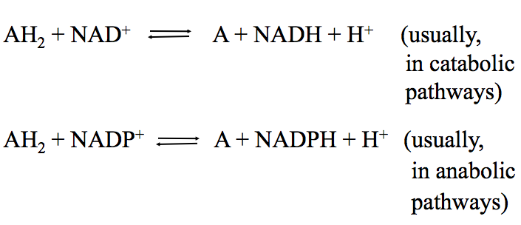
- More than 200 enzymes catalyze reactions of oxidation/reduction involving NADH, NAD+, NADPH, and NADP+
- A is the oxidized substrate; AH2 is the reduced substrate
- Enzymes involving NADH, NAD+, NADPH, and NADP+ are called dehydrogenase (the systematic name is oxidoreductases)
- The cofactors are loosely bound to dehydrogenase and readily diffuse from one enzyme to another
- Examples: Glucose-6-phosphate dehydrogenases, Alcohol dehydrogenase, Lactate dehydrogenases
Flavoproteins
- Flavoproteins catalyze oxidation-reduction reactions using flavin mono nucleotide (FMN) or flavin dinucleotide (FAD) as cofactor
- The cofactor may accept either one or two electrons in the form of hydrogen
- Flavin nucleotide is bound tightly to the enzymes
- Examples: succinate dehydrogenase, fatty acyl- CoA dehydrogenase

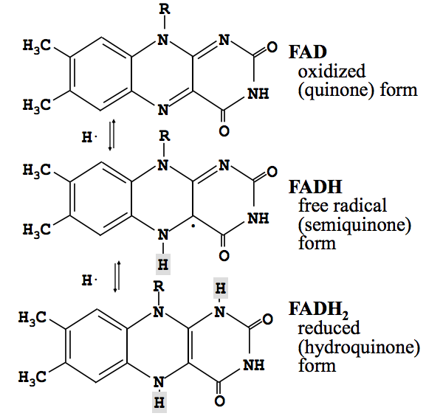
Coupled Reactions
- A) The phosphorylation of glucose to form glucose-6-phosphate and ADP
- B) The phosphorylation of ADP by phosphoenolpyruvate to form ATP and pyruvate.
- Each reaction has been conceptually decomposed into a direct phosphorylation step (half-reaction 1) and a step in which ATP is hydrolyzed (half-reaction 2). Both half-reactions proceed in the direction that makes the overall reaction exergonic (ΔG<0)
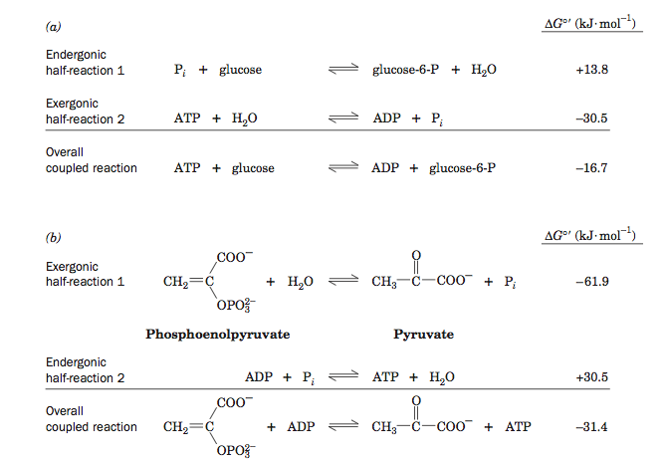
Systems Biology
- Systems biology studies complex interactions within biological systems
- Suffix - ome: “all constituents considered collectively
- Genome all of an organisms hereditary information.
  - Includes both the genes and the non-coding sequence
- Transcriptome set of mRNA and non-coding RNA molecules produced in a population of cells
- Proteome set of proteins expressed in a given type of cells at a given time under certain conditions
- Metabolome set of small-molecule metabolites to be found within a cell or organism at a given time under certain conditions
- Genomics, Transcriptomics, Proteomics, Metabolomics

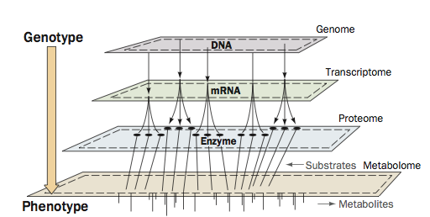
Systems Biology and Metabolism
- The relationship between genotype and phenotype. The path from genetic information (genotype) to metabolic function (phenotype) has several steps. Portions of the genome are transcribed to produce the transcriptome, which directs the synthesis of the proteome, whose various activities are responsible for synthesizing and degrading the components of the metabolome.
Yeast Gene Expressed in the Presence and Absence of Glucose
- All isolated mRNAs – transcriptome
- Reverse transcriptase is used to synthesize single–strand cDNAs (complementary DNAs), which are hybridized to the mRNA strands
- DNA microarray (DNA chip) a solid surface that contains microscopic spots to which single-stranded DNA molecules, which represent a part of the proteome, are attached.
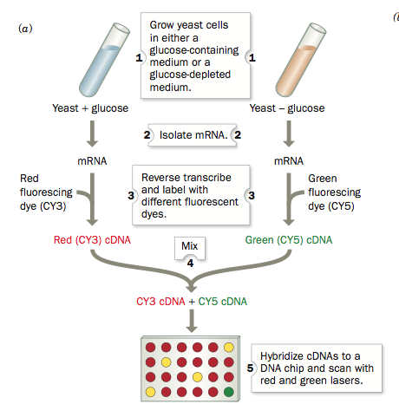
DNA Chip
- DNA chip is used to measure the expression levels of many genes simultaneously

Glucose Metabolism 1: Lecture 16
Metabolism Without Tears
- Control amount of detail: focus on ideas that make sense (e.g. food & nutrition), leave enzymes mechanism to the specialists
- Think of analogy to everyday situations (e.g. metabolic reactions as highways)
- Use ball-park figures (e.g., ATP hydrolysis ~ 30 kJ/mol)
- Understand why (biological functions: e.g. to provide energy even without O₂)
- Learn overall scheme (e.g., 6 C goes to 2 x 3C) and input/output (e.g., ATP, NADH)
- Note key intermediates (e.g. pyruvate)
- Study types of reactions, enzymes, cofactors
- Connect to other pathways, control points
Metabolic Role of Glucose
- Glucose is a standard preferred source of energy (fuel) for brain, muscle and other organs and tissues
- Red blood cells use only glucose as the source of energy
- Glucose is supplied to the organs and tissues via blood
- The concentrations of glucose in blood is kept almost constant
- Too low level of blood glucose leads to coma (deep unconsciousness, usually the result of injury, disease, or poison)
- If the blood level of glucose is too high, it is excreted via kidneys diabetes
- The blood level of glucose is carefully regulated
- Glucose is widely available
  - Grapes and other fruits
  - Disaccharides (sucrose)
  - In highly polymerized form as starch (bread, pasta, potatoes, rice)
  - As liver or muscle glycogen
- In the absence of these produces, glucose is synthesized from proteins via Amino acids
- Glucose catabolism provide large amount of energy:
  - Almost 3000 kJ/mole is released by oxidation
  - Much less (~5-6%) is released during the breakdown of glucose (6C) to 2 pyruvate molecules (3C)
- Glucose catabolism provides intermediates for other metabolic pathways (e.g., ribose)
Glycolysis
- Stage 1 energy investment
  - 2ATP
  - In this preparatory stage, the hexose glucose is phosphorylated and cleaved to yield two molecules of the trios glyceraldehyde-3-phosphate
  - This process consumes 2 ATP
- Stage 2 energy recovery: 4ATP, 2NADH
  - The two molecules of glyceraldehyrde-3-phosphate are converted to pyruvate with concomitant generation of 4 ATP
- Glycolysis therefore has a net “profit” of 2 ATP per glucose
- Stage 1 consumes 2ATP, stage II produces 4 ATP
A. Phosphoryl Group Transfer
- Transfer of a phosphoryl group from ATP to glucose to form glucose-6- phosphate (G6P)
- Hexokinase catalyzes this reaction
- First molecule of ATP is utilized
Glucose Binding to Hexokinase
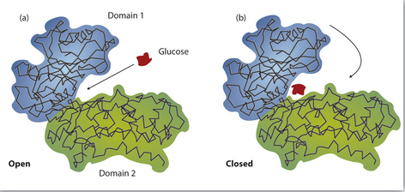
B. Conversion of G6P to F6P
- The substrate binds
- The enzymatic acid, probably the E-amino group of a conserved Lys residue, catalyzes ring opening. Acid catalyzed ring opening
- A base thought to be a His imidazole group, abstracts the acidic proton from C2 to form a cis- enediolate intermediate (the proton is acidic because it is alpha to a carbon group). Base catalysis
- The proton is replaced on C1 in an overall proton transfer. Protons abstracted by bases rapidly exchange with solvent protons. Acid catalysis
- The ring closes to form the product, which subsequently released to yield free enzyme, thereby completing the catalytic cycle. Base-catalyzed ring closure
- Ring opening
- Isomerization of alludes to a ketose
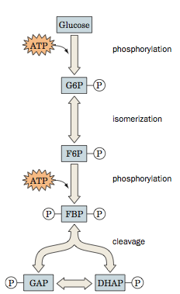
- Ring closure
- Phosphoglucose Isomerase (PGI)
C. Phosphorylation of F6P
- The second ATP molecule is utilized
- Phosphofructokinase (PFK) catalyzes one of the rate-limiting reactions of the pathway.
  - Plays a central role in the control of glycolysis
D. Cleaving Fructose- 1,6-Biphosphate
- FBP (hexose) is cleaved to two trioses
- The reaction is catalyzed by aldolase
- Only GAP continues along the glycolytic pathway. DHAP and GAP, the ketose-aldose isomers are interconvertable
E. Triose Phosphate Isomerase

First Stage of Glycolysis
- A hexose is phosphorylated, isomerized, phosphorylated again, and then cleaved to two inter-convertible triose phosphates
- Investments: 2 ATP are consumed
F. Oxidation and Phosphorylation of GAP
- An exergonic reaction of aldehyde oxidation drives the synthesis of the high-energy compound 1,3, BPG
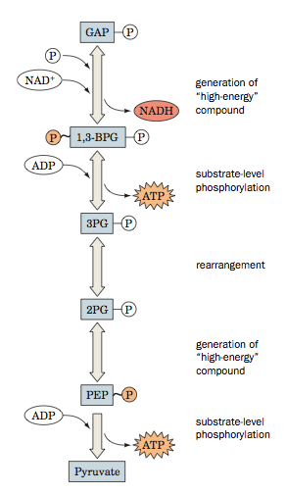
- First high-energy intermediate, NADH is produced
G. 1,3-BPG Dephosphorylation
- First ATP molecule is generated
H. Conversion of 3PG to 2PG
- In this energetically neutral reaction, the phosphate group is transferred within the molecule to prepare a reactant for the next stage of glycolysis
I. Dehydration of 2PG
J. Pyruvate Synthesis
- Pyruvate kinase
- The reaction is very favorable energetically
Counting Income
- Products of glycolysis
- NADH= 2
- ATP -2 +4 =2
- Pyruvate = 2
- In some tissues, ATP produced by the glycolysis satisfies most of the energy needs
- Pyruvate still contains a large amount of energy

Lecture 17: Glucose Part 2
- Glycolysis
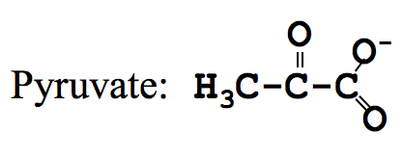

One Glucose Molecule Yields Energy Plus 2 Pyruvate Molecules
- First stage of glycolysis (right)
- Second Stage of glycolysis (left)
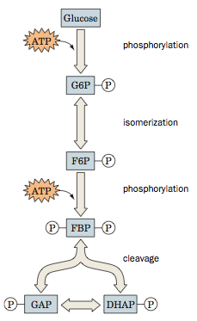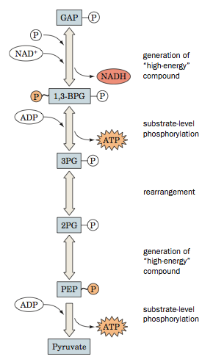

Metabolic Fates of Pyruvate
- Under aerobic conditions the pyruvate is completely oxidized to CO₂ and H₂O via the citric acid cycle
- Under anaerobic conditions pyruvate must be converted to a reduced end product in order to deoxidize the NADH produced by the GAPDH reaction. This occurs in two ways:
- Under anaerobic conditions in muscle, pyruvate is reduced to lactate to regenerate NAD+ in a process known as homolactic fermentation
- In yeast, pyruvate is decarboxylated to yield CO₂ and actealdehyde, which is then reduced by NADH to yield NAD+ and ethanol alcoholic fermentation
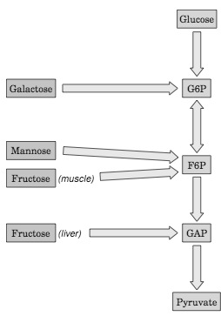
Homolactic Fermentation
- Occurs in muscle, particularly during vigorous activity when
  - High demand for ATP
  - Short supply of oxygen
- Overall process of anaerobic glycolysis
- Glucose + 2 ADP + 2 Pi → 2 lactate + 2 ATP + 2 H 2O + 2 H⁺
- Muscle fatigue and soreness is caused by low pH, not by lactate. Muscle can work long if the pH is kept constant
Anaerobic Glycolysis: Low Efficient but Fast
- Glucose 2 Lactose + 2H⁺ ΔG^{0”} = -196 kJ/mol
- The rate of ATP production by anaerobic glycolysis can be up to 100 times faster than that of oxidative phosphorylation
- When muscles work hard, they rapidly consume ATP and regenerate it almost entirely via anaerobic glycolysis
- Lactate is not oxidized further (the dead end in the pathway). However, the energy reserve is not wasted. Lactate is:
  - Carried by the blood to the liver where new glucose is synthesized
  - Converted to pyruvate in muscle
Glycolytic ATP Production in Muscle
- The muscle of distance runners are rich in slow-twitch fibers
  - Slow-twitch muscle fibres (dark) obtain energy via oxidative phosphorylation. They are enriched with mitochondria
- The muscle of sprinters are rich in fast twitch fibers
  - Fast twitch muscle fibers (light) obtain energy via anaerobic glycolysis

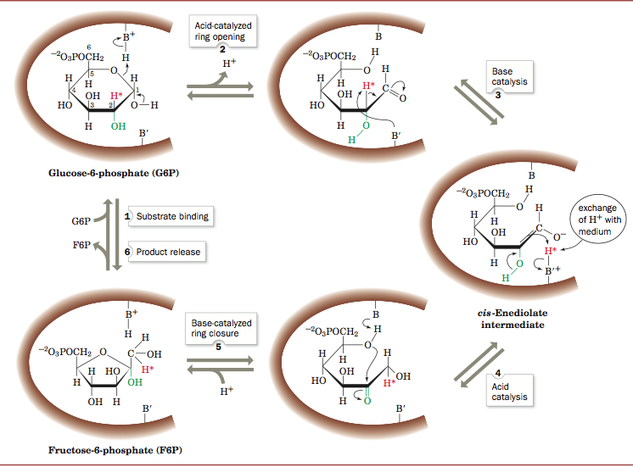
Alcoholic Fermentation
- Occurs in yeast.
- Fermentation is used for thousands of years to produce wine and bread
  - Glucose 2CO₂ + 2-ethanol
    - ΔG^{0”} = -235 kJ/mol
- The alcoholic fermentation is low-effective
- The Pasteur effect yeast consume more sugar when growing anaerobically than when growing aerobically
What is Next with Pyruvate?
- Acetyl-CoA is formed from pyruvate in a multi enzyme complex called pyruvate dehydrogenase
- Thiamine pyrophosphate (TPP) is a cofactor of pyruvate dehydrogenase

Thiamine
- TPP is a coenzyme in pyruvate decarboxylase
- In vertebrates, TPP is a cofactor in several important reactions.
- Thiamine (vitamin B1 is required in diets)
- The teaming deficiency causes a fatal disease beriberi that
  - Was prevalent in some areas of Asia where rice preparation involved removal of thiamine-containing outer layers of the germ
  - Develops in chronic alcoholics because of poor diet habits
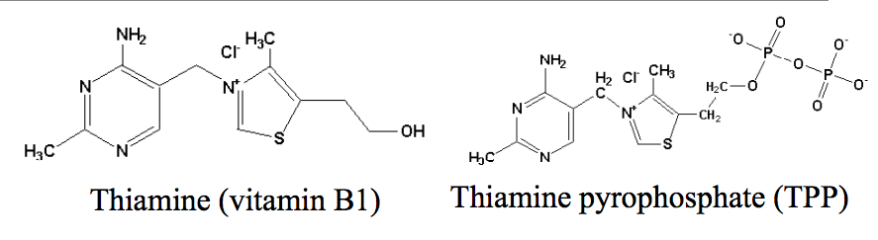
Takaki Kanehiro: Japanese Naval Physician
- In the early 1880’s, two ships left japan on similar 9-month voyages, but with different diets
- The first ship served the usual fare of rice, with some vegetables and fish. The second also served the crew wheat and milk, and more meat
- Beriberi ravaged the first ship, causing 25 deaths. There were not deaths on the second ship
- Takaki soon persuaded the Japanese Admiralty to adopt a new diet for the entire navy
Catabolism of Other Hexoses
- Fructose, galactose, and mannose are also prominent metabolic fuels
- These monosaccharides are carried by the bloodstream to various tissues
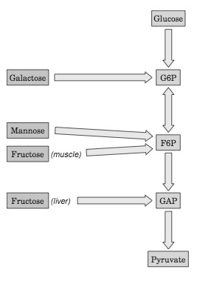
- There they are converted to glycolytic intermediates, which enter the major glycolytic pathway
Entry Points of Hexoses
- G6P, Glucose-6-phosphate
- F6P, Fructose-6-phosphate
- GAP, Glyceraldehyde-3-phosphate
Conversion of Mannose to F6P
- Fructose, mannose and galactose (monosaccharides) are converted to glycolytic intermediates that are then metabolized by the glycolytic pathway
- Fructose (in muscle) and mannose are converted to F6P
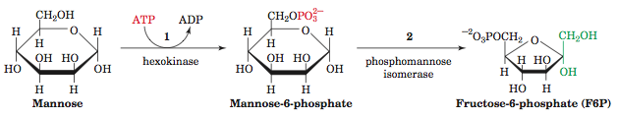
Pentose Phosphate Pathway
- Many endergonic reactions, e.g., biosynthesis of fatty acids and cholesterol, require NADPH
- NADPH is generated from G6P via an alternative pathway of glycolysis, the pentose phosphate pathway
- Ru5P, Ribulose-5-Phosphate
- Xu5P, Xylulose-5-Phosphate
- R5P, Ribulose-5-Phosphate
- Tissues heavily involved in the lipid biosynthesis (liver, mammary glad, adipose tissue) are rich in the enzyme
- 30% of glucose in liver oxidized via this pathway

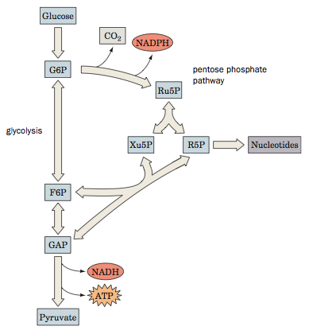

Lecture 18: Glucose Storage and Synthesis
- Brain, RBC and some other tissues depends almost entirely on glucose as the source of energy
- Glycogen is the stockpile of glucose for later metabolic use
- A constant concentration of glucose in blood (~5mM) is provided by glycogen mobilization
- Mobilization of glucose from glycogen occurs primarily in the liver
- After the meal, glucose is plentiful
  - Glycogen is synthesized
- Liver glycogen can supply brain and erythrocytes with glucose for ~12 hours after a good meal can have enough glycogen to supply tissues with glucose for 12 hours
- Muscle stores more glycogen than liver but it does not share glycogen with other organs or tissues muscles are “selfish cells” important for fight/flight responses
- Under fasting conditions, glucose is synthesized from non-carbohydrate precursors (e g amino acids) gluconeogenesis
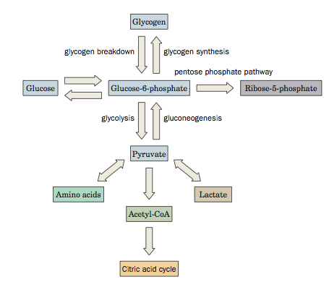
Overview of Glucose Metabolism
- G6P is produced by:
  - Phosphorylation of free glucose
  - Glycogen degradation
  - Gluconeogenesis
- G6P is also the precursor for glycogen synthesis and the pentose phosphate pathway
- Lactate and amino acids, which are reversibly converted to pyruvate, are precursors for gluconeogenesis
- Even if you don't have food at all for several days, concentration of glucose in circulation is pretty constant (homeostasis will shift metabolism of carbs over to amino acids)
- Key intermediates: G6P- starting point for biosynthesis of glycogen and glycolysis
- Need to know names of intermediates for glycolytic pathway:
  - Not so much order
  - Same is true for citric acid and oxidative phosphorylation
  - Do not need to know structural formulas of above
  - Structural formulas to know: amino acids, nucleotides/bases, pyruvate
The Structure of Glycogen
- Glycogen is extremely branched glucose can only be removed from end of branches so speeds up releases of glucose
- There are two types of “ends” in glycogen: non-reducing and reducing ends (anomeric carbon is involved in glycosidic bond + not involved in glycosidic bond respectively)
- Reducing end the sugar whose anomeric carbon does not form a glycosidic bond
- Non-reducing ends sugars whose anomeric carbons form glycosidic bonds
- Why glucose is stored in the polymerized form?
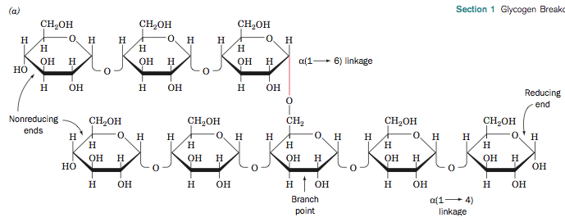

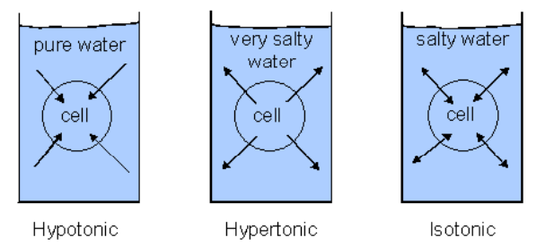
Osmosis
- Diffusion of a convent through a selectively-permeable membrane from a region of low solute concentration to a region of high solute concentration
- For any cell, most glucose molecules are in the glycogen form
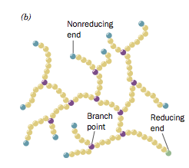
- Osmotic pressure is the reason why our cells do not keep very large amounts of monomers
Branched Structure of Glycogen
- Many non-reducing ends
- One reducing end
- Glucose units are mobilized by their sequential removal from non-reducing ends
- The highly branched structure of glycogen ensures rapid mobilization of glucose
- Many glucose units are released simultaneously at the end of every branch
Glycogen Breakdown (Glycogenolysis)
- Three enzymes involved:
  - Glycogen phophorylase
  - Glycogen debranching enzyme
  - Phosphoglucomutase
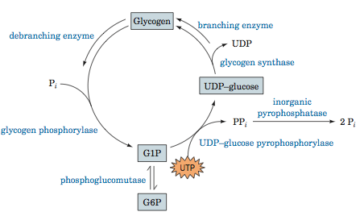
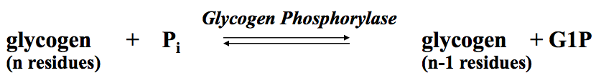

- Glycogen phosphorylase cannot release monomers, which are less than five units away from a branch point
Glycogen De-branching Enzyme
- The enzyme transfers the chain of three terminal glucose residues from the “limit branch” of glycogen to the non-reducing end of another branch
- De-branching enzyme has specific topography that allows it to approach branches that move shorter branches to longer branches because phosphorylase is too big to get close enough
  - De-branching enzyme doesn't remove whole stand but leave one glucose unit behind
  - Need less de-branching enzyme
- The remaining unit in the former branch is hydrolyzed (not phosphorolyzed) by the same enzyme to yield glucose and de-branched glycogen

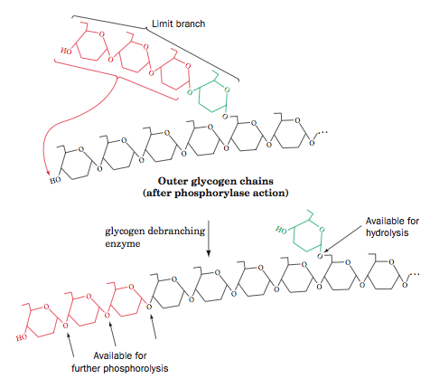

Phosphoglucomutase
- Phosphoglycomutase converts G1P to G6P.
- This near equilibrium reaction also functions in reverse
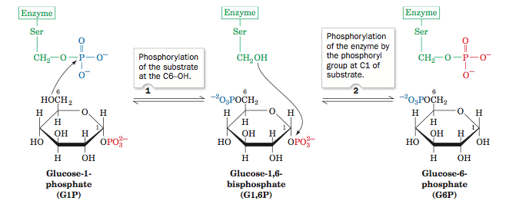

Glycogen Synthesis
- Biosynthesis is more complex then degradation of glycogen but phosphoglucomutase is common to both
- Also need UTP- uridine triphosphate molecule because its an endergonic process (anabolic process requires energy)
- UDP- glucose pyrophosphorylase takes one unit of G1P and attaches UDP to it
- Uridine, nucleoside of uracil
  - UDP, uridine diphosphate
  - UTP, uridine triphosphate
- Enzymes needed:
  - UDP- glucose pyrophosphorylase
  - Glycogen Synthase
  - Glycogen branching enzyme
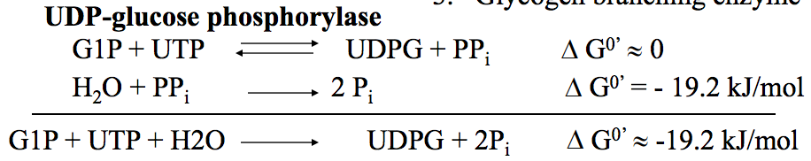
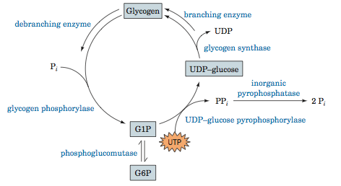

Glycogen Synthase
- UDPG is the “carrier” of glucose molecule
- When UDPG (uridine diphosphate glucose) approaches growing branch it is attached
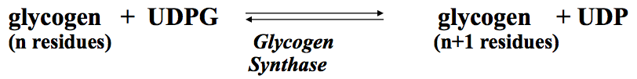
Glycogen Branching Enzyme
- Glycogen synthase produces a liner polysaccharide (a-amylose)
- Glycogen branding enzyme makes branches by transferring 7-residue segments from the end of a C6-OH group of glucose residue
- Glycogen branching enzyme finds long branch, removes piece of branch, and attaches to another point
Glycogen Storage Diseases
- Inherited disorders
- Genetic enzyme deficiencies cause accumulation of glycogen that is abnormal in quantity or quality
- Liver diseases enlarged liver, low blood sugar (hypoglycemia)
- Muscle diseases: muscle cramps and weakness
- Do not need to memorize names of diseases and enzymes in the chart
- Know which tissues are affected by glycogen storage disease: tissues and organs with a lot of glycogen = liver and muscle
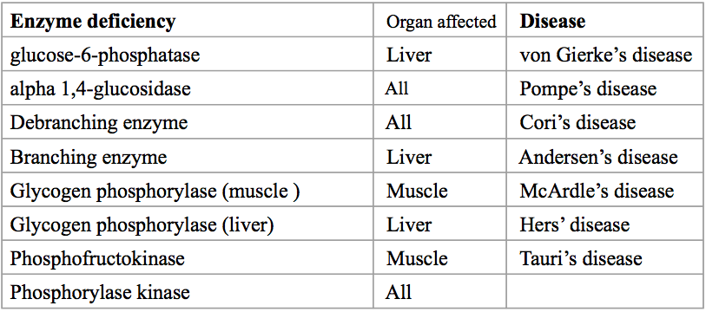

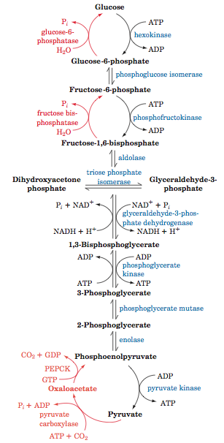

Gluconeogenesis
- Glucose levels in circulation is not dependent on diet/lack of diet
- Occurs when the dietary glucose is not available and the supply of liver glycogen is exhausted
- Provided large fraction of glucose within a few hours after eating
- Non-carbohydrate precursors that can be converted to glucose:
  - Lactate
  - Pyruvate (can get pyruvate by AA)
  - Citric acid cycle intermediates
  - Carbon skeletons of most amino acids
- All these substances are first converted to oxaloacetate

Gluconeogenesis vs. Glycolysis
- Do not have to remember all names of enzymes for gluconeogenesis, only remember for glycolysis intermediates and enzymes are practically the same
- Glycolysis does not have a 10th step
- Some specific enzymes are 1st, 3rd, 9th and 10th step
- Red gluconeogenesis
- Blue glycolysis

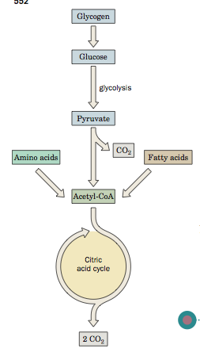
Lecture 19: Citric Acid Cycle Part 1
Overview
- In aerobic organisms, metabolic fuels are oxidized in the citric acid cycle
- The citric acid cycle is a central pathway for obtaining energy from carbohydrates, fatty acids and amino acids
- Before entering the citric acid cycle, the metabolic fuels are decomposed and transformed to two-carbon acetyl groups -CO-CH₃
- The acetyl groups are attached to CoA to form acetyl-CoA
Oxidative Fuel Metabolism
- Intermediated of the citric acid cycle contain four to six carbon carboxylic group
- Acetyl groups derived from carbohydrate, amino acids, and fatty acids, enter the citric acid cycle
- In the citric acid cycle, the acetyl groups are oxidized to CO₂
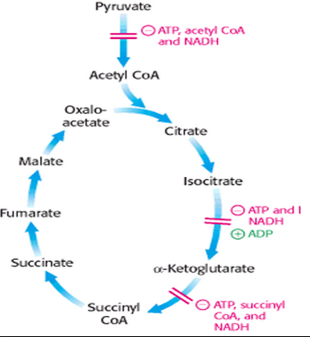
Reactions of the Citric Acid Cycle
- The net reaction of the citric acid cycle:
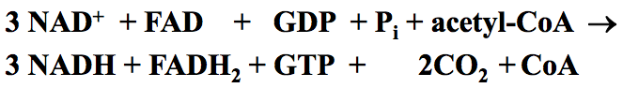

- The citric acid cycle is a series of eight reactions in which the acetyl group of acetyl -CoA is oxidized to two molecules of CO₂
- In the oxidation process, four pairs of electrons are released.
- Three pairs of electrons are consumed in the reduction of three NAD+ to three NADH.
- One pair of electrons is consumed in the reduction of FAD to FADH₂
- Oxaloacetates, the product of the last step (malate dehydrogenase), has four carbons
- Citrate, the product of the first step (citrate synthase) of the cycle has six carbons
- The reactants and products are boxed
General Features
- Citric acid cycle is also called the Krebs cycle or the tricarboxylic acid cycle
- Citric acid cycle is the “hub” of cellular metabolism: it accounts for the major part of the carbohydrate, fatty acid and amino acid oxidation
- The citric acid cycle is a multi-step catalyst: the reactant of the first step, oxaloacetate, is the product of the last step.
- The free energy of oxidation is conserved in the four reduced coenzymes and in GTP.
- In eukaryotes, all enzymes of the citric acid cycle are located in mitochondria
- Substrates are either synthesized in mitochondria or imported to mitochondria
- Products are either consumed in mitochondria or exported from mitochondria
Synthesis of Acetyl CoA
- Acetyl-CoA is formed from pyruvate in a multi enzyme complex
- Pyruvate + CoA + NAD+ acetyl-CoA + CO2 + NADH
- The multi enzyme complex contains three types of enzymes:
  - E1, pyruvate dehydrogenase that decarboxylates pyruvate
  - E2, dihydrolipoyl transacetylase that transfers the acetyl group to CoA
  - E3, dihydrolipoyl dehydrogenase that reduces NAD+ to NADH
- The complex requires five coenzymes: thiamine pyrophosphate (TPP), lipoid acid, coenzyme A, FAD and NAD+
Multi-enzyme Complexes
- A multi-enzyme complex is a group of noncovalently associated enzymes that catalyze several sequential step in a metabolic pathway
- Advantages of multi-enzyme complexes:
  - Enhancing the reaction rate by decreasing the distance between the enzymes and hence the time of diffusion of substrates and products
  - Minimizing size reactions by reducing a probability for intermediates to react with other molecules
  - Coordinated control of catalyzed reactions
Pyruvate Dehydrogenase Complex
- The 24 dihydrolipoyl transacetylase proteins (E2, green) associate as trimers at the corners of the cube
- The 24 pyruvate dehydrogenase proteins (E1, orange) form dimers that associate with the E2 core
- The 12-dihydrolipoyl dehydrogenase proteins (E3, purple) form dimers that associate with the six faces of the E2 cube.
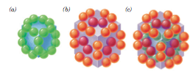
Reactions in the Pyruvate Dehydrogenase Multi-Enzyme Complex
- Pyruvate decarboxylationTPP, Thiamine pyrophosphate
- Reduction of lipoamide and oxidation of hydroxyethyl
- Transfer of Acetyl group to CoA
- Regeneration of lipoamide
- Oxidation of E3 with reduction of NAD+

The Coenzymes and Prosthetic Groups of Pyruvate Dehydrogenase
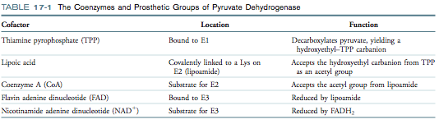
The Lypoillysyl Arm in E2
- The reaction intermediates in the multi enzyme pyruvate dehydrogenase complex move between the three enzymes with the help of a long flexible lypoillysyl arm.
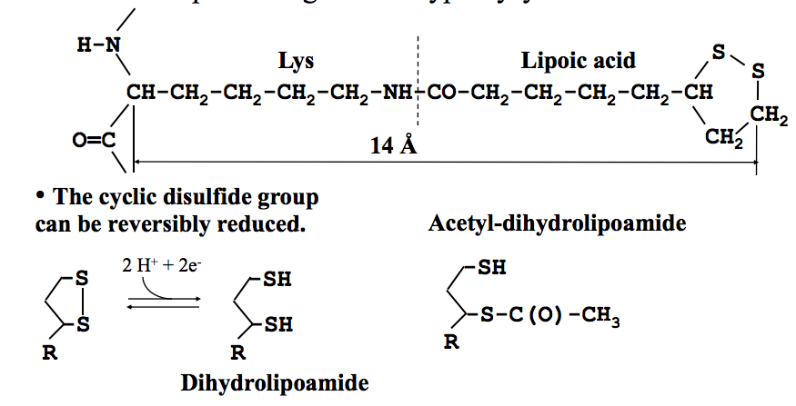
Arsenic Poisoning
- The toxicity of arsenite and organic arsenicals is due to inactivation of lipoamide-containing enzymes such as pyruvate dehydrogenase
- Napoleon Bonaparte died from arsenic poisoning at the age of 52. A possible source of the poison was the wallpaper in Napoleon’s room on the island of St. Helena that contained the arsenic dyes
- In the damp climate, fungi converted the arsenic to a volatile compound
- Organic arsenicals, which are more toxic to microorganisms than to humans, were the first antibiotics used in the early XX century.
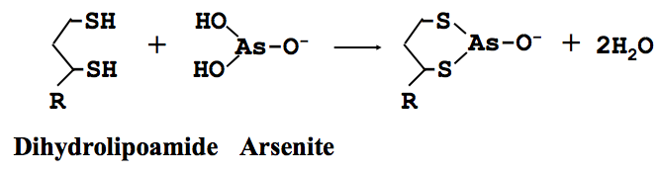
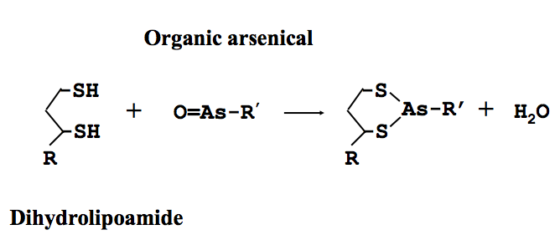

Citric Acid Cycle Part 2
1) Citrate Synthase
- Catalyzes the condensation of Acetyl CoA and oxaloacetate
- The initial reaction of the citric acid cycle
- Carbon atoms from carbohydrates, fatty acids, and amino acids enter the cycle in the form of acetyl group attached to CoA
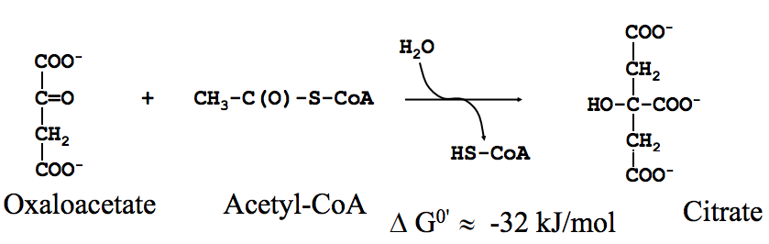

2) Aconitase
- Aconitase catalyzes the reversible isomerization of citrate and isocitrate with cis-aconitate as an intermediate
- The hydration of the double bond of cis-aconitate could yield four stereoisomers.
- The enzyme catalyzes synthesis of only one isomer, isocitrate
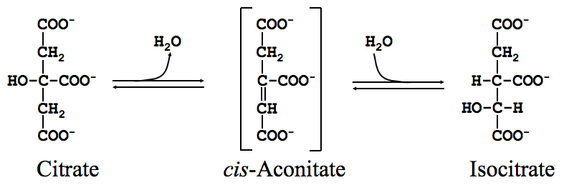

3) NAD+ Dependent Isocitrate Dehydrogenase
- The enzyme catalyzes the oxidative decarboxylation of isocitrate to α-ketoglutarate
- The reaction produces CO₂ and NADH
- The CO₂ carbon entered the first stage of the citric acid cycle as a component of oxaloacetate rather than a component of Acetyl-CoA
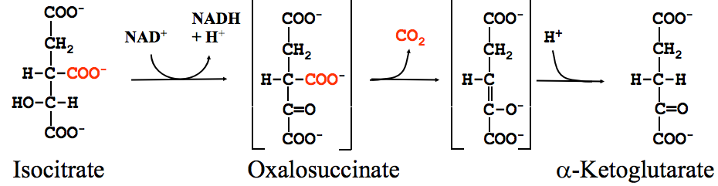

4) α-Ketoglutarate Dehydrogenase
- α-ketoglutarate dehydrogenase is a multi-enzyme complex similar to the pyruvate dehydrogenase
- The vitamin thiamine among coenzymes of the complex
- The complex catalyzes the oxidative decarboxylation of α-ketoglutarate
- The reaction produced CO₂, NADH and a high energy thioester, succinyl-CoA

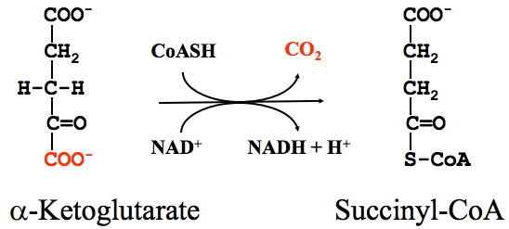

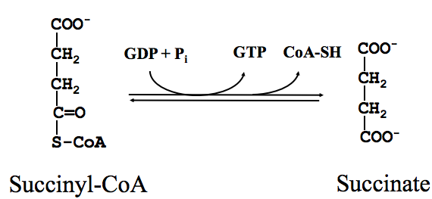
5) Succinyl-CoA Synthetase
- The enzyme catalyzes the conversion of succinyl-CoA to succinate.
- The enzyme couples the exergonic hydrolysis of succinyl-CoA thioester bond (ΔG⁰'≈-33 kJ/mol) to the endergonic synthesis of the high-energy GTP (Δ G⁰' ≈ 30 kJ/mol)

6) Succinate Dehydrogenase
- The enzyme that catalyzes the dehydrogenation of succinate to fumarate with reducing FAD to FADH₂
- The FAD prosthetic group is covalently linked to the enzyme
- Succinate dehydrogenase is the only membrane-bound enzyme of the citric acid cycle
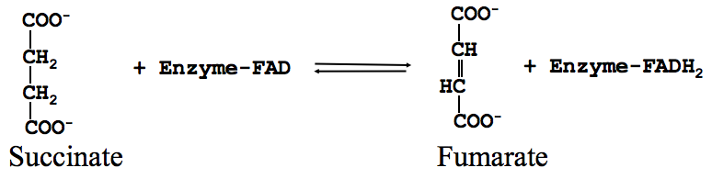
- Upon re-oxidation of FADH₂, the released electrons enter the electron-transport chain of mitochondria

7) Fumarase
- The enzyme catalyzes the hydration of the trans double bond of fumarate to form malate
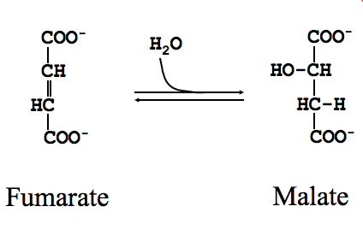

8) Malate dehydrogenase
- The enzyme catalyzes the final step of the citric acid cycle, the oxidation of malate to oxaloacetate
- Simultaneously, NAD⁺ is reduced to yield NADH and H⁺
- Under standard conditions, the reaction is endergonic
- It proceeds from left to right because oxaloacetate, the product of the reaction, is immediately consumed in the first reaction of the cycle
- The physiological concentration of oxaloacetate is very low
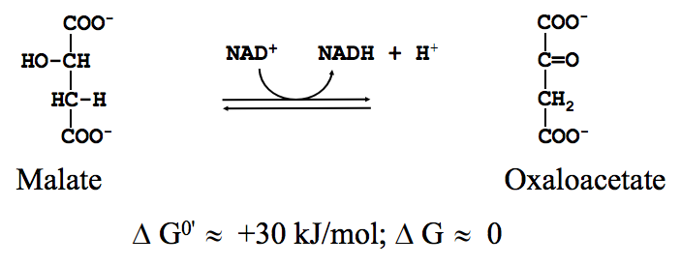

Accounting Energy of Glucose Metabolism
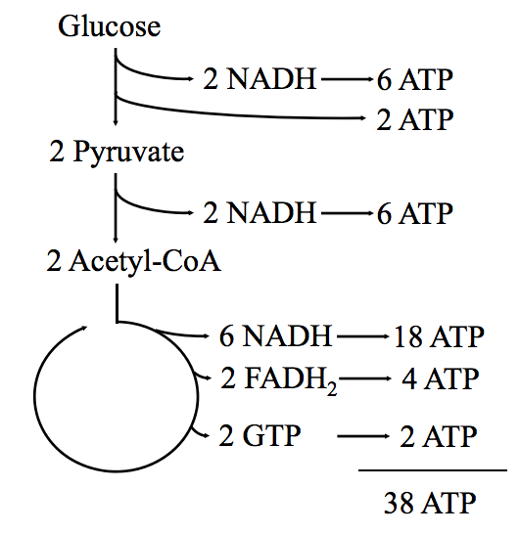

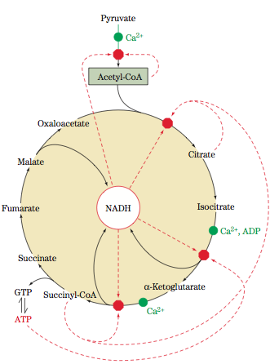
Free Energy Changes of CAC Reactions
- Add textbook info
Regulation of the CAC
- Regulation of the citric acid cycle keeps the cell in the steady state
- Reactions are stimulated in active cells but inhibited in inactive cells
- Decarboxylation of pyruvate is irreversible, therefore, pyruvate dehydrogenase is carefully regulated by two mechanisms: inhibition by products (CoA, NADH) and phosphorylation by pyruvate dehydrogenase kinase
- Image This diagram of the citric acid cycle, which includes the pyruvate dehydrogenase reaction, indicates points of inhibition (red octagons) and the pathway intermediates that function as inhibitors (dashed red arrows). ADP and Ca2+ (green dots) are activators
- When glucose blood levels increase, insulin is released into the blood
- The hormone binding to the insulin receptor leads to activation of pyruvate dehydrogenase phosphatase
- Dephosphorylation of pyruvate dehydrogenase promotes the synthesis of acetyl-CoA
- Another mechanism of insulin action is activation of glycogen synthesis
- Ca2+ is the cellular second messenger that stimulates muscle contraction
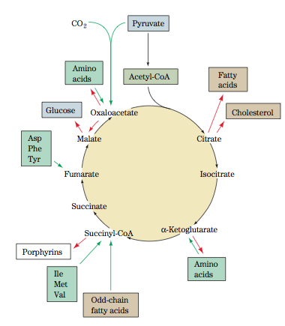
- Simultaneously, Ca2+ inhibits pyruvate dehydrogenase kinase but activates pyruvate dehydrogenase phosphatase, isocitrate dehydrogenase, and α -ketoglutarate dehydrogenase
Amphibolic Function of the CAC
- The cycle is catabolic since the acetyl groups are degraded
- The cycle is anabolic since its intermediates are starting compounds in several anabolic paths
- Thus, the cycle is amphibolic
- Glucose, FA, cholesterol, AA and porphyrins are synthesized in anabolic pathways that consume CAC intermediates
- Image diagram shows the positions at which intermediates are drawn off by cataplerotic reactions for use in anabolic pathways (red arrows) and the points where anaplerotic reactions replenish cycle intermediates (green arrows)
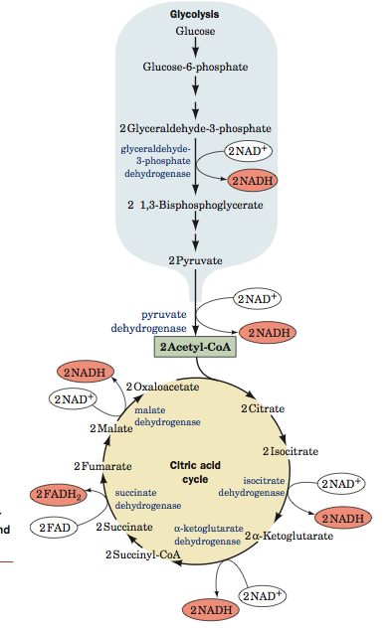
- Consumption of the CAC intermediates in anabolic pathways does not stop the cycle because the loss is replenished by four and five-carbon end products of many catabolic pathways
- The end products of catabolic pathways that degrade AAs and odd chain Fas enter the CAC as fuels

Lecture 21: Mitochondria and Electron Transport
NADH and FADH₂
- The sites of electron transfer that form NADH and FADH₂ in glycolysis and CAC
Two Half Reactions of Complete Oxidation of Glucose
- Overall Reaction
  - C₆H₁₂O₆ + 6O₂ 6CO₂ + 6H₂O
- Two half reactions:
  - C₆H₁₂O₆ + 6H₂O 6CO₂ + 24H⁺ + 24e-
    - Glycolysis and CAC
  - 6O₂ + 24H⁺ + 24e- 12H₂O
    - ETC
The Fate of Electrons Released Upon Glucose Oxidation
- The “elementary” steps of the first half-reaction take place in the cytosol (glycolysis) and in the mitochondrion (the citric acid cycle).
  - The released 12 electron pairs reduce 10 NAD + and 2 FAD yielding 10 NADH and 2 FADH₂
- “Elementary” steps of the second half-reaction take place in the mitochondrion
  - The 12 electron pairs move from NADH and FADH₂ to the ETC that includes more than 10 redox centers in 4 enzyme complexes
- The electron transfer pumps protons out of the matrix in the intermembrane space.
- The resulting electrochemical gradient drives the synthesis of ATP from ADP and Pi in the oxidative phosphorylation process.
The Mitochondrion
- The mitochondrion (Greek: mitos, thread + chondros, granule) is an ellipsoidal-shape organelle with the dimensions of 0.5 x 1 μM
- A typical eukaryotic cell contains about 2000 mitochondria, which occupy 20% of the cell volume.
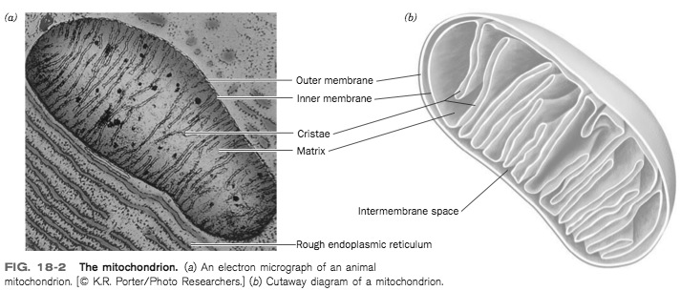
- Mitochondria, which contain their own DNA, ribosomes, an d tRNAs, are thought to evolve from aerobic bacteria that formed symbiotic relationships with primordial eukaryotes
- The mitochondrial outer membrane is permeable for molecules up to 10 kD.
- The protein-rich inner membrane surrounds a matrix.
- The inner membrane is freely permeable only to O₂, CO₂, and H₂O.
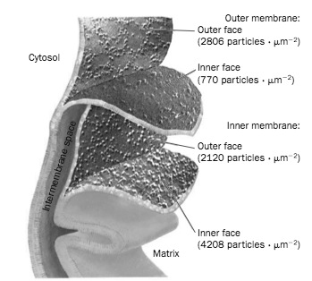
- Mitochondria are the “power plants” of the cell.
Inner and Outer Mitochondrial Membranes
- Concentrations of metabolites and ions in the mitochondrial intermembrane space are equal to those in the cytosol
- Metabolites are transported to and from the matrix via specialized systems
- Freeze-fracture and freeze-etch electron micrographs.
- The inner membrane contains ~ 2 times more particles than the outer membrane
The Glycerophosphate Shuttle
- NADH produced by glycolysis (cytosol) cannot permeate the mitochondrial inner membrane.
- Electrons from NADH are transported in the matrix by the glycerophosphate shuttle in three steps:
- Cytosolic oxidation of NADH coupled to reduction of dihydroacetone phosphate
- Oxidation of 3-phosphoglycerol coupled to reduction of FAD
- Oxidation of FADH₂ with release of two electrons in the electron transport chain
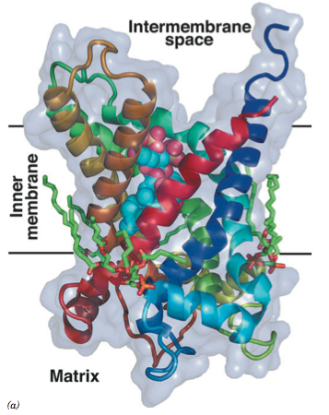
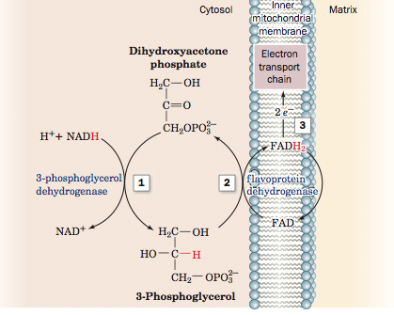
ADP-ATP Translocator
- ATP molecules are synthesized in the matrix
- ADP-STP translocator exchanged ATP for ADP in the cytosol
  - Pi is imorted to the matrix via a Pi-H+ symport system
Free Energy of NADH Oxidation
- The reaction of NADH oxidation
  - NADH + ½ O₂ + H⁺ ⇔ NAD⁺ + H₂O
  - Highly exergonic: ΔG⁰’ = -218 kJ/mol
- Phosphorylation of ADP to ATP is endergonic: ΔG⁰’ = 30.5 kJ/mol
- Oxidation of 1 mol of NADH drives the synthesis of 3 mol ATP
- The efficiency of oxidative phosphorylation under standard conditions:
  - [(3 x 30.5)/218] x 100 = 42%
- The efficiency of oxidative phosphorylation in the cell is ~70%
  - The efficiency of an automobile engine is <30%
The Electron Transport Chain
- Diagram indicates the pathways of electron transfer (blue) and proton translocation (red). Electrons are transferred between Complexes I and III by the membrane-soluble coenzyme Q (Q) and between complexes III and IV by the peripheral membrane protein cytochrome c. Complex II transfers electrons from succinate to coenzyme Q
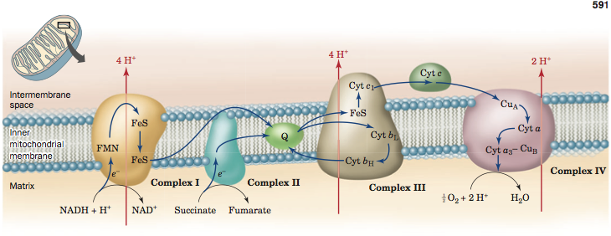
Redox Centers in the ETC
Redox Center | Electrons accepted/donated
NAD⁺ | 2
Flavin Adenine Dinucleotide (FAD) | 1 or 2
Flavin Mono Nucleotide (FMN) | 1 or 2
Coenzyme Q | 1 or 2
Iron-Sulfur Clusters | 1
Fe atoms in Cytochrome | 1
Cu atoms in cytochrome | 1
Coenzyme Q (Ubiquinone)
- The hydrophobic tale makes CoQ soluble in the inner mitochondrial membrane
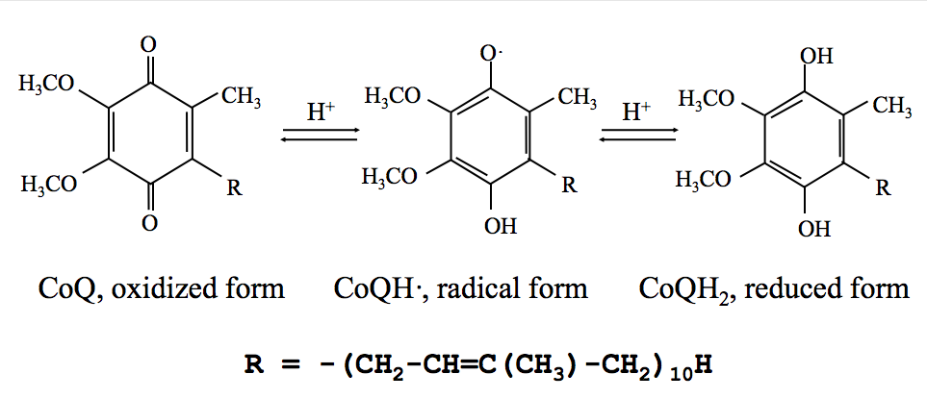

Cytochromes, Redox-Active Proteins
- Found in almost all organisms
- Contain heme groups with an iron atom that may alternate between Fe(II) and Fe(III) oxidation states
- Heme group responsible for light absorption
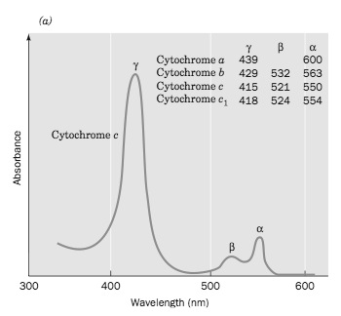
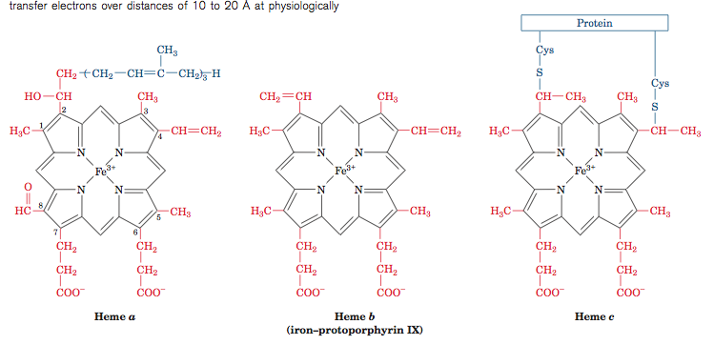
Absorption Spectra of Cytochromes
- The structure of the heme group and the light-absorption properties vary in different cytochromes
- The rightmost wavelength peak in the absorption spectrum identifies a cytochrome
- Absorption spectrum of cytochrome c₅₅₀
- Diagram: spectrum of cytochrome c
Complex III
- A reduced isolated heme group can “fire” an electron as far as 20 Å
- To prevent a non-specific electron transfer, cytochromes insulate the buried heme groups and provide specific pathways for the targeted transfer of electrons to other electron acceptors
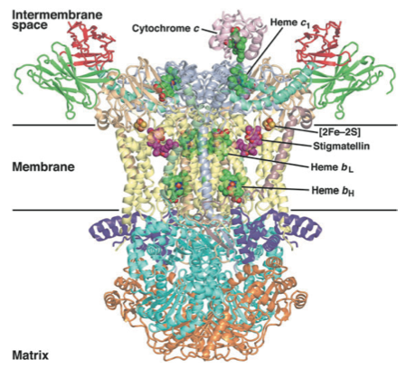

ETC in Mitochondria
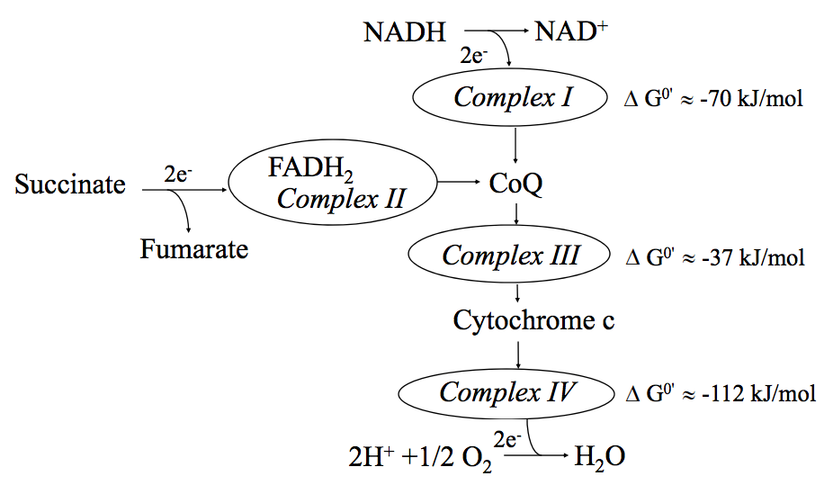
Lecture 22: Oxidative Phosphorylate
Complex 1: NADH-CoQ Oxidoreductase
- Catalyzes oxidation of NADH coupled to the reduction of CoQ
- The largest protein complex in the mitochondrial membrane
- Contains 43 polypeptides.
- Contains 7 redox centers: FMN and 6 iron-sulfur clusters
- Electrons pass between the centers in the stepwise fashion
- This diagram indicates the pathways of electron transfer (blue) and proton translocation (red).
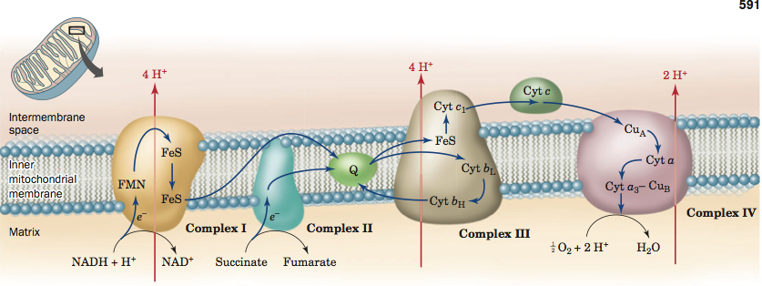
- NADH donated two electrons; cytochrome c can only accept 1 electron
- CoQ can transfer one or two electrons
- The electrons transfer between the 7 redox centers is coupled to pumping four protons out of the matrix
- The detailed mechanism of proton pumping remains unknown
Complex II: Succinate-CoQ Oxidoreductase
- This complex contain succinate dehydrogenase, the only membrane-bound enzyme of the citric acid cycle, and three other hydrophobic subunits
- The complex contains 5 redox centers: FAD, three Fe-S clusters, and cytochrome b
- Electrons move from succinate to FADH₂ then, through Fe-S clusters and cytochrome b, to CoQ
- Complex II works independently of the complex I
- CoQ moves freely with the lipid bilayer
  - It collects electrons from the complexes I and II, and transfers them to complex III
Complex III: CoQ-Cytochrome c Oxoreducatse
- This complex passes electrons from the reduced CoQ to cytochrome c.
- The complex contains four redox centers: two cytochromes b, cytochrome c1, and a Fe-S cluster
- The overall reaction
  - CoQH₂ + 2 cytochrome c₁ (Fe³⁺) + 2H⁺ (matrix) CoQ + 2 cytochrome c₁ (Fe²⁺) + 4H⁺ (intermembrane)
- Cytochrome c is a peripheral membrane protein
- It carries electrons in the intermembrane space from complex III to the complex IV
Complex IV: Cytochrome c Oxidase
- Cytochrome c oxidase catalyzes the overall reaction:
  - 4 Cytochrome c (Fe²⁺) + 4H⁺ + O₂ 4 cytochrome c (Fe³⁺) + 2H₂O
- Complex IV contains 4 redox centers
- The reaction is coupled to the pumping of two protons from the matrix to the intermembrane space
- The oxidation of NADH in the electron transport chain results in expelling of 10 protons from the matrix to the intermembrane space.
- The obtained proton gradient is used as a driving force in the endergonic reaction of ATP synthesis
Chemiosmotic Theory
- The free energy of electron transport is conserved by pumping H + from the matrix to the intermembrane space.
- The obtained electrochemical potential drives the synthesis of ATP
- The chemiosmotic theory was proposed in 1961 by Peter Mitchel to explain the following experimental observations:
  - Ions do not permeate via an intact inner mitochondrial membrane.
  - ATP synthesis is blocked by increasing permeability of the inner mitochondrial membrane for ions and protons.
  - Oxidation of NADH creates an electrochemical gradient across the inner membrane
  - ATP synthesis is stimulated by increasing the cytosolic [H⁺]

ATP Synthase
- The free energy invested in expelling one proton from the matric (21.5 kJ/mol) is less than the energy required to synthesize one ATP molecule from ADP and Pi (>40kJ/mol)
- ATP synthase catalyzes the endergonic synthesis of ATP by coupling it to the exergonic flow of protons to the matrix
- Downhill movement of three protons to the mitochondrial matrix releases energy necessary to synthesize one ATP molecule
- An electron micrograph of cristae from a mitochondrion with ATP synthase fragments projecting into the matrix
- ATP synthase is a multi-subunit protein composed of two functional parts: transmembrane proton channel and water-soluble peripheral membrane protein
- Compounds that block the proton permeation through the channel (e.g. antibiotic oligomycin B) inhibit ATP synthesis
How does ATP synthase move?
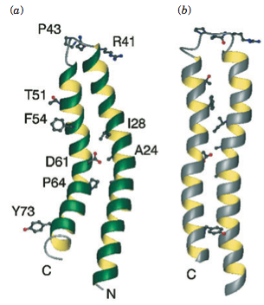
Lecture 23: Control of ATP Synthesis
ATP Synthase, a Molecular Motor
- F₀ forms a wheel, F₁ consists of a rod with one end fixed to the wheel’s hub
- The other end of the rod is embraced by a bundle of six α/β subunits
- Protons pass via the mitochondrial membrane back to the matrix forcing the rod to rotate within stationary bundle
- The rotation provides a mechanical energy necessary to catalyze the endergonic combining of ADP and Pi
Molecular Bearing
- One proton passing the F₀ channel swings F₁ by 120^{O}
- The synthesis of one ATP molecule from ADP and Pi requires 3 protons to make a 360^{O} turn of the rod
- Contacting surfaces of the rod and the wheel lack polar and ionogenic groups and contain predominantly hydrophobic residues that lubricate the bearing
- The 1997 Nobel prize was awarded to Paul Boyer and John Walker for their discovery of mechanism of ATP synthesis and to Jens Skou for his discovery of Na +/K+ ATPase.

Mechanism of ATP synthesis
- The three identical α/β interfaces can adopt three different conformations
  - Open conformation O doesn’t bind ligands
  - Catalytically inactive conformation L binds ligands loosely
  - Catalytically active conformation T binds ligands tightly
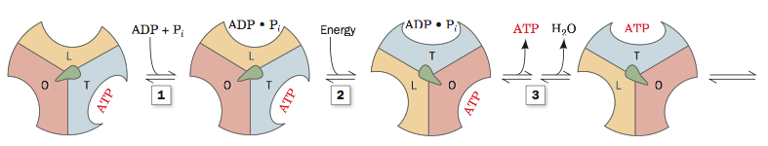
- Three Step ATP synthesis
  - ADP and Pi bind to site L;
  - Conformational transitions: LT, TO, and OL
  - ATP is synthesized at site T; ATP is released from site O
- The energy for the conformational changes within the α₃β₃ assembly is obtained from the asymmetric rod rotation
Uncoupling Electron Transport and Oxidative Phosphorylation
- Electron transport and oxidative phosphorylation are tightly coupled.
- The coupling depends on the impermeability of the inner mitochondrial membrane. H+ ions pumped out from the matrix establish an electrochemical gradient across the membrane
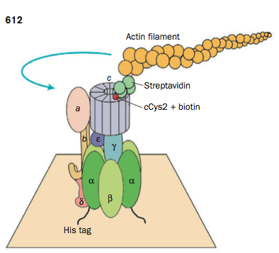
- In the resting state, the need for ATP is minimal. ATP synthase is the major pathway for protons to return to the matrix. The ATP excess inhibits ATP synthase and, hence, the pathway for protons to the matrix
- The increased proton gradient blocks the electron transport
Action of 2,4-dinitrophenol
- 2,4-dinitrophenol carries protons via the inner membrane. The artificial proton permeability discharges the proton gradient, and, hence, stimulates electron transport without synthesis of ATP
- In 1920s, 2,4-dinitrophenol was used as a diet pill to induce weight loss. However, this method often caused fatal side effects.
Heat Generation in the Brown Adipose Tissue
- Physiological function of the brown adipose tissue is the heat generation
- The color of the brown fat is due to cytochromes in mitochondria.
- The inner membrane of the brown fat mitochondria contains thermogenin, a proton channel that uncouples electron transport and oxidative phosphorylation
- In the cold-adapted animals, thermogenin constitutes up to 15% of the protein in the inner mitochondrial membrane.
- Oxidation of nutrients without synthesis of ATP produces heat.
- Thermogenin is activated by free fatty acids and high proton gradient. It is blocked by ATP, ADP, GDP, and GTP
- Hormones regulate heat production in the brown adipose tissue

Control of Oxidative Phosphorylation
- An adult woman requires ~ 7000 kJ of metabolic energy per day. This implies the hydrolysis of 200 mol of ATP
- ATP consumption varies 100-fold depending on the body activity
- The rate of O₂ consumption increases with [ADP].
- The ratio [ATP]/[ADP][Pi ] is high. It depends weakly on the body activity
- The amount of ATP in the body is almost permanent (< 0.1 mol)
- ATP is formed as fast as it is used in the energy-requiring cell activities.
Coordinated Control of Oxidative Metabolism
- The ratio [ATP]/[ADP][Pi ] controls the rates of
  - Oxidative phosphorylation
  - Electron transport
  - Citric acid cycle
  - Pyruvate oxidation
  - Glycolysis
- Increased ratio [NADH]/[NAD +] inhibits pyruvate dehydrogenase, as well as several enzymes in the citric acid cycle.
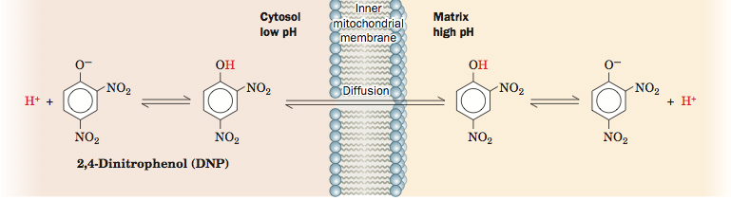
Advantages and Disadvantages of the Aerobic Metabolism
- Advantages
  - High efficiency of energy production
  - Oxygen-dependent mechanisms of detoxification
- Disadvantages
  - Irreversible damage of tissue by oxygen deprivation
  - Damage of biomolecules by reactive oxygen species
Efficiency of Aerobic Metabolism
- Organisms that use aerobic metabolism can extract more energy from the same amount of nutrients than organisms using anaerobic metabolism
- Anaerobic metabolism of glucose
  - C₆H₁₂ O₆ + 2 ADP + 2 Pi → 2 lactate + 2 H⁺ +2 H₂O +2 ATP
- Aerobic metabolism of glucose
  - C₆H₁₂O₆ + 32 ADP + 32 Pi + 6 O₂ → 6 CO₂ + 6 H₂O + 32 ATP
- Aerobic metabolism is 16 times more efficient than anaerobic glycolysis in producing ATP
Cytochromes P450
- Availability of molecular oxygen provides aerobic organisms with the mechanisms of detoxification not found in anaerobic organisms.
- Lipophilic toxins accumulate in cells
- A large and diverse family of proteins, cytochromes P450, use O₂ to protect organisms from intoxication
- Cytochromes P450 catalyzes the hydroxylation of hydrophobic molecules making them more water soluble
  - RH + O₂ + NADPH + H⁺ ROH + H₂O +NADP⁺
- Water-soluble toxins can be excreted from the cell.
- Substrates of a cytochrome P450 induce the synthesis of the enzyme. This is an efficient mechanism of detoxification
Heart Attack and Stroke
- Heart and brain are rapidly respiring tissues
- Myocardial infarction results from the interruption of O₂ supply to the heart
- Stroke results from the interruption of O₂ supply to the brain
- In the absence of O₂, the cell utilizes its supply of glycogen and phosphocreatine to synthesize ATP via anaerobic pathways. After the supply is gone, the following events occur:
  - [ATP] decreases
  - The cell cannot sustain proper concentrations of ions
  - The osmotic balance is damaged
  - The cell absorbs water and swells
  - Membranes stretch and become permeable for macromolecules
  - The cell’s content leaks
  - The cell dies
Reactive Oxygen Species
- Electron transport chain involves one- and two-electron carriers. Ineffective interaction of one-electron carriers with two-electron carriers may produce free radicals.
- One-electron reduction of O₂ yields superoxide radical, a highly reactive oxygen species
  - O₂ + e⁻ O₂⁻
- Protonation of O₂⁻ yields a stronger OH₂
- Two-electron reduction of O2 yields hydrogen peroxide (H₂O₂), a relatively harmless compound. However, it may interact with one-electron carriers to produce most harmful hydroxy radical:
  - H₂O₂ + Fe²⁺ → ·OH + OH⁻ + Fe³⁺
  - O^{2 ¯}· + H₂O₂ → O₂ + H₂O + ·OH
Damaging Effects of Free Radicals
- Free radicals are short lived. However, they can convert other molecules in the free-radical form. The chain reactions involving free radicals destroy double bonds in many molecules
- Lipid damage may disrupt the structure of the membrane.
- Protein damage may cause malfunction of the protein.
- DNA damage may result in point mutations
- Mitochondrial molecules are most vulnerable to the free radical damage since the mitochondrion is the major site of O₂ consumption
- Such degenerative diseases as Parkinson and Alzheimer’s diseases are associated with the oxidative damage of mitochondria.
Antioxidants
- In aerobic organisms, several antioxidant mechanisms have evolved to destroy free radicals and thus to protect cells from their damaging effect.
- Superoxide dismutase catalyzes the reaction
  - 2O₂⁻ + 2H⁺O₂ + H₂O₂
- Catalase catalyzes the conversion of H₂O₂ to water
  - 2H₂O₂ 2O₂ + H₂O
- Glutathione peroxidase uses tripeptide glutathione to catalyze a reaction that converts H₂O₂ to H₂O
- Glutathione supply is vital for the normal function of erythrocytes
- Other antioxidants: Vitamin E and C

