Biochemistry 2EE3 Exam Notes
Lipid Metabolism Part 1
Functions of Lipids
- Components of biomembranes
- Hormones concentration of hormones in our blood is not high, but they play a crucial role in cell signalling
- Energy source fatty acids are more reduced (have less oxygen atoms) than carbohydrates and, therefore conserve more energy
  - The carbon is highly reduced, as a result they have a lot of energy in their chemical bonds and release the energy when broken
- Energy reserves they have their energy in lipids which allows them to travel far distanced
  - Camel’s hump
  - Hibernating animals
  - Migrating birds
Digestion, Absorption, Storage and Mobilization of Lipids
- Chylomicrons deliver dietary triacylglycerols to muscle and adipose tissue, and dietary cholesterol to the liver (blue arrows)
  - TG and cholesterol packaged as chylomicrons
  - Liver converts chylomicron and converts it to low density lipoprotein
  - Chylomicron is hydrophilic, important part of transport, through this process, cholesterol is produced and transported
- Very low density lipoproteins (VLDL’s) transport endogenous triaglycerols and cholesterol
  - VLDL same as chylomicron but smaller, LDL even smaller and HDL smaller; all same structure but different sizes
- VLDLs are degraded by lipoprotein lipase in the capillaries of adipose tissue and muscle (Red Arrows)
- Lipids are transported via lipid proteins this allows them to achieve hydrophilic conditions
- Fat molecules are hydrophobic
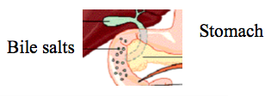
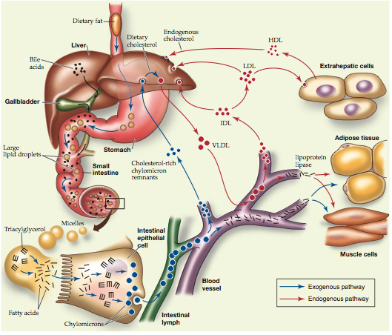
Bile Acids
- Bile acids bile salts are amphipathic detergent-like cholesterol derivatives that solubilize fat globules
- Peristaltic movements of the intestine and emulsifying action of bile acids greatly increase digestion of lipids
- Cholesterol is an important part of health, helps reduce the rigidity of cell membrane
- Hydrophobicity is supplied due to OH
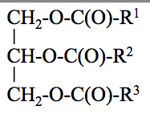
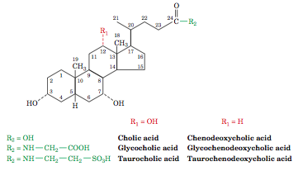
Absorption of Lipids
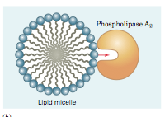
- Lipid digestion produces a mixture of fatty acids, mono- and diaglycerols
- Cells lining the small intestine absorb the mixture
- Bile acids and nonpolar products of lipid digestion form micelles
- Image lipid compound forming a micelle to help increase entropy within the structure
- The hydrophobic region faces inside, hydrophilic is outside
Digesting Triaglycerols
- Triaglycerols constitute 90% of dietary lipids
- R¹, R², and R³ are saturated or unsaturated hydrocarbon chains
- Triaglycerols are water-insoluble
  - Digestive enzymes are water soluble
- Triaglycerols are digested at the lipid-water interfaces
- Pancreatic Lipase and phospholipase A₂ catalyze hydrolysis of triaglycerols to mono and diaglycerols
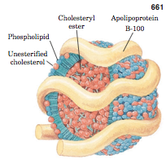
- Diagram of a phospholipid contained in a micelle entering the hydrophobic phospholipid channel in phospholipase A₂
Lipoproteins
- Lipids are poorly soluble in aqueous solution
- They are transported via bloodstream in complex with proteins
- The complexes are taken up by cells in a receptor mediated process
- Lipoproteins are micelle-like particles with hydrophobic cores that contain triacylglycerols and cholesteryl esters
- The amphiphilic surface consists of apolipoprotein, phospholipids and cholesterol
- Overall property of lipoprotein is that they are hydrophilic and can e transported via the blood
- The protein component of the lipoprotein is stretchable
- When the lipid content is taken from lipoproteins, the protein part des not change in terms of amino acids
- Protein amount doesn’t change, only the amount of lipid present changes
  - Lipoproteins are taken into cells via endocytosis
Five Classes of Lipoproteins
- Chylomicrons transport triacylglycerols and cholesterol from the intestine to the tissues
- Very low density lipoproteins VLDL (lower density = bigger protein)
- More protein exterior results in a high amount of lipids in the interior, this causes the density to decrease, overall very large
- Intermediate density lipoproteins IDL
- Low density lipoproteins LDL (bad cholesterol)
- VLDL, IDL and LDL transport internally produced triacylglycerols and cholesterol from liver to tissues
- Fat is essential; energy reserves and cholesterol for its role in monitoring the fluidity of the membrane
- Transmembrane proteins need to be able to provide the correct environment to achieve lipid bilayers, therefore cholesterol provides the correct environment to achieve this
- High density lipoproteins HDL, transport internally produced cholesterol from tissues to liver
- Lipid contents are taken from neighboring cells, which surround the blood vessel.
- The density of the lipoproteins increase when the content is taken out, the lipoprotein shrinks in size, however the protein weighs more than the lipids therefore the density increases
- If cholesterol concentration is too high, excess is packaged in HDL and transported to liver where it can be transported around the body
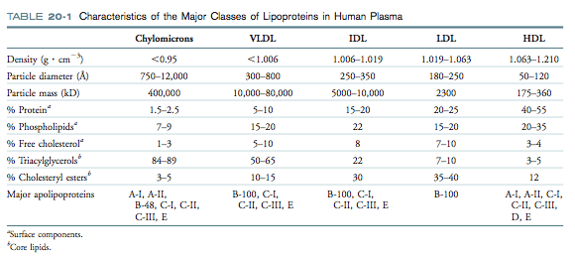
Image the bigger the size, the lower the density, high concentration of lipids is less dense than proteins
- LDL becomes ID: and then VLDL that can be absorbed in the body through endocytosis
Lipoprotein Transport
- Products of lipid digestion absorbed by intestine are converted to triacylglycerols, which are packed to chylomicrons with cholesterol
- Chylomicrons are released via lymphatic vessel to the bloodstream
- An extracellular lipoprotein lipase hydrolyzes triacylglycerols from chylomicrons, which shrink to cholesterol-containing chylomicron remnants
- Chylomicron remnants are delivered to the liver
- VLDLs are synthesized in the liver, they are gradually degraded by lipoprotein lipase, first to IDL and then to LDL
  - Only ones synthesized in the liver
- Unlike other lipoproteins, HDL removes cholesterol from tissues and delivers it to the liver
Endocytosis of LDL
- Cholesterol is an essential component of biomembranes
- Cholesterol affects membrane fluidity
- In the absence of dietary cholesterol, cells synthesize it
- Cells obtain exogenous cholesterol via receptor-mediated endocytosis of LDL
- LDL is recognized by specific LDL receptors, which are clustered on the cell surface with a protein clatharin
- LDL, LDL receptors and clatharin are engulfed by the cell to form a coated vesicle with a polyhedral scaffold clatharin
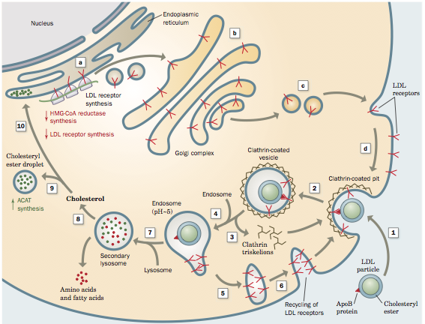
- Receptor-mediated endocytosis is a general mechanism by which cells take up macromolecules

- Only LDLs are imported into cells, how lipids get into cells
- Cholesterol component of the lipoproteins are transported via ER to cells that need it
- Receptor is much smaller than lipoprotein surface, it recognizes the red triangle and then the process of endocytosis occurs
- Movement of hydrophobic compounds cant occur through water, they’re imported via endocytosis
- High level of cholesterol is hard to measure; LDL proteins used to calculate cholesterol levels

Storage of Lipids
- Each adipocyte contains a fat globule that occupies nearly the entire cell
  - They take a very long time to grow, a lot of development time (10-15 years)
  - When you get older, it is harder to get rid of adipocytes
- Adipocytes are specialized in synthesis and storage of triacylglycerols
  - Organisms do not waste fat, it is a product of energy consumed- energy used
  - Evolution has selected for the conservation of energy this can be used to increase an organisms fitness
  - Produces heat and can increase the rate of chemical reactions therefore higher fitness
- When dieting, the amount of adipocytes will shrink, they don’t die (like a bag)
  - All the lipid contents can be taken out however, the adipocytes can still survive
Plant Oils
- Oils are liquid, due to C-C bond rotation near the double bond
- Plant triacylglycerols liquefy at lower temperatures than animal triacylglycerols
- Plant oils function as metabolic fuel reserves
- In castor beans, proportion of oil to carbohydrates and proteins is 60%
- In plants, lipids are stored as oil bodies of 1uM in diameter
- A single seed may contain over 1000 oil bodies

Lipid Metabolism Part 2
Oxidation of Fatty Acids
- Triacylglycerols, which are stored in adipocytes, are mobilized by hormone-sensitive lipases
- Free Fatty acids are released to the bloodstream, where they bind to a simple water-soluble protein albumin
- Before being oxidized, fatty acids are activated in the cytosol by combining with CoA
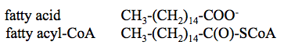
Transport of Fatty Acids into the Mitochondria
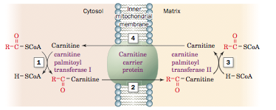
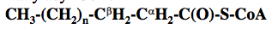
β-Oxidation
- Fatty acyl CoA
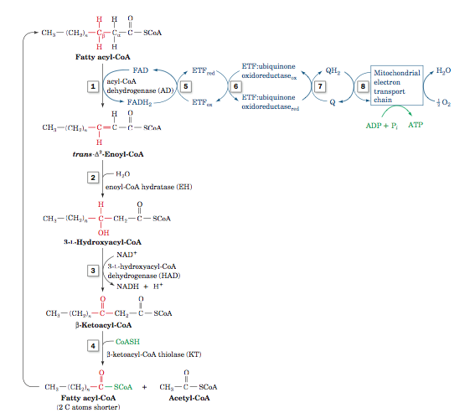
- A sequence of four reactions in the mitochondrial matrix cuts off two-carbon units
- The process is called β-oxidation because the cleavage takes place at β-carbon, which becomes the carboxyl carbon at the next round

Step 1
- Formation of a trans-α,β double bond through dehydrogenation by the flavoenzyme acyl-CoA dehydrogenase (AD)
Step 2
- Hydration of the double bond by enoyl-CoA hydratase (EH) to form a 3-L-hydroxyacyl-CoA.
Step 3
- NAD+-dependent dehydrogenation of the β-hydroxyacyl-CoA by 3-L-hydroxyacyl-CoA dehydrogenase (HAD) to form the corresponding β-ketoacyl-CoA.
Step 4
- Cα-Cβ cleavage in a thiolysis reaction with CoA as catalyzed by β-ketoacyl-CoA thiolase (KT; also called just thiolase) to form acetyl- CoA and a new acyl-CoA containing two fewer C atoms than the original one.
β-Oxidation
- Each round of β-oxidation produces one NADH, one FADH₂ and one Acetyl CoA
- Oxidation of Acetyl-CoA in the citric acid cycle generates additional FADH₂, NADH and GTP
Oxidation of Odd-Chain Fatty Acids
- Stearic acid has an even number of carbons (18)
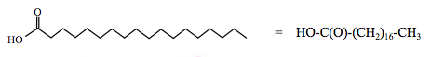

- Fatty acids with odd number of carbons are uncommon
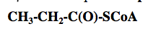
- Oxidation of odd-chain fatty acids start from β-oxidation
  - The last round of β-oxidation produced propionyl-CoA
- Propinoyl CoA is converted to succinyl-CoA in a pathway involving three enzymes
- Succinyl-CoA enters the citric acid cycle
Ketone Bodies
- In the liver mitochondria, large amounts of acetyl CoA is converted to ketone bodies:
- Acetoacetate:
- Acetone:
- D-β-Hydrocybutane:
- Ketone bodies are important metabolic fuels for heart, muscle and other peripheral tissues
- Ketone bodies are water-soluble; they easily circulate in the blood
- Since fatty acids cannot pass via the blood-brain barrier, glucose is the main metabolic fuel for the brain
- During starvation, the ketone bodies substitute glucose in supplying brain with energy
- Ketone bodies are converted to acetyl-CoA in a pathway involving three enzymes

Synthesis of Acetoacetate
- 1) Two molecules of Acetyl-CoA condense to form acetoacyl-CoA
- 2) A Claisen Ester condensation of the acetoacytyl-CoA with a third acetyl-CoA forms β-hydroxy-β-methylglutaryl-CoA (HMG-CoA)
- 3) HMG-CoA is degraded to acetoacetate and acetyl-CoA in mixed aldol-Claisen ester cleavage
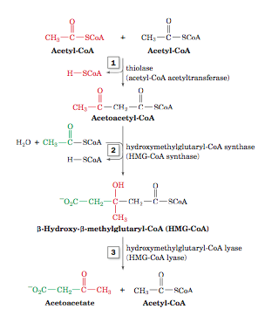
Biosynthesis of Fatty Acids
- Biosynthesis of fatty acids occurs in the cytosol when the body does not need ATP
- Fatty acids are synthesized by condensation of C₂ units.
  - This process is the reverse of β-oxidation
- The biosynthesis requires Acetyl-Coa which is transported from the mitochondrion to the cytosol in the form of citrate
- The growing fatty acid is attached to acyl-carrier protein, ACP, via a thioester bond
- Malonyl-CoA is an intermediate of the fatty acid biosynthesis
  - –OOC-CH₂-C(O)-CoA
- In all anabolic pathways, major cofactors are NADP⁺ and NADPH (not Nad⁺ and NADH)
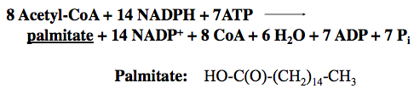

Enzymes Involved in the Fatty Acid Synthesis
- Acetyl-CoA carboxylase converts Acetyl-CoA to malonyl-CoA
- Fatty acid synthase is a multifunctional enzyme that catalyzes seven different reaction in seven different active sites
  - Reaction 1 transfers an acetyl group from Acetyl-CoA to ACP
  - Reactions 2a, 2b, 3, 4 and 5 transfer a C₂ unit from malonyl-CoA to the growing fatty acid chain
  - Six additional cycles of reactions 2-5 yield palmitoyl-ACP
  - Reaction 6 breaks palmitoyl-ACP to palmitate and ACP
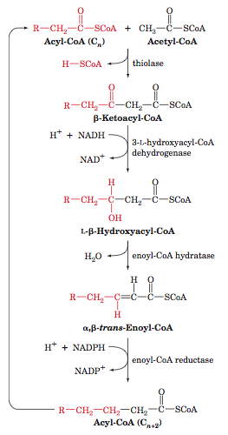
Elongases and Desaturases
- Elongases catalyzes synthesis of longer fatty acids from palmitate
- Desaturases catalyze reactions that convert single bonds of the saturated fatty acid to double bonds

Beta-Oxidation and Biosynthesis
Bottom: Comparison of fatty acid β oxidation and fatty acid biosynthesis; differences occur in:
- Cellular location
- Acyl group carrier
- Electron acceptor/donor
- Stereochemistry of the hydration/dehydration reaction
- The form in which C₂ units re produced/donated

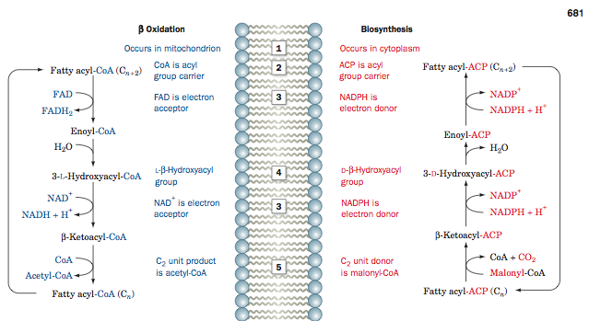

Synthesis of Triacylglycerols
- Triacylglycerols are synthesized in the endoplasmic reticulum or peroxisomes
- The backbone is provided by dihydroxyacetone phosphate or glycerol-3-phosphate
- The hydrocarbon chain are provided by fatty acyl CoA
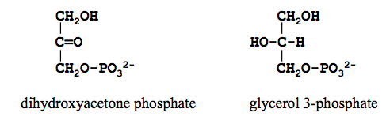
Summary of Lipid Metabolism
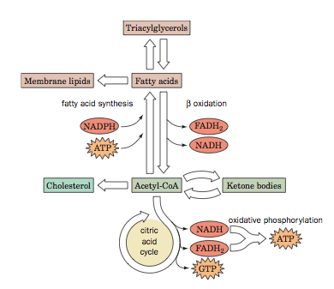
Lipid Metabolism 3
Blood Glucose, Glucagon and Insulin
- Major energy reserves of the organism:
  - Glycogen (liver)
  - Triacylglycerols (adipose tissue)
- Glucose concentration in blood is the major indicator of energetic and dietary state of the organism
- Sensors of glucose concentration: pancreatic α-cells and β-cells
  - α-cells secrete hormone glucagon if [glucose] is low
  - β-cells secrete hormone insulin if [glucose] is high
- Glucagon and insulin regulate glycogen and fatty acid metabolism
Major Energy Metabolites | Carriers in Blood
Triacylglycerols | Chylomicrons
Fatty Acids | Albumin
Glucose, Ketone bodies, Lactate

Control of Glycogen Metabolism
 | Glycogen Breakdown | Glycogen Synthesis
Signal
High [glucose] |  | Liver
Pancreatic hormone | Glucagon | Insulin (muscle)
“Emergency” hormone | Adrenaline
Second messengers | cAMP, Ca²⁺
Enzyme regulated | Glycogen Phosphorylase | Glycogen Synthase
- Epinephrine binding to β-adrenergic receptors on liver and muscle cells increases intracellular [cAMP], which promotes glycogen degradation to G6P for glycolysis (in muscle) or to glucose for export (in liver).
- The liver responds similarly to glucagon. Epinephrine binding to α-adrenergic receptors on liver cells leads to increase cytosolic [Ca²⁺], which also promotes glycogen degradation.
- When circulating glucose is plentiful, insulin stimulates glucose uptake and glycogen synthesis in muscle cells.
- The liver responds both to insulin and directly to increased glucose by increasing glycogen synthesis.
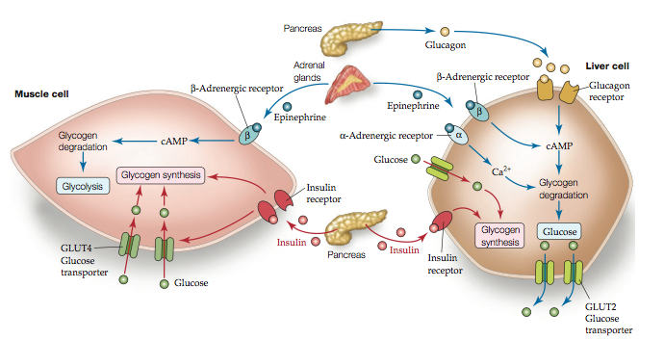

Hormonal Control of Fatty Acid Metabolism
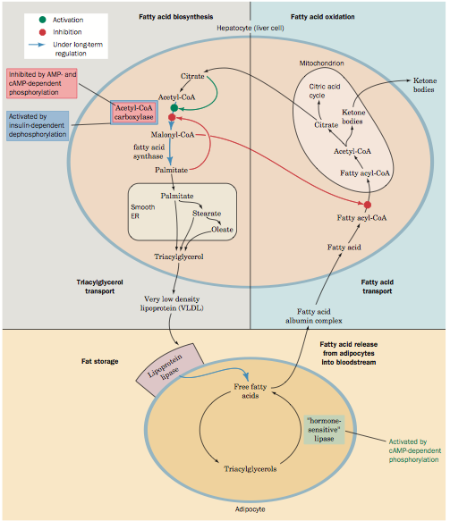
-Oxidative During starvation
-Produce ketone bodies (bring energy to the brain)
~70% of energy is ketone bodies during starvation
-This is done in the mitochondria
-Albumin also brings in lipoproteins
-Citrate is synthesized in mitochondria; it is first reactant in FA synthesis (ie. Palmitate)

-Synthesis- triaglycerols are synthesized
-Packaged with other proteins to create VLDL, and released into circulation
-Synthesis depends on [AMP]

Cholesterol
- Functions of cholesterol:
  - Modulates membrane fluidity
  - Precursors of steroid hormones
  - Precursor of bile acids
- Both dietary cholesterol and that synthesized de novo are transported through the circulation in lipoproteins
- The synthesis and utilization of cholesterol are tightly regulated to prevent its over-accumulation in the body
- Abnormal deposition of cholesterol in the coronary arteries is the leading factor in diseases of the coronary arteries
Biosynthesis and Transport of Cholesterol
- About half of cholesterol in the body is synthesized de novo
  - De novo synthesis of complex molecules from simple molecules (ie. AA, monosaccharides)
- Cholesterol synthesis occurs in the cytoplasm and microsomes from acetate carried by acetyl-CoA
- HydroxyMethylGlutaryl-CoA (HMG-CoA) is an intermediate of cholesterol biosynthesis
- Cholesterol synthesized in the liver is converted to bile acids and cholesteryl esters
- Cholesteryl esters and triacylgylecerols are exported by the liver as VLDL
- In circulation, triacylglycerols are extracted from VLDL, which gradually becomes IDL and LDL
- LDL enters peripheral tissues via receptor-mediated endocytosis
Control of Cholesterol Metabolism
- High blood cholesterol (hypercholesterolemia) results from high production and/or low utilization of LDL
- Two causes of hypercholesterolemia
  - Genetic disease
  - High cholesterol diet
- Strategies to combat hypercholesterolemia
  - Low cholesterol diet
  - Ingestion of resins that bind bile acids
  - Treatment with inhibitors of HMG-CoA reductase, the enzyme involved in the synthesis of HydroxyMethylGlutaryl-CoA
LDL and HDL in Cholesterol Metabolism
- Defective cholesterol-transporting protein ABCA1
- Cells acquire cholesterol and cholesteryl esters via endocytosis of LDL as mediated by the LDL receptor (purple). Cholesterol efflux to form HDL is assisted by the ABCA1 transporter (orange).
- B) In familial hypercholesterolemia, a lack of functional LDL receptors results in high levels of circulating LDL.
- C) In Tangier disease, cells become laden with cholesterol and cholesteryl esters and few HDL are formed because efflux is prevented due to lack of functional ABCA1.
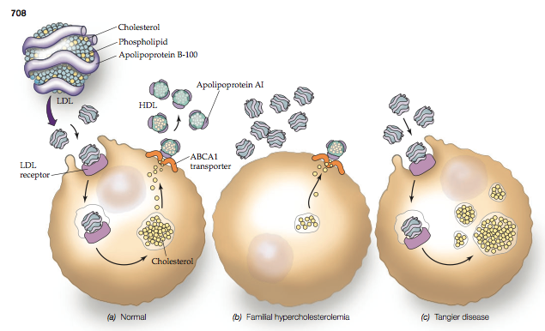
Cholesterol and Atherosclerosis
- Atherosclerosis is a progressive disease in which blood flow is hampered by plaques on the inner lining of arterial walls
  - The blockage of blood flow causes myocardial infarction
- The plaques develop from intracellular deposits of lipids in which cholesteryl ester is the major components
- Development of atherosclerosis is strongly correlated with the level of plasma cholesterol
- The amount of circulated cholesterol increases with the level of LDL
- Women have lower LDL levels and less heart diseases than men
- Cigarette smoke oxidizes LDL, this promotes LDL uptake in the arterial walls
Amino Acid Metabolism Part 1
Protein Turnover
- The major part of the cell’s amino acids is incorporated in proteins
- There is no storage for amino acids analogous to that for glucose (glycogen) or fatty acids (triacylglycerols)
- If the dietary protein exceeds the body’s need of amino acids, the excess amino acids are converted in metabolic fuels
- Proteins are constantly synthesized and degraded by the cell
- This process is necessary for:
  - Storage of amino acids in the form of dynamic pool;
  - Elimination of abnormal proteins that may randomly arise from normal proteins because of thermal motion;
  - Elimination of excessive enzymes, regulatory and transport proteins, a part of metabolic control
Half Life Time of Some Proteins
- Enzymes with the short lifetime are an important points of metabolic control
- Enzymes with the long lifetime have constant catalytic activities
Protein | Half-Life time, h
Ornithine decarboxylase | 0.2
PEP carboxylase | 5
Aldolase | 118
Cytochrome c | 150

Lysosomes
- Lysosomes are organelles containing around 50 hydrolytic enzymes involved in intracellular digestion
- Lysosomes fuse with membrane-enclosed particles that contain
  - Substances imported to the cell via endocytosis
  - Intracellular substances targeted for degradation (vacuoles)
- Inside the lysosome, pH ~5 and cytosolic pH~7
- Lysosomal [H⁺] is ~100 times higher than the cytosolic [H⁺]
- Enzymes of the lysosome have optimal rate at acidic pH, they are low active at the cytosolic pH
- Lysosomal degradation followed by the leakage of its content to the cytosol is not harmful for the cell proteins
Two Pathways of Lysosomal Degradation
- Pathway open under normal conditions but closed in fasting:
  - Nonselective degradation of proteins
- Pathway activated only after long fasting
  - Only those proteins are degraded that contain pentapeptide Lys-Phe-Glu-Arg-Cln (KFERQ)
  - Muscle, liver, kidney contains homogenous tissues that shrink during fasting. These tissues contain KFERQ proteins that are degraded first to supply the organism with metabolic fuels
  - Functionally essential proteins in heterogeneous organs e.g., brain, do not contain KFERQ. Such proteins are degraded last
- Lysosoaml activity increases in many physiological processes, e.g.
  - Digestion of unused or injured muscles
  - Regression of the uterus after childbirth
Ubiquitin
- Ubiquitin is a small protein that marks proteins for lysosomal independent degradation
- The half-life of cytoplasmic proteins degraded via ubiquitin-marking process is determined by the type of N-end residue:
  - 2-3 minutes: ASP, ARG, Leu, Lys, Phe
  - >20 hours: Ala, Gly, Met, Ser, Val
Proteasome
- Ubiquitinated proteins are degraded in the proteasome, a large multiprotein complex
- The proteins are cleaved at 8-residue fragments that diffuse out of the proteasome
- The 8-residue fragments are digested by cytosolic peptidases
- Ubiquitin returns to the cytosol where it marks other proteins
Extracellular Digestion of Proteins
- Dietary proteins are digested in the stomach and intestines by numerous endopeptidases and exopeptidases:
- Exopeptidases hydrolyze peptide bonds at the ends of a polypeptide chain
  - Aminopeptidases cleave N-terminal residues
  - Carboxypeptidases cleave C-terminal residues
- Enopeptidases hydrolyzes internal peptide bonds
  - Gastric proteases e.g. pepsin
  - Pancreatic petidases, e.g. trypsin, chymotrypsin, elastase
- Amino acids and oligiopeptides produced in the gastric and intestine digestion are absorbed by the intestinal mucosa and transported via the bloodstream to tissues
Amino Acid Catabolism
- The amino group is removed and incorporated into urea for disposal. The remaining carbon skeleton (α-keto acid) can be broken down to CO₂ and H₂O or converted to glucose, acetyl-CoA, or ketone bodies.
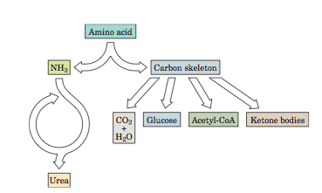
Transamination
- Intracellular degradation of amino acids includes removal of the α-amino group, which finally appears in urea CO(NH₂)₂
- Urea is the major nitrogenous product of protein metabolism and the major nitrogenous compound of urine
- Most amino acids are deaminated by the process of transamination in which the amino group is transferred to α-ketoglutarate to produce α-keto acid and glutamate:
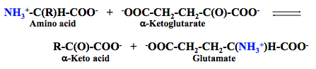

Transamination
- In the second transamination reaction, the amino group is transferred from glutamate to oxaloacetate to produce aspartate and reproduce α-ketoglutarate:
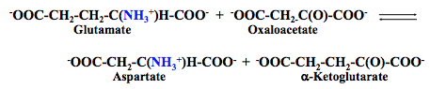
- Reactions of transamination are catalyzed by aminotransferases (transaminases)
- These enzymes require coenzyme pyridoxal-5’phosphate, a derivative of vitamin B₆
Oxidative Deamination
- Glutamate obtained in the first reaction of transamination is oxidatively deaminated in mitochondria by glutamate dehydrogenase
- The reaction produces ammonia and α-ketoglutarate that is recycled for further reaction of transamination
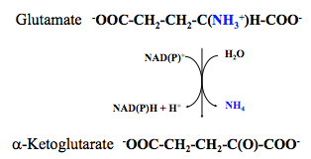
Excess Nitrogen is Converted to Urea
- The ammonia produced in the oxidative deamination is toxic, it is converted to urea in the liver by the urea cycle enzymes
- The overall reaction of the urea cycle:
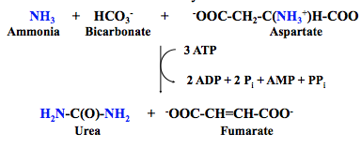
- Urea is secreted to the bloodstream and sequestered by the kidneys for excretion
Toxicity of Ammonia
- Circulating level of ammonia rises if the urea cycle fails to produce urea, or kidneys fail to excrete urine
  - Pathological state is called hyperammonemia
- Ammonia readily traverses the blood brain barrier
- In the brain, ammonia is converted to glutamate via glutamate dehydrogenase, depleting α-ketoglutarate
- Depletion of α-ketoglutarate decreases the level of oxaloacetate
  - Ultimately, the citric acid cycle halts
- Hyperammonemia may irreversibly damage the brain thus causing death

Essential and Nonessential Amino Acids
- Mammals cannot synthesize certain amino acids and must obtain them from the diet
- These amino acids are called essential amino acids
- Other amino acids are called nonessential amino acids
- Essential amino acids
  - Basic Arg⁺, His⁺, Lys⁺
  - Branched-chain Ile, Leu, Val, Thr
  - Aromatic Trp, Phe
  - Other Met
- Nonessential amino acids
  - Acidic Asp⁻, Glu⁻
  - Amidic Asn, Gln
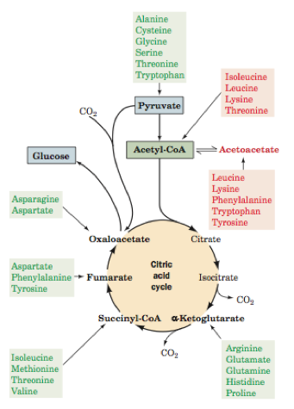
  - Small size Gly, Ala, Cys, Ser
  - Other Pro, Tyr
Degradation of Amino Acids
- Oxidation of amino acids yields 10-15% of the metabolic energy generated by animals
- Standard amino acids are degraded to one of seven metabolic intermediates
- Depending on the pathways of degradation, amino acids are divided into two groups
  - Glucogenic amino acids degraded to the intermediates of the citric acid cycle (pyruvates, α-ketoglutarate, succinyl-CoA, fumarate or oxaloactetate). These intermediates may be further converted to glucose
  - Ketogenic amino acids broken down to acetyl-CoA or acetoacetate, the substances that may be converted to fatty acids or ketone bodies
- Some amino acids are glucogenic and ketogenic
Degradation of Aromatic Amino Acids
- Tryptophan degradation pathway involves 16 reactions that lead to acetoacetate
- Tyrosine degradation pathway involves five reactions leading to fumarate and acetoacetate
- Phenylalanine degradation starts with conversion to tyrosine.
  - The reaction is catalyzed by phenylalanine hydroxylase
  - Further route follow the pathway of tyrosine catabolism
Phenylketonuria
- Genetic disease phenylketonuria (PKU) results from deficiency of phenylalanine hydroxylase that converts Phe to Tyr
- The excess phenylalanine is transaminated to a phenyl-ketone phenyl-pyruvate
  - Ph-CH₂-C(O)-COO⁻ (phenyl- pyruvate)
- Intensive phenylalanine transamination by an amino transferase depletes the neural tissue of α-ketoglutarate
- The lack of α-ketoglutarate in the brain shuts down the citric acid cycle causing the brain damage and severe mental retardation
- All born babies are screened for PKU
- The addition of tyrosine to the diet and restriction of phenylalanine during the first 5 to 10 years of life can minimize the mental retardation
Methionine Synthesis
- The pathway involves methionine synthase that catalyzes the addition of one-carbon unit to homocysteine with the involvement of two coenzymes: B₁₂ and tetrahydrofolate (THF)
- HS-CH₂-CH₂-CH(NH₃)-COO⁻ CH₃-S-CH₂-CH₂-CH(NH₃)-COO-
- Coenzyme tetrahydrofolate (THF) can transfer C₁ units in different oxidized states
- Folic acid is a vitamin obtained from yeast, leafy vegetables and animal liver
- Folic acid is reduced within cells to tetrahydrofolate by dihydrofolate reductase
Sulfonamide Antibiotics
- Bacteria synthesizes both folic acid and tetrahydrofolate
- Sulfonamide antibiotics, such as sulfanilamide, competitively block the synthesis of folic acid and hence tetrahydrofolate
- Sulfonamides are not toxic for mammals because they do not synthesize folic acid
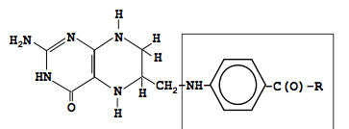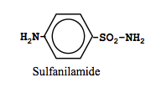
Biosynthesis of Nonessential Amino Acids
- All nonessential amino acids, except tyrosine, are synthesized by simple pathways starting from one of the four well-known metabolic intermediates
  - Pyruvate
  - Oxaloacetate
  - α-ketoglutarate
  - 3-phospholycerate
- Tyrosine is synthesized by hydroxylation of the essential amino acid phenylalanine
- The presence of tyrosine in the diet decreases the need for phenylalanine
Reactions of Transamination
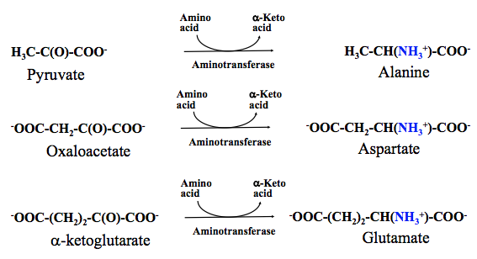

Asparginine and Glutamine
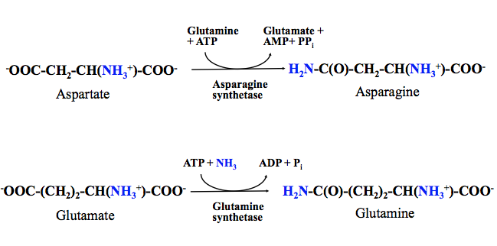
Glutamine Synthetase
- Metabolic functions of glutamine:
  - Donor of amino group
  - Storage form of ammonia
- Control of glutamine synthetase is highly important for metabolism of nitrogen
- Mammalian glutamine synthetase is activated by α-ketoglutarate, which is a product of the oxidative deamination of glutamate
- Activated glutamine synthetase decreases concentration of ammonia, a toxic metabolite
  - This prevents accumulation of ammonia
Heme Biosynthesis
- Heme complex of iron with porphyrin, is a component of many proteins (hemoglobin, myoglobin, cytochromes)
- Heme is synthesized in the erythrocytes and in the liver
- All carbon and nitrogen atoms of the heme are derived from acetate and glycine
- The heme anabolic pathway involves intermediates δ-aminolevulinic acid (ALA) and porphobilinogen (PBG)
- Lead inhibits porphobilinogen synthase that converts δ-aminolevulinic acid to porphobilinogen and, by this way, causes accumulation of δ-aminolevulinic acid in the blood
- δ-Aminolevulinic acid resembles neurotransmitter γ-aminobutyric acid (GABA)
- Lead poisoning is often accompanied by the psychosis
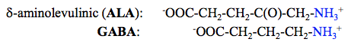
Poryphyrin Derivatives
- Pyrrole (C₄H₅N) is a five membered heterocycle
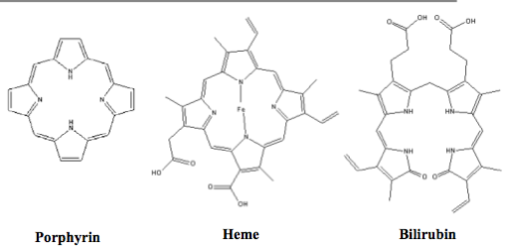
Porphyrias
- Porphyrias are disorders of heme synthesis causing accumulation of porphyrin and its precursors
- The disorders affect erythrocytes and liver
- The symptoms of porphyrias
  - Red urine
  - Reddish brown teeth
  - Ulcerated skin
  - Fine hair growth on much of the face
- The most common disease of this group, acute intermittent porphyria causes neurological dysfunction
  - King George III and several descendants had the disease
Heme Degradation
- After 120 days of the lifetime, erythrocytes are removed from the circulation and degrade
- Heme catabolism yields bilirubin, highly lipophilic compound insoluble in aqueous solution
- Bilirubin derivatives are secreted in the bile, then they are further degraded by the bacterial enzymes in the large intestine
- Abnormally high rate of erythrocyte degradation raises concentration of bilirubin in the blood
- Bilirubin deposition colors skin and white of the eyes, the condition is known as jaundice
- The liver dysfunction and bile duct obstruction also causes jaundice
Nitrogen Fixation
- Although N₂ is abundant in the atmosphere, the bond N≡N is highly stable (ΔG = 945 kJ/mol)
  - Most organisms cannot use N₂
- Only few groups of bacteria called diazotrophs may fix N₂ by converting ammonia
- This energetically costly process is catalyzed by nitrogenase
- NH₃ is incorporated into glutamate or glutamine
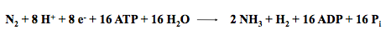
- Diazotrophs live symbiotically with root nodule cells of plants belonging to the pea family
- These plants are widely cultivated because the excess of the fixed nitrogen enriches the soil
- Lightning discharges account for ~10% of the naturally fixed N₂
- One long term goal of the gene engineering is to insert N₂-fixing systems into different plants

Nucleotide Metabolism
Nitrogenous Bases
- Nucleotides are composed of a nitrogenous base linked to a sugar to which a phosphate group is attached
- Bases are structural derivatives of either purine of pyrimidine
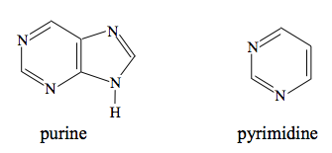

Base, Nucleoside, Nucleotide
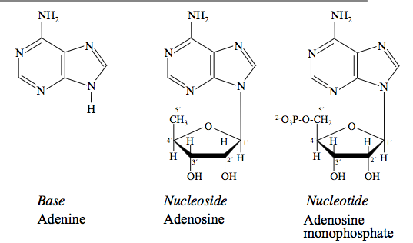

Functions of Nucleotides
- Nucleotides are components of:
  - Nucleic acids
  - Conezymes: FAD, NAD, CoA
  - High energy compounds
    - ATP adenosine triphosphate
    - GTP Guanosine triphosphate
    - UTP Uridine triphosphate
    - CTP Cytidine triphosphate
- Almost all cells can synthesize nucleotides de novo
- Nucleotides do not provide significant amount of metabolic energy
Synthesis of Ribonucleotides
- AMP and GMP are synthesized from inosine monophosphate (IMP)
- Before being incorporated into nucleic acids, nucleoside monophosphates are converted to nucleoside triphosphates
- Iosine monophosphate, a precursor of AMP and GMP is seen in the structural diagram below
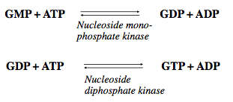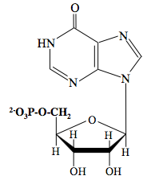
Synthesis of Ribonucleotides
- 5-Phosphoribosyl-α-pyrophosphate (PRPP), a precursor for the biosynthesis of nucleotides
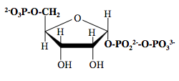
Salvage of Nucleotides
- RNA degradation releases free bases that are used to synthesize new nucleotides
- The ability to salvage nucleotides from sources within the body decreases nutritional requirements for nucleotides
- The purine and pyrimidine bases are not required in the diet
- The salvage pathways are the major source of nucleotides for synthesis of DNA, RNA and enzyme co-factors
Components for DNA Synthesis
- Different components of RNA and DNA
- RNA
  - Ribose residue
  - Uracil
- DNA
  - 2’-Deoxyribose residue
  - Thymine (5-methyluracil)
- Deoxyribonucleotides are synthesized from the corresponding ribonucleotides
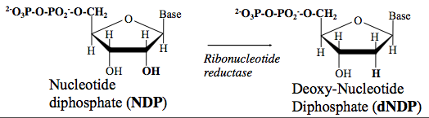
Control of Ribonucleotide Reductase
- A deficiency of dNTP is lethal for the cell
- Overproduction of a dNTP is mutagenic because the increased concentration of the dNTP increases a probability of its erroneous incorporation in the DNA
- Activities of ribonucleotide reductases are regulated by the feedback mechanism
- dNTPs are produced by phosphorylation of dNTPs
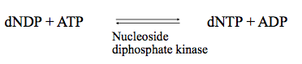
Production of Thymine
- Inhibition of thymidylate synthase or DHFR clocks synthesis of dMTP
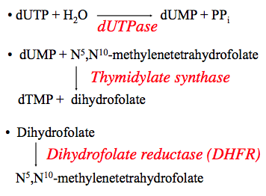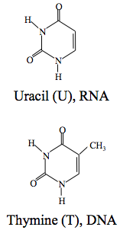
Cancer
- Cancer is a class of diseases characterized by uncontrolled division of cells and their ability to spread
- The malignant cells can spread either by direct growth into adjacent tissue or by implantation into distant sites by metastasis
- Cancer may affect people of all ages, the risk increases with age however
- Cancer is usually treated with a combination of surgery, chemotherapy and radiotherapy
Cancer Chemotherapy
- Dividing cells require deoxythymidine monophosphate (dTMP)
  - Block of dTMP synthesis can kill the cells
- Since tumor cells divide more rapidly than normal cells, they are most vulnerable to the lack of dTMP
- Drugs that inhibit thymidylate synthase or DHFR affect tumor cells
- Inhibitors of thymidylate synthase or DHFR also affect rapidly dividing normal cells
  - Bone marrow cells (blood forming tissue)
  - Immune system
  - Intestinal mucosa
  - Hair follicles
Anti Cancer Drugs
- Antifolates, analog of folic acid
- 5-fluorodeoxyuridilate (FdUMP) irreversibly inhibits thymidylate synthase (left)
- Methotrexate irreversibly inhibits DHFR (right)
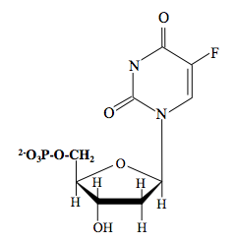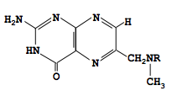
Nucleotide Degradation
- Ingested nucleic acids are hydrolyzed extracellularly by endonucleases, phosphodiesterases and nucleoside phosphorylases
- Endonucleases degrade DNA and RNA at internal sites, yielding oligionucleotides
  - Oligionucleotides are further digested by phosphodiesterases that yield free nucleosides
- The bases are hydrolyzed from nucleosides by phosphorylases that yield ribose-1-phosphate and free bases
- If the nucleosides and/or bases are not recycled, then
  - The purine bases are degraded to uric acid
  - The pyrimidine bases are degraded to β-alanine, β-aminoiosobutyrate, NH₃ and H₂O
- Further catabolism of β-alanine and β-aminoiosobutyrate leads to citric acid cycle intermediates thus yielding metabolic energy
Uric Acid
- In humans, the final product of purine degradation is uric acid, which is excreted in the urine
- Elevated levels of uric acid in body fluids cause gout, the disease characterized by arthritic inflammation of joints
- Uric acid may precipitate in the kidneys as stones
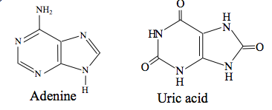

Summary of Nucleotide Metabolism
- Nucleotides are synthesized from amino acids and ribose-5-phosphate
- Nucleotide catabolism produces ribose-1-phosphate, uric acid and malonyl-CoA
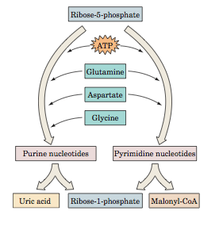
Organ Specialization in Metabolism
Major Pathways of Fuel Metabolism
- Glycolysis: Glucose 2 pyruvate + 2ATP
- Gluconeogenesis: synthesis of glucose
- Glycogen degradation and synthesis: hormonally controlled mobilization and immobilization of glucose
- Fatty acid degradation and synthesis: β-oxidation with formation of acetyl-CoA
- Citric Acid Cycle: Oxidation of acetyl-CoA; production of NADH and FADH₂
- Oxidative Phosphorylation: Oxidation of NADH and FADH₂ to produce ATP
- Amino acids degradation and synthesis: Degradation of excess amino acids for energy
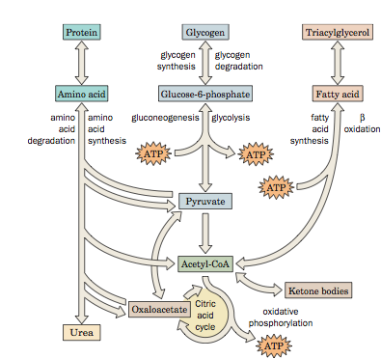

Metabolism Coordination
- In a single cell, metabolism coordination insures
  - Prevention of simultaneous activity of opposing pathways
  - The cell response to changing external conditions
  - Genetically programmed growth
- In a multicellular organism, metabolism coordination insures:
  - Cooperation of individual cells
  - Cooperation of organs
  - The organisms response to changing external conditions
  - Behavioral activity
  - Genetically programmed development
Organ Specialization
- Most organs are specialized metabolically so that only a portion of all possible metabolic pathways operate at high rates
- A notable exclusion is the liver, in which all the common metabolic pathways may operate at a high rate, although not simultaneously
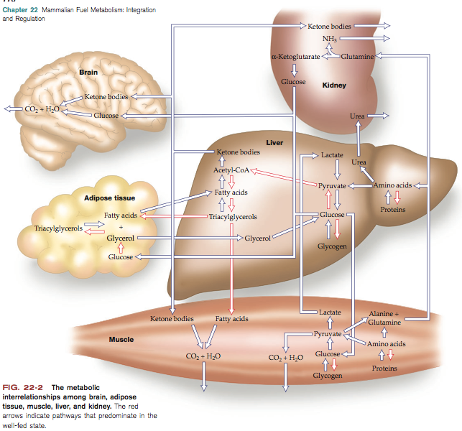

The Brain
- The brain account for ~2% of the adult human body mass
- In the resting body, the brain consume ~20% of O₂
- Na^{+/}K⁺-ATPase is the major consumer of metabolic energy in the brain, the enzyme maintains membrane potential
- Under normal conditions, glucose is the major fuel of the brain
- During fasting, the brain gradually switches to ketone bodies
- The brain cells store only a limited amount of glycogen, and therefore, require a continuous supply of fuel from the blood
- The normal concentration of glucose in the blood is ~5mM
- [Blood glucose] of ~2.5mM causes brain dysfunction
- [Blood glucose] <<2.5mM results in coma and brain damage
Muscle at Rest
- Major fuels for muscle are glucose (glycogen degradation), fatty acids and ketone bodies
- Glycogen accounts for up to 2% of the resting muscle mass
- Advantages of glycogen over fatty acids in emergency situations:
  - High speed of degradation;
  - Existence of both anaerobic and aerobic pathways of degradation
- Glycogen is converted to G6P, which enter glycolysis pathway
- Since muscle lacks glucose-6-phosphatase, it does not export glucose to the bloodstream
- Muscle doesn’t have enzymes for gluconeogenesis
- Carbohydrate metabolism in muscle does not serve other organs
Muscle at High Exertion
- Skeletal muscle at rest uses 30% of O₂ consumed by the human body
- The rate of muscle respiration may increase up to 25-fold under heavy workload
- In emergency situations, muscle needs more ATP than oxidative phosphorylation can supply.
- Additional ATP comes from:
  - The reaction: phosphocreatine + ADP creatine + ATP
  - Glycogen degradation and anaerobic glycolysis of G6P
- Maximal exertion during ~20s causes muscle fatigue and pain
  - The cause is [H⁺] overproduction by anaerobic glycolysis
  - Glucose + 2ADP + 2Pi 2 lactate + 2ATP + 2H₂O +2H⁺
- Complete depletion of ATP would kill muscle
Anaerobic and Aerobic Metabolism
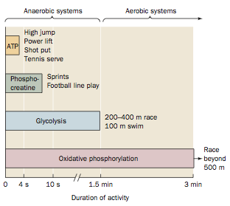

The Heart
- The heart muscle produces ATP entirely from the oxidative phosphorylation
- Mitochondria occupy up to ~40% of the cardiac muscle cell volume
- The metabolic fuels for the heart are fatty acids, glucose, ketone bodies, pyruvate and lactate
- The heart has a limited supply of glycogen that is degraded during heavy work
- Under normal conditions, fatty acids are the major source of the metabolic energy
Adipose Tissue
- The function of adipose tissue is to store fatty acids and to release them as energy fuels
- Adipose tissue is widely distributed in the body, the major location are
  - Under the skin
  - Abdominal cavity
  - Skeletal muscle
- Adipose tissue obtains fatty acids from circulating lipoproteins and keeps them as triacylglycerols
- Hormone sensitive lipases release fatty acids from triacylglycerols
- A normal 70-kg man has ~15kg of fat, it would yield 590,000kJ of metabolic energy necessary for up to 3 month of starvation
Liver is a Buffer of Blood Glucose
- The liver is a buffer of blood glucose
- It converts excess glucose into glycogen and releases glucose during metabolic needs
- After consuming a carbohydrate-rich food, he blood glucose increases to ~6mM
- The liver takes up excess glucose by converting it to G6P
Hexokinase and Glucokinase
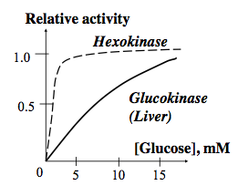
- In the liver, phosphorylation of glucose to G6P is catalyzed by glucokinase, whereas in other organs this reaction is catalyzed by hexokinase
- Glucokinase and hexokinase are isozymes
- Hexokinase activity does no change with blood [glucose] at its physiological concentrations
- Glucokinase activity increases with blood [glucose] at wide physiological range
- Hexokinase but not glucokinase is inhibited by physiological [G6P]
- The higher [blood glucose], the faster lover converts it to G6P
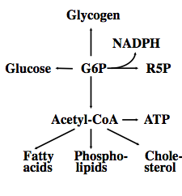
- At low [blood glucose], it is consumed by other organs
Fates of Glucose-6-Phosphate
- Depending on the glucose need by the organism, G6P is used in 4 pathways:
  - Conversion to glucose-6-phosphate
    - When [blood glucose] is below 5mM
  - Conversion to glycogen
    - When [blood glucose] is high
  - Conversion to acetyl-CoA via glycolysis
  - Degradation to ribose-5-phosphate in the pentose phosphate pathway with generation of NADPH for anabolic pathways
Lipid Metabolism in the Liver
- High demand for metabolic fuels:
  - The liver converts fatty acids to acetyl-CoA and then to ketone bodies
  - Ketone bodies are used by peripheral tissues as fuels
  - The liver cannot use ketone bodies as fuels since it lacks the enzyme that converts the ketone bodies to acetyl-CoA
- Low demand for metabolic fuels:
  - The liver synthesizes triacylglycerols from fatty acids
  - Triacylglycerols are released into the bloodstream in the form of VLDL
  - Adipose tissue takes up VLDL

Inter-organ Metabolic Pathways
The Cori Cycle
- High oxygen consumption continues ten minutes after vigorous muscle activity is over
- Lactate produced in the muscle is transported via bloodstream to the liver where it is converted to pyruvate by lactate dehydrogenase
- Gluconeogenesis in the liver regenerates glucose from lactate
- The process requires ATP, which is produced by oxidative phosphorylation with consumption of O₂
- If glucose were synthesized by the muscle, the demand of the working muscle for ATP would increase dramatically
- During prolonged physical activity, the liver helps muscle to do the job by taking up lactate and returning glucose
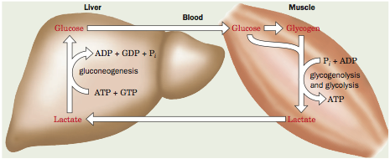
The Glucose-Alanine Cycle
- Glycolysis in muscle yields pyruvate that serves as the acceptor of amino group in reactions catalyzed by certain aminotransferases
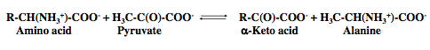
- Alanine is released to the bloodstream and transported to the liver
- In the liver, alanine is converted to pyruvate, which is used for gluconeogenesis
- Glucose produced from pyruvate is returned to muscle
- The amino groups transported to the liver with alanine are transformed to urea
- During the workload the cycle supplies muscle with the liver-made glucose
- During fasting, the cycle supplies the body with glucose synthesized by the liver from products of degradation of muscle proteins
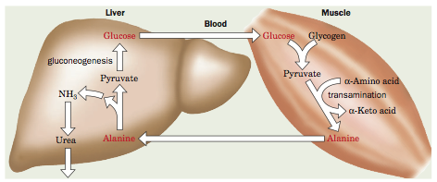
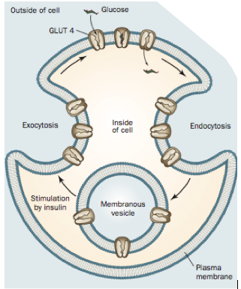
Glucose Transporters
- Hydrophilic molecules of glucose are transported via the hydrophobic membrane into cells by protein carriers
- Glucose transporters GLUT1, which are expressed in the brain and some other tissues are saturates with high [blood glucose]
- Liver and pancreatic β-cells have GLUT2 which does not limit the rate of glucose uptake
- GLUT4 are insulin-sensitive glucose transporters that occur only in the muscle and adipose tissue
- In the absence of insulin, the GLUT4 transporters are localized in the intracellular vesicles
- Insulin induces translocation of GLUT4 to the plasma membrane, allowing cells to rapidly take up glucose
- On the insulin withdrawal, GLUT4 are taken up by the cell via endocytosis
Fuel Reserves of a Normal 70-kg Man
Fuel | Mass (kg) | Calories
Tissues
Adipose Triacylglycerols | 15 | 141,000
Muscle Protein | 6 | 24,000
Muscle Glycogen | 0.15 | 600
Liver Glycogen | 0.075 | 300
Circulation
Glucose | 0.029 | 80
Free fatty acids | 0.0003 | 3
Triacylglycerols | 0.003 | 30
Total |  | 166,000

Starvation
- Insulin and glucagon ensure relatively constant [glucose] in the body
- After an over-night fast, fatty acids are mobilized from adipose tissue
- The body has a one-day supply of carbohydrates. When it is used up, muscles switch to fatty acids for energy production
- Animals lack metabolic pathways to synthesize glucose from fatty acids
- Degradation of triacylglycerols and proteins supply substrates for gluconeogenesis during first days of starvation
- In a longer starvation, ketone bodies produced from the fatty acid oxidation become the main fuel for the brain and muscle
- Brain switches to ketone bodies gradually
- They supply 30% of energy after a 3-day fast, and 70% after 40 days of starvation
- Highly obese individuals can survive a year without food
Obesity
- When the food intake systematically exceeds the organisms needs, the excess is accumulated in the adipose tissue as triacylglycerols
- Synthesis of new adipocytes takes time
- Adipocytes can exist without fat,
  - During short starvation, adipocytes release their fat content but are ready to take up new fat
  - Therefore, the excess weight is easily restored after a short starvation period
- Most individuals may control normal weight by combining appropriate diet with physical activity
- Adipocytes synthesize a polypeptide leptin, the increases level of leptin decrease the appetite
  - Defects in the leptin synthesis, transport or reception by the brain may underline a genetic predisposition for obesity
Making Supplies
- Immediately after a meal, when glucose and fatty acids are abundant, insulin signals tissues to store fuel as glycogen and triacylglycerols. Insulin also stimulates tissues other than liver to take up glucose via the GLUT4 transporter
- Image fed state
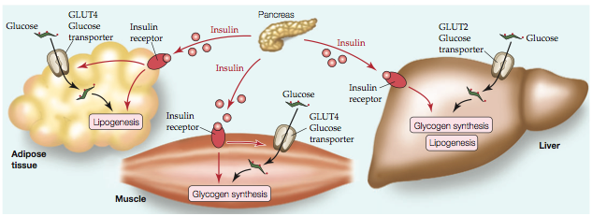
Using Supplies
- When dietary fuels are not available, glucagon stimulates the liver to release glucose and adipose tissue to release fatty acids. During stress, epinephrine elicits similar responses.
- Image fasted state/stress
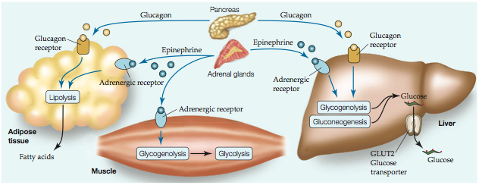
Diabetes
- Diabetes is the third leading cause of death in the USA after heart disease and cancer
- In diabetes, insulin is either poorly secreted or does not stimulate the glucose uptake by the target cells
- The increased blood glucose is excreted to urine, while cells switch to the fatty acid oxidation
- Fatty acid oxidation produces ketone bodies, which become the major metabolic fuel of the organism
- Ketone bodies are acids
  - Elevated ketone bodies decrease the blood pH
  - To stabilize pH, kidneys excrete the excess H⁺ to the urine
- Pi, Na⁺, K⁺, H₂O are co-excreted with H⁺, causing the organism dehydration
  - Excessive thirst is a symptom of diabetes
Types of Diabetes
- There are types of diabetes: insulin-dependent, non-insulin dependent
- In insulin-dependent diabetes, pancreas lacks or has defective β-cells, and insulin isn’t secreted
- The disease develops in the childhood, daily insulin injections are required
- In non-insulin-dependent diabetes, cells have defective insulin receptors that do not respond to insulin
- Non-insulin dependent diabetes accounts for 90% of cases of diabetes
  - It affects 18% of individuals over 65 years old
  - Usually, patients are obese and have a genetic predisposition to the disease
The Insulin Discovery
- Dr. Frederick G. Banting conceived the idea of extracting insulin from the pancreas
  - London ON, October 31, 1920
- Charles Best assisted Banting during the summer of 1921 in preparing pancreatic extracts that prolonged the lives of diabetic dogs
- Dr. James b. Collip Purified the crude insulin extract for use in humans
- Prof. John J.R. Macleod Offered Banting space in his Toronto laboratory and provided advice on methods for extracting insulin
- January 1922 Insulin was successfully tested to save the life of a 14 year old boy
- October 1923 Banting and Macleod had been awarded the Nobel Prize in Medicine
- BBDMR Banting and Best Department of Medical research, U of T

Hormonal Control of Metabolism
Signal Transduction
- Metabolic processes of the organism are under strict hormonal and neuronal control
- Endocrine glands synthesize and release hormones, which are carried by the bloodstream of the target cells
- Example hormones: insulin, glucagon, catecholamines, steroids
- A hormonal or neurotransmitter may affect biochemical reactions within a cell only if the cell ha a corresponding receptor for the signal
- The receptor activation initiates reactions in a signal transduction pathway that triggers the cell response
- A typical cell has receptors for many signaling molecules
- Response to a particular signal depends on whether and how the signal transduction pathway reacts to other signals
- Image Hormones produced by endocrine cells reach their target cells via the bloodstream. Only cells that display the appropriate receptors can respond to the hormones.
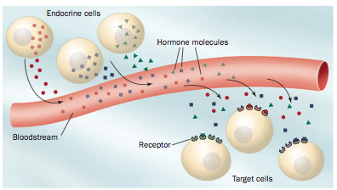
First and Second Messengers
- G protein–coupled receptors (GPCRs) transmembrane proteins that bind their corresponding ligand (e.g., a hormone) on their extracellular side, which induces a conformational change on their cytoplasmic side.
- Heterotrimeric G proteins which are anchored to the cytoplasmic side of the plasma membrane and which are activated by a GPCR when it binds its corresponding ligand.
- Adenylate cyclase (AC) a transmembrane enzyme that is activated (or in some cases inhibited) by activated heterotrimeric G proteins.
- cAMP 3’,5’-Cyclic AMP binds to a variety of proteins so as to activate numerous cellular processes thus, cAMP is a second messenger, that is, it intracellularly transmits the signal originated by the extracellular ligand
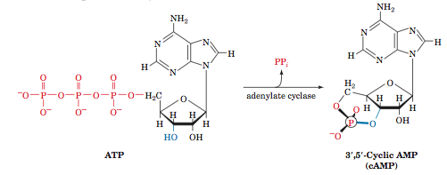
Signal Transduction
- The binding of a ligand to a receptor tyrosine kinase initiates the Ras signaling cascade of phosphorylations, which leads to changes in gene expression.
- The binding of a ligand to its corresponding G protein–coupled receptor stimulates (or in some cases inhibits) adenylate cyclase (AC) to synthesize the second messenger cAMP. The cAMP, in turn, activates protein kinase A (PKA) to phosphorylate its target proteins, leading to a cellular response.
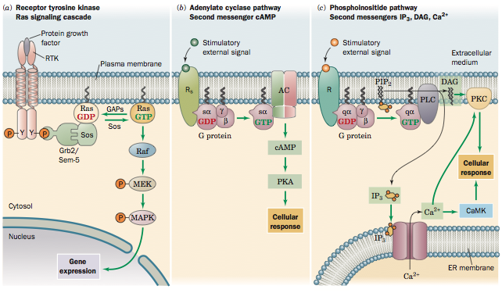

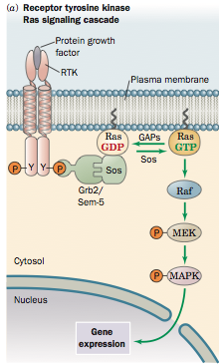
Receptor Tyrosine Kinases
- Growth factors are protein hormones that stimulate proliferation (growth) of their target cells
- Receptors of growth factors are transmembrane proteins having tyrosine kinase activity at the intracellular C-terminal part
- Growth factor binding results in dimerization and consequent autophosphorylation of receptor tyrosine kinase
- Tyrosine-P of receptor tyrosine kinase activates membrane-bound G-proteins Ras
- Activated Ras initiates the Ras signaling cascade resulting in phosphorylation of the nuclear transcription factors that regulate gene expression
- Disturbances in the Ras signaling cascade may result in the uncontrolled cell growth
Oncogenes and Cancer
- The growth and differentiation of cells are strictly controlled
- Uncontrollably proliferating cells cause tumors
- Malignant tumors (cancer) develop because of various reasons
- Tumor cells often have defective proteins involved in signal transduction cascade between growth hormones and nuclear transcription factors
- Tumor cells may contain normal signal transduction proteins, but in excessive amounts
- Oncogenes are genes that encode defective proteins causing tumors
- A mutation in a normal gene may turn it to an oncogene
- Mutations may occur spontaneously or be induced by radiation, chemical carcinogens, virsuses
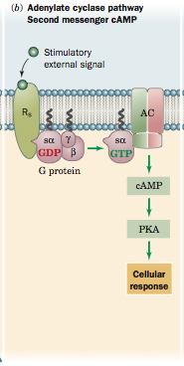
Adenylate Cyclase Signaling System
- The binding of a ligand to its corresponding G protein–coupled receptor stimulates (or in some cases inhibits) adenylate cyclase (AC) to synthesize the second messenger cAMP. The cAMP, in turn, activates protein kinase A (PKA) to phosphorylate its target proteins, leading to a cellular response.
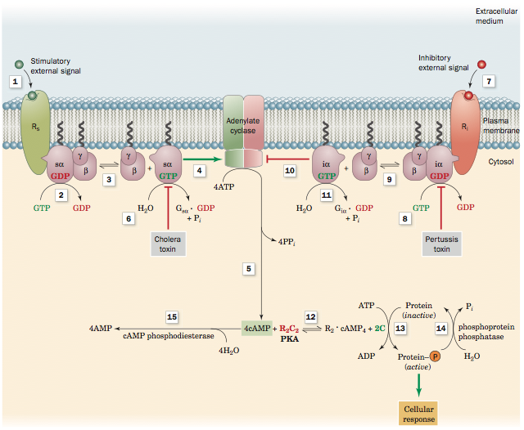
The binding of hormone to a stimulatory receptor Rs (1) induces it to bind the heterotrimeric G protein Gs, which in turn stimulates the GSα subunit (2) to exchange its bound GDP for GTP. The Gsα GTP complex then dissociates from Gβγ (3) and (4) stimulates adenylate cyclase (AC) to convert ATP to cAMP (5). This stimulation stops when Gsα catalyzes the hydrolysis of its bound GTP to GDP (6). The binding of hormone to the inhibitory receptor Ri (7) triggers an almost identical chain of events (8–11) except that the presence of the GiαGTP complex inhibits adenylate cyclase (10). cAMP activates protein kinase A (PKA; R2C2) by binding to the regulatory dimer as R2 cAMP4, causing the catalytic subunit C to dissociate (12), and activates various cellular proteins (13) by catalyzing their phosphorylation. The sites of action of certain toxins are indicated. Signaling is limited by the action of phosphatases (14) and cAMP phosphodiesterase (15). Toxins such as cholera toxin and pertussis toxin act by blocking the hydrolysis of GTP from either Gsα GTP (6) or Giα GTP (8), enhancing their activities.

Phosphoinositide Pathway
- PIP₂, Phospatidyl-ionositol-4,5-biophosphate
- DAG 1,2 diacylglycerol
- PLC Phospholipase C
- PKC Protein Kinase C
- IP₃ Inositol triphosphate
- CaMK Calmudulin dependent protein kinase
- ER endoplasmic reticulum
- The binding of a ligand to its corresponding Gq protein–coupled receptor initiates the phosphoinositide pathway, which activates phospholipase C (PLC) to hydrolyze the membrane lipid PIP2 to the second messengers IP3 and DAG. IP3 causes the release of Ca2+ from mitochondria, DAG activates protein kinase C (PKC), and Ca2+ activates both PKC and Ca2+–calmodulin dependent protein kinase (CaMK). The phosphorylation of target proteins by PKC and CaMK leads to cellular responses

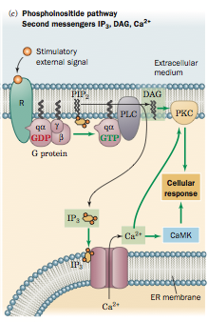

AMP-Dependent Protein Kinase
- Metabolic pathways are affected by the need for ATP
- The [AMP]/[ATP] ratio indicates the need for ATP
- AMP can either activate or inhibit certain enzymes by the allosteric mechanism
- AMP-dependent protein kinase (AMPK) is a major regulator of metabolic homeostasis
- AMPK activates catabolic pathways that generate ATP, but inhibits anabolic pathways, this allows to conserve ATP for most vital processes
Major Effects of AMPK
- Skeletal muscle AMPK stimulates glucose uptake and glucose and fatty acid oxidation while inhibiting glycogen synthesis.
- Heart muscle AMPK stimulates glycolysis.
- Liver AMPK inhibits lipid biosynthesis and gluconeogenesis while activating fatty acid oxidation.
- Adipose tissue AMPK inhibits fatty acid biosynthesis and lipolysis


