ANP1107: Topic #5 - The Anatomy and Physiology of the Male
and Female Reproductive Systems (Chapters 27 & 28)

What are the purposes of the male and female reproductive systems? to produce offspring.
Primary sex organs = testes & ovaries || Gonads produce sex cells (gametes) secrete a variety of steroid hormones = sex hormones
Males manufacture male gametes called sperm and deliver to female reproductive tract, where fertilization can occur.
Female produce female gametes called ova or eggs

What do you need to already understand before approaching the anatomy and physiology of the male and female reproductive systems?

The female system is cyclical whereas the male system is not. What does this really mean? Female provides a protective environment where the embryo develops until birth. What important differences will allow one system to be cyclical and the other to maintain fairly steady production of hormones and gametes? Cyclical? – This is b/c every month the uterus prepares itself for pregnancy and if there is not a baby then the period will come

5.1 Describe the anatomy of the male reproductive system
5.1.1 describe the gross & microscopic anatomy of the testes
• testes located in scrotum: sac of skin + superficial fascia outside abdominopelvic cavity at root of penis
sparse hairs, more heavily pigmented
• midline septum provides one compartment/testis
• exterior position provides essential (why? Because if it was inside of the body the temperature of the body would heat the sperm and kill the sperm) temp 3⁰ C lower than core
What are the roles of the dartos & cremaster muscles in testicular temperature regulation? They are there to help to tell how far away they are from the body to keep it at a regular temperature if it is too cold it will pull the testes towards the body.
The dartos muscle layer of smooth muscle in the superficial fascia, wrinkles the scrotal skin
The cremaster muscle bands of skeletal muscle that arise from the internal oblique muscles of the trunk, elevate the testes

2 tunics:
- Tunica vaginalis: outer, 2-layered (derived from? An outpocketing of the peritoneum)
- Tunica albuginea: fibrous capsule of testis (white coat); septal extensions divide each testis into 250-300 wedge-shaped lobules
- each lobule = 1 to 4 coiled seminiferous tubules

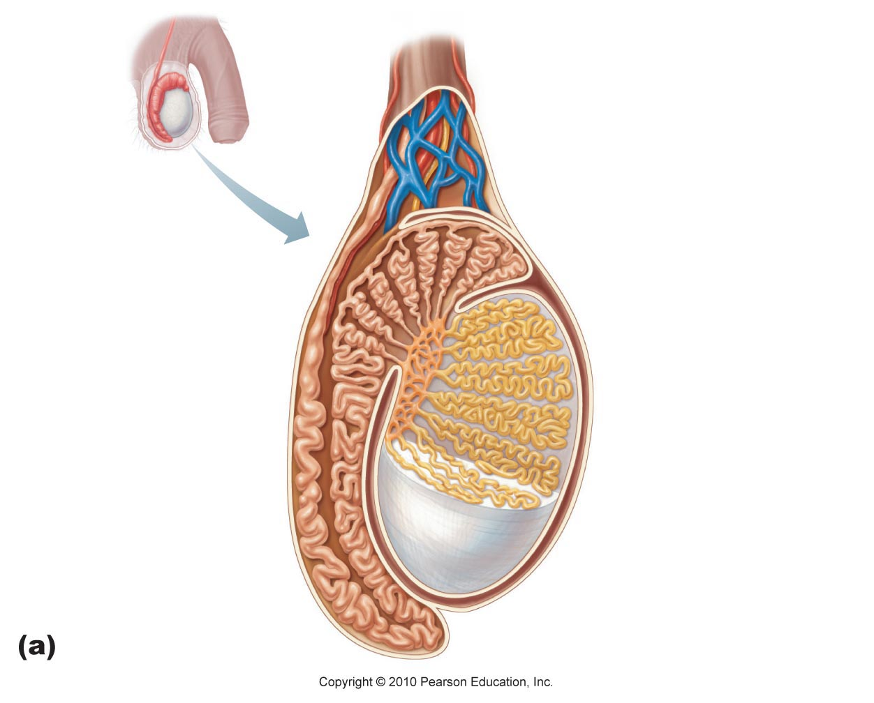
seminiferous tubules (1)

tubulus rectus (2)
3
rete testes (3)

efferent ductules (4)
1
4
epididymis (5)
2
5

figure 27.3a

Leydig Cells
interstitial cells that produce androgens (testosterone)
Interstitial means what??- in between the coils
Blood Supply
• testicular arteries (branch from abdominal aorta)
• testicular veins form pampiniform plexus (role?- it wrap round to try to cool down the blood to maintain the range of 3 degrees below core body temp )
• spermatic cord: blood & lymph vessels, nerves, vas deferens

Where are the Leydig cells? lying in soft connective tissue surrounding the seminiferous tubules are the interstitial endocrine cells (also called Leydig cells)

5.1.2 describe in detail the pathway followed by sperm from the epididymis to the exterior of the body
A. Epididymis (~3.8 cm)
• head caps superior part of testis (receives sperm from ?? leaves testis are moved slowly along the duct of the epididymis through fluid that contains several kinds of antimicrobial proteins)
• body & tail contain highly coiled duct of epididymis ;(uncoiled = ~6 m!)
• sperm that enter epididymis are immature, nonmotile
• ~20 days to traverse epididymis gain ability to swim
What happens to the epididymis during ejaculation? the smooth muscle of in the ducts of the epididymis contracts, expelling sperm into the next segment of the duct system (ductus deferens)
The wall of the epidiymis will contract during ejaculation
What happens to sperm that do not get ejaculated for a long period of time? epithelial cells of the epididymis eventually phagocytize them.
They can stay for around 3 months they will be taken up and recycled
How long can sperm be stored in the epididymis? several months
- They have completed meiosis
- Be cared within the flow of the fluid and they will mature the structure of their membranes

B. Ductus (Vas) Deferens (1/testis)
• ~45 cm long
• describe the pathway taken by the vas deferens to the point where it becomes the ejaculatory duct
• ejaculatory duct passes into prostate gland, then into urethra
• each vas deferens propels sperm out during ejaculation
• What is a vasectomy? Is when the cut that is made so the sperm will not be able to travel to the rest of the pathway. Sperm are still produced, but they can no longer reach the body exterior. Are there any risks associated with this procedure? There is minimal risk and can be undone
C. The Urethra
• terminal portion, serves both urinary & reproductive functions

1) what is the prostatic urethra? the portion surrounded by the prostate
2) what is the membranous urethra? intermediate part of the urethra, in the urogenital diaphragm
3) what is the spongy (penile) urethra? its mucosa contains scattered urethral glands that secrete lubricating mucus into the lumen just before ejaculation

5.1.3. Localize & describe the structure of the male reproductive accessory glands
• produce secretions that, along with sperm, make up semen
A. Seminal Vesicles (2)
• posterior wall of bladder; about size & shape of little finger
• contribute ~60% of semen volume (yellow, viscous, alkaline; fructose, citric acid, coagulating enzyme, prostaglandins)
• sperm + seminal fluid in ejaculatory duct
- Citric acid is a man made acid
- Fructose as their energy source
B. Prostate Gland (1)
single gland, size & shape of chestnut; encircles urethra inferior to bladder
milky secretion (~1/3 semen volume; contains enzymes; role in activating sperm)
secretion to prostatic urethra via several ducts during ejaculation
- Bulbourethral Glands (2)
pea-sized, inferior to prostate
thick, clear mucus to spongy urethra before ejaculation (purpose?? drains into spongy urethra and lubricates the glans penis when a man becomes sexually excited)

5.1.4 describe the structural organization of the penis as a copulatory organ
delivers sperm into ♀ reproduction tract
external genitalia = penis + scrotum
penis = attached root + free shaft or body; enlarged tip = glans penis
foreskin or prepuce = cuff of skin around glans (circumcision)
internally, penis contains:
(i) spongy urethra
(ii) 3 corpora of erectile tissue
2 corpora cavernosa
1 midventral corpus spongiosum
(expands distally glans; proximally, expands bulb of penis)

KNOW DIAGRAM
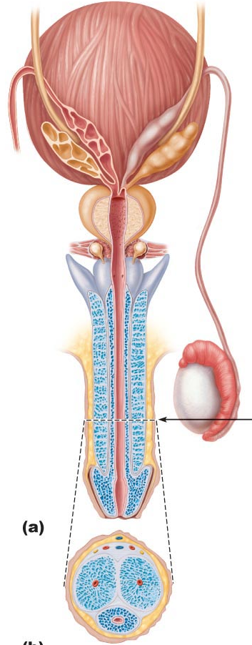figure 27.4
5.1.5 describe the composition of semen
secretions provide:
(i) transport medium
(ii) nutrients (eg: fructose)
(iii) chemicals (eg: PGs) -protect/activate sperm

• pH 7.2-7.6 neutralizes pH 3.5-4 of vagina
SEMEN: 2-5 ml/ejaculation; [sperm] = 50-100 million/ml

Key Choices:
a) bulbourethral glands e) penis i) scrotum
b) epididymis f) prepuce j) spermatic cord
c) ductus (vas) deferens g) prostate gland k) testes
d) glans penis h) seminal vesicles l) urethra
e 1. Organ that delivers semen to the ♀ reproductive tract.
k 2. Site of sperm & testosterone production.
c 3. Passageway for sperm from epididymis to ejaculatory duct.
l (urethra) 4. Conveys both sperm & urine down length of the penis.
h g 5. Organs that contribute to the formation of semen.
a k .
i 6. External sac that houses the testes.
b 7. Tubular storage site for sperm; hugs lateral aspect of testes.
f 8. Cuff of skin encircling the glans penis.
g 9. Surrounds the urethra at the base of bladder; produces a milky, alkaline secretion.
h 10. Produces over half of the seminal fluid.
a 11. Empties a lubricating mucus into the urethra
j 12. CT sheath enclosing vas deferens, blood vessels & nerves.

5.2 Describe the regulation of male reproductive function
5.2.1 differentiate functionally between Sertoli & Leydig cells
• normal rate of sperm production is 2x10⁸ sperm/day
• testis is a source of both germ cells & hormones
• testis is composed of:
(i) seminiferous tubules: = Sertoli cells + spermatogenesis
intermediates; 80% of testicular mass
(ii) Leydig cells: synthesize androgens (testosterone)
Figure 27.3a – seminiferous tubule

5.2.2 distinguish steroid hormones (both structurally and functionally) from amino acid-based hormones
Cholesterol Progesterone Androstenedione Testosterone
What cell type in testis synthesizes testosterone? Leydig cells
Steroid hormones derivatives of cholesterol – ring structure
Leydig cells cholesterol, progesterone, androstenedione, testosterone (androgens = androstenedione and testosterone)

Actions of testosterone:
gonadal: (i) growth/maturation of gonads & accessory organs (puberty)
(ii) essential for spermatogenesis (production of sperm)
somatic: (i) adolescent growth spurts (start & stop - how??? growth plates - as levels rise of testosterone they close off plates lowering the levels)
(ii) growth of larynx & vocal cords
(iii) secretion of sweat
(iv) hair (face, chest, armpits, groin)
metabolic: (i) anabolic (stimulatory effects on hormone synthesis): hematopoiesis, BMR
CNS: (i) maintenance of libido
(ii) aggression behaviour
Which of these events begins first? – Testis (increase in testosterone by testis)
steroid hormones are lipids - significance in terms of their interaction with cells?? – go right to the cell, activate key genes and turn on transcription.
Gonadotropin-Releasing Hormone (GnRH)
Luteinizing Hormone (LH)
Testosterone
(-)
(-)

testosterone synthesis stimulated by LH (luteinizing hormone) from the anterior pituitary

(Chapter 16)
5.2.3 describe the hypothalamic & pituitary regulation of steroidogenesis in the male
Anterior Pituitary Hormones:
• gonadotropins are glycoproteins
• water-soluble – significance?
cell surface receptors; 2nd messengers
> regulate activity of enzymes
Follicle Stimulating Hormone (FSH)
stimulates Sertoli cells (target cells) to support spermatogenesis
(T required testosterone is synergistic)
Luteinizing Hormone (LH)
stimulates Leydig cells to secrete testosterone

Fig. 16.2 Cyclic AMP Second Messenger Mechanism of Water-Soluble Hormones

GnRH: Gonadotropin Releasing Hormone
pulsatile secretion by hypothalamic neurons
stimulates secretion of FSH & of LH
Inhibin: released by Sertoli cells
inhibits secretion of ONLY FSH (no effect on LH)
Higher pulse frequency LH secretion
Lower pulse frequency FSH secretion

5.2.4 outline the main steps in spermatogenesis
• starting point is spermatogonium [diploid]
• at puberty, 6 x 10⁶ spermatogonia per testis; self-perpetuating
What does this mean?? Mitotic to send one cell out and one to keep it in (self-perpetuating)
Primary Spermatocyte
Secondary Spermatocyte
Spermatid
Pg. 1031

From Spermatogonium to Spermatozoan
(i) Spermatogonium: (2N)
• starting point; supply constantly maintained
• first step: spermatogonium B undergoes 2 mitotic divisions 4 1⁰ spermatocytes
(ii) Primary Spermatocyte (2N)
• starting point of meiotic divisions
• first round yields 2 secondary spermatocytes/primary spermatocyte
(iii) Secondary Spermatocyte:
• 2 copies of each of 23 chromatids (eg: if ♂, would have 2 Y chromatids)
• 2nd division 2 haploid (N) spermatids
(iv) Spermatid:
• 22 autosomal chromatids + X or Y - still a round cell
- 2N = diploid

Refer to slide 23 (Snapshot of Meiosis 2n =4)

Fig.27.5: Comparison of mitosis & meiosis

Spermiogenesis
from 1⁰ spermatocyte to spermatozoan takes ~70 days
(v) Spermatozoan:
conversion of spermatid to spermatozoan requires structural reorganization
(i) reorganization of nucleus & cytoplasm

(ii) development of a flagellum

• spermatozoa then released into lumen; still not completely mature
• in epididymis will acquire ability: (i) ……sustain motility…
(ii) plasma membrane changes …

5.2.5 define blood-testis barrier & outline the functions of Sertoli & Leydig cells in supporting spermatogenesis
A. Role of Sertoli Cells
spermatids & spermatocytes at various stages embedded in Sertoli cells
Sertoli cells sit on basement membrane; tight junctions create 2 compartments:
>basal compartment: where there are dipoid cells
>adluminal compartment: toward the lumen, is from the tight junctions
tight junctions create blood-testis barrier; all stages after initiation of meiosis occur in avascular environment
Sertoli cells:
(i) nourish developing spermatozoa
(ii) secrete fluid into seminiferous tubule lumen
(iii) digest cytoplasm discarded by spermatozoa
(iv) bind FSH and testosterone
(v) produce inhibin
B. Role of Leydig Cells
• located between seminiferous tubules
• vascularized - why important? – they need cholesterol in order to make blood
• receptors for LH - stimulated by LH to secrete testosterone to:
> support spermatogenesis
> support accessory organs
5.2.6 describe the functional contributions of the epididymis & the accessory organs to the production of semen
A. Epididymis
sperm spend ~20 days here
further maturation – membrane & enzyme changes to permit:
> sustained motility
> binding to egg
B. Seminal Vesicles
• secrete viscous, yellow fluid rich in fructose
• Why fructose? allows investigators to recognize a sperm trail or residue in instances of sexual attack
• also contains PGs What do they do? enhance sperm motility or fertilizing ability
C. Prostate Gland
• secrete thin, milky fluid to neutralize acidity of male urethra & female vagina
- Bulbourethral Glands
thick, clear mucus
neutralizes traces of acidic urine in urethra

Know sources & roles of :
GnRH controls LH and FSH secretion by anterior pituitary
FSH increases the production of androgen-binding protein, inhibin, and estrogen by Sertoli cells (initiates spermatogenesis in Sertoli by inducing testosterone/androgen receptor)
inhibin by Sertoli to self-downregulate
LH controls the synthesis of testosterone by Leydig cells
Testosterone mainly reduces LH secretion (maturation of sperm, converts to DHT in Leydig, converts to estrogen in Sertoli
Inhibin reduces secretion of FSH
Have an understanding of:
hypothalamus
anterior pituitary
gonadotropin
Sertoli cell
Leydig cell secretes testosterone
(need to know all of these) FSH and LH = gonadotropin

1. A chromosome count in a spermatogenic cell within the adluminal compartment of the seminiferous tubule shows it to be diploid. The cell could be a:
a) spermatogonium
b) spermatid
c) Sertoli cell (supportive cell)
d) primary spermatocyte **
e) b and d
2. Seminal vesicle secretions have:
a) a low pH
b) fructose
c) prostaglandins
d) sperm-activating enzymes
e) b and c **
3. Which of the following statements about gonadotropins is FALSE?
a) secreted by the pituitary gland
b) LH and FSH
c) hormones with important functions in both ♂ and ♀
d) the sex hormones secreted by the gonads ** (steroid hormones by the gonads)

5.3 Describe the anatomy of the female reproductive system
5.3.1 describe the gross and microscopic anatomy of the ovaries
• female reproductive system more complex must:
(i) produce gametes
(ii) prepare to nurture developing embryo
> internal genitalia: ovaries
> accessory ducts: uterine tubes (oviducts), uterus, vagina
> external genitalia: vulva
Ovaries
• anchored by ligaments
Ovarian (label- holds the ovary in place)
suspensory
mesovarium
NB: suspensory/mesovarium ligaments are part of broad ligament that supports uterine tubes, uterus, vagina
• ovarian arteries (branches of ??? of the descending aorta) & ovarian branch of uterine arteries
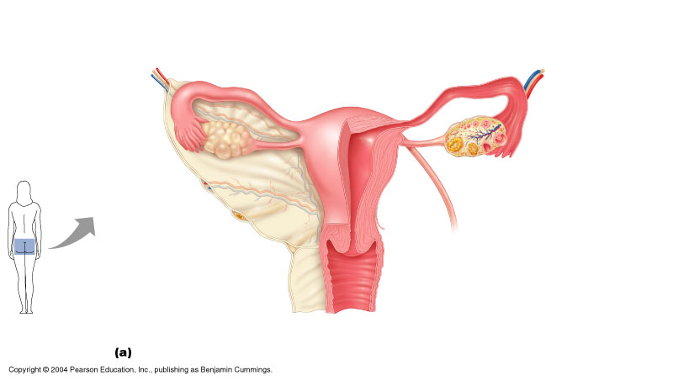figure 27. 14
Suspensory
Mesovarium
Ovarian ligament

ext surface covered by tunica albuginea
final outer covering is germinal epithelium
ovarian cortex contains follicles at all stages of development
oocyte
granulosa cells of the developing follicles secrete : estradiol
theca cells LH STIMULATES THECA CELLS (develop outside granulosa cells)
corpus luteum formed from ovulated follicle each month
- LH required for ovulation (not FSH alone)
- LH converts theca and granulosa cells into progesterone secreting cells

5.3.2 describe the gross and microscopic anatomy of the oviducts
• receive egg & provide site for fertilization; ~ 10 cm long
• ampulla of the oviduct (where fertilization occurs), infundibulum , fimbriae (finger shaped – to create currents in the peritoneal fluid): oocyte released into peritoneal cavity fimbriae direct it into ampulla of oviduct
• structure of wall of oviduct (fallopian tubes) also helps oocyte move toward uterus:
1) ……cilia keep it moving in the right direction … (epithelial cells lining the oviduct)…………..
2) ……smooth muscle of the oviduct to do peristaltic contractions………………..
• ext covering = visceral peritoneum; supported by mesosalpinx
What is the isthmus? The isthmus of the Fallopian tubes is the narrowest and thickest walled region of the fallopian tube bordering on the uterus. From the isthmus the Fallopian tube widens into the ampulla.
5.3.3 describe the gross & microscopic anatomy of the uterus
- anterior to rectum & postero-superior to bladder
• receives, retains, nourishes embryo
• inverted pear in nulliparous women (a woman who has never given birth)
internal os: uterus to cervix
external os: cervix to vagina
cervical glands: mucus fills cervical canal & covers ext os prevents infection; less viscous at midcycle – why?? allows sperm to pass through
Exam-diagram*
Fundus (top)
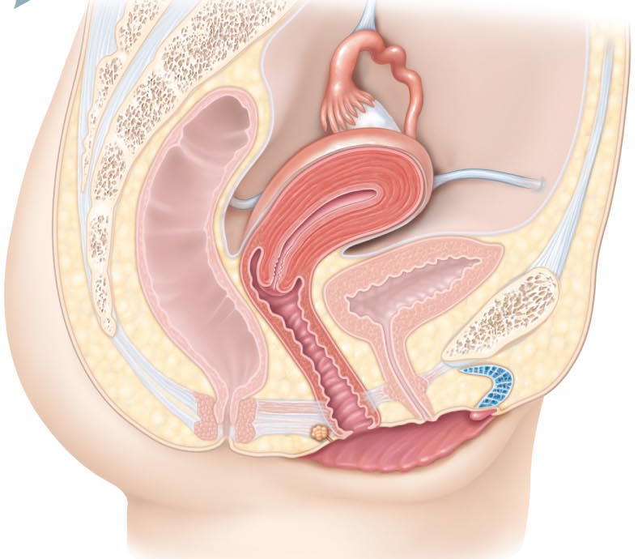
Body (bulky exterior)
Isthmus (bottom of body)
Cervix (under isthmus)
Vagina (bottom)

Supports of Uterus:
mesometrium: laterally (broad ligament)
lateral cervical ligaments: inferiorly; from cervix & upper vagina to lat walls of pelvis
uterosacral ligaments: to sacrum posteriorly
round ligaments: to anterior body wall
• supports allow mobility (eg: during ??? its position changes as the rectum and bladder fill and empty)
• principal support by muscles of pelvic floor (urogenital & pelvic diaphragms)
Refer to slide 37 – DIAGRAM

Uterine Wall:
• 3 layers:
perimetrium: = visceral peritoneum
myometrium: middle, interlacing bundles of smooth muscle
endometrium: simple columnar epithelium + thick lamina propria
stratum functionalis: undergoes cyclic changes in response to blood levels of ovarian hormones and is shed during menstruation (28 days)
stratum basalis: forms new functionalis after menstruation ends

vascular supply:
uterine arteries (from internal iliacs)

to arcuate arteries

radial arteries within myometrium

straight arteries spiral arteries
(stratum basalis) (stratum functionalis)

5.3.4 describe the anatomy of the vagina & the external genitalia
thin-walled tube, 8-10 cm long
urethra embedded in anterior wall
passageway for:
entry of sperm
exit of menstrual flow
delivery of infant
• 3 layers:
adventitia: outer, fibroelastic
muscularis: smooth muscle
mucosa: inner, transverse rugae (stimulate the penis during intercourse); stratified squamuous epithelium (why?? to stand up to friction)
• no glands; lubrication provided by cervical glands
• epithelial cells store glycogen metabolized to lactic acid by resident bacteria acidic pH deters infection, but is hostile to sperm
hymen: incomplete vascular partition of mucosa near vaginal orifice in virgins

External Genitalia
• vulva: mons pubis, labia, clitoris, structures associated with vestibule
mons pubis: fatty, rounded area overlying pubic symphysis; covered with hair
labia majora: elongated, hair-covered fatty skin folds (homologue of scrotum)
labia minora: thin, hair-free skin folds enclosed by labia majora
vestibule: recess between labia minora - contains external opening of urethra & vaginal opening; greater vestibular glands
clitoris: erectile tissue (homologous to penis); hooded by skin fold; richly innervated; corpora cavernosa but no corpus spongiosum
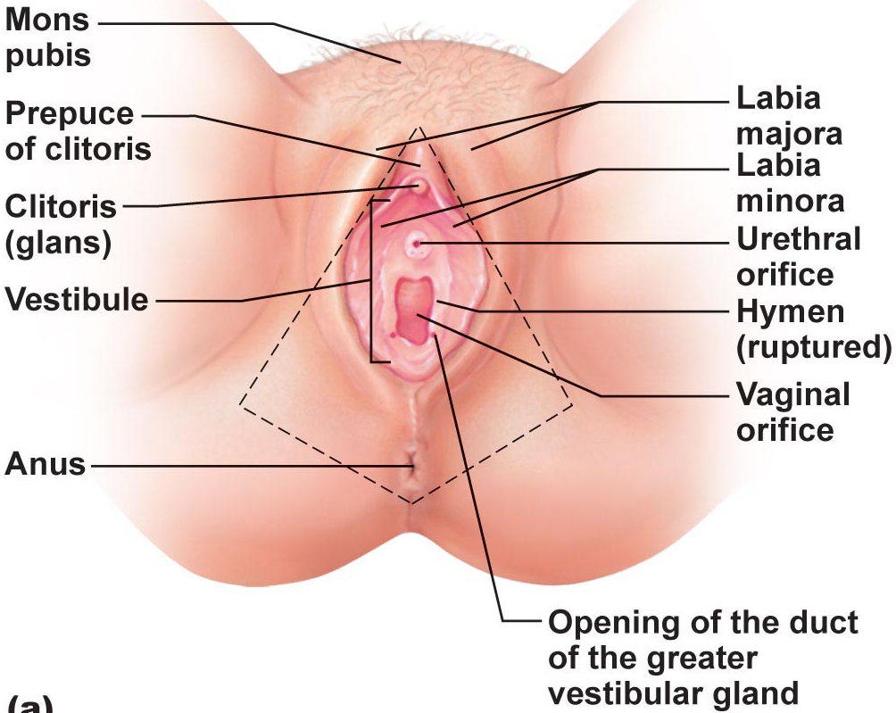*perineum

1. Identify the following female anatomical structures:
Uterus 1. Chamber that houses the developing fetus.
Vagina 2. Canal that receives the penis during sexual intercourse.
Ampulla of the oviduct 3. Usual site of fertilization.
Clitoris 4. Becomes erect during sexual stimulation.
Oviduct 5. Duct through which the ovum (egg) travels to reach the uterus.
The Hymen 6. Membrane that partially closes vaginal canal in virgins.
Ovary 7. Primary female reproductive organ.
Frambia (finger structure) 8. Move to create fluid currents to draw the ovulated egg into the uterine tube.

