Cha Gheill Exam Format

1/6 will be from Quiz 1 ‘footprint’
1/6 will be from Quiz 2 ‘footprint’
1/2 will be from Section 3 ‘footprint’ (i.e. from seismology)
1/6 will be integrative thinking (with tectonics and site investigation being the themes of interest)

PART 1: TECTONICS AND GEOCHRONOLOGY

Section 1 - Conceptual

What are hotspot volcanoes, what is the hotspot reference frame, and what is it used for?
Hotspot volcanoes are volcanoes formed by the passage of the lithosphere over magmatic hotspots (upwellings of mantle plumes), creating a progressive series of volcanoes that form a hotspot reference frame. A hotspot reference frame is a frame of reference generated from the absolute position of mantle plumes and the rate of continental drift, wherein we know the relative ages of volcanoes through other dating methods and can determine the absolute rate of tectonic drift.

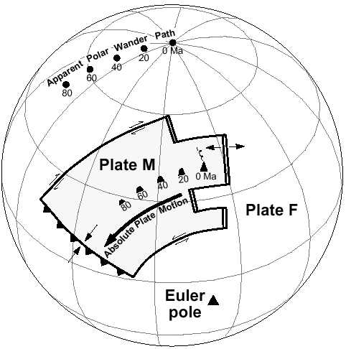

You are on your personal yacht in the Pacific and the echo sounder shows depth below you is getting gradually shallower, yet you know there are no islands for at least 1000km around. Provide three possible causes.

- Crossing mid-ocean ridge
- Leaving ocean trench
- Submarine seamounts (like a hotspot volcano forming)
- Bulge from the flexure of a nearby submerging plate

What is a transform fault? What geometric relationship does it have to mid-ocean ridges and to the Earth’s shape?
Transform faults are faults where plates are moving laterally relative to one another (i.e. ‘sliding’ past each other.) Transform faults form perpendicularly to mid-ocean spreading ridges due to the shape of the earth, and describe the small circles of the Euler pole of the spreading centre.

What is closure temperature?
Closure temperature is the temperature at which a given isotope of an element becomes contained and loses mobility/freedom; the point where an element becomes useful for radioisotope dating.

What is a Wilson Cycle? How long does one cycle take (+/- 100Ma)?
A Wilson cycle describes the complete formation and breakup of a supercontinent like Pangaea or Rodinia. A Wilson Cycle generally takes between 300 and 500 Ma.
Involves Rift, Drift, Subduction (one side), Drift (back), Collision

Section 2 - Conceptual - Numerical

Explain, in principle, how the Rb-Sr isochron method works, using sketches and examples.
The Rb-Sr isochron method dates rocks based on the ⁸⁷Rb/⁸⁷Sr ratios within rocks. Rb-Sr dating suffers from the original value problem, in that we do not know how much initial parent isotope the rock contains. Because all melts have initial ratios of ⁸⁷Sr/⁸⁶Sr but different minerals have different ratios, we can graph all daughter/reference vs. parent/reference ratios (in this case, ⁸⁷Sr/⁸⁶Sr vs. ⁸⁷Rb/⁸⁶Sr). From the intercept of these ratios, we can find the initial amount of parent and the original age. This modifies the daughter equation in the following fashion:

[⁸⁷Sr’]/[⁸⁶Sr] = [⁸⁷Srº]/[⁸⁶Sr] + [⁸⁷Rb’]/[⁸⁶Sr](e^{λt} - 1)

This takes the form of a linear equation with slope m = e^{λt} - 1and intercept [⁸⁷Srº]/[⁸⁶Sr] which can be used to calculate the original amount of parent, and the age of the sample.

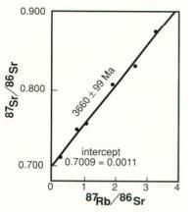
http://hyperphysics.phy-astr.gsu.edu/hbase/nuclear/clkroc.html

Explain, in principle, what the U-Pb Concordia diagram accomplishes, with reference to the systems. Use sketches and examples.
The U-Pb Concordia diagram is a combination of two separate isochrons which can be correlated and checked against one another. By comparing the development of ²³⁸U/²⁰⁶Pb and ²³⁵U/²⁰⁷Pb isochrons, we can create a new curve,

[²⁰⁷Pb/²⁰⁶Pb]_{now} = [²³⁵U/²³⁸U]_{now} (e^{λ235t} -1)/(e^{λ238t} -1)

This is made even simpler by the fact that [²³⁵U/²³⁸U]_{now} is uniformly 1/137.88, which makes this system even simpler. The Concordia system then plots along the following curve:
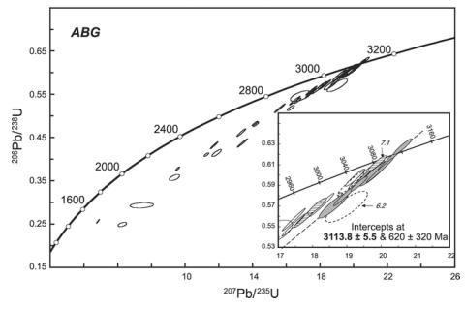
The Concordia plot shows the curve of all perfectly preserved naturally occurring rock samples; any alteration or change in geochemistry would move the sample off the Concordia curve. We can establish linear relationships of altered samples and determine their intercepts and most probable original ratios and ages on the Concordia curve.

What is a model age?
A model age is an assumed age around which we can construct a scientific model of radioisotope dating. It is used where actual quantifiable data is scarce or non-existent, under the assumption that a possibly erroneous model is better than no model at all.

How do isotopes constrain the possible components of the evolved mantle?
By creating a model system where the original, undisturbed mantle has a set Sm/Nd ratio, we can establish the different components of the evolved mantle according to how the evolved end-components’ Sm/Nd ratios diverge from the ideal model and thereby know how and in what ratios the various mantle constituents have mixed and evolved.

What is a geothermal gradient? Describe some geological scenarios with high, average, and low geothermal gradients.
Geothermal gradient describes the gradual change in temperature at increasing depths.
- High: mid-ocean spreading ridge and island arcs due to magma rising to the surface
- Medium: continental crust
- Low: subduction zones due to the thrusting of cold, water-filled sediments beneath the existing crust

What is thermal conductivity? List a geological material with relatively low, average, and high thermal conductivity.
Thermal conductivity is a measure of how readily a material will transfer heat energy. The more organized a structure is, the higher the thermal conductivity.
- Low: Glass, unorganized so will not transfer heat as easily.
- Medium: Quartz
- High: Diamond, highly organized.

For U-Pb, Rb-Sr, and K-Ar, give approximate values for the parent’s half life (order of magnitude). Do systems with longer half-lives have higher or lower decay constants?
²³⁸U/²⁰⁶Pb: 4.468 x 10⁹ a
²³⁵U/²⁰⁷Pb: 7.04 x 10⁸ a
⁸⁷Sr/⁸⁷Rb: 4.88 x 10¹⁰ a
⁴⁰K/⁴⁰Ca: 1.40 x 10¹³ a
⁴⁰K/⁴⁰Ar: 1.19 x 10¹⁰ a

Systems with a longer half-life have a smaller decay constant, due to the inverse exponential
relationship between age and radioactive decay.

Why do we use systems with half-lives close to the ages of the samples we are dating?
We use systems with half-lives close to the ages of the samples we are dating so that we are less susceptible to sampling error – that is, if there is a scarcity of daughter or parent isotopes, any error will be exacerbated in calculating the age.

Lord Kelvin’s estimates of the age of the Earth (20-400Ma) were based on two assumptions. What are these assumptions, and did each make the apparent age longer or shorter than the ‘true’ value?
Lord Kelvin assumed that a) the only transfer of heat within the Earth came from conductivity (when convection and advection are also important factors in heat transfer), which lengthened his estimate of the age of the earth, and b) he also assumed that the Earth was a closed system with no heat production (when in reality, the Earth has its own heat production from the decay of radioactive isotopes), an error which dramatically shortened his estimate of the earth’s age

Given the decay constants λ_{Ar} and λ_{Ca} for the K - Ar/Ca system, draw a sketch of the relative amounts of these three isotopes over time. Calculate the half-life of each isotope and show it on your sketch.

λ_{Ar} = 5.81 x 10⁻¹¹ a⁻¹
t_{1/2} = 0.693/λ
t_{1/2(Ar)} = 0.693/(5.81 x 10⁻¹¹ a⁻¹)
t_{1/2(Ar)} = 1.19 x 10¹⁰ a

λ_{Ca} = 4.96 x 10⁻¹⁰ a⁻¹
t_{1/2} = 0.693/λ
t_{1/2(Ca)} = 0.693/(4.96 x 10⁻¹⁰ a⁻¹)
t_{1/2(Ca)} = 1.40 x 10¹³ a

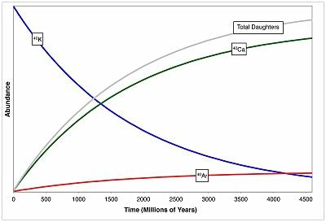

What are characteristic diffusion time and distance? Why do these parameters not accurately reflect the process of heat transfer in the Earth?
Characteristic diffusion time and distance are two functions which describe the diffusion time and distance of heat energy within an ideal system - that is, homogeneous, closed, only conductive energy transfer. This obviously breaks down in experimental situations where none of the previous conditions apply.

Section 3 - Numerical - Demonstrative

Given Rb, Sr and assuming no Sr_{i}, calculate age using (formula given) and (constants given).
Ex: t = 1/λ * ln(1+ D_{now}/ P_{now})
Rb=198.5000g Sr=8.93310g (Rb=86.9092g/mol, Sr=86.9089g/mol)
λ=1.42*10⁻¹¹

Rb = (198.5000g) * (mol/86.9092g) = 2.2840 mol Rb
Sr = (8.93310g) * (mol/86.9089g) = 0.10279 mol Sr
t = 1/λ * ln(1 + Sr/Rb) = 1/1.42*10⁻¹¹ * ln(1 + 0.10279/2.2840)
t= 3100 Ma

Given two Rb, Sr sets and assuming initial Sr, calculate age and initial Sr.

Given U-Pb data for core and rim, calculate age. Provide a geological explanation for the ages.
Ex: t = 1/λ * ln(1+ D_{now}/ P_{now})
λ=1.55*10⁻¹⁰
Outer Rim:
Pb=180.97485g U=312.0000g (Pb=205.9745g/mol, U=238.05079g/mol)

Pb = (180.97485g) * (mol/205.9745g) = 0.87850 mol Pb
U = (312g) * (mol/238.05079g) = 1.31064 mol U
t = 1/λ * ln(1 + Pb/U) = 1/1.55*10⁻¹⁰ * ln(1 + 0.87850/1.31064)
t= 3309.6 Ma

Same calculations for the core data.
Core data should give an older age than rim data. This is because the core cools/ reaches the closure temperature before the rim. Thus the core begins recording an age sooner.

Given heat flow equation, and T change across a horizon, calculate the gradient.
Gradient = ∆T/ ∆z
- change in temperature/ change in depth
q = -k * gradient
- heat flow = - thermal conductivity * gradient

Its all just plug and chug =)

Section 4 - Numerical - Theoretical

For a simple generic decay system (P →D), show the differential equations that govern the fundamental behaviour of the system

In a simple decay system, the primary differential equation which governs the system is dP/dt = -λP, which indicates that decay rate is directly proportional to the amount of parent present .

Derive the P(P_{o}) equation
δP = -λ δt
if δt → 0, then
dP/dt = -λP
(1/P)dP = -λdt
∫(1/P)dP = -∫dt
lnP= -λt + C
if at time t = t_{o} = 0, P=P_{o} then
C = lnP_{o}
lnP = -λt + C becomes
lnP = -λt + lnP_{o}
-λt can be rewritten as lne^{-λt},
lnP = lne^{-λt} + lnP_{o}
lnP = lnP_{o}e^{-λt}
P = P_{o}e^{-λt}

‘Derive’ the half life equation
P_{o} = 1, D_{o} = 0
t = 1/λ ln(1 + D_{now}/P_{now})
At t_{1/2}, P = D
t_{1/2} = 1/λ ln(1 + 0.5/0.5)
t_{1/2} = 1/λ ln(2)
t_{1/2} = 1/λ (0.693)
t_{1/2} = 0.693/λ

OR

P = P_{o}e^{-λt}
At t_{1/2}, P = ½P_{o}
½ P_{o} = P_{o}e^{-λt}_{1/2}
½ = e^{-λt}_{1/2}
ln ½ = -λt_{1/2}
t_{1/2} = ln ½ / -λ ; ln ½ = -.0693
t_{1/2} = 0.693 / λ

Given K, Ar for a perfect sample and the formula for age (given), and knowing independently the true age of the sample, provide a formula for λ

Given the equation for an equilibrium temperature profile, explain the variables, and how these variables might differ between certain geological conditions. Use sketches to show how these differences change the shape of the temperature profile.

T(z) = -A/2K(z²) + ((Q_{d} + Ad)/K)z, where

K = thermal conductivity: variable with mineralogy/rock type, permeability, porosity, density, grain size
A = radioactive heat generation: usually variable with depth and geochemistry; more basic/mafic rocks will (usually) have higher radioactive mineral content and generate more heat
Q = basal heat flow: uniform in equilibrium conditions; will vary with depth
d = thickness of slab
z = depth of bottom of slab

Section 5 - Supplementary

Parent equation:
δP = -λ δt
if δt → 0, then
dP/dt = -λP
(1/P)dP = -λdt
∫(1/P)dP = -∫dt
lnP= -λt + C
if at time t = t_{o} = 0, P=P_{o} then
C = lnP_{o}
lnP = -λt + C becomes
lnP = -λt + lnP_{o}
-λt can be rewritten as lne^{-λt},
lnP = lne^{-λt} + lnP_{o}
lnP = lnP_{o}e^{-λt}
P = P_{o}e^{-λt}

Daughter equation:
P = P_{o}e^{-λt}
P_{o} - D = P_{o}e^{-λt}
D = P_{o}(1 - e^{-λt})
since P_{o} = P + D,
D = (P + D) (1 - e^{-λt})
De_{-λt} = P - Pe^{-λt}
D = P(e^{λt-1})

Time equation:
t = 1/λ ln(1 + D_{now}/P_{now})

Half-life equation:
t_{1/2} = 0.693/λ

Heat flow equation:
q = -K ∂T/∂Z (J/m³s)

Equilibrium heat equation:
T(z) = -A/2K(z²) + ((Qd + Ad)/K)z

Wilson Cycle:
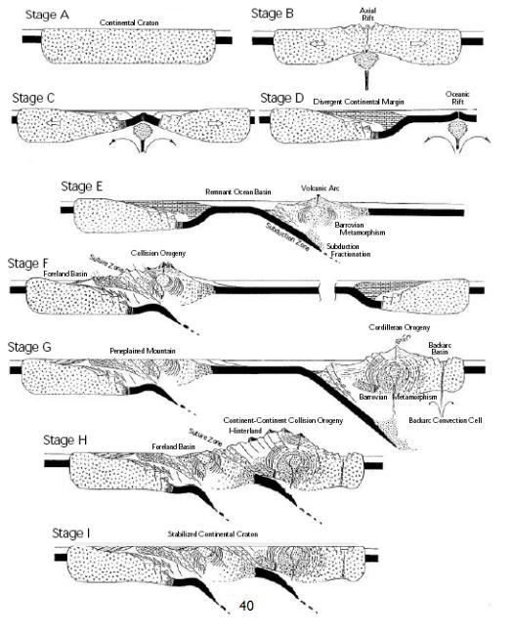

PART 2: GRAVITY AND (PALEO)MAGNETISM

Section 1 - Concepts

What is the geoide? A spheroid of revolution?
The geoide is the model of the Earth’s gravitational field at an equipotential global sea level, i.e. removing all terrain above a calculated mean sea level.

The spheroid of revolution, or reference spheroid, is the idealized shape of the Earth accounting for the various effects which derive from the equatorial bulge (which is roughly 20km greater in radius at the equator): centripetal force and increased radius, which decrease gravity at the equator, and the added mass of the bulge, which increases the gravity at the equator.The net result is a decrease in gravity at the equator (9.83 m/s² at the pole vs. 9.78 m/s² at the equator, a difference of 0.05 m/s²)

How might we determine absolute gravity?
The two common ways of determining absolute gravity are by measuring the period of a standardized pendulum, or by timing free fall of a reference mass in a vacuum cylinder (to eliminate air resistance).

How might we determine the mass of Earth?
We can determine Earth’s mass if we know the radius of the Earth at our current position and the absolute gravity by treating the Earth as a single point mass and calculating the Earth’s mass from Newton’s law of gravitation, g = GM/r².

What major geologic structures influence the broad shape of the geoide?
Major geological features that affect the shape of the geoide include submarine ridges, volcanoes and trenches, and of course continents and continental shelves.

What factors that influence gravity are related to latitude?
The influence of latitude with respect to gravity is compensated for in the Theoretical Gravity Formula. Latitude is also compensated for through the latitude correction, ΔG_{L}, and the Ëotvos correction also has a latitude term in it, although the effect is minor, and Ëotvos correction only applies when you are in motion.

What is the Theoretical Gravity Formula, conceptually? What is it used for?
The Theoretical Gravity Formula is a broad calculation of the conceptual gravitational force/acceleration at any given point on the Earth. It is used to correct for the oblate spheroid shape of Earth.

What is isostasy? Describe two broad conceptual types.
Isostasy is the idea that the Earth’s tectonic plates maintain a state of equilibrium between the rigid lithosphere and the ductile asthenosphere such that “columns” of various size and density will float at different heights to maintain equilibrium. The two conceptual types of isostasy are local isostasy where a series of independent columns are balanced to an isostatic equilibrium, such as the Pratt-Airy model, and regional isostasy, where the flexure of the lithosphere and the distribution of loading through bending maintains an isostatic equilibrium.

Describe a gravity survey: tools, processes.
- Base camp.
  - Take a reading here to calibrate instrument
  - Dee
  - Determine elevation above sea level
- Walk around, take measurements every so often
  - Stand really still + away from machine (can even sense your heart beat)
  - Determine precise latitude
  - Determine elevation
- Periodically come back to the base camp to take a reading to account for drift (of earth, of machine)

Describe lithospheric flexure: does it ‘agree’ with isostasy?
Lithospheric flexure is the idea that Earth’s crust does not behave as a series of floating columns, but rather a semi-rigid beam that flexes under overburden pressure, i.e. glaciation or upwelling, (i.e. Indian plate/Himalaya collision, a system which is currently NOT in isostatic equilibrium). This idea strongly contradicts isostasy, but both models do apply to the shape of the Earth, over varying time scales – most tectonic plates will show evidence of lithospheric flexure in the short term, then gradually transition to a Pratt-Airy isostatic model over long geologic time periods.

What is the Bouguer correction? What is a Bouguer anomaly?
The Bouguer correction is applied to correct for the extra mass beneath a location at an increased elevation, e.g. a mountain. This is different from the free-air correction, which accounts for the loss of gravity from an actual increase in elevation. A Bouguer anomaly is the gravity anomaly produced by an infinite plate of additional mass/density.

The Bouguer correction refers to ONLY the correction its self (ie g_{B} = 0.0419 (ρ_{there} - ρ_{expected})
The Bouguer anomaly refers to all of the corrections up to an including the Bouguer correction (in that yucky long formula).

Will an area in isostatic equilibrium (say, Airy model) have a Bouguer anomaly over a mountain belt? Why, or why not?
An area over an isostatically balanced mountain belt will still have a Bouguer anomaly because while the system is balanced with respect to the equipotential gravitational surface, the effects of gravity measured at the top of the mountain are different for the mountain and the root itself – the effects of the root will be broader and diminished by depth, while the mountain itself will produce a sharper, more intense gravitational anomaly.

Does a compass point to True North? If so, why? If not, what is the correction called?
A compass does not point to geographic north, because the gravitational poles of the Earth are not precisely aligned with the rotational axis. Instead, we compensate for the difference using the magnetic declination, which in this region of Canada is roughly 14° W.

What is the dipole field? Does it account for the entire internal field seen?
The dipole field is the innate magnetic field of the Earth that is generated by the convection of magnetically conductive molten currents within the outer core, creating a dynamo electromagnet which generates 90% of the Earth’s magnetic field. 8% of the Earth’s total magnetic field is generated by other processes such as the local field from paramagnetism, diamagnetism, and ferromagnetism (both induced and remnant).

“What is the exact inclination of the magnetic field of the Earth at a latitude of 30 degrees?” Is this a meaningful question?
This question is largely meaningless as the inclination at any given latitude is not uniform because the geomagnetic poles are not aligned with the revolutionary axis of the Earth, therefore there is no meaningful correlation between latitude and magnetic inclination.

An applied field interacting with a rock induces a field... what factor do we use to measure how much so?
The strength of an induced magnetic field in a rock is measured by the magnetic susceptibility of that rock.

What is paramagnetism? How much does the paramagnetic component vary when the external field goes to zero?
Paramagnetism is a weakly additive magnetic field which is produced by the alignment of excited electrons in incomplete electron shells, and is fairly common in non-ferromagnetic metals. The paramagnetic component of the field is entirely induced and drops to zero when the external field goes to zero.

Describe the orientation of the dipole field in space and in time.
The dipole field is oriented at an inclined angle to the spin axis of the Earth, at an inclination of between 10.5° – 11.9°. The dipole field slowly drifts, or processes, in a region around the geographic pole, and has been moving at a rate of around 0.2° west per year. It is currently moving south through Northern Canada towards Resolute Bay.

What is a coronal mass ejection? Why do we care?
A coronal mass ejection is a sudden plume of electromagnetic energy in the form of charged ions, gamma and x-ray radiation which streams towards the Earth. They are an important event because of the huge interference and havoc they can cause with modern electrical systems. They are relevant because the magnetic field generated by the Earth protects us from solar radiation.

What is true polar drift? What is apparent polar drift? Can we distinguish them based on a single measurement? A large group of measurements?
True polar drift is the absolute movement of the dipole field within the Earth relative to the revolutionary axis. Apparent polar drift is the perceived movement of the dipole field based on continental drift. They can be distinguished if there is a strong model for the plate movement in a region, which allows us to subtract the effects of apparent polar drift to find the true polar drift.

Describe diurnal variations in the field.
Diurnal variation takes on two modes: quiet days, where the field varies by as little as 50 – 200 nT, weakest in the morning and strongest at mid-afternoon. The other mode is disturbed days, where fluctuations of hundreds of nT can occur due to interference from solar winds.

I have a rock sample that is at 1000 degrees. I cool it. It contains magnetite. Describe what happens.
If a sample of magnetite is cooled past its Curie point, the magnetic domains within the sample will align and eventually lock in, creating remnant ferromagnetism within the sample that will be aligned with the magnetic inclination/declination of the external field in which it was cooled.

Can a sediment record magnetization? Describe at least two ways it could!
The two most common ways for a sediment to record magnetism are through detrital settling, where fine sediments are preferentially realigned by an applied external field, and chemical growth, where the in situ growth of ions in a chemical precipitate is aligned with the external field. Post-depositional detrital remnant magnetization (caused by bioturbation or consolidation pressure) can also play a factor in the magnetization of sediments.

What can we do with the polarity of the magnetic field through geologic history?
If we have a way to correlate the changing polarity of a rock with its age, we can create a map of tectonic growth based on the spreading rate of various spreading centres. The changing polarity can also be used to correlate stratigraphy.

What can we do with a measurement of field inclination from an ancient sample?
It is difficult to use a measurement of field inclination unless we know that it is preserved without tilting or subsequent events which have altered its orientation. However, if it is a good sample, we can date that sample based on its inclination at the time when it cooled, by examining it in a lab after reheating it in a demagnetizer.

Section 2 - Geodesy and Gravity Applications

Given a scenario, solve Pratt Model
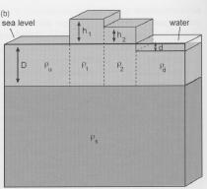
Given a scenario, solve Airy Model
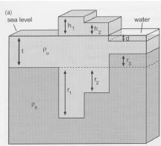

Given a profile, postulate a subsurface model

Given a subsurface model, sketch a profile

Discuss the correction process for gravity data (given formula?)
Δg = g_{obs} - (g_{t} + corrections) mGal
Δg = g_{obs} - (g_{t} - Δg_{Eötvös} - Δg_{drift} - Δg_{L} - Δg_{free-air} + Δg_{Bouguer} - Δg_{terrain} - Δg_{other}) mGal
Δg = g_{obs} - g_{t} + Δg_{Eötvös} + Δg_{drift} + Δg_{L} + Δg_{free-air} - Δg_{Bouguer} + Δg_{terrain} + Δg_{other} mGal

Δg_{Eötvös}: corrects for horizontal motion (i.e. I’M ON A BOAT)LOL
moving east, gravity decreases, correction is positive
moving west, gravity increases, correction is negative
Δg_{Eötvös} = 7.503 v sin(α)cos(Φ) +0.004154 v², where
α = longtitude
Φ = latitude

Δg_{drift}: corrects for instrument drift, performed by setting up a reference gravimeter at a single stable location and calibrating all measurements to the base station

Δg_{L}: corrects for distance from/towards the equator
Δg_{L} = (dg_{t}/ΔΦ) (dΦ/dL) ΔL
Δg_{L} = (0.811 sin(2Φ) mgal/km)D, where
D = distance from the poles/towards the equator

Δg_{free-air}: corrects for altitude
Δg_{free-air} = dg/dr ΔR
Δg_{free-air} = -2g/r ΔR
Δg_{free-air} = (0.3066 mGal/m)h, where
h = height above sea level

Δg_{Bouguer}: corrects for added infinite slab
Δg_{Bouguer} = 2π G Δρ
Δg_{Bouguer} = (0.0419 Δρ mGal/m)T, where
T = thickness of the slab

Section 3 - Mag and Paleomag Applications

Paleomagnetic measurements are equivalent to geochronology. Discuss.
Paleomagnetic measurements are not exactly equivalent to geochronology in that independently, they give us no relevant geochronological data. However, we can establish a strong relationship (or system of geochrons) between paleomagentism and geochronology by using other dating methods such as radioisotope decay (i.e. between K-Ar decay and paleomagnetism), and this does give us a strong method of geochronological dating, so in this manner, paleomagnetism is equivalent to geochronology, although subject to a higher degree of uncertainty and imprecision as paleomagnetic ages are not determined from first principles.

Geochron: Can date the sample with isotopes.
Paleomag: If we know inclination in sample, can know paleo latitude, can know where it was on earth when it formed. We have a model of plate positions for earth, so we can estimate an age.

Paleomagnetic measurements allow a plate to be uniquely placed on the Earth’s surface. Discuss.
Paleomagnetic measurements allow us to measure the relative rates of ocean-floor spreading, and thus the relative motion between plates fairly easily. Determining the absolute position of plates can be more difficult, because one would need a complete set of paleomag data for all spreading centres, which becomes increasingly difficult as we proceed back through the geological time record due to metamorphism, alteration, overprinting and other interference. In addition, subduction of plates in certain locales (i.e. the Juan de Fuca plate or the Cocos plate) have erased entire sections of the paleomagnetic time record. Also of note is that fact that plate boundaries often close and reopen, and the movement of that plate boundary is not recorded while it remains closed. Thus, while it is theoretically possible to assign unique positions to continental plates, in practice, this is almost impossible.

Given paleolatitude (tan(i) = 2 tan(Φ)) we can figure out where the plate was when the rock formed.

Section 4 – Supplementary

Units of gravity:
Gal = 10⁻² m/s²
mGal = 10⁻⁵ m/s²
μg = 10⁻⁶ m/s²

Theoretical Gravity Formula:
g_{t} = g_{e}[1 + 0.005278895 sin²(Φ) + 0.00023462 sin⁴(Φ)], where
g_{e} = 978031.85 gal
Φ = latitude

Anomaly over a sphere:
Δg_{sphere} = 0.0279 Δρ a/(z²[1+{x² + z²}/z²]^3/2) mGal, where
ρ = density
z = vertical depth to center of sphere
x = horizontal distance to center of sphere for the boys

Anomaly over a semi-infinite slab:
Δg_{slab} = 13.34 Δρ T (π/2 + tan⁻¹ (x/z)), where
ρ = density
T = Thickness of the slab
z = vertical depth to center of slab
x = horizontal distance to end of slab

Strength of the magnetic field:
F_{H} = M cos(Φ)/R³
F_{V} = 2M sin(Φ)/R³
F = (M√(1+3sin²(Φ))/R³, where
Φ = magnetic latitude

Magnetic inclination:
tan(i) = 2tan(Φ), where
Φ = magnetic latitude

Magnetic latitude:
Φ = tan⁻¹((tan i)/2), where
i = magnetic inclination

Types of magnetism:

Ferromagnetism: The net repulsive magnetic moment caused by unpaired electrons become strongly aligned/coupled with each other due to the exchange interaction, creating an alignment of magnetic domains in a magnetic field which does not revert after removal of the magnetic field due to imperfections in the crystal lattice of the material. Ex: Magnetite
Paramagnetism: Weak additive alignment of randomly oriented magnetic domains that occurs under the influence of an external magnetic field, caused by the alignment of incomplete electron shells. Ex: Chalcopyrite
Diamagnetism: Very weak repulsive magnetic field generated in opposition of an externally applied magnetic field by changing orbital velocity and therefore the magnetic dipole moment. Ex: Halite

PART 3: Seismology

Section 1 - Short Answer

Explain, in two sentences, elastic rebound theory
Elastic rebound theory is the idea that faults can store seismic energy as elastic energy and resist deformation to a certain point, at which they are loaded past their elastic rebound limit and release the energy in a sudden event; the greater the amount of energy “locked in”, the greater the resultant earthquake event. Faults can store and release energy in a cyclical nature over millions of years, allowing us to analyze and predict the behaviour of earthquakes over time.

Explain, in two sentences, the difference between wave propagation velocity and particle oscillation velocity
Wave propagation speed measures the speed at which any given wavelength or wavefront propagates away from the focus, i.e. the propagation of a single ripple created by dropping a stone in a pond. Particle oscillation velocity is the speed at which any given physical unit is disturbed and either returns to its original setting or moves to a new location, i.e. a the motion of a floating blade of grass that oscillates under the passage of the ripple and then returns to its original position.

Explain what a ray path is
A raypath is a line that shows the path followed by a propagating wave. A raypath shows the instantaneous position of a point source on a wavefront; multiple raypaths can be combined or integrated to define a wavefront; any given wavefront has infinite possible raypaths.

For a diagram showing raypaths and wavefronts, draw conclusions about the velocity in the elastic medium the waves are travelling in; i.e. contrast the following:
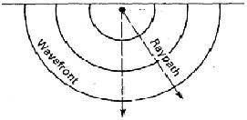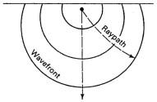

Into what types of new waves is the energy of an incident p-wave partitioned at an interface between contrasting media? What determines how much of the energy is transferred to each of the new waves?
At an interface between two contrasting media, an incident p-wave can produce a number of resultant waves: reflected s-waves or p-waves, refracted s-waves or p-waves, critically refracted s-waves or p-waves, or any combination of the above. The degree of energy transference is dependent on the incident angle from the normal, and the level of contrast between the two media.

What is Snell’s law? What are its implications for how waves behave at material boundaries?
Snell’s law is the formula that governs the relationship between angle of incidence and angle of refraction in rays or waves crossing between two different isotropic media.

For a p-wave incident to a boundary and V2 < V1, which way will the refracted p-wave bend? Is it possible to determine this without more information?
Because of Snell’s Law and the conservation of slowness, a ray crossing into a slower medium will bend towards the normal. This is always true (additional refracted S-waves will conserve horizontal slowness independently of the refracted P-wave; energy is divided between the two refracted waves in the amplitude).

For a p-wave incident to a boundary and V2 > V1, which way will the refracted s-wave bend? Is it possible to determine this without more information?
The S-wave will bend away from the normal because refracted S- and P-waves from an incident P-wave will both conserve horizontal slowness equally, and because V₂ > V₁, according to Snell’s Law, the refracted S-wave will bend away from the normal.

List and explain (one sentence each) three different factors that determine how much damage a building sustains in the event of an earthquake.
- Strength of the earthquake: Larger earthquakes generally do more damage
- Height of building: if oscillation period of building matches period of the earthquake, damage will be significantly amplified
- Soil conditions: Liquefaction and collapse of soil are two of the greatest factors in earthquake damage
- Construction of buildings: unreinforced masonry is the worst type of construction structurally; wood-framed buildings are better, but still more susceptible to earthquake damage than steel-reinforced concrete.

What modiﬁed Mercalli Intensity Scale value would be applicable to a community that, during an earthquake, underwent “general panic” (much masonry destroyed, subsurface pipes broken)?
On the 12-degree modified Mercalli intensity scale, the situation above would be very high and would score a IX.

What is the difference between an earthquake magnitude and an earthquake intensity?
Magnitude and intensity measure different characteristics of earthquakes. Magnitude measures the energy released at the source of the earthquake. Magnitude is determined from measurements on seismographs. Intensity measures the strength of shaking produced by the earthquake at a certain location. Intensity is determined from effects on people, human structures, and the natural environment.

What is Andersonian faulting?
Andersonian faulting is a model that defines the three simplest models of faulting in a heterogeneous stress field where σ₁ > σ₂ > σ_{3.} The three modes of faulting are normal, reverse and strike-slip. By combining these faulting modes and altering the orientation of the stress field we can reproduce almost any type of faulting; the exceptions are very shallow thrust or normal faults, which are usually the result of other mechanical processes.

What is a focal plane solution?
A focal plane solution is a projection of a fault plane on to a hemispherical stereonet. By creating a focal plane solution we can analyze the orientation and mode of a given fault according to its properties on the stereonet. We can determine the deformation and the orientation of the stress field by interpreting the focal plane solution of any given fault.

What was Lithoprobe?
http://www.lithoprobe.ca/

Define epicenter, hypocenter, take-off angle, etc.
- Focus: The point on a fault plane where an earthquake originates
- Rupture plane: The portion of a fault plane on which the earthquake energy is released as a rupture; not all of a fault plane will move in any given earthquake event
- Surface trace: The surface expression of the fault plane on which the earthquake originated; not always apparent, depending on depth of focus
- Hypocenter: Calculated location of the focus
- Epicenter: Calculated position on Earth’s surface above the focus; often the point of most significant damage
- Take off angle: The take-off angle is the angle from the vertical of a seismic ray as it emerges from the earthquake focus.

Roughly how does a seismometer work and what does it measure?
Seismometers measure ground motion caused by earthquakes and other tectonic effects. Seismometers work by suspending an inertial mass on a spring or pendulum arm; vibrations in the ground cause the system to move around the mass, although the mass resists movement through inertia. The movement of the mass or the force required to resist the movement of the mass is recorded and converted into seismic data.

Why is Justin Bieber’s music a valid seismic source, i.e. what is Vibroseis?
Vibroseis is a system of seismic wave propagation that directs seismic energy into the Earth over an extended period of time, rather than an instantaneous pulse of energy from blasting or a seismic hammer. The advantage of Vibroseis is that a wide range of signals and frequencies can be projected from multiple sources and correlated; the disadvantage is the expense and time needed to run a vibroseis system with multiple vibrators.

Given a beachball, determine fault type and list two rough displacement vectors
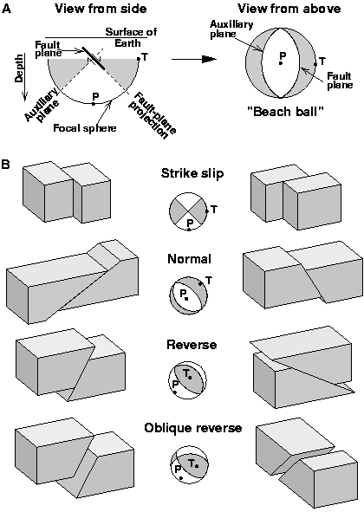

Seismic source types in seismic exploration
Seismic hammer
Buffalo gun (modified 8-gauge shotgun)
Dynamite
Thermonuclear explosion
Vibroseis truck
Airgun (marine)
Spark gun (marine)

Geophone types
Geophones usually consist of electromagnetic coils centered around a spring-mounted magnetic mass, similar to a seismometer. Vibrations in the ground cause the magnet to move and generate an electrical signal which is recorded by the seismograph. 3-component geophones generally contain 3 such coils mounted orthogonally to detect motion in all directions; omnidirectional (simple) geophones are deployed in sequence to detect lateral propagation of waves. In a marine environment, microphones are used instead of geophones; two microphones are used to “triangulate” the position of the arrival and avoid line-of-sight/first arrival issues.

Section 3 - Long Answer

Show the three classical focal plane solutions for faults and their related tectonic environments
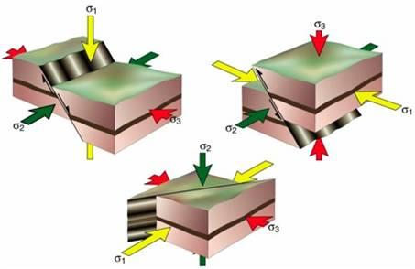
Reverse faults: appear in compressional environments (continental and island volcanic arcs, foreland basin systems)
Normal faults: appear in extensional environments (continental rift volcanism, active and passive rifting margins)
Strike-slip faults: accomodate plate movement in other settings, either perpendicular (ocean floor rifting) or oblique (e.g. San Andreas Fault)

Explain, with diagrams, the steps used to analyze seismic refraction data
There are several steps in analyzing seismic refraction data:
- Identify first arrival times for each geophone
- Draw direct and refracted arrival lines
- Determine V₁ and V₂ from slopes of projected lines
- Determine the intercept of the refracted line graphically to find h, or pick any refracted first arrival time and solve travel time equation for h

Below is the example from Assignment #5:
V_{clay} = 666.666 m/s = V₀
V_{limestone} = 4444.444 m/s = V₁

Θ = sin⁻¹(V₀/V₁)
Θ = sin⁻¹(666.666/4444.444)
= 8.627°

T = 1/V₁* X + C
C = T - 1/V₁ * X
At X = 20 m, T = 23.625 ms = 0.023625 s
C =(0.023625) –1/(4444.444)*(20)
= 0.019125 s
h₀ =(C*V₀)/2cosΘ
h₀ =(0.019125)*(666.666)/2cos(8.627°)
= 6.448 m

Explain, with sketches, the basic mechanics of spring-and-weight seismometers and geophones
Seismometers measure ground motion caused by earthquakes and other tectonic effects. Seismometers work by suspending an inertial mass on a spring or pendulum arm; vibrations in the ground cause the system to move around the mass, although the mass resists movement through inertia. The movement of the mass or the force required to resist the movement of the mass is recorded and converted into seismic data.
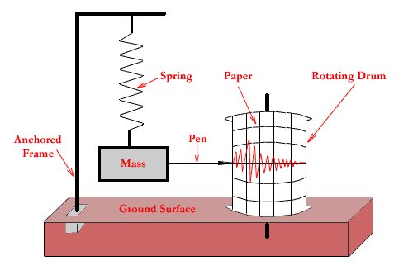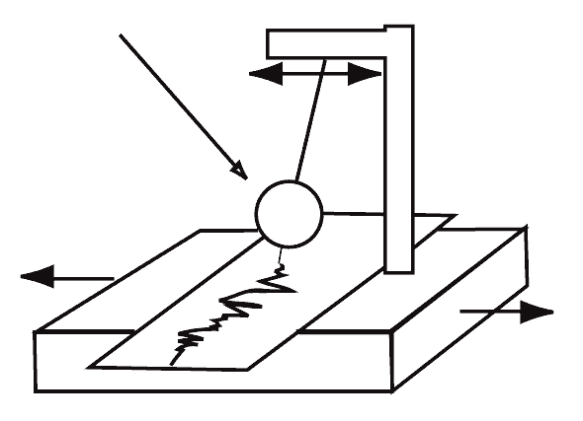
Geophones usually consist of electromagnetic coils centered around a spring-mounted magnetic mass, similar to a seismometer. Vibrations in the ground cause the magnet to move and generate an electrical signal which is recorded by the seismograph. 3-component geophones generally contain 3 such coils mounted orthogonally to detect motion in all directions; omnidirectional (simple) geophones are deployed in sequence to detect lateral propagation of waves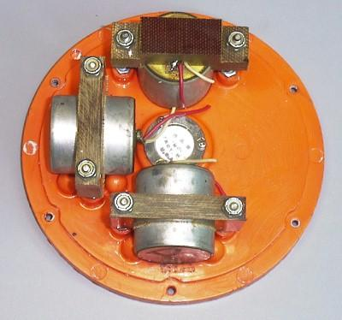

Given some seismic data, locate an earthquake epicenter

Explain how the Earth’s core was discovered
The Earth’s core was discovered as a result of collection of global seismology data, which showed a seismic shadow zone on an arc between two points 100º away from any given epicentre on the other side of the Earth. From this, it was deduced that the Earth must have an internal molten core, since S-waves cannot propagate through a liquid due to the lack of shear within (Newtonian) fluids. The P-wave shadow zone appeared different from the S-wave shadow zone, as it stretched in two arcs from 100º to 145º, but propagated almost directly through the centre of the Earth.

Explain how the Earth’s inner core was discovered
Early in the 1900’s, it was discovered that faint traces of P-waves appeared in zones that were previously considered in the seismic shadow zone. in 1936, Inge Lehmann proposed a model of the Earth with a solid inner core, in which P-waves could either be further refracted on the inner/outer core boundary to arrive in seismic shadow zones.

What is PREM? What is its significance?
The PREM, or Preliminary Reference Earth Model, is a standardized, universally recognized model of the Earth assembled from numerous international data sets. It is an idealized model of seismic velocities within the Earth’s interior, and it allows us to roughly model the behaviour of seismic waves and therefore earthquakes within the Earth’s crust and mantle.

Describe two different earthquake magnitude scales
Richter Magnitude Scale: The Richter scale is a logarithmic magnitude scale which was developed in California for the study of large earthquakes (between 3 and 7 Richter magnitude). It is mostly accurate for larger earthquakes and becomes inaccurate at the smaller end of the scale. An upper magnitude limit of 10 is commonly observed, although there is no theoretical limit.

Moment Magnitude Scale: The moment magnitude scale is a more recently developed system that takes into account a larger number of variables and is more accurate for larger scale events than the Richter scale. It is also less dependent on distance from the epicentre of the earthquake.

(Mercalli is an intensity scale, not a magnitude scale.)

Explain the basic principle of a seismic reﬂection survey
Seismic reflection surveys are seismic surveys that rely on the partial or complete reflection of seismic rays at the boundary between two rocks with different indices of refraction. The survey system uses a seismic source and a series of geophones to detect the progression of reflected seismic waves off a density contrast in the rock. Reflection surveys generally require more data processing, take longer and are more expensive than refraction surveys, but have better lateral resolution due to the high amount of data collected. Due to the relationship between depth and angle of refraction, seismic reflection surveys must generally be at a depth of greater than 50 feet.

(i thought the reason they have to be greater than 50 feet is because any shallower and the reflected waves can not be differentiated from the waves caused by ground roll or air blast?)

What is an auxiliary plane? Why does it occur?
It occurs perpendicular to the nodal plane as due to the symmetry of the earthquake’s ground movement (C,D,C,D), the fault could be located in 2 orientations. The auxiliary plane is the plane where the earthquake did not occur, but still separates compression and dilation data.

For each major method discussed in the course, what would you expect to be able to discover at a ridge / subduction zone / transform (one of)

You have been hired to study a previously unexplored part of a large continental landmass. You are allowed to use one of gravity, seismic, magnetic proﬁling... which do you choose and why?
The preferred method for profiling would be seismic. Seismic surveying is dependent on only density, whereas magnetism is calculated from susceptibility, orientation, polarity and strength of the magnetic field, and heat flow is calculated from conductivity, and is highly variable in an unstable tectonic setting. These factors compound the error in magnetic and heat flow profiling. Seismic profiling is also preferred because by combining reflection and refraction, we can correlate mineralogy, petrology and stratigraphy.

Section 3 - Mathematical

Given that horizontal SLOWNESS (not horizontal velocity) is conserved across a boundary, derive Snell’s law for elastic waves
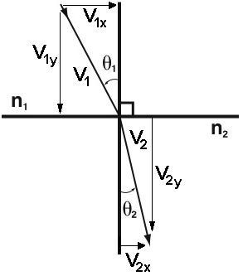
By conservation of horizontal slowness, 1/V_{1x} = 1/v_{2x}
sinθ₁ = opposite/hypotenuse = (1/V_{1x})/(1/V₁) = V₁/V_{1x}
similarly, sinθ₂ = V₂/V_{2x}
V_{1x} = V₁/sinθ₁, V_{2x} = V₂/sinθ₂
since 1/V_{1x} = 1/v_{2x},
therefore V₁/sinθ₁ = V₂/sinθ₂

Give some seismic data, perform a refraction analysis
Given an area (as sketches) with some seismic data and some gravity data, and assuming isostasy, are these
a) qualitatively consistent?
b) do the boundaries in the seismic data correspond to boundaries that would be isostatically compensated?

Section 4 - Supplementary

P-wave velocity:
v_{P} = √((k+4/3µ)/ρ), where
ρ = density
µ = shear modulus (Pa)
k = bulk modulus (Pa)

S-wave velocity:
v_{S} = √(µ/ρ), where
ρ = density
µ = shear modulus (Pa)
k = bulk modulus (Pa)

Snell’s Law:
sinθ_{i}/V_{i} = sinθ_{r}/V_{r}

Seismic Velocities:
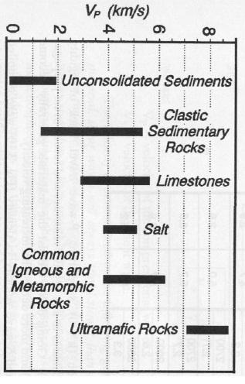

2011 final 3-6 (or 7)
some of these methods don’t apply to certain investigations, so I think some of the blanks make sense
this is done then. Woot. You’re welcome everyone else haha.

Courtesy of: Josi , Maryna and Jake<3 =)
 | Magnetics | Gravity | Isotopes/  Geochron | Earthquake Seismology | Heat
Crust | - record reversals  -find anomalies  -spreading rate  -Record paleolatitudes | -Find anomalies (ore bodies)  -Know density  -find anomalies in geoide | -place plates, date crust | Shape of layers etc  -Anomalies  -Earthquakes  -Tectonic features | - crustal age
Mantle |  | -Mantle anomalies, density  -mantle upwelling | - mantle array → there are large, distinct reservoirs  -MORB → OIB  - model ages of mantle using Sm-Nd, Pb-Pb, Sr-Sr | density, hetero geneous?  slow/fast velocity?  -Mantle reservoirs  -Boundaries  -D” layer | - convection currents
Outer Core | -understand dynamo and reversals | - |  | -Liquid (physical properties)  - D” Layer on the outer core  -P-shadow zone
Inner Core | -understand dynamo/reversal | - |  | Solid (physical properties)  S-shadow zone

