Lecture 18
Review for midterm 2

- Which if these is not a characteristic of apoptosis
  - Swelling swelling is necrosis
- Cell death necrosis vs apoptosis
- Proteases related to the ced genes identified in nematodes; they are responsible for the apoptotic cascade. Name them
  - Caspases
- Importance of calcium
- Mitochondria in apoptosis
  - What happens during apoptosis and how they come in a sequence together
  - Compare this to a cell doing necrosis and apoptosis
  - Link to cell signaling
  - Calcium is involved in both
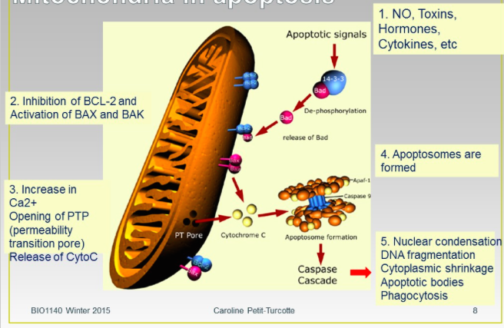
- If mitochondria are damaged, how can the cell respond to manage this injury?
  - Mitophagy
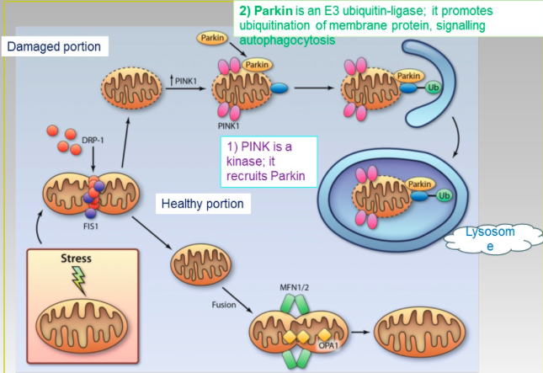
- How mitophagy happens
  - Stress to mitochondria
  - Rescue part of that mitochondria
  - Separate the healthy from the unhealthy portion
  - Express something on the mitochondria’s exterior signal in the cell that some parts of the mitochondria needs to go to the lysosome they are anchored
    - What are they anchored to microtubules
    - How are they transported to the lysosomes through motor proteins
    - What allows them to recognize the portion? Protein called pink on the outer membrane
    - Ubiquinone adding of small proteins
    - What is the flag phosphotildal serine
- As part of osmoregulation the adrenal glands can secrete a chemical messenger to singal the kidneys to increase ion and water reabsorption. Which combination of path/class is the most appropriate
  - Know the 6 classes of steroids
  - Answer endocrine/ mineralocorticoids
    - Need to the now the sub classes of steroids
- Cell comminucation paths
  - 6 classes of messengers
    - necoceloids
    - Steroid
    - Peptide
    - Proteins
    - Purines
    - Amines
    - Gases
  - Receptors 4 classes
    - A table
    - Characteristics of receptors
    - Shape
    - Structure
    - Where are they in the cell
    - Ligands they prefer
    - Stages
  - Give an example of an effectors protein or amplifiers enzyme that can be recruited by distinct receptors. Include the name of the protein and the 2 receptors in your answer
    - Phospholipase C. tyrosine kinase receptors and G protein couple receptors
- Intracellular receptor
  - What happens once the binding is done
  - How is this able to activate transcription or deactivate it
- Ligand gated ion channels
  - How to they work
  - How do they work
  - What is the gating mechanism
  - Achetacolyne
- Tyrosine kinase receptors
  - Growth factors NGF
  - What is the main difference between tyrosine kinase receptors and ligand gated
    - Dimerization
    - Leads to autophosphorilation of tyrosine in specific domains of enzymes
      - Catalytic domain
- What happens in the presence of NGF
  - Ras cascade or PI3 kinase
  - What is the difference ras need adaptor protein
    - PI3 can act directly with the receptor
    - Why? PI3 can bind because it has a SH2
    - Ras doesn’t adaptor rotein has the SH2
- EGF
  - Interact with phospholipase C
  - Leads to the same results as if it was activated by other
- cAMP pathway
  - Structure of G proteins
  - What is particular about it
  - Know they pathway
  - IP3 PIP
  - Know the amplifiers and second messenger
  - What can it do with ca
- DNA replication
  - Bubble
  - Enzymes
  - Proteins
  - Steps
  - Polymerase
  - Tools that work with DNA
  - History portion how we identified as a gene or part of DNA
    - How we describes DNA

