Reduction of Benzil
Name: Yiren Sun
Student number: 7723868
Partner: Madeline Michaelis
Student number: 7808036
Date experiment conducted: Wednesday February 11th, 2015
Date completed: Wednesday February 25th, 2015

Table of Reagents
Compound | Amount | Molecular mass (g mol⁻¹) | Density (g/cm³) | Moles (mmol)
Benzil | 1g | 210.23 | 1.23 | 4.757
NaBH₄ | 0.2g | 37.83 | 1.07 | 5.287
Ethanol | 10mL | 46.07 | 0.789 | 171.3
p-Toluenesulfonic acid | 50mg | 172.2 | 1.24 | 0.2903
2-methoxypropene | 1.0mL | 72.11 | 0.753 | 10.44
Hydrobenzoin | 2.02g | 214.260 |  | 9.42

Procedure
Part A:
- Instead of placing ethanol in the reaction flask right away, the ethanol was placed in the ice bath for 10 minutes.
- Sodium borohydride was added and stirred for around 11 minutes
- Reaction was complete during step 6, so the additional sodium borohydride was not necessary
- Intense bubbling did not stop after 5 minutes, so the solution was boiled for 2 more minutes
- In order to speed up the cooling process of the reaction flask in step 10, the flask was placed in a cold water bath for 10 minutes.
- TLC were run in 10mL of 2:8 EtOAc/Hexane solution
Part B:
- 750mg of diol product was used instead of 600mg
- TLC was run in 10mL of 2:8 EtOAc/Hexane solution

Observations:
TLC drawings
Part A:
For the above, the dot on the left represents the reference, while the dot on the right represents sample. This indicates that the reaction has gone to completion, as the reference does not have the same Rf value as the sample.
Since the sample only shows one dot, therefore, it indicates that the sample is pure.

Discussion:
Part A:
- The purpose of the experiment is to observe the reduction of sodium borohydride. To do this, sodium borohydride acts as a reducing agent to benzil in a protic solvent. The solvent used in this case was ethanol.
- Benzil was initially stirred in the reaction flask with ethanol using a magnetic stir bar in order to complete the mixture. The reaction flask was immersed in an ice bath in order to prevent any reaction taking place between the benzil and ethanol, since this experiment operates under the assumption that all benzils are unreduced.
- Sodium borohydride is added in equal measurements and gradually over a period of time so that it could fully react with ethanol and its alkoxide component, and then reducing benzil into hydrobenzoin (diol).
- After the reaction was warmed to room temperature, the TLC was taken, which showed that the spot of the sample sample was completely different from the reference (benzil), indicating that the reaction had gone to completion. Since this is only a matter of observing whether the reaction has gone to completion, no calculations for Rf is needed.
- Since the sample spot travelled less than the reference in the TLC, it is shown that the reaction sample is more polar than benzil. This is consistent with the mechanism, as a borate ester with a negative charge is produced, meaning that the products of this reaction is more polar than its reactants.
- The flask was then heated in order to speed up the reaction, in which the crystals first formed, which resulted in a white, opaque liquid. The crystals should be a mixture of borate ester and hydrobenzoin, due to their insolubility to ethanol. Water was added in order to purify the hydrobenzoin diol crystals, and turn the borate ester into a more soluble form, which was boric acid.
- The solution was cooled in an ice bath to speed up the crystallization of the hydrobenzoin diol.
- This product was then purified using vacuum filtration, with an end result being a flaky, clear substance.
- A TLC was taken in order to observe whether product was pure. Since there was only one spot on the plate, this indicated the presence of pure product.
- However, this experiment yielded the mass of the crystal being 2.02g, which had a percent yield of 198%.
  - This was the result of leaving the product in the ice bath to cool for too long, which the crystal, which was supposed to be white and opaque, acquired parts which were flaky and clear.
  - Additionally, due to time constraints, the crystals were not fully dried and purified, meaning that water weight could also be a factor of the high percent yield.

Part B:
- The diol product was converted into an acetonide in order to better identify the stereoisomer.
- Acetonide allowed a greater change in polarity between the two stereoisomers, as it fixes the oxygens in place, resulting in only one conformer, as rotations along the bond axis bonding the phenyl group and the oxygen will be limited.
- The first TLC conducted demonstrates whether the reaction has gone to completion. Due to the presence of two dots, one of which matches the reference compound, the reaction has not gone to completion. However, another spot is also present on the TLC which is on a different position than the reference, meaning that whether or not the reaction has gone to completion does not matter. This is due to the spot being able to serve as comparisons between anti and syn stereoisomers.
- As shown in the second TLC for part B, it is revealed that it is the anti-stereoisomer which is present. Additionally, due to the distance travelled by both syn and anti-stereoisomers, it is also revealed that anti is less polar than syn, as it traveled a greater distance up the stationary phase.
- Rf values do not need to be calculated again due to the fact that TLCs were only used to compare.
Questions

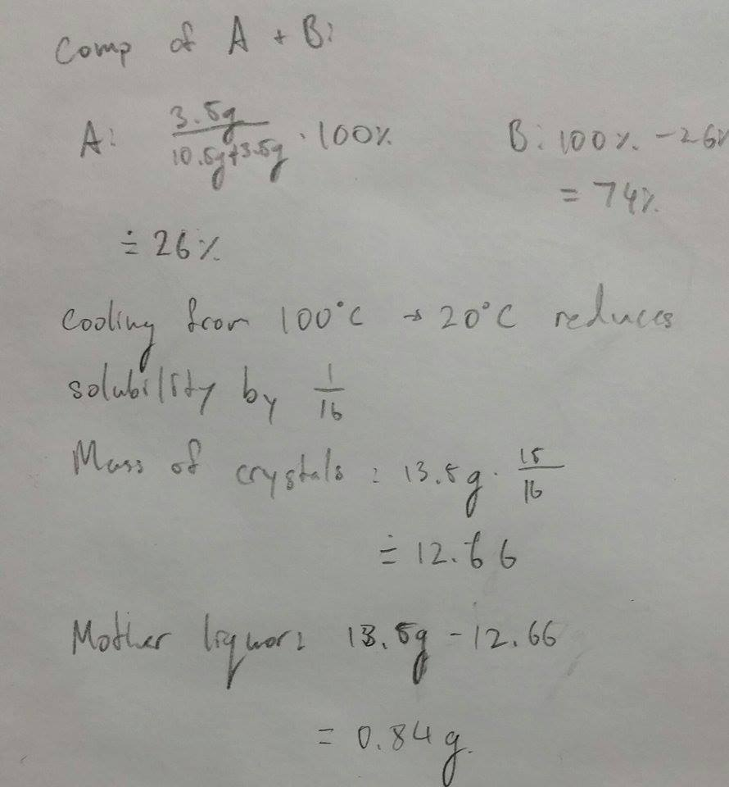

- At 20 degrees Celsius, 1g will remain, meaning that 11.7g will be recrystallized. The crystals should have the same composition as the previous solution, (26% A and 74% B).
- It is possible that the crude product is highly soluble in methanol, thus requiring more energy and more product to obtain a better yield. Additionally, the student only dissolved the crude product at 25 degrees Celsius, while the boiling point of methanol is 65. Additionally, the product was rinsed in ice-cold methanol, even though the crude product is already too soluble to methanol, thus further reducing the amount of product. In order to improve yield, the student should use an organic solvent that the product is less soluble in, this time at boiling point.

  - Sodium borohydride may not be a strong enough reducing agent for the carboxylic acid to be reduced. A stronger reducing agent such as AlH₄ should be used instead.

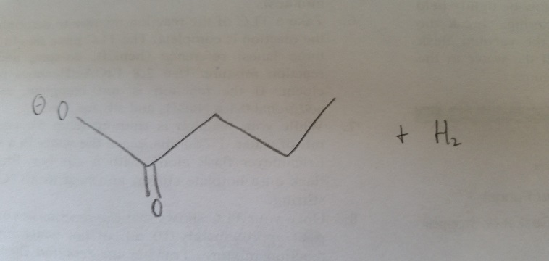

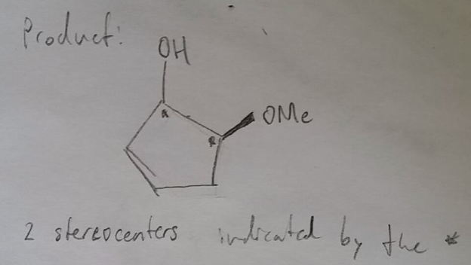
Since borohydride reacts only with the double bonded oxygen, configuration for the OMe stereocenter remains unchanged. This leaves the OH stereocenter to be either anti- or syn- to the OMe. Due to repulsions in electron density, the anti-stereoisomer should be found in the product, as it would be the most stable. Therefore, the OH stereocenter should be in r configuration, while the OMe stereocenter should be in s configuration.

