Note: Please use this file as a template. Copying this will for sure get you a mark of zero. I’m not the best of writers (probably around the worst ones out there),
So use this to look at how to make the sections for the report.
Since this is a fictitious report so many of the stuffs below are fake and won’t make sense at all.
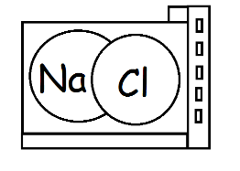
NACL Desalination Plant Headquarters
123 Canal Avenue, Salt Lake City,
Nebraska, Switzerland
December 04, 2014

Eco Li, CEO of NACL Desalination Plant
123 Canal Avenue, Suite 13, Salt Lake City,
Nebraska, Switzerland

Dear Mr. Eco Li

I am submitting this report entitled Designing the first microbial desalination cell plant.

This report was written to explain to you what we did with the budget of $50M you allocated to us to build the plant in Salt Lake City Switzerland. It reviews briefly on the mechanism you discussed during our meeting on December 05, 2012. It describes some of the modification to increase the efficiency. It also describes some of the problems we encountered during the running of the plant. Then, this report describes how we used the budget.

I hope this report will help you consider continuing the maintenance of this plant.
Sincerely

[sign here]

[name here],
Leading Biochemical Engineer at NACL Desalination Plant

Final Report

Report to CEO of NACL Desalination Plant
Designing the first microbial desalination cell plant

[name]
[student

Department of English
University of Ottawa
ENG1112
Miles Tittles
Jenn Macquarrie
December 4, 2014
Table of Contents
Executive Summary 2
1.0 Introduction 3
1.1 Purpose of the report 3
1.2 Background of the report 3
1.3 Scope of the report 3
2.1 Mechanism behind the MDC 4
2.1.1 Solubility 4
2.1.2 Electrodes 4
2.1.3 Ion Exchange Membranes 4
2.1.4 Cell Respiration and Electricity Generation 4
2.2 Increasing the Efficiency 5
2.2.1 Space Usage 5
2.2.2 Materials Used 5
2.2.3 Surface Area 6
2.2.3 Shape and modification of design 7
2.2.4 Microorganism Species 7
2.3 Problems experienced during tests and scaling 8
2.3.1 Low pH values 8
2.3.3 Leakage 8
2.3.4 Wiring 9
2.4 Cost and Returns 9
2.4.1 Maintenance cost 9
2.4.2 Research cost 9
2.4.3 Building cost 9
2.4.4 Salaries 9
2.4.5 Returns 9
Conclusion and Summary 10
Reference 11

Table of Figures

Figure 1: Schematic of a microbial desalination cell. AEM: Anion Exchange Membrane, CEM: Cation Exchange Membrane 5
Figure 2: Overview diagram of the mechanisms 5
Figure 3: Design of the graphite fiber brush. 7
Figure 4: Change in the microbial desalination cell design, from original (left), to newer design (right) 8
Figure 5: Final result of the desalination plant 9
Figure 6: Repartition of the maintenance costs 10
Table 1 Desalination Plant Costs and Productivity for a period of 48 hours 6

Executive Summary

Water is one of the most important element, it is essential to most life. Without water, we could not survive. Fresh water supply is starting to decrease, while the population is increasing and the energy demand is increasing. This is why we decided to build the plant. We want to solve both problems at once.

We begin this report by explaining the purpose of this company designing this report. We states the reasons behind designing the plant

Then, we explain the mechanisms behind microbial desalination cells and why does the cell need to take to produce electricity and desalinate salt water.

We begin explaining how our design came to be. Our first design was exactly how every researcher and scientists were developing their own MDC design. We used what they generally used.

To come to our final design, we found some flaws in the design and we tried finding ways to solve the problem. For example, the bacteria kept dying and falling off the copper anode, so we tried many ways to find the solution to the problem, which was just to use a carbon fiber brush instead of a copper anode.

We also wanted to have the best bacteria culture to have the best desalination possible, so we researched most of the time to finally obtain

We also had many problems after we built, the system. For example, we have lots of water leakage. Although we modified the box containing the modules, we still have leaks. So to avoid this problem, we changed the material and have constant personnels around the area checking for any leaks.

We finally solved most problems after 1 year work and are getting high returns. Although the plant has done, a lots of improvement in the past year, we still need improvement.
We still try our outmost best to improve it.

[signature]

[name], , Leading Biochemical Engineer of NACL Desalination Plant

1.0 Introduction

1.1 Purpose of the report

This report will discuss to the CEO of NACL Desalination Plants how well the management of the new microbial desalination cell plant is running. It will also discuss what kind of improvement should be brought to solve the incoming water shortage and energy shortage we are expecting in the incoming years. We have great hope that this project will give us an opportunity to be ahead of our competitors and save our society from the trouble of lack of water supply.

1.2 Background of the report

Lack of fresh water supply is a crisis that NACL Desalination Plant is striving to solve. Climate change is causing a devastating effect on many developing country: many lakes are drying out in arid regions, while flooding is happening in humid regions, patterns of temperature are changing, and ecosystems are being destroyed. We also have been using more energy, the electricity usage is increasing every year so much that there might be a shortage of energy in few years. Having such an abundant salt water supply, the new microbial desalination cell (MDC) plants might solve both problems at once. Although, MDC technology is relatively new, we expect that if this project comes to completion, we will slow down the incoming crisis.

1.3 Scope of the report

In this report, we will cover:
- Mechanisms making the desalination of the water.
- Increasing the factors of desalination
- Problems encountered during building phase and ways to fix them
- Costs and Returns
This report will mention also compare some aspect of the membrane desalination design.

2.1 Mechanism behind the MDC

2.1.1 Solubility
When a soluble salt dissolves in water, it is compounded of two ions. The positive part of this salt is called cation and the negative is called anion. In a known example such as the table salt (NaCl), the anion would be chlorine (Cl⁻), the cation would be sodium (Na⁻). Although there are many other salts that are desalinated, we will look at the example of table salt specifically to simplify the explanation.

2.1.2 Electrodes
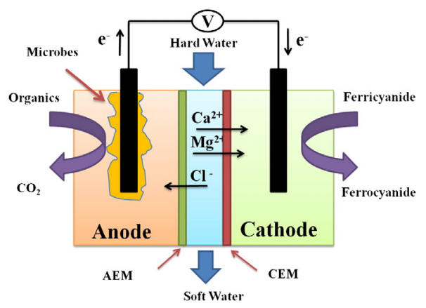
aThe microbial desalination plants run on a normal membrane system in which microorganisms have been included in. Anodes are electrodes that attracts anions. These bacteria called electroactive bacteria are placed in this anode, which is usually made of some sort of metal such as zinc. These bacteria play the role in producing cations in the form of H⁺. ([name], 2014)
Figure 1: Schematic of a microbial desalination cell. AEM: Anion Exchange Membrane, CEM: Cation Exchange Membrane
Source: Kim Young and Bruce Logan (2013) Microbial desalination cells for energy production and desalination.
The H⁺ ions are also attracted to the cathode, which is an electrode that attracts cations. However, the H⁺ cation are stopped by the anion exchange membrane. The cathode side, usually made up of carbon, steel, or platinum attracts the cations whenever the system is out of balance. For instance, if there is more negative charge in the anode, the cathode will attracts the sodium or any other cations. (Kim & Logan, 2013)

2.1.3 Ion Exchange Membranes
However, the most important pieces of this cell are the membranes. Each of these either repulses the anion or cation. In the case of the anion exchange membrane, the membrane repulses cation and lets anions through, while the cation exchange membranes lets cations through but not the anions. .
(Kim & Logan, 2013)

2.1.4 Cell Respiration and Electricity Generation
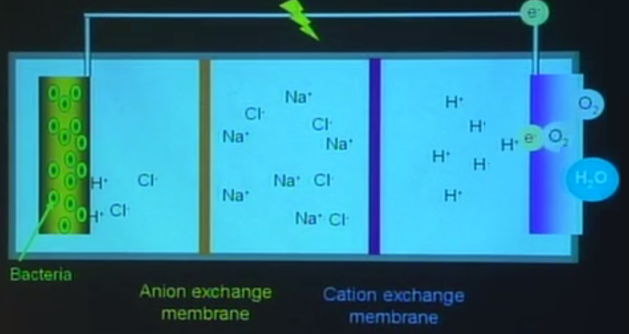
When the bacteria, which is an electroactive microorganisms, undergoes cellular respiration, it produces cations that attracts the anion. When the anion reacts with the new cation produced, the bacteria releases an electron, which runs to the cathode. This movement of electrons creates electricity, which can be used for our needs. At the end of circuit where the electron flows, there are some oxygen molecules and more H⁺ cations which were attracted by the cathode. This produces water and attracts more cation towards the cathode. When this process cycles multiple time, we find desalinated water. (Logan, 2010)
Figure 2: Overview diagram of the mechanisms
Source modified from: (Lecture) Bruce Logan: Bioenergy production using microbial fuel cell technologies at MIT

2.2 Increasing the Efficiency

2.2.1 Space Usage

Looking back at the mechanism behind the desalination cell, the cell simply had a microbe layer on the anode, a cathode, two membranes and a small circuit attached to send the electricity. Looking at the number of components required, we can expect that this is not going to take a lot of space. Having a bigger cell would reduce the attraction towards the electrode. Reducing the cell size has another benefit, it makes the whole process complete much quicker. Since the cations and anions don’t need to move as much, so they get an increase in velocity.

A plant using microbial desalination also is more efficient by using much less space. This is done by having multiple modules of these MDC connected to a central point which distributes the electricity. (Logan, 2010) (Luo, Xu, Roane, Jenkins, & Ren, 2012) An experiment was completed at the NACL Engineering Research Department. We monitored the activity of two plants with very similar features; one plant is an MDC plant and the other plant is a membrane plant. They approximately occupy the same space and the company spent almost the same amount of money to build the plants. Since monitoring the whole plant is very difficult we only monitored a certain part of it.

Table 1: Desalination Plant Costs and Productivity for a period of 48 hours
Source: NACL Engineering Research Department
Cubic Space Taken (ft³) | MDC Facility |  |  | Membrane Facility
 | No. of MDC modules | Amount of water desalinated (thousands of Liters) | Cost of Operation (Thousands of Dollars) | No. of membrane modules | Amount of water desalinated (thousands of Liters) | Cost of Operation (Thousands of Dollars)
1000 | 5000 | 150 | 20 | 3000 | 40 | 18
2000 | 11000 | 370 | 41 | 7000 | 88 | 38
3000 | 18000 | 550 | 64 | 10000 | 140 | 60
4000 | 24000 | 680 | 88 | 15000 | 170 | 85

In this table, the research department of NACL Desalination Plant’s experiment showed various significant result. The amount of water desalinated in the allotted period is 4 times higher than the amount by the membrane facility, while ending up with very similar cost of operations. Therefore, in conclusion, the cost per MDC setups is much lower than with the MDC setups.

2.2.2 Materials Used
In addition to the efficiency of space found in a microbial desalination cell, we modified some material to improve the efficiency of the system. If we simply used a very basic MDC setup, we would only produce 4 mW/m³ in one hour. This could not be used to produce electricity or to desalinate salt water at all. While being extremely costly to run. This is not efficient at all.

However, there are ways to increase the efficiency of the microbial cell. We know that this water contains lots of energy, but is not easy to harvest. So we identified that our original MDC setup was not very material efficient. (Logan, 2010) We originally used a copper based material, as a cathode. However, since this did not yield a good production, we switched to a platinum based cathode. Platinum is an expensive material, even though it gave us good yields of 2.5 W/m³. (Mokdumuzzaman, 2014) However the best option was using a stainless steel mesh as a cathode it gave us a power production of 1.5 W/m³. It was the best option since stainless steel is very cheap, and can be modified into any shape we want giving us even more yield. (Kim & Logan, 2013)

We also modified the anode’s composition. Since we noticed copper oxidizes very easily, we decided to change to material that does not do that. This led us to choose graphite as the material for the anode, since this material does not oxidize. (Kear, Barker, & Walsh, 2004)

2.2.3 Surface Area
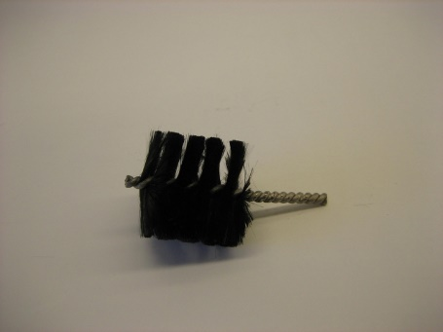
Although materials were important, the most important factor changing completely the power production is probably the surface area. When we switched to platinum and had power production of 2.5 W/m³, the cathode and anodes were modified to help get the most surface area as possible. The bacteria on the anode were originally laid out flat on the copper surface. They were easily falling off, even alive, after some time desalinating. (Mokdumuzzaman, 2014)(Logan, 2010)
Figure 3: Design of the graphite fiber brush.
Source: Penn State University

One of the option was found looking at a brush. The brush contains air pockets in which the bacteria could easily reside in and not fall off. So we switched to a graphite fiber brush that acts as an anode. The brushes are conductive and they’re made commercially and they are very cheap. Doing this, we increased the surface area of our anode in one module to 20,000 cm². This is because each fine fiber has a surface area in each of its sides. So, adding their surface area will give a large value. When comparing this to the flat copper anode, we have only 900 cm². (Logan, 2010)([name], 2014).

The cathode was also modified slightly since we are now including a stainless steel mesh. The mesh increased the surface area by having air pockets in it. We then added on the mesh a catalyst, which increases the speed of a reaction. Having more surface area, it was possible to complete the reaction even faster. We used to have a catalyst that acted both as the cathode and a catalyst, but now we decided to not use any expensive material so we decided to switch to a catalyst known as cobalt tetramethoxyphenyl porphyrin (CoTMPP). (Logan, 2010) This gave us a completely equal yield to that of the platinum of 2.5 W/m³ still being very cheap.
([name], 2014)

2.2.3 Shape and modification of design
Originally, we only had a very simple design. We simply put two membranes separating both sides, two cathodes, and a wire running outside of it to produce electricity. However with the addition of the new components, we discussed in the previous sections.

After noticing how well the change in the cathode went, by adding a stainless steel mesh and a catalyst, we decided to increase the surface area by changing the cathode to a tube-like structure, since the material could not be changed to a brush like structure. Tube shapes are usually the best shapes that increases the surface area.

We also decided to change the shape of the microbial desalination cell to a box shape. This is because box shapes are much easier to stack on top of each other, when building on large scale.
We included a spin handle on top of the brush anode to make maintenance easy to complete.

Another portion of the changed design has the wires completely hidden inside the box. This helps connecting the wires when we will have decided to build the plant.
([name], 2014)

Finally, we decided to make a chamber to contain the salt water and to expulse the desalinated water.
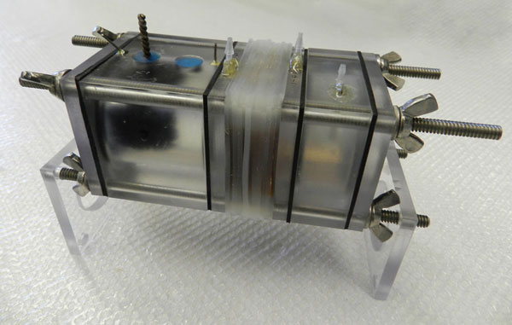
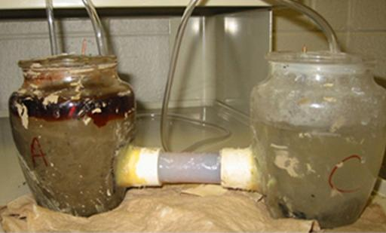
Figure 4: Change in the microbial desalination cell design, from original (left), to newer design (right)
Source: Photo by Bruce Logan in Hybrid Energy Tech Could Clean Wastewater for Free
Photo by egbertfitzwilly in instructables.com

2.2.4 Microorganism Species
Another major part is the species of microorganism we will need to use to have the best result. When we started the project, most engineers had no idea about, which bacterium to use or whether we should use a bacterium or an archae to do the desalination. Another reason for this is that most biochemical engineers working in the project had very little knowledge on electromicrobiology. This is a completely new field created 6 years before the project was started in 2012. Although, there was multiple chemical engineers and electrical engineers, no one had done this before, so a lot of time was spent on researching these electroactive microorganisms.

When we started the project, we chose bacteria, since they were much easier to obtain so we started on the project using an anaerobic bacteria: Geobacter sulfurreducens. This bacteria was famous for its breaking down of organic substances. So if we feed this bacteria with a lot of organic material, which our salty water has a lot, we can use the substances that comes out as a waste of this bacteria, such as the H⁺ cation and the CO₂. However, there was a problem, it does not use cellular respiration on any of the ions, which could make the desalination process complete quicker. (Bond, & Lovley, 2003)(Skydow, et al, 2014)

So, we researched for a certain period of time before we found out about a bacterium named: Shewanella oneidensis. This bacteria was discovered in 1988, so it was already well known in the scientific community. We discovered recently that it was an electroactive bacteria as well. So we decided to use this bacteria, since it can perform cellular respiration on various types of metals and other polyatomic ions such as sulfates, nitrates, and chromates. (Logan, & Watson, 2009)

Both bacteria are useful in different situation. Since we want the fastest rate possible, we wanted to determine the percentage amount of bacteria of each type we should put into the anode. To do this, we had to analyze the concentration of salt water.

We found out that the water composition in the area where we tested our plant was composed of 10% organic substance from dead organisms, 70% ions of all sorts, and 20% metals.
So, we had to put a mixed culture of Shewanella oneidensis and Geobacter sulfurreducens
([name], 2014)

2.3 Problems experienced during tests and scaling

2.3.1 Low pH values
The pH scale is a logarithmic scale that determines the amount of H⁺ cation in a solution. Low pH means a high concentration of these protons, while a high concentration of these protons mean high pH. We had multiple problems relating to this, since the bacteria were practically bringing themselves to their own death by having too low pH. The bacteria were performing cellular respiration and producing massive amount of H⁺. This production basically denatured their proteins composing them.

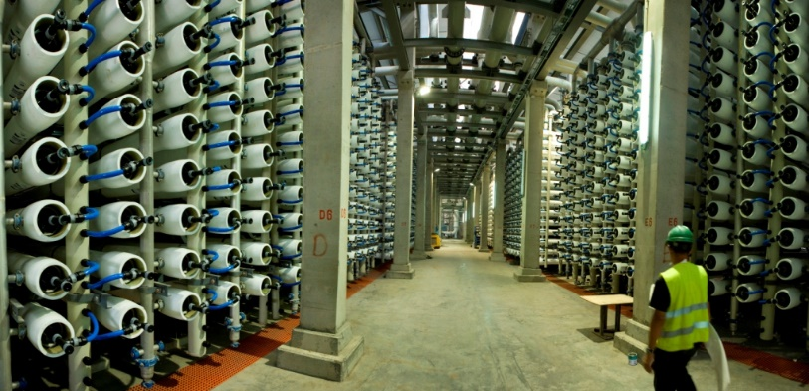
To solve this situation, we added a pH meter into the solution containing the H⁺ and to that we attached a dispenser containing alkaline buffer solution of NaOH. So, the H⁺ ions could react with NaOH to form water. Whenever the pH meter indicated a low pH, the buffer solution was dispensed. ([name], 2014)
Figure 5: Final result of the desalination plant
Source: The Green Prophet

2.3.3 Leakage
Leakage was a common issue, having a lot of modules of MDC, would mean a large body of water. The only way to solve this problem was to reinforce the modules and to keep an active personnel ready in case of leaks. ([name], 2014)

2.3.4 Wiring
Another problem encountered is the massive amount of wiring required. We had to organize different sections containing different modules was placed in different sections. This is how the plant looked like at the end.

2.4 Cost and Returns

NACL Desalination Plant allocated the use of $50M towards the Building, Maintenance, and Research. This is how the money was used.

2.4.1 Maintenance cost
The total maintenance cost for the whole year was approximately $15M. This is how the maintenance cost was divided.

Figure 6: Repartition of the maintenance costs
Source: NACL Desalination Plant

Most of the money was basically spent on leakage. This is one problem that would need to be solved

2.4.2 Research cost
The research was not very costly compared to the amount of money given. Only $2M was spent on the research of the microbial desalination plant, even though the field was relatively new. This is because the research was done using known materials and the processes used were very simple. The research was spent on testing new materials, testing the microorganisms, paying authors for copyright, patenting the plant’s design and copyrighting.

2.4.3 Building cost
The cost of building the plant in total was $35 million

2.4.4 Salaries
The employee salary was $5M for the plant.

2.4.5 Returns
Although almost all the money given from NACL was spent on costs, the plant had very good returns. We generated revenue by having extra electricity in the plants. This was given to other energy plants which required it and giving us a revenue of $40M. The desalinated water produced was to serve a community of 100,000 people. This generated $45M.

Conclusion and Summary

In summary, we designed built a plant that runs on microbial desalination cell technology. Although the mechanisms are relatively simple, the little modifications done to obtain the final result was very complex.
We started by building the first module. This module was very similar to the ones that researchers and scientists were building around that time. Since no engineers had experience with electromicrobiology, we had to research on our own to design the modules, the plants, and the solutions to the problems and design flaws we encountered.

We started first by noticing what could be improved. For example, we noticed that our MDC cathode was pretty much flat. We knew we needed more surface area. So we changed the cathode, which was a stainless steel mesh at that time to a tube, so it could have more surface area.

We also improved the design after creating the plant. We improved the material of the box of the MDC modules so they could have better protection against leaks.

So, at the finally we calculated the costs and noticed that we were still under our budget given by the company. We were enthusiastic when we found out that not only did we manage to make it under the budget, but had a return which was over the budget.

We were excited to know that such a plant can practically run on its own, supplying itself power. From that we realized that this plant was sustainable and environmentally friendly. We see the future in microbial desalination cells.

[signature]

[name] [name],
Leading Biochemical Engineer at NACL Desalination Plant

Reference
Logan, Bruce. (2014, March). Bruce Logan: Bioenergy production using microbial fuel cell technologies, MITEI Seminar. Lecture conducted from MIT Massachusetts Institute of Technology, Cambridge, MI.

Kim, Y., & Logan, B. E. (2013). Microbial desalination cells for energy production and desalination. Desalination, 308(0), 122-130. doi:http://dx.doi.org/10.1016/j.desal.2012.07.022

Luo, H., Xu, P., Roane, T. M., Jenkins, P. E., & Ren, Z. (2012). Microbial desalination cells for improved performance in wastewater treatment, electricity production, and desalination. Bioresource Technology, 105(0), 60-66. doi:http://dx.doi.org/10.1016/j.biortech.2011.11.098
Bond, D. R., & Lovley, D. R. (2003). Electricity production by geobacter sulfurreducens attached to electrodes. Applied and Environmental Microbiology, 69(3), 1548.
Kear, G., Barker, B., & Walsh, F. (2004). Electrochemical corrosion of unalloyed copper in chloride media––a critical review. Corrosion Science, 46(1), 109-135.
Nguyen, T., Roddick, F. A., & Fan, L. (2012). Biofouling of water treatment membranes: A review of the underlying causes, monitoring techniques and control measures doi:10.3390/membranes2040804
Sydow, A., Krieg, T., Mayer, F., Schrader, J., & Holtmann, D. (2014). Electroactive bacteria—molecular mechanisms and genetic tools. Applied Microbiology and Biotechnology, 98(20), 8481-8495. doi:http://dx.doi.org/10.1007/s00253-014-6005-z
Watson, V. J. and Logan, B. E. (2010), Power production in MFCs inoculated with Shewanella Oneidensis MR-1 or mixed cultures. Biotechnol. Bioeng., 105: 489–498. doi: 10.1002/bit.22556

