Experiment 6: Regioselective Nitration of Acetanilide

By Derek Meng
7278698
Partner:
Hadi Sukkar
7241905

CHM 1321 Section A9

Demonstrators:
Spencer Pitre

April 4th 2014

Department of Chemistry
University of Ottawa

Introduction:
Within this experiment, a amide aromatic was nitrated using nitric acid and sulfuric acid. The product was then examined using TLC plates and software in order to determine the regioselectivity of this reaction.
Aromatic rings cannot undergo electrophilic addition, as it would result in the loss of stability of the molecule (as it would no longer be an aromatic compound). As a result, aromatic compounds undergo a substitution reaction instead. The general mechanism for this is shown in Figure 1.
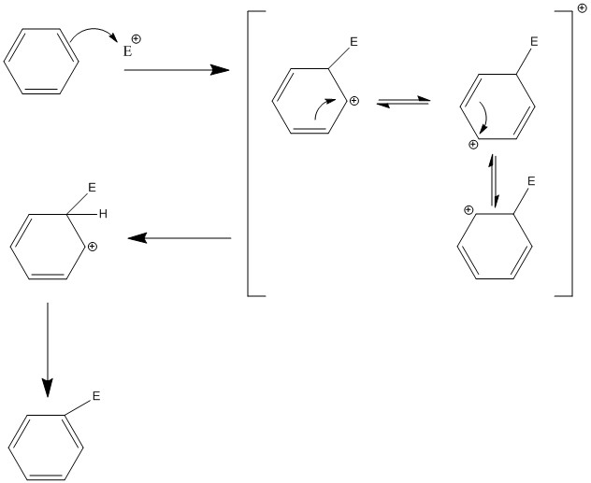
Figure 1 - General mechanism for aromatic electrophilic substitution.
However within this experiment, different configurations are producible where the electrophile bonds in the ortho, meta, or para configuration.

Table of Reagents:
Compound | Mol. Wt  (g/mol) | Amount  (g or mL) | Density  (g/mL) | Moles  (mol)
Acetanilide | 135.16 | 1.03 g | 1.12 | 0.00762
Sulfuric Acid | 98.079 | 4.3 mL | --- | ---
Nitric Acid | 63.01 | 0.7 mL | --- | ---
Water | 18.01 | 20 mL | 1 | 1.11
Ethanol | 46.068 | 20 mL | 0.789 | 0.343

Procedure:
Please refer to page 52 of CHM 1321 (2013) Organic Chemistry Laboratory Manual, by William Ogilvie.

Observations:
The acetanilide crystals were solid, opaque with a tan color. No noticeable smell was detected. Sulfuric acid was a clear, transparent solution, with viscosity the same as water. A very sharp choking odor was detected. Nitric acid was a clear transparent solution, with similar viscosity to water. A sharp choking odor was detected.
When mixing the sulfuric acid with the acetanilide crystal, the solution as initially transparent and clear. It was noted that not all the acetanilide crystals dissolved initially. After addition of the 1.3mL:0.7mL sulfuric acid:nitric acid mixture, the solution turned opaque, and had a dark red wine color. At the end of the reaction, no acetanilide crystals remained out of solution.
After transferring the reaction mixture into a cold Erlenmeyer flask, and placing an ice-water mixture, the solution quickly turned yellow, and translucent. The presence of a yellow “fluffy” opaque precipitate was observed to be created. This solution was then filtered using a vacuum filtration device. The crude filtrated product, when dried, was a pasty yellow, sticky opaque solid. No noticeable odor was detected.
The crude product was re-dissolved in ethanol. This solution was observed to be a yellow and transparent. Precipitation of a fluffy opaque yellow crystal occurred when around 20mL of ethanol was added. When filtered, this solid product had a pasty yellow, opaque color.

TLC Results:
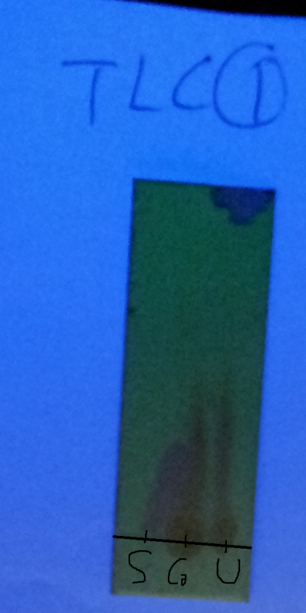
Figure 2 - TLC Plate 1 of crude product versus initial acetanilide solution. Sample lane contains acetanilide while the unknown lane contains the reaction mixture in EtOAc:Hexene 5:5 solvent.

Table 1 - TLC of acetanilide against uknown reaction mixture with 5:5 hexene:EtOAc solvent
Lane | Length Traveled | R_{f} Values
Sample (Acetanilide) | 1.9 | 0.43
Co-spot | 0.4 | 0.09
Unknown (Reaction Mixture) | 0.4 | 0.09

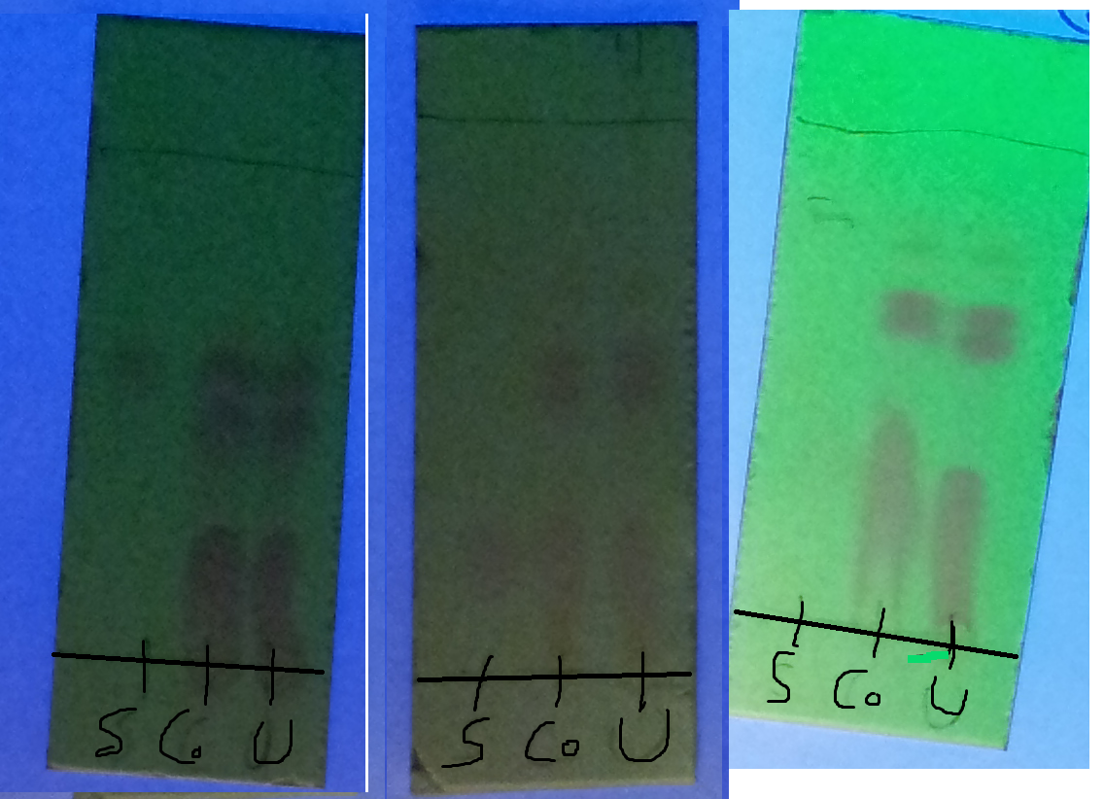
Figure 3 - Second TLC Plate Run, of Crude Product (Unknown lane) against Ortho Sample (Left), Meta Sample (Middle), and Para Sample (Right). A solvent of 5:5 Hexene:EtOAc was used for the middle TLC plate, while a solvent of 9:1 ether:hexene was used for the left and right TLC plates.
Table 2 - TLC of Crude Product Versus Reference Samples Note that bottom streak was not included.

Left TLC Plate
Lane | Length Traveled (Top, Bottom) | R_{f} Values (Top, Bottom)
Sample (Ortho) | 2.5 cm | 0.58
Co-spot | 2.9 cm, 1.9 cm | 0.67, 0.44
Unknown (Crude Product) | 2.9 cm, 2.1 cm | 0.67, 0.48

Middle TLC Plate
Lane | Length Traveled (Top, Bottom) | R_{f} Values (Top, Bottom)
Sample (Meta) | 1 cm | 0.2
Co-spot | 3.3 cm, 2.6 cm | 0.66, 0.55
Unknown (Crude Product) | 3.3 cm, 2.5 cm | 0.66, 0.5

Right TLC Plate
Lane | Length Traveled (Top, Bottom) | R_{f} Values (Top, Bottom)
Sample (Para) | 3.5 cm | 0.79
Co-spot | 3.5 cm, 2.8 cm | 0.75, 0.63
Unknown (Crude Product) | 3.5 cm, 2.8 cm | 0.79, 0.63
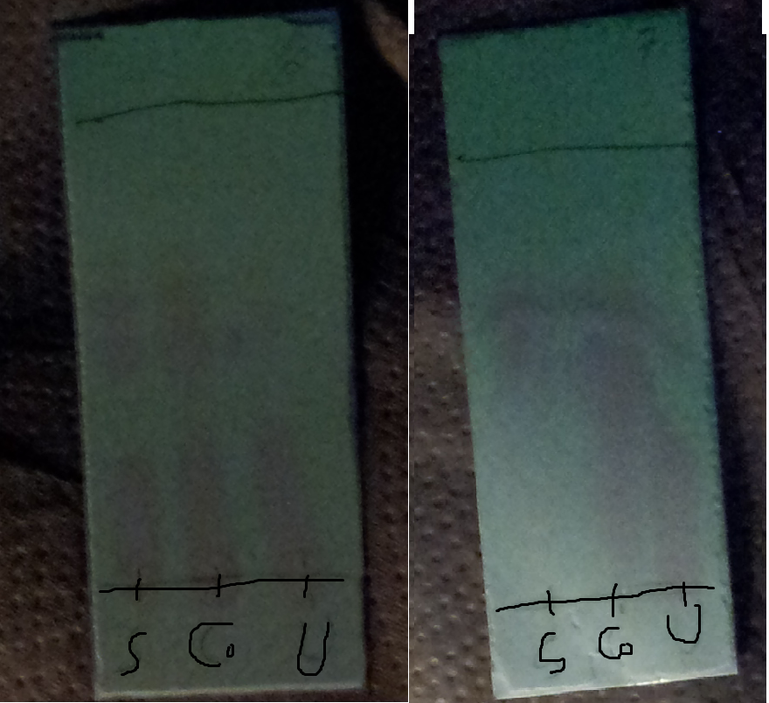
Figure 4 - TLC Plate 3, Unknown Purified Product (Unknown Lane) and Crude Product(Sample Lane) (Left) and Mother Liquid (Sample Lane) (Right) Each was done in a 9:1 Ether:Hexene solvent solution.
Table 3 - TLC of Purified Product Versus Crude Product and versus Mother Liquid Note that Bottom streak was included
Lane | Length Traveled (Top, Bottom) | R_{f} Values (Top, Bottom)
Sample (Crude Product) | 2.7 cm, 2.1 cm | 0.61, 0.77
Co-spot | 2.7 cm, 2.1 cm | 0.61, 0.77
Unknown (Purified Product) | 2.1 cm, 0.6cm | 0.61, 0.13

Lane | Length Traveled (Top, Bottom) | R_{f} Values (Top, Bottom)
Sample (Mother Liquid) | 2.9 cm, 1.8 cm | 0.64, 0.41
Co-spot | 2.9 cm, 1.5 cm | 0.64, 0.34
Unknown (Purified Product) | 2.9 cm, 2.6 cm | 0.66, 0.59

Results:
Table 4 - Values of Crude and Final Products measured in a Vial.
Data | Value
Mass of Vial | 30.77 g
Mass of Vial + Crude Product | 33.95 g
Mass of Vial + Final Product | 31.35 g
Mass of Crude Product | 3.18 g
Mass of Final Product | 0.58 g
Percentage Yield of Crude Product | 232%
Percentage Yield of Final Product | 42.3%

Data Manipulation:

ImageJ to calculate Percentage:
Image J software was used to determine the uncalibrated percentage of the crude product. Through the use of the calibration curve, the actual percentage was found.
$${Area}_{Ortho}=3024.324$$
$${Area}_{dinitro}=3045.897$$
$${Area}_{para}=8123.486$$
$$\%Ortho_{uncalibrated}=\frac{{Area}_{Ortho}}{A{Area}_{Ortho}+{Area}_{dinitro}+{Area}_{para}}×100\%$$
$$\%Ortho_{uncalibrated}=\frac{3024.324}{\left(3024.324+3045.897+8123.486\right)}×100\%$$
$$\%Ortho_{uncalibrated}=21.31\%$$
$$\%Dinitro_{uncalibrated}= \frac{{Area}_{dinitro}}{{Area}_{Ortho}+{Area}_{dinitro}+{Area}_{para}}×100\%$$
$$\%Dinitro_{uncalibrated}= \frac{3045.897}{\left(3024.324+3045.897+8123.486\right)}×100\%$$
$$\%Dinitro_{uncalibrated}21.46\%$$
$$\%Para_{uncalibrated}=100\%-\%Ortho-\%Dinitr \\ \%Para_{uncalibrated} =57.23\%$$
$$x=\frac{21.31\%}{\left(21.31\%+57.32\%\right)}$$
$$x=27.10\%$$
$$y=0.0079{\left(27.10\right)}^{2}+0.1596\left(27.10\right)+3.3788$$
$$y=10.26\%$$
$$\%Para_{no nitro}=100\%-10.26\%=89.74\%$$
The ratio of para to ortho is roughly about 9:1
$$x^{'}=\frac{21.46\%}{\left(21.46\%+57.23\%\right)}$$
$$x^{'}=27.27\%$$
$$y^{'}=0.0223{\left(27.27\right)}^{2}+1.6809\left(27.27\right)+37.421$$
$$y^{'}=10.58\%$$
$$\%Para_{no ortho}=100\%-10.58\%=89.42\%$$
Therefore para and dinitro are at a ratio of roughly 9:1
Ratios are equated:
$$o:p:d=1:9:1$$
$$\%Ortho Final=\frac{1}{9+1+1}×100\%=9.10\%$$
$$\%Para Final=\frac{9}{9+1+1}×100\%=81.81\% \\ \%Dinitro Final=\frac{1}{9+1+1}×100\%=9.10\%$$
Table 5 – Percentage Composition of Crude Product
Criteria | Ortho Product | Para Product | Dinitro Product
Area of Graph | $$3024.324$$ | $$8123.486$$ | $$3045.897$$
Uncalibrated Percentage (%) | 21.22 | 57.32 | 21.46
Final Calibrated Percentage (%) | $$9.10$$ | $$81.81$$ | $$9.10$$

Table 6 - Percentage Composition of Final Purified Product
Criteria | Para Product | Dinitro Product
Area of Graph | 4185.618 | 446.489
Uncalibrated Percentage (%) | 89.76 | 10.24
Final Calibrated Percentage (%) | 78.89 | 21.11

Calculation of Percentage Yield of Crude Product:
$$n_{acetanilide}=0.762 mol$$
$$M_{nitroacetanilide}=180.16 g mol^{-1}$$
$$m_{theoretical}=\left(0.00762 mol\right)×\left(180.16 g mol^{-1}\right)$$
$$m_{theoretical}= 1.37 g$$
$$Percentage Yield=\frac{m_{experimental}}{m_{theoretical}}×100\%$$
$$Percentage Yield=\frac{3.18 g}{1.37 g}×100\%$$
$$Percentage Yield=232\%$$

Calculation of Percentage Yield of the Purified Final Product
$$n_{acetanilide}=0.762 mol$$
$$M_{nitroacetanilide}=180.16 g mol^{-1}$$
$$m_{theoretical}=\left(0.00762 mol\right)×\left(180.16 g mol^{-1}\right)$$
$$m_{theoretical}= 1.37 g$$
$$Percentage Yield=\frac{m_{experimental}}{m_{theoretical}}×100\%$$
$$Percentage Yield=\frac{0.58 g}{1.37 g}×100\%$$
$$Percentage Yield=42.3\%$$

Discussion:

Mechanism of Reaction:
- Within this experiment, an amide aromatic was nitrated using nitric acid and sulfuric acid. The product was then examined using TLC plates and software in order to determine the regioselectivity of this reaction.
- When acetanilide is nitrated, the electrophile is the nitronium ion formed from the protonation of nitric acid by sulfuric acid. This activation of nitric acid by sulfuric acid (nucleophile) occurs due to the fact that sulfuric acid is a stronger acid than nitric acid. In this reaction, the sulfuric acid acts as a catalyst. The mechanism is shown below in Figure 2.
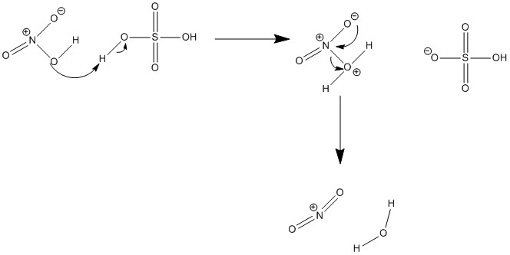
Figure 5 - Creation of the nitronium Ion from Sulfuric acid and nitric Acid.
- Since the nitronium ion contains a positive charge on the nitrogen, it has a strong affinity for electrons in the pi bond. This will cause it to react with the benzene ring of the acetanilide as shown in the Figures 3, 4 and 5.
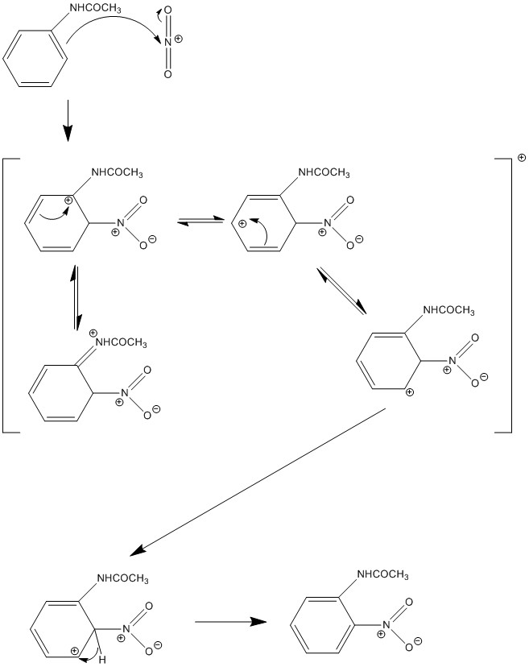
Figure 6 - Reaction of acetanilide and nitronium ion to form the Ortho configuration.

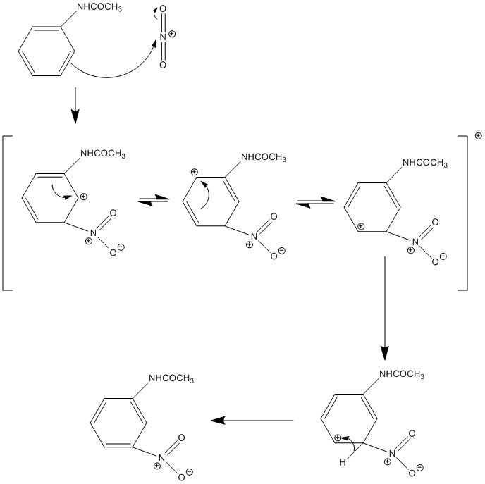
Figure 7 - Reaction of the acetanilide and nitronium ion to form the meta configuration.
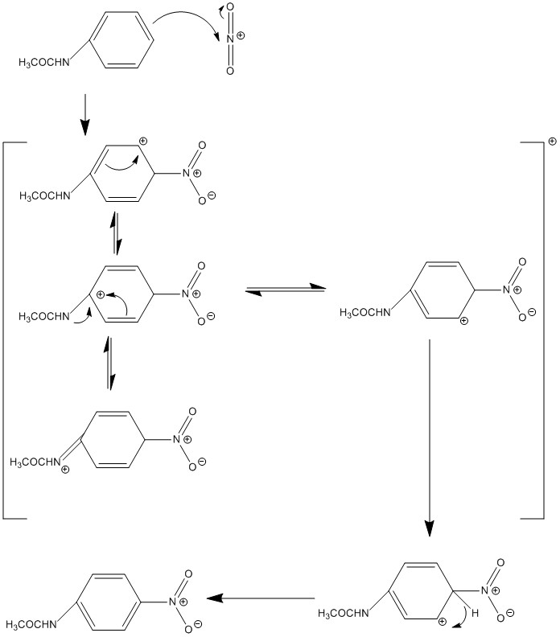
Figure 8 - Reaction of acetanilide and nitronium ion to form the para configuration.

- It is important to note that while three possible products can be formed, only 2 of these products are formed in significant amounts. These are the ortho and para configurations shown in Figure 3 and 5.
- The meta-nitroacetanilide is not formed in significant amounts.
- This is due to the fact that the amide directing group present on the aromatic ring, is a ortho/para directing group. This is due to the fact that the heteroatom is directly bonded to the benzene ring.
  - Since the heteroatom is an electronegative negative nitrogen atom that also contains a lone pair, it will donate its lone pair to the positively charged carbocation that forms under it, forming a double bond with the nitrogen. This will stabilize the carbocation.
  - Since the ortho and para configurations are the molecules who’s resonance allows for the placement of the carbocation directly beside the heteroatom, it gives the compound an additional resonance form, which lowers the overall energy of the compound making it more stable. This makes this reaction a FAST step. As a result, the ortho and para products are more likely to form.
- It is also important to note that the para products are more likely to be formed. This is due to the fact that the para product has the large bulky groups the farthest apart from each other. When compared to the ortho product, which has the two bulky functional groups right besides each other.
  - This results in steric hindrance, and causes destability in the molecule, resulting in an increase in its energy. Due to the increased required energy, the ortho product is less likely to form when compared to the para product (which is lower in energy).
- Initially when adding the nitric/sulfuric acid mixture to the reaction mixture, it had to be done slowly. This is due to the fact that the reaction concerning the acid is an extremely exothermic reaction. This is to avoid adding too much heat to the reaction at once.
  - This was done as the addition of too much heat, would increase the kinetic energy of the molecules. This would have led to a secondary nitration which would have formed 2,4-dinitroacetanilide. This would have led to a decrease yield of the ortho/para nitroacetanilide when it was recrystallized.
  - This also one of the reasons an ice bath was used.
  - A suggested improvement is to add the acid mixture very slowly, giving time for the heat to dissipate, before adding additional acid.

First TLC Plate: Reaction Mixture with Acetanilide
- The first TLC taken in this lab was to determine the progress of the reaction. It is known that the para configuration is the major product. Therefore the Rf values for the reaction mixture, assuming it has gone to completion should be low. This is due to the fact that para-nitroacetanilide is polar, and will absorb to the silica gel backing of the TLC plate more than the acetanilide.
  - This occurs because the para-nitroacetanilide contains a nitrate group, which is very polar.
- This result was clearly seen as the sample lane containing the Acetanilide solution had an Rf value of 0.43, when compared to the unknown lane’s value of 0.09.
  - It can be seen that the acetanilide has a much higher Rf value than the reaction mixture. This indicates that the products in the reaction mixture must have a higher polarity than the acetanilide.
  - Para-nitroacetanilide due to the presence of two nitrogen atoms, is a very polar compound. The fact that the Rf values of the reaction mixture are so low, suggests that the reaction went to completion, with the para configuration being the major product.
- After this reaction, the product was placed in an Erlenmeyer flask containing 20mL of cold water and ice cubes. Since both nitroacetanilide and the dinitroacetanilide do not have the ability to form hydrogen bonds, the transfer to water as they relatively nonpolar. This would ensure that they would precipitate out of solution. This was seen as the yellow “fluffy” solid being created.
  - Cold water was used, as lower temperatures means lower solubility points. The ensures that as much of the product precipitated out of solution as much as possible. This would increase the percentage yield.
  - Some of the solution may have stayed in solution when the suction filtration was done, which would have led to a decrease in the yield of the final product.

Second TLC Plates Crude Product with Stock Solutions of Ortho, Meta and Para:
- The second TLC was carried out to compare the crude product with reference samples of the ortho, meta, and para nitroacetanilide. These results are shown in Figure 7. The results can be interpreted of the character of polarity of the compounds. In order to quantify polarity, a table of the melting points of the compounds can be utilized to analyze this.
Table 7 - Melting points of various compounds expected to be found in Crude Product.
Compound | Melting Point (°C)
(ortho) 2-nitroacetanilide | 94
(meta) 3-nitroacetanilide | 155
(para) 4-nitroacetanilide | 216
2,4-dinitroacetanilide | 120

  - It can be seen from table 7, that the most polar compound is 4-nitroacetanilide. This would form a very low Rf value. This is shown in Figure 7, where a mark on the sample lane is very similar to the mark on the unknown and co spot lanes. This suggests that 4-nitroacetanilide is present in the crude product.
  - The next most polar compound is 3-nitroacetanilide. However analysis of the TLC plate in Figure 7, suggests that this is not present in the crude product. This is because of how there is no concrete spot that lines up in the unknown and cospot lanes with regard to the sample lane. In addition, the 3-nitroacetanilide is the meta product, and is not as energetically favorable as the para and ortho product, suggesting that it was not formed in significant amounts.
  - The least polar compound, the 2-nitroacetanilide is shown to be present in the crude product, as the sample lane matches up with the mark on the unknown and cospot lanes. IN addition, 2-nitroacetanilide is also shown to be the least polar molecule due to the fact that it traveled the farthest up the TLC plate. The low polarity of the 2-nitroacetanilide might be due to the steric hindrance from the close proximity of the functional groups, resulting in a weaker intermolecular attraction force.
- It can be seen in Figure 7, that there exists a spot directly underneath the spot believed to be the 2-nitroacetanilide, in all 3 TLC plates in the unknown lane. It is suggested that this is the 2,4-dinitroacetanilide compound. This can be created by the second nitration of acetanilide. It is known that the melting point of this compound is slightly higher than the 3-nitroacetanilide, but lower than the 2-nitroacetanilide, meaning that it is more polar than the 2-nitroacetanilide but less polar than the 3-nitroacetanilide.
  - This means that the predicted position of this compound when spotted onto the TLC plate, will be in between the dots of the 2-nitroacetanilide and the 4-nitroacetanilide spots.
- Image J software was used to determine the uncalibrated percentage of each product. Through the use of the calibration curve, the actual percentage was found. This was shown in the calculations done above.
  - It can be seen from the analysis of the calibration curves, that the major product that was found in the crude product was the para configuration. This is shown in table 5.
  - It can be said that the crude product had mostly para product, having 81% of the total, while the ortho and dinitro had 9.1% each. Suggesting that the nitration of acetanilide is highly selective for the para product.
  - However it is important to note that the crude product contains more than just the ortho, para, and dinitro products. During the precipitation products, the crystal structures might have formed pockets of impurities that came out with the solid. This increases the yield, and is shown by the percentage yield obtained for the crude product being 232%.
  - High yield suggests a impure product. A solution that was used in this lab to combat this, was to purify this compound again. This was done by recrystallization. This process sees that the impure solid is barely dissolved in a solvent at a high temperature. This ensures that all of the compound (including impurities) is dissolved. Afterwards it is slowly cooled. This slow cooling process ensures that only the pure solid product crystalizes in the solvent. Due to the fact that the product crystalized, instead of precipitated. The process of forming a crystal structure is superior to precipitation as it ensures that only the pure product forms the crystal lattice. However this method leaves some of the product dissolved in solution. In order to improve on this, it is suggested that the ethanol be further cooled in a control manner below room temperature. Perhaps roughly until 10°C.
- It is important to note that in the recrystallization process, the 3 products formed, ortho, para, and dinitro are in the solvent. Due to the chemical properties of ortho and dinitro, they are less likely to recrystallize. This is because they are less polar in comparison to the para isomer. Since they are less polar, they possess lower intermolecular forces, and as such will not overcome the force keeping them dissolved to form the crystal lattice as easily. Para on the other hand, is very polar, and will overcome the force keeping it dissolved to form the crystal lattice structure.
  - This is shown in the flow chart in Figure 9.
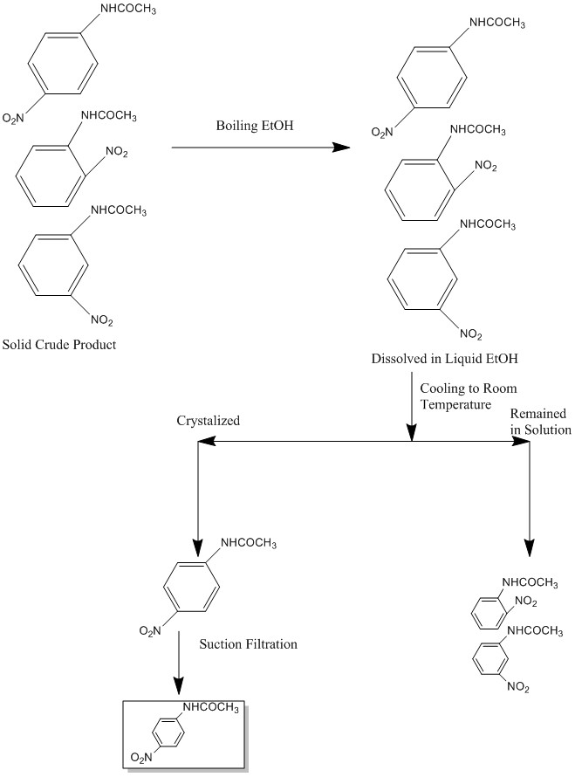
Figure 9 - Flow Chart for Workup by Recrystallization Process of Para Isomer.

TLC Plate 3: Purified Product with Mother Liquid or Crude Product
- From the TLC plate results in Figure 4, it is shown that the purified product has lower Rf values than the mother liquid. This shows that the purified product is very polar, suggesting that it contains the para product. In comparison, the mother liquid contains ethanol, as well as the ortho and dinitro products. These contributed to a higher Rf value as they are less polar compounds. The streaky slides are thought to be the polar ethanol, which would not move up the TLC slide as much.
- When comparing the crude product to the purified product, it can be seen that only the para product exists in the purified product. In addition the addition higher streaks on the Crude product show that it contained a mixture of ortho, dinitro, and para products.

Questions:
- The ortho and para isomers of nitroacetanilide have different polarities. This can be seen by their melting points, where ortho has the lower melting point of 95°C and para has the higher melting point of 216°C. Melting points are an indirect quantitative representation of the intermolecular forces holding molecules together, which in this case, is the polarity. It can be seen that ortho is far less polar than the para isomer, as it has weaker intermolecular forces as shown by its melting point when compared to para (which is more polar). On the TLC plate, this means that the polar para isomer will be more attracted to the silica gel on the TLC (which is polar as well). This will hinder its movement up the TLC plate, as the polar attraction will resist the movement. While on the other hand, the ortho isomer is less polar, and as a result will travel farther up the TLC plate, as it does not have strong attraction to the silica plate. This means that ortho will be farther up a TLC plate, and para will be lower down the TLC plate. The polar characteristic of the para is due to the fact that the two functional groups on para are at opposite ends. When compared to the ortho isomer, which has them close together. This causes steric hinderence in the case of ortho, which lowers resonance and thus decrease polarity. In comparision, the para isomer has extensive resonance, which can move the two charges far away from each other, thus increasing the dipole movement to very high values.
- Both isomers are soluble in hot ethanol. However as it cools, only the ortho nitroacetanilide stays in solution. This is because ethanol is a polar solvent, containing a hydrogen forming hydroxyl functional group. At high temperatures, the increased kinetic energy allows both compounds to dissolve. This is due to the increased intermolecular interactions where the ethanol uses hydrogen bonds to disrupt and overcome the force of attraction the nitroacetanilide molecules have with each other. The difference in the solubility of the ortho and para nitroacetanilide isomers in ethanol can be attributed to their polarity. As the solution cools the decreased kinetic energy means that the ethanol can no longer overcome the more polar para nitroacetanilide’s bonds (which is enhanced as shown in question 1). The ortho isomer on the other hand, has a much weaker polarity due to the steric hindrance its bulky function groups have. As a result, ethanol easily overcomes the ortho isomer’s dipole dipole bonds for each other and thus the ortho isomer stays dissolved in the ethanol.
- The addition of the second nitro gropu in this reaction is much slower than the first nitration of acetanilide due to the fact that:
  - The first nitro group on the nitroacetanilide is an electron withdrawing group, and so will have an affinity to pull the pi bonded electrons on the benzene ring toward it. This results in a decreased nucleophilic character of the benzene ring. This means that the benzene ring is slightly less reactive with an electrophilic compound, thus slowing down this reaction step.
  - After the first nitration, the nitroacetanilide has more bulky functional groups on it. This would result in steric hindrance limiting the available geometry of attacking species to react with the benzene. This slows down this reaction step.
- The para isomer is favored over the ortho isomer due to the fact that within the para isomer configuration, the large bulky groups are bonded farthest apart from each other. This lowers the overall energy of the molecule. When compared to the ortho product, which has the two bulky functional groups right besides each other. Having two bulky groups bonded close to each other results in steric hindrance, and causes destability in the molecule, resulting in an increase in its energy. Due to the increased required energy, the ortho product is less likely to form when compared to the para product (which is lower in energy).
- The preferred position of nitration for the following compounds are denoted by arrows.
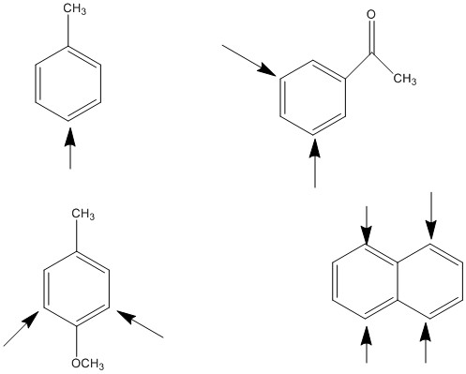

- The reason that the second reaction occurs, is that the benzene ring provides stabilization of this reaction through resonance as shown, while in the first reaction, no resonance forces the hexane ring to form a carbocation that will react with the Bromine Ion.
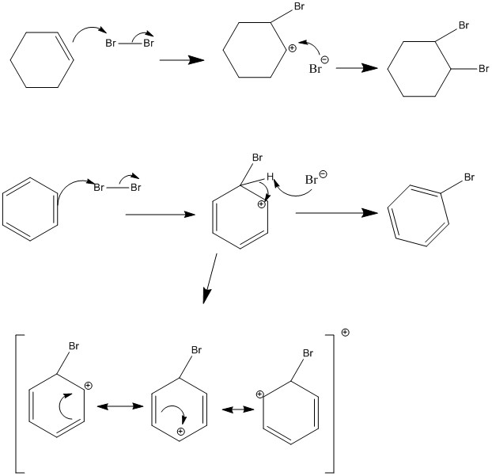
- Answer is as shown:
  - Overall Reaction Equation for First Nitration of Benzene
$$1HNO_{3}+benzene+H_{2}{SO}_{4}→nitrobenzene+H_{2}O+{HSO}_{4}^{-}$$
All reactants are used in a 1:1 molar ratio.
$$Benzene:\frac{780g}{78gmol^{-1}}=10moles$$
$$HNO_{3}= \frac{0.750L}{16molL^{-1}}=12 moles$$
$$H_{2}{SO}_{4}= \frac{0.750L}{18molL^{-1}}=13.5 moles$$
Therefore Benzene is the limiting reagent.
  - Theoretical Yield of Nitrobenzene:
$$Theoretical Yield=780g×\frac{1mol}{78g}×\frac{1 mol nitrobenzene}{1 mol benzene}×\frac{123 g}{1 mol}$$
$$Theoretical Yield=1230g Nitrobenzene$$
$$Percentage Yield= \frac{1000g}{1230g}×100\%$$
$$Percentage Yield=81.3\%$$
Therefore the percentage yield is 81.3%
  - Most probable product with high melting point would be 1,3-dinitrobenzene. This is also known as meta-dinitrobenzene. This is due to the fact that the first nitro group acts as a meta-director since it is an electron withdrawing group.
  - Sulfuric acid is a very strong acid that is able to protonate nitric acid. This is shown in the following mechanism. This is required in order to create the nitronium ion that will react to form the nitro group on the molecule.

Yield of side Product:
$$Yield of C_{6}H_{4}N_{2}O_{4}=1230g×\frac{1 mol}{123g}×\frac{1 mol dinitrobenzene}{1 mol nitrobenzene}×\frac{168g}{1 mol}$$
$$Yield of C_{6}H_{4}N_{2}O_{4}=1680g$$
$$Percentage Yield= \frac{250g}{1680g}×100\%$$
$$Percentage yield=14.9\%$$
Therefore the percentage yield of the side product is approximately 14.9%.
- The reason that the nitration of furan leads to 1-nitrofuran rather than 2-nitrofuran isomer is that the oxygen hetero atom is able to contribute to more resonance forms, and thus it is more stable. This is shown in the following diagram.
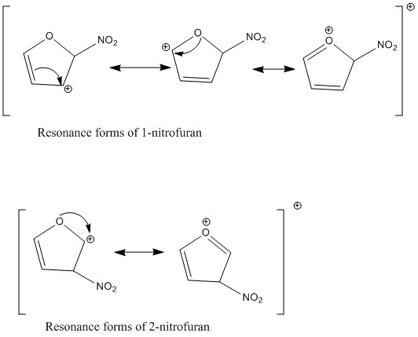

References:
CHM 1321(2013) Organic Chemistry Laboratory Manual, Prof. William Ogilvie, Experiment.
Regioselective Nitration of Acetanilide

Traynham, James G.. "Aromatic Substitution Reactions: When You've Said Ortho, Meta, And Para You Haven't Said It All." Journal of Chemical Education60.11 (1983): 937. Print.
Radhakrishnamurti, P. S., and Janardan Sahu. "Aromatic nucleophilic substitutions. Reactions of chloro- and nitro-substituted benzenes." Canadian Journal of Chemistry 47.23 (1969): 4499-4502. Print.

