Echinoderms
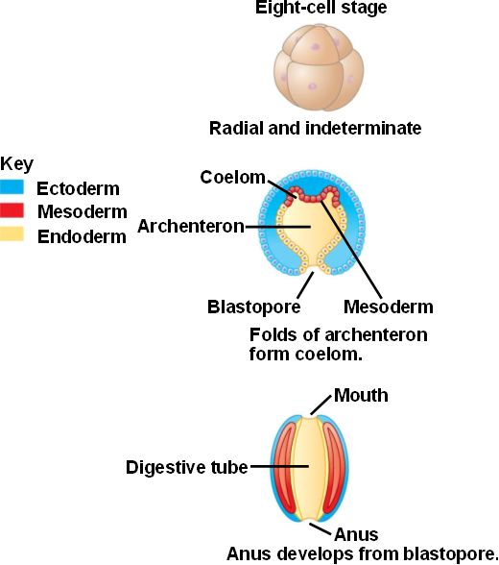
Autoapomorphies: Deuterostomia
- Blastopore formation (gastrulation): A hollow ball of cells (blastula) indents to form a two layer (ectoderm and endoderm) thick ball with a blastopore opening to the outside (the blastopore is the opening to the primitive gut, in this case the archenteron). The coelom originates from the mesoderm. The process of enterocoelous occurs in which the coelom is formed as pouches which bud off the archenteron. The coelom is then lined with endoderm which opens outside through the blastopore which gives rise to the organism’s anus first rather than the mouth. Animals showing enterocoelous, also undergo radial cleavage. This is when cells divide parallel to each other, resulting in pairs of cells positioned directly above and below each other at 90 degree angles. They also show indeterminate development in which the fate of the 8-celled blastomere remains undecided until late in development.
- Tripartite coelom: The coelom pouches out from the primitive gut to form three coelomic cavities called the protocoel (anterior), mesocoel (middle) and metacoel (posterior).
- Unique larval stage: dipleura larva: The dipleura larva is a bilaterally symmetrical, ciliated echinoderm larva which represents the ancestral form of for these primitive deuterostomes. These ciliated bands are located around the opening of the bell shape structure and allows the organism to move and feed.
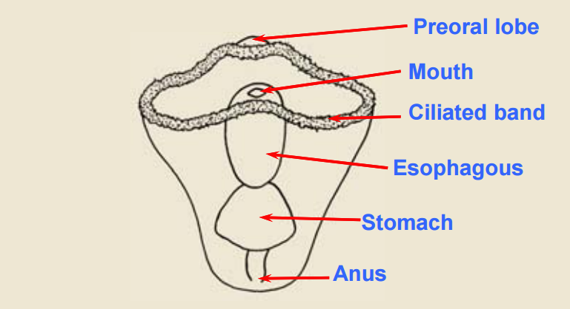
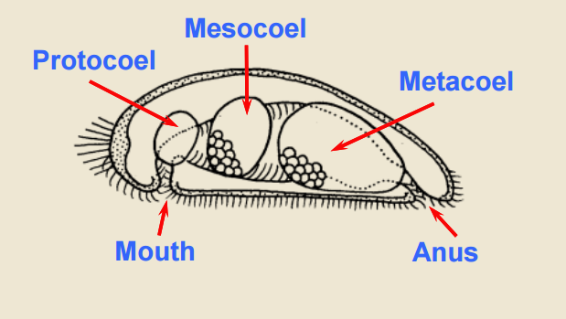
Tripartite Coelom Dipleura Larva

Characteristics and Apomorphies of Echinoderms
- Pentamerous symmetry- Symmetry is usually radial in the adult stage, typically pentamerous, or five parted but is secondarily derived. The larva is bilateral in symmetry.
- Water vascular system- They possess a unique water vascular system of internal canals and external appendages called tube feet. This system functions in locomotion, gas exchange, feeding and sensory reception. The water vascular system brings water into the body that they will use as a hydrostatic skeleton to move around, etc.
- Stereom spicules- They have an internal calcareous skeleton covered with epithelium and is organized in spicules or ossicles (blocks of mineralized calcium) that are connected with each other. The mineralized calcium is spongy and has lots of openings in it (very porous), but are not solid. Stereom refers to the sponge microstructure.
- Mutable connective tissue -They have one type of connective tissue and depending on the nervous control and signals it receives, it can be rigid and hard or soft and flexible (they control the rigidity and consistency of their connective tissue). The nervous system can control whether the connections between the tissues are loose (allowing it to move and change its shape) or stay rigid (animal can not move). This is not seen in any other animals.
- Extra: Some echinoderms have very delicate legs (legs break off, arms fall off as a defensive strategy) - it liquefies connective tissue; shatters itself voluntarily with connective tissue. A self amputation mechanism allows them to escape from predators.

Some Diversity
- Brittle stars- if you pick it up the arms can break off to get away from predators, etc
- Sea cucumbers- since they move very slowly, they throw out their whole digestive tract on predators as a means of a defense mechanism.

Ancient Echinoderms- Why did they go from bilateral to radial symmetry?
- When you think of radial animals you think of sessile organisms. However, the early larval stages were bilateral and settled down onto the ground and became radial. At that time, the echinoderms were sessile. They were stalks attached onto substrates and they had two arms pointing up. On the surface of these two arms were tube feet that caught organic matter and food that was falling through the water column within the ocean. These food particles landed on the centre of the umbrella, and then the tube feet were able to take that food, move it down their arms and bring it to their mouth in the center. This way they were able to feed on the food that they had trapped. To be effective at this, they had to be radially symmetric. Therefore, the dipleura larva changed from a bilaterally symmetric larvae and turned into a radially symmetric animal.

Ancestral Echinoderms
- They were sessile and immobile. All of them had arms extending from the outside (some had 5 and some had 7) but they all had the same mechanism of reaching up and catching food. The mouth was in the middle, facing up with the arms facing outwards. The tubed feet were on the arms and were used to propel the food towards the mouth. Now, only one group remains sessile. The rest detached themselves from the substratum, flipped themselves over so that their mouths would be pointing down (oral side down) and used their tube feet to push the organism across the substratum.

Echinoderm Surfaces
- In radially symmetric animals, there is no anterior or posterior, left or right sides to the animal. These animals are referred to as the oral and aboral side by the location of their mouth. They are orientated oral side down. The oral side contains the mouth and the tube feet. Aboral side refers to the opposite side. This side is opposite to the mouth and is the upper surface (pointing up from the substrate). Running down the length of the arms is the ambulacral groove with the tubed feet sticking out. The tubed feet stick out so that they can push against the substratum and the starfish can walk across the substrate. The tube feet are only on the oral surface and is an essential part of the water vascular system.

Water Vascular System or Ambulacral System
- Locomotion- moves the animal across the bottom of the ocean by the tube feet (using water pressure).
- Circulation- once it’s filled with water, it can be used to move things around internally (such as nitrogenous wastes, nutrients, etc) because it is lined with cilia that creates a current. The water acts as a transport fluid.
- Respiration- the tube feet can be used as a site for gas exchange or oxygen uptake since they are thin enough to be diffusive surfaces.
- Excretion- these animals can use simple ammonias for metabolic wastes because they have a great SA:V ratio.
- Since this group is so dependent on the water vascular system, they are locked into their marine environments in which they live in (since they always need water, its a restriction).

Water Vascular System Pathway
- This is a system of tube feet (or podia) and an internal system of canals derived from the coelom.
- Sea water goes through the madreporite (valve that replenishes the water, found on the aboral surface) first which is an opening on the outside which allows water to come in (no pumping, or flowing, just a big puddle of water). There are cilia within it beating to move water around but its just a reservoir of water. Within this structure is Polian vesicles (reserves) that swell and fill up with extra water if necessary. There are a few cells that come down from the Tiedemann bodies and destroy and remove any contaminants or bacteria that might be in the water but for the most part, it’s just water. The Tiedemann’s bodies (around periphery of central disc) and the Polian vesicles (in between each radial canal) are pouches that are found on the ring canal whose function is to control osmoregulation or hydraulic regulation within the water vascular system. The madreporite connects to the ring canal, and goes through the stone canal (calcareous duct), radiates out to each arm through the radial canals, which diverge into small lateral canals, and then terminates to the ampulla and tube feet (orally directed). The water circulates BUT it is not a circulatory system!!! Just a passive reservoir and system of water. Water can also exit through the madreporite.
- EXTRA: the arms on either side of the madreporite are referred to as bivium and the rest are the trivium.

Tube feet
- They act like little hydrostatic skeletons with a suction cup at the end. They can be found on the bottom of the echinoderms. A very crucial part of the water vascular system.

Mechanism of the Tube Feet
- Muscular contraction of the ampulla forces the fluid to enter the podium and at the same time, it closes a valve in the lateral canal to prevent backflow of water. Due to hydraulic pressure, the podium is extended and the sucker at its tip is brought into contact with the substratum. Once adhesion occurs, the longitudinal muscles of the podium contract, resulting in the shortening of the tube foot. As a result, water is forced back into the ampulla, pulling the body forward. When the podium is extended, it also is swung forward.
- Thus, each podium performs a little step and all of the podia combined together allows a starfish to grip objects and to crawl about.
- The podia do not move synchronously but they are coordinated to a certain extent that they all step in the same direction. One arm acts as the leading arm and exerts a temporary dominance over the other arms. The nervous system is what controls everything so that the tube feet are moving simultaneously. So while the front arm moves forward the back will move backwards.

Body wall
- Echinoderms are all carnivores. However, since there are much more organisms out there, they have to defend themselves or settle on them.
- The whole surface is covered with ciliated epithelium that create a water current that are constantly sweeping away particles, contaminants and sediments on the water surface. A layer of connective tissue beneath it secretes small calcareous ossicles (like bony spines) which prevent another organism to sit on it. Beneath that is a muscle layer that allows the arms to bend. Ciliated peritoneum forms the innermost layer of the body wall and lines the large coelom.

Pedicellaria
- Not only do echinoderms have spines, they have these small jaw like structures. They stick out of the surface and they are two little bony ossicles of the skeletal structure that are pincers. They are hinged together with muscles on them to allow them to open and close. They are associated with the spines to MAKE SURE nothing sits on this animal. They are capable of responding to external stimuli independently from the main nervous system of the animal. Some complex pedicellariae are also poisonous.
- The aboral surface also has small structures called dermal branchia (or papulae). They are small projections and extensions of the coelomic space within the animal. They are located on the aboral surface of the animal. They are used for gas exchange and excretion(as well as the tubed feet). They are composed of a inner peritoneum, and outer epidermis with coelomic fluid circulating within it. The spines in the pedicellaria encircle them so that no animal can get to the dermal branchia to destroy the extra barrier of gas exchange.

Digestive System
- The stomach consists of two components: the cardiac stomach (larger) and the pyloric stomach (smaller). The cardiac stomach is towards the outside (and can be everted) and the pyloric stomach is fixed within the inside of the animal, and branches out into all of the pyloric cecum. The pyloric cecum are great big paired digestive glands (allow specialized digestion events to occur) which extend into each arm of the starfish. This is where final digestion and break down of the food occurs. Digestion occurs first in the cardiac stomach. After that it occurs in the pyloric stomach.
- The cardiac stomach can also wedge itself between clams (bivalves) and pull them open. The starfish catches the clam, takes the tube feet with the suction cups and pulls and locks the mutable connective tissue so that the whole thing is pulling on the clam. While this is happening, the cardiac stomach comes out and places itself within the clam and releases its digestive enzymes, creates a current with cilia that aligns the cardiac stomach to pick the fluids and food up into the pyloric stomach and distribute it into the digestive glands that are in the arms.
- One thing star fish prey upon is corals which are composed of calcareous base with thousands of polyps sticking up. The sea star crawls onto the surface, spreads its stomach out on the surface and regurgitates its digestive enzymes that will liquify the little polyps. The cilia carries the food into the digestive tract.
- When the animal does when it find a prey is they chase it and turn their stomach inside out and surround the meal. The food is brought to the cardiac stomach and the digestive enzymes are regurgitated. Cilia lining the surface cause a current which pulls the food through the cardiac stomach to the pyloric stomach. The food then gets pulled into the pyloric stomach and the cilia carry it into the pyloric cecum where nutrients are absorbed. The food is already quite liquified in the pre digestion process so there is little fecal waste. The food goes back to the pyloric stomach and the small intestine brings the food from the top of the pyloric stomach to the anus. The anus in the animal is not functional. It just sweeps the feces pieces out.

Reproductive System
- Starfish have separate sexes. There are two gonads to one arm, with a simple gonoduct from each leading to an gonopore at the base of the arm.
- The gonads proliferate (expand inside each arm) until the gonad is sitting adjacent to the digestive gland (where final digestion of the nutrients occur). The nutrients are transferred from the digestive to the reproductive system.
- If you open up the starfish arms, all you will see is the pyloric cecum and the gonads. The gonads sit on top of the paired digestive cecum.
- Reproduction is external. The eggs are released freely into the sea water where fertilization takes place. A larva is formed and eventually undergoes metamorphosis.

Sea Star Arm
- The most prominent feature of the water vascular system is the tube feet, the ampulla head and the suction cup feet as these are extending out and are great exchange surfaces for O and CO2 to go in and out, nitrogenous wastes in and out, etc. This is found in the mesocoel.
- The metacoel that contains the digestive tract and gonads, lines the whole space and it sends out substances through the dermal branchiae exchange surfaces that are used for the removal of nitrogenous waste, gas exchange and all of the diffusive things. This metacoel wraps around the ampullae of the tubed feet.
- Therefore, the coelomic spaces are connected to each other. The membrane of the ampullae is wrapped with the membrane of the body cavity. Since the diffusion surface goes all the way across the coelomic space to the dermal branchia, the 2 coelomic cavities are used in diffusive roles.
- The tube feet and dermal branchia increases the surface area.
- So recapping, the mesocoel has the water vascular system and the metacoel is the standard body cavity. However, they have no head, due to the disappearance of the protocoel.
- How can they see and sense? They have a variation of a compound eye that covers the whole surface of the central disk, a series of miniature lenses. This is called an eye spot and it found at the tip of each arm. It is composed of a cluster of photoreceptor and pigment cells. With this, they can create a pixellated image like flies. They can also use tube feet to sense light and chemicals.

Sea urchins
- If you folded up all the arms, tubed feet and the ambulacral groove is pointing outside.
- All that remains is the central disc and the other elements of the disc in the centre with the madreporite and the anus and digestive system. They have a circular shape.
- Their mouth is directed downwards.
- They cannot walk so they use the musculature to move across the substrate.

Echinoidea - Water vascular system
- The structures remain the same except for a few changes. The madreporite is a duct that leads through the ring canal. The radial canal, this time doesn’t project out but projects up inside of the sphere. The tube feet extend out between the spine. The spines are used as a major defensive strategy. So the structures all remain the same, they are just organized differently.

Echinoid Spines & Pedicellaria
- They have long spines that are covered at the base with epithelium. However the consequence is that the feet need to be long enough since the tube feet have to extend beyond the spines. Spins are not great for walking across the substrate but if you have to stick to the substrate or use tube feet for locomotion they are not going to be good if they are shorter than the spines. Therefore, we end up with large tubed feet that are associated with the spines as well.
- Spines sit on balls that are connected to muscles that tilt and tip the spine. Sets of muscles that tilt and tip the spine; they are coordinated by the nervous system. The urchin can move inside rocky crevices inside and between the rocks; take the mutable connective tissue and harden it in place - makes it locked in place. When the urchin wants to get out, it can wave its spine and use it walk out of the cavity that it walks into. The spines can be spread out and anchored so that nothing can dislodge it. When it wants to remove, it can be unlocked and able to move (mutable tissue)
- They have pedicellaria that have 3 jaws instead of two within the groove, sometimes with poison glands.

Echinoidea - Oral surface
- There is a large membranous area. In the center of the membranous area is the feeding structure. All over the surface of the membranous area - the tubed feet have been modified into branched puffy structures that become gills.
- Instead of dermal branchiae to increase the surface area for gas exchange, in the membranous area around the mouth, tubed feet get modified into gills.
- Sea urchins have five sets of teeth that are aligned in rows where the tubed feet are gonna be so they are all pentamerous organized and its part of a little structure called Aristotle’s Lantern.

Aritostle`s lantern
- When it gets cleaned of tissue it looks like a lantern. It’s the major feeding structure of echinoidea.
- Consists of bony plates arranged concentrically around each other & a bony pyramid. Running along inside is a tooth that slides. The tooth extends out the bottom of the bony pyramid. This tooth is used for feeding.
- They can take the whole lantern, extend it out, pull it in, twist or turn it, open or close it and use their 5 drilling teeth to be able to go after food. The orientation of the lantern is achieved using the muscles that suspend it.

Echinoidea - Digestive System
- Sea urchins primarily eat plants because they are herbivores. (Ancestrally they were herbivores but some have now evolved into carnivores)
- Within the sea urchin, there is one long intestine. They have no stomach. Suspended above this large, voluminous space is the gonads. The coelomic space filled with seawater is the diffusive surface for digestion from the intestines to the gonads.
- For plant material, a large digestive system is needed to digest it.
- The Aristotle’s Lantern grabs the plant material, and scrapes away at it and cuts off pieces. However as they scrape at it, the small teeth in the middle is subject to wear, but it is constantly regenerated from the top. The Lantern takes the plant material, and shoves it down into the esophagus and the intestine. It spirals through one half of the organism. However since there’s a lot of water, and the food needs to be concentrated, once the food enters the oral intestine, a second tube called the siphon pulls the water out of the food. This is done so the digestive enzymes can work better on the food since it is more concentrated. Once all of the nutrients are extracted, the water is added back to the waste, and the food comes back and goes into the large anus at the top, and leaves the sea urchin.
- Modified because it is a herbivore, specialized in feeding on nutrient poor food. Plant food is not good for animals since it lacks the nutrients that animals need and the this group is a carnivorous group that became an effective herbivore. As a herbivore, the digestive tract must be lengthened. This is because the digestive tract contains pouches, spaces and regions which deal with the digestion of plant material. The digestive tract spirals from the oral opening to the anus back at the top. This large SA processes plant material (if the food is nutrient poor, you keep it in the digestive tract as long as possible so you can extract all the nutrients from it). So technically, the whole inside of a sea urchin is essentially a digestive tract and suspended from the top of the shell are the giant gonads and thats all that is inside of a sea urchin (gut and gonads).

