LESSON 2 Training and Development Process

Learning Outcomes
  - Understand the meaning of performance management, training development and human resource development

  - ` the organization, employee, and societal benefits of training and development

  - Discuss training and development in Canada

  - Understand and explain the role of the environmental and organizational context of training and development

  - Understand the meaning of strategic human resource management (SHRM), strategic training and development and high performance work systems (HPWS)

  - Discuss the instructional system design (ISD) model of training and development
- Education vs Training
- Is an individual activity which involves the use of ones mind
- Focuses on the development of ones intellect (knowledge acquisition)
- Training deals with learning how to perform specific skills (skill acquisition)
- Is a way to develop skills that are used for social and economic benefit
- Performance Management
  - The process of establishing performance expectations with employees, designing interventions and programs to improve performance, and monitoring the success of interventions and programs.
  - Comprehensive process that involves various activities and programs designed to improve performance.

- Training
  - The acquisition of knowledge, skills and abilities to improve performance in one’s current job
  - Short term focused
  - Learn to do your current job better

- Development
  - The acquisition of knowledge, skills and abilities required to platform future job responsibilities
  - Extensive programs
  - Goal is to prepare individuals for promotions and future jobs as well as additional job responsibilities.

- Human Resource Development
  - Training and Development are a part of this larger system
  - Systematic and planned activities that are designed by an organization to provide employees with opportunities to learn necessary skills to meet current and future job demands.
  - Main function
    - Training and Development
    - Organization development
    - Career development

- First step in the process of a performance management system is the creation of an organizational environment conducive to learning

- Benefits to an Organization
  - Strategy
    - Organizations can be successful by training employees so they have the knowledge and skills necessary to help organizations achieve their goal and objective.
    - Right people, with right skills in the right roles

  - Effectiveness
    - Trained employees can do more and better work, make fewer errors, require less supervision, have more positive attitudes and have lower rates of attrition.
    - Produce higher quality work
    - Positive effect on an organizations competitiveness and effectiveness
    - Companies that invest in training have higher revenues profits and productivity growth than firms that invest in less training.
  - Human resource practices and empowerment are directly related to productivity compared to investment in operational initiatives.

- Employee Recruitment and Retention
  - Training and development is considered an effective tool for attracting and retaining top talent especially for those under the age of 30
  - Many organizations offer extensive training and development opportunities to retain employees.

- Benefits to Employees
  - Benefits to employees are internal/intrinsic
  - Knowledge and attitudes
  - And External.

  - Intrinsic Benefits
    - Training has a positive effect on employees job behaviour and job performance.
    - Self Efficacy and Confidence
    - Positive attitude toward their job and organization
  - Extrinsic Benefit
    - Higher earnings
    - Improved marketability
    - Enhanced opportunities for advancement
    - Wages increased 4-11 percent

- Benefits to Society

  - Educated and Skilled Population
    - Employees use skills learnt to better there lives
    - Creates educated and skilled workforce
  - Economy and Standard of living
    - Keys to a country’s standard of living, incomes and overall prosperity are its productivity and productivity growth
    - Improving education and skills of the workforce is a way of improving
    - Education key factor for improving productivity
    - Training investments lead to job creating and job opportunities

- Training and Development in Canada

- Fewer than 30 percent of adult workers in Canada participate in job-related training.

- Lag in hours, total dollars spent on training for employees

- Lag in total amount spent per employee

- Fewer than 30% of adult workers in Canada participate in job-related training

- Is Training an Investement or an Expense?

  - Is among the top priorities of Canadian organizations according to the conference board of Canada
  - Underinvestment due to appearance that training and development is considered a cost rather than an investment
  - One in five organizations invest in training and development in Canada
  - Consensus is Canadian companies not investing enough

- Quebec’s Training Law
  - In an attempt to increase training investments made by organizations in Quebec government passed the Act to foster… making it the only payroll training tax in North America.
  - For companies making a million and higher
  - Invest 1 % into government-sanctioned training
  - Those who don’t invest money is pooled into a fund that funds training initiatives
  - Goal to get organizations to make training investments that will result in improved organizational productivity and performance.

- Concerns
  - Larger companies meet or exceed the 1 percent requirement, so the law has no effect on them and there s no incentive for them to increase their training investments
  - Small companies have difficult time doing the paper work and essentially pay the 1 percent because its easier.
- Employees reluctance
  - Employers lack confidence in their specific training needs and how best to organize and provide for it when it is identified.
  - Employers are concerned about employees who take advantage of their training opportunities, and then offer their services elsewhere. Some companies have countered this with “firm-specific” training.
  - Small and medium-sized enterprises lack the economies of scale that make training more feasible for larger firms.

- The Context of Training and Development

  - Laws, Technology, Demographics, Labor Market, Economy
- Environment
  - Goals, Values, Strategy, Structure, Culture, Leadership
- Organization
  - HR planning, Job Analysis, Compensation, Recruitment, Selection
- Human Resources Systems
  - Training and Development
- Individual Performance
  - Organizational Effectiveness

- Sometimes sudden changes in the environment can lead to changes in HR policies and practices.
  - Ex: Airports after concerns on terrorism

- Global Competition
  - Forced orgs to improve their productivity and quality of their goods and services
  - Adapting to other economies, require employee training

- Technology
  - Provide orgs with improvement in productivity and a competitive advantage
  - Will only provide productivity gains if employees receive training ti exploit the technology

- The Labor Market
  - Nobody available for the job, must train current employees

- Change
  - Tech revolution, increasing globalization, and competition resulted in a highly uncertain and constantly changing environment.
  - Key part of the process

- The Organizational Context of Training and Development

- Strategic Human Resource Management (SHRM)
  - The alignment of HR practices with an organizations business strategy

- A strategic Model

- Business Strategy HRM Strategy Learning and Training Strategy Training and Development Programs

- Organizational Culture
  - The Shared Beliefs, values, and assumptions that exist in an organization

- High Performance Work Systems (HPWS)
  - An interrelated system of human resource practices and policies that usually include rigorous recruitment and selection procedures, performance contingent incentive compensation, performance management, a commitment to employee involvement and extensive training and development programs.

- Instructional Systems Design (ISD) model
  - A rational and scientific model of the training and development process that consists of a needs analysis, training design and delivery, and training evaluation.

- Itch
  - Is something in the organization that is not quite right or is of concern to someone.

- Needs Analysis
  - Organizational Where
  - Task What
  - Person Who

- Training and Design and Delivery
  - Training Objectives
  - Training Content
  - Training Methods
  - Learning Principles

- Training Evaluation
  - Evaluation Criteria
  - Evaluation Design

- Measures current performance and ends with improved performance

- Case Study:

- Message of Apology towards everyone affected states they have the highest standards of anyone. Take full responsibility.

- Case Study Solution

- External Influences
  - Governing laws regulating, may not have been strict enough
  - Not Followed
  - Inspectors, enforcement spent little time
  - Social Climate Consumer reaction created fear in the products and brand

- Impact
  - Reputation, Financial Situation, Culture, business strategy, future direction of company
  - Leadership to take responsibility

- How are elements of the organizations evident in the company’s
  - Uncertainty
  - Employees future

- New Staff
  - Corrective actions
  - Stricter operating Procedures
  - New Cleaning Techniques
  - Needs Analysis

- Instructional design is sometimes referred to as the ADDIE process :

- Analyze the situation (learners, content, resources, environment).
- Design the instruction (objectives, method).
- Develop the learning material (content, multimedia, resources).
- Implement the training (face-to-face, online, blended delivery).
- Evaluate the outcome (make changes if necessary).

LESSON 3 ORGANIZATIONAL LEARNING

Learing processes
- Learning Environment
- Leadership

- Rate of Learning needs to be greater than the rate of change

- Early discussions abstract, without concrete
- CEO aimed rather than local leaders
- Standards or tools

- One company GE

- Organizational Learning
  - The process of creating, sharing, diffusing and applying knowledge in organizations
    - it is not simply a focus on current needs or deficiencies, but also on continuous learning
    - Main characteristic of an adaptive or agile organization; one that is able to identify the need to alter its practices based on shifts in its environment.

- The Learning Organization
  - Acquires, organizes and shares information and knowledge
  - Uses new information and knowledge to change its behavior in order to achieve its objectives and improve its effectiveness.
  - Able to transform itself by acquiring and disseminating new knowledge and skills throughout the organization
    - Has enhanced capacity to learn, adapt, and change its culture.
    - Has the ability to make sense of and respond to surrounding environment

- Organizational Learning results in continual improvements in :
  - Work Systems
  - Product services
  - Teamwork
  - Management Practices

- Five Disciplines of Organizational Learning
  - Personal Mastery
  - Building a shared vision
  - Mental models
  - Team Learning
  - Systems Thinking

- Personal Mastery
  - Individuals have to be willing to learn on a continual basis
- Building a shared vision
  - A common goal to which all are committed to achieving
- Mental Models
  - People are aware of how they influence their own behaviors (self-reflections, metacognition)
- Team Learning
  - People must be able to work and learn together
- Systems Thinking
  - The ability to see the big picture and to understand the individual parts and the role they play.

- Principles of a Learning Organization
  - ‘Everybody is considered a learner
  - People learn from each other
  - Learning is part of a change process
  - Continuous formal and informal learning
  - Learning is an investment
  - Experimentation is valued
  - Failure is tolerated if it leads to learning

- Four Key Dimensions of a Learning Organization
  - Vision
    - Requires clear vision of organization’s strategy and goals
  - Culture
    - Fosters information sharing and continuous learning
  - Learning Systems/ Dynamics
    - Seek solutions to problems through a systematic view of the organizations and its environment
  - Knowledge management/ Infrastructure
    - Technology, systems and processes to support the capture, dissemination and evaluation of knowledge
    - Ensure the right person as the right knowledge at the right time.

- Knowledge
  - Sum of what is known; a body of truths, information, and principles
    - Found in the minds of the employees
    - Transferred and stored in information systems in the organization
    - Embedded in tools and standard operating procedures
  - More than just information!
  - Info that has been:
    - Edited and put into context
    - Analyzed and interpreted in a way that makes it meaningful and therefore valuable to the organization

- Types of Knowledge:

- Explicit Knowledge
  - Thing that you can buy or trade, such as patents or copyrights and other forms of intellectual property.
    - Can be codified and documented
    - Can be written into procedures or stored in databases
    - It transferred fairly accurately
    - Small proportion of corporate knowledge is explicit
- Tacit Knowledge
  - Known only by the individual and is not necessarily known by the organization
    - Valuable wisdom learned from experience and insight that has been defined as intuition, know how, little tricks and judgment
    - Difficult to transfer
      - People are often not aware of the tacit knowledge they possess and how valuable it is to others.
    - Difficult to articulate
      - Accounts for greater proportion of corporate knowledge
      - Often this knowledge is critical to competitive advantage.

- Intellectual Capital
  - An organizations knowledge experience relationships process discoveries innovations market presence and community influence.
  - The source of innovation and wealth production
  - Has to be formalized captured and leveraged to produce a more highly valued asset
  - Not like other assets- it grows with use
  - It is increasingly viewed as the organizations most valuable asset.

- Types
  - Human
  - Renewal
  - Structural
  - Relationship

- Knowledge skills and abilities of employees- Human
- Intellectual property- Renewal
- Systems and relationships that allow employees to communicate solve problems and make decisions.- Structural
- Organizations relationship with suppliers, customers, and competitors influence how they do business.- Relationship

- Knowledge Management
  - Creation, collection, storage, distribution and application of know what and know how, or seeks to identify and connect individuals based on their expertise and areas of activity

- Knowledge Management/ Infrastructure
  - Refers to systems and structures that integrate people, structures and technology

- Importance?
  - Knowledge is the basis of competitive advantage in a knowledge based economy
  - Knowledge in the form of intellectual capital

- Life Cycle of Knowledge

  - Acquire
    - Knowledge acquisition
  - Interpret
    - Knowledge interpretation
  - Disseminate
    - Knowledge Dissemination
  - Use/Apply
    - Use/Application
  - Evaluate
    - Evaluation
  - Retain
    - Knowledge retention

- 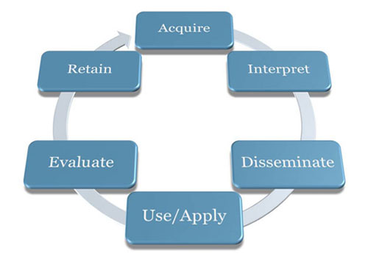

- Knowledge acquisition
  - Environment Scanning
    - Internal and external
  - Formal learning
    - Key part
    - Represents small, but critical part of how employees learn
  - Informal learning
    - Largest portion of employee learning
    - Spontaneous, immediate and task specific
    - Can be based off trial and error, search or social network

Informal Learning
  - There are different nuances in the definitions found in the literature:
  - “learning which takes place in the work context, relates to an individuals performance of their job and/or their employability, and which is not formally organized into a programme or curriculum by the employer. It may be recognized by the different parties involved, and mau or may not be specifically encouraged.
  - Learning outside dedicated learning environment and which arises from the activities and interests of indiciduals and groups, but which may not be recognized as learning.

Factor | Formal Learning | Informal Learning
Control | Controlled by Organization | Controlled by Learner
Relevance | Variable | High
Timing | Delay between learning and use of knowledge acquired | Learning used immediately on the job
Structure | Highly structured | Unstructured
Outcomes | Specific | Not Specific

Knowledge Interpretation
  - Mental models
    - are deeply engrained assumptions, generalizations or images that influence how we understand the world and how we take actions
  - An effective way to develop shared mental models is to establish teams to stimulate work-related learning, solving real problems

- Communities of Practice
  - are networks of people who work together and regularly share information and knowledge
  - compromise individual who share common values, goals, problems or challenges, and a shared language for framing and exploring issues
    - Often members share a disciplinary background, though a CoP could be interdisciplinary
  - No formal mandate, no formal designation of roles and responsibilities, no predefined deliverables or preset lifespan and no specific defined objectives.
  - Learning is largely informal
  - Based on exposure to the practices and norms of the community
  - Enculturation or apprenticeship
  - Dunbar Number upper limit.
  - Facilitating through info and communication technology

- Knowledge Dissemination
  - Moving ideas requires a different set of skills
  - Systems for sharing knowledge
    - Shared mental models and language
  - Information and Communication Technology (ICT)
    - Increased codification of knowledge; that is its transformation into information that can be easily transmitted
    - Intranet and portals are critical components for managing knowledge
  - CoPs are a mechanism for disseminating knowledge ( particularly Tacit knowledge)

- Use/Application
  - In the sphere of knowledge management, it is important to monitor:
  - How knowledge is being used
  - Where it is being used
  - Who is using it

- Evaluation
  - A consideration of the value and potential
  - Could be rated by employees or managers
  - Could be gauged though measurable outcomes (ROI or an innovation)
  - Could be based on usage

- Knowledge retention
  - The way in which useful knowledge is stored and organized in such a way that it an be easily retrieved
  - Knowledge repositories
    - are inventories of knowledge that organizations compile and store, which can be easily retrieved
    - Some are more informal lists of lessons learned white papers, presentations and so on
    - Most have links to the originator of the documents
    - Includes content and document management systems, public file structures and libraries.

- Connection between organizational learning and training:
  - Training is an important element of learning
  - Learning organizations exceed other organizations in terms of both training practices and expenditures
    - Increased spending on training alone does not entail a learning organization.
  - Individuals learn through training and development.

  - Organizational learning is the process of creating, sharing, diffusing, and applying knowledge within an organization.
  - A learning organization is one that establishes and maintains conditions for organizational learning to occur.
  - Senge (1990) identified five disciplines that are widely regarded as guiding principles for creating learning organizations.
  - Learning organizations are characterized by four important principles.
  - Although explicit knowledge is the easiest to quantify and record, tacit knowledge is the most valuable and the most difficult to maintain.
  - Knowledge management practices and intellectual capital have become increasingly important in a competitive, knowledge-based economy.
  - Once knowledge is acquired, it is then interpreted, disseminated, applied, evaluated, and retained/stored.

LESSON 4: LEARNING AND MOTIVATION
- What is learning?
  - The process of acquiring knowledge and skills, and a change in individual behavior as a result of some experience.
  - Interaction between the individual and the environment that results in a relatively permanent change in behavior
  - A persisting change in human performance or performance potential as a result of experience

- Learning Outcomes

- 1) Verbal Information
  - Facts, knowledge, principles, information (declarative knowledge)
  - Verbs: state, recite, tell, declare, define

- 2) Intellectual skills
  - Concepts, rules, and procedures (procedural knowledge)
  - Categories: Discrimination, concrete concept, defined concept, rule, higher order rule.
  - Verbs: Distinguish, identify, classify, solve, label and specify

- 3) Cognitive Strategies
  - Application of information and techniques
  - Understanding how and when to use the information
  - Verbs: adopt, create, originate, invent

- 4) motor skills
  - Coordination and execution of physical movements

- 5) Attitudes
  - Preferences and internal states associated with beliefs and feelings
  - Verbs: Elect, favor, prefer, choose

- Stages of Learning skill

- Declarative Knowledge
  - Learning knowledge, facts and information
  - Learn the alphabet learn conventions about direction of reading separation of words, purpose of punctuation, rote learning of some words

- Knowledge compilation
  - Integrating tasks into sequences to simplify and streamline the task
  - Word recognition becomes automatic, however over time, a proficient reader is able to grasp whole sentences and even passages at a glance
    - This is because the comment sub skills involved in reading have been completely automated and merged together, overcoming limitations of working memory

- Procedural Knowledge
  - Learner has mastered task and performance is automatic and habitual
  - Learner no longer has to think deliberately and consciously about the sounds associated with letter combinations or the meaning of individual words
    - Comprehension increases as working memory no longer has to perform the conscious tasks mentioned above.

- Learning Styles
  - The way an individual gathers, processes and evaluates information during the learning process
  - Four ways to gain experience:
    - Concrete Experience (CE)
    - Abstract Conceptualization (AC)
    - Reflective Observation (RO)
    - Active Experimentation (AE)
  - An individuals preferred learning style is a combination of two of the modes of learning
    - Converger (AC+AE)
      - Thinking and Doing
    - Diverger (CE + RO)
      - Feeling and watching
    - Assimilator (AC+RO)
      - Thinking and watching
    - Accommodator (CE+AE)
      - Feeling and doing

- Learning theory consists of a set of propositions and constructs that attempt to explain how change in behaviour is achieved.
  - 1) Conditioning Theory
  - 2)Situated Cognition
  - 3) Social Learning Theory

- Conditioning theory
  - Learning is a result of reward and punishment contingencies that follow a response to a stimulus
  - A stimulus or cue would be followed by a response, which is then reinforced
  - Strengthens the likelihood that response will occur again and that learning will result
  - StimulusBehaviorConsequence
    - Positive Reinforcement

Application of a positive stimulus after an act
    - Negative Reinforcement
      - Removal of a negative stimulus after an act
    - Punishment
      - Receiving a negative consequence for an undesirable act
    - Both reinforcements will increase or maintain behavior
    - Shaping
      - Reinforcement of each step in a process until it is mastered
    - Chaining
      - Reinforcement of entire sequence of a task
    - Generalization
      - Conditioned response occurs in circumstances different from those during learning.

- Situated Cognition
  - Theory that builds on cognitive approaches to understanding learning.
  - Focuses on the structures that are created in the mind through experience, and that further mediate our interpretation of experience
    - Structures are called mental models or schema
    - Evolve through different processes in which they are tweaked or extended to deal with new experiences or undergo radical restructuring if required. (accretion, tuning restructuring)
  - Learning is seen as a process in which schema are further elaborated to contend with new experiences
  - Key processes are generalization and discrimination
  - Cognitive theories are also based on an information processing model of the mind
  - Key elements in the basic model are short term, working and long-term memory stores or registers
  - Sensory channels provide input to short-term and working memory.
  - These are not permanent storage units, and there are well established limits on how much information can be held in working memory and manipulated
  - The object is to more information from working memory into long-term memory, which is stable repository, for future retrieval.

  - Situated cognition builds on the cognitive paradigm
    - The insight captured in situated cognition is that at the time of learning we also encode aspects of the situation in which we are learning.
    - These become part of our memory structures and affect our ability to successfully apply what we have learned- both facilitating and obstructing performance depending on circumstances.
    - The aspects of the situation that are encoded are, if you like, conditions of applicability.
  - If we learn and practice a new concept or skill over and over in the same or very similar situations of contexts we will find that we are very well able to apply this learning when we are confronted with a similar context
    - Our ability to do this will likely exceed that of someone who has learned the principle or concept in a more abstract fashion. (less situated less applied)
  - However, it is also true that if we are placed in a similar context where the same learning could be useful, we may be unable to recognize this, and fail to retrieve and apply the relevant schema.
  - To enable learners to access and apply schema across a wide variety of relevant situations, learning and practice must involve a variety of contexts!
  - Decontextualized or abstracted presentations of a topic may also lead to greater “wide transfer” of what is learned.

- Social Learning Theory-Three key components
  - Observation
    - Learning by observing the actions of others and the consequences
    - Four key critical elements: Attention, Retention, Reproduction and Reinforcement
  - Self-efficacy
    - Judgments people have about their ability to successfully perform a specific task
    - Influenced by four sources of information in order of importance
      - Task performance outcomes
      - Observation
      - Verbal Persuasion and Social Influence
      - Physiological/emotional state
  - Self-Management
    - Managing ones own behavior through a series of internal processes
      - Observe personal behavior as well as the behavior of others
      - Setting performance goals
      - Assessing personal progress
      - Rewarding oneself for goal achievement
      - Concepts: Self regulation and metacognition

- Differ in the emphasis they place on the environment, the individual and behavior.

  - Behaviorists will argue an influence in the environment will have a change on ones behaviour. Individual differences are not as important
  - Cognitivists believe that the individual is key since individuals can perceive the environment differently and their behaviour will differ accordingly
  - Socio-cultural theorists focus on the effect of the environment on behavior, but particularly on the role the community in shaping ones behavior

- Environment Individual Behavior

- Adult Learning Theory

- Andragogy
  - An adult-oriented approach to learning that takes into account the differences between adult and child learners.
  - Material relevancy, other things going on in their lives
  - Un-teaching what is in there is a huge issue
  - Workplace, location of schools

- Pedagogy
  - The traditional approach to learning used to educate children and youth

Factor | Children | Adults
Personality | Dependent | Independent
Motivation | Extrinsic | Intrinsic
Roles | Student/Child | Employee/parent, citizen, spouse
Openness to change | Keen | Ingrained habits and attitudes
Barrier to change | Few | Negative self-concept
Experience | Subject-centered | Problem-centered

- Motivation: Degree of persistent effort that one directs toward a goal.

- Need Theories
- Maslow:
- 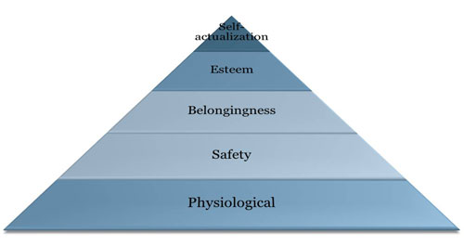

- Clayton Alderfer’s
- Three needs
  - Existence Needs
  - Relatedness Needs
  - Growth Needs

- 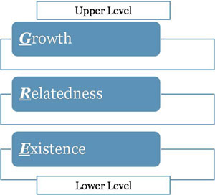
- ERG theory differes from maslows in the following ways
  - Not a rigid hierarchy of needs
  - If unable to satisfy a higher need, then the desire to satisfy a lower level will increase.

- Process Theory
- Expectancy and Goal Setting Theory

- Mastery/Learning Goals
  - Process-oriented goals that focus on learning process

- Performance Goals
  - Outcome-oriented goals that focus attention on achievement of specific performance outcomes.

- Personality Variables that predict training motivation:
  - Locus of control
  - Achievement Motivation
  - Anxiety
  - Conscientiousness
  - Self-efficacy

- Model of Training Effectiveness
- 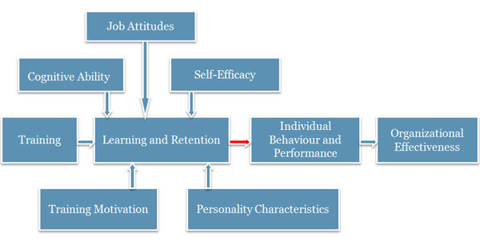

- Key issue for training is ensuring that what is learned is applied in the workplace (in the operational context)
- Degree of transfer attained in training is often limited

- Summary
  - The major goal of all training and development is learning.
  - Learning involves a change in behaviour by an individual based on their interaction with the environment.
  - Different learning theories explain this relationship in various ways.
  - Behaviorists vs. cognitivist vs. social learning
  - Adult learning theory and theories of motivation have implications for the design of training and development.
  - Organizational effectiveness is the end product of a model that involves training, employee characteristics, attitudes, learning and retention, and performance.

LESSON 5

- What is transfer of training?
- Transfer of training refers to generalization of knowledge and skills learned in training on the job and maintenance of acquired knowledge and skills over time.

Two conditons:
- Generalizatoin: use or application of learned material on the job.
- Maintenance: use of application of learned material on the job over a period of time.

The extent of transfer training:
- Positive: trainees effectively apply new learning on the job
- Zero: trainees do not apply learning on the job
- Negative: trainees perform worse on the job after training

Types of transfer training:
Near: applying new learning to situations that are very similar to those in which training occurred.

Far: Appling new learning to situations that are different from those in which training occurred.

Horizontal: transfer across different setting at the same level

Vertical: transfer from the trainee level to organization level

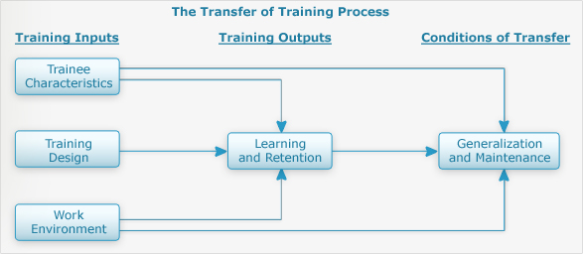

- Training Inputs:
- 1. Trainee Characteristics: Cognitive ability, training motivation, self-efficacy, personality characteristics. Most likely to transfer:
- High cognitive abilities, motivation to learn, self efficacy
- Internal locus of control and high need for achievement
- High job involvement, job satisfaction, and organization commitment

2.Training Design: active practice and conditions of practice. Learning Principles:
- Identical elements (authenticity)
- General principles (theory)
- Stimulus variability (practice)

3.Work Environment: Pre-training
- Management actions send messages/signals regarding importance and organization support of training.
- Organizational constraints: lack of time, equipement, and/or resources.

Post-training
- Support provided by trainees’ supervisor
- Training transfer climate: Characteristics in the work environment that can foster or inhibit applying the training to the job
- Learning culture: transfer of training is greater in an organization that values the acquisition of knowledge and skill (a learning organization)

Transfer of training activities before training:

1.Management: decide who should attend
- Readiness to learn/trainability (ability x motivation x perceptions of the work environment) = readiness to learn and trainability
- Trainability tests

Increase motivation to learn
- Meet with employees to discuss training needs
- “WIIFM” (what’s in it for me?)

Provide employees with support for learning and training

2.Trainer
- Ensure application of ISD model.
- Ensure both trainees’ supervisor and trainees are prepared in terms of knowing objectives and benefits.
- Find out supervisor and trainee needs and expectations.
- Ensure that trainees are prepared for training in terms of prerequisite courses/readings, etc.

Trainees:
- Find out about training objectives prior to attendance.
- Meet with supervisor to discuss training program and develop action plan for learning and transfer.
- Prepare for training program.

Transfer of training activities during training

1.Management:
- Participate in training programs.
- Speak about importance of training programs.
- Attend training programs before trainees.
- Reassign employees' work while they are attending training.

2.Trainer:
- Incorporate conditions of practice, adult learning principles, and other learning principles in design.
- Include content and examples that are relevant and meaningful.
- Include instruction on transfer of training.
- Have trainees prepare a performance contract.

3.Trainees
- Enter training program with positive attitude and motivation to learn.
- Engage themselves by actively participating.
- Develop an action plan for application of training on the job.

Transfer activities after training

1.Management
- Ensure trainees have immediate and frequent opportunities to practice and apply what they learned.
- Encourage and reinforce trainees’ application of new skills.
- Develop action plan with trainees, reduce job pressures and workload, arrange practice sessions, give promotional preference to employees who have received training and, transfer and evaluate employees’ use of trained skills on the job.

2.Trainer

Conduct field visits
- Observe trainees, provide feedback and support

Offer booster sessions
- Definition: extensions of training programs that involve periodic face-to-face contact between the trained and trainees

3.Trainees
- Begin using new knowledge and skills on the job ASAP.
- Meet with supervisor to discuss opportunities for transfer.
- Form a “buddy system”.
- Consider high-risk situations that might cause a relapse and develop strategies for overcoming them and avoiding a relapse.

Transfer of training interventions

Relapse prevention
- Anticipate transfer obstacle and develop coping skills

Self-management and self-coaching
- Perform a series of steps to manage transfer behavior and establish performance maintenance and improvement goals

Goals setting
- Set specific, challenging goals to enhance transfer

Goal setting interventions
- teach trainees about the goal setting process

Booster sessions:
- Extensions of training programs that involve a review of the training material

The transfer system: all factors in the person, training, organization that influence transfer of learning to job performance

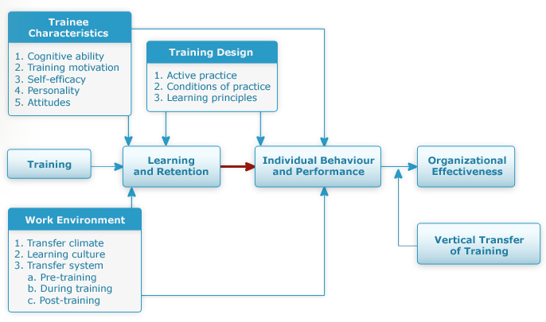
- Key points:
- The transfer of training to the workplace is a serious problem because it is difficult to measure and there are many potential barriers.
- Personal characteristics of the trainee, the design of the training, and the environment in which it is delivered and applied.
- Transfer can be affected by all stakeholders (management, trainer, trainee) before, during, and after the training.
- The transfer system combines human and organizational factors to model the effectiveness of training.
- The Learning System Transfer Inventory (LTSI) can be used to assess this system

