LAB BCH2333
SECTION: 5 (Tuesday morning 1st week)

LAB 4: LIPIDS AND MEMBRANES

March 10th 2015

Purpose
The purpose of this lab is to prepare two separate membrane fractions; the first from an endoplasmic reticulum enriched fraction and the second from a mitochondrial enriched fraction, using rat liver tissue sample. The lipids are extracted from the microsomal fraction (the endoplasmic reticulum fraction), separated by thin layer chromatography and compared with lipids extracted from the entirety of the tissue. The extraction of the lipids in the tissue is done by using Bligh and Dyer lipid extraction with a mixture of chloroform and methanol to segregate the lipids form other polar compounds, The cellular membrane is fractionized by rupturing cells using tissue homogenization in a buffer, where subcellular particles are separated by centrifugation. The membrane lipids and proteins are assayed and the lipid protein ration is measured by measuring the light absorption of the mitochondria enriched fraction following the addition of the dye brilliant blue R.
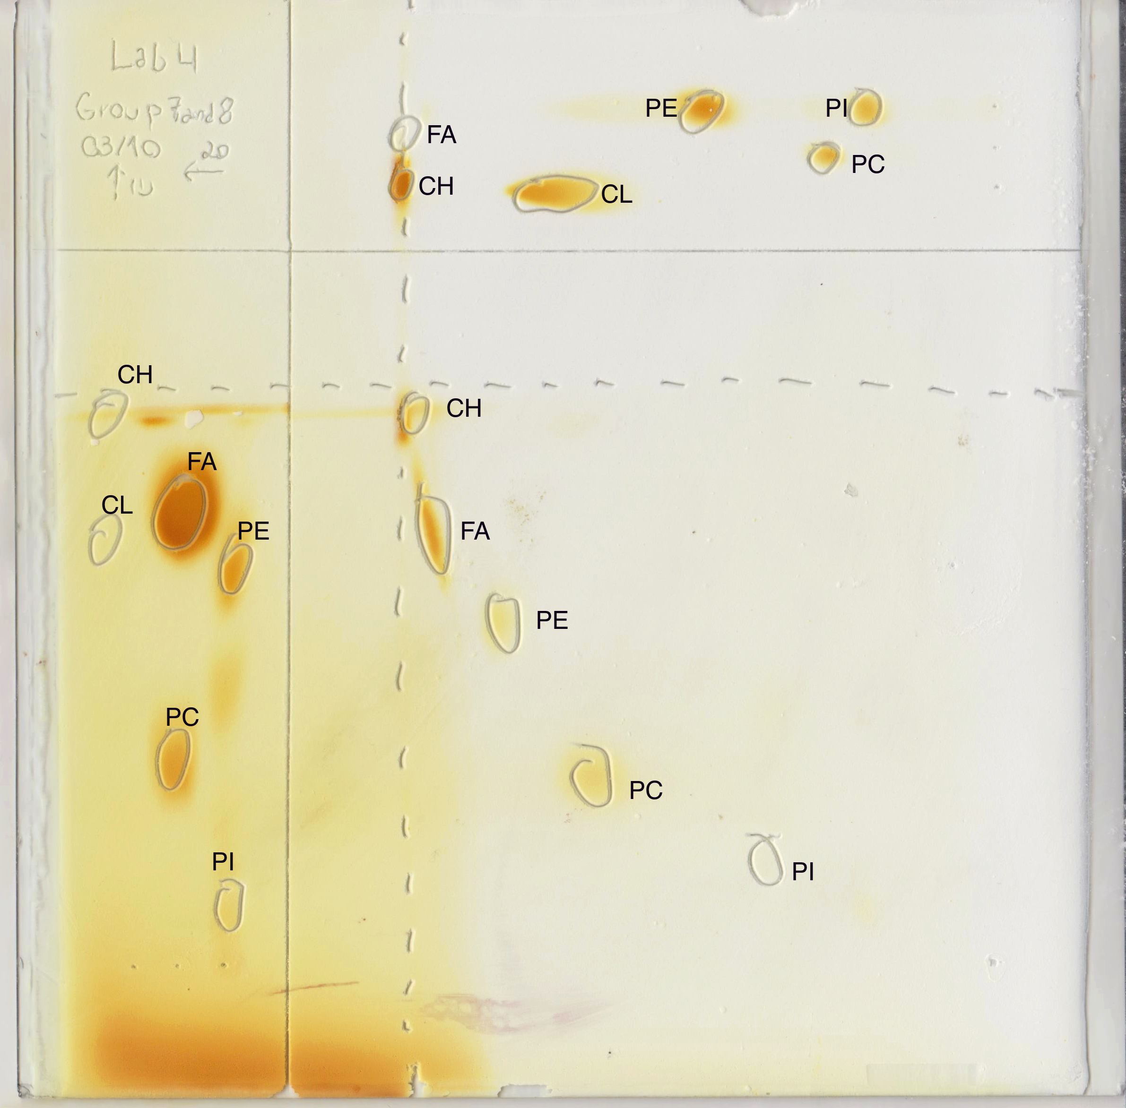
R1.
Figure 1. Two- dimensional TLC of microsomal lipids. The figure shows the separation by polarity of three lipid standards on an activated 20x20 cm Silica G plate using a TLC template. The first standard is composed of cardiolipin and cholesterol, the second of fatty acid and phosphatidylcholine and the third of phosphatidylinositol and phosphatidyllethanolamine. 5 microliters$(μl)$ of each standard were each pipetted at the base of the first and second dimension, the first dimension starting at the bottom left corner and developing towards the top of the sheet and the second dimension starting at the top right corner developing towards the left of the sheet. Each standard was deposited from 1 to 3 going from left to right for both dimensions.10 microliters$\left(μl\right)$ of a sample were pipetted at the bottom right corner of the sheet. The plate was placed in a tank containing a basic solvent system: CHCl₃-MeOH-Ammonia (65:35:5 v/v) in order to develop the first dimension until the solvent reached 1 cm from the solvent (time elapsed approximately 60 minutes in tank containing basic solvent). The solvent front was marked immediately and the plate was dried with a heat gun for 10 minutes. The plate was rotated 90 degrees, placed in a second tank with an acidic solvent system: CHCl₃-acetone-MeOH-acetic acid-H₂O (10:4:2:2:1; v/v) and the second dimension developed until the solvent reached 1 cm from the horizontal line. The plate was again removed, the solvent front immediately traced and the plate dried with 10 minutes with a heat gun. Finally the plate was placed in an iodine-saturated tank for 5 minutes and the spots were marked. Short forms of each component of the lipid standards are used; CL for cardiolipin, CH for cholesterol, FA for fatty acid, PC for phosphatidylcholine, PI for phosphatidylinositol and PE for phosphatidylethanolamine.

Table 1. Rf values of the lipid standards for two solvent systems. This table shows the Rf values (cm) for both the first and second dimension. The first dimension developed using a basic solvent system: CHCl₃-MeOH-Ammonia (65:35:5 v/v) and the second developed using an acidic solvent system CHCl₃-acetone-MeOH-acetic acid-H₂O (10:4:2:2:1; v/v), both for approximately one hour. As shown in figure 1, . 5 microliters$(μl)$ of each standard were each pipetted at the base of the first and second dimension, the first standard being composed of cardiolipin and cholesterol, the second of fatty acid and phosphatidylcholine and the third of phosphatidylinositol and phosphatidyllethanolamine.
 | First dimension | Second dimension
Lipid | Rf Value (cm) | Rf Value (cm)
Cholesterol (CH) | 0.96 | 0.96
Cardiolipin (CL) | 0.78 | 0.76
Fatty acid (FA) | 0.82 | 0.97
Phosphatidylcholine (PC) | 0.46 | 0.38
Phosphatidylethanolamine (PE) | 0.72 | 0.56
Phosphatidylinositol (PI) | 0.29 | 0.30

Sample calculations

Rf calculations for the first dimension

CH (cholesterol)
Where:
$Distance moved by lipid spot=$9 cm
$$Distance moved by solvent front=9.4 cm$$
$$Rf(cm)=unknown$$
Using:
$$Rf=\frac{Distance moved by lipid spot}{Distance moved by solvent front}$$
$$Rf=\frac{9 cm}{9.4 cm}$$
$$Rf=0.96 cm$$

CL (cardiolipin)
Where:
$Distance moved by lipid spot=$7.3 cm
$$Distance moved by solvent front=9.4 cm$$
$$Rf (cm)=unknown$$
Using:
$$Rf=\frac{Distance moved by lipid spot}{Distance moved by solvent front}$$
$$Rf=\frac{7.3 cm}{9.4 cm}$$
$$Rf=0.78 cm$$

FA (fatty acid)
Where:
$Distance moved by lipid spot=$7.7 cm
$$Distance moved by solvent front=9.4 cm$$
$$Rf (cm)=unknown$$
Using:
$$Rf=\frac{Distance moved by lipid spot}{Distance moved by solvent front}$$
$$Rf=\frac{7.7 cm}{9.4 cm}$$
$$Rf=0.82 cm$$

PC (phosphatidylcholine)
Where:
$Distance moved by lipid spot=$4.3 cm
$$Distance moved by solvent front=9.4 cm$$
$$Rf (cm)=unknown$$
Using:
$$Rf=\frac{Distance moved by lipid spot}{Distance moved by solvent front}$$
$$Rf=\frac{4.3 cm}{9.4 cm}$$
$$Rf=0.46 cm$$

PI (phosphatidylinositol)
Where:
$Distance moved by lipid spot=$2.7 cm
$Distance moved by solvent front=9.4$ cm
$$Rf(cm)=unknown$$
Using:
$$Rf=\frac{Distance moved by lipid spot}{Distance moved by solvent front}$$
$$Rf=\frac{2.7 cm}{9.4 cm}$$
$$Rf=0.29 cm$$

PE (phosphatidylethanolamine)
Where:
$Distance moved by lipid spot=$6.8 cm
$$Distance moved by solvent front=9.4 cm$$
$$Rf (cm)=unknown$$
Using:
$$Rf=\frac{Distance moved by lipid spot}{Distance moved by solvent front}$$
$$Rf=\frac{6.8 cm}{9.4 cm}$$
$$Rf=0.72 cm$$

Rf calculations for the second dimension
CH (cholesterol)
Where:
$Distance moved by lipid spot=$9.1 cm
$Distance moved by solvent front=9.4$ cm
$$Rf(cm)=unknown$$
Using:
$$Rf=\frac{Distance moved by lipid spot}{Distance moved by solvent front}$$
$$Rf=\frac{9.0 cm}{9.4 cm}$$
$$Rf=0.96 cm$$

CL (cardiolipin)
Where:
$Distance moved by lipid spot=$7.1 cm
$$Distance moved by solvent front=9.4 cm$$
$$Rf(cm)=unknown$$
Using:
$$Rf=\frac{Distance moved by lipid spot}{Distance moved by solvent front}$$
$$Rf=\frac{7.1 cm}{9.4 cm}$$
$Rf=0.76$ cm

FA (fatty acid)
Where:
$Distance moved by lipid spot=$9.1 cm
$Distance moved by solvent front=9.4$ cm
$$Rf(cm)=unknown$$
Using:
$$Rf=\frac{Distance moved by lipid spot}{Distance moved by solvent front}$$
$$Rf=\frac{9.1 cm}{9.4 cm}$$
$$Rf=0.97 cm$$

PC (phosphatidylcholine)
Where:
$Distance moved by lipid spot=$3.6 cm
$Distance moved by solvent front=9.4$ cm
$$Rf(cm)=unknown$$
Using:
$$Rf=\frac{Distance moved by lipid spot}{Distance moved by solvent front}$$
$$Rf=\frac{3.6 cm}{9.4 cm}$$
$$Rf=0.38 cm$$

PI (phosphatidylinositol)
Where:
$Distance moved by lipid spot=$2.8 cm
$Distance moved by solvent front=9.4$ cm
$$Rf(cm)=unknown$$
Using:
$$Rf=\frac{Distance moved by lipid spot}{Distance moved by solvent front}$$
$$Rf=\frac{2.8 cm}{9.4 cm}$$
$$Rf=0.30 cm$$

PE (phosphatidylethanolamine)
Where:
$Distance moved by lipid spot=$5.3 cm
$Distance moved by solvent front=9.4$ cm
$$Rf(cm)=unknown$$
Using:
$$Rf=\frac{Distance moved by lipid spot}{Distance moved by solvent front}$$
$$Rf=\frac{5.3 cm}{9.4 cm}$$
$$Rf=0.56 cm$$

By analyzing table 1, where the Rf values calculated for the standards for both solvent systems running for a first and second dimension, we can deduct that the Rf values are vaguely higher for the first dimension where the solvent system that is used is basic, and has lower Rf values for the second dimension where the solvent system used is acidic. This is due to the fact that an acidic solvent will protonate a compound, which in turns makes it more polar, causing it to be retained by the stationary phase (silica gel), which is mildly polar, binding polar compounds more tightly than non-polar ones. As the mobile phase moved by capillarity up the plate, the polar lipids that can bind well to the silica gel resided in the stationary phase for a longer time than the less polar lipids. The basic solvent would in turn deprotonate the compounds, rendering them less polar, which causes them to have a higher Rf value, following the same reasoning.
The sole exception is the fatty acid, because this compound contains a carboxyl group which, when protonated becomes stable, rendering the molecule less polar. When it is in presence of an acidic solvent, it will travel further, having a higher Rf value and when it is presence of a basic solvent system, it will be retained, thus having a lower Rf value. Cholesterol and phosphatydilinositol are very close in Rf values, both being non-polar compounds. Even though they should migrate the farthest, being the most non-polar compounds, the basic solvent should have augmented their Rf values. This can be blamed on several sources of error and can be further analyzed by examining the chemical structures of all lipids standards and by comparing the polarity ranking in R2.

R2.
Ranking of standard lipids by increasing order of polarity (1 being the most and 6 being the least polar)
First dimension:
- Phosphatidylinositol (PI)
- Phosphatidylcholine (PC)
- Phosphatidylethanolamine (PE)
- Cardiolipin (CL)
- Fatty acid (FA)
- Cholesterol (CH)

Second dimension:
- Phosphatidylinositol (PI)
- Phosphatidylcholine (PC)
- Phosphatidylethanolamine (PE)
- Cardiolipin (CL)
- Cholesterol (CH)
- Fatty acid (FA)

CH (cholesterol)
Chemical structure
Cholesterol has a small, water-soluble polar region (the hydroxyl group) that dissolves in water, but most of the molecule is non-polar. Its hydrophobic tail is non-polar due to the fact that the carbon-hydrogen bonds don’t have positive and negative poles within themselves.

CL (cardiolipin)
Chemical structure

The phosphate ions of cardiolipin present polar molecules a as well as four carboxylic acid molecules but the symmetry of the molecule renders it non polar.

FA (fatty acid)
Chemical structure
The carboxylic acid is the only polar element found on the fatty acid. The fatty acid chain is neutral and non polar.

PC (phosphatidylcholine)
Chemical structure
Phosphatidylcholine contains a polar region composed of a gilycerol, carbonyl xygen atms, phosphate group and a polar head containing nitrogen. The non-polar portion is composed of a hydrogcarbon tail of fatty acids.

PI (phosphatidylinositol)
Chemical structure

Phosphatidylinositol contains a polar inositol head group, attached to another polar phosphate group. The glycerol backbone and two fatty acid chains are non polar, being relatively neutral.

PE (phosphatidylethanolamine)
Chemical structure
phosphatidylethanolamine has a polar amine group at the head of the molecule as well as a polar phosphate group. The 2 hydrocarbon chains render it non polar.

Comparing polarity ranking between each pair
Cardiolipin and cholesterol
Cholesterol has a small, water-soluble polar region (the hydroxyl group) that dissolves in water, but most of the molecule is non-polar. Its hydrophobic tail is non-polar due to the fact that the carbon-hydrogen bonds don’t have positive and negative poles within themselves. The phosphate ions of cardiolipin present polar molecules a as well as four carboxylic acid molecules but the symmetry of the molecule renders it non polar. Cardiolipin has more polar groups and thus, is retained more easily by the polar gel.

Fatty acid and phosphatidylcholine
Phosphatidylcholine contains a polar region composed of a gilycerol, carbonyl xygen atms, phosphate group and a polar head containing nitrogen. The non-polar portion is composed of a hydrogcarbon tail of fatty acids. The carboxylic acid is the only polar element found on the fatty acid. The fatty acid chain is neutral and non polar.
Phosphatidylcholine has more polar groups and is retained by the gel.

Phosphatidylinositol and phosphatidylethanolamine
Phosphatidylinositol contains a polar inositol head group, attached to another polar phosphate group. The glycerol backbone and two fatty acid chains are non polar, being relatively neutral. Phosphatidylethanolamine has a polar amine group at the head of the molecule as well as a polar phosphate group. The 2 hydrocarbon chains render it non polar. The inositol group renders the phosphatidylinositol more polar, having 5 hydroxyl groups on a 6 carbon ring. It is the most polar out of the standards.

Lipid and assay mitochondrial suspension

R3.

Table 2. Lipid assay. Absorbance reading and dilution factor of lipid assay trials of mitochondrial lipids. 5 assay tubes were assembled containing increasing amounts of a mitochondrial membrane suspension in 2mL of 0.1 M phosphate buffer, pH 1, with a dilution factor of 0, 1/200, 1/100, 1/50 and 1/20 respectively. 2g of rat liver was minced and homogenization buffer was added composed of 10 mM of tris, 0.25M of sucrose, 1mM of EDTA, 1mM of DTT, at ph 7.5. This solution was centrifuged at 1,000xg for 10 minutes at 4 degrees Celsius, the supernatant was filtered and the filtrate (10 mL) was again centrifuged at 25,000xg or 10 minutes at 4 degrees Celsius. The pellet of this centrifugation was taken, resuspended in10 mL of the homogenization buffer. The suspension as sonicated at 50% power and diluted into each test tube and 50 $μl$of brilliant blue R at 1.0 g/L was added to each tube. The resulting absorbance was measure at 559 nm.
Sample | Dillution fraction | Phosphate pH 11, 0.2 M (mL) | Water (mL) | Membrane suspension ($μl)$ | Brilliant Blue R (1.0 g/L) $(μl)$ | A₅₅₉
Control | 0 | 1 | 0.95 | 0 | 50 | 0.692
1/200 | 0.005 | 1 | 0.94 | 10 | 50 | 0.730
1/100 | 0.01 | 1 | 0.93 | 20 | 50 | 0.670
1/50 | 0.02 | 1 | 0.91 | 40 | 50 | 0.523
1/20 | 0.05 | 1 | 0.85 | 100 | 50 | 0.262

Figure 2. Absorbance value at 559 nm of lipid assay plotted against the dilution fraction. Negative linear relationship between absorbance of lipid assay measured at 559 nm with dilution factors of 1/200, 1/100. 1/50 and 1/20, including a blank. Absorbance readings were obtained after preparing 5 assay tubes containing increasing amounts of a mitochondrial membrane suspension in 2mL of 0.1 M phosphate buffer, pH 1, each respecting their assigned dilution factor.2g of rat liver was minced and homogenization buffer was added composed of 10 mM of tris, 0.25M of sucrose, 1mM of EDTA, 1mM of DTT, at ph 7.5. This solution was centrifuged at 1,000xg for 10 minutes at 4 degrees Celsius, the supernatant was filtered and the filtrate (10 mL) was again centrifuged at 25,000xg or 10 minutes at 4 degrees Celsius. The pellet of this centrifugation was taken, resuspended in10 mL of the homogenization buffer. The suspension as sonicated at 50% power and diluted into each test tube and 50 $μl$of brilliant blue R at 1.0 g/L. These values were plotted against their corresponding dilution factors.

Table 3. Protein assay. The absorbance reading and dilution factor of protein assay trials of mitochondrial protein. 2g of rat liver was minced and homogenization buffer was added composed of 10 mM of tris, 0.25M of sucrose, 1mM of EDTA, 1mM of DTT, at ph 7.5. This solution was centrifuged at 1,000xg for 10 minutes at 4 degrees Celsius, the supernatant was filtered and the filtrate (10 mL) was again centrifuged at 25,000xg or 10 minutes at 4 degrees Celsius. The pellet of this centrifugation was taken, resuspended in10 mL of the homogenization buffer. The suspension as sonicated at 50% power and diluted into each test tube Four assay tubes were prepared containing 1/5, 1/25 and 1/100 dilutions of the mitochondrial membrane suspension and a blank, in 2 mL of 0.1 M phosphate buffer, pH 11. Each tube was well mixed and the absorbance was read at 280 nm using a 1 mL plastic cuvette transparent to UV.
Sample | Dillution fraction | Phosphate pH 11, 0.2 M (mL) | Water (mL) | Membrane suspension ($ml)$ | A₂₈₀
Blank | 0 | 1 | 1 | 0 | 0
1/100 | 0.01 | 1 | 0.01 | 0.02 | 0.038
1/25 | 0.04 | 1 | 0.04 | 0.08 | 0.144
1/5 | 0.2 | 1 | 0.2 | 0.14 | 0.697

Figure 3. Absorbance value at 280 nm of protein assay plotted against the dilution fraction. Positive linear relationship between absorbance of protein assay measured at 280 nm with dilution factors of1/100, 1/25 and 1/5 including a blank. Absorbance readings were obtained after preparing 4 assay tubes containing increasing amounts of a mitochondrial membrane suspension in 2mL of 0.1 M phosphate buffer, pH 1, each respecting their assigned dilution factor.2g of rat liver was minced homogenization buffer was added composed of 10 mM of tris, 0.25M of sucrose, 1mM of EDTA, 1mM of DTT, at pH 7.5. This solution was centrifuged at 1,000xg for 10 minutes at 4 degrees Celsius, the supernatant was filtered and the filtrate (10 mL) was again centrifuged at 25,000xg or 10 minutes at 4 degrees Celsius. The pellet of this centrifugation was taken, resuspended in10 mL of the homogenization buffer. The suspension as sonicated at 50% power and diluted into each test tube. Each tube was then well mixed. The absorbance values were plotted against their corresponding dilution factors.

R4.

Concentration of the membrane preparation from increase in absorption in undiluted sample

Find the corresponding point at (1,Y)
y = = -0.1067(1) + 0.8955
y=0.7888

Find the absorption value of the membrane preparation by using increase in absorption in undiluted sample.
Where:
$Absorbance value A=$unknown
$$Y_{2=0}$$
$Y_{1=0.7888}$
$X_{2=0}$
$X_{1=1}$
Using:
The slope from the protein assay graph $\frac{ΔY}{ΔX}or\frac{Y_{2}-Y_{1}}{X_{2}-X_{1}}$

$A=$ $\frac{Y_{2}-Y_{1}}{X_{2}-X_{1}}$
$A=$ $\frac{0-0.7888)}{0-1}$
$A=$0.7888

Concentration of the membrane preparation from increase in absorption in undiluted sample

Where:
$Absorbance value A=$ 0.7888 nm
$$Absorption coefficient at 599 nm ℇ_{405}=2.0 {Lg}^{-1}{cm}^{-1}$$
$$Path length of cell \left(cuvette\right) ι=1cm$$
$$Concentration of membrane preparation c=unknown$$

Using:

A=$ℇ_{280}cι$
$$\frac{0.7888}{1 cm}= \frac{2.0 {Lg}^{-1}{cm}^{-1}∙c ⋅1cm}{1 cm}$$
$$\frac{0.7888}{2.0 {Lg}^{-1}{cm}^{-1}}= \frac{2.0 {Lg}^{-1}{cm}^{-1}∙c }{ 2.0 {Lg}^{-1}{cm}^{-1}}$$
$$0.394\frac{g}{L}=c$$

The Concentration of the membrane preparation from increase in absorption in undiluted sample is 0.394 g/L

R5.
Concentration of lipids in the mitochondria-enriched fraction from decrease in absorption corresponding to the undiluted sample

Find the corresponding point at (1,Y)
y = 0.2197(1) - 0.3295
y=-0.1098

Subtract from control

$$A_{control}-A_{undiluted sample }=A_{\begin{aligned} of undiluted sample after decrease in dye absorption \\ \end{aligned}}$$
$A_{\begin{aligned} of undiluted sample after decrease in dye absorption \\ \end{aligned}}=$0.642-(-0.1098)
$$A_{\begin{aligned} of undiluted sample after decrease in dye absorption \\ \end{aligned}}=0.7518 nm$$

Calculate the concentration of lipids in the mitochondria enriched fraction

Where:
$Absorbance value of known solution A=$ 0.7888 nm
$$Concentration of membrane lipids c=\frac{1.0μg}{ml}$$
$Absorbance value of unknown solution A=$ 0.011 nm
$$Concentration of unknown solution c=unknown$$

Using the Beer-Lambert Law:
$\frac{Absorbance value of unknown solution}{Concentration of unknown solution}$=$\frac{Absorbance value of known solution }{Concentration of membrane lipids}$

$$\frac{0.011 nm}{c}=\frac{0.7888 nm}{\frac{1.0μg}{ml}}$$
$c=$71.7 $\frac{μg}{ml}$

$$∴ 71.7 \frac{μg}{ml}*1000\frac{ml}{L}*\frac{1g}{100000071.7}\frac{μg}{}$$

c=0.0717 g/L

The concentration of lipids in the mitochondria-enriched fraction is 0.0717 g/L

R6.

Where:
2g of liver tissue used
Supernatant 1 collected= 10 mL=0.01 L
Amount of protein obtained= $0.394\frac{g}{L}$

Experimental value (mitochondria preparation in mg of mitochondrial proteins
Experimental value= $0.394\frac{g}{L}*0.01 L$
$$=0.00394 g x 1000$$
$=3.94$ mg
Yield

Yield= Experimental value/ theoretical value
Yield=$3.94$ mg/ 2g rat liver
Yield=1.97 mg/g

The yield for the mitochondria preparation in mg of mitochondrial proteins per gram of liver tissue is of 1.97 mg/g.

