Greg Taylor, 6855628
TYPHON (TYPHOEUS)
Before you start with your assignment please read the guidelines in the posted file “Assignment Guidelines”
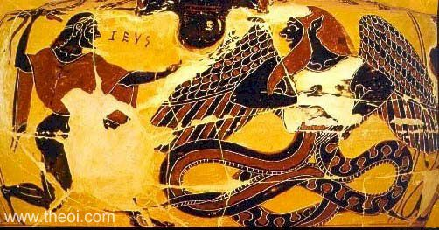
To get familiar with the stories and characters for this assignment, read your textbook on Typhoeus p.49. You may also consult the following links:
For Typhoeus: http://www.theoi.com/Gigante/Typhoeus.html
For Echidna: http://www.theoi.com/Ther/DrakainaEkhidna1.html
For Aegipan: http://www.theoi.com/Georgikos/Aigipan.html

SECTION 1: PRIMARY SOURCES
Written Sources: Answer the following questions providing answers taken from the indicated sources:
Read Hesiod’s Theogony, verses 820- 880:
- Why do you think Gaia decided to produce such a terrible monster?
A: It appears from the beginning of this passage that Typhoeus was created to reap revenge on the gods for imprisoning the rest of Gaia’s children (the titans). As seen at the beginning of the passage “When Zeus drove the Titans from Olympus,
monstrous Gaia bore her last child Typhoeus” (820-821)
- What sounds of all sorts did he emit?
A: Line 829-835 states that he makes all sorts of evil noises. He varies his voices, from a hiss, the cry of a bull, the cry of a lion, sounds of puppies, and a language that even the gods could understand.
- How was the fire produced by the monster?
A: 824-828 Make it evident that the fire this monster produces originates from the heads of the monster itself “From all the heads, as he looked, burned fire.”

- When Zeus confronted Typhoeus what were the consequences for Earth, Sky, Sea and Tartaros?
A: When Zeus finally cast Typhoeus into tartaros he released a great wind. This wind can never be stopped. It dwindles down but re appears and is devastating to sailors on sea, it also destroys many things created by man on the land.
- How did Zeus finally defeat Typhoeus?
A: Zeus finally defeated this monstrous creature, by setting fire to all of his heads with his lightning. This weakened the beast. Once the beast was wounded Zeus crippled him with flogging. Zeus finished him off with one big shot of fire and the beast was struck, and then casting him into tartaros.
- What kinds of winds come from Typhoeus?
A: When Typhoeus was cast into Tartaros he released a wind. A devastating wind that will never stop “there is no remedy for such evil” This wind will never stop. It torments sailors while at sea and it destroys monuments created by earth born men.
Read Apollodorus Library [1.6.3]:
- How does the description of Typhoeus by Apollodorus differ from that of Hesiod?
A: There are some similarities between both descriptions, such as the height, the serpent’s tail and the hissing noises. With that in mind, there are some major differences. For instance when describing Typhoeus Hesiod states that this monster has no head and that the heads of the dragons replace the head of his own. This is a difference in Appolodorus’ article. He states that Typhoeus has dragonheads instead of fingers and that they came right out of his hand. This brings another difference. In Hesiod’s’ article there is not mention of hair. This would be because he doesn’t have the head of a man and so he has no hair. But in Appolodorus states that this monster has long and un kept hair on his head and face. There is also no mention of wings in Hesiod’s article but in Appolodorus’ article his whole body is covered in wings
- According to that version of Apollodorus, Typhoeus initially defeated Zeus. What did the monster do to him?
A: Lines 12-20 of Apollodorus outlines this battle. After Zeus attempts to grapple the beast, Typhoeus turned the tables on Zeus and cut the sinews of the gods hands and feet. HE then proceeded to take Zeus through the sea stopping at a cave where he left the god. After this the beast hid the sinews and enlisted a half bestial she dragon to watch them.
- Who saved Zeus and how?
A: Hermes and Aegipan helped Zeus by stealing back the sinews from the she dragon and fixing them.

- The final battles between Zeus and Typhoeus took place on two mountains. What is the explanation of Mt Haemus’ name and what is the explanation about Mt Etna?. Compare that to Aeschylus’ Prometheus Bound, approximate lines[350]-[370]
A: The reason for the name of Mt Haemus is that during the battle had by Zeus and Typhoeus they were throwing mountains at each other but when one bounced back and hit the mountain a gush of blood came out thus giving it the name the bloody mountain or Mt Haemus. The explanation about Mt Etna is that Zeus hurled this mountain at the beast and as it was such a huge mountain it was a devastating blow and the beast was trapped under the mountain. Though Prometheus bound doesn’t say much about MT Haemus, it does say some things about Etna. The stories told by both are quite similar. Although Prometheus bound never says that Zeus threw the mountain it says that the beast is trapped under their. But it states that what killed him was a lightning shot right to the heart which differs from Apollodorus.
Several scholars mention another version of the myth where Olympians find refuge in Egypt and transform themselves to animals to avoid being detected by Typhoeus. Hyginus in his Astronomica connects that incident with the creation of the zodiac sign Capricorn. Read Astronomica 2:28 and
- Explain how the image of the sign that is used today fits into the myth.
- What is the explanation about the Egyptian gods according to Hyginus?
A: His explanation is that the gods fled to Egypt to escape the wrath of Typhoeus. When he followed them their the gods changed into animals. Therefore any of the animals that the gods changed themselves into cannot be killed as the Egyptians think they are representations of the gods.
Typhoeus has a powerful monster wife, Echidna: Read Theogony 295- 332;
- What is the appearance of Echidna?
A: Lines 295-230 state that she was a beautiful maiden on top with wonderful cheeks; on the bottom she was a disgustingly large serpent.
- What her monstrous children by Typhoeus?
A: Her first child is known as the grey ones dog. Her second was the fifty-headed dog of Hates named Kerberos. Lastly she birthed the Hydra.
- Where did she live? Where was this region imagined to be?
A: Echidna lived in a cave far bellow the earth far away from the Gods and the mortal men so she cannot harm or destroy anything. This is relevant through lines 301-303
- Homer in Iliad: Book 2 , around line [780] mentions the same place referring to Typhoeus’ lair. The reference to Typhoeus here is a simile. What does Homer compare?
A: Homer compares the ground rumbling as soldiers move out, to the sound that emerges when Zeus gets angry and strikes the group around Typhoeus.
Strabo the Geographer tries to give a more rational explanation about Typhoeus’ location: Read Geography XII, chapter 4, paragraph 11:
- What does Catacecaumene mean? (See note in the text) and what good think does it produce? Do you think that the specific conditions of the natural environment make it good?
A: This translates to the burnt country. The specific conditions of the natural environment sure make it appealing to creatures and beasts like Typhoeus. It produces the Catacecaumena vine, which makes some of the best wine. The specific conditions of this natural environment make the wine good because it is the soil that produces the vines, which make the wine. This is evident due to the fact that there is another place similar to this, which also makes amazing wines.
- This area is located in Mysia. Where is it? (You can certainly find it on the map in your textbook pp.13-14)
A: Mysia was located in the area that in western cultures is now know as turkey ( or at least close to their)
- What is Strabo’s logical explanation about Typhoeus?
A: He states that it is unreasonable to say that the land such as the one in question was all created by or because of Typhoeus but rather earth made fires. These fires no longer exist but are to blame for the lack of trees and the black fields that surround this area.

Visual source: See the image on p.1. Does the appearance of Typhoeus match with primary written sources that you have read?
A: This picture matches the primary source Apollodorus. As in this primary source it is described as having a human head with a beard that is vey un kept as well as being winged. These things are not the case in Hesiod’s source as he stated that beast has no head is it is replaced with many serpent heads. It also fails to mention the wings.

SECTION 2:
IMPACT OF THE MYTH(S) ON MODERN AND /OR POPULAR CULTURE
Give one example relevant to the theme of your assignment that shows the impact of a character or a myth on one of the following: art, science, literature, products or companies, mass media. It can be an example going back as far as the Renaissance period (around the 1500s) up to the present day. You should explain the connection and cite your source of information and provide an image

A: It has become relevant to me through the reading of these articles and excerpts that the character talked about in them deserve the mass media coverage that they have received today. Zeus, the Titans Hades, Heracles, all these characters have had a pretty large impact on the movie industry. Most of all Zeus conquering the Titans. Due to the heroic/ destructive deeds that these creatures and gods have done mass media can not keep their hands of these myths. This is evident through the 100s of Greek mythology movies that exist. Ranging from The Immortals, Wrath and Clash of the Titans, Hercules, all the way down to the created universe based on these myths that is Percy Jackson and the Olympians. With this in mind it is clear that Greek Myth does and will continue to have a powerful place within the movie industry due to its epic hero’s, demonic villains, and truly gripping tails.

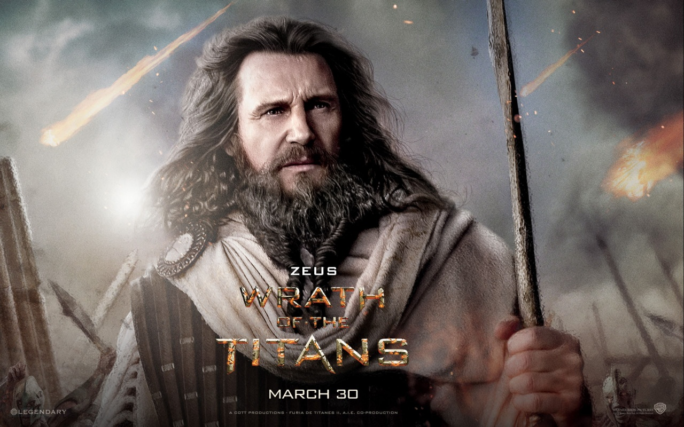

In this image you see how powerful Zeus is portrayed and how a very good actor in Liam Neison plays him. This shows that this character holds some merit in the industry.

http://www.3dwallpaperart.com/view/wrath_of_the_titans_zeus-1280x800.html: Image

Source Imdb: "Wrath of the Titans." IMDb. IMDb.com, 20 Mar. 2012. Web. 10 Feb. 2014. <http://www.imdb.com/title/tt1646987/>.

"Greek Mythology ." IMDb. IMDb.com, 10 June 2013. Web. 10 Feb. 2014.

<http://www.imdb.com/keyword/greek-mythology/?start=101>.

Ethics Agreement
Personal Ethics Agreement Concerning University Assignments
I submit this assignment and attest that I have applied all the appropriate rules of quotation and referencing in use at the University of Ottawa. I also confirm that I have taken knowledge of and respected the Says who? : Integrity in Writing: Avoiding Plagiarism at http://www.sass.uottawa.ca/writing/kit/plagiarism.pdf
I attest that this work conforms to the rules on academic integrity of the University of Ottawa.

Greg Taylor 6855628 2014-02-10
Name Student number Date

Simile: Figure of speech comparing two unlike things, usually introduced by “like” or “as”

