NATS1745 6.0 History of Astronomy Final Exam Review
Chapter 8

1) What was William Herschel looking for when he discovered Uranus? ‬‬‬‬‬‬
He was cataloguing stars to aid the search for stellar parallax
What made Herschel particularly suited for discovering planets?
He was an amateur astronomer who built the largest telescope of his time
In what 2 ways did Uranus reveal itself to Herschel as a planet?
i) He observed a star-like object, which increased in size when he increased his telescope magnification
ii) Shortly after, he observed it’s motion relative to the stars
What is it about Uranus' orbit that caused it to be considered a planet instead of a comet?
Further investigation revealed its near-circular orbit (84 years orbital periods). Comets have an elliptical orbit.
What is the origin of Uranus' name?‬
Greek god of the sky, father of Saturn, grandfather of Jupiter).

2) What did Kepler believe existed between the large space between Mars and ‬‬‬‬‬‬
Jupiter?
When Kepler observed the large gap between Mars and Jupiter, he proposed it contains an undiscovered planet
Explain why Bode's Law supported this idea.‬
Bode’s Law: the orbital radii of the 6 known planets follow a sequence of numbers. Bode’s sequences were very close to the actual distances. The number at 2.8AU at no corresponding planet, which falls within that gap which suggested that there might be an undiscovered planet.
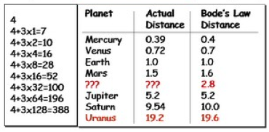

3) What is the name of the object found in 1801 between Mars and Jupiter? ‬‬‬‬‬‬
Ceres
What was this object finally classified as, and why?
Downgraded from a planet to asteroid when it was found to be smaller than the Moon (asteroid is Greek for star-like)
What is this object a part of?‬
Asteroid belt; This object is a part of the circular belt that contains hundreds of asteroids discovered between Mars and Jupiter.

4) What caused ‬Adams and Leverrier to suspect the existence of a planet beyond Uranus? ‬‬‬‬‬‬
Deviations were detected in the orbit of Uranus.
When this planet was found, what was it named, and why?
This planet was named Neptune (Roman Sea God), owing to its bluish colour.
5) How were the masses of Uranus and Neptune 1st measured? ‬‬‬‬‬‬
Kepler’s 3rd Law was applied to get the mass of whatever the moon was orbiting around.
How do their masses compare with the other planets?
Uranus’s mass is 15x Earth, and Neptune’s mass is 17x Earth’s; they are not nearly as massive as Jupiter or Saturn.
Based on the masses and sizes, what do we know about their densities and compositions?‬
They are light like Jupiter and Saturn and are low density and therefore, gaseous (Gas Giants).
We call them Ice Giants because a lot of their material is frozen. Their composition has a small rocky core; the rest of the planet is hydrogen gas and frozen based hydrogen based molecules.

6) What is today's theory for why all the planets in our solar system orbit the Sun in the same direction and in roughly the same plane? ‬‬‬‬‬‬
Current theory: after the Sun was born from a spinning, collapsing gas cloud, the remaining gaseous and rocky particles in the Sun's spinning circumstellar disk coalesced into planets
What is the observational evidence for this theory?‬
The proof: disks of matter have been found around newborn stars in star-forming nebulae

7) What is today's theory for the asteroid belt? ‬‬‬‬‬‬
The asteroid belt is likely the leftover debris from the Sun’s circumstellar disk that couldn’t coalesce into a planet due to the opposing gravitational pulls of the Sun and nearby giant Jupiter
What about planetary rings?‬
Planetary rings are likely the leftover debris from protoplantary (disk around a planet rather than a disk around a star) disks, which couldn’t coalesce into a moon

8) What 3 attributes are unique to the 4 planets beyond Mars? ‬‬‬‬‬‬
The 4 planets beyond Mars are all gas giants, have numerous moons, and all have rings
What is the current explanation for this?‬
The reasons: The outer circumstellar disk contained more material allowing the outer planets to collect more mass and to attract more debris into orbit as moons and rings.

9) Which planets are the terrestrial planets? ‬‬‬‬‬
The inner most planets (Mercury, Venus, Earth, and Mars)
What is the current explanation for their lack of gas?‬‬
The planet’s solid cores were likely the 1st to form. Since the outer planets grew faster, they had more gravity to draw in the gas particles, leaving the inner planets with much less gas

10) What is the current theory for the origin of Mars' two moons? ‬‬‬‬‬
The theory that they were once asteroids and they got pulled from the asteroid belt or they collided with something and got thrown outside of the asteroid belt and then head towards Mars and got caught in Mars’ gravity

What is the evidence to support this theory?‬‬
Both look like asteroids, and 1 is retrograde; they don’t spin counterclockwise

11) Why is it unusual for Earth to have such a large moon? ‬‬‬‬‬
Because Earth is an inner planet, and it was formed in the inner part of our solar system where there is not enough matter to make a moon
What is the current theory for the origin of Earth's moon?‬‬
The large size and composition of Earth’s 1 moon suggests that it came from a large Earth impact

12) What belief about Mars was popularized by Percival Lowell, and why? ‬‬‬‬‬
Lowell popularized the idea of intelligent life on Mars because he was an American businessman and astronomer, particularly interested in finding life on other planets
Was he right?‬‬
His theories were rejected after close up observations of Mars

13) Why was there suspected to be a planet beyond ‬Neptune?‬‬‬‬‬‬
An initial understatement of Neptune’s mass led to the theory that an additional planet is disturbing Uranus’ orbit

14) When ‬Lowell's predicted planet was finally detected, what was it named, who named it, and why did she choose this name?‬‬‬‬‬‬
The planet was named Pluto (Greek god of the Underworld) by a young girl from England; a dark and gloomy planet

15) Why did the discovery of Pluto turn out to be a coincidence?‬‬‬‬‬‬‬
The discovery of Charon (largest of Pluto’s 3 moons) revealed Pluto’s mass (.002 x Earth, too small to disturb Uranus). Pluto’s discovery was therefore a coincidence.

16) The discovery of what kind of objects motivated the IAU to define the conditions for being a planet? ‬‬‬‬‬
Hundreds of Kiuper Belt Objects (KBO’s) have been discovered, some larger than Pluto
Where are these objects?
These objects are a disk of icy debris around the planets, left over from the solar system's birth, beyond the orbit of Neptune; sometimes they are called trans-Neptunal object
What was the significance of the object now known as Eris?‬‬
Eris was found to be more massive than Pluto; it was first thought that Eris was named to be a 10th planet, but more of these Pluto like objects were found in the Kiuper Belt; it motivated our definition of a planet

17) What are the IAU's planet conditions? ‬‬‬‬‬
- It must be in solar orbit (excludes moons)
- It must be a sphere by its own gravity (excludes comets and some asteroids)
- It must have cleared the debris around its orbit (excludes all asteroids and KBOs)
Which condition(s) does Pluto fail?
#3 because Pluto is in the Kuiper belt and it is full of debris and it is part of that debris
What condition(s) do comets fail?
#2 (generally not spheres) and #3 (they come from a cloud of debris)
What condition(s) do asteroids fail?‬‬
#3 (they are in the asteroid belt and it is a region of debris), most asteroid fails #2 (some are round like Ceres)

18) What is Pluto now considered? ‬‬‬‬‬
Dwarf Planet
What are the condition(s) for this type of object?
#1 and #2
Is this type of object expected to be common in our solar system?‬‬
Currently there are 5 identified dwarf planets but nearly 2000 are expected to be out there
Chapter 9
1) Why did all attempts to detect stellar parallax fail until the 1830s?‬
Owing to the incorrect assumption that the brightest stars are he nearest stars

2) What did Halley announce about stars in the early 1700s? ‬‬‬‬
Halley compared ancient star catalogues with current star positions and found 3 moving stars
How did this discovery aid the detection of stellar parallax?‬
Repeated star cataloguing revealed increasing numbers of moving stars; this suggested that stars had their unique motion cross the sky; we can’t perceive it.

3) What is our nearest star, and how far away is it (approximately) in light years?‬
Alpha Centauri has a distance of 270k AU (4.4ly, or 1.3pc)

4) What is the definition of a light year?
The distance light travels in 1 year
What is the definition of a parsec? (NOTE: the specific values in km aren't necessary here).
The distance of an object with a parallax of 1 arcsecond
Which unit is bigger, and by approximately how much?‬
Parsec is bigger by ~ 3 ly

5) According to the wave theory of light, what are all light waves composed of?‬
Light waves are composed of oscillating electric and magnetic energy fields

6) Describe how a wave from a bright blue light source is different from a wave from a faint red light source.‬
Wavelength decreases from red to blue; blue light source is hottest (shorter wavelength and higher amplitude; red light source is coolest (long wavelength and low amplitude)

7) What colour of visible light is shortest in wavelength?
Violet
What colour of visible light is longest in wavelength?
Red
What colour of visible light has the lowest frequency?
Red
What colour of visible light has the most energy?‬
Violet

8) In the full spectrum of light, what kind of light is shortest in wavelength? ‬‬‬‬
Gamma Rays
What kind of light is longest in wavelength?
Radio waves
What kind of light has the most energy?‬
Gamma Rays

9) What is a spectroscope?‬
Pass sunlight through glass and observed the spectrum through a telescope

10) What is Fraunhofer’s Spectrum a spectrum of? ‬‬‬‬
It was a spectrum of sunlight he used to create ~ 600 think dark lines and labeled them with letters to designate their wavelength
What does it contain (ie., continuum emission, absorption lines, and/or emission lines)?‬
Absorption lines

11) Describe (briefly) how the chemical composition of a star can be determined.‬
You match up it’s absorption lines with emission lines of own chemicals and that tells you what chemicals are in its atmosphere

12) What did Bunsen and Kirchhoff observe in the spectrum of sunlight combined with a gas flame?
They found the darker lines got thicker
What was their correct explanation for this, and what did it cause them to predict about the Sun?
They concluded, the Sun’s core, which produces the full spectrum of light, is surrounded by a gas layer (an atmosphere). Molecules in the Sun’s atmosphere absorb light at their signature wavelengths, producing the dark lines (“absorption lines”)
How was their prediction proven in the 1860s?‬
During the solar eclipse, the spectrum of the Sun’s atmosphere was produced, revealing the “emission lines” predicted by B & K
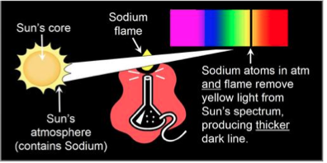
13) How did the element Helium get its name?‬‬‬‬‬
Lockyer discovered a new emission line in the Sun’s atmosphere and named it “Helium” (Helios = Greek god of the Sun)

14) In a graphical spectrum, what do emission lines appear as? ‬‬‬
Peaks are emission lines
What do absorption lines appear as?‬‬
Dips are absorption lines
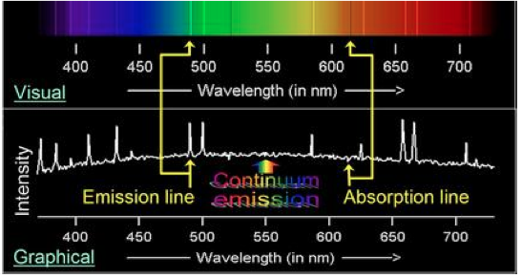
15) What does the spectrum of a star contain (ie., continuum emission, absorption lines, and/or emission lines)? ‬‬‬
Star – absorption lines and has continuum emission lines
How about the spectra of a gas cloud, a star cluster, and a gas/star system?‬‬
Gas cloud - emission-line nebulae
Star cluster – continuum emission and absorption-lines
Gas and Star systems - Continuum emission line (from stars) and absorption-line
(from stars) and emission lines (from gas cloud)

16) Why was the element Oxygen originally named "Nebulium"?‬‬‬‬‬
Huggins produced the spectrum of a planetary nebula. It contained unidentified emission lines. The lines were named Nubulium
17) What does the spectrum of a planetary nebula (gas cloud; expanding gas from a dying star) contain (ie., continuum emission, absorption lines, and/or emission lines)? ‬‬‬
Emission lines
When Huggins discovered this, what did it prove about planetary nebulae (ie., what are they made of)?‬‬
Proved that it is a gas cloud (oxygen)

18) What is radial motion? ‬‬‬
The approaching or receding motion
How does it effect light waves?
If I am giving out light waves as I move towards you, the light waves are going to get compressed, as I move away from you the light waves are going to get stretched
What is the name of this effect?‬‬
Dopler Effect

19) How does a light source's spectral lines reveal that the spectrum is redshifted? ‬‬‬
A stretched wave and moves to the red side
How about blueshifted?
A compressed wave and move to the blue side
If a spectrum is redshifted, what does this tell us about the motion of the light source?
The object is moving away from us
How about if the spectrum is blueshifted?‬‬
The object is moving towards us

20) What is astrophotography? ‬‬‬
The production of long exposure sky photos using a camera attached to a telescope
Why does it allow us to see deeper into space than with the eye and telescope alone?
With a camera you can take long exposure photos and capture more light than with your eye
Who was one of the pioneers of this?
Henry Draper
What sort of survey did he conduct?‬‬
Photogenic spectroscopic survey of all visible stars

21) What were the members of "‬Pickering's Harem" hired to do?‬‬‬‬
Pickering hired a team of women to complete the Henry Draper Catalogue of spectra of over 225,000 stars

22) What property of stars was used to place the spectral types in their original alphabetical order? ‬‬‬
By the strength of their Hydrogen lines
What property of stars was used to re-arrange their order into their current order (O-B-A-F-G-K-M)?‬‬
Re-ordered the special types from blue to red (hottest to coldest)

23) What do we know about the chemical composition of the reddest stars, due to their numerous spectral lines?‬‬‬‬‬
The reddest stars (K, M) have more metals than other special types

24) If a star has a spectral type of B8, which type of star is it more similar to, O or A?‬‬‬‬‬
A
Each spectral type was subdivided into 10 sub-types from 0 to 9 (i.e. O0, O1, … O9, B0, B1, … B9, A0, …)

25) What is a photon?‬‬‬‬‬
A photon is a particle of light (another way of representing light, like the wave)

26) According to the Bohr model of the atom, what are the 3 components of an atom? ‬‬‬
Proton, Neutron, and Electron
What determines an atom's chemical element?
‬‬The number of protons determines an atom’s number of electrons and its chemical element; 1p1e = Hydrogen, 2p2e = Helium, etc.

27) Explain (briefly) what causes atoms to produce absorption lines. ‬‬‬
When an e- absorbs a photon with the exact E (or photon λ) it needs to get excited, e- jumps to a higher shell, causing an absorption line

What about emission lines?‬‬
When an excited e- drops down a shell, it emits a photon with the exact E (or lambda λ) to return to ground state, causing an emission line

28) What unusual discovery did Cecilia Payne make about the chemical composition of stars?‬‬‬‬‬
All stars are predominately composed of H (and He)

29) Describe how Eddington proved one of the predictions of Einstein's General Relativity theory (gravity is created by the curvature of space).‬‬‬‬‬
By observing that when light rays pass near the Sun, their path is bent by the curved space around the Sun

30) What was Eddington and Bethe's correct explanation for the energy source of stars? ‬‬‬
The energy from stars is produced from the fusion of Hydrogen nuclei into Helium at high temperatures (i.e. nuclear fusion)
Why does this process release energy?
For nuclear fusion process from Hydrogen to Helium: 4H = 1He + Energy (since mass_{4H}>mass_{1He}) where the energy (E=mc²) is in the form of gamm-waves
How does it explain why stars produce so much energy?
H-atoms are plentiful in stars
How does it explain the existence of Helium in stars?
Helium is the product of fusion of hydrogen and that’s why stars have helium
How does it explain the full spectrum of light that we receive from stars?
The gamma rays downgrade to other λs as they interact with atoms in the stars
How does it explain the long lifetimes of stars?‬‬
The initial fusion reaction of Hydrogen takes a billion years

31) At what rate does light dim with distance?‬‬‬‬‬
Light dims with distance according to the inverse-square law (i.e. the amount of light we receive from a source is 1/d² of its actual light production)
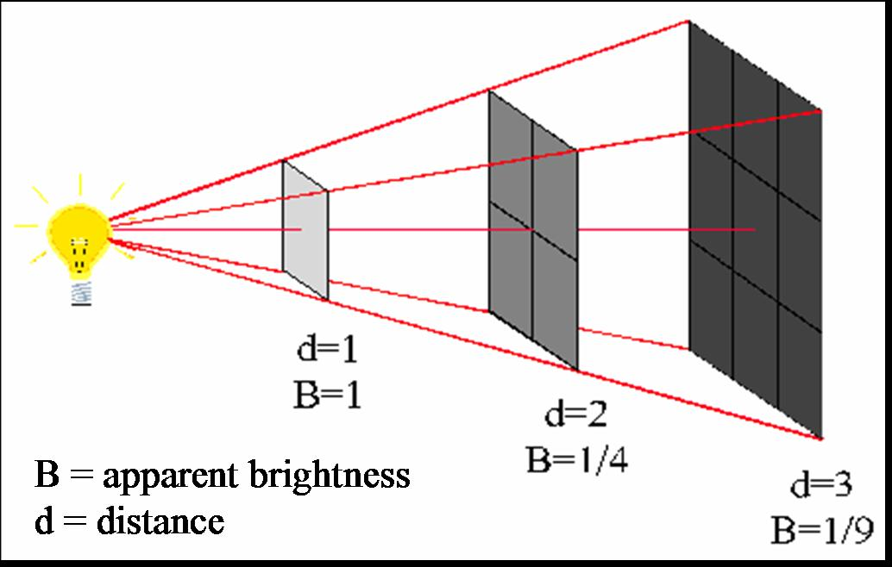

32) What is the difference between the apparent brightness and the intrinsic brightness of a light source?‬‬‬‬‬
Apparent brightness: the brightness of a light source as it appears from Earth (depends on distance)
- ex. if something is far away the apparent brightness is going to be dim
Intrinsic brightness: the total amount of light produced by the light source (the true power of light source), does not depend on distance
- a star’s true power is its true power no matter where it is relative to us

33) Which appears brighter, a star with an apparent magnitude of 2 or a star with an apparent magnitude of -2?‬‬‬‬‬
-2

34) For a group of stars in the same star cluster (i.e. at the same distance from Earth), how can we tell which stars are the most luminous?‬‬‬‬‬
The stars that look the brightest, have the brightest apparent magnitude are in fact truly the most luminous.
Same as the stars that look the dimmest are the least powerful, truly the least luminous

35) What relationship among Main Sequence stars was found by Hertzsprung & Russell in the 1910s? ‬‬‬
Hertzsprung: found that the luminosity of cluster stars depends on their spectral type (O stars are most luminous, M stars least luminous).
Russell: found the same relationship between luminosity and spectral type among non-cluster stars with parallax distances
What two kinds of stars were found to not follow this relationship?‬‬
Red Giants and White Dwarfs (they don’t follow the diagonal trend)

36) What is the spectral type of the Sun?‬‬‬‬‬
G2V
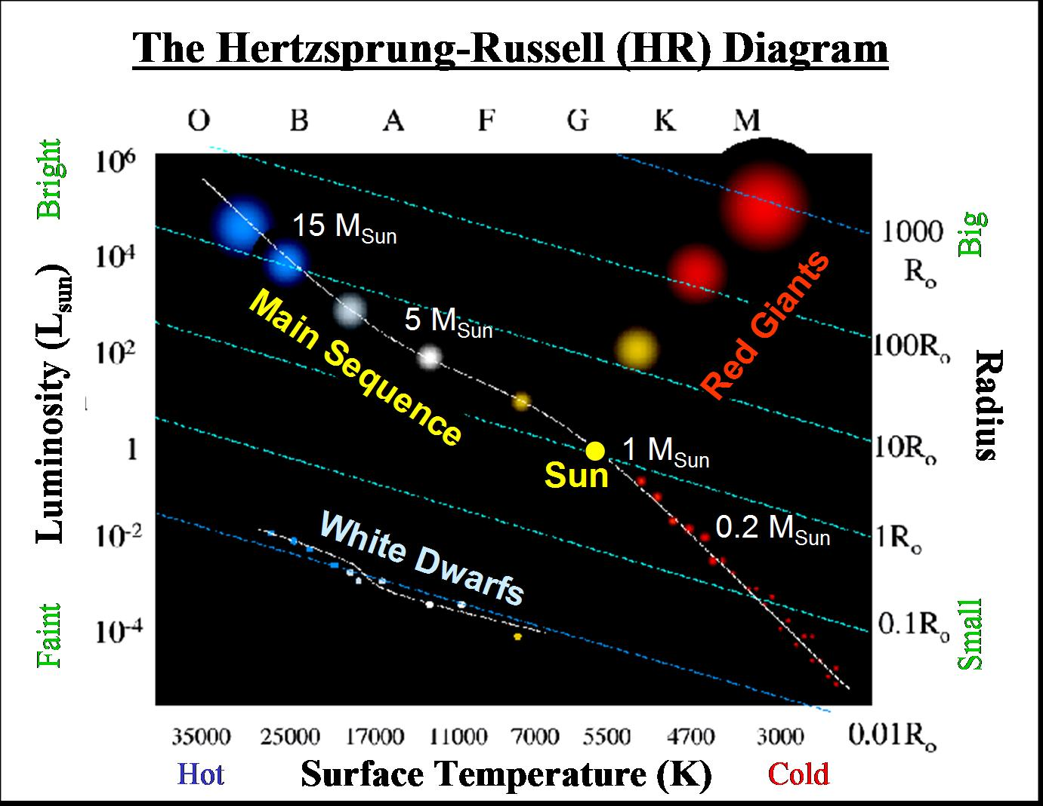
37) Using the HR diagram, compare the luminosity, temperature, colour, and size of Red Giants to the Sun.‬‬‬‬‬
Luminosity - Red Giants are more luminous than the Sun
Temperature - Red Giants are cooler than the sun
Color - Red Giants are orange to red in color meanwhile the sun is yellow Size - Red Giants are larger than the sun

38) Describe the mass and size of a White Dwarf. ‬‬‬
Mass ~1M_{Sun} packed into a radius of ~1R_{Earth}
Using the HR diagram, compare their luminosity, temperature, and colour to the Sun.‬‬
Luminosity - sun has higher luminosity than white dwarfs
Temperature - White dwarfs are hotter than the sun
Color - White dwarfs are light blue to white color meanwhile sun is yellow
*Exam you will see an HR diagram – it’s going to have the axis drawn in and main sequence line but it won’t have location of the red giants and white dwarfs and so you are going to be asked questions such as O stars compared to M stars and how red giants compared to the sun for example. Remember where the white dwarf and red giants are***
39) What relationship among Main Sequence stars was found by Eddington in the 1920s? ‬‬‬
Eddington showed, for Main Sequence (MS) stars:
i) The more luminous a star, the higher its mass (the more fuel it has the brighter it is going to appear)
ii) Typical star masses are from 0.1-30 Msun
What 2 things did this discovery tell us about the Sun?‬‬
Therefore the Sun is a low-mass star and is the most common kind of star

40) Compare the luminosity, temperature, colour, size and mass of a Main Sequence O star to a Main Sequence M star.‬‬‬‬‬
Luminosity - the O stars is the most luminous, gets dimmer towards M star
Mass - the O star is the heaviest and gets lighter as it approaches the M star Colour - O star is blue and to M star it is red
Temperature - O star is the hottest and it gets cooler towards M star
Size - O star is the largest and as it gets smaller as it approaches M star

41) What determines a star's spectral type on the Main Sequence? ‬‬‬
its birth mass determines its spectral type and post-MS fate, stars with a lot of mas becomes O or B stars, stars that are born with smaller mass are G,K,M stars
How do we know that a star's Main Sequence spectral type can't change?‬‬
It violates the conservation of mass and energy
For a M star to evolve into an O star the star would have to gain both mass and luminosity. This isn’t possible – a gain of one means a loss of another. (e.g.lifting weights causes you to lose mass but never to gain mass. Same with eating – causes you gain mass but not to lose mass)

42) What was Hoyle's correct explanation for the existence of elements heavier than Helium in stars? ‬‬‬
Stellar nucleosynthesis (i.e. the creation of heavier elements from existing atom)
How do these elements get on to planets like ours?‬‬
When stars die, they eject their heavy elements into the interstellar medium. Gas clouds in the chemically-enriched medium eventually collapse into new stars and planets.
43) How do we know that our solar system must have come from the ejecta of other stars?‬‬‬‬‬
Since our solar system contains elements higher than helium, it contains a lot of Carbon and other elements

44) When a star is on the Main Sequence, what allows its properties to remain stable?‬
In a Main Sequence (MS) star, its inward gravitational pressure (GP) balances outward radiation pressure (RP) from nuclear fusion. If it doesn’t change and remains balanced it will not change and stay on the main sequence.
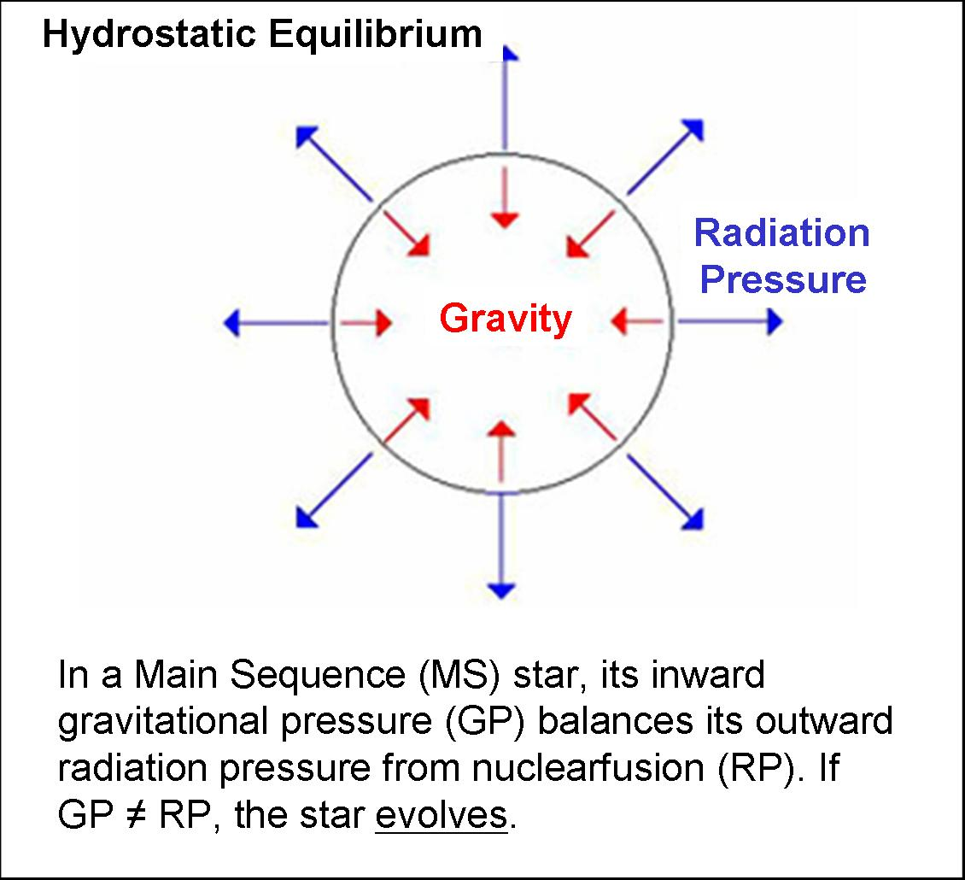
45) What causes stars to leave the Main Sequence?‬‬‬‬‬
While MS stars are fusing H to He, GP = RP. This continues until H runs out, causing stars to leave the
Main Sequence (GP will not equal RP = star evolves)

46) Why do we find more low-mass Main Sequence stars than high-mass ones?‬‬‬‬‬
The H-fusion phase is shorter in the high-mass stars, as fusion is faster at higher temperatures. Once it finishes fusing its hydrogen, it leaves the MS. High mass stars leave the MS first and this leaves more low-mass stars on the MS
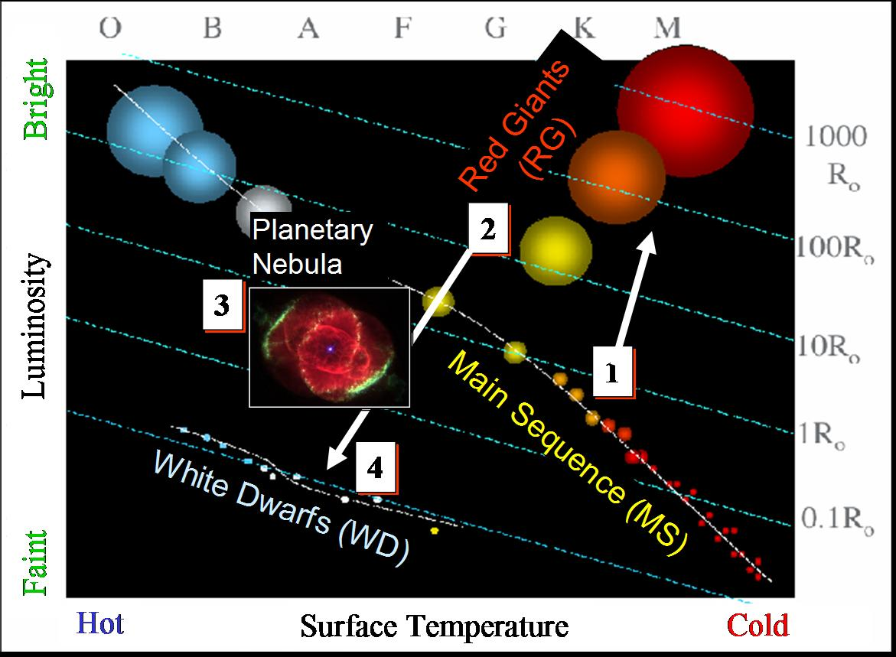
47) Describe what will happen to our Sun from the time it leaves the Main Sequence to its ultimate corpse. Include how its luminosity, temperature, colour and size will change as it evolves, and how these changes are due to the shifting in the balance between gravity and radiation pressure.‬‬‬‬‬

1) They are main sequence star
2) They expand into red giants
- If the star is changing in size, one of the forces of RP or GP has broken the balance. When H runs out, the sun will fuse its He. He-fusion produces more energy, which causes RP>GP. The star expands, brightens cools and reddens into a Red Giant.
3) Then they eject their outer layers into a planetary nebulae
4) Then their remaining mass collapses at the core into a white dwarf
When He runs out, low mass stars are too cold to fuse He-products. This causes RP<GP. The core shrinks into a dense, hot, low-luminosity corpse (a White Dwarf), while the outer layers shed into a Planetary Nebula
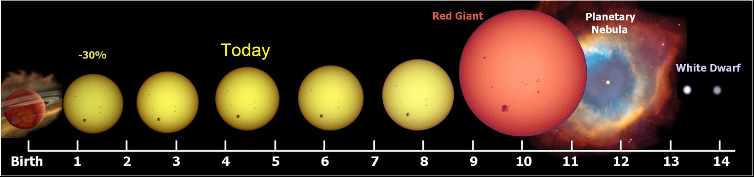
48) What kinds of stars are able to fuse elements heavier than Helium, and why?‬‬‬‬‬
High mass stars at the end of their life would fuse elements heavier than helium, because they are hot enough and the hotter it is the heavier the element that the star can fuse

49) Describe what will happen to an O-star from the time it leaves the Main Sequence to its ultimate corpse. Include how its luminosity, temperature, colour and size will change as it evolves, and how these changes are due to the shifting in the balance between gravity and radiation pressure.‬‬‬‬‬
1) You got a high mass star on the main sequence
2) It expands into a red giant
When H runs out, star fuses its He. He-fusion produces more energy, which causes RP>GP. The
star expands, brightens cools and reddens into a Red Giant
3) Then a supernova happens
Eventually it runs out of fuel, RP<< GP (RP goes way down) and gravity has won its battle and so the star collapses really quickly and in the process it ejects its outer layer of gas in a quick explosion called a supernova
4) The remaining high-mass core collapses into there's no space between neutrons (a neutron star).
- These stars have masses between 1-2M_{sun} packed into 20-50km! (much denser than white dwarf)
5) Cores with masses greater than ~2M_{Sun} (extremely massive stars) collapses further into black hole (no light can escape their gravity)

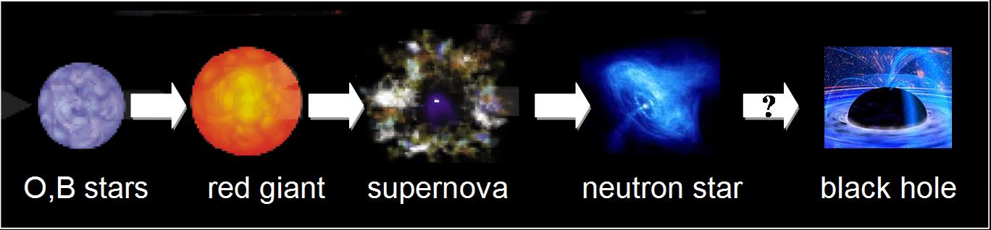
Chapter 10
1) What is the "Island Universe" theory?‬
Elliptical (a circle viewed at an angle) nebulae are disked-shaped star systems, and that we line in one such system

2) Why did the Ancient Greeks use the word "galaxy" to describe the bright strip of light across the sky?
Galaxy means milk in greek. It was given this name due to its milky appearance
What do we call this strip of light today?
Milky Way
What part of our galaxy does this strip represent?‬
Our view through the disk’s length

3) What did William, Caroline and John Herschel produce together?
Used their giant telescope to catalogue over 5000 nebulae
What was Herschel attempting to prove from this research?
The attempted to identify whether nebular are distant star systems or nearly glowing gas clouds
Why was he not able to prove this?‬
Owing to the large variety of nebulae, he could not come to a general conclusion about their composition

4) What did Herschel's map of the visible stars reveal about the shape of our galaxy?‬
Revealed our disk shaped system

5) What did Lord Rosse discover when he looked at the elliptical-shaped nebulae through his Leviathan telescope?‬‬‬
Many elliptical nebulae are spiral nebulae

6) What is a variable star? ‬‬
Stars which fluctuate in brightness at regular time intervals
What characterizes the Cepheid variables? Explain briefly why Cepheids pulsate.‬
Cepheid: luminous variable stars which pulsate rapidly (at intervals of days to weeks) and has highly opaque surface (its outward photons push surface outwards, which temporarily expands star and reduces its opacity)

7) What are the SMC and LMC? ‬‬
SMC is the Small Magellanic Cloud and LMC is the Large Magellanic Clouds (they are galaxies).
What did Henrietta Leavitt discover when she observed Cepheids in the SMC?
The brighter the Cepheid, the longer its period (of pulsating)
Why was this discovery so valuable?
By constructing the period-luminosity relation for Cephieds with known distances, a measurement of a Cepheid’s period, reveals its luminosity (and therefor its distance)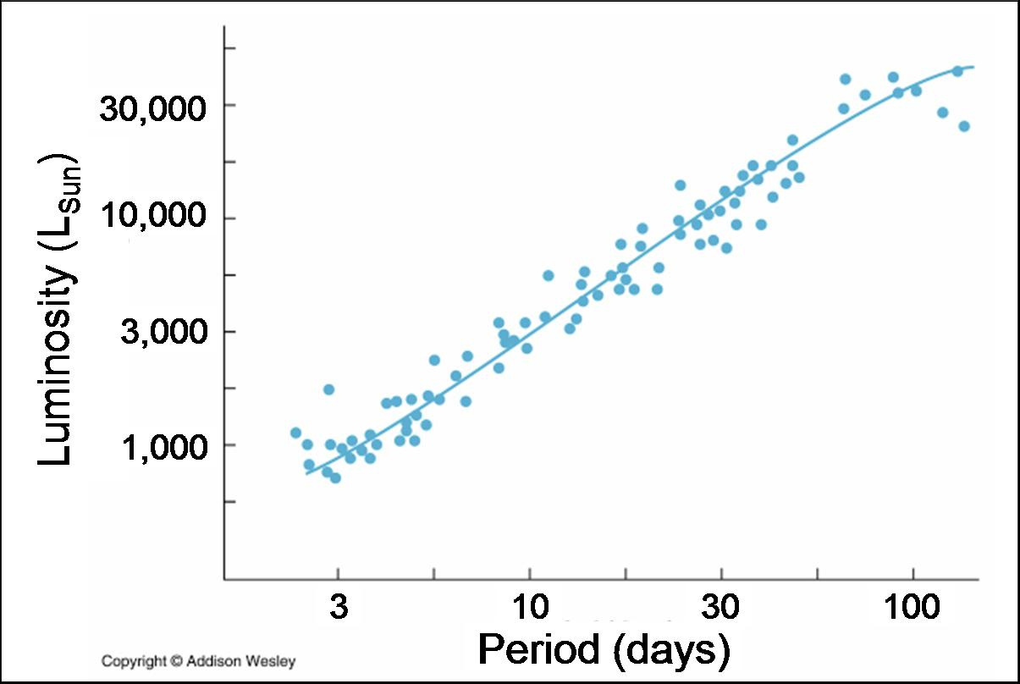
Who used her discovery to determine the boundaries of our galaxy?‬
Harlow Shapley

8) What are the 3 components of our galaxy, according to Shapley's model? ‬‬
a) its disk is 300 00 ly in diameter, this implies all nebulae are systems within our galaxy (SMC is in our galaxy)
b)our sun reside in the outskirts of its disk
c) the milky way is in sagittarus
Where is the Sun located in this model?
At the origin
Where is the Galaxy's centre?
16 kpc on x-axis
In what 2 ways is this model incorrect?‬
He was wrong about where the spiral resided and the size of the disk (he estimated it was three times bigger).
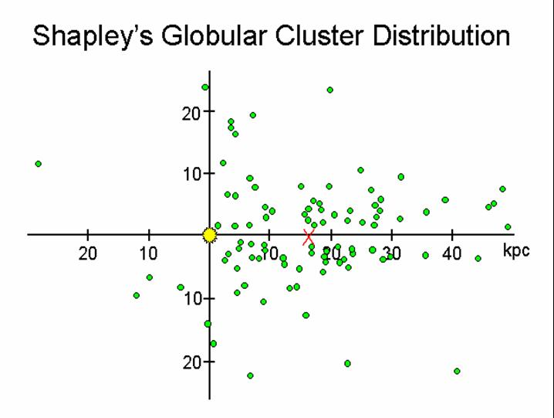
9) Why was Shapley convinced that the spiral nebulae are within our galaxy's boundaries?‬‬‬
Maps of spiral nebulae revealed spirals aren’t seen near the Milky Way disk
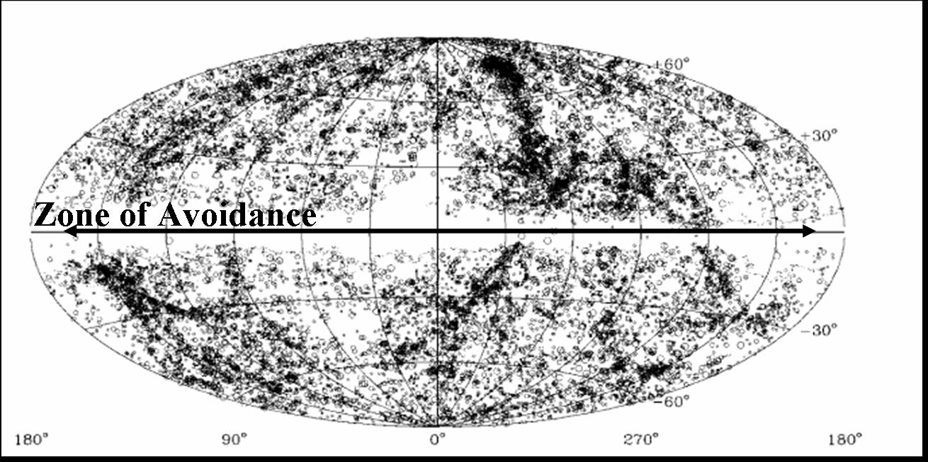
10) What is the Zone of Avoidance?
Spirals are pushed from our disk by radiation pressure form its high density of stars, creating a Zone of Avoidance. Therefore, the spiral are within our galaxy.
What was Shapley's explanation for it?
Since the disk is a very dense measure of stars, perhaps all the stars combined energy output, radiation pressure is pushing the spirals away from the disk.
What was Curtis'?
Curtis said: If the Milky Way’s disk contains a band of dust, and if the spirals are outside our Galaxy, they aren’t seen in the “Zone of Avoidance” because our vision is obscured by the dust.
Who was correct?‬
Curtis

11) What observation led Curtis to suspect that the disks of galaxies are filled with interstellar dust?
Completed a high-resolution survey of spiral nebulae, which revealed DUST in their disks
Where does this dust come from?‬
Our Galaxy’s disk filled with microscopic metallic grains (from dying stars) which absorb sunlight

12) What did Vesto Slipher observe about the spectra of spirals?‬‬‬
Slipher measured large redshift in the absorption lines of spiral, suggesting recessional speeds as high as 1000 of km/secs.
13) In the Shapley-Curtis Debate, what did Shapley argue? ‬‬
spirals are pushed from our disk by radiation pressure from its high density of stars, creating a ZONE OF AVOIDANCE. Therefore, the spirals are WITHIN our galaxy. HE ARGUED AGAINST ISLAND UNIVERSE.
What did Curtis argue?
Curtis argued if spirals are moving faster than stars in our Galaxy, the spirals must be OUTSIDE our galaxy. CURTIS ARGUED FOR ISLAND UNIVERSE
What 4 pieces of evidence did Curtis present?‬
1) Spiral radial velocities are larger than star velocities
2) Spiral spectra are indicative of star systems
3) Faintness of what appear to be novae in spirals suggest they’re distant star systems
4) Spirals show evidence of obscuring matter in their disks; If Milky Way is such a spiral, this explains Zone avoidance

14) Who finally resolved the Shapley-Curtis debate?
Edwin Hubble
Explain how he did this.
Found a Cepheid in M31, with the PL-relation he found a distance to M31 of 1 million light years. And this proved the spirals are galaxies beyond the Milky Way
What was NASA's tribute to this discovery?‬
The Hubble Space Telescope was launched into Earth-orbit

15) Describe (briefly) the 4 types of galaxies in Hubble's Classification system (a system in which galaxies are classified by their appearance)? ‬‬
- Spiral (S): a flattened disk containing spiral structure and possibly a central bulge, MILKY WAY
-Lenticular (S0): a flattened disk and possibly a central bulge, but no spiral structure -Ellipticals (E): an elongated spheroid, produced by mergers of equal-mass SPIRAL GALAXIES
-Irregular (I): small dwarf irregulars are the most numerous type of galaxy in the Universe and the building blocks of larger galaxies, GALAXY WITH NO UNIFORM STRUCTURE
Which are the most numerous?
irregular
Which are the least numerous?
ellipticals
What are the two types of spiral galaxies?
Barred Spiral and Spiral (Milky Way)
What type of galaxy is the Milky Way?‬
Spiral

16) What is the Local Group?
Contains ~30 galaxies dominated by 2 large “cannibalizing” spirals (The Milky Way and M31)
How does the size of the Milky Way and M31 compare to other galaxies in the Local Group?
The two biggest
How did the Milky Way and M31 get this way?‬
The big galaxies are cannibal galaxy (consumes other galaxies)

17) What is the Local Supercluster?‬
cluster of galaxy clusters (local group is apart of it)

18) What is Hubble's Law?
Larger a galaxy’s redshift ( or recessional velocity), the further its distance
What does the slope of Hubble's Law tell us?
Rate of universe expansion
What does the inverse of the slope tell us?‬
The age of the universe

19) Prior to the discovery of Hubble's Law, who had found theoretically that the Universe is expanding?‬‬‬
Einsten

20) Describe what Einstein referred to as the "biggest blunder" of his career.‬‬‬
When Hubble showed the Universe is expanding, Einstein called his constant “the biggest blunder of my career”

21) Describe the 4 possible fates of the Universe according to Einstein's cosmological equation, including the density and Cosmological Constant associated with each fate.‬‬‬
1) Big Chill/Rip = universe will expand at an accelerating rate forever, RIP: hubble’s constant increase (p=p_{crit} and Λ=0)
2) Big Chill =Universe will expand forever, hubble’s constant eventually remains constant( p>p_{crit} and Λ=0)
3) Big Freeze = Universe’s expansion will eventually half, hubble’s constant decreases to zero (p<p_{crit} and Λ=0)
4) Big Crunch = Universe’s expansion will halt and contract, hubble's constant decrease. (p<=p_{crit} and Λ>0)

p= density of the universe
p_{crit}= critical density required for gravity to halt the initial expansion momentum
Λ=cosmological constant

22) What is the Big Bang theory? ‬‬
The universe began from a single point and is expanding with time, decreasing in density
What is the Steady State theory?
The density of the universe is constant; as galaxies recede from each other, new galaxies take their place
What is the Steady State explanation for Hubble's Law?‬
Predicts that galaxy spacing has remained constant
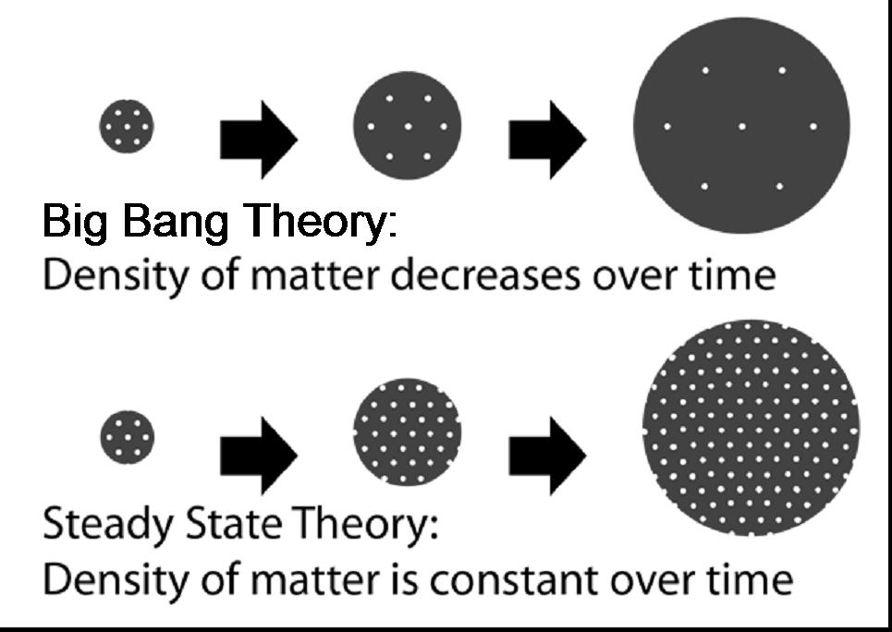

23) Describe the 2 pieces of observational evidence for the Big Bang.‬‬‬
a) 1950: radio surveys of the most distant galaxies revealed that they’re closer together than the nearby galaxies. Predicts 400,000 years after Big Bang, matter & light separated. The matter formed galaxies, while the light formed an expanding shell of radiation around the matter
b) 1960: It was theorized that Big Bang radiation has expanded to microwaves. Shortly after, the all sky microwaves were detected

24) Describe the observational evidence that the expansion of the Universe is accelerating. ‬‬
A survey of extragalactic supernovae was used to measure distances to the most distant galaxies in order to determine the rate of Universe’s expansion in the past
the results: Hubble’s Constant was LOWER in the past, therefore the Universe is expanding at an ACCELERATING rate, toward a Big Rip or Big Chill
What does this tell us about Hubble’s Constant?‬
It was lower in the past

25) What does a map of the CMB give us a picture of, and why?‬‬‬
WMAP satellite mapped CMB in high-res, revealing distribution of matter 400, 000 yrs after Big Bang. All sky-microwaves detected (CMB)

26.) What did WMAP tell us about the composition of the Universe? ‬‬
Size of CMB fluctuations correspond to density equal to critical density with normal matter comprising 27% of Universe (4% we can see and rest is “dark matter” = 73%)
What effect is "dark energy" believed to be having on the Universe?
Effect dark energy has on Universe is it’s responsible for Universe’s accelerated expansion
How is dark energy now accounted for in Einstein's cosmology equation?‬
Dark energy is represented by Einstein's "cosmological constant" in his equation

27) Describe the ways that dark matter has been detected in galaxies and in intracluster space.‬‬‬
a) Outer stars in galaxies rotate faster than predicted by galaxy’s visible mass, suggesting presence of intergalactic DM
b) Gravitational lensing of background galaxies suggests presence of dark matter in galaxy halos as well as in INTRACLUSTER dark matter

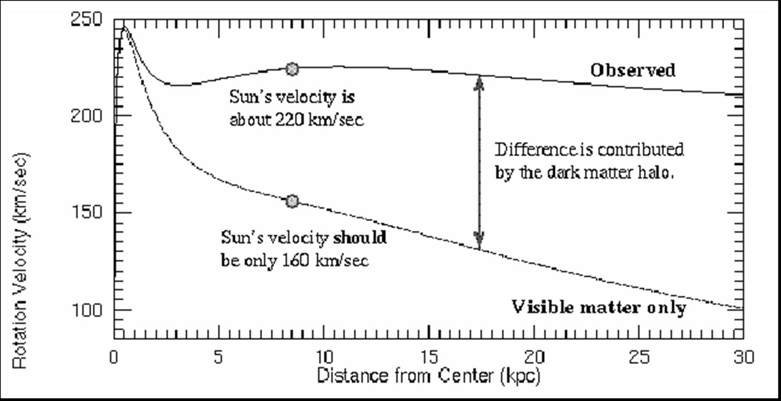

Chapter 11

1) What are the advantages of radio astronomy compared to visible-light astronomy?
a) can be detected on Earth both night and day (not overwhelmed by sunlight) because the sun produced so little radio emission that radio waves from space can easily be detected over the sun’s radio light
as well as through clouds because radio waves are so long and so much space between their wave peaks, they are completely impervious to the molecules in clouds, they just blast past them like they are not even there
b) easily detected with ground-level telescopes (they completely penetrate Earth’s atmosphere) because they are so long, they have no trouble penetrating the earth’s atmosphere
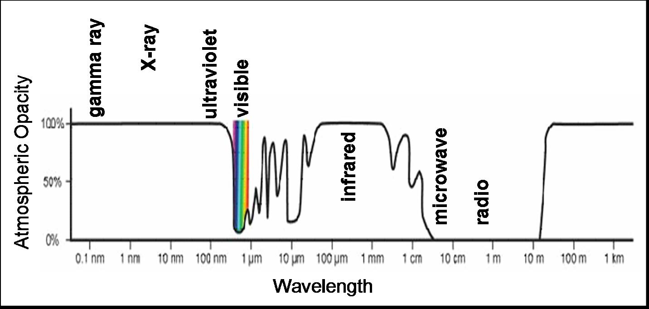
c) reflect off most metallic surfaces
d) not absorbed by interstellar dust because they are impervious to interstellar dust; zips right past it when encounters a dust particle
e) strongly emitted by distant (young) galaxies, allowing us to observe galaxies as they appeared in the distant past
Make sure that you understand *why* radio waves have each of these advantages.

2) Who was the 1st person to detect radio emission from space?
Karl Jansky
Where was this emission coming from?
Jansky concluded that the radiation was coming from the Milky Way and was strongest in the direction of the center the galaxy, in the constellation of Sagittarius.
How did he know this?
The rising and falling of the hiss every 24 hours is due to the fact that the center of the Milky Way rises and sets each day due to the Earth’s daily motion.

3) When Grote Reber mapped out the radio emission from the Milky Way, what did he find?
Was able to identify a few discrete radio sources. The map showed difference between discrete radio source and the galactic hiss. The map revealed that there was a broad radio peak on the right surrounded by gradual contours. To the left of Sagittarius are two smaller peaks that indicate of other sources of radio emissions at those specific coordinates.
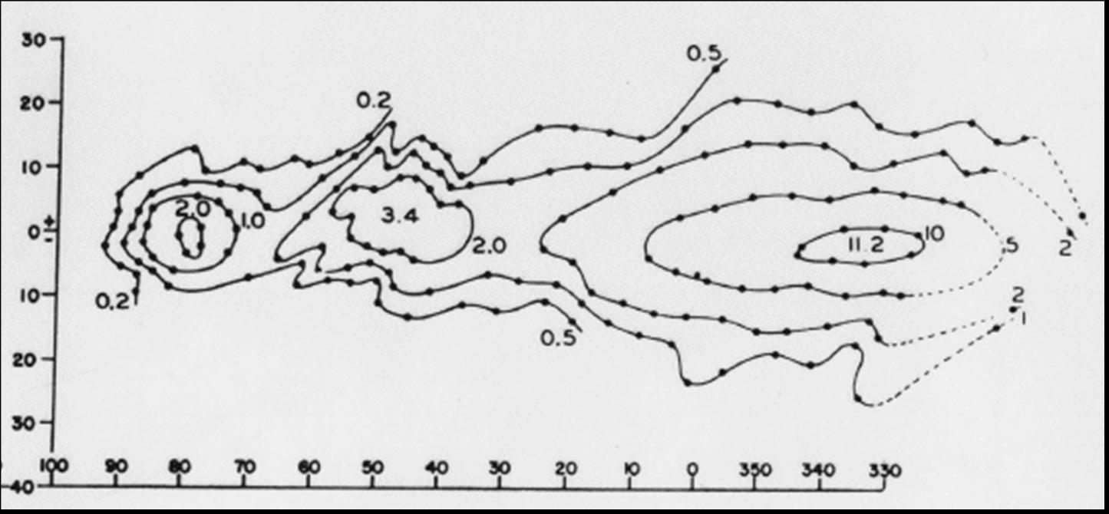

4) Describe the process that is producing the 21-cm radio emission in our galaxy.
In a hydrogen atom, when the magnetic poles of the proton and electron are aligned, the electron eventually flips over. Since the flipped-over state is lower in energy, the electron emits a photon with energy equal to the energy difference between the two states. The hydrogen atoms naturally emit a 21-cm radio wave when their electron flips over.

5) What did maps of the 21-cm radio emission in our galaxy reveal about the structure of our galaxy?
Revealing its interstellar H-gas and spiral structure
Interstellar space in our galaxy is filled with hydrogen. Our galaxy contains 4 well-defined spiral arms. We can’t see the spiral arms on the other side of the galaxy due to the shadow of the Galantic center. Proof that we are a spiral galaxy.
Where is the Sun located in this structure?
Resides around the arc

6) What did Stanley Hey identify as the source of the radio emission that was interfering with British radar during WWII?
Interfered by large surges of radio emission from solar flares (eruptions of radiation which trace out magnetic field lines from sunspots)

7) What are solar flares?
Eruptions of radiation which trace out magnetic field lines from sunspots

8) Describe how the Sun spins.
It spins differentially from earth; its rotation speed decreases with latitude. Rotates around its own axis. Takes between 25-35 days to complete one rotation. Its atoms don’t all spin together. Regions close to the equator spin quickly, while regions near poles spin slowly – differential rotation. Spinning sphere of metal.
How has this effected the Sun's magnetic field.
Its magnetic field is not a simple bar magnet, but a complex field which twists and untwists
Horizontal slices all spinning at different speeds due to differential rotation. Therefore, each slice has its own bar magnet, magnetic field of different strengths. Equatorial slice is strongest because rotation is fastest there. Slice at the poles is weakest in magnetic field strength. The magnetic lines will get skewed over time.
What happens to the Sun's magnetic field every 11 years as a result?
They untwist every 11 years. This causes the frequency of sunspots and flares to increase every 11 years.
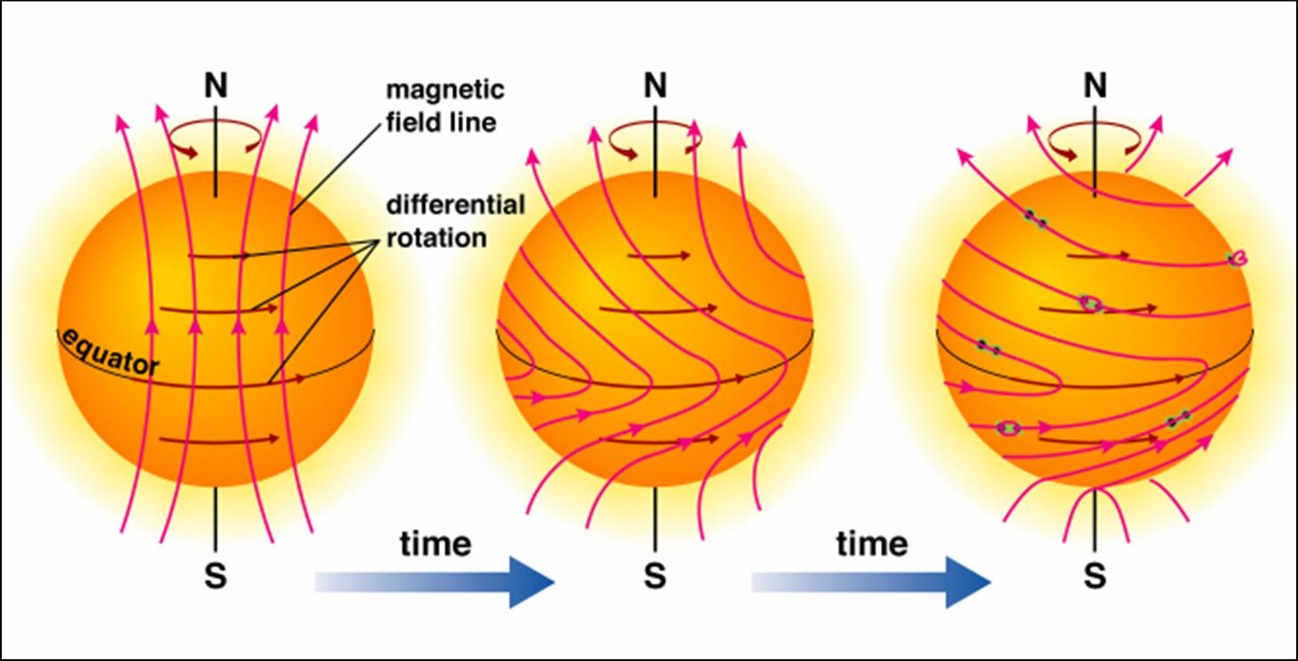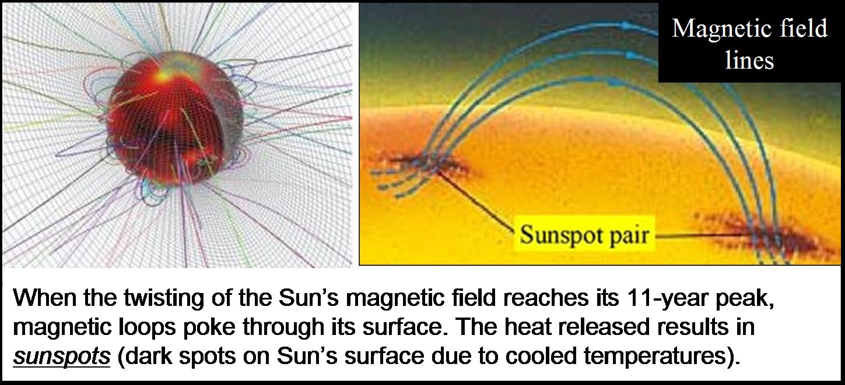
9) What causes magnetic storms on Earth?
Due to the winds of charged particles produced by sunspots. Magnetic storms – sudden scrambling of the magnetic fields. Caused by the distortion of Earth’s magnetic field by solar winds of charged particles.
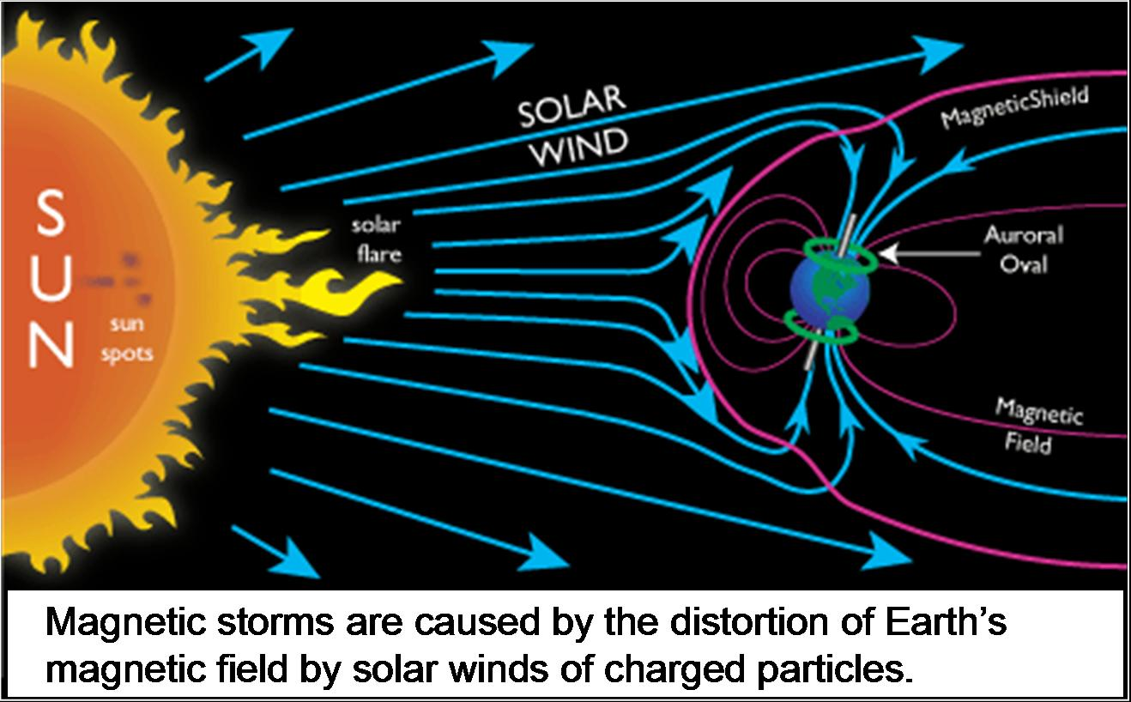
10) What causes aurora on Earth?
Winds of charged particles produced by sunspots. Aurora’s are the glow of charged particles from solar winds, which are interacting with the Earth’s magnetic field. (Primarily near the poles, where Earth’s magnetic field is strongest)
Why are aurora most often seen at high latitudes?
Most concentrated near north and south poles where Earth’s magnetic field is strongest.
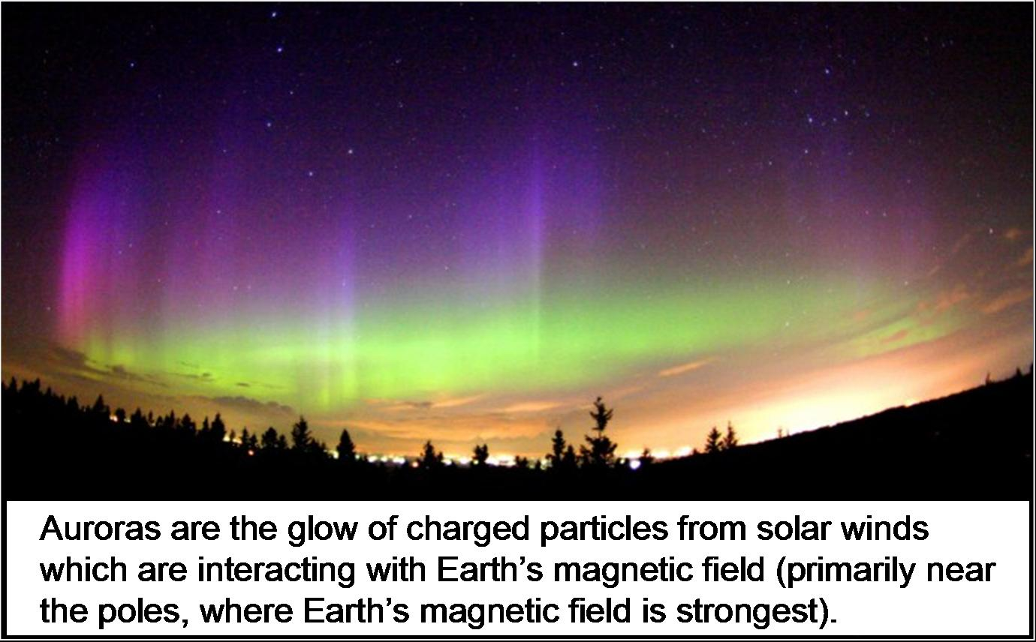
11) What happens to the number and intensity of sunspots, magnetic storms and aurora every 11 years, due to the Sun's magnetic cycle?
The Sun reverses its magnetic field, thus producing a cycle of storms marked by solar flares. Violent eruptions occur more violent on the Sun.

12) What was developed in the 1960s to extend the limits of the observable Universe in radio light?
Radio array – collection of radio dishes, which work together by combining the light it receives from a light source.

13) Describe the radio emission from a pulsar.
Flashes bright radio light on and off at 30 flashes per second. Every beat is 1 radio flash.
What did Hewish initially suspect that the signal was coming from?
Alien communication
What is the true explanation for the pulses?
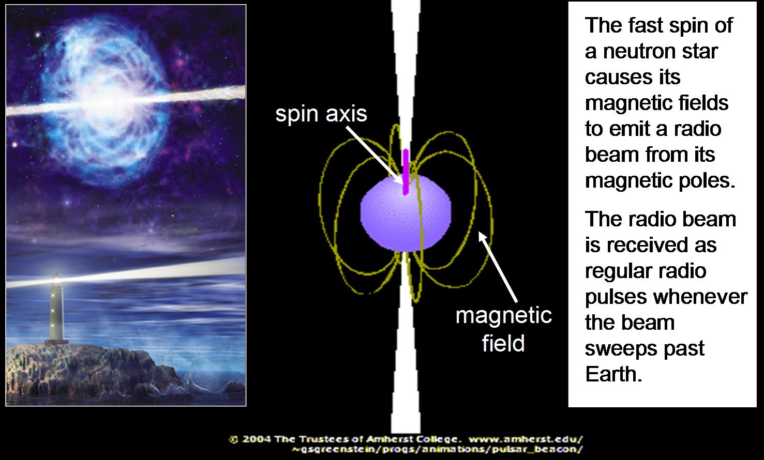
Are all neutron stars pulsars? Why/why not?
Pulsars are neutron stars whose radio beams are periodically aimed at the earth, which means that not all neutron stars are pulsars. A neutron star can be spinning in such a way that its radio beams doesn’t ever aim directly at the Earth therefore we would not receive the flash.

14) What is time dilation?
Prediction of General Relativity that time slows down in a strong gravity field.
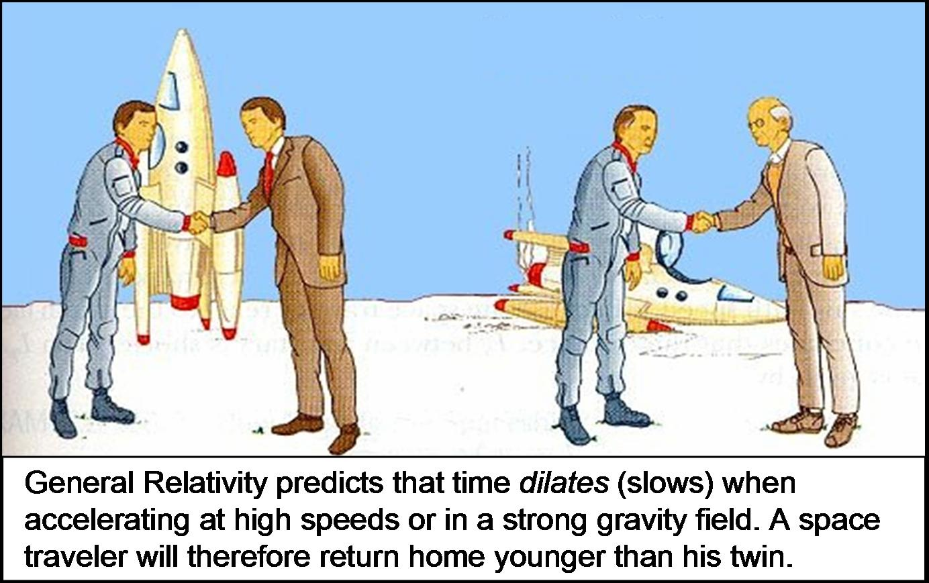

How was it proven to exist using pulsars in binary systems?
Binary pulsars were found to tick slower when closest to their center of mass, proving the general relativity prediction. In 1980s the ticking of binary pulsars was monitored throughout their entire orbit around their high mass companion star and it was found that their ticking noticeably slows down whenever the pulsar is closest to the center of gravity of its binary system and it speeds up when its far away from the center of gravity from its system.
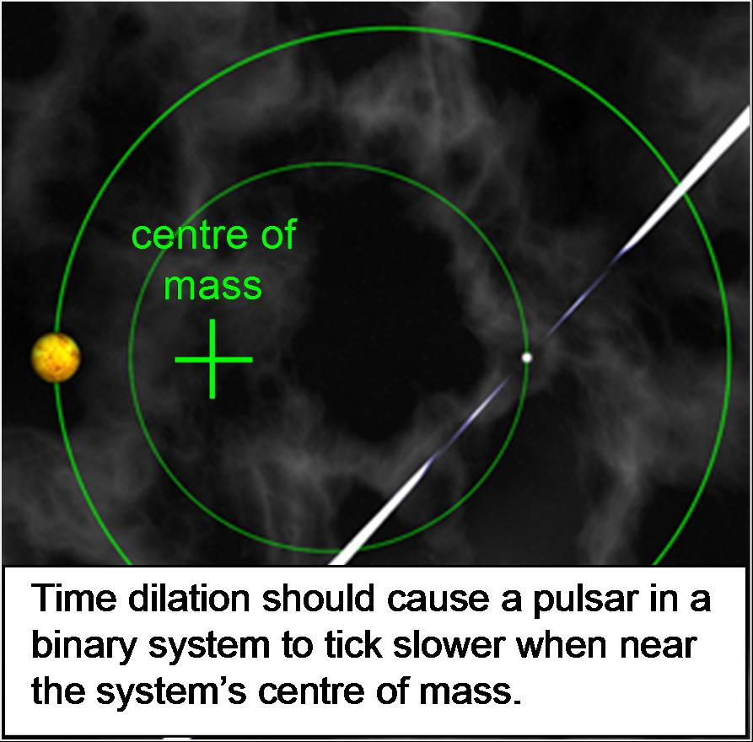
15) What is a radio galaxy?
Giant ellipticals with jets of radio emission from the galaxy’s nucleus.
16) What does "quasar" stand for?
Quasi-stellar radio sources
What do quasars look like in visible light?
Single bright point in the sky
What do they look like in radio light?
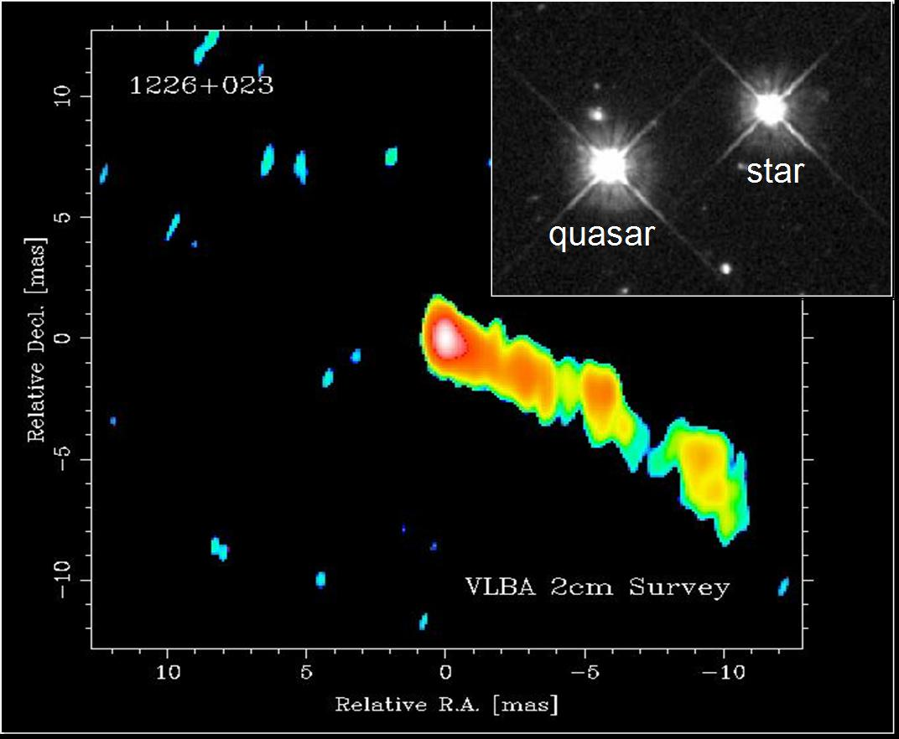
What revealed that quasars are distant galaxies?
They had huge redshifts which meant they were billions of light years away. Had high recessional speed and according to Hubble’s Law the higher the recessional speed, the further the quasars.

17) What is currently believed to be the cause of the radio emission produced by radio galaxies and quasars?
The bright star like appearance is a huge accretion disk of swirling matter around a supermassive black hole at the galaxy’s center.
Theory: The strong radio lobes are a result of strong magnetic field produced from the black hole’s spin.
What is the observational proof in support of this?
High-resolution images of radio galaxies reveal huge disks of hot gas and dust around a central dark object.

18) What is the current explanation for why quasars are only seen in the distant Universe?
Since quasars are billions of light years away we see them as they were billions of years ago and we’re seeing the quasars when they were very young, shortly after they were born. They must be an infant stage galaxy.

19) What is the current explanation for why radio galaxies aren't as radio-loud as quasars?
They are less dense than quasars

20) What is suspected to be at the centre of the Milky Way?
Sagittarius A. Super massive black hole. All galaxies likely have a central black hole, but most are presently quiet having consumed all nearby matter.
What is the observational evidence in support of this?
The radio emission from Sagittarius tells us that the black hole is only about 6 light hours in size. A black hole that tiny has zero gravitational pull on any stars except for in its very immediate surroundings. The center of our galaxy is in the Sagittarius constellation. Our black hole isn’t completely asleep. The consumption of little dwarf galaxies that get close to our galaxy and as it continues to happen we can expect our black hole to flare up again.

21) What kind of telescope is the Chandra Observatory, and why is it in space?
X-ray telescope. To observe x-ray sources in space.

22) What kind of object is Cygnus X-1?
Strongest Galactic X-ray Source.
What is believed to be the cause of its X-ray emission?
It was believed that its x-ray emission is coming from the black hole.
How was this proven in 1972?
It was proven when optical images of Cygnus X-1 revealed a massive star in orbit around an unseen companion.
At what observatory was this discovery made, and in what city?
Dunlop Observatory, located in Richmond Hill, ONT.

Chapter 12
1) What is the van Karman line?
The boundary line at which Earth’s atmosphere is too think for air navigation
What was the first man-made object to breach it?
The V2 rocket, a German WWII missile
Who designed this object, and where did he end up working?
Werner von Braun, the German rocket scientist, surrendered to the U.S. He later became on of the key architects of the American space program

2) How were the 1st photographs of Earth taken from space?
V2 rockets were used

3) What kinds of animals were first launched into space by the U.S (after the fruit flies)?
Monkey
What about the Soviet Union?
Dog

4) Which country launched the first satellite into Earth-orbit, and what was this satellite called?
Soviets launched Sputnikl
5) Which country launched the 1st human into space?
Soviet Union
Describe how this trip was made.
Yuri Gagarin was launched into a complete Earth orbit

6) Which country made the first unmanned landings and orbits of the Moon?
Soviet
What did the Luna 3 take photographs of for the 1st time?
The moon’s far side (not visible from earth due to the Moon’s synchronous orbit not visible from earth due to the Moon’s synchronous orbit)

7) Why can't we see the far side of the Moon from Earth?
Not visible from earth due to the Moon’s synchronous orbit (rotation period = orbital period)
Why is the far side more cratered than the near side?
The craters on the near side have been filled in with lava and solidified, likely due to the earth’s gravitational pull on the lava when it was still liquid

8) Which country made the first manned landing on the Moon?
U.S.
What was this name of the astronaut who first stepped on the Moon?
Neil Armstrong

9) What is an orbiter?
Crafts in orbit around another body
What is a lander?
Crafts, which land on a body’s surface and remain at the landing site
What is a rover?
Crafts, which move across a body’s surface

10) Which planets in our solar system have been landed on by human-made crafts?
Venus and Mars
Were these missions manned or unmanned?
Unmanned

11) What did NASA's Space Shuttle consist of?
A rocket, orbiter and re-entry space plane that would detach itself from the orbiter and go off flying elsewhere

What was its purpose?
Satellite maintenance, space experiment and trips to the International Space Station

12) What is the International Space Station (ISS)?
A habitable satellite for conducting space experiments,
What is its purpose?
Conduct space experiments

13.) What is the Canadarm?
A 15-metre robotic arm
Where are Canadarms permanently installed, and what is their purpose?
Currently installed in ISS and it is used to hold/tether astronomers to the ISS as they perform maintenance on the exterior so they don’t float away in space and also to transport cargo into the station itself.

14) What have our space missions left behind around the Earth?
Space Junk, the world’s satellites and space mission have created a shell of debris around the earth. Now estimated in the tens of millions, the debris includes non-functional satellites, equipment & collision fragments

15) What discovery was made when Pete Conrad returned from the Apollo 12 mission to the Moon?
He brought back a camera from Surveyor 3 that was left there for 2 years- an unmanned craft sent to Moon and NASA scientist found earthly bacteria on it which was probably left behind by a technician and it survived on the moon. This proved organisms can survive in space

16) What are extremophiles?
Life forms which can survive extreme conditions that can’t sustain human life
What are some of the extreme environments on Earth where extremophiles are found?
They are able to survive harsh temperatures ( high or low), found in boiling pools in Yellow Stone National Park and depths of the pacific ocean

17) What is the Habitable Zone?
The distance from a star at which a planet can sustain liquid water on its surface (a necessity for carbon based life)
Which planets in our solar system are in this zone?
Earth

18) What is it about the Carbon atom that makes carbon-based life likely?
The unique ability of carbon to form complex molecules

19) What 2 surface features of Mars suggest that it could have supported life in the past, and why?
Evidence of water – polar ice caps which we know contain frozen H20 and also the Mars’canyons and the canyons on Earth are formed from liquid, erosion due to liquid water and so where there is water there is usually life so this might suggest that Mars was once habitable for life. In the past Mars might have been warmer when our solar system was younger and hotter and that would have melted the water (polar ice caps) and we would have liquid water and that’s where life tend to thrive
What is it about Mars' atmosphere that makes Earth-like life currently unlikely?
Mars’ atmosphere is too thin (no ozone layer and virtually no oxygen) and
so by the present day with the Sun’s gamma radiation would have burnt
off any kind of life on the surface of Mars

20) What was the mission of the Viking space probes?
To find evidence of carbon based life

What was concluded on their return, and why?
They did not find any carbons in their sample – so it was concluded that there is no carbon based life on mars

21) What was found when synthesized Martian soil was studied on Earth?
If you give nutrients to Martian soil, which it doesn’t normally have it will digest that stuff and it was found by making the soil radioactive so that if the soil did digest the nutrients then you would see these burps of light. So that was detected, so that suggested there might be some life there, as far as we know these samples of Martian soil, they were not carbon based. So whatever it is digesting this soil is some kind of simple microorganism that is not like carbon based life on Earth. We don’t really know what happened there.

22) What is rock ALH 84001?
A meteorite that had fallen on the pristine snows of Antarctica. The rock had been blasted out of Mars by collision with an asteroid – later to land on Earth.
Why does it suggest that life once existed on Mars?
ALH84001 was found to contain what appeared to be microscopic, fossilized ‘maggots’ inside the rock

23) What evidence of water was found by the Pheonix lander?
NASA’s Pheonix lander found water ice, carbon and minerals in a Martian polar region
What about the Opportunity rover?
Found veins of water deposited minerals in Martians rocks
What is the mission of the Curiosity rover?
NASA’s Curiosity is expanding the search for evidence of life on Mars by studying the soil beneath the surface.

24) Why was the Galileo spacecraft intentionally crashed into Jupiter?
The craft was intentionally commanded to the collision course with Jupiter to eliminate any chance of a future impact with Europa (or any local moons) that could contaminate the icy moon with terrestrial bacteria.

25) Where is Europa?
Center-stage 1900 miles (3000km) orbiting Jupiter (one of the largest moon)
What is the evidence for liquid water on this celestial body?
Found a cracked icy surface on Europa, possible due to a liquid ocean underneath were temperatures are warmer

26) Where are Titan and Enceladus?
Moons orbiting Saturn
What is the evidence for carbon and liquid water on these celestial bodies?
The evidence is that on Titan we find 2 bits of evidence: it has these methane lakes (carbon based molecule) and both Titan and Enceladus have these volcanoes which are iced volcanoes, what we find that spews out of these volcanoes we find H20 water vapor and more carbon based molecule like methane and carbon monoxide
What is Titan the only moon in the solar system to possess?
A thick atmosphere (orange atmosphere of nitrogen) nearly twice as dense as Earth

27) What does SETI stand for, and who was its original founder?
Search doe Extraterrestrial Intelligence founded by Frank Drake

28) What is the mission of SETI's Project Pheonix?
To monitor ~800 nearby sun-like star for radio signals form ETs
Has it been successful so far?
No

29) What does the Drake Equation measure?
It estimates the # of communicating civilizations in our galaxy (N)
Can it currently be accurately solved? Why/why not?
No, It cannot be solved since it terms are mostly unknown, some are guessed based on what we observe on Earth

30) Briefly describe the 3 attempts that Earth has made to send messages into space.
a) The Arecibo message (radio message from the Arecibo dish).
-Showed basic chemistry of life on Earth, the DNA molecule and the arrangement of our Solar System. Also gave the population, Earth’s size and the size of the telescope which was sent

b) The Pioneer plaques (engravings on the Pioneer spacecraft)
- Crude line drawings of human beings and how to locate the Earth with respect to 14 nearby pulsars

c) The voyagers Golden record (record with audio message and engraving on voyager 1)
-old-fashion LP record on their sides, complete with a stylus. The discs were encoded with sounds, pictures and messages from Earth
What were the general contents of each message?
Earth sent 3 messages into space, each containing info about earth and humans.

31) Where is Voyager 1 right now?
~20 years from reaching interstellar space

32) Describe the Doppler-Wobble method for detecting extrasolar planets.
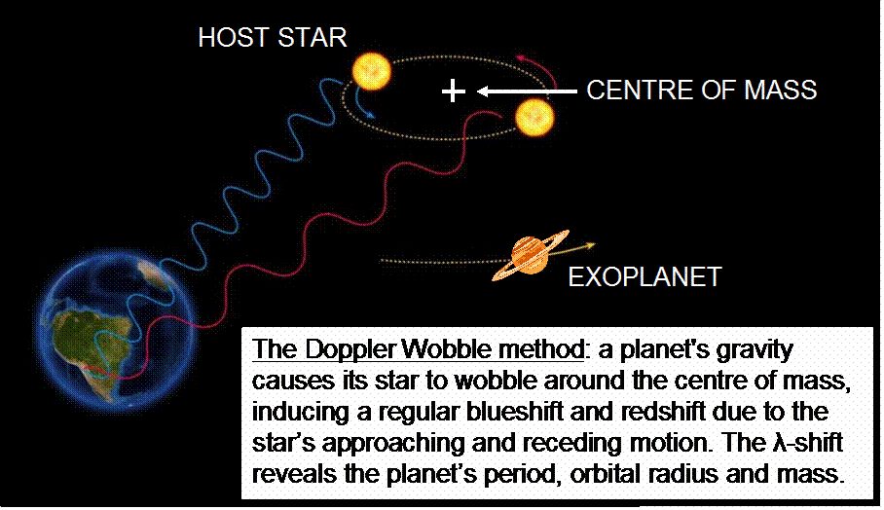
33) What types of planets are most likely to be found with the Doppler-Wobble method, and why?
Hot Jupiters (giant gas planets that are near their star), as these planets induce large wobbles

34) Why could "Hot Jupiters" not have been born at their present locations?
Giant planets like Jupiter has to be formed in the outer parts of solar system because that’s where all the matter is inside a circumstellar disk, if you try to form a Jupiter planet in an inner orbit you will just run out of material because the orbit is so small. So we know Jupiter can’t have formed in their present location because there isn’t enough matter in its small orbit.
How are they suspected to have reached their present locations?
They must have been formed in the outer circumstellar disk of their stars but then either they were formed in an unstable orbit or perhaps something knocked them out of their orbit in which they would have spiraled towards their star, some of them would have been consumed by their star but it is also possible that due to other gravitational sources of their system it would have achieved a final orbit as it was spiraling inwards as a stable orbit and that would explain how they could exist so close to their star yet have formed from an outer disk (they migrated inwards)
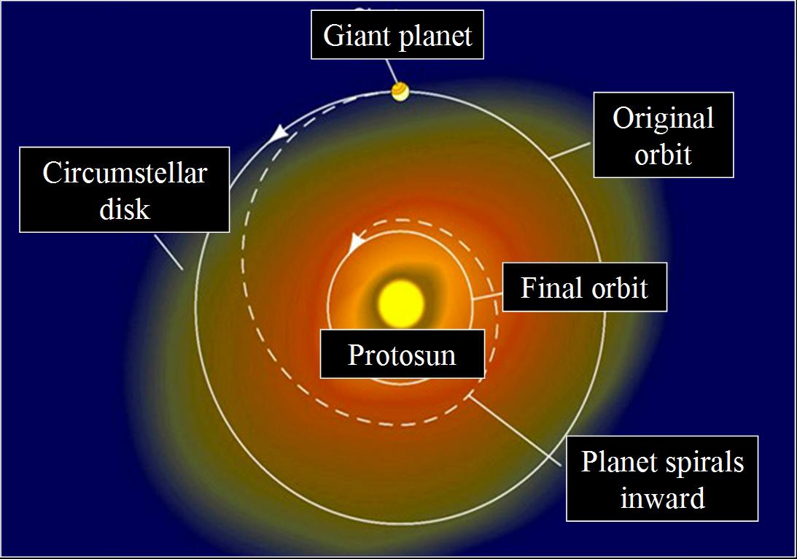
35) What is the goal of the Kepler Mission?
To find Earth like planets. To find planets in the size of Earth and in the habitable zone of their stars

How will it aid SETI?
If we can get a huge target list of Earth-like planets then SETI they will be able to use that target list to maximize their chance of detecting radio communication from life from one of these Earth-like planets

36) Describe the method that the Kepler Mission is using to detect extrasolar planets.
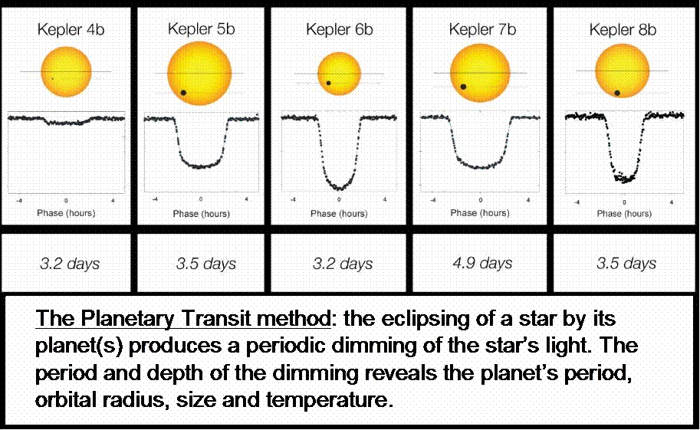

37) Is Kepler surveying a large or small fraction of the stars in the Milky Way?
Very small, only a tiny fraction
Based on their preliminary results, our Earth-like planets common or rare?
Common
Has Kepler found any planet candidates in the Habitable Zone?
Yes
How about Earth-like planet candidates in the Habitable Zone?
Yes
How many planets in the Habitable Zone have been projected for our entire Galaxy?
Millions are potentially in the Habitable zone – they are basing on the map that they find on their little sample of the Galaxy and they project that outwards to the size of the whole Galaxy

38) Describe how planets can be investigated for Earth-like habitability and signs of life.
We want to produce a spectrum of planet’s atmosphere that will tell if their atmosphere is breathable to us and it will tell us whether we might see some artificial pollutants in those spectra which could be as a sign of life. We produce the spectrum of a star at the same time a planet is passing in front of it. Wait until planet is no longer in front of the star and you take a spectrum of the star, you subtract the two spectra and out comes the spectra of a planet’s atmosphere

