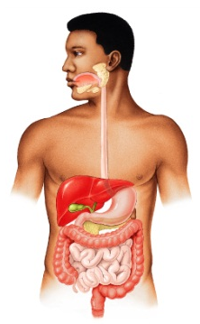
Anatomy
- Study of structure and shape of the body and its parts
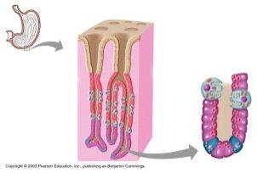
Macroscopic
Microscopic
- Study of how body parts function (Function together)
Physiology

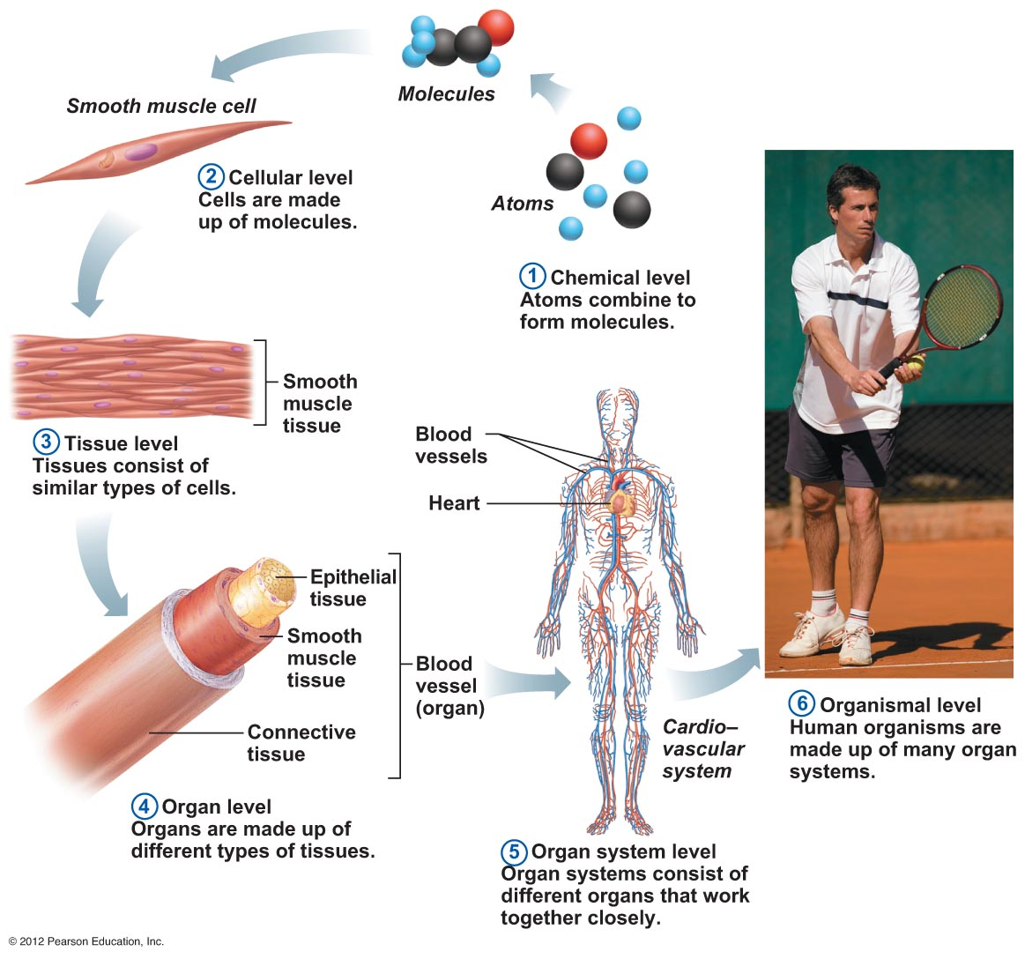
Levels of Structural Organization

Tissues –
- epithelial
- connective
- muscle
- nerve



11 Organ systems in the human body (ON THE FIRST TEST AND POSSIBLY THE LAST EXAM)
Complete the table by matching the correct functions found on page 10 of these notes to each body system.

Body system | Functions
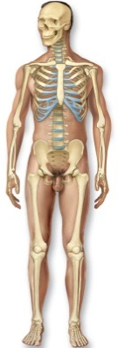  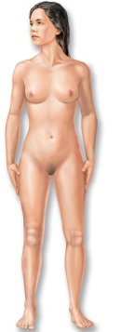  Integumentary | - synthesizes vitamin D  - location of cutaneous sensory nerve receptors  -  -  -
Skeletal | - site of blood cell formation  - stores minerals (inorganic salts)  -  -
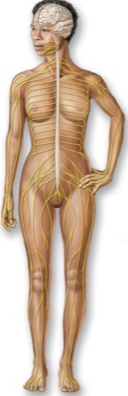  Muscular | 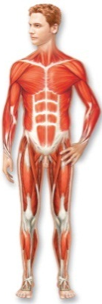  - maintains posture  - produces heat  -
Nervous | - activates muscles, organs and glands  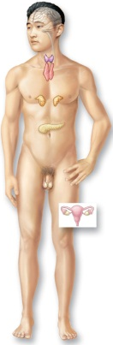  -  -  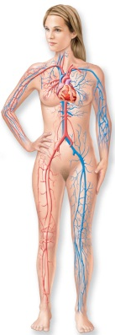
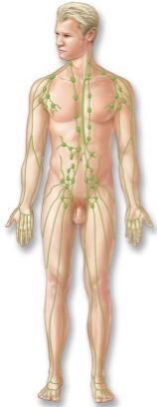  Endocrine | -
Cardiovascular | -
Lymphatic | - returns fluids leaked from blood vessels to blood  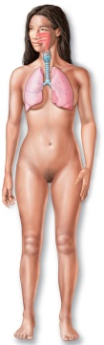  - disposes of debris  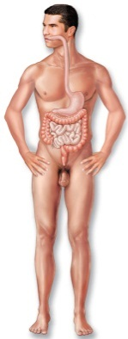  -
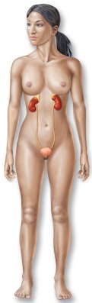  Respiratory | -
Digestive | - eliminates indigestible material  -
Urinary | - maintains acid – base balance of body fluids  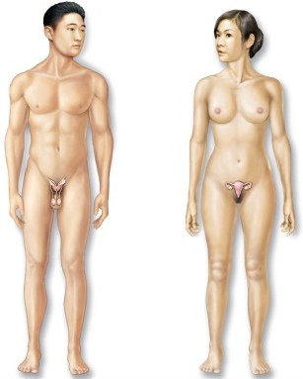  - eliminates nitrogenous wastes from body
Reproductive | -
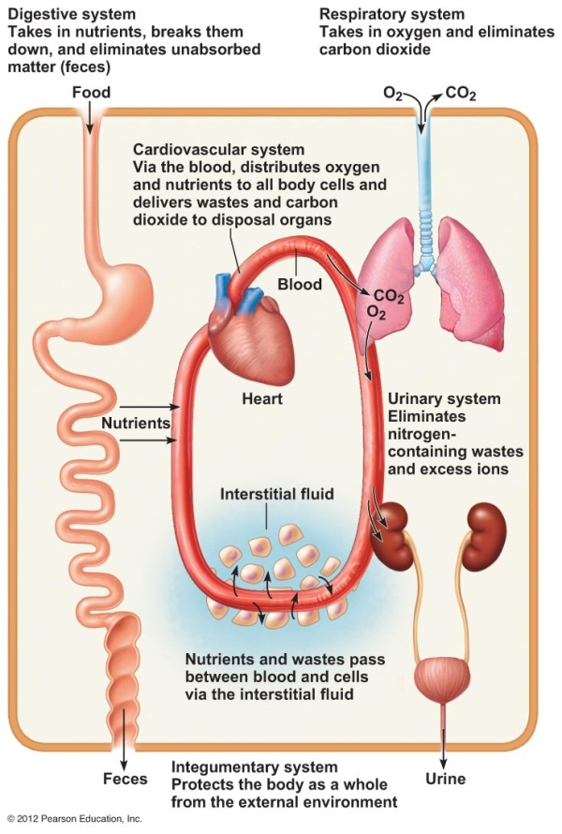
Interrelationship of organ systems

RESPIRATORY SYSTEM
GLUCOSE+O2CO2+H20+ ATP (ENERGY)

10 Necessary Life Functions
- Movement –From one place to another
-motion of internal organs
- Responsiveness – Sense changes to environment and react
- Respiration – obtain oxygen which is used by cellular respiration to release from food and eliminate carbon dioxide waste
- Circulation – Moves substances in body fluid
- Digestion – Break down nutrients into small molecules ready to absorb
- Absorption – Move small molecules into body fluids
- Assimilation – Change absorbed molecules into body molecules
- Excretion – Remove waste produced by metabolic processes (respiratory, urinary, and digestion systems use this)
- Reproduction – Production of offspring
- Growth – Increases size and number of cells

Metabolism b
- All chemical reactions in the body which include the 10 process listed above

5 Human Survival Needs
1. Nutrients - chemical used as sources of:
- Energy (ATP)
- Material for cell building or regulation of cell activity (enzymes, antibodies, hemoglobin)

2. Oxygen
- Used during cellular respiration, the process which releases energy stored in food

3. Water
- Solvent for metabolic reactions
- Transports substances
- Helps regulate body temperature

4. Stable body temperature
- For enzymes to work (if not enzyme is denatured)

5. Atmospheric pressure must be appropriate
- For gas exchange with environment

Homeostasis
- Maintenance of stable internal environment between upper/ lower set points (normal range) – dynamic equilibrium

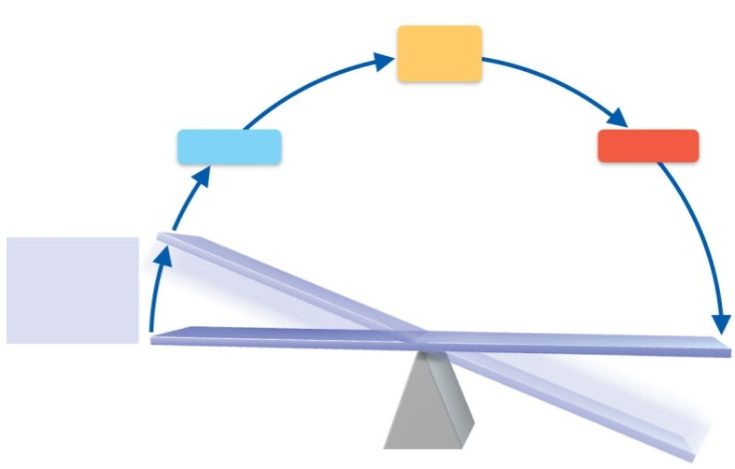
3. Input signal sent along afferent pathway to
(Sensory pathway)
4. Output signal sent along efferent pathway which activates
Control
center

2. Change detected by receptor
5. Response of effector returns variable to normal range
Effector
Receptor

1.Stimulus produces change in variable
upper
set point
Imbalance
Normal Range for this variable
Variable

Imbalance
lower
set point

Homeostasis is maintained in the body through neural & hormonal control systems. These systems include:

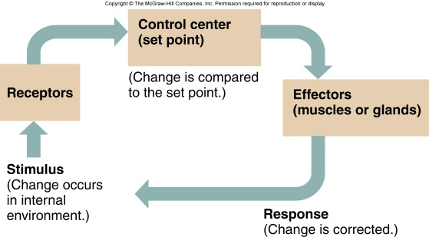
- Receptor
- Detects changes in the environment (variable) and sends afferent signal to (control center)

- Control center
- Determine set points/ Analyzes input then determines appropriate response

- Effector
- Muscles or gland changes its activity

Feedback Mechanisms
- Negative feedback
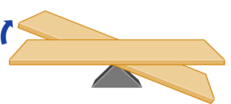
- Works to reverse the initial stimulus and bring variable back into normal range. Most control mechanisms in body are this type (ex. Control of body temperature)

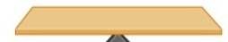
- Positive feedback
- Works to increase initial stimulus to push variable farther
- Very few examples (ex. Blood clotting)

You breathe faster when exercising, what is the:
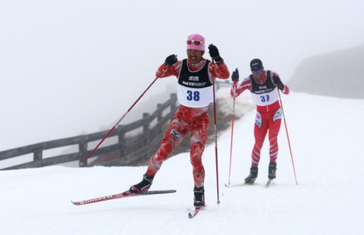
stimulus? – higher CO2 levels
receptor? –chemoreceptor detects the CO2 levels
control center? – Pons and Medulla Oblongata
effector? – Diaphragm and rib muscles (intercostal muscles between ribs)

What is the effect of this feedback mechanism?
Lowering CO2 levels

The Language of Anatomy
Special terminology is used to prevent misunderstanding
Exact terms are used for:
- position **palms forward**
- direction
- regions
- structures
Fill in the blanks: (superior/inferior)

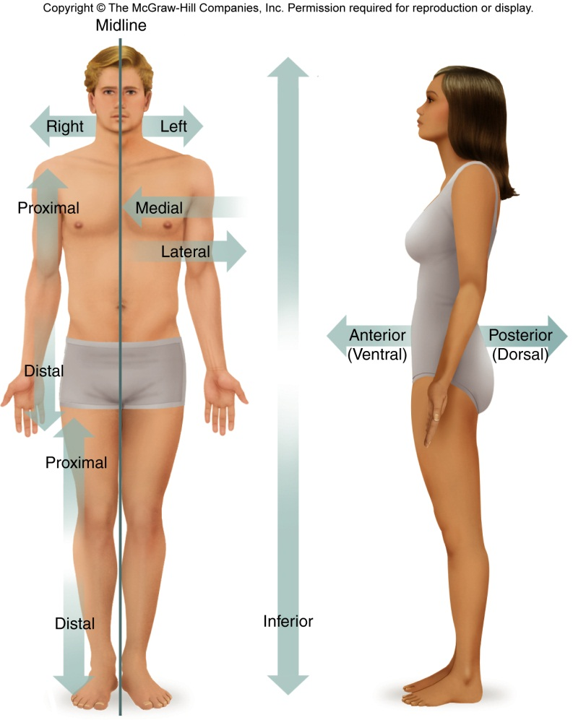
Head is superior to hips.
Hips are inferior to the shoulders.
Heart is superior to the stomach.

(anterior/posterior)
Eyes are Anterior to the brain.
Nails are on Anterior side of hand.
Spine is Posterior to the stomach.
superior
Shin is on the side of the leg.

(medial/lateral)
Ears are lateral to the nose.
Hips are medial to the arms.
Heart is medial to the lungs.

(distal/proximal)
Knee is proximal to the ankle.
Elbow is distal to the wrist.
Fingers are on the distal end of the arm.
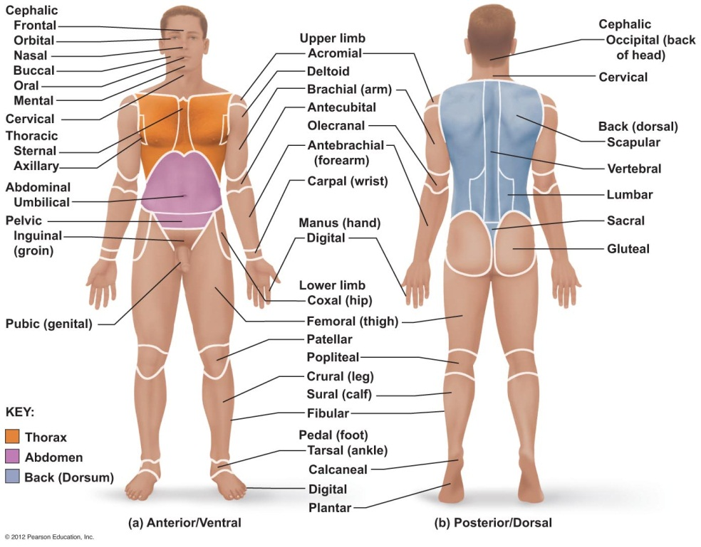
Thigh is proximal to the knee.
Feet are on the end of the leg.

Body Landmarks

Ray has been in a motor cycle accident and the triage nurse reports he has received abrasions to these areas of his body:
scapular
axillary
brachial
Where are these injuries located?
Right back
Left Thorax (Under Arm) / Arm

Body Planes and Sections
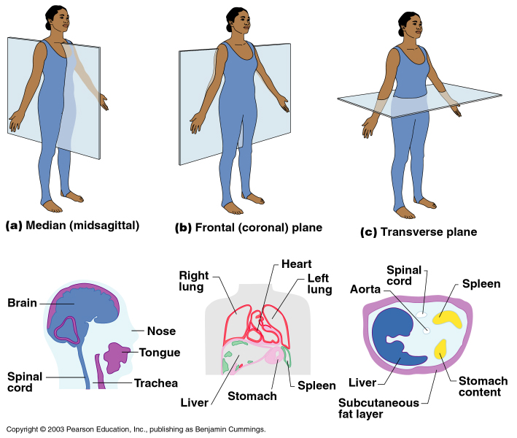
Median (midsagital) plane - left & right
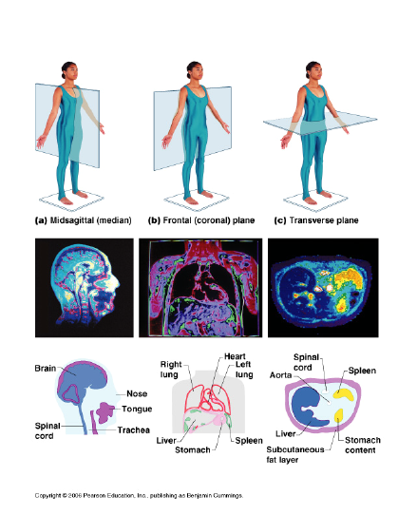

Frontal (coronal) plane - front & back

Transverse plane - upper & lower

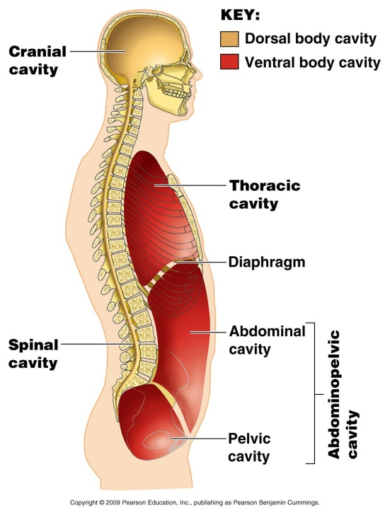
1. Dorsal
- Enclosed by bone
sub-cavities
a) Cranial
- Contains spinal cord
- Contains brain
b) Spinal

2. Ventral
- Chest and abdomen (space at the front) Contains most of the organs

sub-cavities
a) Thoracic
- Protected by rib cage (Chest Cavity) Contains heart and lungs. Separated from abdomen by diaphragm

b) Abdominal
- No boney protection (Contains stomach, liver, intestines, pancreas, soleen, kidney)

c) Pelvic
- Protected by pelvic bones (Contains reproductive, organs, bladder and rectum)

Abdominopelvic Regions Abdominopelvic Quadrants
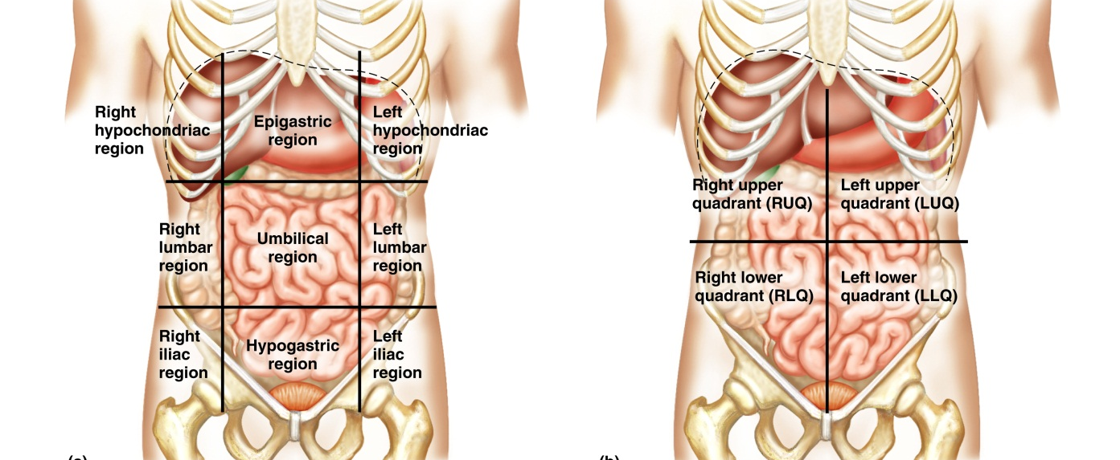

Complete the table by identifying the quadrant & region where each organ is located.
Use the reference plate on page 35 of the etextbook to help identify the organs.
Organ | Quadrant | Region
Liver
Stomach
Small intestine | Lower Quadrant | Umbilical Area + left and right lumbar
Rectum
Ascending colon
Spleen

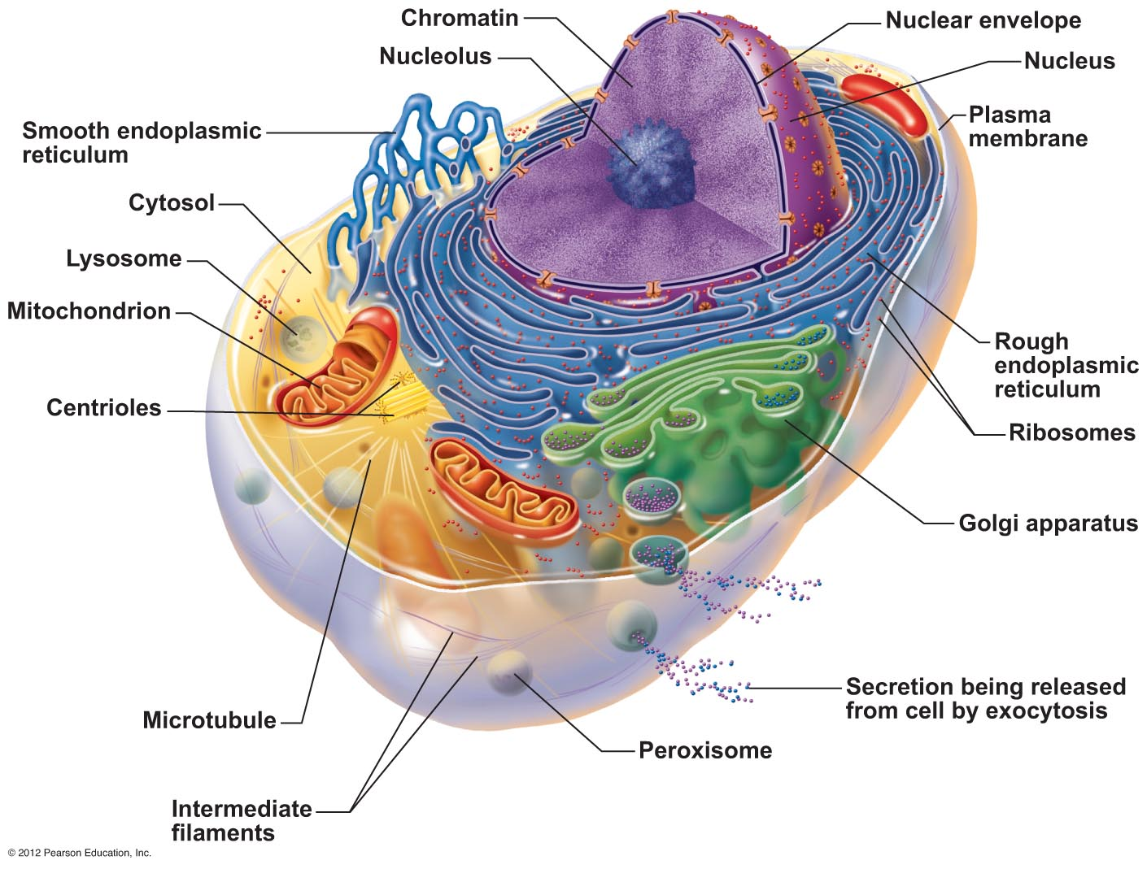
REVIEW
Parts of the cell

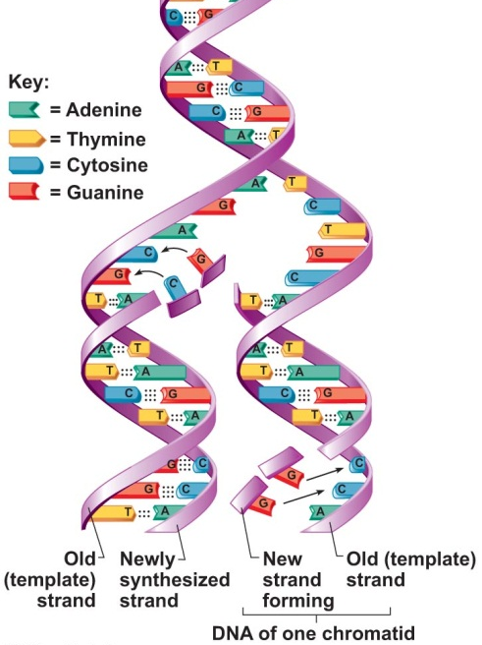
DNA Replication

- DNA is a polymer formed from nucleotide monomers
- Each side of DNA forms a template for the new daughter strand
- Free nitrogen bases match complementary exposed base A-T, G-C
- DNA polymerases make covalent bonds between nucleotides on new strand

Cell Life Cycle

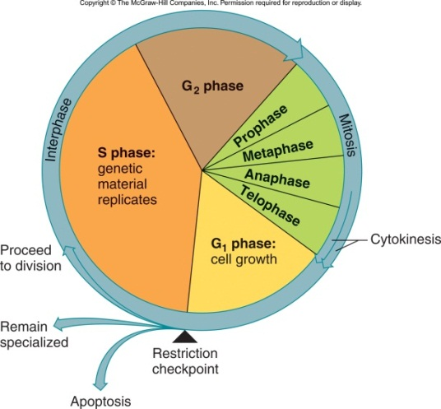
Interphase

- G₁ – period of cell growth
- more cell parts are made

- S – DNA replicates
- G₂ – cell prepares for division

Stages of Mitosis

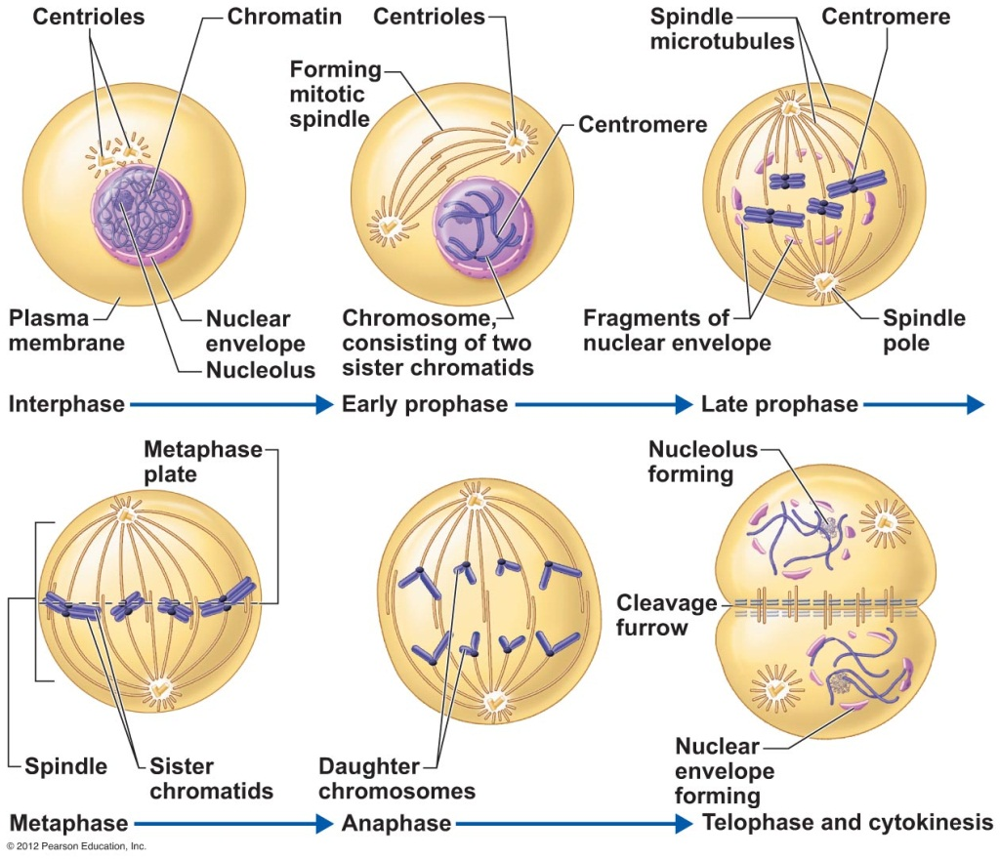

Metabolic processes of cells
1) Protein Synthesis
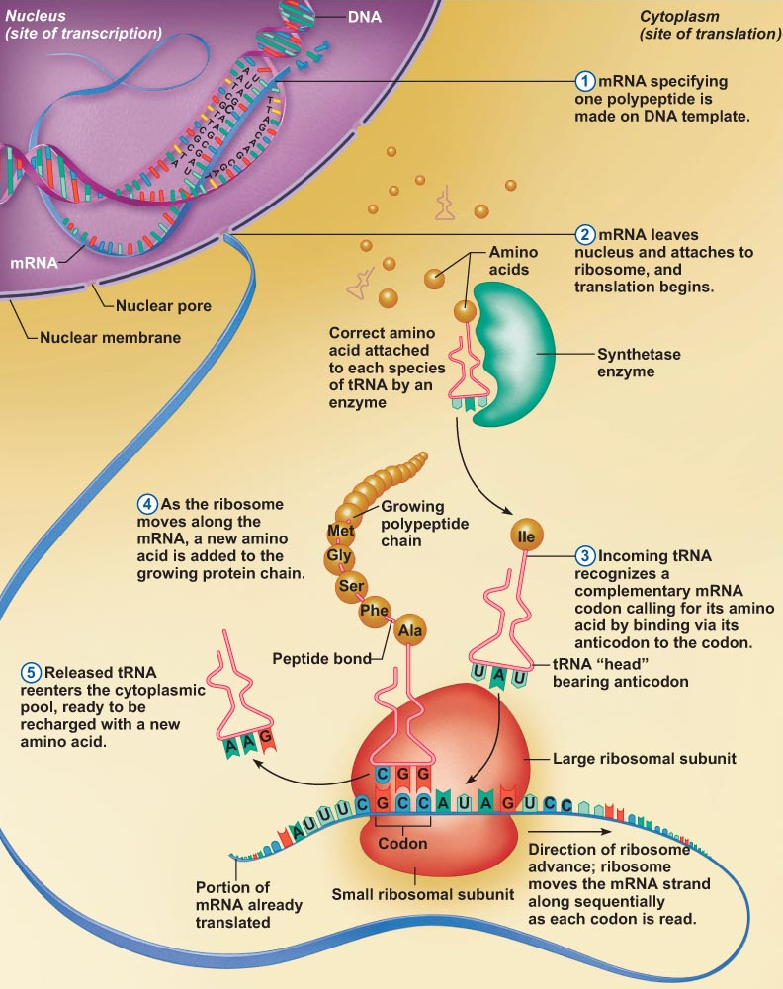
Transcription

  - transfer of information from DNA’s base sequence to the complimentary base sequence of mRNA

  - three-base sequences on mRNA are called codons

Translation

  - base sequence of nucleic acid is translated to an amino acid sequence when anticodon on tRNA matched complementary bases on mRNA codon

  - amino acids sequence forms protein

  - sequence of amino acids determines function of the protein

2) Cellular respiration to form energy (ATP)
glucose + oxygen carbon dioxide + water + ATP

How ATP Drives Cellular Work
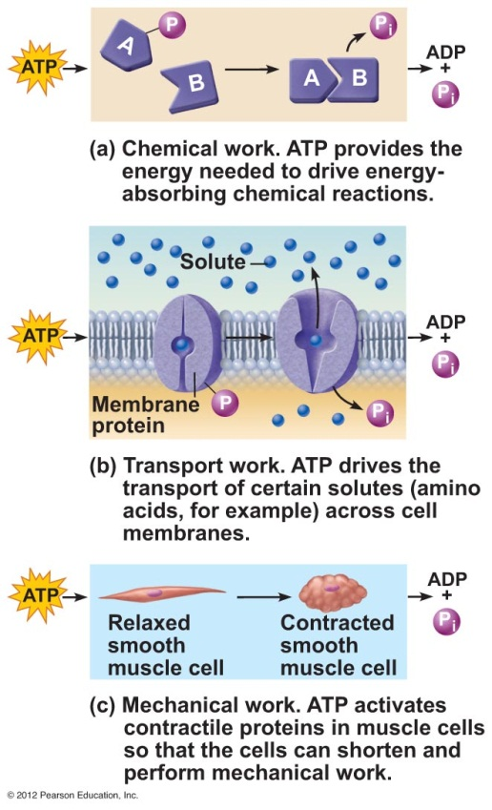

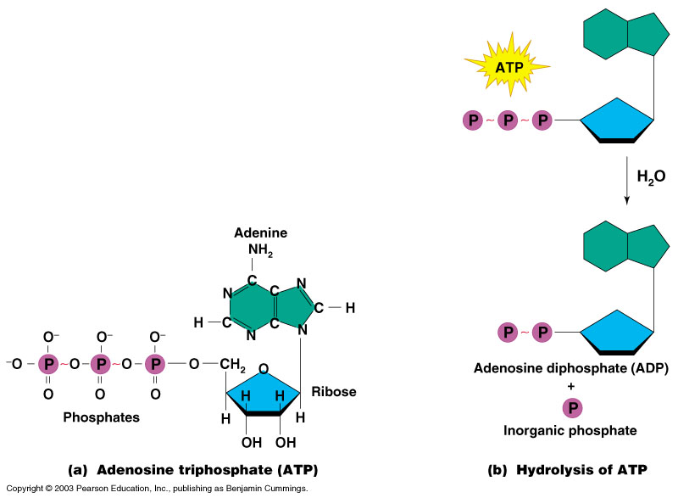

Match these functions with the correct Body System on the table on page 2 of the notes:

- forms the external body covering
- protects and supports body organs
- protects deeper tissue from injury
- transports materials in body via blood pumped by heart
- allows movement
- fast-acting control system
- responds to internal and external change
- location of sweat and oil glands
- regulates levels of water and electrolytes in body
- keeps blood supplied with oxygen and removes carbon dioxide
- breaks down food into small units and absorbs them into blood
- production of offspring
- involved in defending the body against infection
- secretes regulatory hormones to control growth, reproduction, and metabolism
- provides framework for muscle attachment

