CHAPTER 10

Why new product ? to adapt to changing tastes, technologies and competition (satisfy consumer’s needs and wants) but also to remain competitive, keep up with technologies, changing consumer tastes, follow the market trends, diversifying the product offering to lower risk
New product development : development of original products, product improvements, modifications and new brands, through the firm’s own R&D efforts (internal source), aquisition of company, patent or license, external sources or crowdsourcing.
High risk and failure rates because market size was overestimated, actual product was not designed as well as it should have been, incorrect positioning in the market, price was too high, advertised poorly, costs of NPD were higher than expected, high competition..
- offer real value, cherish the brand, be different but not too different, accentuate the positive, understand consumers, markets and competitors
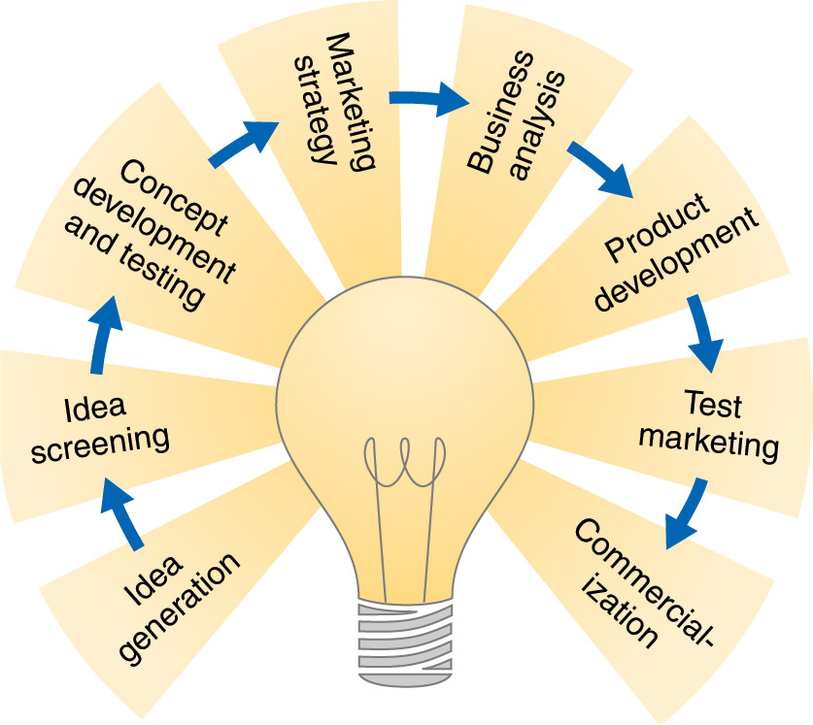
Stages in New Product Development
Systematic search for new product ideas from
- internal sources (brainstorming, employees, R&D)
- external sources (customers, competitors, distributers, suppliers..)
- crowdsourcing (open the door to everyone)
Identify good ideas and drop poor ones to avoid spending any more money on developping them
(Consider usefulness to consumers, good fit with company objectives and strategies, have the resources, add value) -> R.WW process (Real, win, worth doing)
Concept development creates a detailed version of the idea stated in meaningful consumer terms.
Concept testing asks target consumers to evaluate the product concept

Product idea = idea of possible product
Product concept = detailed version of the idea
Prouct image = the way consumers perceive the product
Initial marketing strategy for introducing a product to market
1rst statement : describes target market, product positioning, sales and profit goals for first few years
2nd statement : outlines product’s price, distribution and marketing budget for 1rst year
3rd statement : describes the long-run sales and profit goals and marketing mix strategy
Review of the sales, costs and profit projection for a new product to determine if they will satisfy company objectives
Developping the product concept into a physical product to ensure that it can be done (requires large investment, building a prototype, testing for safety, durability and acceptability)
Testing the product and marketing program in a more realistic market settings (to determine target market profile), assess consumer acceptaility, trial, repeat purchase rate, evaluate trade reception and distribution penetration
Design effective media plans (standard test market, controlled test market (products and tactics are tested on group of customers and stores), simulated test markets (people test product in laboratory or simulated shopping environment))
Introducing a product into the market (large investment required, need to decide on introduction timing and scale of event : if it’s recession, wait for lunch, if your competitor is ready to luch same product : push the lunch, market rollout (introduce into new location one step at a time) or full-scale introduction (introduce everywhere at the same time))

Going from stage 1 to 8 with a sequential product development (one stage at a time) can be dangerously slow, it can result in product failures, lost sales and profit and crumbling market position. Team-based product development approach (departments work closely together in cross-functional teams, overlapping the steps in the product development process to save time and increase effectiveness) with customer-centered approach is the GOAL : you gain a big competitive advantage and you get new (and right) product to market faster.
- In recession company’s shouldn’t cut budget on new-product ideas because firm would be less competitive and have a confused positioning

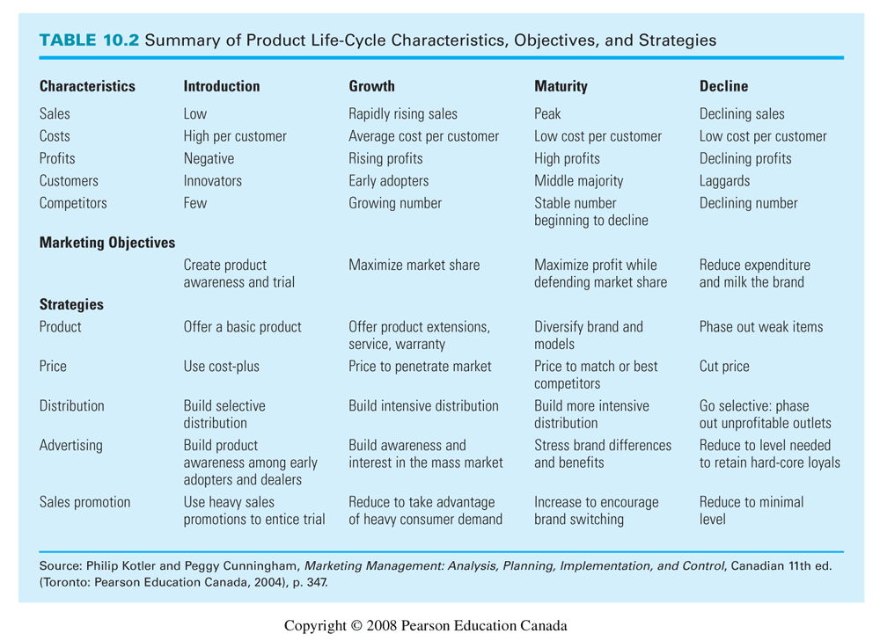
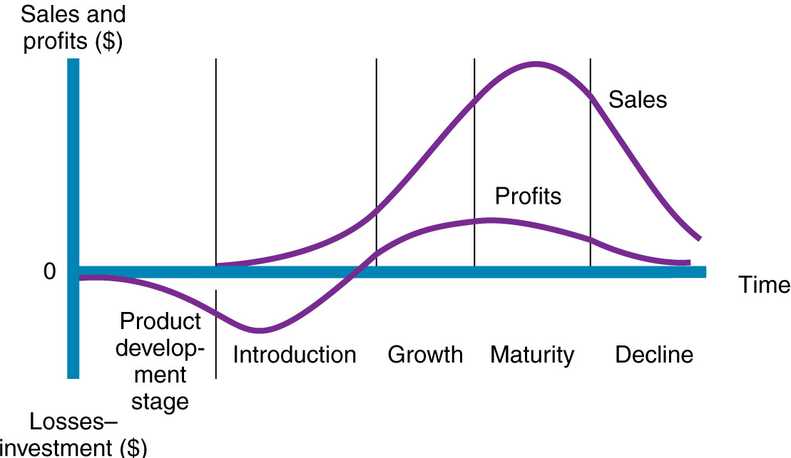
Product Life-cycle strategies : course of a product’s sales and profits over its life, PLC can describe a product class, form or brand (not all products follow this exactly). Competition and rate of technology change can influence the length of PLC

Style : basic and distinctive mode of expression (steady sales)
Fashion : currently accepted or popular style in a given field (high sales for a period of time and then decline)
Fads : temporary periods of unusually high sales driven by consumer enthusiasm and immediate product or brand popularity

Problem of using PLC : hard to identify which stage of PLC the product is in. Difficult to forecast the sales level, the length of each stage and the shape of PLC. Strategy is both a cause and a result of PLC.

