CHAPTER 9
Product : anything that can be offered to a market for attention, acquisition, use or consumption that might satisfy a need or want.
Service : form of product that consists of activities, benefits or satisfactions offered for sale (intangible and do not result in ownership of anything)
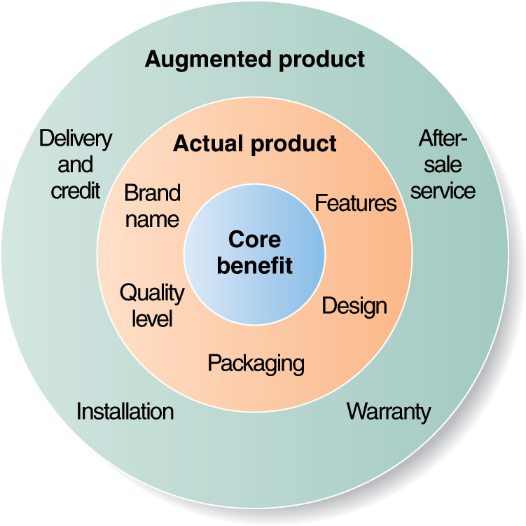
3 level of products :
- core benefit :reason why people buy your product, what benefit you want to deliver
- actual product : tangible actual product
- augmented product : some firms offer more than actual product (all benefits offered outside products)

Type of consumer products :
- convenience : frequent purchase, little comparision or involvment, quick decision process, habitual buying behavior -> make sure product is always available + mass promotion
- shopping : less frequent purchase, high involvment, complex buying behavior, expensive -> focus on deeper sale support, advertising and personal selling
- specialty : strong brand preference and loyalty, low price sensitivity, high price : luxury goods -> exclusive distribution, carefully targeted promotions
- unsought : little product awareness and knowledge (often negative interest) ex : life insurance, pricing varies, dissonance buying behavior -> aggressive advertising and personal selling by producers and resellers, distribution varies, build awareness
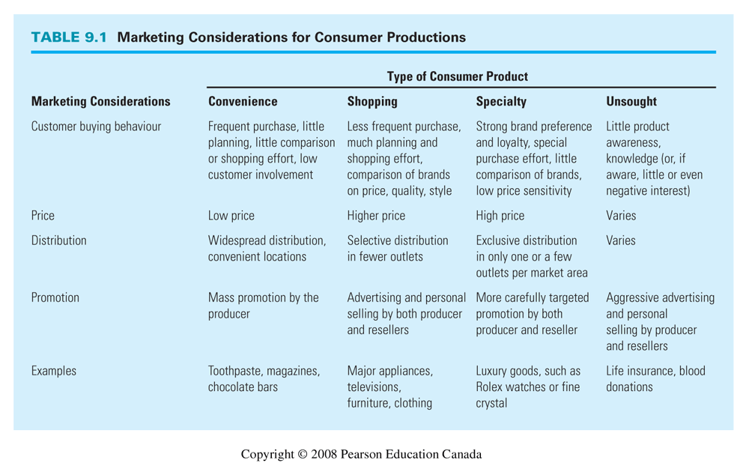
Different type of marketing :
- organisation marketing : action undertaken to create, maintain or change attitudes and behaviour of target consumer toward an organisation
- person marketing : same but toward a person (ex : politician)
- place marketing : same but toward a place (ex : tourism agency)
- social marketing : same but about a social change (improve well-being)

Individual product and service decisions :
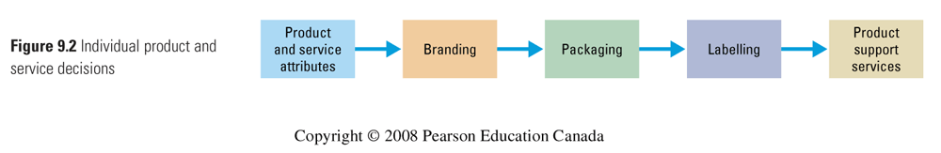

PRODUCT & SERVICE ATTRIBUTES :
- quality : absolute level of quality has to be stable and consistent and lined to customer value and satisfaction
- features : competitive tools for differentiating product, should be valued by the customer as determined through market research (is it worth adding a feature ? is revenue > cost ?)
- style and design : good style (appearance) will attract customer, good design contributes to product’s usefulness will capture consumers
BRANDING : Name, term, sign, symbol or design that help identify the product. It can add value to a product and a clear brand positioning (as well as company’s culture). It helps buyers identify the product and determine its quality. It helps sellers convey product quality, provide legal protection and segment markets.
PACKAGING : includes :
- primary container : contain and product, outside the product
- secondary package : promote, (primary container is inside)
- shipping package
Function : contain, protect, promote, differentiate the product, get people’s attention, make it unique, special, focus on frustration-free packaging as well as sustainability.
LABELLING : Helps identify the product, describe it, promotes it. Must be careful not to mislead customers, fail to describe the ingredients or fails to include safety warnings. It must support brand positioning and explain how to use it.
PRODUCT SUPPORT SERVICE : Survey customers regularly to assess current customer service. Companies use a mix of phone, email, fax and internet and interactive voice and data technologies to collect info. Kind of a “follow up program”

Product line decisions :
A product line is a group of products that are closely related because they may function in similar manner, are sold to the same customer groups, market through the same type of outlets or fall within given price ranges.
A product line length, purpose : extra profits, satisfy dealers, use excess capacity, being leading company, plugging holes to keep out competitors. Careful not to have too big product line -> cannibalization and/or confusion about brand positioning.
- Line stretching : adding products that are higher or lower priced than the existing line. Can stretch downward (when facing a slow-growth and/or high competition), upward (to add prestige to their current product or be attracted by a faster growth or higher margins at the higher end) or both
- Line filling : adding more items within the present price range
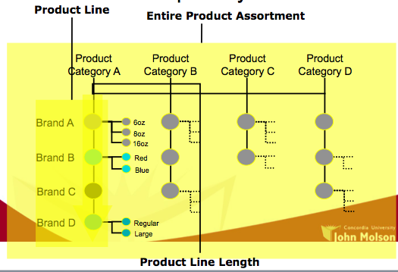
Product mix : also know as product assortment. Consist in all the products lines and items that a particular seller offers for sale. Consider :
- width : nb of product lines
- length : nb of products in lines
- depth : nb of versions of each product carried
- consistency : how closely related the product lines are to each other

Ex : Apple
-> product line : ipod, iphone, Imac, ipad (4)
-> in iphone there’s iphone 4, iphone 4s, iphone 5, 5c, 5s, 6, 6+
-> with a lot of different versions : white 16gb, black 16gb ..

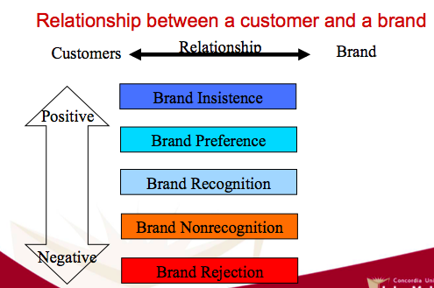
- special product for you, you don’t even compare it to other brands. Loyal customer.
- opportunity for spin-off (=capture lifetime value)
- people know and like your brand (ex : Apple)
- make product always available (because if it’s not people will switch brands)
- I know the product but I don’t have any opinion
- Work on differentiation, promotion to show benefits and competitive advantage
- new product, people don’t know it
- increase awareness through promotion
- people know your brand well but theu don’t want to buy it (ex : Blackberry)
- change target segment and positioning

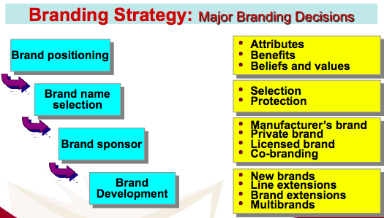
Brand strategy :
Brand equity is the positive differential effect that knowing the brand name as on the consumer response to the product or service.
One measure of equity is the extent to which people are willing to pay more for the brand. Brand valuation is the process of estimating the total financial value of a brand. Brand with strong equity have many competitive advantages : high consumer awareness, strong brand loyalty, helps when introducing new products, less susceptible to price competition.

Brand positioning :
- product attributes : least effective
- benefits
- beliefs and values : taps into emotions
Brand name selection : suggest something about the product or its benefits, easy to say, recognize and remember, distinctive, extandable, translate well into other languages, can be registered and legally protected
Brand sponsorship :
- manufacturer brands
- private (store) brands : costly to establish and promote, higher profit margins
- licensed brands : name and character licensing has growth
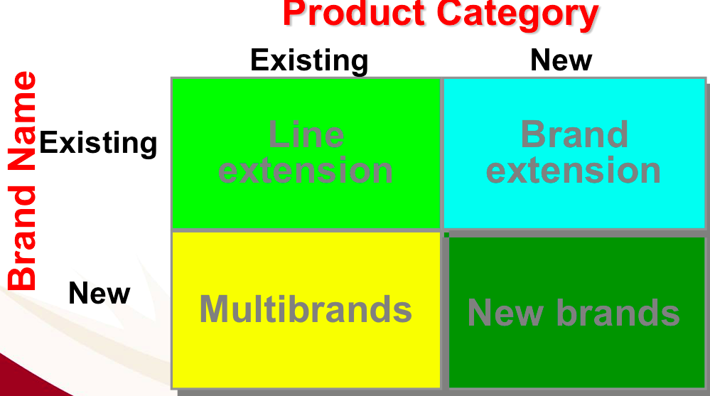
- co-branding : advatages/disadvantages (ex : TD and VISA works together on a debit visa)
Brand development :
- line extensions : minor changes to existing products (ex : new flavors)
- brand extensions : successful brand names help introduce new products (ex : Special K is Kellogg’s healthy line)
- multibrands : multiple products entires in a product category (ex : P&G =pantene, head&shoulders..)
- new brands : new product category (ex : Lexus)

Private branding : target different segments, retailer can earn more profit in private brands than in national brand. Enhance retailer’s bargaining power when dealing with national brand

 | LINE EXTENSION | BRAND EXTENSION | MULTIBRAND | NEW BRAND
Advantage | - keep same brand so keep brand loyalty and familiarity (low risk)  - low cost + utilize excess capacity | - instant recognition and faster acceptance  - saving high advertising costs (same brand) | - establish different features and appaeal to different buying motives  - allow company to lock up more reseller “shelf space” | - no effect from existing bad brand
Disadvantage | - lose its specific meaning, cause confusion or frustration of consumer  - cannibalization | - may confuse image of main brand  - if a brand extension fails, may harm consumer attitudes toward other products of the brand  - brand name may not be appropriate to new product | - each brand may obtain only a small market share and none may be very profitable (marketing and resources are limited) | - can result in a company spreading its resources too thin

Services marketing : 69% of canadian GDP, 75% of employment
Government services = courts, employment services, hospitals, police, firefighter, schools, postal services, military services..
Private not-for-profit services = museums, charities, churches, universities, foundations, hospitals..
Business organisation services = airlines, banks, computer and info services, insurance, consulting, medical and legal practises, entertainment..

4 service characteristics :
- Intangibility : cannot be seen, tasted, felt, heard or smelled before purchase. (-> Send right signals about quality, with “evidence management”)
- Inseparability : cannot be separated from their providers
- Perishability : cannot be stored for later sale or use + demand fluctuates (ex : rush hours) so service companies have to adapt (ex: hire more pers.)
- Variability : quality of services depends on who provides them and when, where and how
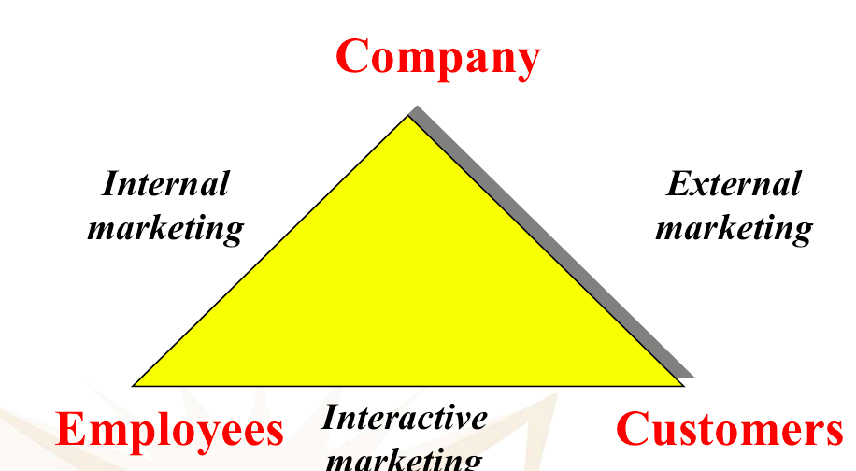
GOAL : differentiated services, quality and productivity

Differentiation : different offer, image and delivery (ex : hotels offer high speed internet), its achieved through symbols and branding
Quality : deliver higher quality than competitors. We can evaluate with consumer retention (because it depends on how consistent a company is in delivering value). Good service recovery is also essential to turn an angry customer to a happy and loyal one
Productivity : train better their employees, hire skilled employees, increase quatity by giving up a bit of quality (avoid !), add equipment, standardize production
1 – orienting and motivating customer contact employees and supporting service people to work as a team to provide consumer satisfaction
4 P ‘s
3 – Interactive marketing : training services employees n the fine art of interacting with customers to satisfy their needs
Internal Service Quality
Satisfied & Productive Service Employees
Greater Service Value
Satisfied & Loyal Customers
Healthy Service Profits & Growth

Superior employee selection, good environement to work in
Satisfied and loyal employee will be productive
Effective and efficient service delivery
And repeat purchase
Superior service firm performance

