CHAPTER 8
Why segment the market ? EFFICIENCY (make efforts more efficient by targeting people more likely to buy) + DIVIDE AND CONQUER (divide to best match custimer needs and provide superior value compared to competitors) + OPPORTUNITY (identify new opportunities not discovered by competitors)
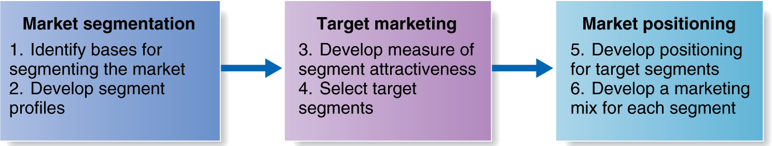
Market segmentation : divide market into distinct groups with distincts needs, characteristics or behaviors who might require separate product or marketing mixes.
Target marketing : evaluate each market segment’s attractiveness and selecting one or more to serve
Market positioning : create a clear, distinctive and desirable position in the target’s consumer mind

Basis for segmentation :
- geographic (region/country, city/rural, climate, density) -> business tend to adapt to different environement (ex : Walmart in Quebec have more cheese in stores than in Ontario)
- demographic (age, gender, family size, family life cycle, income, occupation, education, race, nationality, religion, generation)
- psychographic (social class, lifestyle, personality)
- behavioral based on knowledge, attitute, uses and response to a product/brand (occasions : when buyer get the idea to buy, benefits : what consumers seeks, user status : non-user, ex-user.., usage rate : light, medium, heavy user, loyalty status) -> ex : benefits of sportswear is different a normal person will seek function and style and an athlete will seek performance and function.

Segmenting markets effectively : homogeneous consumers within segments but heterogeneous consumers accross segments
- Measurable (size, purchasing power..)
Target market : consists of a set of buyers who share common needs or characteristics that the company decicde to serve (intermarket or cross-market segmentation is when consumers have same needs or buying behavior but are from different countries)

- Accesible (can be reached and served easily)
- Substantial (large and profitable enough to serve)
- Differentiable (respond differently)
- Actionable (effective programs can be developped)

Target marketing : evaluate market segments based on segment size and growth, segment structural attractiveness (level of competition, substitute products, power of buyers, powerful suppliers) and company objectives and resources
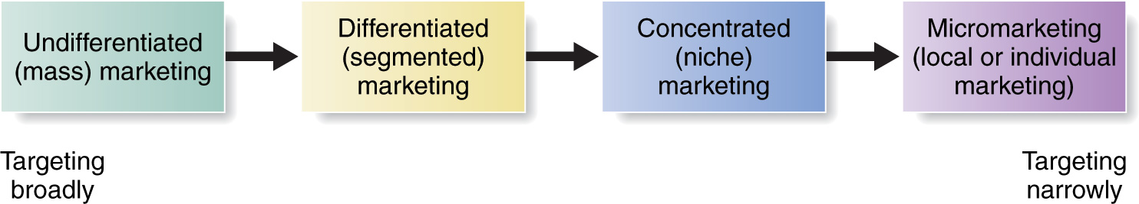

Socially responsible marketing : some segments (like children) are sensible to potential abuse, the issue is not targeting who but how and for what ?
Choosing a target marketing strategy :
- Company resources : if you have limited resources go for concentrated marketing
- Product variability : if you sell uniform product -> undifferentiated marketing, if it’s varying form of products -> differentiated or concentrated mark.
- Product’s life-cycle stage : new product = one version -> undifferentiated or concentrated marketing ; mature stage -> differentiated
- Market variability : from consumers’ need side (if most buyers have same tastes and react the same way -> undifferentiated marketing)
- Competitors marketing strategies : when competitors use differentiated or concentrated marketing, using undifferentiated is suicide, follow competitors
Concentrated (niche) marketing

Pursuing a large share of one or few submarkets (ex : truck for airports -> very small market segment but high share)

Advantages : more efficient and effective, small company can compete, can be highly profitable
Disadvantages : higher risks, threat from large competitors, rely heavily on one small market

Differentiated (segmented) marketing

Targeting several market segments and designing separate offers for each

Advantages : increase customer satisfaction, total sales increase, stronger prosition within segments
Disadvantages : more costs, cannibalization (internal competition)
Micromarketing (local or individual marketing)

Tailoring products and marketing programs to the need/wants of specific individualsand local customer gorups (local marketing)

Advantages : customisable, good for customer relationship, good quality product
Disadvantages : tailored product cost more, low economies of scale, logistics problem, brand positioning is not always clear
Undifferentiated (mass) marketing

Ignoring market segments differences and targeting the whole market with one offer

Advantages : cheap costs (prod. + marketing)
Disadvantages : not everyone will like it

Positioning : the way a product is definied by consumers on important features. The place the product occupies in consumer’s mind relative to competition. Involves implanting the brand’s unique benefits in the consumers mind. Segmentation is firm’s view of consumer, positioning leads the consuemrs view of the firms and its products. A key to positioning a product effectively is understand consumer’s perceptions (evaluation and judgments of the important features and existing brands).
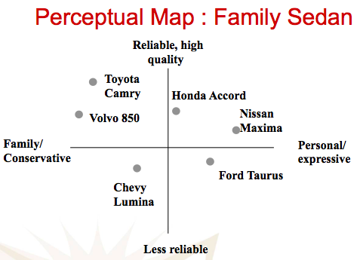
Choosing a positioning strategy :
- Identify possible competitive advantage (differentiation can be based on products, servies, channels, people, image..)
- Choosing the right competitive advantage (unique selling propositiong or advertise several benefits ; chose what feature to advertise based on importance, distinctiveness, value, communication, afforadable..)
- Selecting an overall positional strategy (value propositions represent the full positioning of the brand : marketing mix) possible values proposition : more for more, more for the same, more for less, same for less, same for much less)

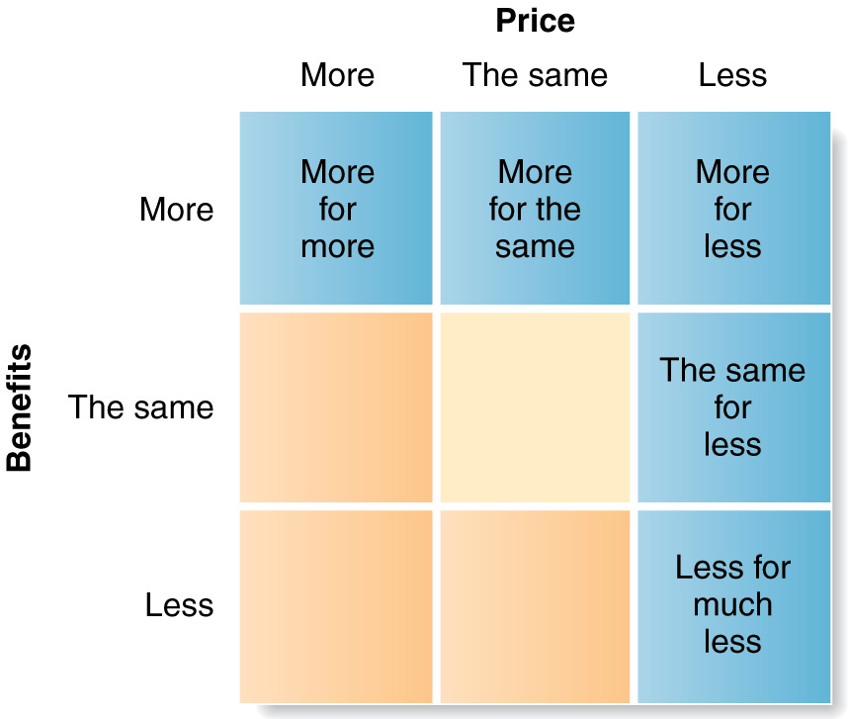
Repositioning : involves changing the place an offering occupies in a consumer’s mind relative to competitive offerings
Approaches to product positioning :
- head-to-head : competing directly with competitors on similar attributes in the same target market (ex : when pepsi introduced pepsi diet, coca cola introduced diet coke)
- Away/differentiation positioning : relate to existing mental structures in the consumer’s mind. Position the product against something consumers already know (usually away from the leader)
A positioning statement summarizes the company or brand positioning.

Companies must take strong steps to deliver and communicate the desired position to target consumers. The marketing mix efforts must support the positioning strategy (ex : more for more – high quality product, high price, few stores, narrow promotion). Positions must be monitored and adapted over time to match changes in consumer needs and competitor’s startegies
Dollarama, discount airlines
Amazon, best buy
GOAL (walmart)

lexus
Luxury goods
Loser
Loser
Loser
NO
C.A.

