CHAP 6
Advantage of focus group : flexible, you can observe reaction, stimulate other opinions, fast
Disadvantage : bias (people don’t tell the truth or if sample is not representative of population), one person can dominate discussion

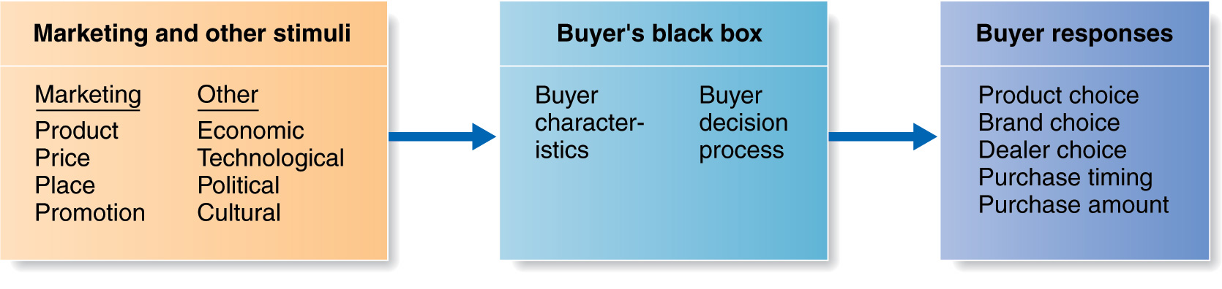
Consumer Buying Behaviour = help understand buying behaviour of final customers (personal consumption) and how to sell them your product (influence them)
Consumers are exposed to many stimuli including the marketing mix and other external factors (perception depends on consumer characteristics)
Marketing : controllable / other stimuli : out of control
Buyer response : observable so main focus is on buyer black box
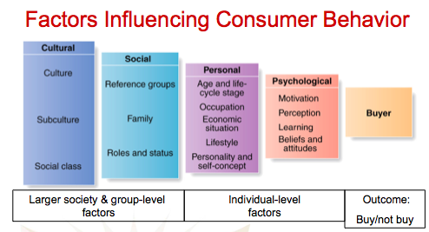
CULTURAL :
- Culture : (GOAL : spot cultural shift) set of values, perceptions, wants and behaviors learned from family and important institutions (core values remain stable)
- Subculture : group of people with shared value systems based on common life experiences and situations (ex : Quebecers= bilinguals, more history, European style, party hard) (question : member of visible minority ? mature or young customer ?..)
- Social classes : relatively permanent and ordered divisions in a society, share similar values, interests and behaviors. Measured by a combination of income, occupation, education, wealth and other variables. Consumer behaviors are consistant within a given social class

SOCIAL :
- Groups : consumers belong to membership groups (ex: Concordia), compare themselves to reference groups (ex: McGill) and may aspire to becoming a member of a group (ex : Canadians of Mtl). Group influence varies across products/brands, strongest when the product is visible to (respected) others (you’re influenced by peers, if all your friends have an iphone you might want an iphone). Opinion leader (or influentials) = person within a reference group with skills, knowledge, strong personality who has exerts power of others (ex : celebrity)
- Family : first and strongest influence on behaviour (trend : children know brands early).
- Initiators (gives the idea)
Purchases roles in family
You can decide to convince consumer (who will convice purchaser) or directly convince purchaser
- Influencers (make comments on purchase)
- Decision makers (ex : parents)
- Purchasers (who give the money)
- Consumers (who use the product)
- Roles and statuts : consumers play many roles, each requiring some type of consumer behaviour, products can be used to show status (you buy product reflecting your status)
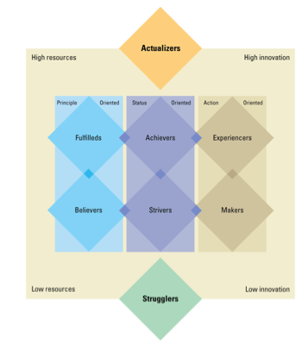
PERSONAL :
- Age and lifecycle stage : Consumer needs change over their lifetimes in (somewhat) predictable ways (having a baby, getting divorced..). Family life cycle combines age with marital status and presence of children to classify consumers into groups (young/middle aged/older)
- Occupation : type of work performed may necessitate different consumption patterns (businessman : suit/cashier : sneakers), it will also affect how much income is available
- Economic situation : ability to borrow, economic factors such as employment, inflation, interest rates and consumer debts levels are used to predict changes in buying power
- Lifestyle : Person’s pattern of living as expressed by their activites, interests and opinions (AIO’s), lifestyle segmentation (ex: vegan, organic..)
- Personnality : Unique psychological characteristics leading to relatively consistent and lasting responses to one’s own environement, traits (confidence, autonomy, sociability..) consumer will choose brand that is consistant with its personality. Lifestyle classification table (next)

PSYCHOLOGICAL :
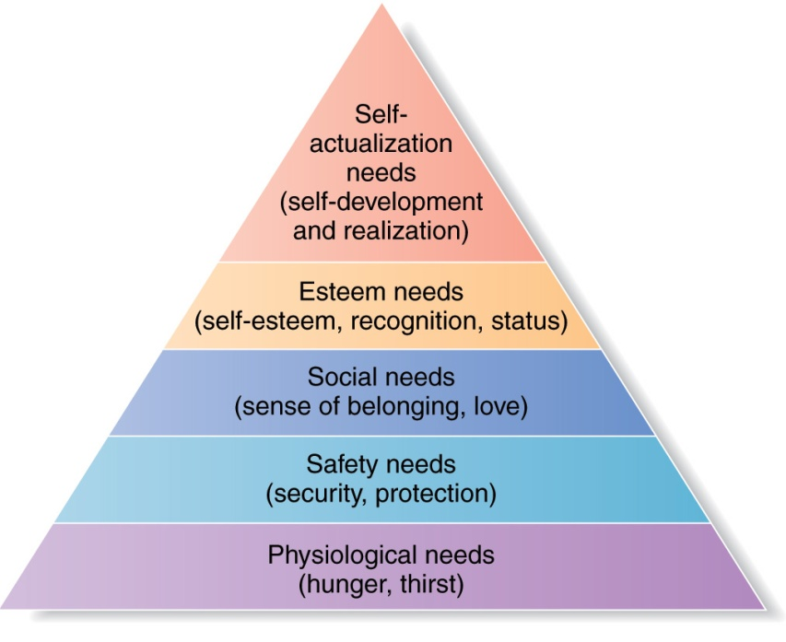
- Motivation : humans are characterized by goal-directed behaviour, different needs/wants produce different behaviour. Motivation = a need that is sufficiently pressing to direct the person to seek satisfaction
- Freud : focused on hidden and unconscious urges directing our behaviour
- Maslow (left) : hierarchy of needs focuses on how needs can be classified in terms of important
- Perception : process by which people select, organize and interpret information
- Selective attention = screen out most of info to which you’re exposed
- Selective distortion = interpret info in a way that will support what you already believe
- Selective retention = retain the info that supports personal attitude and beliefs (ex: don’t remember anything bad about apple)
- Learning : changes in an individual’s behaviour arising from experience (through drives, stimuli, cues, responses and reinforcement), consumer learn what satisfies their needs and what doesn’t (ex : Corona is showing a beach 1rst (unconditional stimulus : relaxing feeling) then show the beer (conditional stimulus) then combine them a lot at the end we associate beer to a relaxing feeling without seing the beach)
- Beliefs and attitudes : Belief = descriptive thought about something. Attitude = a person’s consistently favourable or unfavourable evaluations, feelings and tendencies towards something (difficult to change)

BUYER DECISION PROCESS :
Influenced by :
- level of involvment (interest) in the decision
- memory (internal) search
- external search : commercial, trials, sources of info..
- Word-of-mouth (most influencial)
Evaluation procedure depends on the consumer and the buying situation. Attributes and importance weigths are chosen as criteria. Alternatives compared against the criteria.
Do I need it right now ? Can I fin dit cheaper ?
Evaluate : price, quality, ease of use, length of life, warranty, style/look, ease of maintenance..

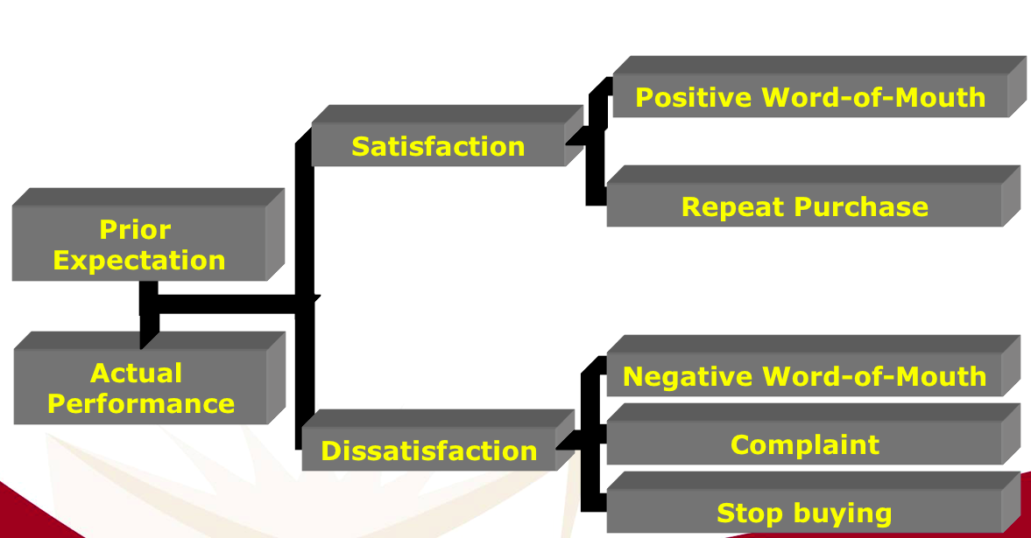
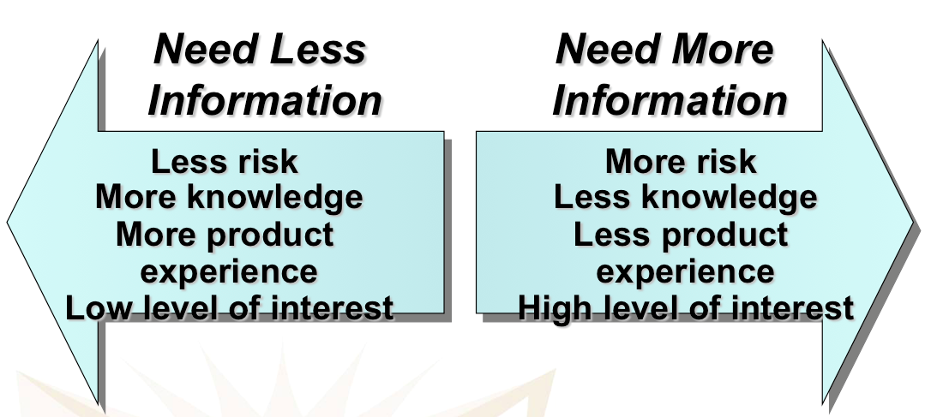
Triggered by internal (i need a car to go to work) or external (need is created by smelling smtg good) stimuli. Must reach an intensity high enouth to become a drive
Two factors interced between purchase intentions and actual decision :
- attitudes of others
- unexpected situational factors

What the consumer thinks and does after purchasing and using the product/service.
Relationship between consumer expectation and perceived performance

Cognitive dissonance : when you regret your choice. Buyer discomfort caused by postpurchase conflict -> good reason for customer follow-up programs (reinsure them)
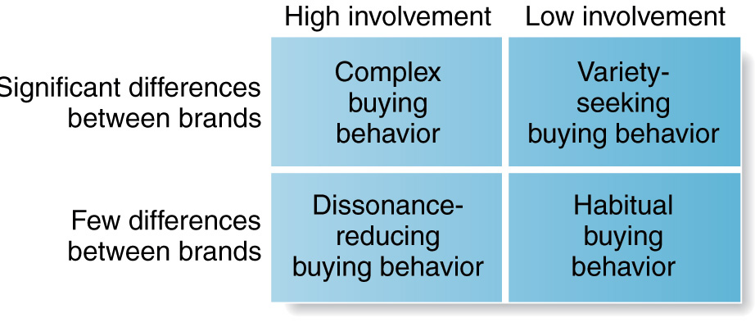
Want to try something different (ex : different flavors), not about brand loyalty or dissatisfaction. Be attractive
Types of buying decision behavior :
- Degree of involvment : how much consumer cares about purchase decision (expensive ? risky ? purchased infrequently ? ..)
- Degree of perceived difference between brands

Type of decision will influence the promotional strategy most likely to be effective

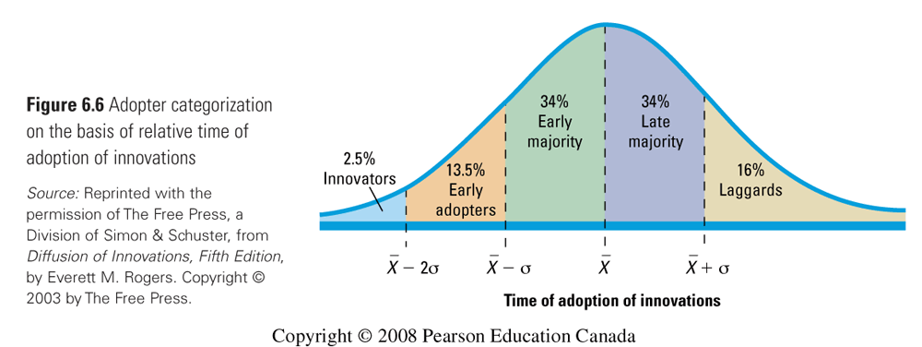
Consumer scan be classified into 5 adopter categories, each of which behaves differently toward new products
- Innovators : young, money-driven, like to take risks
- Early adopters : their behavior influance others
- Early Majority
- Late majority : skepticals
- Laggards : suspicious at changes

Influence of product characteristics on rate of adoption :
- Relative advantage (compared to existing product)
- Compatibility (how easily it can fit in your lives)
- Complexity (is it hard to use)
- Divisibility (can you offer trials easily)
- Communicability (word-of-mouth)

Ex : you don’t buy a TV cable if TV channels don’t exist
NEW PRODUCTS :
Adoption process : Mental process trough which an individual passes from 1rst hearing about the innovation to final adoption (Awareness ; Interest ; Evaluation ; Trial ; Adoption)

Low knowledge, we can’t know the difference, not confident druing purchase --> lead to cognitive dissonance
Frequent purchase (brand familiarity)
I know what I’m looking for, confident purchase (brand conviction-

