CHAPTER 5
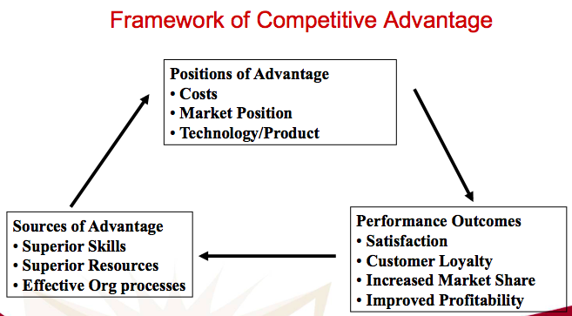
Important to analyze competition to identify competitive advantage and competitors

Competitive advantage : something that your company does especially well in comparison to others (must be difficult to imitate). Ex : High quality product, low cost/low price, superior customer service, convenient distribution

Marketing Information System : people and procedures for assessing information needs, developing the needed information and helping to analyse and use info to develop customer insight, make marketing decisions and manage customer relationships
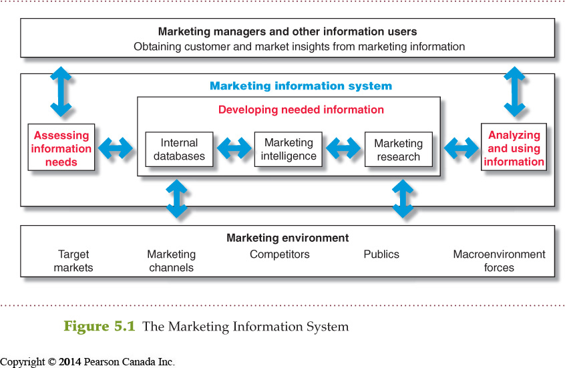
(Customer insight : fresh understanding of customers and the marketplace)

Customer Relationship Management (CRM) = managed detailed info about individual customers and manage their touchpoint to maximize custimer loyalty

Data mining = sending promotion or ad based on customer gender, habit, or spending pattern (ex : Gilette sends promo to men, Pampers sends promo to woman around 30..) -> part of CRM

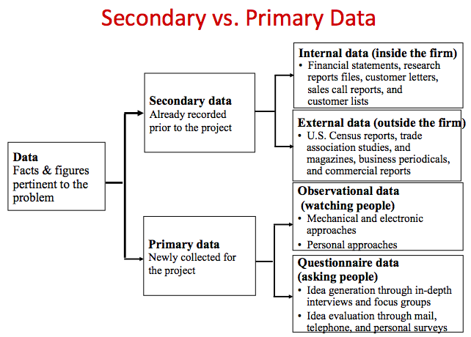
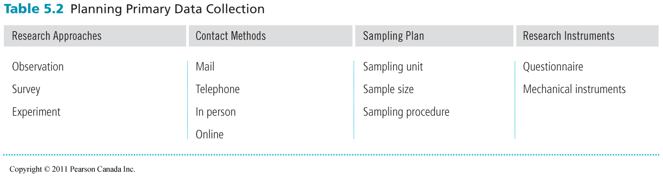
- Define the problem & research objectives : manager and researcher must work together

- Exploratory research (gather preliminary info to help better define problems and opportunities via observation, interview)
- Descriptive research (research to better describe marketing problems, situations, attitudes of consumers.. via surveys, personal interview)
- Causal research (research to test cause and effect relationshhip between variables via experimental approach)

- Developing research plan : translate research objectives into specific info needed (choose between primary/secondary data)

Primary data completes the research in secondary data

Type of sample :
PROBABILITY SAMPLE
- simple random sample (equal chance of selection in pop)
- stratified random sample (pop is divided into groups and samples are taken from each group)
- cluster sample (pop is divided into groups, only one group is picked)

NON PROBABILITY SAMPLE
- convenience sample (easiest pop members to obtain info)
- judgment sample (researcher use his judgment to select sample from pop)
- quota sample (researcher finds and interviews prescribed nb of people in each categories)

During surveys careful about leading question, avoid ambiguous questions, unanswerable question, two question in one or non-mutually exclusive answers
3. Implement research plan : data is collected, processed and checked for accuracy and completeness, then analyzed

4. Interpreting results : researcher interprets findings, draw conclusions and report to management

