CHAPTER 3

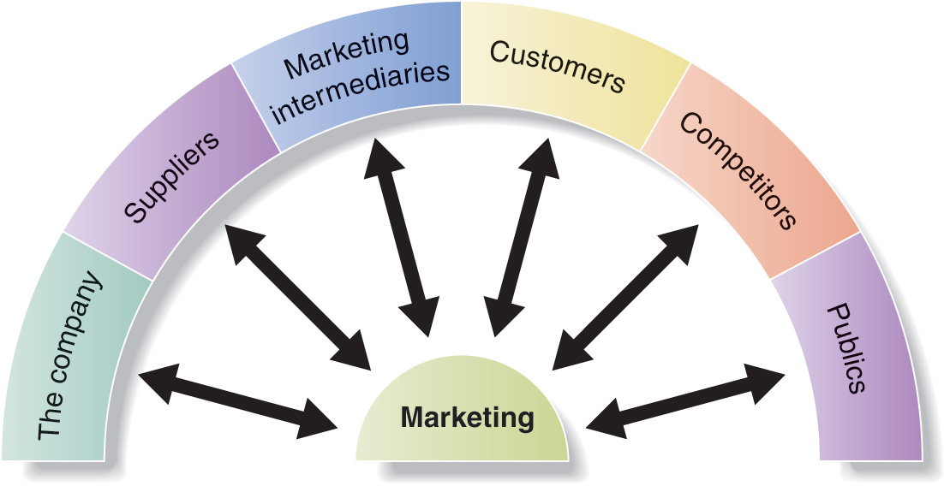
Marketing environment : actors and forces outside marketing that affect marketing management’s ability to build and maintain successful relationships with target customer
Other parts of the company (R&D, accounting..)
Marketing decisions must relate to broader company goals and strategies
Marketers must watch supply availability and pricing
Effective partnership with suppliers is essential
They help to promote, sell and distribute goods to final buyers (resellers, physical distribution firms, marketing agencies..)
Effective partnership with them is essential

5 customer market :
-Consumer (personal consumption) B2C
-Business (production) B2B
-Reseller (resell)
-Government (public service or giving to people in need)
-International (same but in other countries)
Competitor analysis is critical for success
Marketers must monitor its competitors’ offerings to create strategic advantage
Public=any group that has an actual or potential interest in or influence on an organisation
7 publics :
-Financial (ability to obtain funds)
-Media (carry news, features, opinion)
-Government (respect the laws)
-Citizen-action (take minorities.. in consideration)
-Local & General (public image)
-Internal (how your employees see your company)

MICROENVIRONMENT
Demographic trends in Canada :
-population is aging
-fewer children
-children tend to stay with their parents longer
-more dual-income families
-single parent families, extended families, same sex marriage, disabled people living alone..
-people move to suburban areas (no more rural)

Pay attention to income distribution rather than average income

MACROENVIRONMENT :

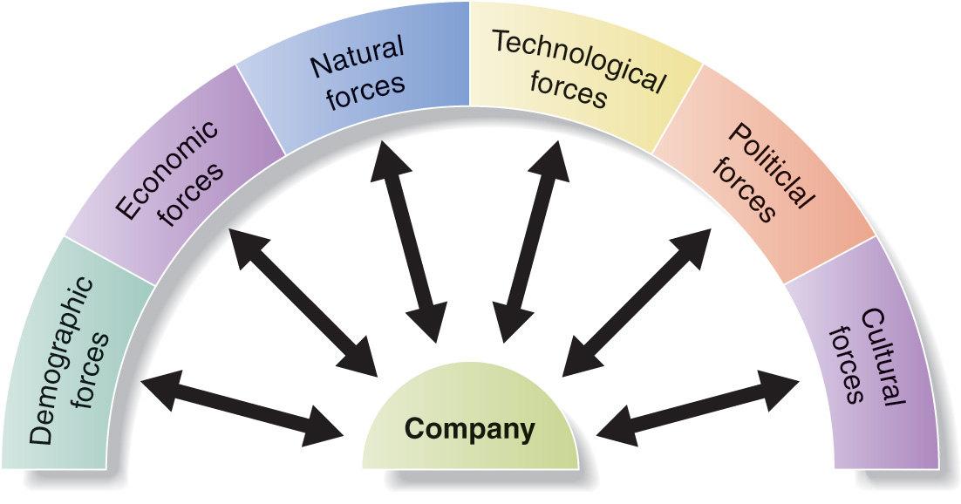
Study of human population in terms of size, density, location …
Very useful for companies to find target consumers and understand their needs (buying power, spending patterns..)

Baby boomers : 1947-1966
-Represent 30% of population, 40% workforce and 50% of personal income
-Earn a lot of money, work longer and spend wisely (due to recession)
-Target industries : health, babks, insurance, travel agency
Generation X : 1967 – 1976
-not optimistic about future economy, skeptical
-spend carefuly and tend not to believe in marketing pitches
-primary market (replace baby boomers + lot of woman entered workforce)
Generation Y or Millennials : 1977 – 2000
-confortable with technology, highly educated
-attractive and challenging target for marketers (we like to try different things but we like to change brand + we know how to search good deals) + huge life time value
-confident about future, we tend to take more risks and spend more
3 type of economies
Subsistance : very poor countries, you just consumer what you have/produce, low potential
Developping economies : offer outstanding marketing opportunities
Industrial economies : rich market for many different kind of goods

Engel’s law : what you will buy if you have more money (change in spending patterns)
Involves natural resources that are needed are affected by marketing activities (inputs..)

Trend :
-increase pollution
-increase government intervention
- green movement
-focus on sustainability
Most dramatic force shaping our destiny. Rapidly changing force which creates many new marketing opportunities (but also push existing products out of date)
Government agencies regulate new product safety (to prohibit dangereous products)
Consists of law, government agencies, pressure groups that influence or limit various organizations and individuals in given society (they protect companies from each other + protect consumers from unfair business practises + protect society’s interest agains unrestricted business behavior)
Made up of intitutions and other forces that affect society’s basic values, perceptions, preferenecs and behaviors.
-persistence of cultural value
-secondary cultural values (more subject to change with time)

Companies can be engaged in worthwhile causes (ex : every purchase = $1 to poor children)
Cultural environment includes people’s views of :
-themselves (identify woth brands for self-expressiob)
-others (recent shift from « me » to « we » society)
-organizations (trend of decline in trust and loyalty to companies)
-society (patriotism on the rise)
-nature (« lifestyles of health and sustainability » on the rise)
-universe (includes religion and spirituality)

MACROENVIRONMENT

Some companies are “proactive” and craft their strategies to design environments, others simply watch and react to changes

CONTINUUN OF COMPETITION

BASIS OF COMPARISON | Pure competition | Monopolistic competition | Oligopoly | Monopoly
- nb of sellers  - product differentiation  - importance of marketing mix (4 P’s) | - similar products  - many sellers  - price takers  - focus on distribution | - unique but substitutable product  - many sellers  - different range of prices (ex : clothes)  - focus on price + product itself | - few players  - similar products (Ex : Coca/Pepsi)  - focus on promotion | - One seller  - Unique and unsubstitutable product  - Price maker  - SAQ, Hydro Quebec  - Focus on places
Many sellers

One seller

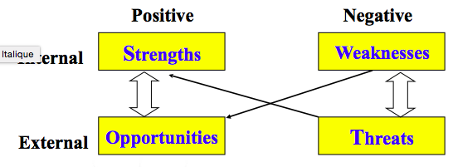
SWOT ANALYSIS
vulnerability
constraints
problems
leverage
External factors (macroenvironment) : identify opportunities/threats

External factors (uncontrollable)
-competition
-political/regulatory
-economic
-social/cultural
-technological
Internal factors (microenvironment) : identify strength/weaknesses

Internal factors (controllable)
-financial resources
-technological expertise (R&D..)
-cost structure
-relationship with supplier
-relationship with customer
-human resources

Evluate the impact of each factor : Internal factors are usually evaluated against both existing and potential competitive markets. External factors are evaluated with respect to positive and negative factors identified (internal)
Positive factors (strength or opportunities) / Negative factors (weaknesses or threats)

