CHAPTER 2

Strategic Planning : overall strategy for long-run growth and profitability. Develop/maintain strategic fit (identify opportunities (out of control) that are good for you based on you capabilities)

- Define company’s mission
- Set company’s objectives and goals
- Design business portfolio
- Plan marketing and other functional strategies
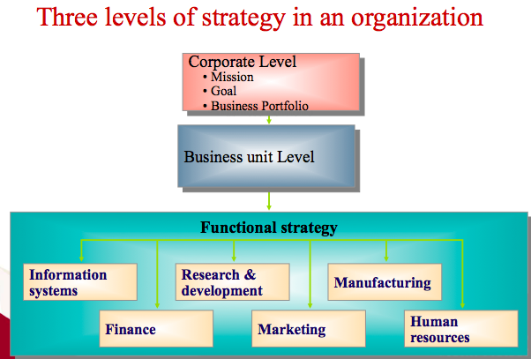
Name of the company (ex : Apple)
Different kind of products available (ex : iphones, ipod..)
1 functional strategy for each business unit (product)

1. DEFINE MISSION
Like a core purpose, it’s state company’s purpose (what they want to accomplish), it’s an “invisible hand” that guide and motivate the company, it can’t be too narrow or too broad. It should be :
- Market oriented (not product oriented because a product can go out of date)
- Realistic
- Specific
- Motivating

2. SET OBJECTIVES AND GOALS
Mission is turned into precise business objectives (much more specific), company has to develop strategies to achieve goals. Type of goals :
- profit
- revenue
- market share
- quality
- consumer satisfaction

3. DESIGN BUSINESS PORTFOLIO
Business portfolio is the collection of businesses and products that make up the company. Business portfolio planning involves two steps :

- Analyzing current business portfolio (identify/evaluate businesses and make resource allocation decisions)
Identify Strategic business unit (SBU : brand, product or model) : unit with separate mission and objectives, planned independently from other businesses.

BCG Matrix : use to assess how much support a SBU deserves. Affected by market growth rate (attractiveness of market) and relative market rate (how strong you are in the market)

Strategies in BCG Matrix :
- to build : $↑$ cash invested
- to hold : no change in cash (stay like this)
- to harvest : $↓$ cash (rely on other things : reputation..)
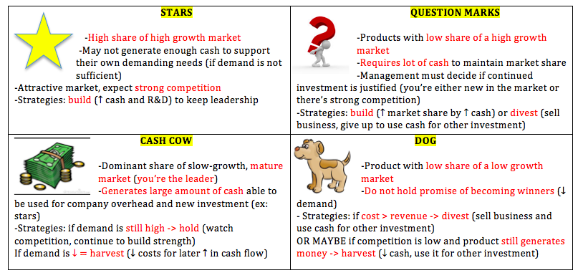
- to divest : $↓$ cash a lot (give up)
MARKET GROWTH RATE

RELATIVE MARKET SHARE

- Shaping future portfolio by developing strategies for growth and down sizing
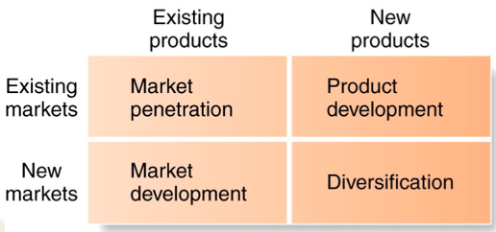
Marketers must identify, evaluate and select market opportunities and lay down strategies for growing some business portfolio but also for downsizing others (dogs..) Companies must be careful not to make growth itself an objective (must manage profitable growth).

Product Market Expansion Grid (portfolio-planning tool for identifying company growth opportunities)
- Market penetration : make promotions (to sell more), open new stores..
- Market development : open stores in new area (sell to new customers)
- Product development : new sandwiches at Tim Hortons
- Diversification : ex : Yahoo create a home page with local info for every country.

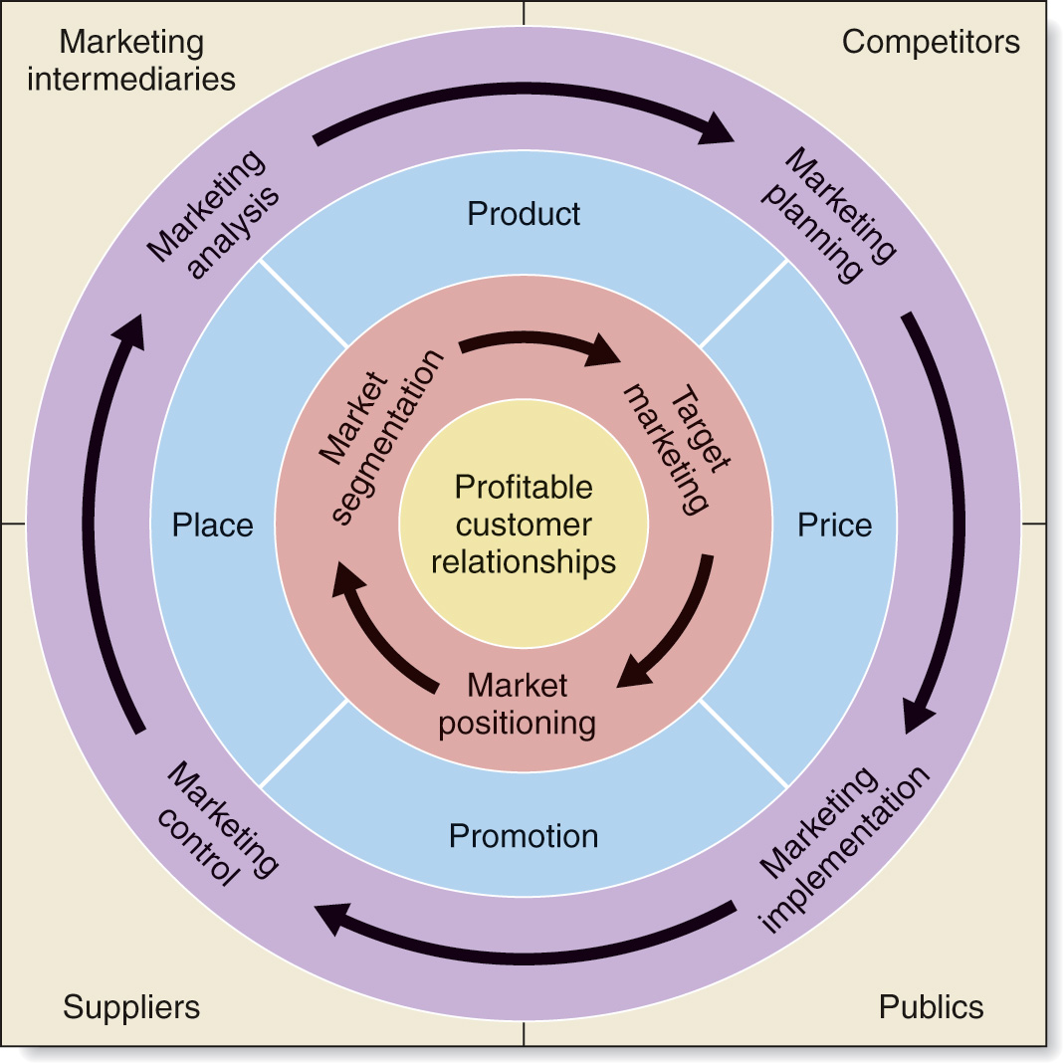
4. PLAN MARKETING AND OTHER FUNCTIONAL STRATEGIES
Value chain : departments work together to deliver products with lowest costs and highest value
Value delivery network involves company, suppliers and distributors they have to partner with each other to improve the performance of the whole system.

Marketing Strategy : marketing logic by which the business unit hopes to achieve its marketing objectives (create customer value and achieve profitable customer relationship)
Marketing mix : company designs a mix made up of factors under its control (4 P’s)
Firm watches and adapts to the actors and forces in the marketing environment.
Customer-centered Marketing strategy :
- Market segmentation (dividing)
-Dividing market into groups with distinct needs and who will respond in similar way to marketing efforts (homogeneous groups)
- Target Marketing (analysing and choosing)
Evaluating the attractiveness of each market segment, select the one with greatest long-term profitability, decide which segment to enter
- Market Positioning (finding your place)
Find the place that the product occupies in consumer’s mind relative to competing products. Marketers look for clear, distinctive and desirable places in positioning (customers know what to expect from you). Differentiation by offering and delivering greater value.

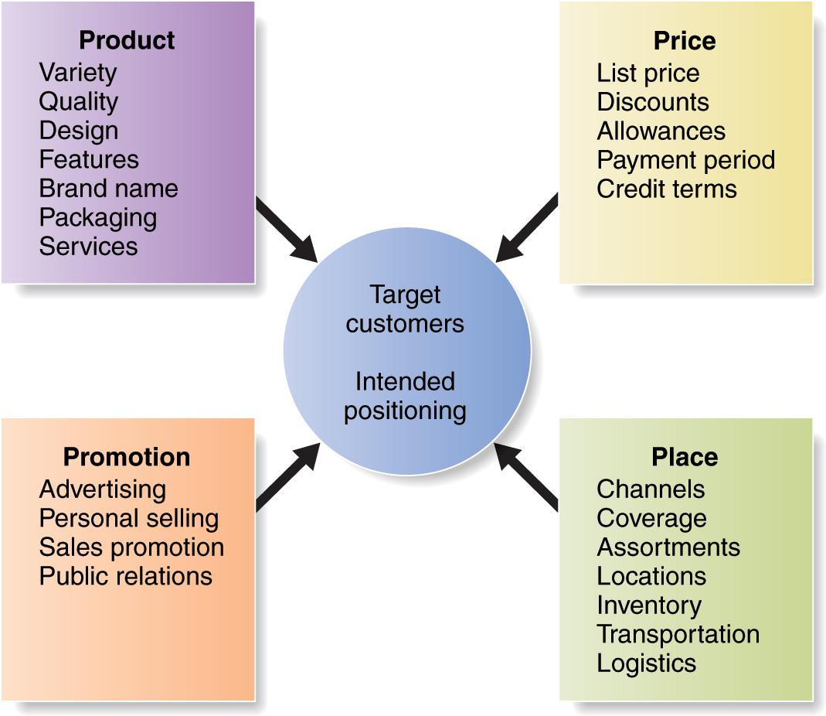

MARKETING MIX
4 P’s must be consistant
4 P’s are for company, for consumers :
- product = consumer solution
- price = consumer cost
- place = convenience
- promotion = communication

Managing the marketing effort :
- Market analysis : internal and external analysis (SWOT analysis)
- Marketing planning : deciding on marketing strategies to attain objectives (why and how)
- Implementation : turning plans into action (execution)
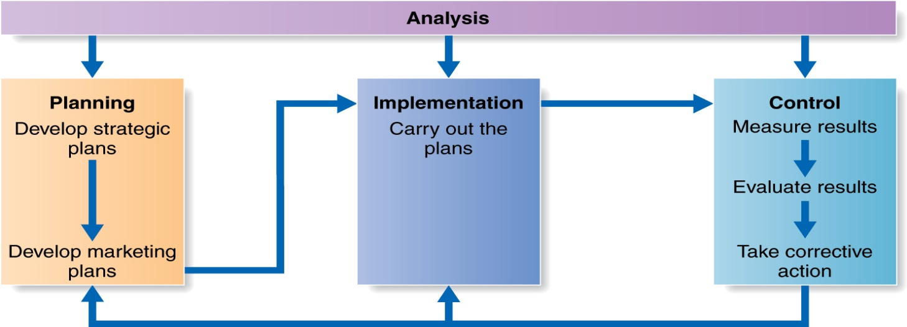
- Control : evaluating the results

Return on marketing (Marketing ROI) : net return from a marketing investment/costs of investment -> hard to measure, some features are not tangible (brand awareness, customer satisfaction..), marketing is not an expense it’s an investment.

