CHAPTER 1
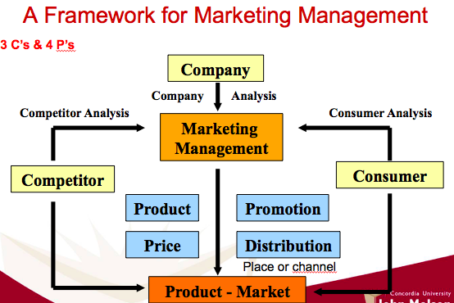
Marketing : managing profitable customer relationships (attraction and retention) by satisfying customer’s needs.

Marketing process
- Understand the marketplace
Create value
- Design a customer-driven marketing strategy
- Preparing a marketing plan & program
- Building customer relationships
- Capturing value from customers

1. UNDERSTAND THE MARKETPLACE
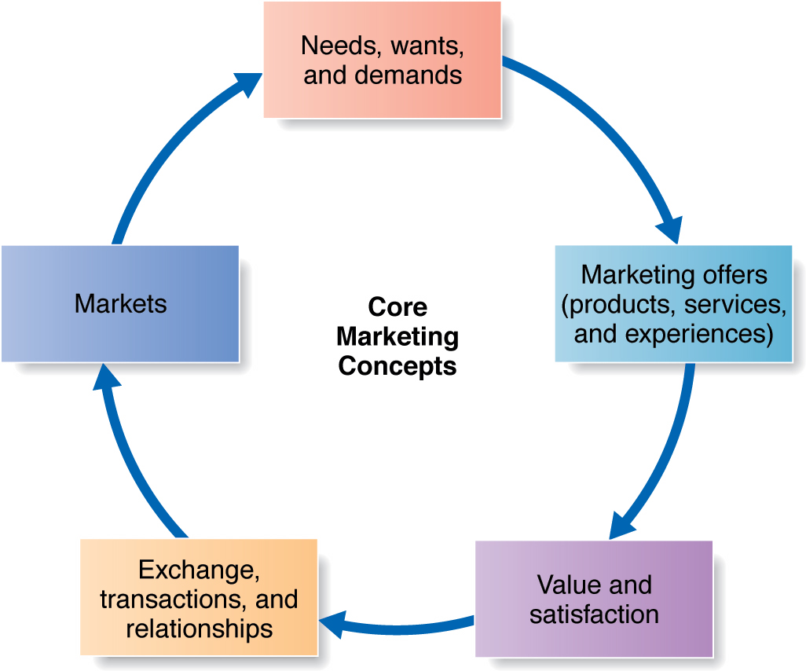
Needs :
-not created by marketers
-state of felt deprivation (physical, social, individual)
Ex : I’m thirsty
Wants :
-form of your needs shaped by your culture and the individual
Ex : I want a coke/tea/water
Demands :
-wants which are backed by buying power
Ex : I have the money to buy only water
Combinaison of products, services, information of experiences that satisfy a need or a want (MUST PROVIDE A SOLUTION)

Careful about Marketing Myopia : forget that a product exist to solve a consumer problem
Value :
-customers form of expectations regarding value
-marketers must deliver value to consumers
Satisfaction :
-a satisfied customer will buy again and tell others about their experience.
-Act of obtaining a desired object from someone by offering something in return
-One exchange is not the goal, relationships with several exhanges are the goal.
-set of actual and potential buyers of a product
-marketers seek buyers that are profitable

2. DESIGNING A CUSTOMER-DRIVEN MARKETING STRATEGY

Marketing Management : Find, attract, keep and grow target customers by creating, delivering and communicating superior customer value. (Choose the right customer and make them happy)
- Market segmentation (divide people in segment, people in the same segment have same behaviour)
- Select customers that are profitable
To serve customers best, you have to differentiate yourself from other companies (with brand culture) + set values and benefits your company will deliver to consumers to satisfy their needs.
- Production concept
Consumers will favour available/affordable products, firms should focus on improving production/distribution efficiency. USEFUL PRODUCT
- Product concept
Consumers favour products with the best : quality, performance, features. Focus on continuous improvements (but don’t fall into marketing myopia)
- Selling Concept
Unsought goods (what people don’t think of, ex : an insurance company will sell the insurance plus other features to the customer) + hard sell (convincing your customer to buy something because they have little knowledge about it).
- Marketing concept

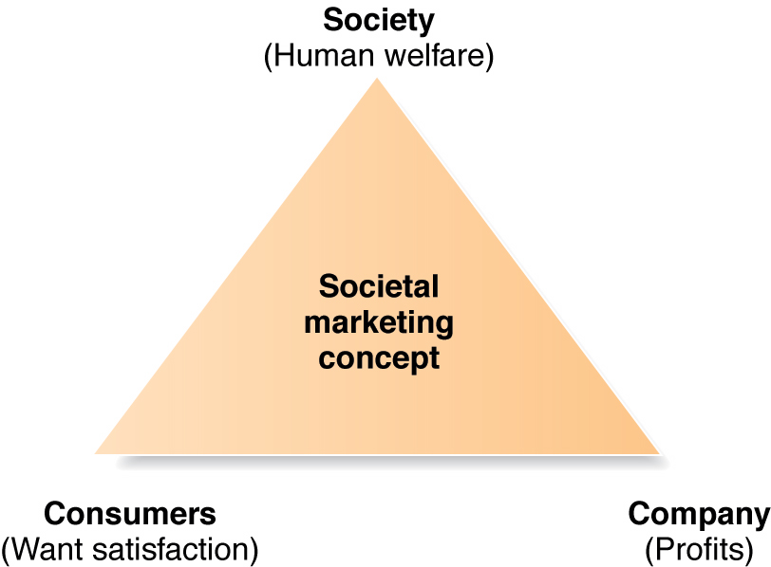
Societal marketing calls sustainable marketing
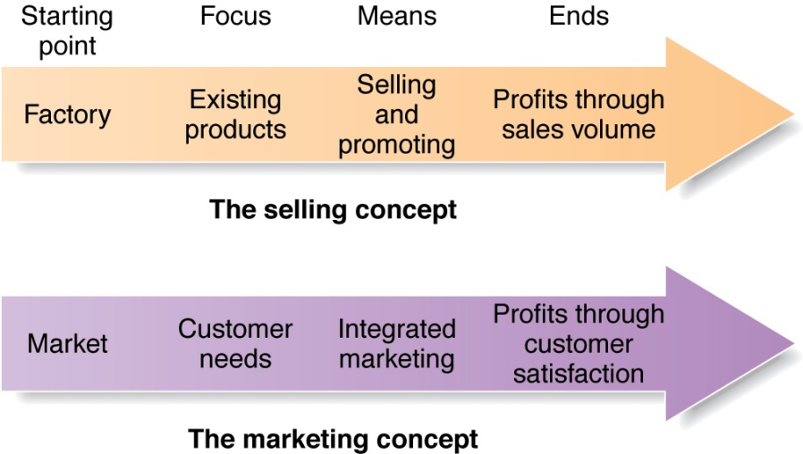

3. PREPARING A MARKETING PLAN AND PROGRAM
Build customer relationship by transforming the marketing strategy into action (marketing mix and 4 P’s)

4. BUILDING CUSTOMER RELATIONSHIPS
Customer Relationship Management (CRM) : process of building and maintaining profitable customer relationships by delivering superior customer value and satisfaction. Depends on :
- Customer perceived value (their evaluation of the difference between benefits and costs, ex : in a recession some people think price should decrease)
- Customer satisfaction (product’s perceived performance relative to customer’s expectations)

You can improve your relationship level with :
- full partnerships (with key customers that you know well)
- frequency marketing program (reward customers who buy frequently or in large amount)
- club marketing programs (offer members special discounts + create member communities)
It’s important to work closely with partners in other companies, inside the company and suppliers.

5. CAPTURING VALUE FROM CUSTOMERS
Customer’s satisfaction leads to emotional relationships and loyalty + you capture their lifetime value (shows the true worth of a customer)
Growing share of customer : portion of company’s products of total customer’s purchases., it’s achieved through offering greater variety cross-sell (different products, ex : from Sony TV to Sony camera) and up-sell (higher and higher models) strategies. Increase market share (measurement of past/current performance) and Customer equity (measurement of future performance)

