Thin Layer Chromatography and Extraction
Lab #1

Lab week 2
Section 2
Date: January 14, 2014

Demonstrators Name:

Introduction:

Chromatography is known as a method of separation, where the components that are desired to be separated are distributed between two phases; one of the phases is stationary phase and the other is a mobile phase (Wixom & Gehrke, 2010). There are three general types of chromatography. One of the types is called Thin Layer Chromatography (TLC). TLC involves a very thin layer of sorbent layer on top of a material such as glass, plastic or aluminium for support (Snyder, Kirkland & Dolan, 2010). There are many different kinds of sorbent layer that can be used, but a few common ones include silica gels, cellulose, and aluminium oxide. This is called the stationary phase. Samples are then applied in spots to the sorbent layer. Next, an eluent is allowed to flow through the sorbent, starting at a point just inferior to the spots where the samples were applied. This is achieved by placing the eluent in a jar or glass box where the eluent is about 5mm high and after the sorbent plate is placed within it, a lid is placed on top to prevent evaporation. As the eluent front moves up the sorbent layer, the samples do as well. The speed of the movement depends on the hydrogen bonding between the samples and the eluent, and the force of the eluent itself. For an example, when a highly polar eluent is used, the force of the eluent is so strong that the samples will rise much farther up the paper compared to an eluent with no force. However, the solvent front goes at one rate whereas the different samples migrate at different rates depending on their polarity. This is how the samples are separated. Once the eluent front has moved up the paper to about 1cm from the top, the TLC is looked at under a UV light where the spots can be clearly visualized (Wall, 2005).
The distances that different samples travel on thin-layer chromatograms are described by R_{f} values. An R_{f} value can be calculated by $\frac{distance sample travelled}{distance eluent travelled }$ . Calculating the R_{f} value for each sample is how they are quantitatively separated. (Fried & Sherma, 2005)
Another efficient separation technique is called an extraction. A product can be purified or isolated if the two solutions that are mixed are immiscible. Two layers will form and the solution with the heavier density can be drained out (Bart, 2001)

Reactions:

Procedure:
Refer to Experiment 1: Extraction and Think Layer Chromatography, in the Organic Chemistry 1 Laboratory Manual for CHM1321 course in the Winter session of 2014 at the University of Ottawa. Exceptions: In step 8 of part D, add 100mg of mixture (benzophenone and benzoic acid) in the Erlenmeyer flask.

Data and Tables:
Table 1: R_{f} Values for solutions in 2:8 mixture of ethyl acetate and hexanes
Solution | R_{f} Value
Benzophenone | 0.60
Biphenyl | 0.84
Unknown in figure 1 | 0.60
Unknown in figure 1.1 | 0.64

Table 2: R_{f} Values for solutions in ethyl acetate
Solution | R_{f} Value
Unknown | 0.93
Biphenyl | 0.95

Table 3: R_{f} Values for solutions in hexane
Solution | R_{f} Value
Unknown | 0.27
Biphenyl | 0.63

Table 4: R_{f} Values for an aqueous solution and a mixture (benzophenone and benzoic acid) in 2:8 mixture of ethyl acetate and hexanes
Solution | R_{f} Value
Aqueous | 0.04
Mixture | 0.57

Table 5: R_{f} Values for an organic solution and a mixture (benzophenone and benzoic acid) in 2:8 mixture of ethyl acetate and hexanes
Solution | R_{f} Value
Organic | 0.68
Mixture | 0.68

Calculations:

Question:
- Increasing the polarity of the solvent system affects the results by moving the components of the mixture faster up the paper. This happens because when the silica and the solvent interaction increases, the interaction between the silica and the sample is not as strong so the sample will not cling on as easily.

- a) Benzyl alcohol would have the smallest R_{f} because it is the most polar of three molecules therefore it would stick to the polar silica the most.
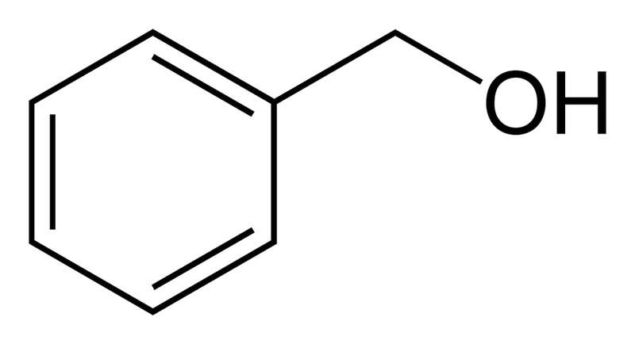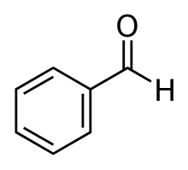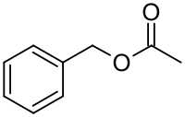
b)N,N-dimethylaniline would have the smallest R_{f} because it is the most polar of the three molecules therefore it would stick to the polar silica the most.
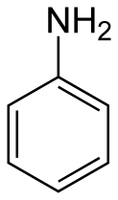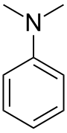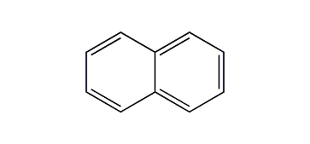
c) Benzoic acid would have the smallest R_{f} because it is the most polar of the three compounds therefore it would stick to the silica paper the strongest and not travel up.
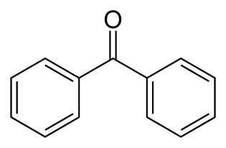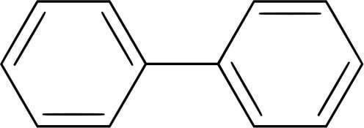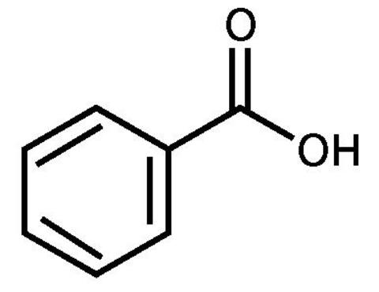
- It would be difficult to perform an extraction using ethanol and water because ethanol is soluble in water. Therefore, when they combined they would mix instead of separating.
- By adding NaCl to a test tube containing water, ether and methyl blue, the amount of dye in the aqueous layer would decrease due to the salting out effect. Salting out increases the ionic strength of the aqueous phase and pushes out the organic compounds. The methylene blue is an organic dye so it will be pushed into the organic layer.

- If a student lost track of which layer was organic or aqueous, the student could wither use the drop test or search up the density. The drop test is when a water droplet is dropped on top of the solution and if the student can see it drifting down into the bottom layer, then the bottom layer is water because it will go towards the aqueous layer. The solution with the heaviest density will go to the bottom so if water has a heavier density it will be the bottom layer.

- If you had a mixture of benzyl amine and naphthalene you would add an acid to it to make the organic base charged which would then make it soluble in water. After this you could add water and an ether. The benzyl amine which is now charged and soluble in water would dissolve in the water layer and the naphthalene which is not soluble in water would dissolve in the ether layer.

Flow chart between benzoic acid and benzophenone

Discussion:
In this experiment, the polarity of compounds and effects of eluents were discovered by preforming an extraction and multiple TLCs.
In part A when methylene blue was added the test tube containing an ether and water it was originally purple throughout. Once the NaCl was added the purple faded from the water layer because the ionic strength of the water increased with the added charges from NaCl. Since the methylene blue is an organic dye it moved up with the organic layer because the organic layer is immiscible with water.
In part B the unknown 81 was determined to be benzophenone because of their identical R_{f} values. The R_{f} values were determined by producing two TLC, one which compared benzophenone with the unknown and the other that compared biphenyl with the unknown. The benzophenone TLC only showed one co-spot which is a result of the same compound. The R_{f} value of benzophenone was 0.6 and the R_{f} value of biphenyl was 0.84; this can be seen in table 1, figure 1 and figure 1.1. The higher the R_{f} value, the farther the compound travelled. The fastest compound is the most non-polar because a non-polar compound is repulsed by the polar eluent and the polar silica plate.
In part C the unknown and biphenyl were placed onto a TLC which used ethyl acetate as an eluent. The results showed very high R_{f} values of the unknown (0.93) and the biphenyl (0.95) which can be seen in table 2 and figure 2. The reason for the high R_{f} values is a result of the polarity of the eluent. The force of the eluent overcame the hydrogen bonding and pushed the compounds up at the same rate. In figure 3 and table 3, the low R_{f} value of the unknown (0.27) is shown. Unlike the polar eluent, the hexane eluent resulted in the biphenyl to proceed as normal while the unknown barely climbed the TLC. This occurs because the hexane eluent does not have a strong force so the reaction depends on hydrogen bonding. Since hexane has no polar molecules, the unknown compound did not stick to the eluent. It was seen after using the two eluents that having a very polar solvent and a non-polar solvent is not nearly as useful as having a mixture in this experiment.
In part D, the aqueous layer was separated from the organic layer because the two layers are immiscible. Once the NaOH was added, the aqueous layer became very charged due to the addition of the Na+ atom and full of hydrogen bonding while the organic layer was full of Carbon-Carbon bonding and Carbon-Hydrogen bonding. This allowed for an easy extraction as there was a very distant line. After three extractions the organic layer and the aqueous layer were placed on a TLC with a mixture (benzophenone and benzoic acid). The R_{f} value of the organic compound, shown in table 5 and figure 5, is 0.68. This value was the same as the mixtures value. This result showed that the organic compound was made up of benzophenone and benzoic acid. On the other hand, the aqueous layer had an R_{f} value of 0.04 which was very different from the mixture. This result occurred because the aqueous layer was polar and charged which allowed for it to strongly stick to the silica plate. The mixture was organic so it had no polar properties and moved quickly up the paper. These results can be seen in table 4 and figure 4.
There were a number of possible sources of error in this laboratory that could have substantially changed the values found. First, while handling the TLC plates our hands may have touched the silica gel surface of the plate, leaving oils on it which would affect how the samples travelled on the plate. In order for this problem to be fixed, gloves could have been worn while handling the TLCs. A second source of error in this experiment was during the extraction portion of the laboratory. If the stopcock was turned too quickly and not all the organic layer was drained out, then the aqueous layer would contain some organic contents. This combination would affect the way the spot travelled on the TLC.
Overall, this laboratory showed that non polar compounds travel farther than polar compounds on TLC and that eluents are affect TLCs greatly. In extractions, salting out is a very effective way to easily separate compounds.

References

Bart, H. J. (2001). Reactive Extraction. Berlin, Germany: Springer

Fried, B & Sherma, J. (2005). Thin-layer chromatography (4th Ed.). New York, NY: Marcel Dekker, Inc.

Snyder, L.R. Kirkland, J. J. & Dolan, J. W. (2010). Introduction to modern liquid chromatography (3rd Ed.). Hoboken, NJ: John Wiley & Sons, Inc

Wixom, R. L. & Gehrke, C. W. (2010). Chromatography: A science of discovery. Hoboken, NJ: John Wiley & Sons, Inc.

Wall, P. E. (2005). Thin- layer chromatography: A modern practical approach. Cambridge, UK: The Royal Society of Chemistry

