Moral Philosophy: A branch of philosophy that reasons about the good life, about what is better and worse, about whether there is any objective right and wrong. Specifically, it attempts to determine what actions are right and what are wrong.

1. Introduction
Utilitarianism功利主义 is a highly influential moral theory that came to prominence突出 in Britain in the eighteenth and nineteenth centuries.

In a nutshell简单的, we can say that utilitarianism thinks that the moral worth of any action can be measured by the extent to which it provides valued results to the greatest number of people.
It can be added that utilitarianism is a consequential moral theory.
Consequentialism: The position that people’s actions are right or wrong because of their consequences (their results).

2. Jeremy Bentham(1748-1832) and Utilitarianism
Typically, Jeremy Bentham, a legal commentator and radical political reformer, is cited as being the founder of the moral theory known as utilitarianism.
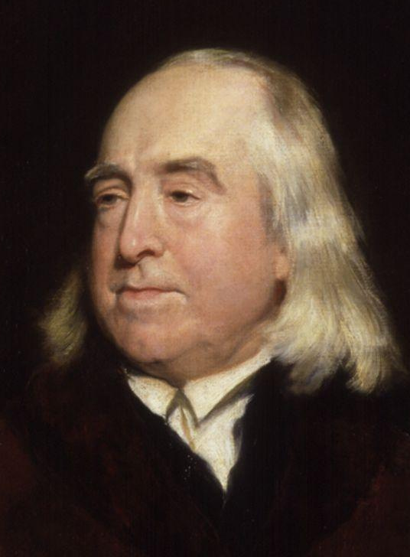
What is valuable, in the eyes of Bentham, is producing as much pleasure or happiness as possible while at the same time, producing as little pain as possible.
In his work, An Introduction to the Principles of Moral Legislation, Bentham writes:

Nature has placed mankind under the governance of two sovereign masters, pain and pleasure. It is for them alone to point out what we ought to do, as well as determine what we shall so. … They govern us in all we do, in all we say, in all we think.
According to Bentham, what we should do is maximize pleasure in the social realm and minimize pain.

To this point, Bentham introduces what is known as the utility principle, which tells us that greatest happiness of the greatest number is the correct measure of right and wrong.

This is also known as the greatest happiness principle, which tells us that a morally good act is one that results in the most happiness.

It is important to note that Bentham equates pleasure with happiness.

As a moral theory we can say that utilitarianism seeks to maximize happiness and minimize pain.

Perhaps, it can be said that Bentham sees or even reduces moral theory to counting.
Why can this be said about Bentham?
According to Bentham, everyone affected by some action must be counted equally, and our own happiness counts no more than that of others.

Imagine a scenario like this:
Act A makes me happy and two other people happy.
Act B makes me unhappy but five others happy.
Which act would Bentham’s utilitarianism endorse as the morally right or proper act?

1. A group of U of O students have taken to heart the teachings of the utilitarian Jeremy Bentham. They have decided that it is too painful to get up early every morning to go to classes that they do not enjoy. Instead, they have realized that they get more pleasure from sleeping-in, staying home to watch movies and play video games. In fact, they no longer bother to go to class at all. What would Bentham say about the actions of these students? Are they happy?

2. You are a physician who has five patients under your care. One needs a heart transplant, two need one lung each, one needs a liver, and the last needs a kidney. Now into your office comes a healthy young bachelor needing an immunization. You know that he is a loner with no family or friends. You judge that he would make a perfect sacrifice for your five patients, and contemplate injecting him with a fatal drug and then using his organs to save your five other patients. What would utilitarianism inform about being the morally good course of action in this situation?

3. John Stuart Mill (1806-73)
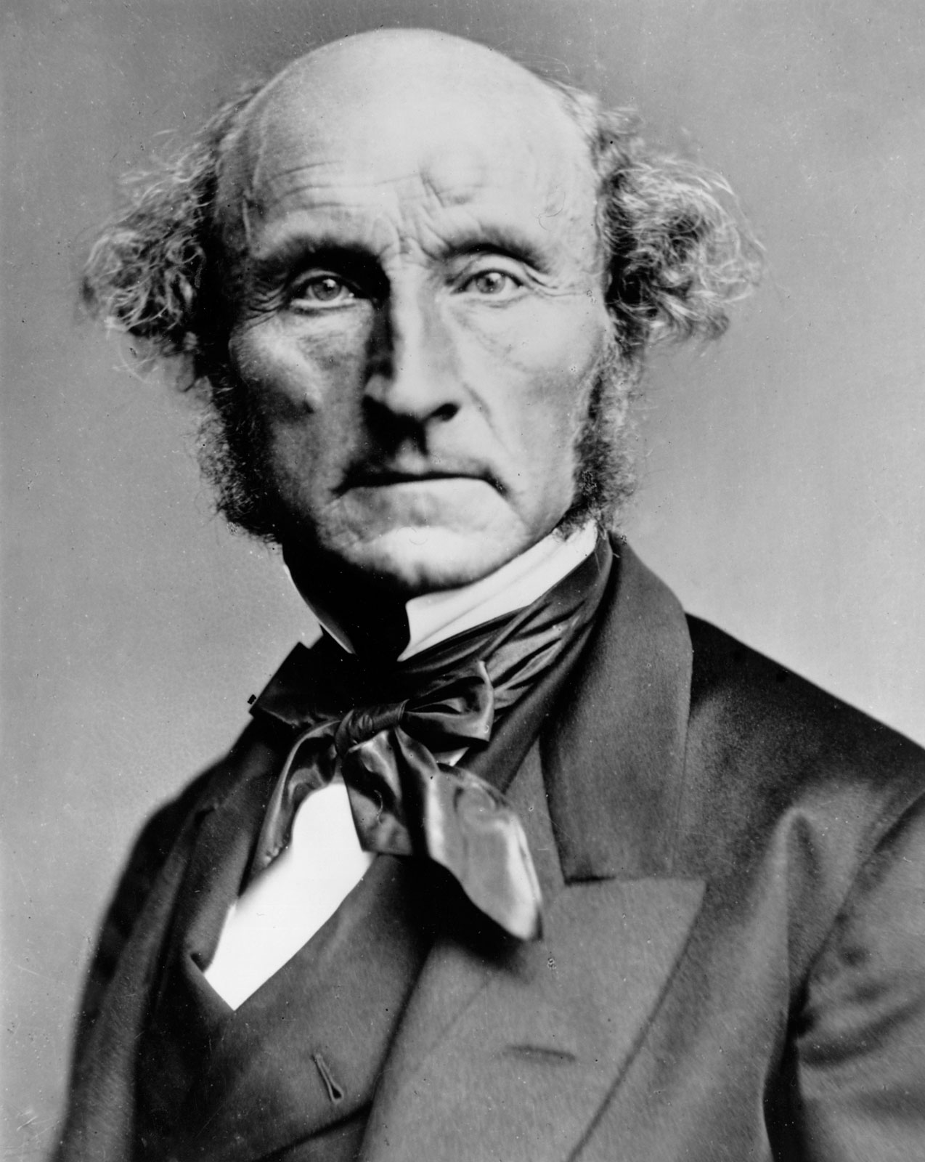
Mill was a prominent public intellectual in nineteenth century England.

He wrote on a variety of topics, including liberalism, the subjection of women, logic, political economics, and of course, utilitarianism.
Mill seeks to rehabilitate or improve the moral theory of utilitarianism that Jeremy Bentham puts forth.

To carry out this task, Mill writes an extended essay, entitled, Utilitarianism (1861), for a magazine that has wide public readership.

In this essay Mill seeks to tone down the excesses, in his eyes, of Bentham’s presentation of utilitarianism.

Specifically, as we will see, Mill wants to emphasize the quality of happiness over the quantity of happiness, something that Bentham fails to do.

4. Mill’s Utilitarianism

In Utilitarianism, Mill writes:
The creed which accepts the foundation of morals “utility” or the “greatest happiness principle” holds that actions are right in proportion as they tend to promote happiness; wrong in as they tend to produce the reverse of happiness. By happiness is intended pleasure and the absence of pain; by unhappiness pain and the privation of pleasure. (U Ch.2)

So far it does not seem that Mill differs from Bentham in that he essentially restates Bentham’s idea of the greatest happiness principle.

Mill like Bentham maintains that a morally good act is one that results in or promotes happiness while a morally bad act is one that reverses or takes away happiness.

Also, Mill, again like Bentham, stresses the importance of pleasure and happiness with pain for his moral theory.
However, Mill distances himself from Bentham by arguing that it is just not the quantity but also the quality of pleasure that must be taken into consideration.

According to Mill, it is absurd to say pleasure depends upon quantity alone.

In making this claim, Mill distinguishes between pleasures of the intellect and pleasures of sensation.

The former, pleasures of the intellect, are of a higher rank or of more importance than the latter, pleasures of sensation.

Essentially, Mill makes a hierarchy of pleasures, with higher pleasures (those of the intellect) being more important than lower pleasures (those of sensation).

Perhaps, Mill would elaborate that playing video games and reading Shakespeare both provide pleasure. But, at the same time, he would argue that reading Shakespeare would be a superior form of pleasure since it engages our intellect, imagination, and so on.

The question becomes: How do we know that higher pleasures are better than lower?

To this question, Mill argues that those who have enjoyed both higher and lower pleasures will admit that higher pleasures are better as they exercise our faculties and, in doing so, makes us better humans.*

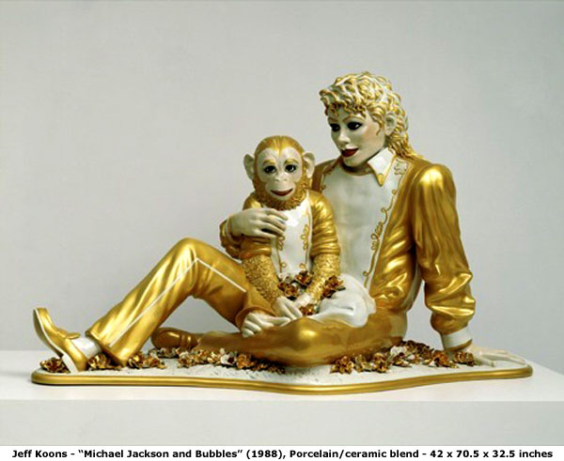

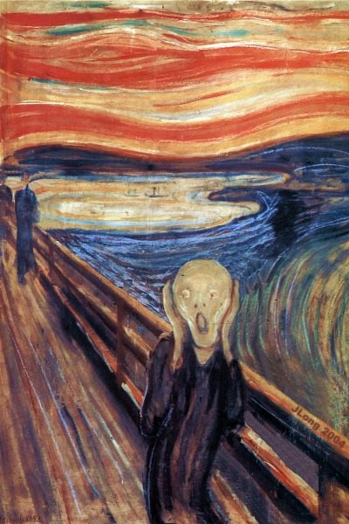

The Scream, Edvard Munch, 1893

5. Immanuel Kant
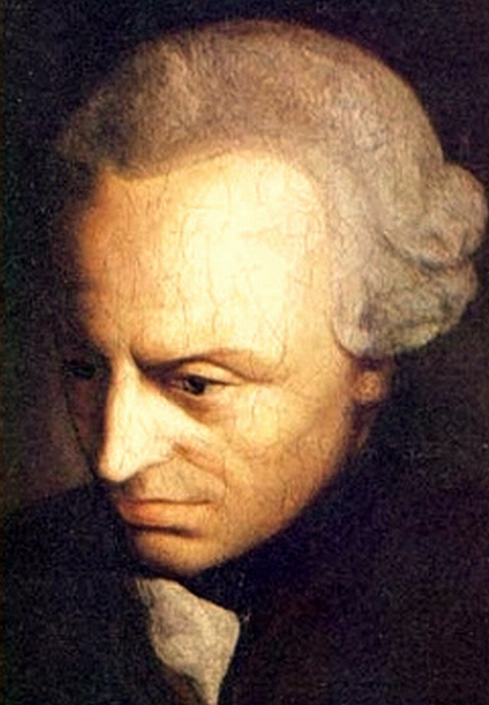
Immanuel Kant (1724-1804) was a German philosopher who is probablyone of the most important philosophers of the Modern Period.
Deeply indebted to the European Enlightenment, Kant believed in the potential for reason to improve the human condition.
One of Kant’s many important contributions is in moral philosophy.

As we shall see, Kant proposes what is known as a deontological ethics.
A deontological ethics is typically contrasted with consequential moral theories such as utilitarianism.
Deontological ethics holds the view that results or consequences of actions are morally irrelevant.
Instead, deontological theories pertain to duty or obligation.
Kant claims: [Duty] is the necessity of an action from respect for law.
Kant is not using law in a legal sense; rather, for him a law is a general rule concerning conduct.

According to Kant, dutiful individuals do the moral thing not because they feel like doing it, but because it is their duty, it is what the moral law requires of them.
To act out of duty is to do what is right simply because it is right and for no other reason, and humans, according to Kant, can be dutiful or moral because they rational and freed.

Since humans are free to take the morally right course of action, humans are capable of being judged according to how rational or irrational their behaviour is.

6. Kant’s Groundwork for the Metaphysics of Morals
Kant begins this work by writing:
It is impossible to think of anything at all in the world, or indeed even beyond it, that could be considered good without limitation except a good will.
When Kant mentions good will we can think of it along the lines of good intentions.
In his eyes, all of moral value can be traced back to the good will or good intentions.

As noted, as a deontological thinker, Kant maintains that it is not the consequences of our actions that are of moral importance, as consequences have no bearing on the moral worth of our behaviour.

Rather, Kant argues that it is what happens via our reason that is of moral importance, it is what the individual intends that is of crucial importance.

Kant argues that the individual should intend, via good will, to obey the moral law.
According to Kant, without good intentions, the best possibilities can go bad, as good things can be turned into bad ends.

For example, one can use intelligence – which is a good thing – to become a clever criminal. One can use physical strength – which is a good thing – to intimidate others.
Though intelligence and strength are valuable, bad intentions can make them bad.
A good will though, is always good.

Kant would hold the view that if people with good intentions are unable to accomplish very much in life, the fact that they are trying, in itself, counts as a moral achievement.

Of course the question becomes: What does a good will, will?
To understand Kant’s answer to this question, we must examine the difference he draws between a hypothetical imperative and a categorical imperative.

7. Hypothetical Imperatives and Categorical Imperatives
First, we can understand that an imperative is simply a form of a statement that tells us to do something.
“Be quiet” or “Close the door” would be two examples of imperatives.
With respect to hypothetical imperatives, Kant states: “Now, if the action would be good merely as means to somethingelse, the imperative is hypothetical.” (501)
Here we can interpret Kant as saying that hypothetical imperatives relate to acts done to achieve some goal. In other words, hypothetical imperatives inform us of what needs to be done to aim at a particular goal.

For instance, if I want to be well-rested for tomorrow, then I ought to go to bed early tonight.

If I want an education, then I ought to go to university.
If I want to be a philosophy major, then I ought to study the thought of Immanuel Kant.
With respect to hypothetical imperatives, we can say that they are individualized, as different people will have different goals, and they are open to change.
In short, we can say that hypothetical imperatives only apply hypothetically since they only apply if the individual decides to do some optional task.

Again, hypothetical imperatives are optional and may be different for everyone, they are individualized.
Also, hypothetical imperatives are not what Kantian ethics is about.
Ethics for Kant is neither optional nor individualized; ethics must be the same for everyone.

A categorical imperativerelates to an act that must be done regardless of what we want to happen.
Back to the question what does a good will, will?
A good will is one that makes good laws.
What is a law?
As noted, a law is to be understood not in a legal sense, but it is to be thought of as a general rule concerning conduct.
The best law will be one that is so general that it allows for no exceptions at all, one that is a universal law, a law that applies across the board all the time and everywhere.
In the eyes of Kant, any law, command, or order that can be universal and that can be willed or chosen is morally good and breaking it or going against it must be morally wrong or bad.
This is what Kant means by a categorical imperative.
The first formulation of the categorical imperative that he provides goes like this:
Act only in accordance with that maxim through which you can at the same time will that it become a universal law.
Maxim: The general rule in accordance with which the individual intends to act.

Law: An objective principle, a maxim that passes the test of being universal.

We can think of Kant’s categorical imperative along these lines:
When you are thinking of doing a certain action, you are to ask yourself what rule would you be following if were to do that action – this is maxim of the act.
Next, you are to ask whether you would be willing for that rule to be followed by everyone all the time – this is what makes it a universal law.

If you rationally decide that the rule may be followed by everyone, then the act is morally good.
However, if you would not be willing for everyone to follow the rule, then you must not follow it, as the act would be morally wrong.

Example:
A man needs to borrow, and he knows that no one will lend him money unless he promises to repay the borrowed sum. But he also knows that he will be unable to repay the borrowed money.
He faces this dilemma – should he promise to repay the debt, knowing that he cannot do so, in order to persuade someone to make the loan?
If he were to do, the maxim of his act would be –
Whenever you need a loan, promise to repay it regardless of whether you believe you can actually repay it.
Could this maxim become a universal law?

An individual who is a known terrorist potentially has information that could thwart a terrorist attack in North America. Getting information from this individual would possibly save the lives of thousands in North America. All the same, after the standard line of questioning, this individual will not confess to any possible information he may know. Would it be morally alright to torture him to get additional information?

What would be the morally right course of action, according to Kant? What might utilitarianism inform?

