COMM 220 : ANALYSIS OF MARKETS

chapter 6 : supply of labour
This chapter focuses on the issues of worker behaviour.

The labor force particiation rate is the percentage of a given population that is looking for a job or has one.
The labour force is unemployed and employed people.

Main labour supply decisions :
- whether to participate in the labour force
- whether to seek part time or ful time
- work at home and work for pay

Employers must offer hours and pay to enhance their own profit but also to match employee preferences (full time or part time, work at more than one job etc)

A theory of the decision to work; a decision between LEISURE and WORK FOR PAY
The demand for leisure is a function of...
1. oppurtunity cost of 1 hour of leisure is the WAGE rate that could be earned for an hour of work
2. income or wealth. it includes financial assets, physical properties and skills. hard to measure so we calculate the returns from wealth, or total income
3. Preferences between income and leisure (income effect)

Defining the Income effect
If income (Y) increases
all wages (W) held constant
the demand for leisure hours will rise;
implies the demand for work hours will fall (H)
(example: if he receives inheritance)

we say the income effect is negative because the sign of the fraction is negative. If income goes up, hours of work fall. If income goes down, hours of work increase. The numerator and denominator move in opposite directions. 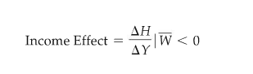

Defining the Substitution Effect
If wages (W) increase
holding income constant (Y)
the demand for leisure hours will fall;
implies the demand for hours of work (H) will rise
(example decrease in taxes from pay with a rise in another tax at the same level, income constant but wage higher)

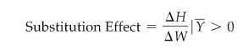

BOTH EFFECTS OCCUR WHEN WAGE RISES...
(normally both are present, often working in opposite directions, which makes it difficult to predict the labor response)
- Income effect: the increase in wages implies an increase in wealth and income. Since leisure is a normal good, as income rises the demand for leisure rises and the demand for work falls. Labour supply will have negative slope.
- Substitution effect: the increase in wages represents an increase in the oppurtinity cost of leisure, so demand for work hour rises. Labour supply will have a positive slope.
- the actual labour supply response will be the SUM of these two effects.
- which effect is stronger depends on the preferences of the labour force for income vs leisure (depicted using indifference curve diagrams)
- if the income effect is stronger, the person will respond to a wage increase by decreasing his supply labour.

Review of Utility theory
U: total utility is the level of satisfaction derived from consuming given quantities of a good or service.
MU: marginal utility is the change in total utility due to one unit change in quantity consumed of a good or service. Its the extra satisfaction from consuming one more unit of something.
(example: first hamburger is 8 on 10 MU, the second is 5 and the third is 2 because you aint hungry no more)

Review of the law of diminishing marginal utility
as consumption of a good increases, eventually the consumers marginal utility for a good decreases. As a consumption of a good decreases, eventually the consumers marginal utility for it increases.
Assumption that preferences are:
- complete: any two bundles can be compared and ranked
- reflexive: any bundle is a least as good as the identical bundle
- transitive: if A is stricly prefered to (little sign) B and B is stricly prefered to C, then a is stricly prefered to C.
- monotonic: good being considered are normal. as income increases we prefer to consume more rather than less of the good.
- goods are substitutes: not necessarily because they are similar, but because if the consumer consumes less of one, he will buy more of the other using up the entire budget.
Things to know about this:
-A consumers indifference curve shows all combination of two goods that give the same level of total utility U.
- the slope of the indifference curve is the ratio of the marginal utilities for the goods called the marginal rate of substitution (MRS) = MUa/MUb (where B is the vertical axis)
- customers have a budget constraint. the slope of the budget line is the ratio of the prices of the two goods. the slope of the budget line is Pa/Pb
- a consumers indifference curve is similar to the firms isoquant. Higher indifference curves imply higher total U. cannot cross
- a consumer will strive to achieve the highest level of TU given a budget constraint.
- budget line is similar to a firms isoexpenditure.
- when MUa/MUb = Pa/Pb is the utility maximizing condition.
- the indefference curve and budget lines are negatively sloped because they are substitutes.

Preferences applied to Labour Supply model
- workers choose between leisure time and the goods they can buy. prices of goods are fixed so the choice is between Leisure Time and Money Income (nominal money rather than real or inflated adjusted money)
- Leisure and money income are at least partially substitutable. You can cut back on income to enjoy more leisure time, vice versa.
- indefference curve is derived from the fact that since each point on the curve yeilds equal utility, a person is indefferent about where on the curve to be. Its different combinations of income and hours of leisure that outcome into a level of utility. Other combinations give the same level of utility. it varies between individuals though.
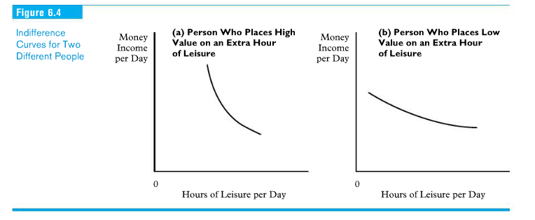
- the BUDGET LINE depends on income (Y) from earning wages and the hours available for leisure (H). The slope of the budget line is the wage rate.
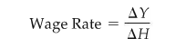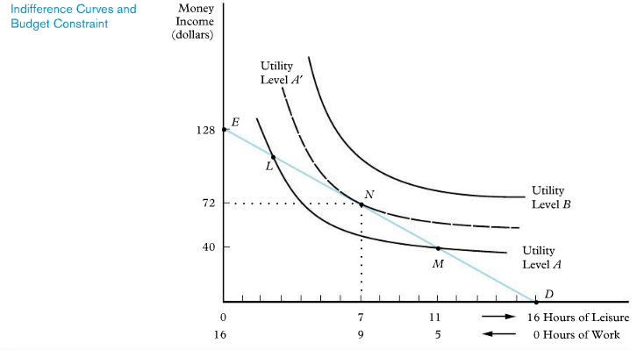
The Reservation Wage
- the wage below which a person will not work
- give a specific dollar value to their time
- minimum number of hours and specific wage

Income Effect
- if the income increases (other support than from the wages), the budget constraint will shift up parallel to the orginal line (same slope for wages). The person will achieve a higher degree of utility, higher indefference curve.
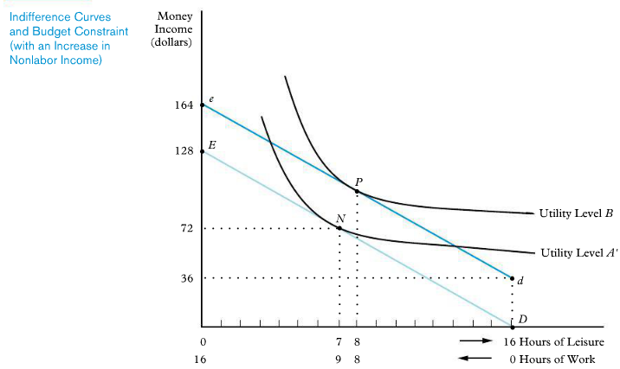

WAGE INCREASE ON SUBSTITUTION AND INCOME EFFECT
- workers face a higher oppurtinity cost of leisure.
- if the worker prefers leisure, the labour supply curve will be negative (then the income effect dominates); if the worker preferes income, the labour supply curve will be positive (and the substitution effect dominates)

Which effect is stronger ? Influenced by factors that dominate
- the larger the wage change, the greater the income effect
- the greater the preference for income vs leisure, the greater the income effect. those who work long hours will demonstrate a greater income effect
- labour force participation decisions reflect a dominant substitution effect. (If someone enters the work force because wages have gone up, it demonstrates a dominant substitution of leisure for income.)

there are some programs to help those who are not working
- workers compensation in case of injury
- employenent insurance (involuntary job loss)

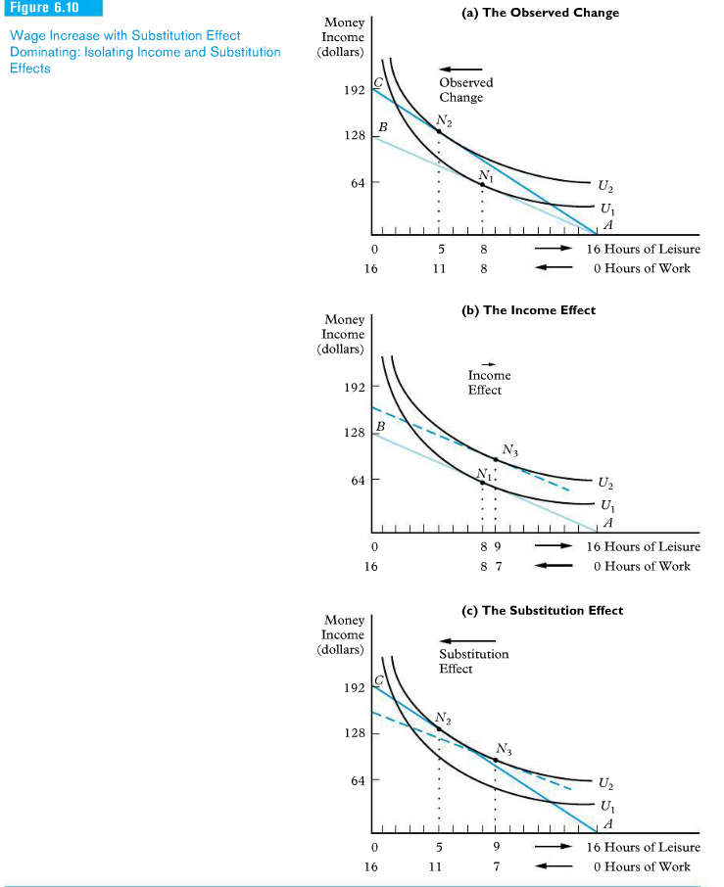

budget constraints = spikes

Chapter 7 (cp p.139) : Uncertainty and consumer behaviour
- to find the risk related to an outcome, list all the possibilities and asses probability of occurance.
- to compare how people make choices between risky alternatives
a) explore ways to measure risk
b) risk averse people find risk undesirable. We must measure peoples preferences for risk, degree of risk aversion.
c) examine the way risk can be reduced or eliminated. diversification of securities we invest in , buying insurance, additional information
d) examine the trade offs between risk and return made when we invest in securities
- Probability is the likelihood that a given outcome occurs. Can depend on the nature of the even, the beliefs of the people involved (subjective interpretation), frequency of occurance (objective interpretation).
- Probabilities are mutually exclusive, so they total 1 or 100%
- Two main components in risk calculation:
1) Expected value : probability weightes average of the payoffs associated with all
the possible outcomes
- where pay off is the value associated with possible outcomes.

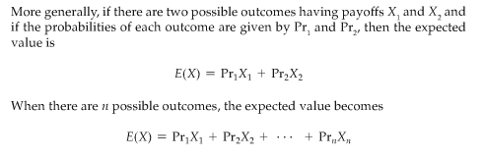
2) variability : extent to which possible outcomes of an uncertain event differ. For this we measure the variance and the standard deviation around the expected value
SD: square root of the weighted average of the saquares of the deviations (difference between expected payoffs and actual payoffs) of the payoffs associated with each outcome from their expected values

(exercices p. 141)
- if you divide expected return by risk, you get the expected return pe unit of risk. this is called COEFFICIENT OF VARIATION. (where the higher the better)

Preferences for varying degrees of risk:
-investors have preferences toward risk. why ? because the TU curve with respect to income is increasing at a decreasing rate. this means MU is diminishing as income increases
- risk averse: condition of preferring a certain income to a risky income with the same expected value
- risk neutral: condition of being indefferent between a certain income and an uncertain income with the same expected value
- risk loving: condition of preferring a risky income to a certain income with the same expected value.
- risk premium: maximum amount of money the investor would have to be paid to be indefferent (have the same total utility); maximum amount of money the risk-averse person will pay to avoid taking a risk.
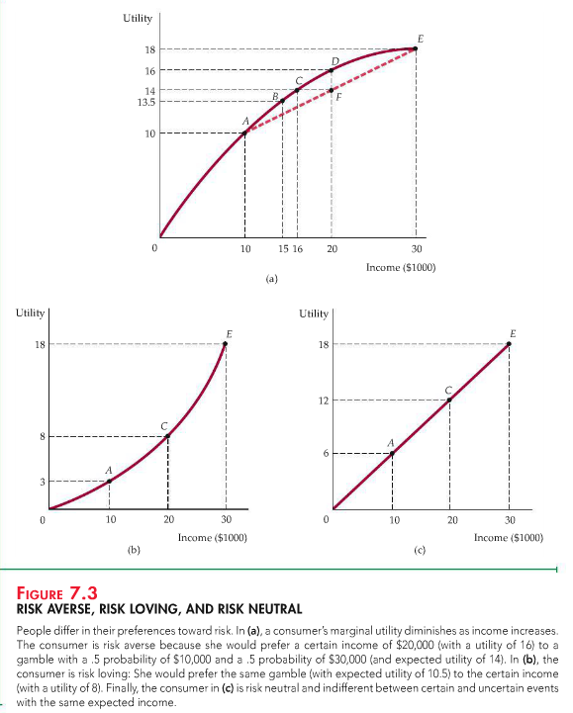

There is usually a positive relationship between the riskiness of an asset and its expected return

Reducing risk
there are three basic ways of reducing risks : diversification, insurance and finding information
1) Diversification : reduce risk by investing in a variety of securities
market risk = systematic risk
- non diversifiable risk that influences the market in general.
unique risk= unsystematic risk
- diversifiable risk that affects a single asset or a small group of assets
Diversification and portfolio risk.
- the weight of the individual securities within the porfolio become smaller as more securities are added. THis causes the portfolio risk to approach the average risk of the overal stock market. Market risk is not diversifiable and cannot be reduced, unique risk is diversifiable and can be reduced by diversification.
- mutual fund: organization that pools funds of indiviudal investors to buy a large number of different stocks or other financial assets.
-negatively correlated variables: variables having a tendency to move in opposite directions
-positivily correlated variables: variables having a tendency to move in the same direction

2) Insurance
- the concept of risk premium is that people will pay to avoid risk.
- the cost of insurance is equl to the expected loss
- buying insurance assures the consumer will have the same income even if a loss occurs
- risk is the SD of the variance.
- variance is the probability time the sum of differences between actaual and expected values, squared.

THE LAW OF LARGE NUMBERS
the ability to avoid risk by operating on a large scale is based on the law of large numbers.
- the average outcome of many similar events can be predicted. (toss a coin 1000 times)
Actuarial fairness
- by operating on a large scale, insurance ocmpanies can be reasonably sure that total premiums paid by policy holders will equal the amount of money paid out.
- ressembles risk diversification
- when the insurance premium is equal to the expected payout, he insurance is actuarially fair. The premiums are usually larger than expected loss in order to make profit. Competition between insurance firms makes the amount as close to actuarial fairness as possible.

3) Acquire information
The value of complete information : is the difference between the expected value of a choice when there is complete information and the expected value of a choice when information is incomplete. Calculate both and the difference.

THE DEMAND FOR RISKY ASSETS
an asset is something that provides a flow of money or services to its owner. There are two ways to gain from owning an asset. Cash flow and Capital Gains.
1) Cash Flows: the streams of income the asset pays. (rented house, interest on account)
2) Capital Gains or Losses : the change in price of the asset. If it increases in value or decreases in value. (gain/loss). Only realized once the asset is sold, until then they are paper gains or paper losses.

The return on any asset need to exceed the rate of inflation, otherwise the purchasing power of the income will fall.
The real return on an asset is its nominal return minus the inflation rate.
Choosing assets for you personal investment portfolio the choices are:
- riskless assets: like gvt treasury bills, return is low and steady
pays a cash flow that is known for certainty (T-bills; a promise by the gvt to repay princiap plus interest in a year or less. safe because short term and little inflation risk)
- risky assets: like stocks, increased riskiness is tolerated because of the higher expected returns.
provides a monetary flow that is at least in part random. The longer you hold on to it the larger the inflation risk may be as well

Expected vs actual returns.
- compare assets by evaluations the expected returns
- as riskiness increases, so does expected return (positive relationship)
The trade off between risk and return
Rp= expected return on an investors portfolio
Rm= expected return on overall stock market
rm= actual return on overall stock market
Rf= risk-free rate of return on t-bills (where expected return = actual return)
SD= sd of returns, riskiness of assets
b= fraction of an investors portfolio invested in the stock market
(1-b)= fraction invested in t-bills

Rm is bigger than Rf, otherwise risk averse investors would buy only t-bills

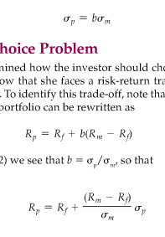
this equation says that the expected return on the portfolio increases as the riskiness of the portfolio increases. The slope of the line (Rm-Rf)/SDm is the price of risk; it tells us how much extra risk an investor must incur to enjoy a higher expected return.

Bubblezzzzzzzz
an increase in the price of a good based not on the fundamentals of demand or value, but instead on the belief that the price will keep going up. It represents irrational behaviour
- can be the result of informational cascade (an assessment based in part on the actions of others, which in turn are based by the actions of others.) It can be rational .
- if investors early in the chain obtained positive information they expected positive gain.
- making irrational decisions based on a myth or believing word of mouth for investment.

Behavioral economics
our model of consumer theory assumed that consumers have clear preferences for some goods over others, have a defined budget in mind and try to maximize utility subject to their budget constraints. perhaps our understanding of consumer demand and decisions of firms would be improved if we incorporated more realistic and detailed assumptions regarding human behavior.
examples; not buying a shovel because they put up the price as soon as it snowed and youre pissed. buying book online because its cheaper but forgetting to count the shipping fee.
Reference points: the point from which an individual makes a consumption decision
- endowment effet : tendancy of individuals to value an item more when they own it than when they dont
- loss aversion: tendancy for individuals to prefer avoiding loss over acquiring gains. (a common example is not wanting to sell stocks when its going down because you actually paid for it at first... even if with the money made with the sales you could buy a new stock thats actually going up)
- framing: tendency to rely on the context in which a choice is described when making a decision

Rules of thumb and biases in decision making
- anchoring : tendency to rely heavily on one prior piece of information when making a decision (charity says check a box, 20 $, 50 $, 100$ )
- rules of thumb: (ex: tip 15pct) can lead to strong biases, but often used to save time and effot of making decision or calculating probabilities
(example p. 154)

Chapter 8 : overview of the financial market
The financial system of a country are the institutions and regulatory structure that handle the demand and supply for funds for households, firms, the governement and foreigners.
The main purpose of a financial system : to transfer funds from savers (those who have surplus funds to lend) to those who have shortage of funds and want to borrow

ways to transfer from lenders to borrowers :
1. DIRECTLY: through markets for financial instruments or securities.
Financial securities are assets for the purchaser but liabilities for the borrower
Stocks are also financial securities. It represents partial ownership of a company. Company has a liability towards the lender
2. INDIRECTLY: through financial organizations such as chartered banks, trust companies, credit unions, insurance companies, gvt pensions, mutual funds companies. The intermediary burrows funds from lender, and uses these to make loans to borrowers.
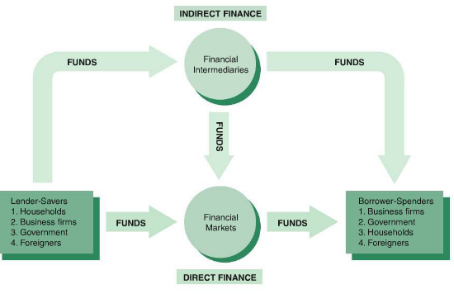

Structure of financial market (direct)
Debt market
- the market for bonds, treasury bills and mortgages.
- these are contracts for borrowers to repay lenders a fixed dollar amountof principal and interest at regular intervals
- term to maturity is the date the last payment is due on
- short term if the maturity date is less than 1 year (t-bill)
- intermediate term if the maturity date is 1 to 10 years (bonds and mortgages)
- long-term if the maturity is more than 10 years (bonds and mortagages aswell)
Equity market
- the market for common and preferred shares in companies
- claims to share in the net income and the assets of a business
- equities make periodic payments (dividends) to their holders and are considered long term securities beause they have no maturity date.
- main disadvantage of owning equity istead of debt is that an equity holder is a residual claimant; corporation must pay all the debt holders before paying its equity holders.
- advantage of being an equity holder is that you benefit directly from any increase in the corporations profitability becasue you have ownership rights with the equity (debt holders dont benefit because their dollar payments are fixed)

Money market = market for short term debt
capital market = for long term debt and equities
brokers= agents of investors who match buyers with sellers of securities
dealers = link buyers and sellers by buying and selling securities at stated price on their behalf.

The primary market
- where new issues of securities are sold to initial buyers by the corporation or gvt agency borrowing the funds. Investment banks assist this by underwriting securities (guaranteeing a price for a corporations securities and then selling them to the public.)

The secondary market
- a financial market in which securities that have been previously issued can be resold.
- make financial securities more desirable to buyers because they make them seem more liquid (easier to buy and sell)
- when sold on the secondary market, no new funds are donated to the company, only people who exchange will make profit.
secondary markets - exchanges and over the counter
- secondary markets exist for stocks on organized exchanges like the toronto stock exchang
- all bonds must be sold through banks, which is considered over the counter market.
- "over the counter" means the institution has a specific inventory of bonds to buy and sell

FINANCIAL MARKET INSTRUMENTS:

Treasury Bills or T-bills
- short term debt instruments issued by canadian gvt.
- common maturities are 1,3,6 and 12 months.
- sold at discount from face value
- least default risk (riskless asset)

Certificates of deposit or CDs
- debt instrument sold by a bank to depositors that pays annual interest of a given amount and at maturity pays back the original purchase
- often negotiable, can be traded
- in bearer form, which means there is no record in the issuers books, no name associated with the security (bearer deposit notes)
- the non negotiable CDs cannot be sold to someone else and cannot be redeemed before hand without paying large financial penalties. (Those are term deposit receipts. )

Commercial paper
- unsecured short term debt issued by large banks and large corporation like Microsoft or Bombardier.
- only the largest and most crediworthy corporations issue commercial paper
- most are sold on a discount basis

Repurchase agreements (Repos)
- short term loans (2 weeks or less) for which T-bills serve as collateral (lender receives t-bills if the borrower cant repay back the loan)

Overnight funds
-banks lend to banks for 1 or 2 days
- when banks dont have sufficient reserve
- the overnight interest rate indicates if th bank credit needs are high or low

CAPITAL MARKET INSTRUMENTS:
debt and equity instruments with maturities of greater than a year

stocks
-equity claims on the net income and assets of a corporation
mortgages
- loans to households or firms to purchase land, real estate or other structure where the building or land serves as collateral
- lenders are banks, life insurance companies, caisse populaires

Corporate bonds
- long term bonds issued by corporations with very strong credit ratings
- most corporate bonds pay semi-annual interest and the price of the face value is repaid on the maturity date
- they carry more default and liquidity risk
- some are convertible into a specific number of shares of stock at any time up to the maturity date (this makes the bond more attractive to purchaser and allows the issuing company to lower the interest payments on the bond)
- market for a corporate bond is quite smaller than the overall stock market, but there are new bonds each year so its still very important to corporate finance decisions
- principal buyers are life insurance companies, pension funds and households

Government of Canada bonds
- intermediate and long term bonds issued to finance gvt spending and debt obligations
- buyers are households, firms, banks
- registered bonds have the name of the owner on the certificate

Canada Saving bonds (CSB)
- non marketable bonds issued by the gvt of Canada
- they are flotting rate bonds, offered exclusively to individuals, estates and specified trust
- registered bonds and can be purchased through payroll savings plans or through financial institutions
- dont rise and fall in value
- redeemable at face value plus accrued interest at any time before the maturity

Provincial and municipal governement bonds
- issued by provinces and municipalities to finance spending on schools, roads etc
- issued in canadian currency or other foreign currencies (US, Swiss franc)
- mainly held by pension plans, social security funds and foreigners

Governement agency securities
- long term bonds issued by agencies such as Hydro
- assist municipalities to finance things like power generating equipment, farm loans etc.
- the province guarantees many of these securities

Consumer and Commercial Banks loans
- loans to consumers and businesses made by banks or sometimes loans made by finance companies

INTERNATIONAL (GLOBALIZATION) OF FINANCIAL MARKETS:

Foreign bonds:
- bonds sold in a foreign country and denominated in the currency of the country in which the bond is sold

Eurobonds:
- A bond denominated in a curreny other than that of the country in which issued it and also other than of the country where it is sold

Eurocurrencies
- foreign currencies deposited in banks outside the home country
- short term deposits that earn interest, similar to euro bonds
- canadian banks borrow eurodollar deposits from other banks or from foreign branches

world stock markets
- sufficiently large that investors now look at a variety of stock markets and not just that of their home country
- foreign entities provide funds to canadian companies and to canadian gvt

FUNCTION OF FINANCIAL INTERMEDIAIRIES (indirect finance)
Help transfer funds from lenders to borrowers. It is the primary source of funding for corporations, much more than stock and market bonds because...
1. Transaction costs are much lower with financial intermediairies because the economy of scale (legal advice cost spread, writing cheks and paying bills). Because banks have a lower transaction cost, they can offer services like liquidity that make it easier for customers to do transactions.
2. Financial intermediairies offer large volumes of fairly low risk assets and liabilities. This allows them to take on riskier projects like start ups. The higher risk can be spread over a large customer base. This is called risk sharing or asset transformation. Promote risk by diversifying and lowering the amount of risk in individual portfolios.
3. Assymetric information (one party has access to more information than the other party, who is then disadvantaged) leads to two problems
- before the transaction occurs, Adverse Selection; choosing an investment at the dispense of the other. often the one who seeks investment the most are most likely to be bad credit risk. poor quality clients chosen because of assymetric information (example with the two aunts the gambler and the conservative)
- after the transaction occurs, moral hazard; using the loan for a different purpose then planned. This increases the risk of not seeing the money again.
4. Financial intermediairies also have economies of scope by providing multiple services to customers. They can lower the cost of information production for each service by applying one information resource to many different services. It can be vulnerable to conflict of interest by its clients.

Types of financial intermediairies
3 categories: Depository institutions, contractual saving institutions and investment intermediairies

1. Depository institutions :
-Chartered banks: offer checking, saving and term deposits. issue business, consumer and mortgage loans
-trust and loan companies: near banks, offer checking, saving and term deposits, Offer debentures (loans without collateral)
- credit unions and caisse populaires : near banks, offer deposits usually to specific groups like unions, employees of particular firms, and offer primarily mortgage and consumer loans
2. Contractual savings institutions:
- life insurance companies: acquire funds from the premiums people pay on their policies and use them mainly to buy corporate bonds and mortgages
- property and casualty insurance companies: also receive funds in premium but have a greater possibility of loss funds if disasters occur. they buy more liquid assets
- pension fund companies and governement retirement funds : acquire funds by contributions from employers and employees by automatic payroll
3. Investment intermediairies:
- finance companies: these sell commercial paper and also issue stocks and bonds. they lend the funds to customers for things like furniture, cars and home improvment. lend to small businesses.
- mutual fund companies: these sell shares to many individuals and use the proceeds to buy diversified porfolios of stocks and bonds. this allows the company to lower transaction costs by buying stocks and bonds in volume, and in turn the mutual fund shareholders have more diversity than they could achieve alone. shares can be sold at any time. risk varies.
- money market mutual fund companies: similar to mutual fund companies but also offer deposit-type accouns. The funds contain money market instruments like t Bills and commercial paper and the interest is paid to shareholders

REGULATION OF THE FINANCIAL SYSTEM
the gvt regulates the system for 3 reasons...
1. to increase the information available to investors (to reduce the risk of adverse selection and moral hazard due to asymmetric information and to discourage insider trading which can lead to manipulation of the stock prices in ways contrary to public interest)
2. to ensure soundess of the financial system to prevent widespread weaknesses and possible failures of financial intermediairies, which can lead to financial panic.
3. to improve control of monetary police by the bank of Canada there are
- restrictions on entry (what is needed before a bank can be incorporated or charted)
- stringent disclosure requirements (banks must report their holdings)
- restrictions on the kind of assets and activities that an intermediary can engage in
- the gvt insures banks deposits through the CDIC
- limits on competition in order to maintain greater control of domestic banking activities and ensure regular banking services are available even to small communities in Canada

Chapter 9 : an economic analysis of financial structure
we find 8 basic facts that need to be explained to understand the financial world
1. Stocks are not the most important source of external financing for business. Stocks accounted for 12% of canadian corporate financing
2. issuing bonds is not the primary source of finance for businesses. Accounted for 15% of canadian corporate financing
3. Indirect finance, involving financial intermediairies is many times more important than direct finance for businesses
4. financial intermediairies, espicially banks, are the most important source of external funds used to finance business (50% in the US. 70% in Canada, Germany and Japan)
5. The financial system is among the most heavily regulated sectors of the economy
6. only large, well established corporations have easy access to securities market to finance their activities. individuals and smaller businesses that are not well established are less likely to raise funds by issuing bonds or stocks.
7. collateral is a prevalent feature of debt contracts for both households and businesses. Collateral is property that is pledged to a lender to guarantee payment of a loan. Collateralized debt (secured debt) is the predominant form of household debt in Canada: mortgages, car loans, commercial and farm mortgages.
8. Debt contracts typically are extremely complicated legal documents that place substantial restrictions on the behaviour of the borrower. Provisions on these contracts are called covenants.

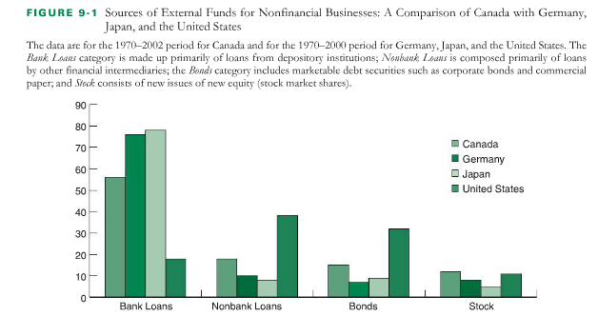

EXPLANATIONS

Transaction costs are a reason why financial intermediairies are the main source of personal and business finance.
- transactions made through financial intermediairies like banks are much lower than those in the stock and bond markets because banks and mutual fund companies have economie of scale.
-they have expertise that help lower costs
- the lower transaction costs allow companies to offer liquidity services

Problems of asymmetric information : adverse selection and moral hazard
- when one party has less information than the other one
- adverse selection: when those most likely to produce an anwanted outcome are the ones most likely to ask for a loan
- moral hazard: those who have undertaken a commitment change their behaviour in a way that leads to market failure
- free riders are people who dont pay for the information but take advantage of it

Adverse selection influences financial structure
If investors cant distinguish between good firms with high expected profits and low risk, and bad firms with low expected profits and high risk, then investors will not be willing to pay enough for stocks and bonds, and shares will diminish and may disappear
the solution is to eliminate the information asymmetry

1. private production and sale of information
Companies gather data and analyze them. They sell them but once sold they become public accessible information and free riders take the info. Securities adjust accordingly and it becomes less advantegeous to buy these information. Regulation is required but private production and sale cannot completely solve the problem because of free riders.

2. Governement regulation to increase information
In Canada, regulations require firms selling securities to have independant audits in which accounting firms certify the firm adheres to standard accouting principles and discloses information about sales, assets and earnings. This doesnt work perfectly as there have been major instances of firms not fully disclosing information.

3. Financial intermediairies have information on individuals and companies. This helps distinguish between good companies with solid credit and the others. Banks dont have the free rider problem since the information is used internally.

Improvement in information technology mean that larger, better-known companies have an easier time raising funds directly through stock and bond issues because the public has easier acces to info

Moral Hazard affects the choice between debt and equity
Equity contracts, such as common stock, are claims to a share in the profits and assets of a business. Equity contracts are subject to a particular type of moral hazard calle principal agent problem.
- agency relationships: exists whenever there is an arrangement in which one persons welfare depends on what another person does. The asymmetry comes about because of incomplete information and the fact that to find the information would require costly monitoring, which tends not to happen
- the agent is the person who acts and the principal is the party affected by the actions
- with companies the owners of the company (shareholders) are not the same individuals as those who control the company (managers) The separation of ownership raises an agency problem because the managers could be tempted to act in their own interest rather than the interest of the stock holders. Corporations want to minimize costs but the power of managers often stem from the size of the budgets they control. The incentives of manager to pursue their own objectives are fringe benefits, respect of peers, power to control departments, job security.

Tools to solve the principal agent problem :
1. Production of information Monitoring
- auditing the firm frequently (costly)
- vigilance for free riders
2. Government regulation to increase information
- requires quartely reports sent to shareholders with penalties if not done
3. Financial intermediation
- venture capital firms pool the resources of the partners to invest in new firms
-they receive an equity share in the business
- put their own employee on the board to guide the new firm
4. Debt contracts
- only need to verifiy when they are unable to pay back
- moral hazard in debt contracts: companies issuing bonds mais still undertake risky projects, therefore the net worth of the company is kind of a collateral
-legal convenants
- financial intermediation : monitoring and enforcement of restrictive collateral can be costly, the free rider problem arises. Banks acquire their own information

Financial information and economic growth

Recent research has found that an important reason why many developing countries have low rates of economic growth is that their financial system is underdeveloped. In many of them, the system of property rights functions poorly, making it hard to use restrive covenants and collateral requirements. Gvt often block lenders from foreclosing on borrowers for agriculture. Corrupted gvts send money to themselves. If the gvt owns the commercial banks, even harder to obtain a loan.

Understanding interest rates
Interest reflects the "time value of money"
The interest that a bank will pay you on your depost is the banks compensation to you for not having access to the funds for a specific time period.
Interest on a deposit: the interest that a bank will pay you on your deposit is the banks compensation to you for not having access to funds for a specific period
Interest on a loan: interest is what is charged by lenders to compensate for their loss of the use of their money over time

Simple interest
the interest paid or received on only the intial investment (the principal)
bonds pay interest to bond holders
P= your principal amount that you start with
n= number of time periods
i= interest rate in decimal form

TIme value (simple interest)
= P + (i x P x n)

Chapter 10 : Understanding interest rate

Important definitions
Cash Flow (CF): payments made at regular intervals. For example, interest paid to owners of bonds, or regular deposits into a retirement savings account, or dividends paid on a share of company stock (usually quartely)
Simple Interest : interest earned only on the original principal amount invested. It assumes that any interest earned is spent and not reinvested as it is earned.
Interest on interest: interest earned on the reinvestment of previous interest payments
Compound interest: interest earned on both the initial principal and the interest reinvested from prior periods

Compounding : finding the FV
P: the principal deposited
i: the interest rate
n: the period in years
FV: the future value accumulated at the end of period n

FV= P(1+i)^n
(or with calculator, PMT is 0)

Discounting : finding the PV

PV= P/ (1+i)^n
in this case i is known as the discount rate or cost of money
(or with calculator, PMT is 0)

Coupon Bond
a bond is a promise to repay principal plus interest over a period of time longer than one year. Major borrowers such as governement or large corporations issue bonds rather than taking bank loans. A bond has several elements :
FV: face value of the bond. (1000 or 10 000). This is the principal amount being borrowed by the issuer
C: coupon payment. This is a fixed dollar amount of interest paid by the bond issuer to the bond holder at regular intervals. The coupon amount is specified on the bond itself. The amount of the coupon never varies througout its life. Only payments that are made until bond matures.
c: coupon rate. This is the coupon payment divided by the face value expressed as a percent.
M: maturity date. The last payment date of the bond, the last coupon payment is made and the full face value of the bond is repaid to the bond holder
y: yield (or yield to maturity) on a bond is the discount rate that will make PV of all the cash flows on the bond equal to its price. It is the rate of return the bondholder may expect if all cash flows (coupons) are reinvested to earn interest at the same interest rate as the yield. when bonds are first issued the coupon rate and the yield have the same value so the price of the bond is the same as the face value of the bond. Over time the coupon rate will remain fixed while the discount rate will fluctuate as market interest rates change and the price of the bond can change

coupon bond-coupon rate = yield
see p. 176

coupon rate is smaller than market rate = coupon sold at discount
coupon rate is higher than market rate (or yield)= sold at premium

Bond yields and bond prices
1. Bond prices move in the opposite direction to bond yields: increases in interest rates cause bond prices to fall and vice versa
2. The difference between the coupon rate and the yield to maturity affect the bond prices as follows:
c < i bond trades at a discount from face value PVbond < FV
c > i bond trades at a premium over face value PVbond > FV
c = i price of bond is face value PV bond = FV

it is easier to undertant this concept if we consider the yield on a perpetual bond (never matures). For these bonds the formula for yield is
i = coupon PMT / bond price x 100
this formula is also called current yield.

If c < i all bondholders would like to sell their holdings in this bond and invest their proceeds in something else that will pay the higher interest rate. As more people send this bond, the price of bond will adjust downward (bond price, denominator, becomes smaller) until the yield approaches the prevailing market rate of interest on similar bonds.

Discount bonds or zero coupon bonds (T-bills)

- A discount bond is always bought below its face value.
- the face value is repaid at the maturity date
- doesnt make interest payment, just pays off the FV
PV= FV / (1+ i) (exposant le nombre de periode si yen a)
- the larger the discount on the price of the bond compared to the face value, the higher the yield will be. IF bond price drop, yield will go up and vice versa.

Disctinction between interest rates and return

- Returns: the return on a financial security consists of two components - the income (periodic payments of dividends from stocks or interest from bonds) and the capital gain or loss (change in price)
- Income yield on a security (CF as % of price paid) : CF1/Po x 100
where CF is the expected cash flow
and Po is the price paid TODAY
- For bonds, the yield to maturity is the return earned by buying a bond and holding it to maturity, and also the expected return over that very long investment horizon. But if the bond is not held to maturity then the income yield is probably different from the yield to maturity.
- Capital gain or loss on a security : (P1-Po)/Po x100
where P1 is the current price and
Po is the book value (purchase price)

Total return = income + capital gains
RET = (CF1 + P1 - Po) / Po x 100

Interest rate risk of bonds
Recall that bond prices move in the opposite direction to changes in interest rates.
Interest rate risk in the context of bonds is the extent to which bond prices will move when there is a change in interest rates.
The risk: when you want to sell your bond before maturity, if interest rates have gone up since you bought them you will have to sell at a lower price then originally paid.
The sensitivity of bond prices to changes in interest rates is influenced by the number of years to maturity. The prices of longer maturity bonds will move by a greater percentage than shorter bonds.
All things being equal, the longer the term to maturity, the greater the interest rate risk.
If interest rates fall, an investor would prefer a longer term bond to a shorter term bond because the longer one will have a greater price increase

Nominal and real interest rates - inflation risk
The interest rates so far were NOMINAL interest rates (i); they are unadjusted to the purchasing power in the future
we need to calculate the REAL interest rate (ir) ; inflation adjusted
This is calculated by taking risk free rate (Rf) which is on the interest rate on the gvt t-bills and substracting expected inflation

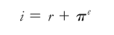
Real interest rate = nominal interest rate - expected inflation (Fischer relationship; investors try to protect themselves from the loss of purchasing power caused by inflation by demanding higher yields or interest rates when lending. Nominal interest rates will be low when expected inflation is low and high when its high.

The real interest rate is a better indicator of the incentives to borrow and lend and it appears to be a better guide to how people are affected by events in credit markets. When real interest rate is low, there are greater incentives to borrow and fewer incentives to lend.
Real return bonds: provide investors with protection against inflation by having and adjustable face value pegged to the inflation rate and then the coupon rate applies toa moving face value; the real rate of return remains fairly constant

Chapter 11: The behaviour of interest rates

Demand for any financial asset is driven by
1. Wealth: including all assets of the owner
holding all factors constant, as wealth increases demand for assets increases
2. Expected return on one asset relative to alternative assets
holding all factors constant, as the expected return on an asset rises relative to that of other assets, demand for that asset will rise.
3. Risk : degree of uncertainty about expected return on an asset
holding all factors constant, if an assets risk rises relative to that of other assets, demand for that asset will decrease
4. Liquidity of the asset: ease with which it can be turned into cash
holding all else constant, the more liquid an asset is, th more desirable it is and demand for it will be greater. The selling can be done quickly and at low cost because there are many participants in the market.

Demand curve for bonds
The demand for bonds is the relationship between the quantity demanded for bonds and bond prices, holding all variables (excluding interest rates) constant, considered from the point of view of the bondholder (buyer or investor)
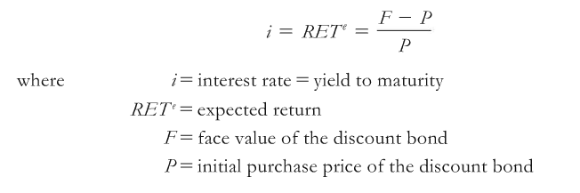
quantity demanded for bonds is negatively related to bond prices and positively related to interest rates. Negative straight curve.

Four things will cause Shifts in demand for bonds
1. Wealth:
as wealth of the investors increase, (economic expansion), demand for bonds will shift to the right and the opposite in recession
2. Expected return on one asset relative to alternative assets
if other assets suddenly have lower expected returns, then bonds become more attractive as an investment and the demand curve will shift to the right. If other assets have higher expected return than before, (ex: increase in expected inflation for houses, making real assets more attractive than bonds) then bonds become less attractive investment and demand curve shifts left.
3. Risk of bonds relative to other assets:
if bonds suddenly have greater risk compared to other assets, then demand for bonds shifts left. Thats because if interest rates rises, the real return on bonds will be lower. The curve will shift to the right if interest rates are expected to fall because that would mean bond prices are expected to rise in the future.
4. Liquidity of the asset:
the greater the number of participants in a segment of a bond market, the easier it is to sell bonds and at lower cost. Therefore if liquidity of bonds improves, the demand for bonds will shift right. The opposite would happen if there were fewer investors in the bond market, then the demand curve would shift left.

Basically demand curve for bonds shifts right if:
- wealth increases (economic recovery)
- other assets have decreased their expected return
- bonds become less risky compared to other assets
- bonds become more liquid (more participants in bond market)

Supply of bonds
The supply of bonds is the relationship between the quantity supplied for bonds and bond prices, holding all variables (excluding interest rates) constant considered from the point of view of the bond issuer.

For the issuer of the bonds, the lower the interest rate, the lower the cost of borrowing by issuing bonds. and the greater will be the supply of bonds. Because of the inverse relationship between bond prices and yields (or interest rates) the lower the interest rate, the higher the bond price and the more attractive it is to issue bonds.
Therefore, the quantity supplied of bonds is positively related to bond prices and negatively related to interest rates.

supply of bonds is upward sloping because higher bonds prices mean lower interst rates

Shifts in the supply of bonds are caused by
1. Expected profitability of investment oppurtunities. Firms issue bonds in order to invest in projects. The higher the expected profit on those projects is, the higher the interest rate is tolerated by the issuer.
In an economic expansion, profitable investment oppurtunities are plentiful and the supply of bonds tends to increase (supply shifts right). Similarily in a recession, profitable investment projects are more scarce and supply bonds shift left.
2. Expected inflation.
Expected inflation decreases the REAL return for those who buy bonds
Decreases the real cost of borrowing for those who issue bonds
For a given NOMINAL interest rate(and bond price), higher inflation means lower REAL interest rate (and expected increase in the future value of investment projects).
Higher expectation inflation increases bond supply (shifts to the right)
Lower expectation inflation would shift bond supply to the left
3. Changes in the government budget
If government spending (G) is greater than total tax revenue (T), the government is in deficit
If government spending is less than total tax revenue, the gvt is in surplus.
Gvt borrow by issuing bonds. The larger the deficit the greater the supply of gvt bonds and therefore the total supply of bonds will shift to the right.
If the governments deficit is reduced, it shifts left.

Basically supply of bonds shifts right if:
-economy expands : expected increase in profitable projects
-inflation increases: reduces real borrowing costs
-gvt budget deteriorates: more gvt bonds issued

Equilibrium in bond markets & interest rate determination
Equilibrium in the bond market occurs where the quantity demanded of bonds matches the quantity supplied. This implies both a market clearing bond price and interest rate. The demand and supply of bonds are important factors in the movement of interest rates.
Ex; government budget deficit INCREASES, supply of bonds shifts right, bonds prices fall and interest rate RISE. (shift supply to the right)
Ex; an increase in expected inflation affect both demand who shift left (because higher expected inflation makes other real assets for example houses, more attractive than bonds as an investment) Supply of bonds will shift right because real borrowing costs will be lower and expected future value of investment projects will be higher
Since both curves move in opposing directions. There will be downward pressure on bond prices which will cause interest rates to rise.
- Supply curve shifts greater extent than demand, bond price falls, interest rate rise
- Supply curve shifts less than demand, bond price falls, therefore interest rate rise
Ex; economic recovery will affect both demand and supply bonds. The recovery means an increase in wealth for bond holders to demand shifts right. It means an increase in profitable investment oppurtunities so supply shifts right aswell. Both curves move in the same direction. Supply curve shifts to A GREATER EXTENT than demand, bond price falls, therefore interest rate rise.
Rememeber in economic expansions, interest rate rise and in recession, interest rates fall.
Ex; economic recession will affect both demand and supply of bonds. Decrease in wealth for bond holders so demand shifts left. It also means a decrease in profitable investment oppurtunities so supply also shifts left. We know demand will shift by less than supply so bond prices will rise and interest rates will fall.
Read p.191 for real nat

Supply & Demand for money – liquidity preference framework
Instead of using the demand and supply for bonds as an explanation for changes in interest rates you can also use the demand and supply for money slash liquidity. This is from our dear John Maynard Keynes
Assumptions : there are two main types of assets that people use to store their wealth ; money and bonds.
Total wealth in the economony must equal the total quantity of bonds supplied (Bs) plus the total quantity of money supplied (Ms) in the economy.
The quantity of money (Md) and bonds (Bd) that people want to hold and therefore demand, must also be equal to the total amount of wealth, because you cant purchase more than the total assets.
Bs+Ms= Bd+Md and Bs- Bd= Md-Ms
- By assuming there are 2 kinds of assets, framework ignores the impact of changes in price of things like real assets, but it yields the same results as the bond market analysis
- The demand and supply for bonds is easier to use when analyzing the effects from changes in expected inflation.
- The demand and supply of money is easier to use when analyzing the effects from changes in income, the price level and the supply of moneay

Money demand is negatively related to interest rates because:
- Money is defined as simple M1 ; we assume that money has close to zero rate of return, while bonds have a return equal to the rate of interest. As interest rate rise, the expected return on bonds rises relative to the expected return on money and this causes the emand for money to fall
- As interest rates on bonds risem the amount of interst that could have been earned by holding bonds instead of cash goes up. This is the Oppurtunity cost of holding cash instead of bonds. If interest rate rise, money is less desirable and the demand for money will fall.

The demand for money can shift for two reasons :
- Income effect: as the economy expands and income rises, wealth increases and people want to hold more money. Increases in income shift Md to the right. Decreases in income shift Md to the left.
- Price level effect: when the price level rises, the same nominal amount of money does not buy as many goods & services, so people want to hold more money. A rise in the price level shifts Md to the right. A fall in the price level shift Md to the left.

The bank of Canada can increase the supply of money (Ms shifts right, expansionary monetary policy) or decrease the supply of money (Ms shifts left, contractionary monetary policy)
Therefore, interest rates will INCREASE if Md shifts right (because increase of income or price level) or if Ms shifts left
Interest rates will DECREASE if Md shifts left (decrease in income or price level) or if Ms shifts right (banks have more cash so they can lower interest rates on loans and deposits, this is also called liquidity effect)

Application of Liquidity Preference framework – monetary policy
The assumption that an increase in the money supply lowers interest rates (liquidity effect)
Ignores the subsequent stimulus to aggregate demand (AD) that should eventually either raise the price level or at least put a floor under it. If the price level rises, interest rates will also rise (a rise in the price level shifts Md to the right)
- Income effect of an increase in the money supply : an increase in the Ms initially causes interest rates to fall, but that in turn stimulates an economic expansion. We know from the demand and supply of bonds that in an economic expansion interest rates rise and bond prices fall
- Price level effect of an increase in the money supply: an increase in the Ms will cause economic expansion. This leads to greater demand for goods and services, then leads to shortages and increase in the price level as AD shifts to the right. A rise in the price level shifts Md to the right and interest rates rise.
- Exected inflation effect of an increase in the money supply : an increasing in Ms may lead people to expect a higher price level in the future, so the expected inflation rate will be higher, but we know that an expected increase in the inflation rate leads to lower bond prices and higher interest rates

If there is a one time only increase in the price level, without an accompanying increase in the Ms, the interest rate will rise due to the price level effect and the expected inflation effect. When the price stops rising next year, there will be no further increase in expected inflation, so the interest rate will fall back to its former level
Buttttttt if the increase in the price level is accompanied by an increase in the growth rate of the Ms, then the economy will continue to be stimulated, inflation will continue to rise and interest rates will continue to rise.

The liquidity effect suggests that an increase in the money supply causes interest rates to fall. Banks have more cash so they can LOWER interest rates on loans and deposits. This happens in the short run.
But the income, price level and expected inflation effects of an increase in the money supply suggest an increase in the money supply will EVENTUALLy lead to higher interest rates. The income and price level effects happen in the LONG Run because it takes time for the stimulating effect ts of the expansionary monetary policy to cause economic expansion and eventual shortages. The expected inflation effect can unfold quick or slow depending to how fast people are adjusting their expectations when the money supply is increased.

Chapter 12: the risk and term sturcutre of interest rates
At every point in time, there are a range of interest rates that differ widely, depending on a variety of factors including time frame of the loan or bond quality of the issuer and market conditions.
To understand why debt instruments with the same maturity can have different interest rates, we examine the risk structure of interest rates (which can also include liquidity risk)
To understand why debt instruments of different terms to maturity will have the same interest rates, we examine the structure of interest rates.

Risk Structure of Interest Rates
Historical data show that in general, corporate bonds offer higher interest rates than government bonds of the same maturity. Two main types of risk are relevant :
- Default risk : the risk that the bond issuer will suffer financial distress and be unable to either pay all the coupons or to repay the bond at maturity
  - Governemnet bonds are considered default free bonds because the government can always raise taxes to cover its debt obligations to bond holders
  - Corporate bonds are considered more likely to have some default risk because companies profits and their ability to pay depends on market conditions and corporate decision making, The amount of default risk can vary over time
The difference between corporate and government bonds yields stemming from the default risk is called the risk premium. This indicates how much extra interest investors must earn in order to be willing to hold a risky bond.

Using the supply and demand for bonds we can see why the increase in the default risk of corporate bonds would do three things:
- Increase the required interest rate on corporate bonds for investors
- Decrease the interest rate on gvt bonds
- Increase the size of risk premium (difference between both becomes larger)
  - Bond ratings: firms pay to have their bond rated. CBRS and DBRS. This is an assessment of the credit worthiness of the issuer. It concerns primarily the risk default.
Continue on p. 198
Contents
COMM 220 : ANALYSIS OF MARKETS 1
chapter 6 : supply of labour 1
A theory of the decision to work 1
Defining the Income effect 1
Defining the Substitution Effect 2
Review of Utility theory 2
Review of the law of diminishing marginal utility 2
Preferences applied to Labour Supply model 2
WAGE INCREASE ON SUBSTITUTION AND INCOME EFFECT 2
Chapter 7 (cp p.139) : Uncertainty and consumer behaviour 2
Preferences for varying degrees of risk: 2
Reducing risk 2
THE LAW OF LARGE NUMBERS 2
THE DEMAND FOR RISKY ASSETS 2
Expected vs actual returns 2
Bubblezzzzzzzz 2
Behavioral economics 2
Rules of thumb and biases in decision making 2
Chapter 8 : overview of the financial market 2
ways to transfer from lenders to borrowers : 2
Structure of financial market (direct) 2
The primary market 2
The secondary market 2
FINANCIAL MARKET INSTRUMENTS: 2
CAPITAL MARKET INSTRUMENTS: 2
INTERNATIONAL (GLOBALIZATION) OF FINANCIAL MARKETS: 2
FUNCTION OF FINANCIAL INTERMEDIAIRIES (indirect finance) 2
Types of financial intermediairies 2
REGULATION OF THE FINANCIAL SYSTEM 2
Chapter 9 : an economic analysis of financial structure 2
EXPLANATIONS 2
Transaction costs 2
Adverse selection influences financial structure 2
Moral Hazard affects the choice between debt and equity 2
Tools to solve the principal agent problem : 2
Financial information and economic growth 2
Understanding interest rates 2
Simple interest 2
Chapter 10 : Understanding interest rate 2
Important definitions 2
Compounding 2
Discounting 2
Coupon Bond 2
Bond yields and bond prices 2
Discount bonds or zero coupon bonds 2
Disctinction between interest rates and return 2
Interest rate risk of bonds 2
Nominal and real interest rates - inflation risk 2
Chapter 11: The behaviour of interest rates 2
Demand for any financial asset is driven by 2
Demand curve for bonds 2
Supply of bonds 2
Equilibrium in bond markets & interest rate determination 2
Supply & Demand for money – liquidity preference framework 2
Money demand is negatively related to interest rates 2
Application of Liquidity Preference framework – monetary policy 2
Chapter 12: the risk and term sturcutre of interest rates 2
Risk Structure of Interest Rates 2

Contents
COMM 220 : ANALYSIS OF MARKETS 1
chapter 6 : supply of labour 1
A theory of the decision to work 1
Defining the Income effect 1
Defining the Substitution Effect 2
Review of Utility theory 2
Review of the law of diminishing marginal utility 2
Preferences applied to Labour Supply model 2
WAGE INCREASE ON SUBSTITUTION AND INCOME EFFECT 2
Chapter 7 (cp p.139) : Uncertainty and consumer behaviour 2
Preferences for varying degrees of risk: 2
Reducing risk 2
THE LAW OF LARGE NUMBERS 2
THE DEMAND FOR RISKY ASSETS 2
Expected vs actual returns 2
Bubblezzzzzzzz 2
Behavioral economics 2
Rules of thumb and biases in decision making 2
Chapter 8 : overview of the financial market 2
ways to transfer from lenders to borrowers : 2
Structure of financial market (direct) 2
The primary market 2
The secondary market 2
FINANCIAL MARKET INSTRUMENTS: 2
CAPITAL MARKET INSTRUMENTS: 2
INTERNATIONAL (GLOBALIZATION) OF FINANCIAL MARKETS: 2
FUNCTION OF FINANCIAL INTERMEDIAIRIES (indirect finance) 2
Types of financial intermediairies 2
REGULATION OF THE FINANCIAL SYSTEM 2
Chapter 9 : an economic analysis of financial structure 2
EXPLANATIONS 2
Transaction costs 2
Adverse selection influences financial structure 2
Moral Hazard affects the choice between debt and equity 2
Tools to solve the principal agent problem : 2
Financial information and economic growth 2
Understanding interest rates 2
Simple interest 2
Chapter 10 : Understanding interest rate 2
Important definitions 2
Compounding 2
Discounting 2
Coupon Bond 2
Bond yields and bond prices 2
Discount bonds or zero coupon bonds 2
Disctinction between interest rates and return 2
Interest rate risk of bonds 2
Nominal and real interest rates - inflation risk 2
Chapter 11: The behaviour of interest rates 2
Demand for any financial asset is driven by 2
Demand curve for bonds 2
Supply of bonds 2
Equilibrium in bond markets & interest rate determination 2
Supply & Demand for money – liquidity preference framework 2
Money demand is negatively related to interest rates 2
Application of Liquidity Preference framework – monetary policy 2
Chapter 12: the risk and term sturcutre of interest rates 2
Risk Structure of Interest Rates 2

