Midterm 1: Management: Chapter 1: Organizations and organizational theory

Topic: Any companies, throughout the entire world, need to choose the right strategy and then design the right structure. We see the importance of the changing environment and its impact on Air Canada’s effectiveness.
Organizational theory draws lessons from organizations such as the Rolling Stones, IBM, and Air Canada make those lessons available to students and managers. In short, organization constantly changes due to the environment and managers can learn something from these changes. In addition, all industries are fragile and vulnerable: Organizations are not static, they continuously adapt to shifts in the external environment.
Today, many companies are facing the need to transform themselves into dramatically different organizations because of new challenges in the environment.

Current challenges

The world is changing more rapidly than ever before.
Surveys of top executives indicate that coping (manage) with rapid change is the most common problem facing managers and organizations.
Some specific challenges are dealing with globalization, maintaining high standards of ethics and social responsibility, responding rapidly to environmental changes and customer needs, managing the digital workplace, and supporting diversity.

- Globalization:

In French: mondialisation. With rapid advances in technology and communications, markets, technologies and organizations are increasingly interconnected. The growing interdependence means that the environment for companies is becoming extremely complex and competitive. Organizations have to learn to cross lines of time, culture, and geography in order to survive. Companies, large and small, are searching for the right structures and processes that can help them reap (recueillir) the advantages of global interdependence and minimize the disadvantages.

- Ethics and Social Responsibility:

Ethics and Social responsibility have become two of the hottest topics in organizations today. The list of executives and major corporations involved in financial and ethical scandals continue to grow. Although some executives and officials continue to insist that it is a few bad apples involved in all the wrongdoing, the public is quickly forming the opinion that all corporate executives are crooks. Leaders face tremendous pressure from the government and the public to hold their organizations and employees to high ethical and professional standards.

- Speed of Responsiveness:

A third significant challenge for organizations is to respond quickly and decisively to environmental changes, organizational crisis, or shifting customer expectations. Today, globalization and advancing technology have accelerated the pace at which organizations in all industries must roll out new products and services to stay competitive.

- The Digital Workplace:

Some traditional managers feel particularly awkward in today’s technology-driven workplace. Organizations have been engulfed by information technology that affects how organizations are designed and managed.
These advances mean that organizational leaders not only need to be technologically savvy but also are responsible for managing a web of relationships that reaches far beyond the boundaries of the physical organization, building flexible e-links between a company and its employees, suppliers, contract partners, and customers.

- Diversity:

Diversity is a fact of life that no organization can afford to ignore. The growing diversity brings a variety of challenges, such as maintaining a strong organizational culture while supporting diversity, balancing work and family concerns, and coping with the conflict brought about by varying cultural styles.
Managing diversity may be one of the most rewarding challenges for organizations competing on a global basis.

Definition

Organizations as diverse as a family, a prison, a hospital, and Air Canada have characteristics in common. The definition used to describe organizations is as follow: Organizations are (1) social entities that are (2) goal directed, (3) designed as deliberately structured and coordinated activity systems, and (4) linked to the external environment.
Organizations comprise people and their relationships with one another. An organization exists when people interact with one another to perform essential functions that help attain goals. They work together toward common goals.

Types of Organization

Some organizations are large, multinational corporations. Others are small, family-owned shops.
Another important distinction is between for-profit businesses and non-profit organizations. There are some differences to keep in mind.
The primary difference is that managers in businesses direct their activities toward earning money for the company, whereas managers in non-profit direct their efforts toward generating some kind of social impact.
The unique characteristics and needs of non-profit organizations created by this distinction, present difficult challenges for organizational leaders.
Financial resources for non-profits have come from government grants and individual and corporate donations, rather than from the sale of products or services to customers.
Profit Organization managers focus on improving the organization’s products and services to increase sale.
Non-profit Organization Need to secure a steady stream of funds to continue operating.

Importance of Organization

Organizations as we know them are relatively recent in the history of humankind.
The modern corporation may be the most significant innovation of the past 120 years.
Organizations are all around us and shape our lives in many ways.
But what contributions do organizations make? Why are they important?
There are seven reasons organizations are important to you and to society:
- Bring together resources to achieve desired goals and outcomes: We can think to the creation of an airplane.
- Produce goods and services efficiently (think to the economy of scope)
- Facilitate innovation
- Use modern manufacturing and information technologies
- Adapt to and influence a changing environment
- Create value for owners, customers and employees
- Accommodate ongoing challenges of diversity, ethics, and the motivation and coordination of employees.

Perspectives on Organization

There are various ways to look at and think about organizations and how they function. Two important perspectives are the open-systems approach and the organizational-configuration framework.

Open systems

One significant development in the study of organization was the distinction between closed and open systems. A closed system would not depend on its environment. The management of a closed system would be quite easy. The environment would be stable and predictable and would not intervene to cause problems. The primary management issue would be to run things efficiently.
An open system must interact with the environment to survive; it both consumes resources and exports resources to the environment (voir graphique). It must constantly adapt to the environment. Open systems can be enormously complex.
To understand the whole organization, we must view it as a system. A system is a set of interacting elements that acquires inputs from the environment, transforms them, and discharges outputs to the external environment.

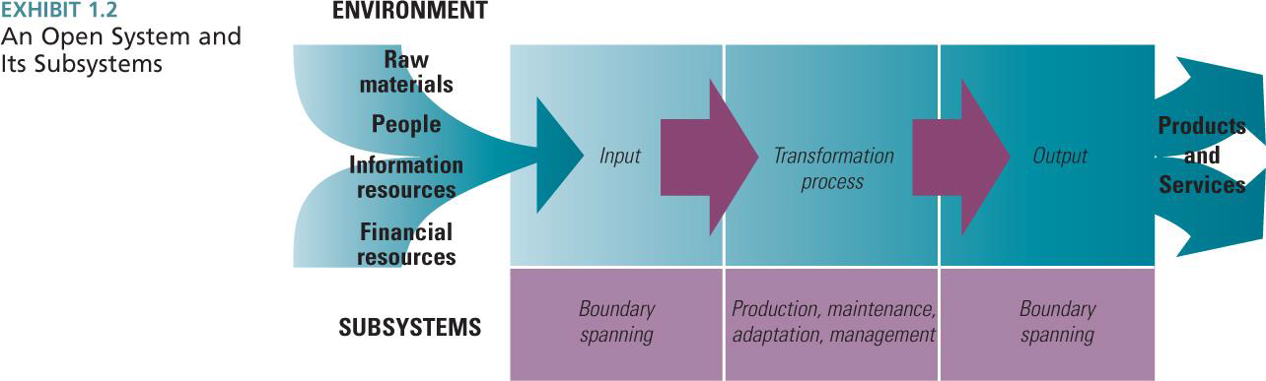

- Interacting elements means that people and department depend on one another.
- Input includes raw materials, people, employees or financial resources and so on.
- The transformation process changes these inputs into something of value that can be exported back to the environment.
- Outputs include specific products and services for customers and clients.

A system comprises several subsystems, as illustrated. These subsystems perform the specific functions required for organizational survival, such as boundary spanning, production, maintenance, adaptation and management. Boundary subsystems are responsible for exchanges with the external environment.
The maintenance subsystem maintains the smooth operation and upkeep of the organization’s physical and human elements.

Organization configuration

Henry Mintzberg suggests that every organization has five parts.

These parts include: technical core, top management, middle management, technical support, and administrative support.

Technical core: The technical core includes people who do the basic work of the organization. It performs the production subsystem function and actually produces the product and service outputs of the organization. This is where the primary transformation from inputs to outputs takes place. For example: a teacher to the university or the pilots and flights attendants for an airline.

Top and Middle Management: Management is a distinct subsystem, responsible for directing and coordinating other parts of the organization.
Top management provides direction, strategy, goals and policies for the entire organization.
Middle management is responsible for implementation and coordination at the department level.

Technical Support: The technical support function helps the organization adapt to the environment. Technical support employees such as engineers and researchers scan the environment for problems, opportunities, and technological developments. Technical support is responsible for creating innovations.

Administrative Support: The administrative support function is responsible for the smooth operation and upkeep of the organization, including its physical and human elements. This includes human resources activities such as recruiting and hiring, establish compensation and benefits.

Dimension of Organizational Structure

The next step is to look at dimensions that describe specific organizational design traits.
Organizational dimensions fall into two types: structural and contextual.
Structural dimensions provide labels to describe the internal characteristics of an organization. They create a basis for measuring and comparing organizations.
Contextual dimensions characterize the whole organization, including its size, technology, environment and goals.

- Structural Dimensions

Structural dimensions include the six following processes: Formalization, Specialization, Hierarchy of authority, Centralization, Professionalism and Personnel ratio.
F S H C P P

Formalization: it pertains to the amount of written documentation in the organization. Documentation includes procedures, job descriptions, regulations, and policy manuals. Formalization is often measured by simply counting the number of pages of documentation within the organization. Large university tend to be high on formalization because they have several volumes of written rules for things such as registration or dropping and adding classes.
Specialization: it is the degree to which organizational tasks are subdivided into separate jobs. If specialization is extensive, each employee performs only a narrow range of tasks. If specialization is low, employees perform a wide range of tasks in their job. Specialization is sometimes referred to as the division of labour.
Hierarchy of authority: It describes who reports to whom and the span(=durée) of control of each manager. The hierarchy is depicted(=illustré) by the vertical lines on an organizational chart.
Centralization: It refers to the hierarchical level that has authority to make a decision. When decision-making is kept at the top level, the organization is centralized. When decisions are delegated to lower organizational level, it is decentralized.
Professionalism: It is the level of formal education and training of employees. Professionalism is generally measured as the average number of years of education of employees.
Personal ratios: It refers to the deployment of people to various functions and departments. A personal ratio is measured by dividing the number of employees in a classification by the total number of organizational employees.

- Contextual Dimensions

Structural dimensions include the five following processes: goal and strategy, environment, size, technology and culture.
S E S T C

Goal and strategy: It defines the purpose and competitive technique that set it apart from other organization. A strategy is a plan of action that describes resource allocation and activities for dealing with the environment. Goals and strategy define the scope of operations and the relationships with employees, customers, and competitors.
Environment: It includes all the elements outside the boundary of the organization. It includes: industry, government, customers, suppliers and financial community.
Size: it is the organization’s magnitude as reflected in the number of people in the organization. The number of employees typically measures size.
Technology: it refers to the tools, techniques, and actions used to transform inputs into outputs.
Culture: An organization’s culture is the underlying set of key values, beliefs, understandings, and norms shared by employees.

The 11 contextual and structural dimensions discussed here are INTERDEPENDANT.

Performance and Effectiveness Outcomes

Managers adjust structural and contextual dimensions ad organizational subsystem to most efficiently and effectively transform inputs into outputs and provide value.
Efficiency refers to the amount of resources used to achieve the organization’s goal.
It is based on the quantity of raw material, money, and employees necessary to produce a given level of output.
Effectiveness is the degree to which an organization achieves its goals.
In short, efficiency is “ doing things rights” while effectiveness is “ doing the right things”.

However, achieving effectiveness is not always a simple matter because different people want different things from the organization.
For example, the customers desire high-quality products and services at a reasonable price, whereas employees are mostly concerned with adequate pay, good working conditions, and job satisfaction.
Managers carefully balance the needs and interests of various stakeholders in setting goals and striving for effectiveness.
A stakeholder is any group within or outside the organization that has a stake in the organization’s performance. The satisfaction level of each group can be assessed as an indication of the organization’s performance and effectiveness.

Voir page 23 pour le tableau des stakeholders: (major stakeholder groups and what they expect)
Ex: - Government: fair competition
-Management: efficiency and effectiveness
-Customers: high-quality goods and services
- Employees: Satisfaction, Pay, and Supervision

In reality, it is unreasonable to assume that all stakeholders can be equally satisfied. However, if an organization fails to meet the needs of several stakeholders groups, it is probably not meeting its effectiveness goals.

Managers strive to at least minimally satisfy the interests of all stakeholders.

The evolution of organizational theory and design

Historical Perspectives

Efficiency is everything: Scientific management postulates that decisions about organizations and job design should be based on precise, scientific study of individual situations.
Managers develop precise, standard procedures for doing each job; select workers with appropriate abilities; train workers in the standard procedures; carefully plan work; and provide wage incentives to increase output.
The role of management is to maintain stability and efficiency.
Scientific management focused primarily on technical core.

How to get organized?

Administrative principles look at the organization as a whole propose principles
Bureaucratic organizations application of standard rules

What about people?
Hawthorne study (a fucking study) concluded that positive treatment of employees improved their motivation and productivity. The publication of these findings let to a revolution in worker treatment.
These human relations and behavioural approaches added new and important contributions to the study of management and organizations.

Don’t forget the environment?

Many problems occurs when all organizations are treated as similar, which was the case with scientific management and administration principles approaches that attempted to design all organization alike.
Contingency (=éventualité) means that one thing depends on other things, and for organizations to be effective; there must be “a goodness of fit” between their structure and the conditions in their external environment.

Contemporary Organizational Design

The challenges presented by today’s environment (globalization, diversity, ethical concerns and so on) call for dramatically different responses from people and organization. The perspectives of the past do not provide a road map for steering today’s organizations.
Over the 20th century, organizations became large and complex, and boundaries between functional departments and between organizations were distinct. Internal structures grew more complex, vertical and bureaucratic.
The environment of today is anything but stable.
The science of chaos theory suggests that relationships in complex system are nonlinear and generate divergent choices that create unintended effects and render the universe unpredictable.
The ideas of chaos theory suggest that organizations should be viewed more as natural system instead of predictable machines.
Many organizations are shifting from strict vertical hierarchies to flexible, decentralized structures that emphasize horizontal collaboration.
Many managers are redesigning their companies toward something called the learning organization.
The learning organization promotes communication and collaboration.
The learning organization is based on equality, open information, little hierarchy, and a culture that encourages adaptability and participation.

Efficient Performance versus the Learning Organization

As manager struggle toward the learning organization, they are finding that specific dimension of the organization (task, system, structure) have to change.

From Vertical to Horizontal Structure:
- Traditionally, the most common organizational structure is activities, which are grouped together by common work from the bottom to the top of the organization.
Generally, little collaboration occurs across functional departments, and the whole organization is coordinated and controlled through the vertical hierarchy, with decision-making authority residing with upper-level managers.
This structure can be quite effective. However, in a rapidly changing environment, the hierarchy becomes overloaded (= surchargé)
- In the learning organization, the vertical structure that creates distance between managers at the top of the organization and workers in technical core is disbanded. (=Released)
Structure is created around horizontal processes rather than departmental functions.
The vertical hierarchy is flattened (=aplati). Self-directed teams are the fundamental work unit in the learning organization. Boundaries between functions are practically eliminated because teams include members from several function areas.

From Routine Tasks to Empowered Roles:
- Another shift in thinking relates to the degree of formal structure and control placed on employees in the performance their work. A task is narrowly defined piece of work assigned to a person. In traditional organizations, tasks are broken down into specialized, separate parts, as in a machine. Knowledge and control of tasks are centralized at the top of the organization, and employees are expected to do as they are told.
- A role is a part in a dynamic social system. A role has responsibility, and needs to achieve an outcome or meet a goal. In the learning organization, employees play a role the team or department. There are few rules or procedures. Employees are encouraged to take care of problems by working with one another and with customers.

From Formal Control System to Shared Information:
- In young and small organizations, communication is generally informal and face-to-face. However, when organizations grow large and complex, the distance between top leaders and workers in the technical core increases.
- In learning organizations, the widespread sharing of information keeps the organization at an optimum level. The learning organization strives to return to the condition of a small enterprise, where all employees have complete information. Ideas and information are shared throughout the organization.
In addition, learning organization maintain open lines of communication with customers, suppliers, and even competitors to enhance learning capability.

From Competitive to Collaborative Strategy:
- In traditional organizations, strategy is formulated by top managers and imposed on the organization. Top executives think about how the organization can best respond to competition and efficiently use resource.
- In the learning organization, the accumulated actions of an informed workforce contribute to strategy development. Since all employees are in touch with customers, suppliers, and new technology, they help needs and solutions and participate in strategy making.

From rigid to adaptive culture:
- For a traditional organization, its culture should encourage adaptation to the external environment. A danger for many organizations is that culture becomes ossified. Organizations that were highly successful in stable environments often become victims of their own success when the environment begins to change dramatically.
- In the learning organization, the culture encourages openness, equality, continuous improvement, and change. The whole system minimizes boundaries within the organization and other organizations.

Managers today are involved in a struggle as they attempt to change their companies into learning organizations.
The critical challenge for managers is to maintain some level of stability as they actively promote change toward the new way of thinking, to navigate between order and chaos.

Level of analysis.

Four levels of analysis normally characterize organizations. (voir tableau page 32).
The individual human being is the basic building block of organization. The next higher system level is the group or department. These are collections of individuals who work together to perform group tasks. The next level of analysis is the organization itself. Organization themselves can be grouped together into the next higher level of analysis, which is the interorganizational set and community.

Organizational theory focuses on the organizational level of analysis. To explain the organization, we should look at not only its characteristics, but also the characteristics of the environment and of the departments and groups that make up the organization.

Organizational theory is distinct from organizational behaviour.

- Organizational behaviour is the micro approach to organizations because it focuses on the individuals within organizations as the relevant units of analysis. O.B examines concepts motivation, leadership style and personality.
- Organizational theory is a macro examination of organizations because it analyses the whole organization as a unit. O.T is concerned with people aggregated into departments and organizations.
- A new approach to organization studies is called meso theory. Meso theory concerns the integration of both micro and macro level of analysis.
Top managers are responsible for the entire organization and must set goals, develop strategy, interpret the external environment, and decide organizational structure and design.
Middle managers do much the same for major departments within the guidelines provided by top management.

Midterm 1: Management: Chapter 2: Strategy, Organizational Design, and Effectiveness.

Purpose of the chapter: Top managers give directions to organizations. They set goals and develop the plans for their organizations to attain these goals. The purpose of this chapter is to help you understand the types of goals that organizations pursue and some of the competitive strategies managers use to reach those goals.

The role of strategic Direction in Organizational Design

Voir feuille et tableau page 52.

Organizational Purpose

Organization are created and continued in order to accomplish something. All organizations exist for a purpose. This purpose may be referred to as the overall goal, or mission.
One major distinction is between the officially stated goals (or mission), and the operative goals the organization actually pursue.

Mission

The overall goal for an organization is often call the mission.
The mission is sometimes called the officials goals, which refers to the formally stated definition of business scope and outcomes the organization is trying to achieve.
The mission statement communicates to current and prospective employees, customers, investors, suppliers, and competitors what the organization stands for and what it is trying to achieve.

The Operative Goals

Operative goals designate what the organization is actually trying to do. Operative versus official goals represent actual versus stated goals.
Operative goals pertain to the primary tasks an organization must perform.
Learn the following: (types of operative goals)
O R M E I P

- Overall Performance: Profitability reflects the overall performance of for-profit organization. Profitability may be expressed in terms of net income, earning per share, or return in investment. Other overall performance goals are growth and output volume. Growth pertains to increases in sales or profits over time.
- Resources: Resources goals pertain to the acquisition of needed material and financial resources from the environment. They may involve obtaining financing for the construction of new plants, finding less-expensive sources for raw materials, or hiring top quality technology graduates.
- Market: Market goals relate to the market share or market standing desired by the organization. Market goals are the responsibility of marketing, sales, and advertising departments.
- Employee development: Employee development refers to the training, promotion, safety, and growth of employees. It includes both managers and workers.
- Innovation and Changes: Innovation goals need to be adapted to unexpected changes in the environment. Innovation goals are often defined in terms of the development of specific new services, products, or production processes. For example, Facebook has been awarded to become the most visited web sited, better than Google.
- Productivity: Productivity goals pertain to the amount of output achieved from available resources.

Successful organizations use a carefully balanced set of operative goals. Increasing numbers of companies assess their environmental and social performance as well as their profit. Innovation and change goals are increasingly important.

The Importance of Goals

Official goals describe a value system for the organization. Official goals legitimize the organization.
Operative goals represent the primary tasks of the organization. They are explicit and well defined.
Goals can act as guidelines for employee behaviour and decision-making.

A framework for Selecting Strategy and Design

To support and accomplish the direction determined by an organizational mission and operative goals, managers have to select specific strategy and design options that will help organization achieve its purpose and goals within tis competitive environment.
A strategy is a plan for interacting with the competitive environment to achieve organizational goals.
Goals and strategies are not interchangeable: goals define where the organization wants to go and strategies define how it will get here.
Two models for formulating strategies are the Porter Model of competitive strategies and Miles and Snow’s strategy typology.

Porter’s Competitive Strategies

Porter introduced three competitive strategies: low-cost leadership, differentiation, and focus. The focus strategy in which the organization concentrates on a specific marker or buyer group, is divided into focused low-cost leadership and focus differentiation. Managers evaluate two factors, competitive advantage and competitive scope.
voir graph (page 60)

Differentiation: In a differentiation strategy, organizations attempt to distinguish their products or services from others in the industry. An organization may use advertising, distinctive products features and so on. This strategy usually targets customers who are not particularly concerned with price.
A differentiation strategy can reduce rivalry (=rivalité) with competitors because customers are loyal to the company’s brand. However, companies must remember that successful differentiation strategies require a number of costly activities, such as product research and design. They need strong marketing strategies.

Low-cost leadership: The low-cost leadership strategy tries to increase market share by emphasizing low cost compared to competitors.
The low-cost leadership strategy is concerned primarily with stability rather than taking risks or seeking new opportunities for innovation and growth.
A low-cost strategy can help a company can help a company defend against current competitors because customers cannot find lower prices elsewhere.

Focus: With this strategy, the organization concentrates on a specific regional market or buyer group. There are two distinctive focus strategies: the company will try to achieve either a low-cost advantage or differentiation advantage within a narrowly defined market.

Many Internet companies have failed because they did not develop competitive strategies that would distinguish them in the marketplace. On the other hand, eBay and Google have been highly successful with coherent differentiation strategies.

Miles and Snow’s strategies Typology

The Miles and Snow’s strategy is based on the idea that managers seek to formulate strategies that will be congruent with the external environment.
The four strategies that can be developed are: Prospector, Defender, Analyze and Reactor.

Prospector: The prospector strategy is to innovate, take risks, seek out new opportunities, and grow. This strategy is suited (=est adaptée) to a dynamic, growing environment, where creativity is more important than efficiency.
Defender: The defender strategy is almost the opposite of the prospector. Rather than taking risks and seeking out new opportunities, the defender strategy is concerned with stability and even retrenchment. The defender is concerned primarily with internal efficiency and control to produce reliable, high-quality products for steady customers.

Analyser: The analyze tries to maintain a stable business while innovating on the periphery. It seems to lie midway between the prospector and the defender. Some products will be targeted toward stable environment in which an efficiency strategy designed to keep current customers is used. Others will be targeted toward new, more dynamic environments, where growth is possible.

Reactor: The reactor strategy is not really strategy at all. Rather, reactors respond to environmental threats and opportunities. In a reactor strategy, top management has not defined a long-range plan or given the organization an explicit mission or goal, so the organization takes whatever actions to meet immediate needs.

The Miles and Snow typology has been widely used, and researchers have found strong support for the effectiveness of this typology for organization managers in real-world situations.

How Strategies Affect Organizational Design (voir tableau page 64)

Choice of strategy affects internal organization characteristics. Organizational design characteristics need to support the firm’s competitive approach.

With a low-cost strategy, managers take an efficiency approach to organizational design, whereas a differentiation strategy calls for a learning approach.

Low cost strategy & Defender:
- Efficiency orientation
- Centralized authority
- Tight cost control
- Close supervision
- Little employee empowerment

Differentiation & Prospector:
- Learning orientation
- Strong horizontal coordination
- Decentralized structure
- Reward employee creativity, risk taking, and innovation

C’est un peu: Efficiency and Control versus Learning and Flexibility.
Pour résumé un peu,
Efficiency: vertical
Learning: horizontal

Other Factors Affecting Organizational Design

Strategy is one important factor that affects organizational design. However, organization design is a result of numerous contingencies. The emphasis placed on efficiency and control versus learning and flexibility is determined by the contingencies of strategy, environment, technology, size and life cycle and culture.
S E T S C

In term of size and life cycle, young, small organizations are generally informal and have little division of labour, few rules and regulations. Large organization such as Coca-Cola, have an extensive division of labour, numerous rules and regulations, and standard procedures and systems for budgeting, control, rewards, and innovation.

A final contingency that affects organization design is organizational culture. An organizational culture that values teamwork, collaboration, creativity, and open communication among all employees and managers, would not function very well with a tight, vertical structure, and strict rules of regulations.

Et ainsi de suite pour les autres.

Donc par exemple, quand tu es une nouvelle entreprise, généralement tu n’as pas beaucoup de fonds et donc par exemple il serait mauvais de choisir une stratégie comme prospector car tu ne peux pas forcément avoir les fonds nécessaires pour effectuer des recherches, remercier les employés.

One responsibility of managers is to design organizations that fit the contingency factors of strategy, environment, size and life cycle, technology, and culture.
Finding the rights fit leads to organizational effectiveness, whereas a poor fit can lead to decline or even the demise of the organization.

Assessing Organizational Effectiveness

Organizational goals represent the reason for an organization’s existence and the outcomes it seeks to achieve.
Recall that organizational effectiveness is the degree to which an organization realizes its goals. Effectiveness is a broad concept.
Efficiency is a more limited concept that pertains to the internal workings of the organization.
Organizational efficiency is the amount of resources used to produce a unit of output.
If one organization can achieve a given production level with fewer resources than another organization, it would be described as more efficient.
Sometimes, efficiency leads to effectiveness. In other organization, efficiency and effectiveness are not related. An organization may be highly efficient but fail to achieve its goals because it makes a product for which there is no demand.
Overall effectiveness is difficult to measure in organizations.
One study found that many managers have a difficult time with the concept of evaluating effectiveness based on characteristics that not subject to hard, quantitative measurements.
However, there are new ways to measure effectiveness, including the use of such “soft” indications as “customer delight” and employee satisfaction.

Contingency Effectiveness Approaches

Three approaches exist to measure the effectiveness of an organization: resource-based approach, internal-process approach and goal approach. (Voir la concept map page 67)

Just remind that Organizations bring resources in from the environment, and those resources are transformed into outputs delivered back into the environment.

Resource-based approach

Organizational effectiveness (in this section) is defined as the ability of the organization to obtain scarce and valued resources and successfully integrate and manage them.
Indicators:
- Bargaining position: the ability of the organization to obtain from its environment scarce and valued resources, including financial resources, raw materials, human resources and technology.
- The abilities of the organization’s decision makers to perceive and correctly interpret the real properties of the external environment.
- The ability to use tangible (supplies, people) and intangible (knowledge) resources to achieve superior performance
- The ability to respond to changes in the environment.

Usefulness: this approach is very useful when other indicators of performance are difficult to obtain.

Cons:
- Vague consideration of customer needs.
- Suppose stability in the market place.

Internal-Process Approach

In the internal-process approach, effectiveness is measured as internal organizational health and efficiency. An effective organization has a smooth, well-oiled internal process; employees are happy and satisfied; department activities meet together to ensure high productivity. This approach does not consider the external environment.
The important element in effectiveness is what the organization does with the resources it has.

Indicators:
- Strong organizational culture
- Positive spirit, group loyalty
- Confidence, trust, and communication between employees
- Rewards for performance, growth and development
- Low conflict

Usefulness: The internal-process approach is important because the efficient use of resources and harmonious internal functioning are ways to assess organizational effectiveness.

Cons:
- It does not consider the external environment
- Evaluation of health is subjective

Goal Approach

The goal approach to effectiveness consists of identifying an organization’s output goals and assessing how well the organization has attained those goals.
This is a logical approach because organizations try to attain certain levels of output, profit, or client satisfaction.

Indicators: The important goals to consider are operative goals. Although official goals tend to be abstract and difficult to measure, operative goals reflect activities the organization is actually performing.

Usefulness: The goal approach is used in business organization because output goals can be readily measured. Business firms typically evaluate performance in terms of profitability, growth, market share, and return on investment.

Cons:
- It is not always easy to identify operative goals to measure performance
- Conflict of goals within the organization it cannot be assessed by only one factor.
- Difficult measuring goal attainment.

An Integrated Effectiveness Model

- Competing-values model: balances a concern with various parts of the organization rather than focusing on one part
- It combines several effectiveness indications into a single framework
- It’s based on the assumption that there are disagreements regarding what constitutes effectiveness
- Indicators:
  - Company’s focus: internal (employees’ well-being) vs. external (environment) focus
  - Organizational structure: flexibility vs. stability
- Pros:
  - Integration of different concepts of effectiveness into a single perspective
  - It calls attention to effectiveness criteria as a management values and shows how opposing values exist at the same time

 |  | Structure
 |  | Flexibility | Control
Focus | Internal | Human Relation emphasis | Internal-Process Emphasis
Focus | External | Open-Systems Emphasis | Rational-Goal Emphasis

Human Relation Emphasis:
- Primary goal: HR development
  - Employees are given opportunity for autonomy and development
- Subgoals: cohesion, morale, training

Internal-Process Emphasis
- Primary goal: stability
  - Companies are established in the environment and want to maintain their current position
- Subgoals: information management, communication

Open-Systems Emphasis
- Primary goal: growth and acquisition of resources
  - Establishing a good relationship with the environment
- Subgoals: flexibility, readiness, external evaluation

Rational-Goal Emphasis
- Primary goal: productivity, efficiency, profit
  - Achieving goal in a controlled way
- Subgoals: planning, goal setting

Midterm 1: Management: Chapter 3: Fundamentals of Organizational Structure

Organizational Structure:

There are three key components in the definition of organizational structure:

- Organizational structure designates formal reporting relationship, including the number of level within the company, and the span of control of each managers and supervisors.
- Organizational structure identifies the grouping together of individuals into department.
- Organizational structure includes the design of system to ensure effective communication, coordination of departments.

The three elements of structure pertain to both vertical and horizontal aspects of organizing.

An organizational chart is the visual representation of a whole set of underlying activities and processes in an organization at a particular point in time.

We will examine five basic structural designs and show how they are reflected in the organization chart.

Information-Processing Perspective on Structure

In order to apply what we already learnt and to understand the differences between horizontal and vertical system structure, here are some points:

Vertical Structure are designed for EFFICIENCY vertical linkages such as hierarchy or rules and plans.

Horizontal Structure are designed for LEARNING horizontal communication and coordination.

A good respect of the structure allows a better efficiency for the organization. However, it is hard and difficult to know, for a new and fresh company, which structure would be the most appropriate.

Vertical Structure:
- Specialized Tasks
- Strict Hierarchy, many rules
- Vertical communication and reporting systems
- Few teams
- Centralized decision making

Horizontal Structure:
- Shared tasks, empowerment
- Relaxed Hierarchy, few rules
- Horizontal communication, and face to face
- Many teams
- Decentralized decision-making

Vertical Information Linkage

Vertical information linkages are used to coordinate activities between the top and bottom of an organization. Organization may use any of a variety of structural devices to achieve vertical linkage, including hierarchical referral, rules and plans, and vertical information system.

Hierarchical Referral: The first vertical device is the hierarchy (or chain of command). If a problem arises that employees don’t know how to solve, it can referred up to the next level in the hierarchy.

Rules and Plans: The next linkage device is the use of rules and plans. To the extent that problems and decisions are repetitious, a rule or procedure can be established so employees know how to respond without communicating directly with their manager. (Ex: en télémarketing, on a pleins de réponses types).

Vertical Information System: It includes the periodic reports, written information and computer-based communication.

Horizontal Information Linkage

Voir tableau page 96 (avec le dernier qui est mieux mais qui demande plus de temps et d’argent)

Horizontal communication overcomes barriers between departments and provides opportunities for coordination among employees to achieve unity of effort and organizational objectives.
Horizontal linkage refers to the amount of communication and coordination horizontally across organizational departments.

The following devices are structural alternatives that can improve horizontal coordination and information flow:

Information system: it is the use of cross-functional information system.
Computerized information system can enable managers to exchange information about problems, opportunities, activities, or decisions.

Direct Contact: One way to promote direct contact is to create a special liaison role.
A liaison role is located in one department but has the responsibility for communicating and achieving coordination with another department.

Task Forces: A task force is a temporary committee composed of representatives from each organizational unit affected by a problem. Each member represents the interest of a department. It is a device for temporary issues.

Full-Time Integrator: A stronger horizontal linkage is to create a full-time department solely for the purpose of coordination. A full-time integrator frequently has a title such as product manager or project manager. The full-time integrator does not belong to one of the functional departments. He or she is located outside the departments and has the responsibility for coordinating several departments.
Integrator has a lot of responsibility but little authority.

Teams: It is the strongest horizontal linkage mechanism. Teams are permanent task forces. He has the same function than task forces but it is permanent. It is a solution, which is more expensive, but which can be efficient for new companies launched.

Pour comprendre:
Departments are created to perform tasks considered strategically important to the company.
As organizations grow larger and more complex, more and more functions need to be performed. Organizations typically define new departments or divisions as a way to accomplish tasks deemed valuable by the organization.

Once required work activities and departments are defined, the next question is how these activities and departments should fit together in the organizational hierarchy.

Functional, Divisional, and Geographical Designs

Functional Structure

In a functional structure, activities are grouped together by common function from the bottom to the top of the organization.
All engineers are located in the engineering department. The same is true in marketing, Research and Development and so on.
Strengths:
- Allow economies of scale within functional department.
- Allow efficiency
- Enables Skill development
- Is best with one or a few products.

Weaknesses:
- Slow response time in environmental changes
- Leads to poor horizontal coordination among departments
- Results in less innovation
- Involved restricted view of organizational goals

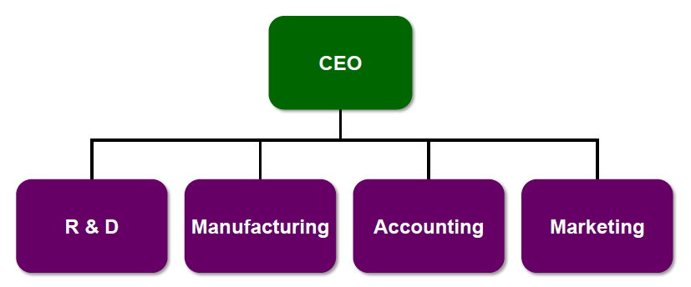

If you want success with a functional structure, you need to be small or medium company because you have a poor horizontal coordination among departments. The environment needs to be simple and stable. It is better if there is low interdependence between functions.

Divisional Structure

With this structure, divisions can be organized according to individual products, services, divisions, businesses and so on.
The distinctive feature of a divisional structure is that grouping is based on individual outputs.
The divisional structure promotes flexibility and change because each unit is smaller and adapt to the needs of its environment.
Coordination across functional departments within each product group is maximized.
The divisional structure decentralizes decision making, because the lines of authority converge at a lower level in the hierarchy.

Strengths:
- Suited to fast change in environment
- Involves high coordination across functions
- Best in large organization with several product
- Decentralized decision making
- Customers can contact the correct division and achieve satisfaction.

Weaknesses:
- Eliminate economy of scale in functional departments
- Poor coordination between product lines
- Need enough personal: cost more money.

En fait, tu peux avoir le même nombre de personnes dans une functional et divisional structure. SI tu as 50 personnes dans une functional, tu en auras 10 par fonctions (si t’as 5 fonctions) dans une divisional. Tu vas donc perdre des économies d’échelles et perdre de l’efficacité. Il te faut donc + d’employés ce qui coute + d’argent et ce qui implique de prendre plus de risques;

Product lines become separated from each other, and coordination across product lines can be difficult.
You have problem with horizontal coordination.
Task forces can be needed.

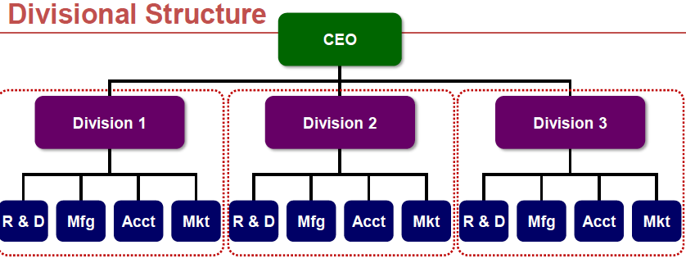

Geographical Structure

Another basis for structural grouping is the organization’s users of customers.
The most common structure is this category is geography since each region of the country may have distinct tastes and needs.
The strengths and weaknesses of a geographic divisional structure are similar to the divisional organization characteristics.
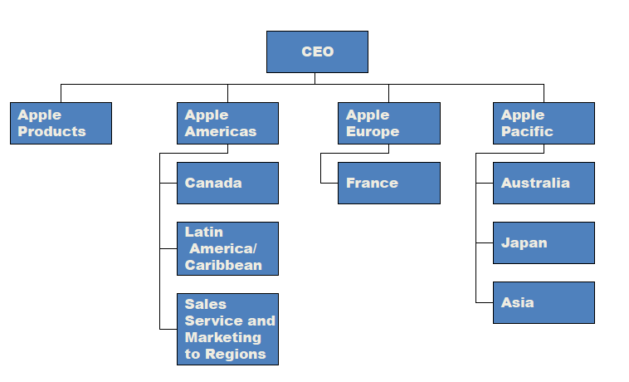

Matrix Structure

Activities are grouped together by a combination of product and function or product and geography

The matrix structure often is the answer when organizations find that the functional, divisional, and geographical structures combined with horizontal linkage mechanism will not work.
The matrix is a strong form of horizontal linkage. Both product division and functional structures are implemented simultaneously.
Vertical: Functional Managers
Horizontal: Product Managers

The product managers and the functional managers have equal authority within the organization, and employees report to both of them.
The matrix structure is similar to the use of the full-time integrators.

There are three conditions to exercise the matrix structure:

Condition 1: Pressures exist to share scare resources across product lines.
For example, the organization is not large enough to assigned engineers full-time to each product line, so engineers are assigned part-time to several products or projects.

Conditions 2: Environmental pressure exists for two or more outputs.

Condition 3: the environmental domain of the organization is both complex and unstable.

Employees can develop an in-depth expertise to serve all products lines efficiently.

Many companies have found a balanced matrix hard to implement and maintain because one side of the authority structure often dominates.
As a consequence, two variations of matrix structure have evolved: the functional matrix and the product matrix.
Functional matrix: the functional bosses have the primary authority.
Product matrix: the product bosses have the primary authority.

All kinds of organizations can experiment this type of structure.

Strengths:
- Achieves coordination necessary to meet dual demands from customers
- Flexible sharing of human resources across products
- Suited to complex decision and unstable environment
- Provides opportunity for both functional and product skill development
- Best in medium-sized organizations with multiple products

Weaknesses:
- Causes participants to experience dual authority, which can be confusing
- Participants needs good interpersonal skills and extensive training
- Involves frequent meetings and conflict-resolution sessions
- Require great efforts to maintain power balance

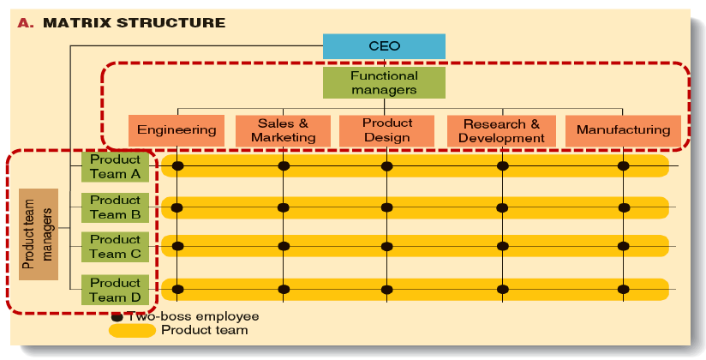

Horizontal Structure

Horizontal grouping means employees are organized around core work processes.
All the people who work together on a core process are brought together in a group rather than being separated into functional departments.

Organizations typically shift toward a horizontal structure during a procedure called re-engineering.

A process refers to a group that work together to transform input into outputs that create value for customers.
When a company is re-engineered to a horizontal structure, all the people throughout the organization who work on a particular process have easy access to one another so they can communicate and coordinate their efforts.

In short,

Market analysis Research Product planning Testing Customer

Strengths:
- Promote flexibility and rapid response to changes in customer needs
- Direct the attention of everyone toward the production and delivery of value to the customers
- Each employee has a broader view of organizational goals
- Promote a focus on teamwork and collaboration
- Improves quality of life for employees by offering them the opportunity to share responsibility, make decisions, and be accountable for outcomes.

Weaknesses:
- Determining core processes in difficult and time consuming
- Requires changes in culture and management philosophy
- Traditional managers do not have authority anymore
- Requires significant training of employees to work effectively in a horizontal team environment

Virtual network grouping

Departments are separate organizations that are electronically connected for the sharing of information and completion of tasks.

Strengths:
- Enable small organizations to exist
- Enable the company to be flexible
- Reduce administrative costs

Weaknesses:
- Managers do not have control
- There is a risk of failure if a partner fails to deliver business

Hybrid Structure

Organizations often use a hybrid structure, which combine characteristics of functional, divisional, geographical, matrix, horizontal, or network structure to take advantage of the strengths of various structures and to avoid some the weaknesses. Hybrid structures tend to be used in rapidly changing environment because they offer organization greater flexibility.
One type of hybrid that is often used combines characteristics of the functional and divisional structure. Functions that are important to each product or market decentralized to the self-contained units. However, some functions that are relatively stable and require economies of scale and in-depth specialization are also centralized at headquarters.

Midterm 1: Management: Chapter 9: Organization Size, Life Cycle, And Decline.

As organizations grow large and complex, they need more complex systems and procedures for guiding and controlling the organization. Unfortunately, these characteristics can also cause problems of inefficiency, rigidity, and slow response time.
Every organization wrestles (=se débattre) with questions about organizational size, bureaucracy, and control. However, as organization become larger, they often find it difficult to respond quickly to changes in environment.
We are going to analyse which characteristic is the most appropriate between small and bigger and company.

Size is related to structure and control

Organization Size: Is bigger better?

Pressure for growth

Small and simple company: Respond fast to environment changes
Cela n’empeche pas les grosses entreprises qui grandissent, de tres bien marcher.

The vision of practically every businessperson is to have his or her company and growing fast and becoming large.
A decade ago, analysts and management scholars were announcing a shift away from “bigness” toward small, nimble companies that could quickly respond in a fast-changing environment.
Yet, despite the proliferation of new, small organizations, the giant continue to grow. Moreover, these agencies grew primarily to better serve their clients, which were themselves growing larger and more global. Companies, in all industries, strive for growth to acquire the size and resources needed to compete a global scale, to invest in new technology, and guarantee access to market. There are other pressures for organizations to grow. Many executives have observed that firms must grow to stay economically healthy and believe that to stop growing is stagnate. To be stable means that customers may not have their demand fully met or that company will increase market share at the expense of your organization.

Prenons l’exemple d’Apple qui se doit dorénavant de lancer des nouveaux Iphone tous les 2 ans environ sous peine de voir la concurrence lui “voler” des customers.

In addition, growing organizations can be vibrant, exciting places to work, which enables these companies to attract and keep quality employees. When the number of employees is expanding, an organization can offer many challenges and opportunities for advancement.

In short:
- Mieux servir ses clients qui eux même grandissent en même temps que toi
- Acquérir une taille and des ressources nécessaires pour pouvoir investir dans le marché ou dans les technologies
- Rester économique stable et ne pas stagner sous peine de voir la concurrence mieux se développer et donc baisser l’entreprise.
- Pouvoir donner de meilleurs conditions de travails à ces employés et donc leur offrir + de challenges et d’opportunités.

Dilemmas of Large Size

Organization feel compelled to grow, but how much and how large? What size is the most appropriate?

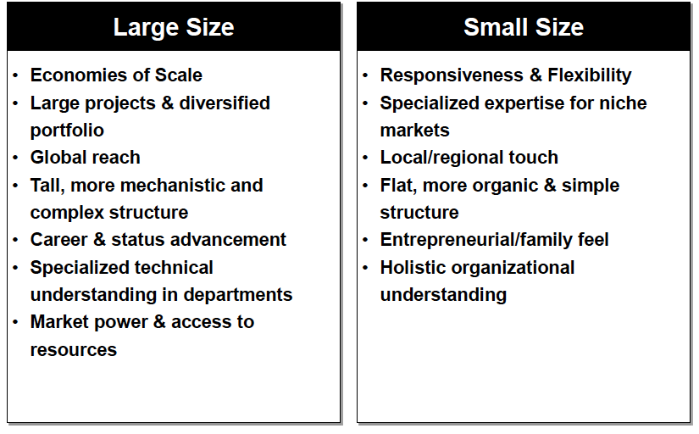

Large:
- A large company will make economy of scale, for example, only a large corporation like Airbus Industry can afford to build the A 380 and only a large Virgin Atlantic Airways can buy it.
- Large company have the resources to be a supportive economic and social force in difficult time.
- Large organizations are able to get back to business more quickly following a disaster.
- Large companies are standardized: they offer hundreds of functional specialties to perform multifunctional task and to provide varied product
- Large company can be a presence that stabilize a market and provide longevity, raises, and promotions.
- Vertical hierarchy and stable market

Small:
- Small companies are RESPONSIVENESS AND FLEXIBILITY IN FAST-CHANGING MARKETS
- Small companies can provide significant advantages in terms of quick reaction to changing customer needs.
- Small organizations have a flat structure and an organic management style that encourages entrepreneurship and innovation.
- Moreover, the personal involvement of employees in small firms encourages entrepreneurial motivation and commitment, because employees personally identify with the company’s mission.

Big Organization/Small Organization Hybrid

The paradox is that the advantages of small organizations sometimes enable them to succeed and, hence, grow large. Most of the 100 firms on fortune’s list of the fastest-growing companies are small firms characterized by an emphasis on being fast and flexible in responding to the environment.
Giant companies are “built for optimization, not innovation”.
The solution is the “big company/small company hybrid” that combines a large corporation’s resources and reach with a small company’s simplicity and flexibility.
The divisional structure is one way some large organizations attain a big/small design.
Big companies also find a variety of ways to act both large and small. They use the advantage of size in areas such as advertising, purchasing, and raising capital; however, they also give each individual store the autonomy needed to serve customers as if it were a small.

Organizational Life Cycle

Organizational structure, leadership style, and administrative systems follow a fairly predictable pattern through stages in the life cycle. Stages are sequential and follow a natural progression.

Stages of Life-Cycle Development
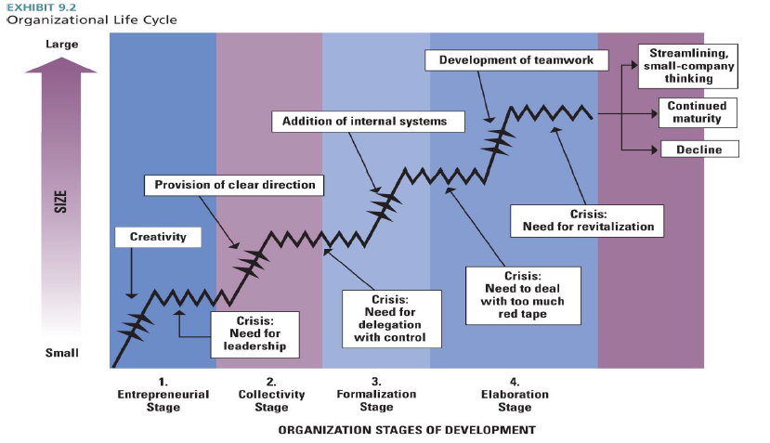

Research of organizational life cycle suggests that four major stages characterize organizational development.
The stages are associated with transition to each stage. Growth is not easy. Each time an organization enters a new a stage in the life cycle, it enters a whole new arena with a set of rules for how the organization functions and how it relates to the external environment.

- Entrepreneurial stage: The entrepreneurial stage is the start-up an organization. When an organization is born, the emphasis is on creating a product or service and surviving in the marketplace.
Crisis: Need for Leadership. As the organization starts to grow, the larger number of employees causes problem. The creative and technically oriented owners are confronted with management issues. At this time of crisis, entrepreneurs must either adjust the structure of the organization to accommodate continued growth or bring managers who can do so. When Apple begins to growth, Steve Jobs and his partner hired someone to manage the structure.
They have developed informal structure.
- Collectivity Stage: In the collectivity stage, the organization grows and develops a more elaborated design. If the leadership crisis is resolved, strong leadership is obtained and the organization begins to develop clear goals and direction. Department are established with a hierarchy of authority.
Crisis: Need for delegation with control. Looking for a formal structure, and more professional management. If the new management has been successful, lower-level employees gradually find themselves restricted by the strong top-down leadership. Lower-level managers begin to acquire confidence in their own functional areas and want more discretion. The organization needs to find mechanisms to control and coordinate departments without direct supervision from the top.
- Formalization Stage: The organization becomes more bureaucratic. It implies the installation of rules, procedures, and control system. Communication is less frequent and more formal. Top management becomes concerned with issues such as strategy and planning, and leaves the operation of the firm to middle management.
Crisis: Need to deal with too much red tape. At this point in the organization’s development, the proliferation of systems and programs may begin to strangle middle-level executives. The organization seems bureaucratized. Innovation may be restricted. The organization seems too large and complex to be managed through formal programs.
- Elaboration Stage: The organization becomes more flexible in its design. The solution to the red-tape crisis is a new sense of collaboration and teamwork. Throughout the organization, managers develop skills to confronting problems and working together. Managers learn to work within the bureaucracy. Formal system may be simplified and task forces can be established.
Crisis: Need for revitalization. After the organization reaches maturity, it may enter periods of temporary decline. The organization becomes over-bureaucratized and must go through a stage of innovation.

Summary: 84% of organizations that make it past the first year still fail within five years because they can’t make the transition from the entrepreneurial stage.

Organizational Characteristics: See table on page 328.

Organizational Bureaucracy and Control

As organizations progress through the life cycle, they usually take on bureaucratic characteristic as they grow larger and more complex.

What Is Bureaucracy?

Although we can perceive bureaucracy as a threat to basic personal liberties, it is also the most efficient possible system of organizing. Bureaucracy ensures more efficient functioning of organizations.
There are six organizational characteristics linked to the bureaucracy.
- Rules and procedures: it enables activities to be performed in a routine manner.
- Written documentation and records: it provides an organizational memory and continues over time.
- Hierarchy of authority: sensible mechanism for supervision and control.
- Specialization and division of labour: each employee had a clear task to perform.
- Technical qualified people: people are hired for their quality
- Separate position from position holder: employee did not have an inherent right to the job.
Size and Structural Control:

In the field of organizational theory, organization size has been described as an important variable that influences structural design and methods of control.
Studies indicate that large organizations are different from small organizations along several dimensions of structure, including formalization, centralization, and personnel ratios.

Formalization and Centralization: formalization refers to rules, procedures, and written documentation that describe the rights and duties of employees. The evidence supports the conclusion that large organizations are more formalized. The reason is that large organizations rely on rules, procedures, and paperwork to achieve standardization and control across their large numbers of employees and departments, whereas top managers can use personal observation to control a small organization.
Centralization refers to the level of hierarchy with authority to make decisions. In centralized organizations, decisions tend to be made at the top. In decentralized organizations, similar decisions would be made at a lower level.
Decentralization represents a paradox because, in the perfect bureaucracy, the top administrator, who would have perfect control, would make all decisions. However, as an organization grows larger and has more people and departments, decisions cannot be passed to the top because senior managers would be overloaded.
Larger organizations permit greater decentralization.
In small start-up organizations, on the other hand, the founder or top executive can effectively be involved in every decision, large and small.

Personal ratio: tant pis

Bureaucracy in a Changing World

By establishing a hierarchy of authority and specific rules and procedures, bureaucracy provided an effective way to bring order to large groups of people and prevent abuses of power.
The world is rapidly changing, however, and the machine-like bureaucratic system of the industrial ago no longer so well as organizations face new challenges.
The problems caused by over-bureaucratization are evident in the inefficiencies of some government organization. Some agencies have so many clerical staff members and confusing job titles that no one is really sure who does what.
Narrowly, defined job descriptions, for example, tend to limit the creativity, flexibility, and rapid response needed in today’s knowledge-based organization.

Organizing Temporary Systems for Flexibility and Innovation

How can organizations overcome the problems of bureaucracy in rapidly changing environment? Some are implementing innovative structural solutions. One structural concept, called the incident command system (ICS), is commonly used by organizations, such as police and fire departments.
The incident command system was developed to maintain the efficiency and control benefits of bureaucracy yet prevent the problem of slow response to crises.
The basic idea behind the ICS is that organization can glide smoothly between a highly formalized, hierarchical structure that is effective during times of stability and a more flexible, loosely structured one needed to respond will to unexpected and demanding environmental conditions.
During times of high uncertainty, the most effective structure is one that loosens the lines of command and enables people to work across departmental and hierarchical lines to anticipate, avoid, and solve unanticipated problems within the context of a clearly understood mission and guidelines.
Developing and ICS requires a significant commitment of time and resources, offers great potential for organizations that require extremely high reliability, flexibility and innovation.

Organizational Control Strategies

Even though many organizations are trying to decrease bureaucracy and reduce rules and procedures that constrain employees, every organization needs systems for guiding and controlling the organization.
Managers at the top and middle levels of an organization can choose among three overall control strategies: Bureaucratic, market and clan control.
Each form of control uses different types of information. However, all three types may appear simultaneously in an organization.

Bureaucratic control

Bureaucratic control is the use of rules, policies, hierarchy of authority, written documentation, standardization, and other bureaucratic mechanisms to standardize behaviour and assess performance. Bureaucratic control uses the bureaucratic characteristics.
To make bureaucratic control work, managers must have the authority to maintain control over the organization. Legitimate and rational authority was preferred over other types of control (ex: favouritism).
It exists three types of authority:
Rational-legal authority is based on employees’ belief (most organization).
Traditional authority is the belief in traditions (religion).
Charismatic authority is based on the devotion to the exemplary character (army).

Market Control

Market control occurs when competition is used to evaluate the output and productivity of an organization. A dollar price is an efficient form of control, because managers can compare prices and profits to evaluate the efficiency of their corporation.
Without competition, the price does not accurately reflect internal efficiency.
Each division can be evaluated on the basis of profit or loss compared with other division.
Market control can bed used only when the output of an organization, division, or department can be assigned a dollar price and when there is competition.

Clan control

Clan control is the use of social characteristics, such as organizational culture, shared values, commitment, traditions, and beliefs, to control behaviour. Organizations that use clan control require shared value and trust among employees. Clan control is important when ambiguity and uncertainty are high. High uncertainty means the organization cannot put a price on its services, and things change so quickly that rules and regulations are not able to specify every correct behaviour.

In short:

Bureaucracy: Rules, standards, hierarchy, legitimate authority
Market: Prices, competition, exchange relationship
Clan: Tradition, shared value and beliefs, trust

Organizational Decline and Downsizing

Earlier in the chapter, we discussed the organizational life cycle, which suggests that organizations are born, grow older, and eventually die. Every organization goes through periods of temporary decline. In addition, a reality in today’s environment is that for some organization, continual growth and expansion may not be possible.
In this section, we examine the causes and stages of organizational decline and then discuss how leaders can effectively manage downsizing that is often a reality in today’s organization.

Definition and causes

Three factors are considered to cause organizational decline.

Organizational Atrophy: Atrophy occurs when organization grow older and become inefficient and overly bureaucratized. Often, atrophy follows a long period of success, because an organization becomes attached to practices and structures that worked in the past, and fails to adapt to changes in the environment.

Vulnerability: Vulnerability reflects an organization’s strategic inability to prosper in its environment. This often happens to small organizations that are not yet fully established.

Environmental decline or competition: Environmental decline refers to reduced energy and resources available to support an organization.

A model of Decline Stage

Companies, if not managed properly, can move through five stages resulting in organizational dissolution.

- Blinded stage: The first stage of decline is the internal and external change that threatens long-term survival and may require the organization to tighten up. The organization may have excess personnel, cumbersome procedures, or lack of harmony with customers. Leaders often miss the signals of decline.
- Inaction stage: The second stage of decline is called inaction, in which denial occurs despite signs of deteriorating performance.
- Faulty action stage: In the third stage, the organization is facing serious problems, and indicators of poor performance cannot be ignored. Leaders are forced by several circumstances to consider major changes.
- Crisis stage: the organization still has not been able to deal with decline effectively and is facing a panic. The organization may experience chaos, efforts to go back to basis, sharp changes, and anger.
- Dissolution stage: This stage of decline is irreversible. The organization is suffering loss of markets and reputation. The only strategy is to close down the organization.

Midterm 1: Chapter 10: Organizational Culture and Ethical Values

This chapter explores ideas about organizational culture and ethical values, and how these are influenced by organizations.

Organizational Culture

Every organization has a set of values that characterize how people behave and how the organization carries out everyday business.
Strong cultures can have a profound impact, which can be either positive or negative for the organization.
Some organization works for hiring the right individual, to keep staff well informed, and to collect feedback from its employees.
A related concept concerning the influence of norms and values on how people work together and how they treat one another and customers is called social capital.

Social capital refers to the quality of interactions among people and whether they share a common perspective.
In organizations with a high degree of social capital, for example, relationships are based on trust, mutual understandings, and shared norms and values that enable people to cooperate their activities to achieve organizational goal.
One-way to think of social capital is as goodwill (=bonne volonté).
A high level of social capital facilitates smooth organizational functioning.
Ex: Ebay: the company builds goodwill through mechanisms such as feedback system that enables buyers and sellers to rate one another, discussion boards that build a sense of community among site users, and regular all-day focus groups with representative buyers and sellers.

Other organizations also build social capital by being open and honest and cultivating positive social relationships among employees and with outsiders.

The popularity of the organizational culture topic raises a number of questions. Can we identify cultures? Can culture be aligned with strategy? How can cultures can be managed or changed?

What is culture?

Culture is a set of values, norms, and beliefs that is shared by members of an organization and is taught to new members.
Everyone participates in culture, but culture generally goes unnoticed.
Organizational culture exists at two levels.
On the surface visible: observable symbols (ceremonies, stories, slogan, acts…)
On the invisible surface: Underlying values, assumptions, beliefs, attitudes, and feelings.

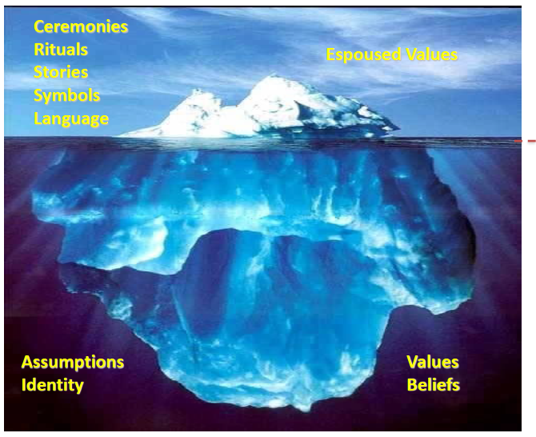

Emergence and Purpose of Culture

An organization’s culture generally begins with a founder or early leader who articulates and implements particular ideas and values as a vision, philosophy, or business strategy.
When these ideas and values lead to success, they become institutionalized, and an organizational culture emerges that reflects the vision and strategy of the founder or leader.
Cultures serve two critical functions:
1) Internal integration: allows employee to develop a collective identity and know how to work together effectively.
2) External adaptation: how the organization meets goals and deals with outsiders.

Both functions of culture are related to building the organization’s social capital.

Interpreting culture

To identify and interpret culture requires that people make inferences based on observable artifacts.
Some of the typical and important observable aspects of culture are rites and ceremonies, stories, symbols, and language.

Rites and ceremonies:

Type of rite | Example | Social consequences
Passage | Induction and basic training, Canadian military. | Facilitate transition of persons into social roles and statuses that are new for them
Enhancement | Annual awards night | Enhance social identities and increase status of employees
Renewal | Organization development activities | Refurbish social structures and improve organization functioning
Integration | Office holiday party | Encourage and revive common feelings that bind members together and commit them to the organization

Stories: stories are narratives based on true events that are frequently shared among organizational employees and told to new employees to inform them about an organization. Many stories are about company heroes who serve as models or ideals for serving cultural norms and values.

Symbols: A symbol is something that represents another thing. In one sense, ceremonies, stories, slogans, and rites are all symbols; they symbolize deeper values of an organization. Another symbol is a physical artefact of the organization.

Language: The final technique for influencing culture is language. Many organizations use a specific saying, slogan, metaphor, or other form of language to convey special meaning to employees.

Recall that culture exists at two levels (the underlying values & assumptions and the visible artifacts and observable behaviours). The slogan, symbols, and ceremonies just described are artifacts that reflect underlying company values. These visible artifacts and behaviours can be used by managers to shape company values and to strengthen organizational culture.

Organizational Design and Culture

Organizational culture should reinforce the strategy and structural design that organization needs to be effective within its environment. For example, if the external environment requires flexibility and responsiveness, such as the environment for Internet-based companies such as Ebay, the culture should encourage adaptability. The correct relationship among cultural values, organizational strategy and structure, and the environment can enhance organizational performance.

Four categories of culture associated with differences (flexibility, stability, internal, external) are adaptability, mission, clan, and bureaucratic. The four categories relate to the fit among cultural values, strategy, structure, and the environment. Each can be successful, depending on the needs of the external environment and the organization’s strategic focus.

The adaptability culture

The adaptability culture is characterized by strategic focus on the external environment through flexibility and change to meet customer needs. The culture encourages entrepreneurial values, norms, and beliefs that support the capacity of the organization to detect, interpret, and translate signals from the environment into new behaviour responses. This type of organization, however, doesn’t just react quickly to environment changes- It actively creates change. Innovation, creativity, and risk taking are valued and rewarded.

The mission culture

An organization concerned with serving specific customers in the external environment, but without the need for rapid change, is suited to the mission culture. The mission culture is characterized by emphasis on a clear vision of the organization’s purpose and on the achievement of goals, such as sales growth, profitability, or market share, to help achieve the purpose.
Because the environment is stable, they can translate the vision into measurable goals and evaluate employee performance for meeting them. In some cases, mission cultures reflect a high level of competitiveness and a profit-making orientation.

The clan culture

The clan culture has a primary focus on the involvement and participation of the organization’s members and on rapidly changing expectations from the external environment. More than any other, this culture focuses on the needs of employees as the route to high performance.
In a clan culture, an important value is taking care of employees and making sure they have whatever they need to help them be satisfied as well as productive. Companies in the fashion and retail industries often adopt this culture because it releases the creativity of employees to respond to rapidly changing tastes.

The bureaucratic culture

The bureaucratic culture has an internal focus and consistency for a stable environment. This organization has a culture that supports a methodical approach to doing business. Personal involvement is somewhat lower here, but is outweighed by a high level of consistency, conformity, and collaboration among members. This organization succeeds by being highly integrated and efficient.
 | Flexibility | Stability
External | Adaptability culture | Mission culture
Internal | Clan culture | Bureaucratic culture

A culture of Discipline

We can identify a number of characteristics that define truly great companies. One aspect is a culture if discipline.
How is a culture of discipline built? Here are some of the key factors:

- Level 5 leadership: All good-to-great companies begin with a top leader. Level 5 leaders are characterized by an almost complete lack of personal ego, coupled with a strong will and ambition for the success of the organization.
- The right values: Leaders build a culture based on values of individual freedom and responsibility, but within a framework or organizational purpose, goals, and systems. People have the autonomy to do whatever it takes.
- The right people in the right job: These people are described using terms such as determined, diligent, precise, systematic, consistent, focused, accountable, and responsible.
- Knowing where to go: three intersecting circles: what they can be the best in the world at, what they are deeply passionate about, and what makes economic sense for the organization.

Culture strength and Organizational subculture

Culture strength refers to the degree of agreement among members of an organization about the importance of specific values. If widespread consensus exists about the importance of those values, the culture is cohesive and strong; if little agreement exists, the culture is weak.
A strong culture is typically associated with the frequent use of ceremonies, symbols, stories, heroes, and slogans. These elements increase employee commitment to the values and strategy of a company. In addition, managers who want to create and maintain strong organizational cultures often emphasize the selection and socialization of employees.
However, culture is not uniform throughout he organization, particularly in large companies. Even in organizations that have strong cultures, there are several sets of subcultures. Subcultures develop to reflect the common problems, goals, and experiences that members of a team, department, or other unit share.
Subcultures typically include the basic values of the dominant organizational culture and additional values unique to members of the subculture.

Organizational Culture, Learning, and Performance

Culture can play an important role in creating an organizational climate that enables learning and innovation. A strong culture encourages adaptation and change and enhances organizational performance by energizing and motivating employee. Thus, creating and influencing an adaptive culture is one of the most important jobs for organizational leaders.
A number of studies have found a positive relationship between culture and performance. Some evidences suggest that companies that intentionally managed cultural values outperformed similar companies that did not.
Strong cultures that don’t encourage adaptation, however, can hurt the organization. A danger for many successful organizations is that the culture becomes set and the company fails to adapt as the environment changes. When organizations are successful, the values, ideas, and practices that helped attain success become institutionalized. As the environment changes, these values may become detrimental to future performance. Many organizations become victims of their own success.
Nonadaptive cultures encourage rigidity and stability. Strong adaptive culture often incorporate the following values:
- The whole is more important than the parts, and boundaries between parts are minimized.
- Equality and trust are primary values
- The culture encourages risk taking, change, and improvements.

In adaptive cultures, managers are concerned with customers and employees as well as with the internal processes and procedures that bring about useful change.
Look table page 368.

Ethical Values and Social Responsibility

Of the values that make up an organization’s culture, ethical values are now considered among the most important. Top corporate managers are under scrutiny from the public as never before, and even small companies are finding a need to put more emphasis on ethics to restore trust among their customers and the community.

Sources of Individual Ethical Principles

Ethics is the code of moral principles and values that governs the behaviours of a person or group with respect to what is right or wrong.
Ethics are personal and unique to each individual, although in any given group, organization, or society there are many areas of consensus about what constitutes ethical behaviour. National culture, religious heritage, historical background, and so forth lead to the development of societal morality, or society’s view of what is right and wrong.
It is important to look at individual ethics because ethics always involve an individual action, whether it is a decision to act or the failure to take action against wrongdoing by others. Organizational culture has a profound influence on individual choices and can support and encourage ethical actions or promote unethical and socially irresponsible behaviour.

Managerial Ethics and Social Responsibility

Recent events have demonstrated the powerful influence or organizational standards on ethical behaviour.
Unethical conduct in organizations is surprisingly widespread. More than 54 per cent of human resources reported observing employees lying to supervisors or co-workers, falsifying reports or records, or abusing drugs alcohol while on the job.
Managerial ethics are principles that guide the decisions and behaviours of managers with regard to whether they are right or wrong. The notion of social responsibility is an extension of this idea and refers to management’s obligation to make choices and take action so that the organization contributes to the welfare and interest of all organizational stakeholders, such as employees, customers, shareholders, the community, and the broader society.

Ethics and social responsibility are about making decisions (on va penser par exemple a un snack qui va peut être vendre des produits pas frais ou tomber par terre alors que le bon sens voudrait le contraire). Les décisions des managers obnubilés par le chiffre sont parfois confrontées à ceux des employés et des clients).
Managers make choices every day about whether to be honest or deceitful with suppliers, treat employees with respect or disdain, and be a good or a harmful corporate citizen. Some issues are exceedingly difficult to resolve and often represent dilemmas. An ethical dilemma arises in a situation concerning right and wrong in which values are in conflict.

Does It Pay to Be Good?

The relationship of an organization’s ethics and social responsibility to its performance concerns both organizational managers and organization scholars. Studies have provided varying results but generally have found that there is a small positive relationship between ethical and socially responsible behaviour and financial results.
Also, customers pay attention. A study indicates that, price and quality being equal, two-thirds of people say they would switch brand to do business with a company that makes a high commitment to ethics.

Sources of Ethical Values in Organizations

Ethics in organization is both an individual and an organizational matter. External stakeholders can influence standards of what is ethical and socially responsible. The immediate forces that impact on ethical decisions in organizations are the following:
- Personal Ethics (Beliefs and values, Moral development and Ethical framework): Historical, cultural, family, religious, and community backgrounds of managers shape their personal values and provide principles by which they carry out business.
In addition, people go through stages of moral development that affect their ability to translate values into behaviour. At the highest level of moral development, people develop an internal set of standards: these are self-chosen ethical principles that are more important to decisions than external expectations.
The other personal factor is whether managers have developed an ethical framework that guides their decisions. Ethical decisions should be made to generate the greatest benefits for the largest number of people.
- Organizational culture (Rituals, ceremonies, stories, heroes, language symbols…):
Business practices also reflect the values, attitudes, and behaviours patterns of an organization’s culture. To promote ethical behaviour in the workplace, companies should make ethics an integral part of the organization’s culture. Organizational culture has a powerful impact on individual ethics because it helps to guide employees in making daily decision.
- Organizational systems (Structure, rules, code of ethics, policies…):
It includes the basic architecture of the organization, such as if ethical values are incorporated in policies and rules: if an explicit code of ethics is available and issued to members and so on…
- External Stakeholders (government regulations, customers, special-interest groups):
Companies must operate within the limits of certain government regulations, such as safety laws, environmental protection requirements, and many other laws and regulations. Customers are another important stakeholder group. Customers are primarily concerned about the quality, safety, and availability of goods and services. Also, Special-interest groups continue to be one the largest stakeholders concerns that companies face. The concept of sustainable development, a dual concern for economic growth and environmental sustainability, has been gaining ground among many business leaders.

How Leaders Shape Culture and Ethics

Top leaders are responsible for creating and sustaining a culture that emphasizes the importance of ethical behaviour for all employees every day.
The following sections examine how managers signal and implement values through leaderships as well as through the formal systems of the organization.

Value-Based Leadership

Organizational values are developed and strengthened primarily through values-based leadership, a relationship between a leader and followers that is based on shared, strongly internalized values that are advocated and acted upon by the leader.
Leaders influence cultural and ethical values by clearly articulating a vision for organizational values that employees can believe in, communicating the vision throughout the organization, and institutionalizing the vision through organizational system and policies.
Managers should remember that every statement and action has an impact on culture and values. To be effective, values-based leaders, executives often use symbols, ceremonies, speeches, and slogans that match the value. You can make a visible commitment to values through speeches, video addresses, and regular communication.

Ensuite il y a la structure qui peut également etre importante avec un code of ethics or training program.
Sans oublier le formal system can include an ethical committee.

Midterm 1: Chapter 4: The External Environment

Some companies are surprised by shifts in the environment and are unable to quickly adapt to new competition, changing consumer interests, or innovative technologies.
The external environment, including international competitive and events, is the source of turbulence, uncertainty, and major threats confronting today’s organizations.

The environmental Domain

In a broad sense the environment is infinite and includes everything outside the organization. However, the analysis presented here considers on those aspect of the environment to which the organization is sensitive and must respond to survive.
Thus, organizational environment is defined as all elements that exist outside the boundary of the organization that have the potential to affect all or part of the organization.

The environment of an organization can be understood by analysing its domain within external factors. An organization’s domain is the chosen field of action. Domain defines the organization’s niche and defines those external sectors with which the organization will interact to accomplish its goals.
The environment comprises several sectors. Ten sectors can be analysed for each organization: industry, raw material, human resources, financial resources, market, technology, economic conditions, government, sociocultural and international.
The sectors can be further subdivided into the task environment and general environment.

The Task Environment

The task environment includes sectors with which the organization interacts directly and that have a direct impact on the organization’s ability to achieve its goals.
It includes the industry, raw materials, and market sectors, and perhaps the human resources and international sectors. (Example page 136).

Example of raw material: an interesting example in the raw materials sector concerns the beverage can industry. Steelmakers owned the beverage can market until the mid-1960s, when Reynolds Aluminium Company launched a huge recycling program to gain a cheaper source of raw materials and make aluminium cans price competitive with steel.

General Environment

The general environment includes those sectors that might not have a direct impact on the daily operations of a firm but will indirectly influence it.
The general environment often includes the government, sociocultural, economic conditions, technology, and financial resources sectors.

Example of sociocultural sector: Shifting demographics is a significant element in the sociocultural sector. A 2007 study found that foreign-born people make up almost 20 per cent of Canada’s population. As the birth rate declines, immigration is expected to be the primary source of labour.

International Context

The international sector can directly affect many organizations, and it has become extremely important in the last few years. Then, all domestic sectors can be affected by international events.
Even if you stay in your hometown, your company may be purchased tomorrow by the English, American and so on. For example, Toyota is a Japanese company but it has built more than ten million vehicles in North American factories.
These increasing global interconnected have both positive and negative implications for organizations.
The growing importance of the international sector means that the environment for all organizations is becoming extremely complex and extremely competitive.

Environmentally Uncertainty

Here, we will discuss in greater detail how organizations can cope and respond to increasing environmental uncertainty and instability.

Environment can be described along several dimensions, such as whether the environment is table or unstable, homogenous or heterogeneous, simple or complex and so on. There are two essential ways the environment influences organizations: the need for information about environment and the need for resources from the environment.
The environmental conditions of complexity and change create a greater need to gather information and to respond based on that information.

Environmental uncertainty applies primarily to those sectors that an organization deals with on a regular, day-to-day basis. Recall the earlier discussion of the general environment and the task environment. Although sectors of the general environment -such as economic conditions, social trends, or technologies changes – can create uncertainty for organizations, determining an organization’s environmental uncertainty generally means focusing on sectors of the task environment.
To be measured, each sector can be analysed along dimensions such as stability or instability and degree of complexity.
Uncertainty means do not have sufficient information about environmental factors, and having difficult time predicting external changes.

Simple-Complex Dimension

The simple-complex dimension is the number and dissimilarity of external elements relevant to an organization’s operation. The more external factors, the greater the complexity is. A complex environment interacts with and is influenced by numerous diverse and different elements.

Stable-Unstable Dimension

The stable-unstable dimension refers to whether elements in the environment are dynamic. An environmental domain is stable if it remains the same over a period of months or years. Under unstable conditions, environmental elements shift abruptly and unexpectedly. Environmental domains seem to be increasingly unstable for most organizations.
Instability may occur when competitors react with aggressive moves and countermoves regarding advertising and new products, as happened with Nokia.

Although environments are more unstable for most organizations today, an example of a traditionally stable environment is a public utility.
Toy companies, by contrast have an unstable environment. Hot new toys are difficult to predict, a problem compounded by the fact that children are losing interest in toys at a younger age, their interest captured by video games, cable TV, and the Internet.

Framework

The simple-complex and stable-unstable dimensions are combined in a framework for assessing environmental uncertainty.

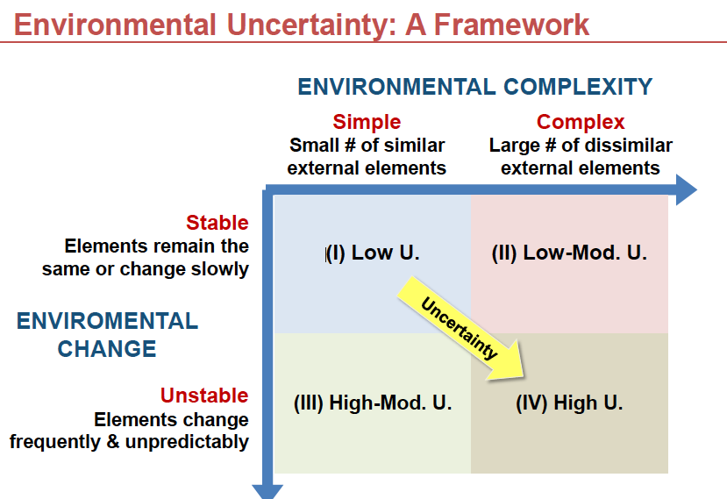
Simple: Small number of external elements, and elements are similar.
Complex: Large number of external elements, and elements are dissimilar.
Stable: Elements remain the same or change slowly.
Unstable: Elements change frequently and unpredictably.

Example:
- (I): Soft drink bottlers, beer distributors.
- (II): Universities, Insurance companies.
- (III): fashion clothing, E-commerce.
- (IV): computer firms, aerospace.

Adapting to environmental Uncertainty

How do organizations adapt to each level of environmental uncertainty?

Recall from chapter 3 that organizations facing uncertainty generally have a more horizontal structure that encourages cross-functional communication and collaboration to help the organization adapt to changes in the environment.
Organizations need to have the right fit between internal structure and the external environment.

Positions and Departments

As the complexity and uncertainty in the external environment increases, so does the number of positions and departments within the organization, which in turn increases internal complexity. Each sector in the external environment requires an employee or department to deal with it.
For example, the human resource department deals with unemployed people who want to work for the company. The marketing department finds customers. Procurement employees obtain raw materials from hundreds of suppliers. The finance group deals with bankers. The legal department works with the courts and government agencies.

Buffering and Boundary Spanning (page 145): ask teacher.

Page147:
Boundary-spanning roles link and coordinate an organization with key elements in the external environment. Boundary spanning is primarily concerned with the exchange of information to (1) detect and bring into the organization information about changes in the environment and (2) send information into the environment that presents the organization in a favourable light.

To detect and bring important information into organization, boundary personnel scan the environment. For example, a market-research department scans and monitors trends in consumer tastes.
The greater the uncertainty in the environment, the greater the importance of boundary spanners is.

One new approach to boundary spanning is business intelligence.
Business intelligence is related to another important area of boundary spanning, known as a competitive intelligence.
Competitive intelligence gives top executives systematic way to collect and analyse public information about rivals and use it to make better decisions.
In today’s turbulent environment, many successful companies involve everyone in boundary-spanning activities.

Differentiation and Integration

Another response to environmental uncertainty is the amount of differentiation and integration among departments.
When the external environment is complex and rapidly changing, organizational departments become highly specialized to handle the uncertainty in their external factor.
Employees in an R&D department thus have unique attitudes, values, goals, and education that distinguish them from employees in manufacturing or sales departments.
Each department interacted with different external groups.

One outcome of high differentiation is that coordination among departments becomes difficult. More time and resources must be devoted to achieving coordination when attitudes, goals, and work orientation differ so widely.
Integration is the quality of collaboration among department.
Thus, formal integrators are often required to coordinate departments.
Finally, as environmental uncertainty increases, so does differentiation among department, hence the organization must assign a larger percentage of managers to coordinate roles.

Organic versus Mechanistic Management Processes

Another response to environment uncertainty is the amount of formal structure and control imposed on employees. When the external environment was stable, the internal organization was characterized by rules, procedures, and a clear hierarchy of authority. Organizations were formalized. They were also centralized, with most decisions made at the top. It is called a Mechanistic organizational system.

On the other hand, in rapidly changing environments, the internal organization was much looser, free flowing, and adaptive. Rules regulations often were not written down or, if written down, were ignored. People had to find their own way through the system to figure out what to do. The hierarchy of authority was not clear. Decisions-making authority was decentralized. It is called Organic organizational system.

Mechanistic | Organic
Tasks are broken down into specialized, separate parts | Employees contribute to common task of the department
Tasks are rightly defined | Tasks are adjusted and redefined through employee teamwork
There is a strict hierarchy of authority and control, there are many rules | There is less hierarchy of authority and control, and there are few rules
Knowledge and control of tasks are centralized at the top of the organization | Knowledge and control of tasks are located anywhere in the organization
Communication is vertical | Communication is horizontal

Planning, Forecasting, and Responsiveness

The whole point of increasing internal integration and shifting to more organic processes is to enhance the organization’s ability to quickly respond to sudden changes in an uncertainty environment.
When the environment is stable, the organization can concentrate on current operational problems and day-to-day efficiency. Long-range planning and forecasting are not needed because environmental demands in the future will be the same as they are today.
With increasing environmental uncertainty, planning and forecasting become necessary.

Framework for Organizational Responses to Uncertainty

Voir tableau page suivante
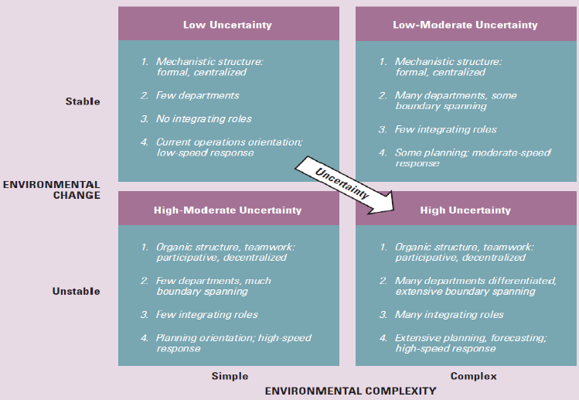

Resource dependence

We turn now to the third characteristic of the organization-environment relationship that affects organizations, which is the need for material and financial resources.
Resources dependence means that organizations depend on the environment but strive to acquire control over resources to minimize their dependence. Organizations are vulnerable if vital resources are controlled by other organizations, so they try to be as independent as possible.

Although companies like to minimize their dependence, when costs and risks are high they also team up to share scarce resources and be more competitive on a global basis. Formal relationships with other organizations present a dilemma to managers.
Organizational linkages require coordination, and they reduce the freedom of each organization to make decisions without concern for the needs and goals for other organizations.

Controlling Environmental Resources

Organizations maintain this balance between linkages with other organizations and their own independence through attempts to modify, manipulate, or control other organizations. To survive, the focal organization often tries to reach out and change or control elements in the environment. Two strategies can be adopted to manage resources in the external environment: (1) establish favourable linkages with key elements in the environment and (2) shape the environment domain.

Establishing Interorganizational Linkages

- Ownership: Companies use ownership to establish linkages when they buy a part of or a controlling interest in another company. This gives the company access to technology, products, or other resources it doesn’t currently have.
A greater degree of ownership and control is obtained through acquisition or merger. An acquisition involves the purchase of one organization by another so that the buyer assumes control.
- Formal Strategic Alliances: When there is a high level of complementarity between the business lines, geographical positions, or skills of two companies, the firms often go the route of a strategic alliance rather than ownership through merger or acquisition. Such alliances are formed through contracts and joint ventures.
- Cooptation, Interlocking Directorates: Cooptation occurs when leaders from important sectors in the environment are made part of an organization.
An interlocking directorate is a formal linkage that occurs when a member of the board of directors of one company sits on the board of directors of another company. When one individual is the link between two companies, this is typically referred to as a direct interlock. An indirect interlock occurs when a director of company A and a director of company B are both directors of company C.
- Executive Recruitment: Transferring or exchanging executives also offers a method of establishing favourable linkages with external organizations.
- Advertising and Public Relations: A traditional way of establishing favourable relationships is through advertising. Organizations spend large amounts of money to influence the taste of customers. Advertising is especially important in highly competitive consumer industries and in industries that experience variable demand.

Controlling the Environmental Domain:

In addition to establishing favourable linkages to obtain resources, organizations often try to change the environment. There are four techniques for influencing or changing an organization’s environmental domain.

- Change of Domain: An organization can seek new environmental relationships and drop old ones. An organization may try to find a domain where there is little competition, no government regulation, abundant suppliers, affluent customers, and barriers to keep competitors out.
- Political Activity, Regulation: Political activity includes techniques to influence government legislation and regulation. Political strategy can be used to erect regulatory barriers against new competitors or to quash unfavourable legislations.
- Trade Associations: Much of the work to influence the external environment is accomplished jointly with other organizations that have similar interests.
- Illegitimate Activities: Illegitimate activities represent the final technique companies sometimes use to control their environmental domain. Many well-known companies have been found guilty or unlawful or unethical activities.

Midterm 1: Chapter 5: Interorganizational Relationships.

Organizations of all sizes in all industries are rethinking how they do business in response to today’s chaotic environment. One of the most widespread trends is to reduce boundaries and increase collaboration between companies, sometimes even between competitors.

Good example: You can see the results of interorganizational collaboration when movies such as Harry Potter series are launched. Before seeing the movie, you might read a cover story in entertainment magazines, see a preview clip or chat live with the stars at an online site, find action toys being promoted through a fast-food franchise, and notice retail stores loaded with movie-related merchandise. For some blockbuster movies, coordinated action among companies can yield millions in addition to box-office and DVD profits. In the new company, organizations think of themselves as teams that create value jointly rather than as autonomous companies that are in competition with all others.

Purpose of this chapter: This chapter explores the most recent trend in organizing, which is the increasingly dense web of relationships among organizations. Companies have always been dependent on other organizations for supplies, materials, and information. The question is how these relationships are managed.
Today a company can choose to develop positive, trusting relationships.
horizontal relationships across organizations.
Interorganizational research has yield perspectives such as resource dependence, collaborative networks, population ecology, and institutionalism.

Organizational Ecosystems

Interorganizational relationships are the relatively enduring resource transactions, flows, and linkages that occur among two or more organizations.
A company may be forced into interorganizational relationships depending on its needs and the instability and complexity of the environment.
One current view argues that organizations are now evolving into business ecosystems. An organizational ecosystem is system formed by the interaction of a community of organizations and their environment. An ecosystem cuts across traditional industry lines. A company can create its own ecosystem.
For instance, Microsoft travels in four major industries: consumer electronics, information, communications, and personal computers. Its ecosystem also extends to hundreds of suppliers, and millions of customers across many markets.
Samsung of South Korea is the major supplier of parts in Apple’s iPhone.
Apple and Microsoft develop relationships with hundreds of organizations cutting across traditional business boundaries.

Is competition Dead?

Research indicates that a large percentage of new alliances in recent years have been between competitors. These alliances influence organizations’ competitive behaviour in varied ways.
Traditional competition, which assumes a distinct company competing for survival and supremacy with other stand-alone businesses, no longer exists because each organization both supports and depends on the others for success, and perhaps for survival. In today’s world, a new form of competition is in fact intensifying.
Organizations now need to coevolve with others in the ecosystem so that everyone gets stronger.
In an organizational ecosystem, conflict and cooperation frequently exist at the same time. Mutual dependencies and partnerships have become a fact of life in business ecosystem, so is competition dead?

The Changing Role of Management

Within business, ecosystems, managers learn to move beyond traditional responsibilities of corporate strategy and designing hierarchical structures and control systems.
In this new world, managers think about horizontal processes rather than vertical structures.
Moreover, horizontal relationships now include linkages with suppliers and customers, who become part of the team.
Managers learn to see and appreciate the rich environment of opportunities that grows from cooperative relationships with other contributors to the ecosystem.

Interorganizational framework

The models and perspectives for understanding interorganizational relationships ultimately help managers change their role from top-down management to horizontal management across organizations.
Relationships among organizations can be characterized by whether the organization types are dissimilar or similar and whether organizations relationships are competitive or cooperative. By understanding these perspectives, managers can assess their environment and adopt strategies to suit their needs. The first perspective is called resource-dependence. It describes rational ways organizations deal with each other to reduce dependence on the environment. The second perspective is about collaborative networks, wherein organizations allow themselves to become dependent on other organizations to increase vale and productivity for both. The third perspective is population ecology, which examines how new organizations fill niches left open by established organizations, and how a rich variety of new organizational forms benefit society. The final approach is called institutionalism and explains why and how organizations legitimate themselves in the larger environment and design structures by borrowing ideas from each other.

 | Organization Type
Organization Relationship |  | Dissimilar | Similar
Organization Relationship | Competitive | Resource Dependence | Population Ecology
Organization Relationship | Cooperative | Collaborative Network | Institutionalism

Resource Dependence

When organizations feel resource or supply constraint, the resource-dependence perspective says they manoeuvre to maintain their autonomy through a variety of strategies. One strategy is to adapt to or alter the interdependent relationships. This could mean purchasing ownership in suppliers, developing long-term contracts or joint ventures or building relationships on other ways.
Organizations may also join trade associations to coordinate their needs, sign trade agreements, or merge with another firm to guarantee resources and material supplies.
Organizations operating under the resource- dependence philosophy will do whatever is needed to avoid excessive dependence on the environment to maintain control of resources and hence reduce uncertainty.

Collaborative Networks

Traditionally, the relationship between organizations and their suppliers has been an adversarial one. North American companies typically have worked alone, competing with each other and believing in the tradition of individualism. Today, however, thanks to an uncertain global environment, realignment in corporate relationships is taking place. The collaborative network perspective is an emerging alternative to resource-dependence theory. Companies join together to become more competitive and to share scarce resources. For instance, technology companies join together to produce next-generation products.

Why Collaboration?

Why all this interest in interorganizational collaboration? Major reasons are sharing risks when entering new markets, mounting expensive new programs and reducing costs, and enhancing organizational profile in selected industries or technologies. Cooperation is a prerequisite for greater innovation, problem solving, and performance.

Interorganizational linkages provide a kind of safety net that encourages long-term investment and risk taking.

From adversaries to Partners

Community organizations collaborated to achieve greater effectiveness and better use scarce resources.
More companies are changing from a traditional adversarial mind-set to a partnership orientation.
Rather than organizations maintaining independence, the new model is based on interdependence and trust. Performance measures for the partnership are loosely defined, and problems are resolved through discussion and dialogue.
Companies work toward equitable profits for both sides rather than just for their own profit.
In this new view of partnerships, dependence on another company is seen to reduce rather than increase risks.

Traditional Orientation: Adversarial | New Orientation: Partnership
Low dependence | High dependence
Suspicion, competition | Trust, addition of value to both sides, high commitment
Detailed performance measures, closely monitored | Loose performance measures, problems discussed
Price, own profit | Equity, fair dealing, both profit
Limited information and feedback | Electronic linkages to share key information, problem feedback, and discussion
Minimal involvement, separate resources | Involvement in partner’s product design and production, share resources
Short-term contracts | Long-term contracts

Population Ecology

The population ecology perspective differs from the other perspective because it focuses on organizational diversity and adaptation within a population of organizations. A population is a set of organizations engaged in similar activities with similar patterns of resource utilization and outcomes. Organizations within a population compete for similar resources of similar customers.
Innovation and change in a population of organizations take place through the birth of new forms and kinds of organizations.
New organizations meet the new needs of society more than established organization that are slow to change.

What does this theory means in practical terms? It means that large, established organizations often become dinosaurs and have had tremendous difficulty adapting to a rapidly changing environment.
Why do established organizations have such a hard time adapting to a rapidly changing environment?
Hannan and Freeman, argue that there are many limitations on the ability of organizations to change. The limitations come from heavy investment in plants, equipment, and specialized personnel.
They come also from: the organization’s own successful history that justifies current procedures, and the difficulty of changing organizational culture. True transformation is a rare and unlikely event in the face of all these barriers.

When looking at an organizational population as a whole, the changing environment determines which organizations survive or fail. The assumption is that individual organizations suffer from structural inertia and find it difficult to adapt to environmental changes. Thus, when rapid change occurs, old organizations are likely to decline or fail, and new organizations emerge that are better suited to the needs of the environment.

Some theories suggest the forms that survive are typically best fitted to the immediate environment.
Some years ago, Forbes magazine reported a study of American businesses over 70 years, from 1917 to 1981. Of the 22 that remained in the top 100, only 11 did under their original names.
In 1917, most of the top 100 companies were huge steel and mining industrial organizations, which were replaced by high-technology companies such as IBM.
Meanwhile, technology continues to change the environment. The expansion of the Internet into many consumers’ households has brought a proliferation of new organizations such as Facebook, Google, Skype, and Ebay.

Organizational Form and Niche

The population-ecology model is concerned with organizational form. Organizational form is an organization’s specific technology, structure, products, goals, and personnel, which can be selected or rejected by the environment. Each new organization tries to find a niche (a domain of unique environmental resources and needs) sufficient to support it. The niche is usually small in the early stages of an organization but may increase in size over time if the organization is successful. If a niche is not available, the organization will decline and may perish.
Success or failure of a single firm is predicted by the characteristics of the environment as much as by the skills or strategies used by the organization.

Process of Ecological Change

The population-ecology model assumes that new organizations are always appearing in the population. Thus, organization populations are continually undergoing change. The process of change in the population is defined by three principles that occur in stages: variation, selection, and retention.

Variation | Selection | Retention
Large number of variations appear in the population of organizations | Some organizations find a niche and survive | A few organizations grow large and become institutionalized in the environment.

- Variation: it means the appearance of new, diverse forms in a population of organizations. For instance, in recent years, a large number of new firms have been initiated to develop computer software, to provide consulting and other services to large corporations, and to develop products and technologies for Internet commerce.
- Selection: It refers to whether a new organizational form is suited to the environment and can survive. Only a few variations are “ selected “ by the environment and survive over the long-term. Some variations will suit the external environment better than others. Some prove beneficial and thus are able to find a niche and acquire resources from the environment necessary to survive.
- Retention: it is the preservation and institutionalization of selected organizational forms. Certain technologies, products, and services are highly valued by the environment, and the retained organizational form may become a dominant part of the environment. McDonald’s, which own 43 per cent of the fast-food market and provides the first job for many teenagers, has become institutionalized in North American Life.

From the population-ecology perspective, the environment is the important determinant of organizational success or failure. The process of variation, selection, and retention leads to the establishment of new organizational forms in a population of organizations.

Strategies for Survival

Another principle that underlies the population-ecology model is the struggle for existence, or competition.

In the population-ecology perspective, generalist and specialist strategies distinguish organizational forms in the struggle for survival. Organizations with a wide niche or domain, those offer a broad range of products or services or that serve a broad market, are generalists. Organizations that provide a narrower range of goods or services or that serve a narrower market are specialists.

Institutionalism

Organizations are highly interconnected. Just as companies need efficient production to survive, the institutional view argues that organizations need legitimacy from their stakeholders. Companies perform well when they are perceived by the larger environment to have a legitimate right to exist. Thus, the institutional perspective describes how organizations survive and succeed through congruence between an organization and the expectations from its environment. The institutional environment is composed of norms and values from stakeholders (customers, investors, associations, boards, government, and collaborating organizations).

Legitimacy is defined as the general perspective that an organization’s actions are desirable, proper, and appropriate within the environment’s system of norms, values, and beliefs.

Having a good reputation was significantly related to higher levels of performance measures such as return on assets and net profit margin.

The Institutional View and Organizational Design

The institutional view also sees organizations as having two essential dimensions – technical and institutional. The technical dimension is the day-to-day work, technology and operating requirements. The institutional structure is that part of the organization most visible to the outside public.

Institutional Similarity

Organizations have a strong need to appear legitimate. Interorganizational relationships thus are characterized by forces that cause organizations in a similar population to look like one another. Institutional similarity is the emergence of a common structure and approach among organizations in the same field.

Exactly how does increasing similarity occur? Mimetic, coercive, and normative forces.

- Mimetic forces: Most organizations, especially business organizations, face great uncertainty. It is not clear to senior executives what products, services, or technologies will achieve desired goals, and sometimes the goals themselves are not clear. In the face of this uncertainty, mimetic forces, the pressure to copy or model other organizations, occur.
For instance, Starbucks was one of the first companies to adopt Wi-Fi. The practice has rapidly been copied by both large and small companies.
- Coercive forces: All organizations are subject to pressure from environment, regulatory agencies, and other important organizations in the environment, especially those on which a company is dependent. Coercive forces are the external pressures exerted on an organization to adopt structures, techniques, or behaviours similar to other organizations.
- Normative forces: Normative forces are pressures to change to achieve standards or professionalism, and to adopt techniques that are considered by the professional community to be up-to-date and effective. Changes may be in any area, such as information technology, accounting requirements, marketing techniques, or collaborative relationships with other organizations.
An organization may use any or all of the mechanisms of mimetic, coercive, or normative forces to change itself for greater legitimacy in the institutional environment. Firms tend
Midterm 1: Chapter 13: Conflict, Power, and Politics

Conflicts is a natural and inevitable outcome of the close interaction of people who may have diverse opinions and values, pursue different objectives, and have differential access to information and resources within the organization.
Too much conflict can be harmful to an organization. However, conflict can also be a positive force because it challenges the status quo, encourages new ideas and approaches, and leads to change.
In learning organizations, which encourage a democratic push and pull of ideas, the forces of conflict, power, and politics may be particularly evident.

In this chapter, we discuss the nature of conflict and the use of power and political tactics to manage and reduce conflict among individuals and groups.

Intergroup Conflict in Organizations

Intergroup conflict requires three ingredients: group identification, observable group differences, and frustration.
Frustration means that if one group achieves its goal, the other will not, it will be blocked.
Intergroup conflict can be defined when participants identify with one group and perceived that other groups may block their group’s goal achievement or expectations.
Intergroup conflict within organizations can occur horizontally across departments or vertically between different levels of the organization.

Sources of Conflict

Some specific organizational characteristics can generate conflict. These sources of intergroup conflict are goal incompatibility, differentiation, task interdependence, and limited resources.

Goal incompatibility: goal incompatibility is probably the greatest cause of intergroup conflict in organizations. The achievement of one department’s goals often interferes with another department’s goals.
For instance, university police have a goal of providing a safe and secure campus. They can achieve goal by locking all buildings on evenings and weekends and not distributing keys. Without easy access to buildings, however, progress toward the science department’s research goals will proceed slowly. On the other hand, if scientists come and go at all hours and security is ignored, police goal for security will not be met. Goal incompatibility throws the departments into conflict with each other.
The potential for conflicts is perhaps greater between marketing and manufacturing than between other departments because the goals of these two departments are frequently at odds.

Differentiation: Functional specialization requires people with specific education, skills attitudes, and time horizons. For example, people may join a sales department because they have ability and aptitude. After becoming members of the sales department, they are influenced by departmental norms and values. Departments or divisions within an organization often differ in values, attitudes, and standards of behaviour, and these subcultural differences lead to conflict.

Task Interdependence: Task interdependence refers to the dependence of one unit on another for materials, resources, or information.
Generally, as interdependence increases, the potential for conflict increases. Employees must communicate frequently, and differences in goals or attitudes will surface.
Greater interdependence means departments often exert pressure for a fast response because they have to wait on other department.

Limited resources: Another major source of conflict involves competition between groups for what members perceive as limited resources. In their desire to achieve goals, groups want to increase their resources.
Resources also symbolize power and influence within an organization. The ability to obtain resources enhances prestige. Departments typically believe they have a legitimate claim on additional resources.

Rational versus Political Model

The degree of goal incompatibility, differentiation, task interdependence, and conflict over limited resources determines whether a rational or political model of behaviour is sued within the organization to accomplish goals.

When goals are in alignment, there is little differentiation, departments are characterized by pooled interdependence, and resources seem abundant, managers can use a rational model or organization.
The rational model of organization is an ideal that is not fully achievable in the real world. In the rational organization, when a decision is needed, the goal is defined, alternatives are identified, and the choice with the highest probability of success is selected. The rational model is characterized by centralized power and control and an efficiency orientation.

The opposite view of organizational process is the political model. When differences are great, organization groups have separate interests, goals, and values. Disagreement and conflict are normal, so power and influence are needed to reach decisions. There will be debate to decide goals and reach decisions.
Organizations want democracy when there decision-making.

Power and Organizations

Power is often defined as the potential ability of one person (or department) to influence other people (or departments) to carry out orders or to do something they would not otherwise have done.
The achievement of desired outcomes is the basis of the definition used here: power is the ability of one person or department in an organization to influence other people to bring about desired outcomes.
Power exists only in a relationship between two or more people, and it can be exercised in either vertical or horizontal directions.
When one person is dependent on another person, a power relationship emerges in which the person with the resources has greater power.

Individual versus Organizational Power

Managers have five sources of personal power:
- Legitimate power is the authority granted by the organization to the formal management position a managers holds.
- Reward power stems from the ability to bestow rewards – a promotion or raise to other people.
- Coercive power is the authority to punish or recommend punishment.
- Expert power derives from a person’s greater skill or knowledge about the tasks being performed.
- Referent power is derived from personal characteristics: people admire the manager and want to be like or identify with the manager out of respect and admiration.

LRC ER

Power versus Authority

Anyone in organization can exercise power to achieve desired outcomes.
Authority is also a force for achieving desired outcomes, but only as prescribed by the formal hierarchy and reporting relationships. Three properties identify authority:

- People have authority because of the positions they hold, not because of personal characteristics or resources.
- Subordinates comply because they believe position holders have a legitimate right to exercise authority
- Authority exists along the formal chain of command, and positions at the top of the hierarchy are vested with more formal authority than are positions at the bottom.

In the following sections, we will examine vertical and horizontal sources of power for employees throughout the organization.

Vertical Sources of Power

Although a large amount of power is typically allocated to top managers by the organizational structure, employees throughout the organization often obtain power disproportionate to their formal positions and can exert influence in an upward direction. There are four major sources of vertical power: formal position, resources, control of decision premises and information, and network centrality.
Formal position: Certain right and responsibilities accrue to top positions. People throughout the organization accept the legitimate right of top managers to set goals, make decisions, and direct activities. Thus the power from formal position is sometimes called legitimate power.
The allocation of power to middle managers and staff is important because power enables employees to be productive. Allowing people to make their own decisions increases their power.
Access to powerful people and the development of a relationship with them provide a strong base of influence.

Resources: Organizations allocate huge amounts of resources. Buildings are constructed, salaries are paid, and equipment and supplies are purchased.
In most cases, top managers control the resources and, hence can determine their distribution. Resources can be used as rewards and punishments, which are additional sources of power.

Control of Decision Premises and Information:
Control of decision premises meant that top managers place constraints on decisions made at lower levels by specifying a decision frame of reference and guidelines.
In one sense, top managers make big decisions, whereas lower-level participants make small decisions. Top management decides which goal an organization will try to achieve, such as increased market share. Lower-level participants then decide how the goal is to be reached.
The control of information can also be a source of power. Managers in today’s organizations recognize that information is a primary business resource and that by controlling what information is collected, how it is interpreted, and how it is shared, they can influence how decisions are made. In some of today’s companies, especially in learning organizations, information is openly and broadly shared, which increases the power of people throughout the organization. However, top managers generally have access to more information than do other employees.

Network centrality:
Network centrality means being generally centrally located in the organization and having access to information and people that are critical to the company’s success. Top executives are more successful when they put themselves at the centre of a communication network, building connections with people throughout the company.
Middle managers and lower-level employees can also use the ideas of network centrality.
Employees also have power when their jobs are related to current areas of concern of opportunity.
For example, managers at all level who possess crisis leadership skills have gained over power in today’s world of terror alerts, major natural disasters, and general uncertainty.
Employees increase their network centrality by becoming knowledgeable and expert about certain activities or by taking on difficult tasks and acquiring specialized knowledge and that makes them indispensable to managers above them.

Horizontal Sources of Power

Horizontal power pertains to relationships across departments or divisions. All vice-presidents are usually at the same level on the organizational chart. Does this mean each department has the same amount of power? No. Horizontal power is not defined by the formal hierarchy or the organizational chart. Each department makes a unique contribution to organizational success.
In most firms, sales had the greatest power. In a few firms, production was also quite powerful. On average, the sales and production departments were more powerful than R&D and finance.
Horizontal power is difficult to measure because power differences are not defined on the organizational chart. However, some initial explanations for departmental power differences have been found.

Strategic contingencies:

Strategic contingencies are events and activities both inside and outside an organization that are essential for attaining organizational goals. Departments involved with strategic contingencies for the organization tend to have greater power. Departmental activities are important when they provide strategic value by solving problems or crises for the organization. For example, if an organization faces an intense threat from lawsuits and regulations, the legal department will gain power and influence over organizational decisions because it copes with such a treat.
The strategic contingencies approach to power is similar to the resource dependence model. Recall that organizations try to reduce dependency on the external environment.

Power Sources:

A department rated as powerful may possess one or more of the following characteristics: dependency, financial resources, centrality non-substitutability and coping with uncertainty.
- Dependency: Interdepartmental dependency is a key element underlying relative power. The power of department A over department B is greater when department B depends on department A.
- Financial resources: There’s a so-called golden rule in the business world: ‘The person with the gold makes the rules’. Money can be converted into other kinds of resources that are needed by other departments. Money generates dependency; department that provide financial resources have something other departments want.
- Centrality: One measure of centrality is the extent to which the work of the department affects the final output of the organization. For example, the production department is more central and usually has more power than staff groups.
- Non-substitutability: power is also determined by non-substitutability, which means that a department’s function cannot be performed by other readily available resources. Similarly, if an employee cannot be easily replaced, his or her power is greater.
- Coping with uncertainty. Elements in the environment can change swiftly and can be unpredictable and complex. In the face of uncertainty, little information is available to managers on appropriate courses of action. Departments that reduce this uncertainty for the Non-substitutability will increase their power.

Political Processes in Organizations

Politics, like power, is intangible and difficult to measure.
Generally, most managers have a negative view toward politics; believe that political behaviour is common in all organizations; believe that political behaviour occurs at the top level of the organization.

Definition

Power is the ability of one person or department in an organization to influence other people to bring about desired outcomes. Politics is the use of power to influence decisions in order to achieve those customers.
Although politics can be used in a negative, self-serving way, the appropriate use of political behaviour can serve organizational goals.
Politics is simply the activity through which power is exercised in the resolution of conflicts and uncertainty.
Organizational politics involves activities to acquire, develop, and use power and other resources to obtain the outcome when there is uncertainty or disagreement about choices.

When Is Political Activity Used?

Politics is a mechanism for arriving at consensus when uncertainty is high there is disagreement over goals of problem priorities.
The political model is associated with conflict over goals, ambiguous information and uncertainty.
Thus, political activity tends to be most visible when managers confront non-programmed decisions.
Resources are critical for the survival and effectiveness of departments, so resource allocation often becomes a political issue.
Three domains of political activity: structural change, management succession, resource allocation.

Using Power, Politics, and Collaboration

One theme is this chapter has been that power in organizations is not primarily a phenomenon of the individual.
Position and responsibility, more than personality and style, determine a manager’s influence on outcomes in the organization.
Power is used through individual political behaviour, however.
To fully understand the use of power within organizations, it is important to look at both structural components and individual behaviour.

The following table briefly summarizes various tactics that managers can use to increase the power base of their departments, political tactics they can use to achieve desired outcomes, and tactics for increasing collaboration.

Tactics for Increasing the power base | Political tactics for using power | Tactics for enhancing collaboration
Enter areas of high uncertainty | Build coalitions and expand networks | Create integration devices
Create Dependencies | Assign loyal people to key positions | Use confrontation and negotiation
Provide scarce resources | Control decisions premises | Schedule intergroup consultation
Satisfy strategic contingencies | Enhance legitimacy and expertise | Practise member rotation
 | Make a direct appeal | Create share mission and superordinate goals

