Title: Lab 2 – Osmosis
BIOL 204
25/06/14

ABSTRACT
Dialysis tubing can be used as cell models to demonstrate Osmosis owing to the semi permeable nature of the tubing. When the tubes were filled with sucrose solution or water and immersed in beakers with water or sucrose solution, the weight of the tube changed, demonstrating the process of Osmosis.
INTRODUCTION
All cells need to communicate with each other and the external environment for survival. The selectively permeable membrane of the cell allows this communication by permitting substances into and out of the cell according to the requirement. The movement of substances may involve energy expenditure which is called Active transport. However, most processes are simple and do not require energy and are called Passive transport. One of the simplest examples of Passive transport is that of Diffusion. The movement of molecules of a substance from a region of higher concentration to lower concentration is called Diffusion. The movement of water molecules in particular, from higher to lower concentrations is called Osmosis.
Osmosis depends on the concentration of solutes molecules inside the cell and the external environment. Water molecules from inside the cell will move to the external environment with a higher concentration of solute (hypertonic). If the cell has a higher concentration of the solute than the external environment (hypotonic), the water molecules will move into the cell. As a general rule, water molecules move by osmosis to establish an equal concentration between the cell interior and the environment (isotonic).
For each of the models used in the experiment, there will be flow of water from its region of higher concentration to lower concentration to bring about equilibrium in the system.
MATERIALS AND METHODS
Three beakers were filled to three quarters, one with water and two with sugar solution (250g of sugar in 250 ml of water) and numbered 1, 2 and 3. Three segments of Dialysis tubing cut to about 10 cm long were taken and numbered 1, 2 and 3. One end was folded backwards and tied tightly with a string to prevent leakage. Tube 1 was filled with sugar solution and immersed in beaker 1 filled with water. Tube 2 and beaker 2 were filled with sugar solution. Tube 3 was filled with water and immersed in beaker 3 with sugar solution. These were the ‘cell models’ (Fig.1). The tubes were observed for 3 hours and weight was recorded every hour.
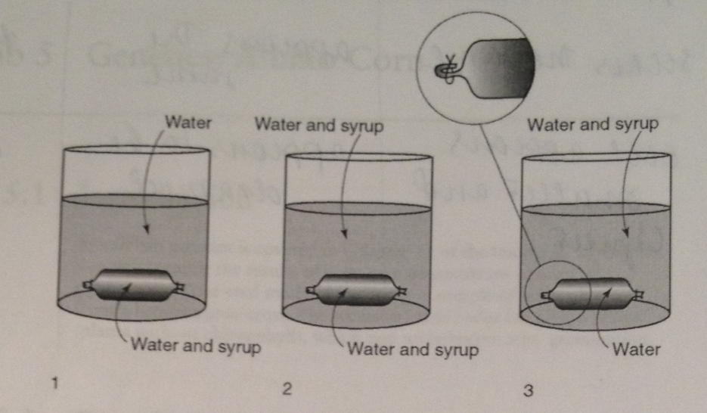
Figure 1 – Simulated Cell models

RESULTS
The results can be summarised as follows-
Model Cell 1- at every hour, the tube gained weight and was very heavy at the end of 3 hours.
Model Cell 2 – at every hour, the tube appeared to be the same and the weight of the tube did not change even at the end of 3 hours.
Model Cell 3 – at every hour the tube seemed to be drained and at the end of 3 hours the weight of the tube was lesser than at the beginning.
The results can be tabulated as follows,
Model Cell Number | After 1 hour |  | After 2 hours |  | After 3 hours
 | Appearance | Weight | Appearance | Weight | Appearance | Weight
1 | smaller | Heavy | Smaller | Heavy | Much smaller | Very heavy
2 | Same | Same | Same | Same | Same | Same
3 | Drained | Light | Drained | Light | Much drained | Very light
Table 1 – Cell models after every hour

DISCUSSION
The results from Table 1 can be interpreted as follows-
Model Cell 1 – The tube with sugar solution was immersed in the beaker with water. The tube gained weight every hour. This is because of the flow of water from higher concentration to lower concentration, i.e from the beaker to the tube which has sucrose solution. With time, the water accumulated in the tube making it heavy. This is a version of hypotonic medium.
Model Cell 2 – The tube with sucrose solution was immersed in the beaker with sugar solution. The concentration of sugar both inside the tube and beaker was same. Thus, this cell model was at equilibrium, hence there was no weight gain or loss of the tube. This is a version of isotonic medium.
Model Cell 3 – The tube with water was immersed in the sugar solution. The concentration of sugar in the beaker is higher than in the bag. Hence, water moves from higher concentration to lower concentration, i.e. from the tube to the beaker. This is a version of hypertonic medium.
The experiment is a simple demonstration of osmosis. Concentration gradient as a factor influencing osmosis has been demonstrated here. The other factors that affect osmosis are temperature, surface area and pressure. The solute particles (sugar) are not permeable to the membrane and hence do not move. However, they do exert a pressure on the membrane and move at random. This momentum is rapidly transferred to the surrounding water molecules and they move out of the membrane. This is also the reason for water to move from higher concentration to lower concentration. The rapid momentum can be increased by increase in temperature of the solution. The kinetic energy of the molecules will increase and osmosis will be rapid. Osmosis also increases with increase in surface area, this fact exploited by plants which have deep and extensive root system to absorb water from soil.

CONCLUSION
The results obtained were as predicted and has proved that Osmosis is indeed the movement of water molecules from a higher concentration to lower concentration. Understanding osmosis helps us to understand that while it is a simple process which does not involve energy expenditure; it may pose a problem for cells without a cell wall, like animal cells. One of the most important instances of osmosis is seen in the kidneys in humans.

REFERENCES
McCandless, J. (1997). Diffusion, osmosis and cell membranes.
Molecular Cell Biology (Lodish, Molecular Cell Biology) by Harvey Lodish, Arnold Berk, Chris A. Kaiser, Monty Krieger, Matthew P. Scott, Anthony Bretscher, Hidde Ploegh, Paul Matsudaira.chapter 2
Biology 204. Principles of Biology. Home Lab Manual. Lab 2: Osmosis, pp. 13-15

