- THU. Oct 9th – WK7
- LECTURE #1:
- MOVEMENT CONTROL & AUTONOMIC NERVOUS SYSTEM
- Prof. Dr. John Ciriello

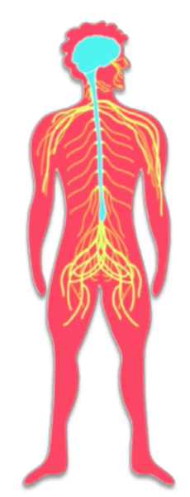
2 NERVOUS SYSTEMS ARE:
  - CENTRAL NERVOUS SYSTEM (CNS)
    - Comprised of the spinal cord and the brain.
    - Responsible for analyzing and interpreting information.
  - PERIPHERAL NERVOUS SYSTEM (PNS)
    - Comprised of the somatic and automatic nervous systems.
    - Responsible for collecting and sending stimulus information to the central nervous system

- MAJOR TERM TO REMEMBER
  - AFFERENT
    - SENSORY
  - EFFERNT
    - MOTOR

- WHAT ARE THE TWO MAIN FUNCTIONS OF THE NERVOUS SYSTEM
  - To tell the brain, of everything that’s going on around us and tell the brain about everything occurring in our internal environment
  - To move within our environment and things within us (our heart) (sensation)

- WHERE IS THE AUTOMONIC NERVOUS SYSTEM FOUND?
- 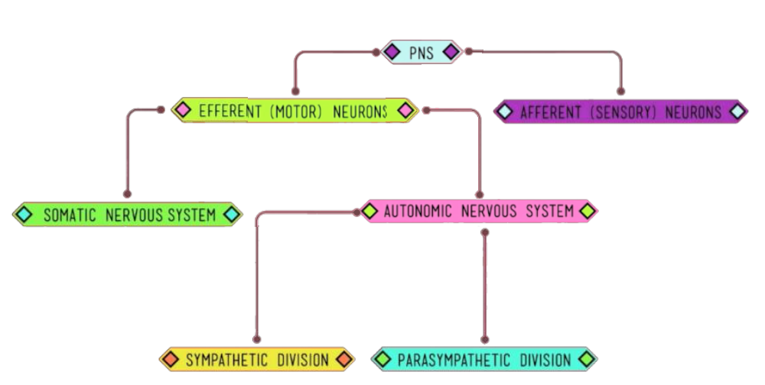

- Where are all neurons formed and orginate?
  - In the spinal cord
- 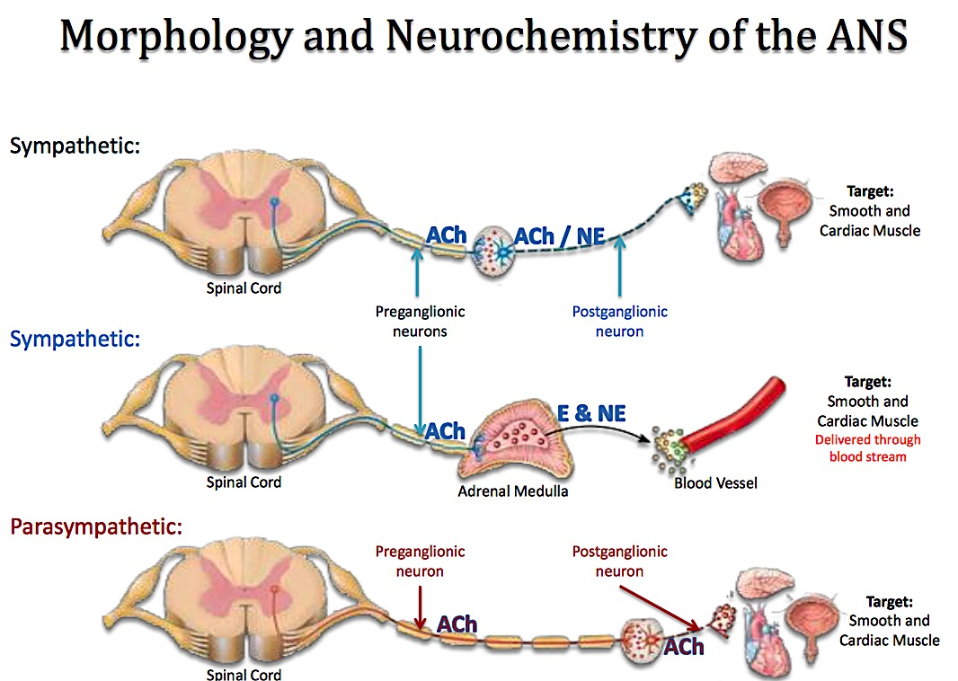

- Autonomic Nervous System:

- Where is the ANS found?
  - Everywhere (from top cerebral cortex to your big toe)
  - Throughout neuroaxis-head is found in the hypothalamus.

- Parasympathetic Nervous System (PNS):
  - Both pre- and post- ganglionic neurons release ACh.
  - Two divisions – PNS and SNS – usually antagonistic, but sometimes work in a cooperative or complementary manner.
  - BUT, some are
    - Cooperative and Complimentary

- Sympathetic Nervous System (SNS):
  - Preganglionic neuron releases ACh while postganglionic neuron releases NE
    - both are antagonist to each other if one increases the other decreases
    - two exceptions are:
      - both the PNS and SNC produce saliva
        - something watery with the food the consumed
        - in the case of exercising (saliva is different)
          - we produce saliva differently due to composition
          - this is called cooperative
          - AND complimentary

The parasympathetic nervous system is faster/slower?
  - Faster because it’s more faster when delivering the message
    - it has a telephone wire that runs messages through quite quicky
      - The more myelination on a neuron the faster the neuron that

- THE MOTOR UNIT

- DEFINE MOTOR UNIT:
  - Motor Unit: is a group of skeletal muscle fibers and the somatic motor neuron that controls them.
    - Motor units are the basic unit used for motor movement
    - 3 IMPORTANT THINGS TO MOVE A MUSCLE:
      - What muscles to use
      - The length of the muscle to use
      - Tension & force
- 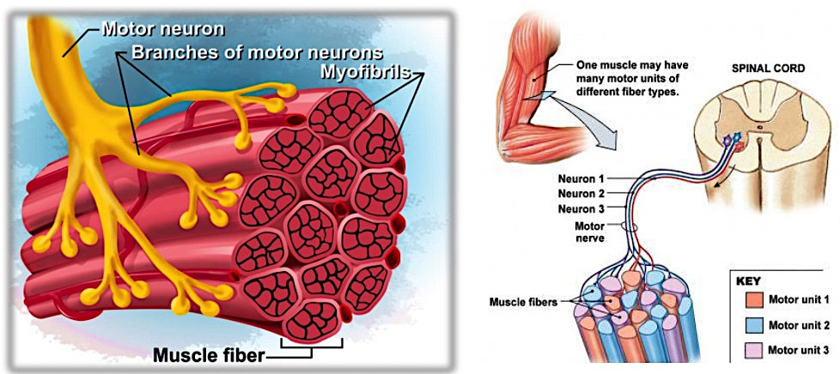

- DEFINE REFLEX
  - Reflex: defined as the involuntary response to a stimulus which requires the integrity of the nervous system. The end result of a reflex may either be contraction or secretion.

- A REFLEX ARK IS?
  - Reflex Arc: is the pathway followed by the nerve impulse producing the reflex
    - REFLEX ARC INCLUDE 5 THINGS:
      - Sensory receptor
      - Afferent/Sensory neurons
      - Synapse at an Integrating center
      - Motor neuron
      - Effector
- 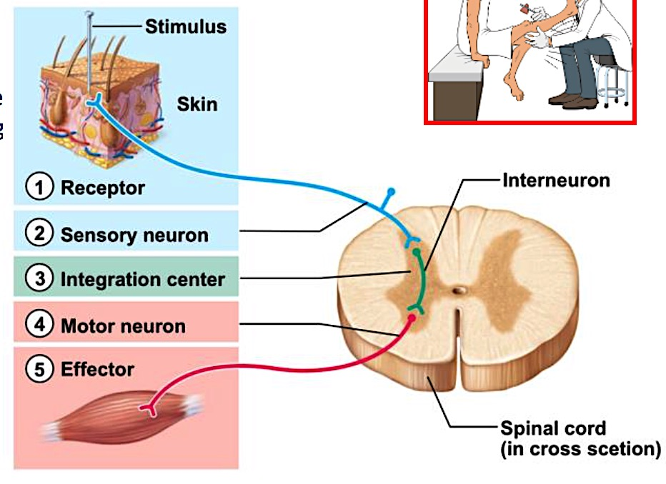

- 2 SKELETAL MUSCLE REFLEXES:
  - Monosynaptic reflex: has a single synapse between the afferent and efferent neurons.
  - Polysynaptic reflex: have two or more synapse. This somatic motor reflex has both synapses in the CNS.

- WHAT DOES THE MUSCLE SPINDLE DO?
  - Muscle spindle: sends information about muscle stretch to the CNS
    - WHERE ARE MUSCLES SPINDLES FOUND?
      - Muscle spindles are buried among the extrafusal fibers of the muscle.
- 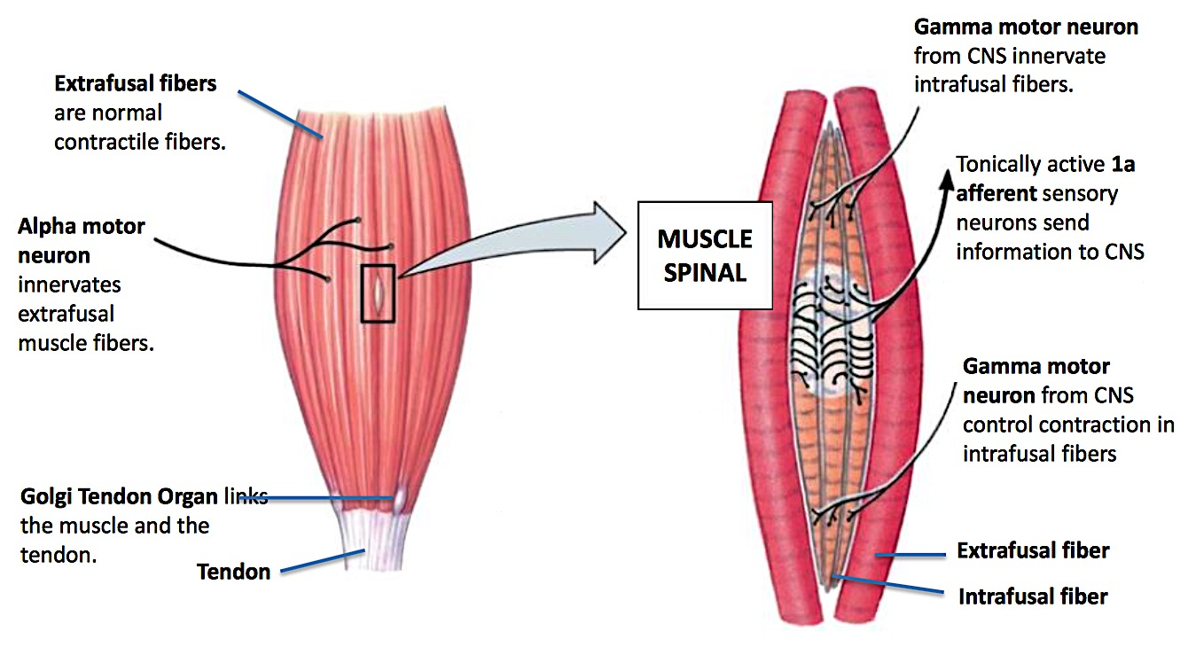

  - The nerve 1A afferent neuron takes information from muscle spindles to the spinal cord (sensory neuron)

- WHY WOULD A SPECIALIZED NEURON BE MADE?
  - Carries that information very fast for survival
    - When an action potential happens in the big

- DEFINE GOLGI TENDON ORGAN:
  - Golgi Tendon Organ: protective mechanism
    - consists of the sensory nerve endings interwoven among collagen fibers
- 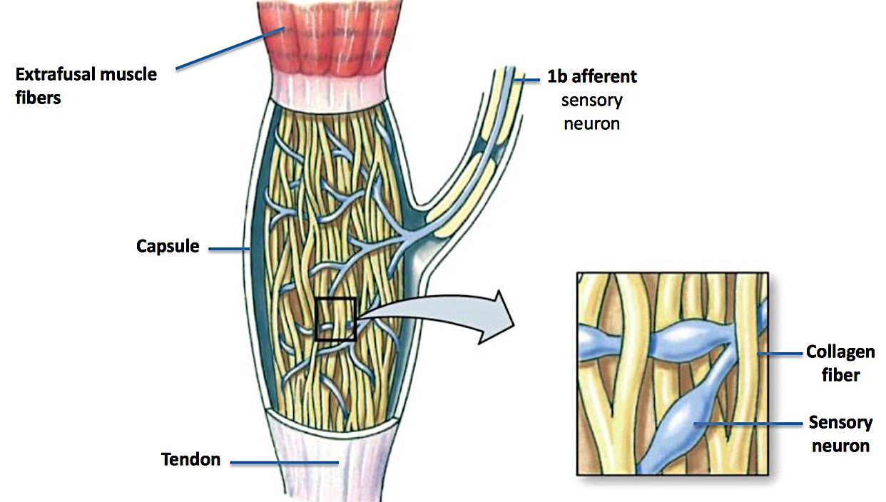

- RECIPIRCAL INNERVATION:
  - When ever one muscle contracts the other relaxes
- 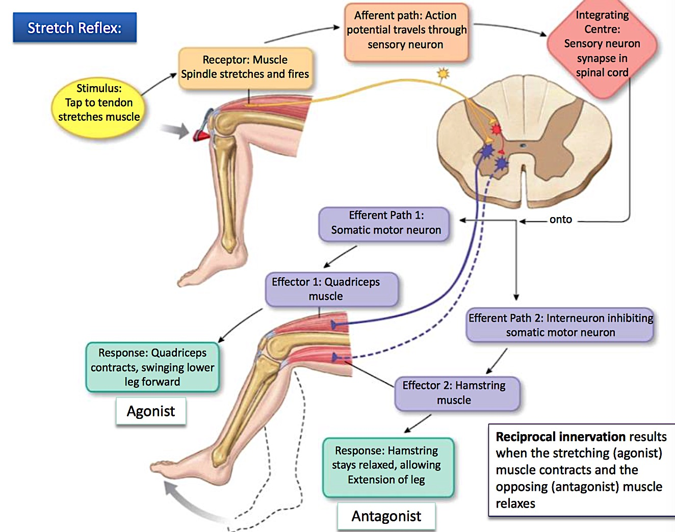

- FOR ANYMOVEMENT TO OCCUR THE OPPOSITE MUST BE WHAT?
  - Relax, by shutting down on

- 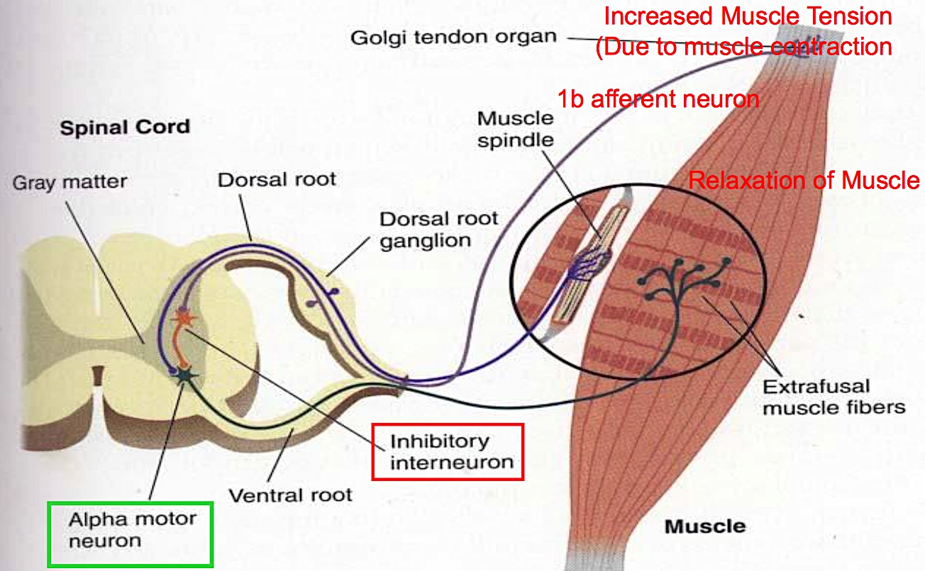

- 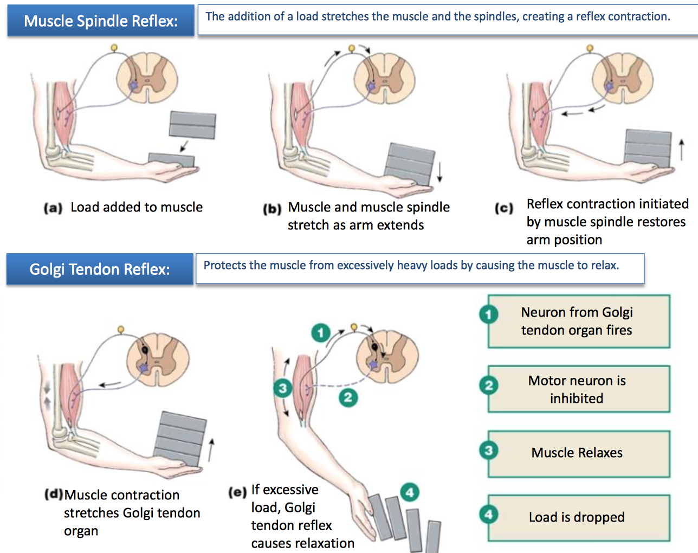

- CROSSED EXTENSION IS?
  - Crossed extensor reflex: Helps your body maintain its balance when it has been disrupted, often as a result of a flexor reflex.

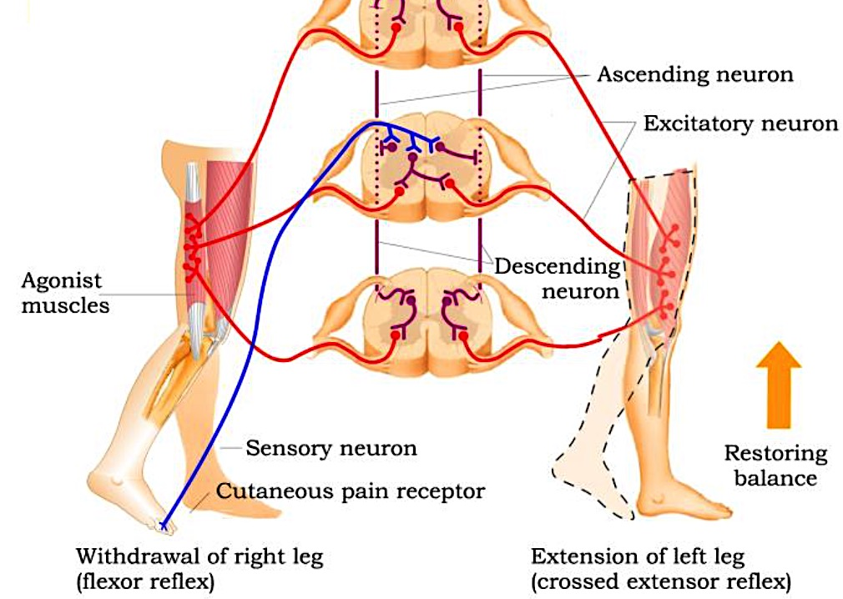

TAKE HOME MESSAGES!

BASIC UNIT IN MOVEMENT IS?
  - The motor unit

- THE NERUON THAT LEADS TO THE MUSCLE IS THE?
  - Alpha motor neuron

- TO PERFORM A MOVEMENT WE NEED TO KNOW:
  - Which muscle to use -> learned
  - Length muscle spindles 1a afferent neuron
  - Tension Golgi tendon organ 1b afferent neuron

WHAT IS THE MUSCLE SPINDLE:
  - In parallel with extrafusal muscle fibers
  - Responsible for information about length and change in length of skeletal muscle

- GOLGI TENDON ORGAN (GTO)
  - In series with tendon/muscle fibers
  - Responsible for information about tension within muscle.

- REFLEX ARC:
  - Receptor is the afferent neuron
  - Synaptic contact in spinal cord (CNS)
  - Motor neuron effector

Monosynaptic Reflex:
  - Stretch reflex

- POLYSYNAPTIC REFLEX:
  - Simultaneous activation of skeletal muscle fiber (alpha motor neuron) and muscle spindle (gamma motor neuron) causing both to contact
  - Increases sensitivity of muscle spindle and maintain afferent information to CNS about muscle length.

