CHM2123 FINAL EXAM 2012
- 10 points; 5,5) Separations. Using a flowchart and any necessary reagents found in the Reagent Box on page 15. Provide a method for the separation of the following mixture of compounds in dichloromethane. Isolate each compound in their solid form. (Recrystallization not necessary).

2. (15 points) Oxidation and Reduction: While performing the oxidation shown, a student decides to monitor the progress of the reaction using thin layer chromatography. Two TLCs for the reaction are represented below.
a) Calculate the R_{f} values of A and B for TLC 1. Show your calculations. (2 points)
b) Draw the structure of the reactant and products 1 and 2 corresponding to spots A, B and C. (3 points)
A: B: C:

c) Using key words, briefly justify your reasoning for this assignment (in part b)) based on the principles of thin layer chromatography. (3 points)

d) The students eluted one TLC with 1:4 hexanes : ethyl acetate, and another with 1:1 hexanes : ethyl acetate, but forgot to label the plates. Which solvent system for each of the above TLCs? (2 points)
TLC 1: TLC 2:

e) In the experiments you performed in the lab using NaBH₄ as a reagent, it was important to ensure that your glassware was free of traces of acetone. Provide a mechanism for the side reaction of NaBH₄ with acetone in an ethanol solution. Include the formation of the tetrahedral borate as a key intermediate. (5 points)

Substitution reactions (10 points)
Experiments were performed by students to evaluate the kinetics of different leaving groups on the rate of the reaction.
Data was collected using both 1-bromobutane and 1-iodobutane as substrates, where the data is presented below.
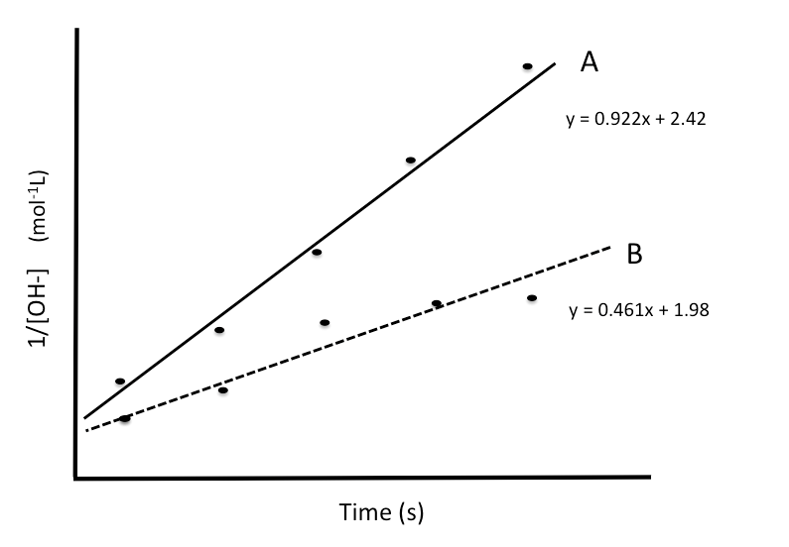

- Assign the results to the corresponding substrates. (1 point)
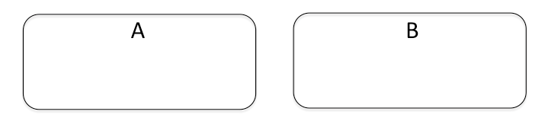
Justify your choice using a chemical perspective. (2 points)
- Using the results provided, determine the rate constant, k, and the overall order of the reaction for substrate A. (2 points)

- Using the data provided, determine the initial concentration of KOH in the reaction with substrate A. (1 point)
- At the end of the experiment, students are asked to regenerate 1-bromobutane for the next group of students to perform the lab. Propose a method to synthesize 1-bromobutane from 1-butanol (max. 3 steps) Any reagents necessary are available in the Reagent Box on p.15. Provide a mechanism for the transformation (3 points)

4. Reactions of carbonyl compounds (10 points)
a) Provide a mechanism for the following reaction to yield intermediate 1 and product 2 (5 points)

b) Provide a name for the type of reaction to yield product 4 (1 point)

c) Under the given reaction conditions, identify the structure of the molecule that behaves as a nucleophile. What causes this nucleophilic character? (2 points)

d) Provide the products 5 and 6 of the following reaction. (2 points)

5. Fischer Esterification Compound 7 was reacted with an excess of methanol to yield compound 8 possessing an apple-like fragrance. (4 points)
Based on the following ¹H NMR and with the help of the scheme on p.15 , identify the structures 7 and 8 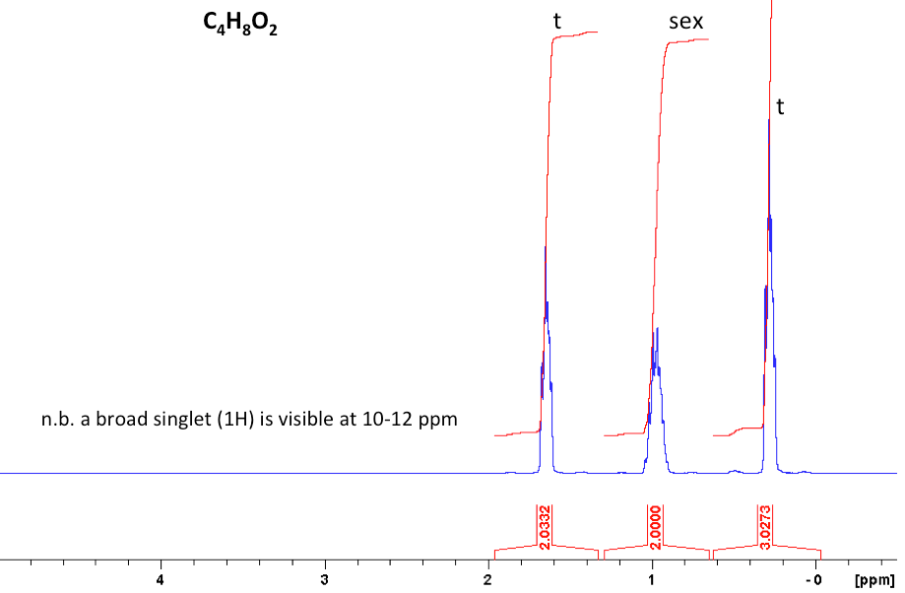
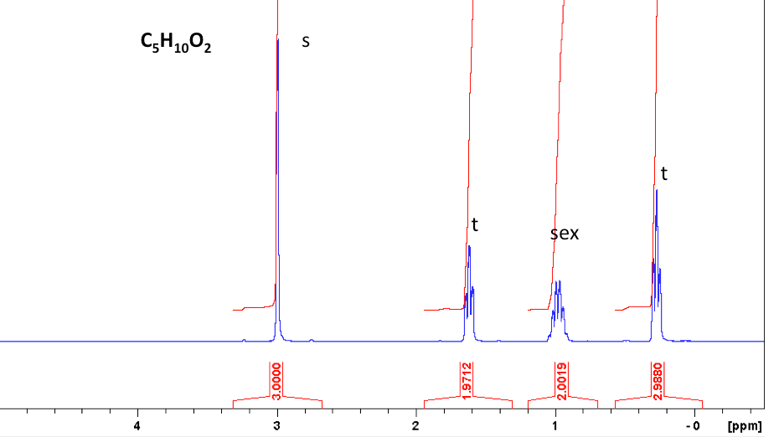

6. Synthesis of soaps and detergents (10 points)
a) Suppose that you wanted to prepare a soap from the following generic triacylglyceride. Indicate the structures of the products 9 and 10 obtained in such a reaction. (2 points)

b) How can you convert a soft soap into a hard soap? Use and equation, and explain briefly the change that is occurring. (2 points)

c) Why is this saponification reaction with NaOH irreversible? (2 point)

d) Suggest a test to distinguish between aqueous solutions of soap and a detergent. (3 points)

7. Acetal chemistry. The procedure for the synthesis of an acetal is given below.
In a 25 mL round bottom flask, hydro-cinnamaldehyde (1.02 g, MW 134.18 g/mol) was dissolved in ethylene glycol (1.0 mL, MW 62.07 g/mol, d = 0.97 g/mL) followed by dropwise addition of p-toluenesulfonic acid (0.23 mL, MW 172.2 g/ml, d = 1.24 g/mL). The reaction was then stirred at room temperature for 2 hours. Once the transformation was considered complete by TLC, the reaction mixture was transferred to a seporatory funnel containing 10 mL dichloromethane (MW 84.93 g/mol, 1.33 g/mL), and extracted three times with 10% sodium bicarbonate (3 x10 mL, MW 84.00 g/mol) The organic solvent was removed via distillation to afford 0.99 g of the pure product.
- Complete the table of reagents using the necessary chemicals (4 points)
Compound (structure) | Molecular Mass (g/mol) | Amount  (g or mL) | Density (g/mL) | Moles (mol) | Equiv.

- Determine the limiting reagent in this reaction. (2 points)

- What is the percent yield of the product? (2 points)

8. For those who can handle the heat! (10 points)
a) Propose a three-step method for the synthesis of capsaicin, one of the active ingredients in chili peppers.
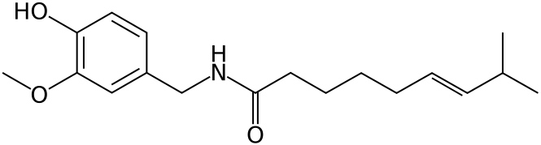
Starting from the following compounds. You may select any necessary reagents from the Reagent Box on p.16. (A mechanism is not required) Outline a general approach to the problem. You must use reactions that you have seen in this course. Reaction conditions for all steps must be shown. (8 points)

b) Does the order of reactions matter? Explain. (2 points)

10. Short answer questions: (23 points)
a) In a liquid-liquid extraction with aqueous sodium bicarbonate and dichloromethane, which layer is on top? (1 point)

b) What is an emulsion? How can an emulsion be removed from solution during extraction? (2 points)

c) Why is only a minimum amount of hot solvent needed for recrystallization? (2 points)

d) Provide the major product, 11, in the following reaction. (1 point)
e) Provide the product,12, in the following reaction. (1 point)
f) Would a mixture of H₂O and MeOH be more useful to perform an extraction or a recrystallization? Why? (2 points)

g) When running a TLC, why do you make a ‘co-spot’ of the starting materials and reaction mixture spot? (1 point)

h) Briefly explain cross-linking, and give one example of cross-linking in nature. (3 points)

i) Provide the structures of compounds 13 and 14 for the reaction performed this semester. (2 points)
j) A student acquired the following TLC 20 minutes after the reaction with NaBH₄. Propose a structure for compound 15. (1 point) (This chemistry does not involve the use of triethylamine)
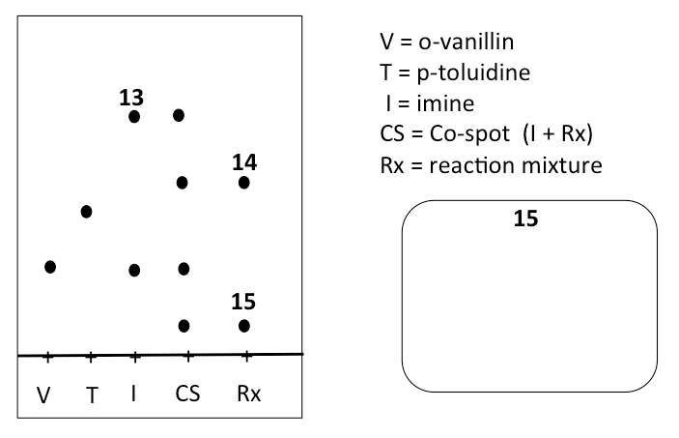

k) To what phase is Na₂SO₄ added at the end of an extraction? (1 point)

l) After dissolving your crude product in hot ethanol and allowing it to cool slowly to room temperature, no crystals have formed. Suggest three techniques to induce crystallization. (3 points)

1.
2.
3.

m) Will an equilibrium constant (K) greater than 1 favour formation of products or reactants? (1 point)

n) What is the difference between washing a phase and extracting a phase? (2 points)
Reagent Box

